Titan Service Platform Maintenance

User Guide

**Version 1.0**

**Jacky Gu**

**Jacky.gu@titan-arc.com**

**Table of Contents**

# Document Information

## Revision History

|  |  |  |  |
| --- | --- | --- | --- |
| **Date** | **Version** | **Author** | **Description** |
| 2013/10/13 | 1.0 | Jacky Gu | Initial document. |
|  |  |  |  |
|  |  |  |  |
|  |  |  |  |
|  |  |  |  |
|  |  |  |  |

## Reference

|  |  |  |  |
| --- | --- | --- | --- |
| **Date** | **Author** | **Document** | **Version** |
|  |  |  |  |
|  |  |  |  |
|  |  |  |  |

# Register Server: Admin Site

URL:

<http://ttw.tech-titan.com/register/admin>

Default administrator account: admin/123456

## Account Management

* Account Management 🡪 Account

This function supports to manage account for admin site.

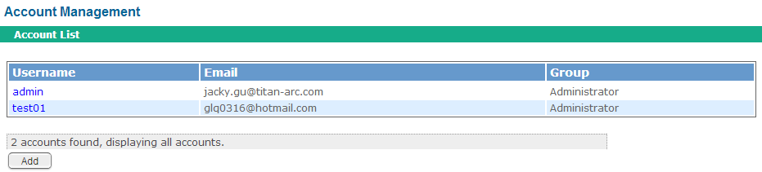

## Product Management

* Product Management 🡪 Import MAC

This function supports to import device information. If the device information is not in the database, it can not be registered. The device information must be imported into database first. We should prepare an excel file first, in the file, there should be two columns, the first column is serial number, the second column is MAC address.

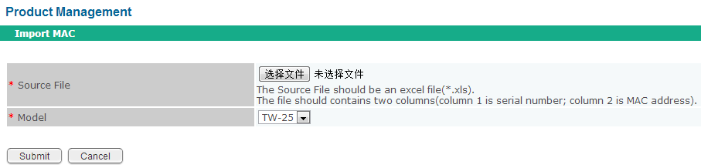

## Service Management

* Service Management 🡪 Generate License Key

This function supports to generate license keys needed.

Service Code: define the service type, for detailed information, refer to ES.

Card Type: currently, only TW-25 is defined

Quantity: the needed license number

Usage: Formal (for formal usage) / Test (for test usage)

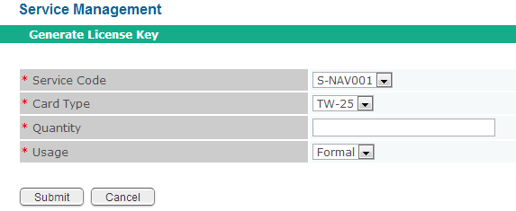

* Service Management 🡪 Query X

Input one or multiple query conditions, to query service information.

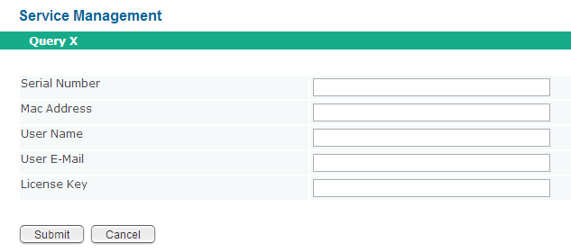

* Service Management 🡪 Service Reset

If we need to reset the registered service, we can do service reset operation here.

To do Service Reset, there are two steps:

1. Input one or both items, then click “Search” button. If the device is registered, we can see the registered information.
2. Click “Reset” button.

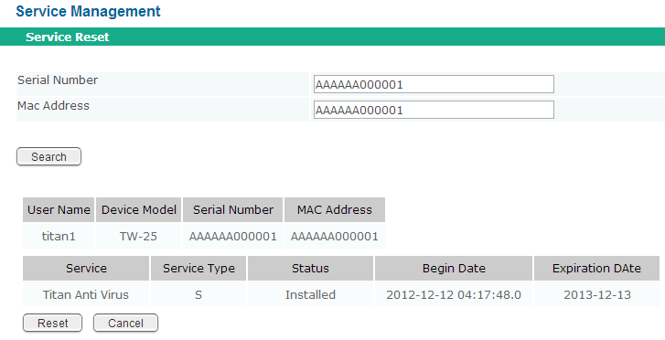

# Update Server

URL:

<http://ttw.tech-titan.com/upd>

Default administrator account: admin/123456

## Account

* Account 🡪 Account

This function supports to create/update/delete account.

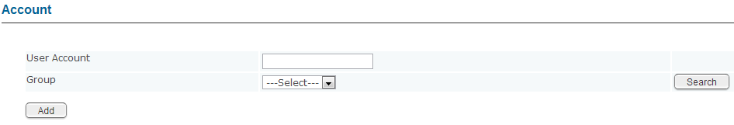

* Account 🡪 Privilege

This function supports to update privilege of group.

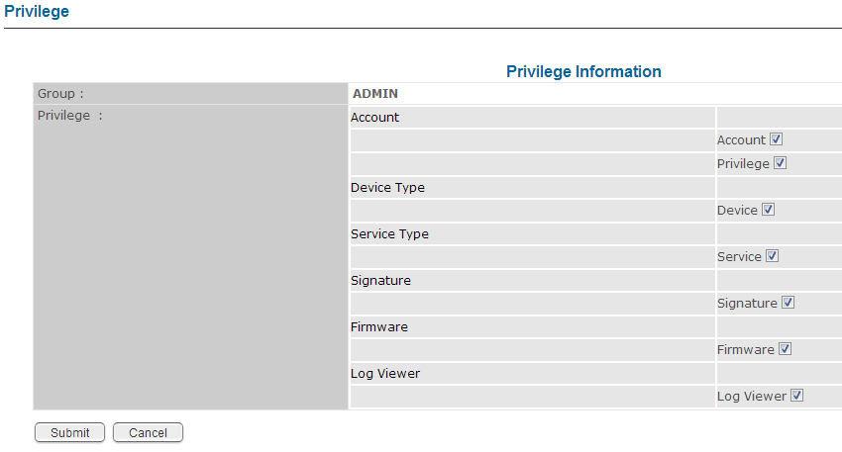

## Device Type

* Device Type 🡪 Device

This function supports to define Device Type. If we plan to support a new device type, we can add one.

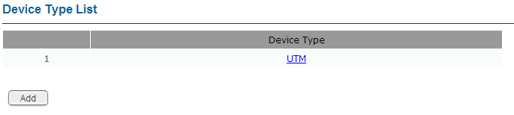

## Service Type

* Service Type 🡪 Service

This function supports to define Service Type. If we plan to support a new service type, we can add one.

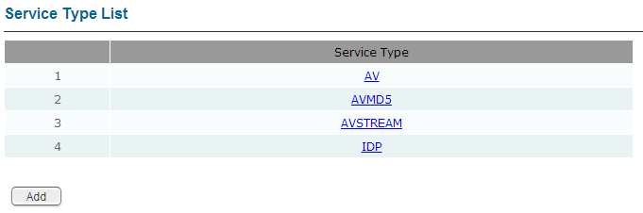

## Signature

* Signature 🡪 Signature

This function supports to add/update/delete/search signatures.

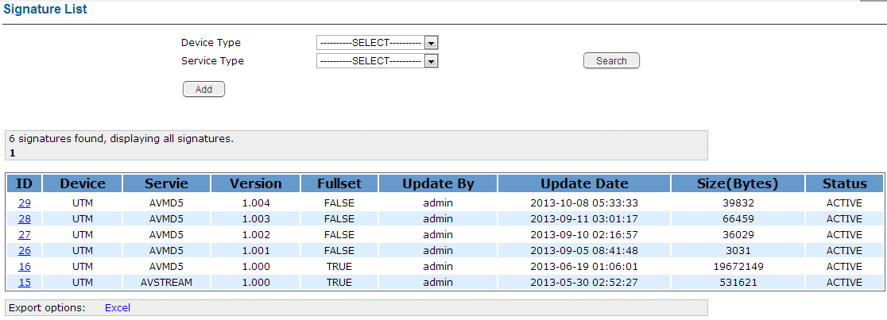

## Firmware

* Firmware 🡪 Firmware

This function supports to add/update/delete/search firmwares.

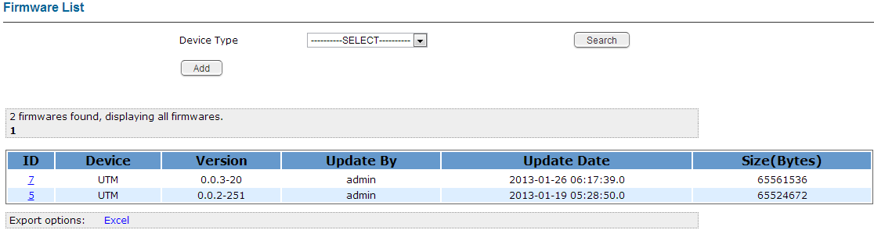

## Log Viewer

* Log Viewer 🡪 Log Viewer

This function supports to query server / device logs.

Category:

System: to search server logs

Signature Request / Signature Download: to search signature update related logs

Firmware Request / Firmware Download: to search firmware update related logs

Start Time: the start time of the time range

End Time: the end time of the time range

Keyword: the keyword contained in the log, it can be MAC, Source IP, …

