Test Coverage

Program source
#include <stdio.h>

int const max_words_in_input_line = 40 ;
int const max_word_length = 80 ;

char table [max_words_in_input_line][max_word_length];
char buffer [max_word_length];

int row =0 ; /* current row to be filled in the table */

int i,j ; /* counters */

char c; /* current character read from the input */

char const blank = ' ' ;

void main()
{
Do
{
/* Skipping blanks */
do
c = getchar() ;
while ( c == blank ) ;
if ( c != '\n')
{
/* And now read the next word and put it into the table : */
j = 0;
while ( (c != blank) && (c != '\n') )
{
c = getchar() ;
table[row][j] = c ;
j++ ;
}
table[row][j] = '\0' ;
row++ ;
}
}
while ( c != '\n') ;
/* all other rows in the table remain empty : */
for (i = row; i < max_words_in_input_line; i++)
table[i][0] = '\0';
printf ("Total number of non-empty words in the input line: %d" , row-1);
for (i = 0; i < max_words_in_input_line; i++)
{
if ( table[i][0] == '\0' ) /* the word in this row is empty */
{
printf("Empty word \n");
continue;
}
/* for non-empty-word: copy it into the buffer, and then print */
for (j = 0; j <= max_word_length; j++)
{
buffer[j] = table[i][j];
if (table[i][j] == '\0' )
break ;
}
printf ("%s\n", buffer);
}
printf(" DONE !!! \n");
} /* end of main */

Analysis of control flow graph

Flow Graph
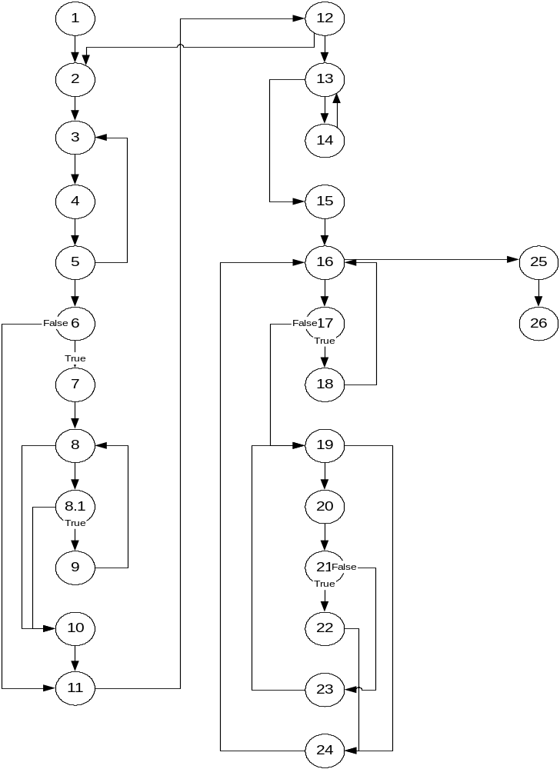

Cyclomatic complexity
NumberOfEdges = 35
NumberOfNodes = 27
Complexity = 10

Independent paths
1,2,3,4,5,6,7,8,8.1,9,8,10,11,12,13,15,16,17,19,20,21,22,24,16,25,26
1,2,3,4,5,3,4,5,6,7,8,8.1,9,8,10,11,12,13,15,16,17,19,20,21,22,24,16,25,26
1,2,3,4,5,6,11,12,13,15,16,17,19,20,21,22,24,16,25,26
1,2,3,4,5,6,7,8,8.1,10,11,12,13,15,16,17,19,20,21,22,24,16,25,26
1,2,3,4,5,6,7,8,10,11,12,13,15,16,17,19,20,21,22,24,16,25,26
1,2,3,4,5,6,7,8,8.1,9,8,10,11,12,13,14,13,15,16,17,19,20,21,22,24,16,25,26
1,2,3,4,5,6,7,8,8.1,9,8,10,11,12,13,15,16,17,18,16,19,20,21,22,24,16,25,26
1,2,3,4,5,6,7,8,8.1,9,8,10,11,12,13,15,16,17,19,24,16,25,26
1,2,3,4,5,6,7,8,8.1,9,8,10,11,12,13,15,16,17,19,20,21,23,19,24,16,25,26
1,2,3,4,5,6,7,8,8.1,9,8,10,11,12,2,3,4,5,6,7,8,8.1,9,8,10,11,12,13,15,16,17,19,20,21,22,24,16,25,26

Control flow Coverage testing
No | Goal | Input | Expected Result | Actual result
 | Read one one character word character | ‘a\n’ | Print total number of non empty =1  Print the string “a” | Total number of non-empty words in the input line: 0
 | Read one word with length > 1 | ‘aaa\n’ | Print total number of non empty =1  Print the string  “aaa” | Total number of non-empty words in the input line: 0aa
 | Read a few one character word, separated with only space. | ‘a b c\n’ | Print total number of non empty =3  Print every word in separate line | Total number of non-empty words in the input line: 2  Print none word
 | Read a few words longer than 1 separated by single space | “aa bb cc dd\n” | Print total number of non empty =4  Print every word in separate line | Total number of non-empty words in the input line: 3a  b c d
 | Handle the line of spaces | “ \n“  The length of line < 80 | Print total number of non empty =0 | Total number of non-empty words in the input line: -1
 | Read a few one character word, separated with several spaces. | ‘a b c d e\n’ | Print total number of non empty = 5  Print every word in separate line | Total number of non-empty words in the input line: 4
 | Read a few word longer than 1 char separated with several spaces. | ‘aa ba ca da e\n’ | Print total number of non empty =4  Print every word in separate line | Total number of non-empty words in the input line: 4a  a  a
 | Read the string without eol char at end | ‘aaaaa bb’ | Program must wait | Crash the program
 | Handle one heading space and one word | “ xyz” | Print total number of non empty =1  Print xyz in the next line | Total number of non-empty words in the input line: 0yz
 | Handle several heading spaces and one word | “ xyz “ | Print total number of non empty =1  Print xyz in the next line | Total number of non-empty words in the input line: 0yz
 | Handle several heading spaces and several words | “ xyx ab” | Print total number of non empty =2  Print xyz and ab in the next lines | Total number of non-empty words in the input line: 1yz  B
 | Handle trailing spaces | “xyz \n“ | Print total number of non empty =1  Print xyz in the next line | Total number of non-empty words in the input line: 0yz

Boundary cases

Empty string
Goal: Process an empty string
Input ‘\n’
Output Total number of non-empty words in the input line: 0
Actual result Total number of non-empty words in the input line: -1

Space Input line length more than 80 character
Goal: Check if it is possible to process the lines longer than permitted
Input: Any sequence of char with length > 80 ended by ‘\n’
The sequence must include space char only.
Result: the program must not allow input the lines with length >80
Actual result the program allows entering lines longer than screen length.

Non Space Input line length more than 80 character
Goal: Check if it is possible to process the lines longer than permitted
Input: Any sequence of char with length > 80 ended by ‘\n’
The sequence must not include space.
Result: the program must not allow input the lines with length >80
Actual result the program allows entering lines longer than screen length.

Input line length more than 80 character
Goal: Check if it is possible to process the lines longer than permitted
Input: Any sequence of char with length > 80 ended by ‘\n’
The sequence must include non – space char.
Result: the program must not allow input the lines with length >80
Actual result the program allows entering lines longer than screen length.

Input line length = 80 character and the all the input are spaces
Goal: Handling the String of spaces with length = 80
Input : The String of spaces with length = 0
Output: Print total number of non empty word: 0
Actual result: Total number of non-empty words in the input line: -1

Input line length = 80 character and the all the input is not pace string
Goal: Handling the String of spaces with length = 80
Input: The String of chars with length = 80 the string must contain chars different from space
aa bb cc bb aa bb cc bb aa bb cc bb aa bb cc bb aa bb cc x\n
Output: Print number of the words and all the words inside of the input string
Actual result Total number of non-empty words in the input line: 19a

Bugs in the programs

  - The number of non-empty words is less one than real number. Happens in all scenarios
Line 15
printf ("Total number of non-empty words in the input line: %d" , row-1);

Solution The variable row contains the real number of words, so it is necessary to print row instead row – 1.

  - The print omits the first letter in the word. Happens in all scenarios
The problem is block lines 9
c = getchar() ;
table[row][j] = c ;
The flow fist read next character and omit the previous non space character
Solution These lines must be swaped
  - The program prints lines Empty word after the real content this is not according to design. Happens in all scenarios

Line 17
if ( table[i][0] == '\0' ) /* the word in this row is empty */
{
printf("Empty word \n");
continue;
}
Solution Don’t print this statement
  - The first word in input printed with the same line as “Total number …
Statement. Happens in all scenarios
Solution add ‘\n’ to this print statement.

  - The program does not warn about illegal inputs (length > 80) Boundary case scenarios
Solution: Count every input char see getchar statements line 15.1 and 17.4.2. In case the input size > screen size print error message and exit the program.

