Integration test

Procedure call graph
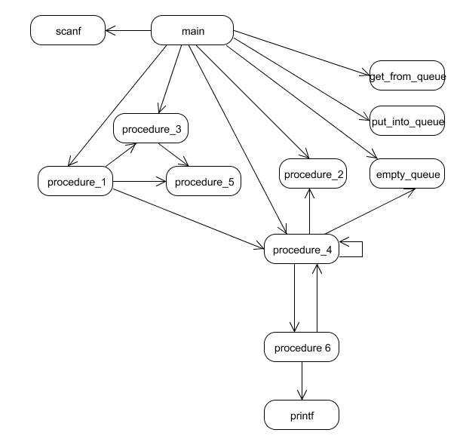

Tests

Flow acronyms
Procedure_* used p*
Get_from_queue used gfq
Put_into_queue used piq
Empty_queue used eq

Every procedure/function is called at least once
No | Flow | Test list | Remarks
 | Main->p2->p3->p5 | Run program, type number >100
 | Main->p1->p4->eq->p6->p2 | Run program type number <10 | It is impossible to reach p6 as the procedure invoked only if eq method return 0, but as the queue is empty this method always return 1. Endless recursive call happens here p4->eq->p4…
 | Main->eq->gfq | Run program , type any number and G | This is impossible to reach the gfq method as eq always return 1 in the current integration
 | Main->piq | Run program , type any number and P

Every simple path Taken at least once
No | Flow | Test list | Remarks
 | The tests from previous chapter
 | Main->p1->p5 | The same as test 2 from previous chapter
 | Main->p4->p6 | The same as test 2 from previous chapter
 | Main->p2 | Run program , type number >10 and <100 number | After exiting p2 the flow enters to p4 and stuck in the enless recursive call to p4 see flow 2 from previous chapter

Loops in the graph
No | Loop | Test list | Remarks
 | P4->p4 |  | This loop is endless as queue is empty
 | p4->p6->p4 |  | It is impossible to reach the p6 procedure from p4 because the queue is always empty

