Exercise #4

Date Due: Dec. 16th. Make sure that your solution is clear and readable. Whenever possible, use word and diagram processing tools.

- Use the UML notation to draw an ERD [Entity relationship diagrams] that represents the following requirements for a new information system for Israel’s Public University, affectionately known as PU [not to be confused with the bear known to most children]. Limit yourself to the requirements specified below, which are only a part of the complete requirements of the system. In drawing the diagram you should separate relationships from attributes by placing all the attributes on a separate diagram. I.e., you should submit two diagrams, one for the classes and their attributes and one for the classes and their inter-relationships. There may be requirements that are not naturally expressible in an Entity-Relationship Model. These should be listed in the next part of the exercise. Do not over model.

- In the accompanying table enter
  - assumptions that you have made that are not explicitly stated in the requirements but are needed for you to complete the assignment,
  - questions/clarifications/suggestions that you would like to ask the users, clients, etc.
  - problems [for example, incompleteness, ambiguity, inconsistency, lack of clarity] in the requirements,
  - requirements that are not expressible in the ERD
  - rationale or considerations in making your “design” decisions or choosing between alternatives.

PU enables citizens of Israel to acquire a higher education [first degree and second degree] in various academic disciplines. Students study full-time or part-time, in a flexible, open environment near their homes. PU has learning centers in all parts of the country.

The new PU information system will keep track of information related to administrative staff and teaching staff, students, campuses, departments [both academic and non-academic], courses provided by the academic departments, and sections of courses offered during the university’s three semesters fall, spring and summer.

PU is a “distributed” university with many learning centers throughout the Israel. Each learning center is uniquely identified by a name; has an address and telephone number; and has a learning center manager, who is a member of the PU administrative staff. The PU consists of academic and non-academic departments. Academic departments have teaching staff and provide undergraduate and graduate courses. Non-academic departments provide services [for example, library, personnel, student services] to the university community, both students and staff. Each department has a unique name, number and mission. Employees may be either administrative staff or teaching staff. Each employee is identified by his identity number. The system will also keep track of the employee’s name, address, telephone number, email address, bank account number and monthly salary. Every member of the teaching staff must have an appointment to an academic department. Every employee is assigned to a single university department [academic or non-academic] in which he is currently working. Note that teaching staff may be assigned to work in non-academic departments. Teaching staff are divided into senior teaching staff and junior teaching staff. Each teacher has a rank. Junior teaching staff are either lecturers or senior lecturers and senior teaching staff are either associate professors or full professors. Each academic department has a chairperson. The chairperson of each academic department must be a member of the senior teaching staff appointed to that department and assigned to that department. Each academic department has an official secretary. The secretary of each academic department must be an administrative staff member assigned to that department. Each non-academic department has a manager. The manager of each non-academic department may be either a member of the teaching staff or a member of the administrative staff. Other staff may be assigned to either an academic or non-academic department.

Students are either undergraduate [studying for a first degree] or graduate [studying for a second degree]. Each student is identified by his identity number. The system will also keep track of his name, address, telephone number and email address. Undergraduate students must complete 120 credits to get a first degree. Each undergraduate student must declare his major field [i.e., department] of study and his minor field of study. Of the 120 required credits required for a first degree, 60 must be in the student’s major department and 30 must be in the student’s minor department. At least 15 must be in any department other than the student’s major or minor department. The remaining credits may be in any department. Each graduate student must declare his department of study. Graduate students must complete 36 credits to qualify for a second degree, of which at least 30 credits must be from his department of study. The system will store for each graduate student the name of the institution from which he received his first degree and the year in which he completed it. Each student is assigned an advisor. Undergraduate students are assigned junior teaching staff members as advisors, while graduate students are assigned senior teaching staff members as advisors.
Each department gives a large number of courses, some are offered every semester, while some are offered less frequently. Each course has a name, description, number of credits earned, and a unique course number. Each course is assigned a course coordinator, who must be a member of the senior teaching staff. Each semester the courses that are offered are organized into one or more sections [i.e., learning groups] offered in the various PU learning centers in Israel. Each section is given a unique number. Each section is taught by a member of the teaching staff. A teaching staff member will teach no more than four sections each semester. Students register for a specific section of a course. At the end of every semester, the instructor of each section assigns a grade to each of the students registered for his section.

This information is retained in the PU information system and will be used to generate various reports including

- a semester course list sent to each course coordinator listing the course’s department name, course name and number and all the sections of the course for the given semester, including for each section - the section’s number, instructor and number of students registered.

- a section roster sent to the section instructor at the beginning and end of each semester listing the course name and number, section number and learning center, and a list of the registered students.

- A student’s transcript - a chronological list of the courses the student has competed [successfully or unsuccessfully], including the course name and number, semester, section number, learning center, instructor and grade.

Solution

Entities attributes diagram

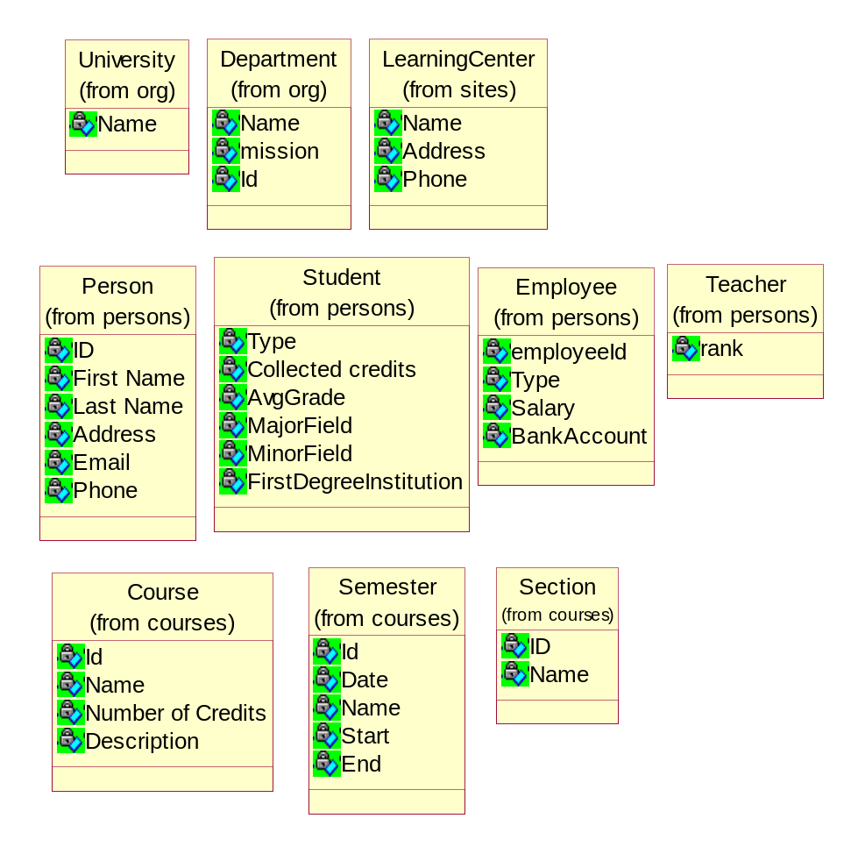

Entities relation diagram
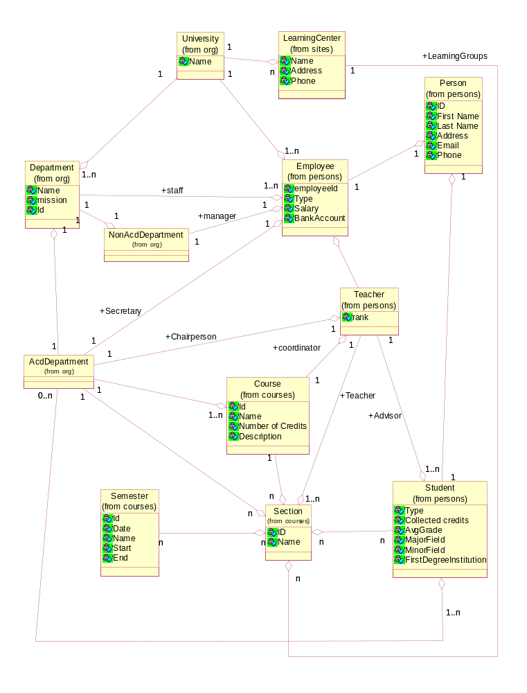

Requirements Issues: Assumptions, Questions, Problems [missing req, inconsistency, etc.], Unexpressible requirements, Rationale

No. | Type | Problem Description
 | Question | Can Student study in two departments (run for two degrees simultaneously)
 | Question | What is graduating process – automatically or student must send a request
 | Proposal | Add study program entity , as it missing in the design
 | Proposal | Add study scheduling information
 | Question | Can teacher study in two different departments
 | Question | The same course can belong to different departments via different sections ?
 | Unexpressible requirements | How to express in ERD number of credits or any quantity bussenes parameters
 | Proposal | All magic number , e.g. 120 Credits, store in dedicated repository

