Project name | Meeting Manager (MM)
Document type | HLD&DD (product design document)
Document revision
Date submitted
Author | Alexander Stekolchik
Project abstract | The tool for collecting, following up and reporting the issues discussed in the different forums.
Change log | Revision | Date | Change description
Change log | 1 | 21.03.05 | Create document

1. Introduction 1
1.1. Purpose 1
1.2. Scope 1
1.3. Glossary 1
1.4. References 2
1.5. Document Overview 2
2. Implementation model 2
2.1. Possible solutions 2
2.1.1. Plug-in to outlook 2
2.1.2. Clarify CRM classic client 2
2.1.3. Compare 2
3. DB design 2
4. SW design 3
4.1. GUI 3
4.2. Engine 3
5. User guide 3

Introduction

Purpose
This document is design for meeting manger organization tool. The document is base for developer, implementing the tool. This document is user guide also.

Scope
The scope of the document is
- Selecting implementation model
- Design the processes,
- GUI
- Tool engine
- User instructions
The document based on the documents
SPIP proposal.doc the proposal document
SPIP_ReqList.doc requirement list

Glossary
AI – action item
OI – open issue
MO – meeting organizer
MP – meeting participant
CR – change request
CUSMS – the tool for change request creating and tracking

References
SPIP proposal.doc
SPIP_ReqList.doc

Document Overview
Document structure is
- Introduction – this chapter
- Implementation model – selecting optimal implementation using the requirements list
- DB design – list of entities and relations using in the tool implementation
- SW design – the necessary software design
- User guide – instruction how to use the tool

Implementation model

Possible solutions

Plug-in to outlook
All the meeting data exist in the company outlook repository. The solution is
- Prepare DB for store the follow up data – follow up repository
- Develop software for the retrieving data from outlook repository and from follow-up repository
- Develop update layer

Clarify CRM classic client
Existing BUG tracking system, implemented as Clarify thick client allows to connect outlook and set the meetings.
This tool allows also define the change requests and dispatch it to execution queues. The tool also allows exporting the data as CSV file and process it in any report tool, like crystal report or MS ACCESS.
The AI and OI will be implemented as change requests, while CR description will contains the meeting title.
The CR will be dispatched to relevant execution queue.
The generation of the follow up reports will periodically (weekly) and distributed as mails, or printed hardcopy to all involved participants

Compare
The solution #Clarify CRM classic client is preferable. The only change it need is
- Directives how to create the meeting CR
- Developing reports in MS Access or Crystal Report, in fact the are an existing one

DB design
In fact the only DB needed is the MS access tables for import CUSMS data and generates reports.
Here is ERD
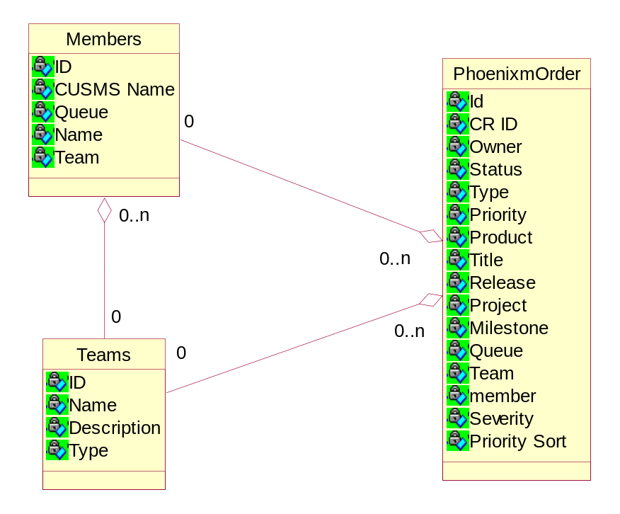

- Members – the table of the employees
- Teams – the table of the teams of employee
- PhoenixmOrder – the table of the CR’s, this strange name is historical inheritance

SW design

GUI
- Input GUI
The user input the data using the standard clarify CRM classic client program. See the picture bellow:
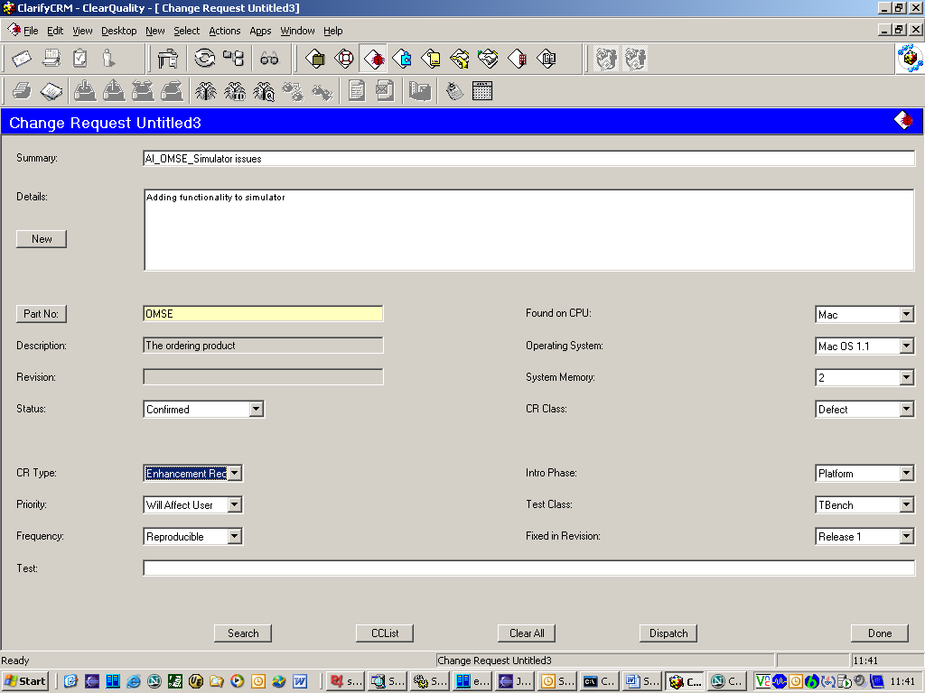

- The CR (change request) belongs to the project (PART).
- CR owner field indicates who handle the CR
- The title prefix indicates the CR type – action item or open issue
- Priority indicates the priority of the CR (critical, blocking, urgent, cosmetic, etc)
- The status field is about what is the current state of the CR
- Fixed in release – indicates the time limits of the CR handling.

Reports
CR summaries by member
Not fixed CR’s summary
Statistic’s

Report Engine
Report engine is MS-Access program. The data from the Clarify DB imported to the MS Access while using the clarify query export engine. See the document
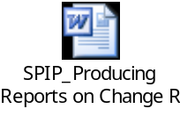

User guide
The proposed process intended to make the follow up the meetings decision effective and easy.
The solution based on the existing Clarify change request tracking system. The gathered data from the Clarify system imported into the MS access application for report generation.
The full process description brought in the table bellow:
No | Step Name | Description | Responsibility | Comment
 | Meeting definition | Define the meeting using the out look calendar; invite the people, set place and time. Set the meeting code be a prefix of the meeting title. Every meeting has to get the unique ID. This id needed for belonging all the related items to meeting, and execution of the query of such items.  The Id structure is  Type AI or OI etc.  Project name , e.g. OMSE  Meeting reason or issue, e.g G.T. (global transaction),  The rest data logged into CR body  Here is example for meeting prefix  “AI-OMSE-GT” | Meeting organizer | Possible to invoke the outlook using the Clarify classic client CRM application
 | Carry out the meeting | Logs all the items raised during the meeting, prepare the meaning of meeting | Meeting organizer
 | Create the CR’s for all raised issues AI and OI | Create the CR’s into the Clarify CR tracking system(subsystem of the clarify classic client) | Meeting organizer
 | Follow up the meeting related items | Import the data from CRM system into the ms-access db. Printing the reports and distributing the reports to all the involved sides | Project Manager, meeting organizer

