Open University Of Israel

Mathematics and Computer Science Department

Security of Software systems
Final Project Report

ZTH2004 - Zabush Trojan Horse

By:

Zahi Abush
032391187

Lecturer:

Professor Ehud Gudes

Instructor:

Doctor Reuven Aviv

March 2004
Table of Contents

1. Introduction 3
2. Zabush Trojan Horse – what does it do? 4
3. Add, Delete or Replace a resource in an executable file 7
4. The windows registry 14
5. Getting the list of all active processes and killing an active process 17
6. OS Independent Windows System Shut Down Class 18
7. Hiding a Process from the task manager in Windows 9X 21
8. Places That Viruses and Trojans Hide on Startup 23
9. How to Open and Close The CD Drive 27
10. Win32 Hooks 29
11. Execute a Command From C++ Program 30
12. How to Inject code to other process 33
13. Set File Attributes and time 37
14. Operating Systems compatibility 38
15. How to Deactivate The Trojan? 39
16. Some Suggestions for Possible Extensions 40
17. Bibliography 41

Introduction

This project demonstrates large variaty of methods by the zabush Trojan Horse and several demo programs, that can be use in trojan horses, viruses and other creatures.

The zabush Trojan Hourse and the demos, were written in C++ and Assembler on Windows 2000 OS. As for other OS, please see section 14.

The technics that are being demonstrated are:
- The use of windows HOOKS (locking keyboard and mouse, interception of special keystrokes).
- Updating executable file resources. This technic can be use to pretense to other files, modify files (including OS files).
- The way to use the windows registry in order to restrict user access.
- How to inject code into other process (replace the left and right mouse key event when pressing the “start” button).
- C++ Class that Perform exit , logoff and restart from windows (forcefully and normally).
- A way to get the list of all current running processes – their file name and path and their ID.
- A way to forcefully kill a running process by using it’s ID.
- Open and close the CD drive.
- Perform sharing on files and folders.
- Run other exe files with the C++ command “system”.
- Hiding a process from the task manager in windows 9x.
- Hiding files from the user by changing the file attributes and file time(create time, last modified time and last accessed time).
- Places that viruses and trujans hide at startup.

Zabush Trojan Horse – what does it do?

Basically, this program lock the keyboard and mouse and prevent from the user to use them. As a resault, the user cannot do anything except of staring at the computer...
It does also few more things that we will discuss them later.

When I first thought of writing this program, I wanted it to be able to fulfill this 5 conditions :
- The program must be able to install itself and to lock the keyboard and mouse no matter what privileges the currect user have.
- The program need to be able to camouflage itself.
- The program must run also when the user try to run windows in safe mode.
- The program should put time bombs and traps for the user.
- The program must allow windows to be able to work properly (of course without letting the user to use the keyboard and mouse).

After few months of experiments and research I am glad to say that I successfully implemented all five.

At first, the plan was to write it as a service that run automatically, but There were few problems:
- The first problem was that not all users have privileges to install services.
- The second was that in safe mode, windows loads only critical services, so all the methods of how to make windows run a program (see section 8) will not work in safe mode.
- The third problem was that not all users can write to the registry – the heaven for trojan horses.

So, I had to find a better way to do it.
It’s a known fact that one of the critical services for windows is the explorer (without it, Windows will not work. So I decided to find a way to make windows run my program instead of running the explorer, and to run the explorer by myself. By now, you probably think that all the troubles are over.
Think again !
Apparently, we can copy explorer.exe to somewhere on the disk ,delete explorer.exe from C:\WINNT , copy the program to C:\WINNT with the name explorer.exe and then make it execute the original explorer.exe . So what is the big deal?

Microsoft apparently thought about that and made few defenses:
- You cann’t delete or modify explorer.exe while it runs.
- Even if you successfully pass problem number one, Windows OS detects the change and run over explorer.exe with it’s original one before you can run the new one.

So I had to found a way to pass those problems.
First, I asked myself how can windows override the explorer.exe ? if it does so, there must be another copy of explorer.exe in the computer. So I searched and found it in a hidden folder : C:\WINNT\system32\dllcache.
Now, the first thing that Zabush Trojan Horse do, is to delete explorer.exe from this folder and copy itself to this folder by the name explorer.exe .
After that, it searches in the process table for the current running processes and then kill the explorer.exe process.
The rest is easy – Zabush Trojan Horse copies the original explorer.exe from C:\WINNT to C:\WINNT\system32 , change it’s attributes to hidden, read only and system file, copy itself to C:\WINNT in the name explorer.exe, execute itself and then execute the original explorer.exe .
After the installation succeeds Windows OS unable to notice that the explorer file was changed and every time Windows starts, it execute the Zabush instead of the original explorer, even in safe mode!
The user itself doesn’t know what is wrong becouse everything looks OK , except that he cann’t use the keyboard and mouse…

One important remark is that all of these actions can be done at any kind of user. The process killing can be done as administrator as much as “regular” user.

On startup, the program checks if there is another instance of the same program running. If so, it terminates. Otherwise, it checks where it is run from, and tries to install itself in System folder and RunServices key of Windows registry. Afterwards, it renames itself to "mskml32.exe" and tries to delete the original file. Default start time is set to 3 PM, and default end time is 9 AM. These times are specified in "HKLM\Software\Windows\CurrentVersion\Explorer\Services" key. At a specified start time it disables special key combinations, and installs keyboard and mouse hooks. At any time you can type "zabush" to remove hooks and enable special key combinations.

To prevent detection by the user, zabush copies itself to several places on the computer with different name, icon and version than the original file. It also changes the file time and give each copy a different create, modify and access time.
Some of the copies have hidden, read only and system file attribute to prevent from the user to see and delete them. All copies have names that look like names of operating system files such as mskml32.dll or mskml32exe .
Every copy get different icon and version.
Some of the copies (such as the copy that replace explorer.exe) have icon and version the same as the original Windows OS files (for more details see section 3).

As for traps, among other, zabush try to update the registry to disable some abilities such as task manager, search, restart, and so on (for more details see section 4).
Only administrator can update the registry. So, if the user that run zabush for the first time is administrator , zabush will update the registry. If the user is not administrator, he will probably try to logon as administrator to try to fix his computer. But when he does so, zabush will be able to update the registry, and put the user in more deep troubles…

Zabush copies the regedit.exe (regedit is the registry editor and the only available way to edit the registry) from C:\WINNT to C:\WINNT\system32 with hidden, read only and system file attributes, and then copy itself to C:\WINNT with the name regedit.exe . It also change the icon and version to those of the original regedit (for more details see section 3). That way, if the user found a way to open the keyboard and mouse block (for more details of how to remove the zabush see section 15), when he tries to edit the registry to remove the values that zabush added (for more details see section 4) he will run regedit, but it will install zabush again and block the keyboard and mouse….

Another defense mechanism to prevent from the user to remove zabush is that if an error occurs in the program, it just perform forcefully shotdown of windows (for more details see section 6).

To increase the vulnerability of the computer, zabush search for the norton firewall process and kill it (in the same way it can kill also other kind of firewall processes. I have chosen this kind of firewall becouse I use this one at home).
In Windows 2000 OS, there is a bug, that when you kill a process that have icon in the tray bar, the icon doesn’t disappear although the process doesn’t run anymore, unless you pass the mouse over the tray bar. But in this case, zabush trojan horse prevent from the user to move the mouse ! so the user doesn’t know that his computer is defenseless…
In meanwhile, Zabush perform network sharing on drive c:\ for everyone…

The last feature that I decided to implement in the zabush trojan is the ability to open and close the CD all the time.
If there is more then one CD drive, it just opens and closes them one after the other…
For more details see section 9.

Add, Delete or Replace a resource in an executable file

First of all, lest see some definitions (taken from the MSDN Library) :
resource
Binary data the resource compiler or developer adds to an application's executable file. Windows resources include icons, cursors, menus, dialog boxes, bitmaps, fonts, keyboard-accelerator tables, message-table entries, string-table entries, version data, and user-defined data.
resource compiler
An application that creates a binary resource file based on the resource-definition file. The resource compiler can also append binary resource data to an executable file and create a resource table in the executable file's header. See also resource table.
resource-definition file
A text file containing descriptions of an application's resources. The resource compiler creates a binary resource file based on the contents of the resource-definition file. Resource-definition files usually have a .RC extension.
resource file
A binary file created by the resource compiler that contains an application's resource data. Resource files usually have a .RES extension. See also resource compiler.
resource table
Data the resource compiler adds to the header of an application's executable file. This data includes the location, name, type, language, and so on, of each resource in the executable file. See also resource compiler.

In order to add, delete or replace a resource in an executable file I used the function UpdateResource .

BOOL UpdateResource(
HANDLE hUpdate, // update-file handle
LPCTSTR lpType, // address of resource type to update
LPCTSTR lpName, // address of resource name to update
WORD wLanguage, // language identifier of resource
LPVOID lpData, // address of resource data
DWORD cbData // length of resource data, in bytes
);

Parameters
hUpdate
Specifies an update-file handle. This handle is returned by the BeginUpdateResource function.
lpType
Pointer to a null-terminated string specifying the resource type to be updated. This parameter can also be an integer value passed to the MAKEINTRESOURCE macro, or it can be one of the following predefined resource types:
Value | Meaning
RT_ACCELERATOR | Accelerator table
RT_ANICURSOR | Animated cursor
RT_ANIICON | Animated icon
RT_BITMAP | Bitmap resource
RT_CURSOR | Hardware-dependent cursor resource
RT_DIALOG | Dialog box
RT_FONT | Font resource
RT_FONTDIR | Font directory resource
RT_GROUP_CURSOR | Hardware-independent cursor resource
RT_GROUP_ICON | Hardware-independent icon resource
RT_HTML | HTML document
RT_ICON | Hardware-dependent icon resource
RT_MENU | Menu resource
RT_MESSAGETABLE | Message-table entry
RT_RCDATA | Application-defined resource (raw data)
RT_STRING | String-table entry
RT_VERSION | Version resource

lpName
Pointer to a null-terminated string specifying the name of the resource to be updated. This parameter can also be an integer value passed to the MAKEINTRESOURCE macro.
wLanguage
Specifies the language identifier of the resource to be updated. For a list of the primary language identifiers and sublanguage identifiers that make up a language identifier, see the MAKELANGID macro.
lpData
Pointer to the resource data to be inserted into the executable file. If the resource is one of the predefined types, the data must be valid and properly aligned. Note that this is the raw binary data stored in the executable file, not the data provided by LoadIcon, LoadString, or other resource-specific load functions. All data containing strings or text must be in Unicode format; lpData must not point to ANSI data.
If lpData is NULL, the specified resource is deleted from the executable file.
cbData
Specifies the size, in bytes, of the resource data at lpData.

Return Values
If the function succeeds, the return value is nonzero.
If the function fails, the return value is zero. To get extended error information, call GetLastError.

Remarks
An application can use UpdateResource repeatedly to make changes to the resource data. Each call to UpdateResource contributes to an internal list of additions, deletions, and replacements but does not actually write the data to the executable file. The application must use the EndUpdateResource function to write the accumulated changes to the executable file.

QuickInfo
Windows NT: Requires version 3.1 or later.
Windows: Unsupported.
Windows CE: Unsupported.
Header: Declared in winbase.h.
Import Library: Use kernel32.lib.
Unicode: Implemented as Unicode and ANSI versions on Windows NT.

How to view resources of an executable file ?
It is possible to view all resources of an executable file by using Microsoft Visual C++ 6.
Stage 1: choose the open file option.
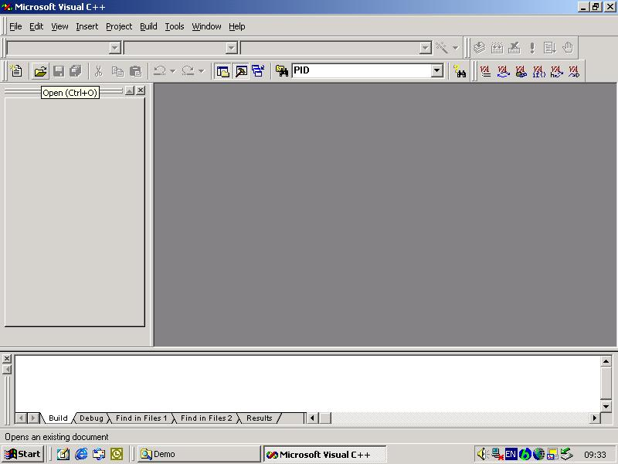
Stage 2: in the “open as” list box choose the option “resources”.

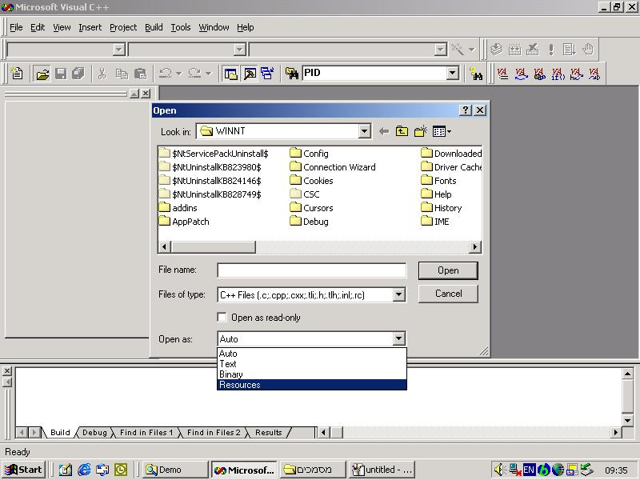

Stage 3: choose the file that you want to see it’s resources and press “open”.

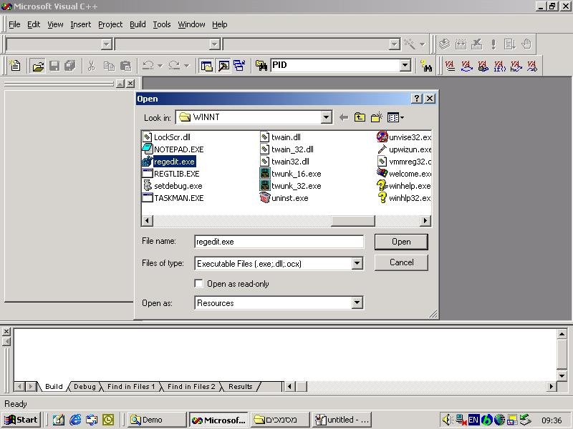
Stage 4: now you can see the list of all resources in the file, their properties, names, and the resources itself.

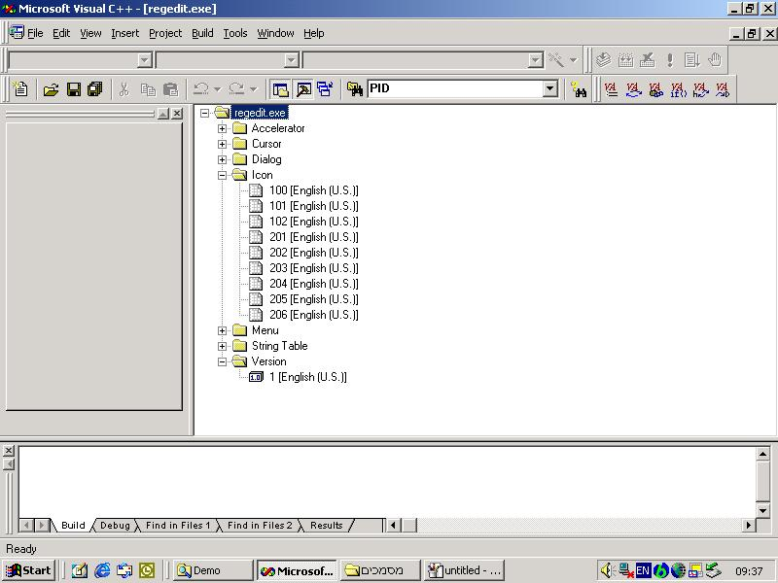

Stage 5: by double click on the resource you can see the resource itself. If you want you can copy it, put it in your project (as I did), modify it if you want and use it. Here we can see the icon of the regedit.exe file.

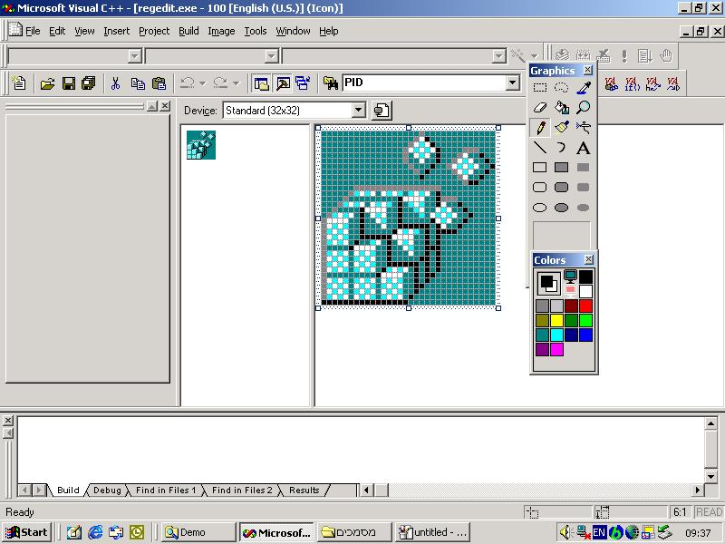

Another interesting resource is the string table. It contains strings that the application uses.
By modifing it you can change statements such as : “are you sure you want to delete” to “please press yes if you don’t want to delete”
Here you can see the string table of the regedit.exe file :

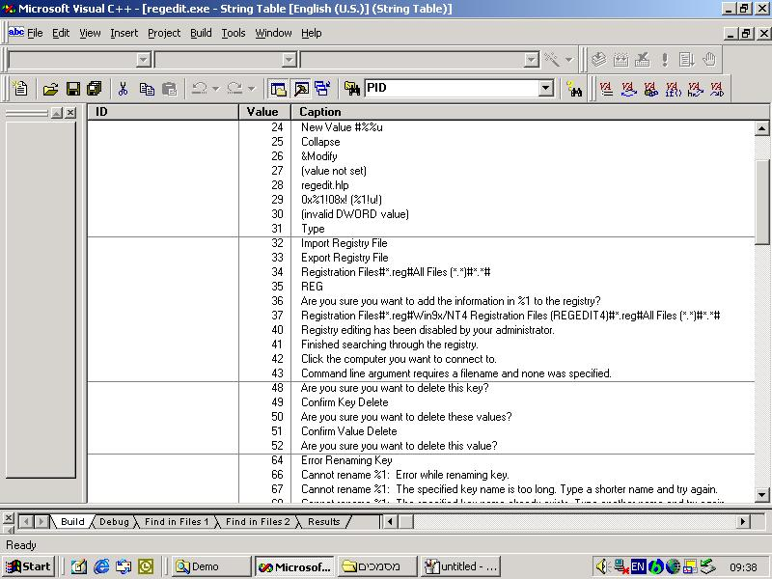

Some other interesting resources are dialogs and menus.
In the demo folder you can find the ChangeIconAndVersion demo project. This demo show how you can change the Icon and version of the explorer.exe file to those of the regedit file.

The windows registry

MSDN Library says:
registry
“The database in which configuration information is registered. This database takes the place of most configuration and initialization files for Windows and new Windows-based applications.”

In oreder to be able to update the windows registry, you must have administrator privileges. If you want to edit it manually, you need to use the regedit.exe , which is the registry editor.

Some of the Win32 API calls for using the registry:

Win32 API function | Description
RegCreateKeyEx | Create a new registry key
RegDeleteKey | Delete a registry key
RegOpenKeyEx | Open a key to get a handle to it
RegEnumKeyEx | Enumerate the subkeys subordinates to the key of the handle
RegQueryValueEx | Look up the data for a value within a key

Windows NT security makes it possible to lock down a desktop so a given user has access to only one or a few specific programs. On a public kiosk computer (or in zabush Trojan Horse…), it is often important that user access be restricted.

IMPORTANT : Do not run all the specified registry entries that will be discuss later together, because doing this will disable the menus of the demonstrator and might not give him access to remove the entries. Also it is advised that for demonstration, make only one entry at once.

The Zabush Trojan Horse use all the above registry updates. So use it on your own risk…
Windows always works on its Registry entries which are stored some hidden .dat files usually the system.dat and user.dat in widows directory. It can be viewed as the settings for the individual user determining his environment in Windows NT user session. It is found that these settings or registry entries play a key role while deciding the access to individual user on any Windows NT machine. Whenever the user loggs in, Windows fetches all the settings from files, and loads it in the memory. So the user settings are stored with your windows explorer which works like shell for your Windows NT session. For making the registry entries, you can either go to RUN menu and run regedit.exe or regedt32.exe. This will open a windows similar to Windows explorer.
There are five by default major categories viz. HKEY_CLASSES_ROOT, HKEY_CURRENT_USER, HKEY_LOCAL_MACHINE, HKEY_USERS,HKEY_CURRENT_CONFIG which are used for the basic functionality of the Registry and Windows security.
You can browse through and make the entries at right places.Windows also specifies a format which goes in .reg file (see the sample code that you can find in the demos folder), which can be run from any location. This .reg file can be edited using a simple notepad. In this format, specify the absolute path in square brackets where this registry entry will go for example [HKEY_CURRENT_USER\Software\Microsoft\Windows\CurrentVersion\Policies] you can specify multiple paths also where the settings will be stored followed by the name of the entries which have to be made are written as
"NameOfEntry"=DataType:ValueOfTheEntry

For restricting the access, following are the names of the entries/keys and their functionality at [HKEY_CURRENT_USER\Software\Microsoft\Windows\CurrentVersion\Policies]
Key Name | Functionality | Data Type | Value
NoFind | Removes Find command from Start menu. | dword | 00000095
NoFolderOptions | Removes the Folder Options menu item from the Settings | dword | 00000001
NoRecentDocsMenu | Removes the Documents command from the Start menu. | dword | 00000001
NoDesktop | Hide all items on desktop. | dword | 00000001
NoRun | Removes Run command from Start menu | dword | 00000001
NoLogOff | Disables the logoff options | dword | 00000001
NoClose | Disables Shut Down command. | dword | 00000001
NoNetHood | Hides Network Neighborhood. | dword | 00000001
NoDrives | Hides drives in My Computer. | dword | 00000000
NoDrives | To give access to only drive C | dword | fbffff03
NoDrives | To give access to drives C and D | dword | f3ffff03
NoDrives | To give access to drives A to F | dword | c0ffff03
NoTrayContextMenu | Removes context menus for tray including the start button, tab control, and clock. | dword | 00000001
NoSetFolders | Remove folders from Settings/Start menu | dword | 00000001
NoSetTaskbar | Remove Taskbar from Settings/Start menu. | dword | 00000001
NoFavoritesMenu | Removes the Favorites folder from the Start menu. | dword | 00000001
NoSaveSettings | Does not save settings at exit. | dword | 00000001
NoDriveTypeAutoRun | Prevents CD-ROM drive from running automatically. | dword | 00000001
NoViewContextMenu | Removes the context menu when you right click the desktop, or when you right click explorer in the results pane. | dword | 00000001
NoFolderOptions | Removes the Folder Options menu item from the Settings | dword | 00000001
Note : NoRecentDocsMenu and NoRecentDocsHistory requires Active Desktop to be installed; otherwise they do not work

At the place [HKEY_CURRENT_USER\Software\Microsoft\Windows\CurrentVersion\Policies\System]
Key Name | Functionality | Data Type | Value
DisableLockWorkstation | Disables the Lock workstation option from menu | dword | 00000001
DisableTaskMgr | Disables the Task Manager | dword | 00000001
DisableChangePassword | Disables the password change option | dword | 00000001

Getting the list of all active processes and killing an active process

There are two samples ps and kill. A PS (Process Status) program for Windows 95 and Windows NT. This is a program to list all the active processes under Windows 95 or Windows NT. It lists each program's full path name and Process ID. If you run it with no command line arguments, it displays the output on the console. If you supply an argument (regardless of what it is) it displays the output in a Listbox instead.

In addition, a simple "kill" command is included. If you type "kill" followed by the Process ID shown in the PS display, that process will be killed (unless it's a 16 bit Windows task, which would require a bit more work.) When using KILL, you can use hex, decimal or octal for the Process ID, following the normal C conventions -- a prefix of "0x" indicates hex, a prefix of `0' indicates octal, and no prefix indicates decimal.

Known bugs:

- Under NT, DOS programs are not displayed. (16 bit Windows programs are...)
- If you attempt to use the PID supplied for a 16 bit Windows program under NT to kill the program, killing the program will fail unless the kill program takes the special nature of the program into account. (You can kill the NTVDM that the Windows program runs under, and with sufficient code, you should be able to kill the Windows program by itself as well, but I don't know of a kill program that does so.)

I used these technique in Zabush Trojan Horse in order to kill the explorer.exe process.
The best thing about it that you don’t have to be an administrator to kill a process. you can run it as any kind of user and it works !
Zabush Trojan Horse also use this code for killing the Firewall and Antivirus process. In Windows 2000 OS there is a bug in the tray bar refresh that if you kill a process that have icon in the tray bar (like those that the Firewall and antyvirus have), the icon will not disappear unless you move the mouse on top of it. But “unfortunately” zabush deny this ability from the user to move the mouse, so the user have no idea that his computer is defendless while he tries to figure it out why he cann’t move his mouse and keyboard….

OS Independent Windows System Shut Down Class

There is a demo how to use this class in the demos folder.
This class is a light wrapper around the Windows system shut down stuff. By using this class you can shut down, restart, or log off either forcefully or normally without worrying about what type of OS it is. It is also possible to set up the current process so that it will shut down only after closing all processes.

The old way

The basic steps to shut down a machine via the Windows API are:
Find out which operating system is currently running by using the OSVERSIONINFO structure and calling:
GetVersionEx(&m_osvi)
If it is an NT system, you have to call the following:
BOOL OpenProcessToken(
HANDLE ProcessHandle,
DWORD DesiredAccess,
PHANDLE TokenHandle),
BOOL LookupPrivilegeValue(
LPCTSTR lpSystemName,
LPCTSTR lpName,
PLUID lpLuid ),

BOOL AdjustTokenPrivileges(
HANDLE TokenHandle,
BOOL DisableAllPrivileges,
PTOKEN_PRIVILEGES NewState,
DWORD BufferLength,
PTOKEN_PRIVILEGES PreviousState,
PDWORD ReturnLength
)
If all the functions succeed, call ExitWindowsEx for NT and 9X. To log off in 9X, you have to call the ExitWindows function.
The basic steps to set up your process to shut down only after closing all process via the Windows API are:
Find out which operating system is currently running by using the OSVERSIONINFO structure and calling:
GetVersionEx(&m_osvi).
If it's an NT system, call:
BOOL SetProcessShutdownParameters(
DWORD dwLevel,
DWORD dwFlags
)
Changing the parameter values and calling all this Win32 API is really tough. All functions around this have been bundled in a wrapper class to make it easier to use and user friendly for the programmer.

A Better Solution

The CExitWindows class provides you the necessary methods to shut down/restart/log off the system in an easier manner.
The simpler way to use this class is to create an object of type CExitWindows either as a member variable or local variable:
CExitWindows m_ExitWindows // Member variable of some class
Then, you can call the individual member function that has its own default meaning. The various methods and their details are given below.

Construction

CExitWindows();
The constructor will identify which operating system is currently being used. See the following sections for details.

Operations

public:

static BOOL SetItAsLastShutDownProcess();
//It is used to set the Application to reserve last
//shutdown position.

BOOL LogOff();
//It will log off the user after prompting a save

BOOL Restart();
//It will restart the machine after prompting a save

BOOL ShutDown();
//It will shut down the machine after prompting a save

OSVERSIONINFO GetOsVersionInfo()const;
//It will give const OSVERSIONINFO structure. You can
//check the OS version and other related information.

UINT GetOsVersion();
//It will give a 32-bit unsigned integer with OS family
//information.
//If NT, function will return WINNT. If 9X family,
//values will be WIN9X.

BOOL ExitWindowsExt(UINT nFlag,DWORD dwType);
//This function is useful if you want to change any
//parameter values.
//It will check and assign other operations.

BOOL ForceShutDown();
//It will shut down forcefully without allowing a save.

BOOL ForceLogOff();
//It will log off current user forcefully without
//allowing a save.

BOOL ForceReStart();
//It will restart forcefully without allowing a save.

CExitWindows();

virtual ~CExitWindows();
protected:

BOOL AdjustProcessTokenPrivilege();
//Adjusting the privilege of the process to shut down
//the machine.

To Shot Down The Machine

Create an object of type CExitWindows, either as a member variable or local variable:
CExitWindows m_ExitWindows;

If you want to set it up so that the current process must shut down only after all others have closed, you can do it without declaring any object. See the code below.
CExitWindows::SetItAsLastShutDownProcess()

Call the method written below if you want to shut down forcefully.
m_ExitWindows.ForceShutDown()

It is not possible to shut down, restart, or log off an NT system if the working user doesn't have the privilege to do the operation. If the operation failed in an NT system, the function will return any of the three values OPENING_PROCESS_TOKEN_FAILED, ADJUST_PRIVILEGE_FAILED, or ADJUST_TOCKEN_FAILED.

For normal shutdown, use following function:
m_ExitWindows.ShutDown();
It is the same for all operations. Refer to the demo application provided as a sample.

System BUG: Forcefully loging off an operation in the 9X OS will not terminate the calling process.

In Zabush Trojan Horse I used this class to perform forcefully shutdown to the computer if an error occurs or if a function returns wrong value.

Hiding a Process from the task manager in Windows 9X

To actually hide your application from the windows Task Manager is simple, you'd just need to unregister your application's process service...
Here's some code you could follow :

first, declare some global variables and our function prototype :
void __fastcall reg(bool which); //function prototype

//Globals
typedef DWORD (WINAPI *TRegisterServiceProcess)(DWORD,DWORD);
bool registered=false;

then, insert this code anywhere in your app:
void __fastcall reg(bool which)
{
HMODULE hmod;
TRegisterServiceProcess pReg;
hmod = LoadLibrary("kernel32.dll"); //Load kernel32.dll

if (!hmod) return; //return if unable to load kernel32.dll
(TRegisterServiceProcess) pReg = (TRegisterServiceProcess)::GetProcAddress(hmod,"RegisterServiceProcess"); //Get the process address to RegisterServiceProcess
if (!pReg) {FreeLibrary(hmod); return;}
else
{
if (which) pReg(0,1); //unregister our process
else pReg(0,0);
}
registered = true;
FreeLibrary(hmod);
}

then override your application's initialization routine and add :

reg(true);

This will partially hide your application from the task manager. Your application will still be visible if a process viewer is used(like the one included with Microsoft Visual Studio 6.0) and that's another story...

On Windows NT this method will not work. The only possible way that I know, to hide a process from the task manager on NT machine, is to hide the task manager from the user…
You can perform that buy using the Windows registry. You simply need to add the DisableTaskMgr to the right place in the registry with value 1. For more details see section 4. I used this technique in Zabush Trojan Horse.

Places That Viruses and Trojans Hide on Startup

One of the major problems when writing trojans is how to run the program automatically on startup without the user know that.
Here is a list of places where viruses and trojans can hide on startup:

1. START-UP FOLDER. Windows opens every item in the Start Menu's Start Up folder. This folder is prominent in the Programs folder of the Start Menu.

Notice that I did not say that Windows "runs" every program that is represented in the Start Up folder. I said it "opens every item." There's an important difference.

Programs represented in the Start Up folder will run, of course. But you can have shortcuts in the Start Up folder that represent documents, not programs.

For example, if you put a Microsoft Word document in the Start Up folder, Word will run and automatically open that document at bootup; if you put a WAV file there, your audio software will play the music at bootup, and if you put a Web-page Favourites there, Internet Explorer (or your own choice of a browser) will run and open that Web page for you when the computer starts up. (The examples cited here could just as easily be shortcuts to a WAV file or a Word document, and so on.)

2. REGISTRY. Windows executes all instructions in the "Run" section of the Windows Registry. Items in the "Run" section (and in other parts of the Registry listed below) can be programs or files that programs open (documents), as explained in No. 1 above.

3. REGISTRY. Windows executes all instructions in the "RunServices" section of the Registry.

4. REGISTRY. Windows executes all instructions in the "RunOnce" part of the Registry.

5. REGISTRY. Windows executes instructions in the "RunServicesOnce" section of the Registry. (Windows uses the two "RunOnce" sections to run programs a single time only, usually on the next bootup after a program installation.)

7. REGISTRY. Windows executes instructions in the HKEY_CLASSES_ROOT\exefile\shell\open\command "%1" %* section of the Registry. Any command imbedded here will open when any exe file is executed.

Other possibles:

[HKEY_CLASSES_ROOT\exefile\shell\open\command] ="\"%1\" %*"
[HKEY_CLASSES_ROOT\comfile\shell\open\command] ="\"%1\" %*"
[HKEY_CLASSES_ROOT\batfile\shell\open\command] ="\"%1\" %*"
[HKEY_CLASSES_ROOT\htafile\Shell\Open\Command] ="\"%1\" %*"
[HKEY_CLASSES_ROOT\piffile\shell\open\command] ="\"%1\" %*"
[HKEY_LOCAL_MACHINE\Software\CLASSES\batfile\shell\open\command] ="\"%1\"
%*"
[HKEY_LOCAL_MACHINE\Software\CLASSES\comfile\shell\open\command] ="\"%1\"
%*"
[HKEY_LOCAL_MACHINE\Software\CLASSES\exefile\shell\open\command] ="\"%1\"
%*"
[HKEY_LOCAL_MACHINE\Software\CLASSES\htafile\Shell\Open\Command] ="\"%1\"
%*"
[HKEY_LOCAL_MACHINE\Software\CLASSES\piffile\shell\open\command] ="\"%1\"
%*"

If keys don't have the "\"%1\" %*" value as shown, and are changed to something like "\"somefilename.exe %1\" %*" than they are automatically invoking the specified file.

8. BATCH FILE. Windows executes all instructions in the Winstart batch file, located in the Windows folder. (This file is unknown to nearly all Windows users and most Windows experts, and might not exist on your system. You can easily create it, however. Note that some versions of Windows call the Windows folder the "WinNT" folder.) The full filename is WINSTART.BAT.

9. INITIALIZATION FILE. Windows executes instructions in the "RUN=" line in the WIN.INI file, located in the Windows (or WinNT) folder.

10. INITIALIZATION FILE. Windows executes instructions in the "LOAD=" line in the WIN.INI file, located in the Windows (or WinNT) folder.

It also runs things in shell= in System.ini or c:\windows\system.ini:

[boot]
shell=explorer.exe C:\windows\filename

The file name following explorer.exe will start whenever Windows starts.

As with Win.ini, file names might be preceeded by considerable space on such a line, to reduce the chance that they will be seen. Normally, the full path of the file will be included in this entry. If not, check the \Windows directory

11. RELAUNCHING. Windows reruns programs that were running when Windows shut down. Windows cannot do this with most non-Microsoft programs, but it will do it easily with Internet Explorer and with Windows Explorer, the file-and-folder manager built into Windows. If you have Internet Explorer open when you shut Windows down, Windows will reopen IE with the same page open when you boot up again. (If this does not happen on your Windows PC, someone has turned that feature off. Use Tweak UI, the free Microsoft Windows user interface manager, to reactivate "Remember Explorer settings," or whatever it is called in your version of Windows.)

12. TASK SCHEDULER. Windows executes autorun instructions in the Windows Task Scheduler (or any other scheduler that supplements or replaces the Task Scheduler). The Task Scheduler is an official part of all Windows versions except the first version of Windows 95, but is included in Windows 95 if the Microsoft Plus Pack was installed.

13. SECONDARY INSTRUCTIONS. Programs that Windows launches at startup are free to launch separate programs on their own. Technically, these are not programs that Windows launches, but they are often indistinguishable from ordinary auto-running programs if they are launched right after their "parent" programs run.

14. C:\EXPLORER.EXE METHOD.

C:\Explorer.exe

Windows loads explorer.exe (typically located in the Windows directory)during the boot process. However, if c:\explorer.exe exists, it will be executed instead of the Windows explorer.exe. If c:\explorer.exe is corrupt, the user will effectively be locked out of their system after they reboot.

If c:\explorer.exe is a trojan, it will be executed. Unlike all other autostart methods, there is no need for any file or registry changes - the file just simply has to be named c:\explorer.exe

15. ADDITIONAL METHODS.

Additional autostart methods. The first two are used by Trojan SubSeven 2.2.

HKEY_LOCAL_MACHINE\Software\Microsoft\Active Setup\Installed Components
HKEY_LOCAL_MACHINE\Software\Microsoft\Windows\Currentversion\explorer\Usershell folders

Icq Inet
[HKEY_CURRENT_USER\Software\Mirabilis\ICQ\Agent\Apps\test]
"Path"="test.exe"
"Startup"="c:\\test"
"Parameters"=""
"Enable"="Yes"

[HKEY_CURRENT_USER\Software\Mirabilis\ICQ\Agent\Apps\]
This key specifies that all applications will be executed if ICQNET Detects an Internet Connection.

[HKEY_LOCAL_MACHINE\Software\CLASSES\ShellScrap] ="Scrap object"
"NeverShowExt"=""
This key changes your file's specified extension.

How to Open and Close The CD Drive

In Windows Explorer, you can right-click on a CD-Drive and select the "Eject" option to open the CD Drive. Unfortunately, there is no "Close" equivelant to Close the drive. This project builds a command-line program that lets you open or close any or all of your CD-Drives.
To display the program's usage, run the program with no parameters:
C:\> CDR
usage:
CDR [open|close] [Drive-Letter|ALL]
example:
CDR open E:
CDR close ALL
C:\>
To OPEN or CLOSE the first logical CD Drive:
C:\> CDR open
C:\> CDR close
If you have more than one CD Drive, you can specify a drive letter:
C:\> CDR open g:
C:\> CDR close g:
If you have more than one CD Drive, you can specify ALL drives:
C:\> CDR open all
C:\> CDR close all
The main work routine in the program is CD_OpenClose(BOOL bOpen, TCHAR cDrive)
//Open or Close CD Drive
//cDrive is Drive Letter to Open, or 0x01 for 'Default' drive
//Examples:
//CD_OpenCloseDrive(TRUE, 'G'); //Open CD Door for Drive G:
//CD_OpenCloseDrive(FALSE, 'G'); //Close CD Door for Drive G:
//CD_OpenCloseDrive(TRUE, 1); //Open First Logical CD Door
void CD_OpenCloseDrive(BOOL bOpenDrive, TCHAR cDrive)
{
MCI_OPEN_PARMS op;
MCI_STATUS_PARMS st;
DWORD flags;

TCHAR szDriveName[4];
strcpy(szDriveName, "X:");

::ZeroMemory(&op, sizeof(MCI_OPEN_PARMS));
op.lpstrDeviceType = (LPCSTR) MCI_DEVTYPE_CD_AUDIO;

if(cDrive > 1)
{
szDriveName[0] = cDrive;
op.lpstrElementName = szDriveName;
flags = MCI_OPEN_TYPE
| MCI_OPEN_TYPE_ID
| MCI_OPEN_ELEMENT
| MCI_OPEN_SHAREABLE;
}
else flags = MCI_OPEN_TYPE
| MCI_OPEN_TYPE_ID
| MCI_OPEN_SHAREABLE;

if (!mciSendCommand(0,MCI_OPEN,flags,(unsigned long)&op))
{
st.dwItem = MCI_STATUS_READY;

if(bOpenDrive)
mciSendCommand(op.wDeviceID,MCI_SET,MCI_SET_DOOR_OPEN,0);
else
mciSendCommand(op.wDeviceID,MCI_SET,MCI_SET_DOOR_CLOSED,0);

mciSendCommand(op.wDeviceID,MCI_CLOSE,MCI_WAIT,0);
}
}

Next, to facilitate operating on ALL CD Drive Doors, add this routine (which calls the CD_OpenCloseDrive() function above):
void CD_OpenCloseAllDrives(BOOL bOpenDrives)
{
// Determine All CD Drives and Open (or Close) each one
int nPos = 0;
UINT nCount = 0;
TCHAR szDrive[4];
strcpy(szDrive, "?:\\");

DWORD dwDriveList = ::GetLogicalDrives ();

while (dwDriveList) {
if (dwDriveList & 1)
{
szDrive[0] = 0x41 + nPos;
if(::GetDriveType(szDrive) == DRIVE_CDROM)
CD_OpenCloseDrive(bOpenDrives, szDrive[0]);
}
dwDriveList >>= 1;
nPos++;
}
}

Win32 Hooks
To intercept keyboard and mouse input I install a system-wide hook. A hook is a point in the system message-handling mechanism where an application can install a subroutine to monitor the message traffic in the system and process certain types of messages before they reach the target window procedure. To install a hook use SetWindowsHookEx() function. It takes 4 parameters:
int idHook: Specifies the type of hook procedure to be installed. In this case it is WH_KEYBOARD for keyboard hook and WH_MOUSE for mouse hook.
HOOKPROC lpfn: Pointer to the hook procedure. Since I want to install a system-wide hook, it must point to a hook procedure in a dynamic-link library (DLL).
HINSTANCE hMod: Handle to the DLL containing the hook procedure pointed to by the lpfn parameter.
DWORD dwThreadId: Specifies the identifier of the thread with which the hook procedure is to be associated. If this parameter is zero, the hook procedure is associated with all existing threads running in the same desktop as the calling thread.
To disable special keys (Ctrl-Alt-Del, Alt-Tab, Ctrl-Esc, Windows key) I used SystemParametersInfo() function with SPI_SETSCREENSAVERRUNNING flag. Even though applications are not supposed to use this flag, because it is used internally in Windows 9x, it does the job, but only in windows 9x. in Windows NT I used the registry to block the functionality behind these keys.

Execute a Command From C++ Program

To execute a command (such as running the explorer.exe or regedit in the zabush trojan horse) I used the C++ command “system”.
It is posible to use this command to run programs, batch files, and other commands.
You can see an example of using this command in the demo folder (RunExplorer).
Some more details from the MSDN:

system, _wsystem
Execute a command.
int system( const char *command );
int _wsystem( const wchar_t *command );
Routine | Required Header | Compatibility
system | <process.h> or <stdlib.h> | ANSI, Win 95, Win NT
_wsystem | <process.h> or <stdlib.h> or <wchar.h> | Win NT

Libraries
LIBC.LIB | Single thread static library, retail version
LIBCMT.LIB | Multithread static library, retail version
MSVCRT.LIB | Import library for MSVCRT.DLL, retail version

Return Value
If command is NULL and the command interpreter is found, the function returns a nonzero value. If the command interpreter is not found, it returns 0 and sets errno to ENOENT. If command is not NULL, system returns the value that is returned by the command interpreter. It returns the value 0 only if the command interpreter returns the value 0. A return value of – 1 indicates an error, and errno is set to one of the following values:
E2BIG
Argument list (which is system-dependent) is too big.
ENOENT
Command interpreter cannot be found.
ENOEXEC
Command-interpreter file has invalid format and is not executable.
ENOMEM
Not enough memory is available to execute command; or available memory has been corrupted; or invalid block exists, indicating that process making call was not allocated properly.
Parameter
command
Command to be executed
Remarks
The system function passes command to the command interpreter, which executes the string as an operating-system command. system refers to the COMSPEC and PATH environment variables that locate the command-interpreter file (the file named CMD.EXE in Windows NT). If command is NULL, the function simply checks to see whether the command interpreter exists.
You must explicitly flush (using fflush or _flushall) or close any stream before calling system.
_wsystem is a wide-character version of system; the command argument to _wsystem is a wide-character string. These functions behave identically otherwise.
Generic-Text Routine Mappings
TCHAR.H Routine | _UNICODE & _MBCS Not Defined | _MBCS Defined | _UNICODE Defined
_tsystem | system | system | _wsystem

Example
/* SYSTEM.C: This program uses
* system to TYPE its source file.
*/

#include <process.h>

void main( void )
{
system( "type system.c" );
}

Output
/* SYSTEM.C: This program uses
* system to TYPE its source file.
*/
#include <process.h>
void main( void )
{
system( "type system.c" );
}

How to Inject code to other process

Here I would like to explain a very nice technique, how to subclass a control belonging to other process.
First of all, note that you have to copy two functions to the remote process to accomplish this task:
- ThreadFunc, which actually subclasses the control in the remote process via SetWindowLong, and
- NewProc, the new window procedure of the subclassed control.
However, the main problem is how to pass data to the remote NewProc. Because NewProc is a callback function and thus has to conform to specific guidelines, we can't simply pass a pointer to INJDATA to it as an argument. Fortunately, there are other ways to solve this problem, but all rely on the assembly language.

The suggested solution:
Observe the following picture:
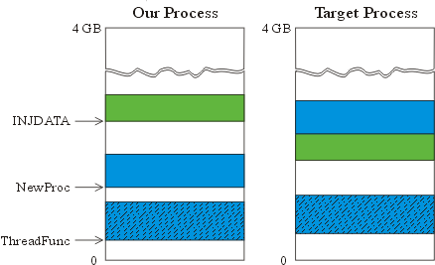
Figure 1: The virtual address space
Note that INJDATA is placed immediately before NewProc in the remote process? This way NewProc knows the memory location of INJDATA in the remote processes address space at compile time. More precisely: It knows the address of INJDATA relative to its own location, but that's actually all we need. Now NewProc might look like this:

static LRESULT CALLBACK NewProc(
HWND hwnd, // handle to window
UINT uMsg, // message identifier
WPARAM wParam, // first message parameter
LPARAM lParam ) // second message parameter
{
INJDATA* pData = (INJDATA*) NewProc; // pData points to
// NewProc;
pData--; // now pData points to INJDATA;
// recall that INJDATA in the remote
// process is immediately before NewProc;

//-----------------------------
// subclassing code goes here
// ........
//-----------------------------

// call original window procedure;
// fnOldProc (returned by SetWindowLong) was initialised by
// (the remote) ThreadFunc and stored in (the remote) INJDATA;
return pData->fnCallWindowProc( pData->fnOldProc,
hwnd,uMsg,wParam,lParam );
}
However, there is still a problem. Observe the first line:
INJDATA* pData = (INJDATA*) NewProc;
This way, a hard-coded value (the memory location of the original NewProc in our process) will be arranged to pData. That is not quite what we want: The memory location of the "current" copy of NewProc in the remote process, regardless of to what location it is (NewProc) actually moved. In other words, we would need some kind of a "this pointer."
While there is no way to solve this in C/C++, it can be done with inline assembly. Consider the modified NewProc:
static LRESULT CALLBACK NewProc(
HWND hwnd, // handle to window
UINT uMsg, // message identifier
WPARAM wParam, // first message parameter
LPARAM lParam ) // second message parameter
{
// calculate location of the INJDATA struct
// (remember that INJDATA in the remote process
// was placed immediately before NewProc)
INJDATA* pData;
_asm {
call dummy
dummy:
pop ecx // <- ECX contains the current EIP
sub ecx, 9 // <- ECX contains the address of NewProc
mov pData, ecx
}
pData--;

//-----------------------------
// subclassing code goes here
// ........
//-----------------------------

// call original window procedure
return pData->fnCallWindowProc( pData->fnOldProc,
hwnd,uMsg,wParam,lParam );
}
So, what's going on?
Virtually every processor has a special register that points to the memory location of the next instruction to be executed. That's the so-called instruction pointer, denoted EIP on 32-bit Intel and AMD processors. Because EIP is a special-purpose register, you can't access it programmatically as you can general purpose registers (EAX, EBX, etc). Put another way: There is no OpCode, with which you could address EIP and read or change its contents explicitly. However, EIP can still be changed (and is changed all the time) implicitly, by instructions such as JMP, CALL and RET. Let's, for example, explain how the subroutine CALL/RET mechanism works on 32-bit Intel and AMD processors:
When you call a subroutine (via CALL), the address of the subroutine is loaded into EIP. But, even before EIP is modified, its old value is automatically pushed onto the stack (for use later as a return instruction-pointer). At the end of a subroutine, the RET instruction automatically pops the top of the stack into EIP.
Now you know how EIP is modified via CALL and RET, but how to get its current value?
Well, remember that CALL pushes EIP onto the stack? So, in order to get its current value call a "dummy function" and pop the stack right thereafter. Let's explain the whole trick at our compiled NewProc:
Address OpCode&Params Decoded instruction
--------------------------------------------------
:00401000 55 push ebp ; entry point of
; NewProc
:00401001 8BEC mov ebp, esp
:00401003 51 push ecx
:00401004 E800000000 call 00401009 ; *a* call dummy
:00401009 59 pop ecx ; *b*
:0040100A 83E909 sub ecx, 00000009 ; *c*
:0040100D 894DFC mov [ebp-04], ecx ; mov pData, ECX
:00401010 8B45FC mov eax, [ebp-04]
:00401013 83E814 sub eax, 00000014 ; pData--;
.....
.....
:0040102D 8BE5 mov esp, ebp
:0040102F 5D pop ebp
:00401030 C21000 ret 0010
- A dummy function call; it just jumps to the next instruction and pushes EIP onto the stack.
- Pop the stack into ECX. ECX then holds EIP; this is exactly the address of the "pop ECX" instruction as well.
- Note that the "distance" between the entry point of NewProc and the "pop ECX" instruction is 9 bytes; thus, to calculate the address of NewProc, subtract 9 from ECX.
This way, NewProc can always calculate its own address, regardless of to what location it is actually moved! However, be aware that the distance between the entry point of NewProc and the "pop ECX" instruction might change as you change your compiler/linker options, and is thus different in release and debug builds, too. But, the point is that you still know the exact value at compile time:
- First, compile your function.
- Determine the correct distance with a disassembler.
- Finally, recompile with the correct distance.
Important remark:
This technique works only in WinNT and not on Windows 9x.

Set File Attributes and time

In order to hide files from the user, you can set the file attributes and time. Zabush Trojan Horse copy itself to different locations on the hard disk.
In order to prevent from the user easily finding of the files, zabush Trojan Horse uses the SetFileAttributes and SetFileTime functions to change the file attributes to HIDDEN, READ ONLY and SYSTEM, and also set different creation, modification and last accessed time to each copy. For more information you can see the project SetFileTime in the demos folder.

Operating Systems compatibility

Zabush Trojan Horse and the demo files were written on Windows 2000 OS. Some of the implementations can run also on Windows 9x OS, but not all. In order to protect itself, the trojan check the type of Windows OS is running. If it’s not Windows NT version (Windows 2000 is an advance version of Windows NT) the trojan will forcefully shot down Windows every time it starts-up. On NT it will work as described in section 2.

The hooking mechanism is working on NT and 9x. In windows 9x it’s also disable the special keys (Alt-Ctrl-Del). In NT they are not disable, but the logoff, shot down, lock computer, task manager and change password options is disable (see section 4). The killing process mechanism, the CD manipulation mechanism and the Windows system shot down class works on Windows NT and 9x.

How to Deactivate The Trojan?

There are two techniques how to deactivate Zabush Trojan Horse:
- The first one is to press the “zabush” combination of keys. It will open the keyboard and mouse lock but it will not remove the trojan from the computer (need to be implemented).
- The second one require Windows start-up diskete.
You must activate the computer with Dos, then change the files attributes, remove the trojan files and copy the explorer.exe and regedit.exe to C:\WINNT .
Then you can restart windows , and remove the registry entries by using the regedit.exe .

Some Suggestions for Possible Extensions

- complete self removal ability. I added the ability to press the keystroke combination “zabush” to remove the keyboard and mouse lock. It is also possible to add the ability to make Zabush Trojan Horse remove itself from the computer.
- Adjustments to work on any kind of Windows OS. I already did most of the work but there still few things to do.
- Distribution ability. To add ability to connect the outlook, get the personal mailing list, and send it to all the addresses with different file names.
- Add ability to connect mail servers (such as hotmail or walla). The Trojan perform sharing on the folders. You can add the ability to send by mail the IP address.
- Modify it to be use as computer protection mechanism.
- …

Bibliography

I used three main sources for this project:
  - The first one is the MSDN – Microsoft Developer Network. Some of the information that I wrote here in this document was taken from the MSDN, and also one of the Domos (sharing folder).
  - The second one is the internet. Some of the information came from hacker’s sites, other from developers and programmers forums sites such as codeproject and codeguru. I had to clean up some trojans that found their way to my computer while I searched for information in hackers sites. In all cases, the firewall and anty vivrus (I use Norton 2003) didn’t help at all (not in detecting and not in removing) so I had to clean then by myself.
  - The third was experiments and personal knowledge. It took me 4 months to work on this project. In few cases I almost locked out of my computer… but eventually I successfully wrote this few thousand of code lines project.

