**NAME:Voleti Ravi  
REGNO: 15BCE0082  
Experiment 3**

**A i)**

**Circuit Diagram**

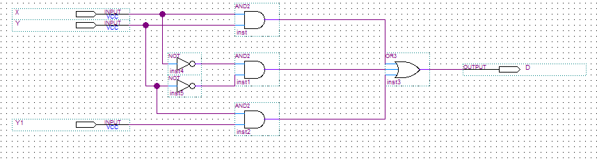

**Wave Output**

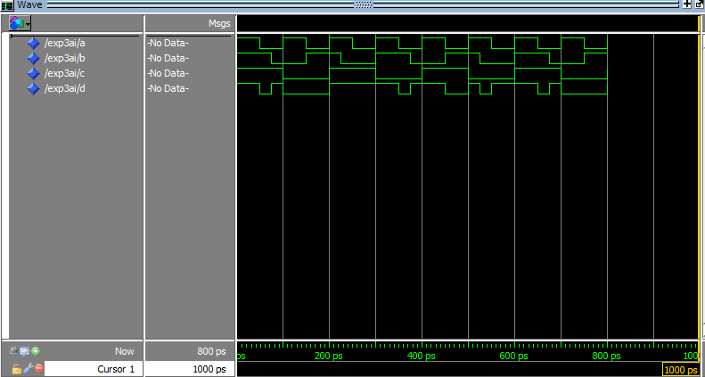

**A ii)**

**Circuit Diagram**

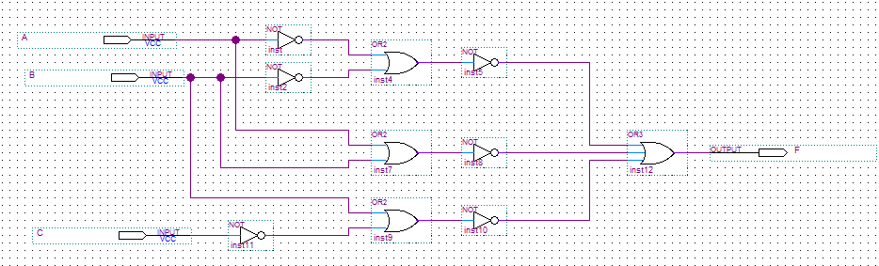

**Wave Output**

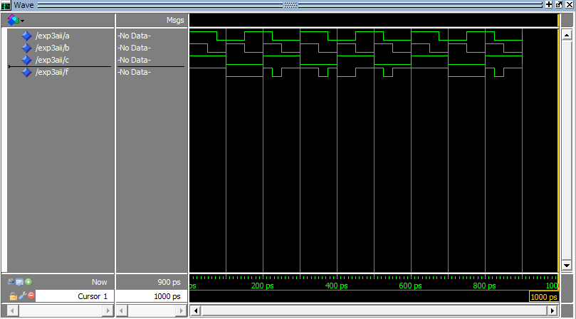

**A iii)**

**Circuit Diagram**

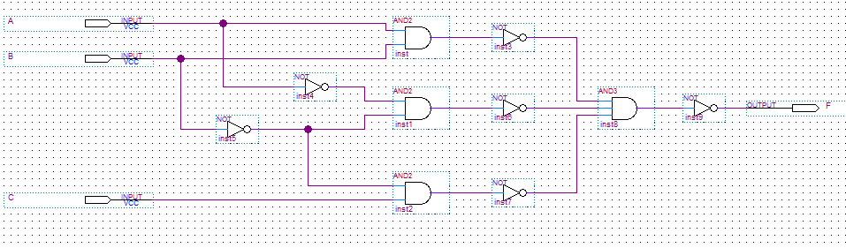

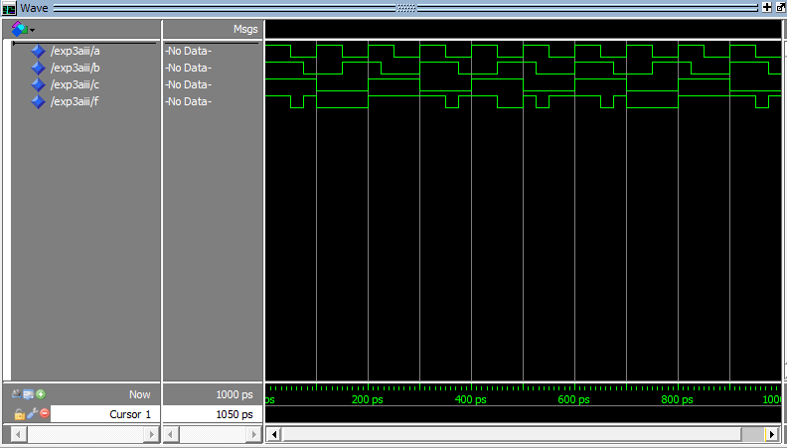**Wave Output**

**A iv)**

**Circuit Diagram**

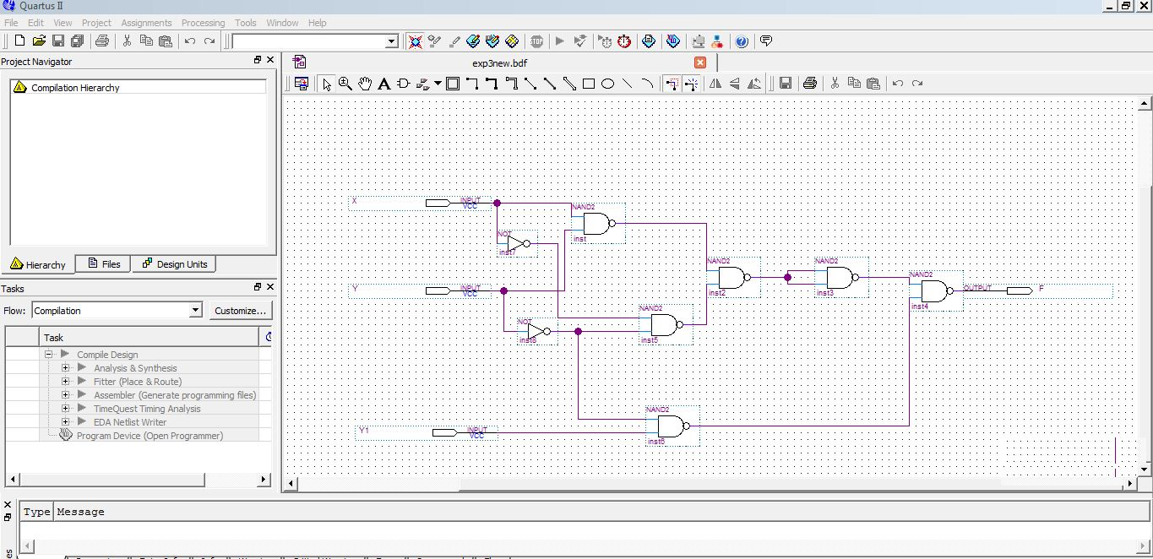

**Wave Output**

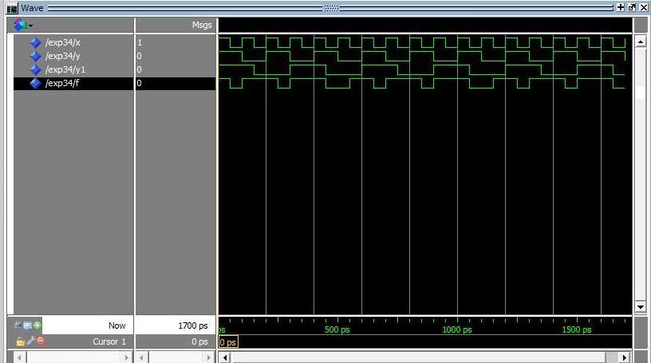

**A v)**

**Circuit Diagram**

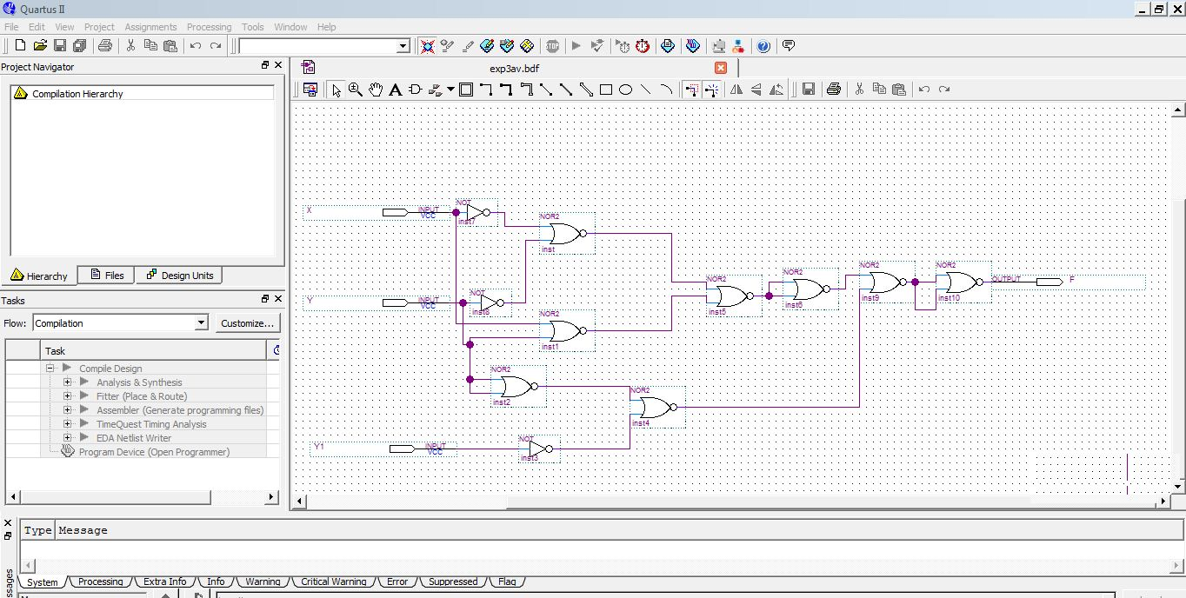

**Wave Output**

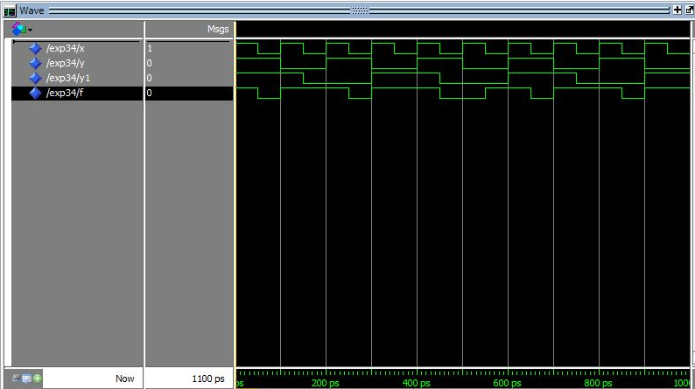

**B**

**Circuit Diagram**

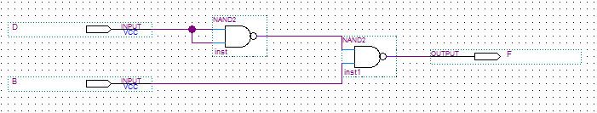

**Wave Output**

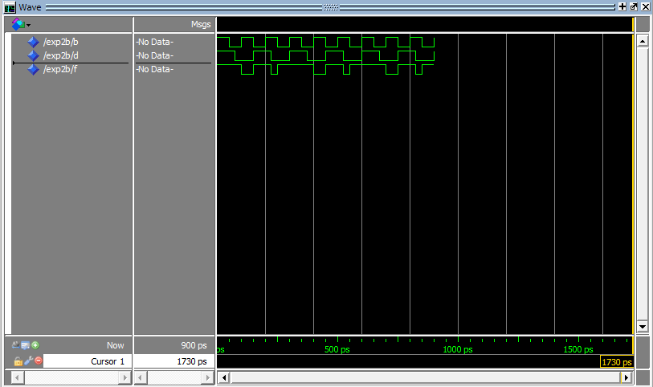

**C**

**Circuit Diagram**

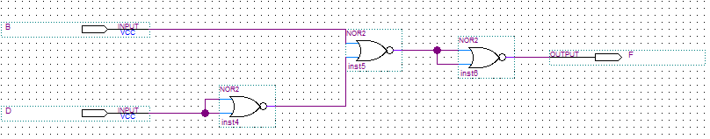

**Wave Output**

