**NAME: VOLETI RAVI**

**REGISTRTION NUM: 15BCE0082**

**Experiment 4**

**A**

**Truth Table**

|  |  |  |  |  |
| --- | --- | --- | --- | --- |
| **A** | **B** | **C** | **D** | **F** |
| **0** | **0** | **0** | **0** | **0** |
| **0** | **0** | **0** | **1** | **1** |
| **0** | **0** | **1** | **0** | **0** |
| **0** | **0** | **1** | **1** | **0** |
| **0** | **1** | **0** | **0** | **0** |
| **0** | **1** | **0** | **1** | **1** |
| **0** | **1** | **1** | **0** | **0** |
| **0** | **1** | **1** | **1** | **0** |
| **1** | **0** | **0** | **0** | **0** |
| **1** | **0** | **0** | **1** | **1** |
| **1** | **0** | **1** | **0** | **0** |
| **1** | **0** | **1** | **1** | **0** |
| **1** | **1** | **0** | **0** | **1** |
| **1** | **1** | **0** | **1** | **1** |
| **1** | **1** | **1** | **0** | **0** |
| **1** | **1** | **1** | **1** | **0** |

**Circuit Diagram**

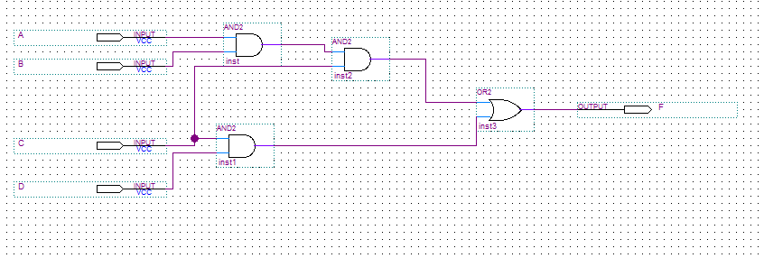

**Wave Output**

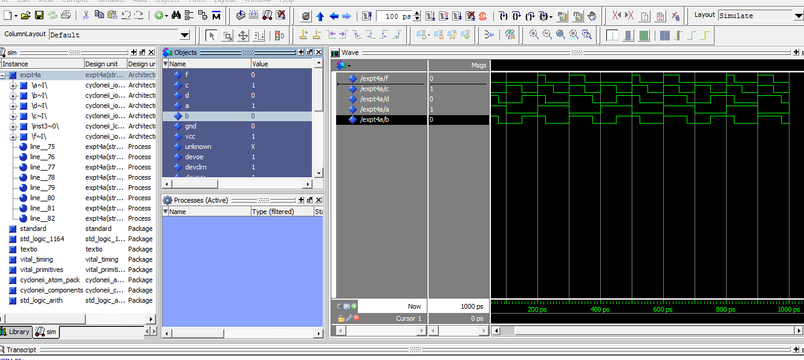

**B**

**Truth Table**

|  |  |  |  |  |
| --- | --- | --- | --- | --- |
| **A** | **B** | **C** | **D** | **F** |
| **0** | **0** | **0** | **0** | **0** |
| **0** | **0** | **0** | **1** | **0** |
| **0** | **0** | **1** | **0** | **0** |
| **0** | **0** | **1** | **1** | **0** |
| **0** | **1** | **0** | **0** | **0** |
| **0** | **1** | **0** | **1** | **0** |
| **0** | **1** | **1** | **0** | **0** |
| **0** | **1** | **1** | **1** | **1** |
| **1** | **0** | **0** | **0** | **0** |
| **1** | **0** | **0** | **1** | **0** |
| **1** | **0** | **1** | **0** | **0** |
| **1** | **0** | **1** | **1** | **1** |
| **1** | **1** | **0** | **0** | **0** |
| **1** | **1** | **0** | **1** | **0** |
| **1** | **1** | **1** | **0** | **0** |
| **1** | **1** | **1** | **1** | **1** |

**Circuit Diagram**

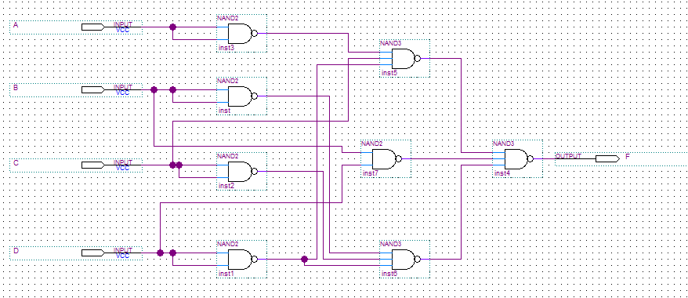

**Wave Output**

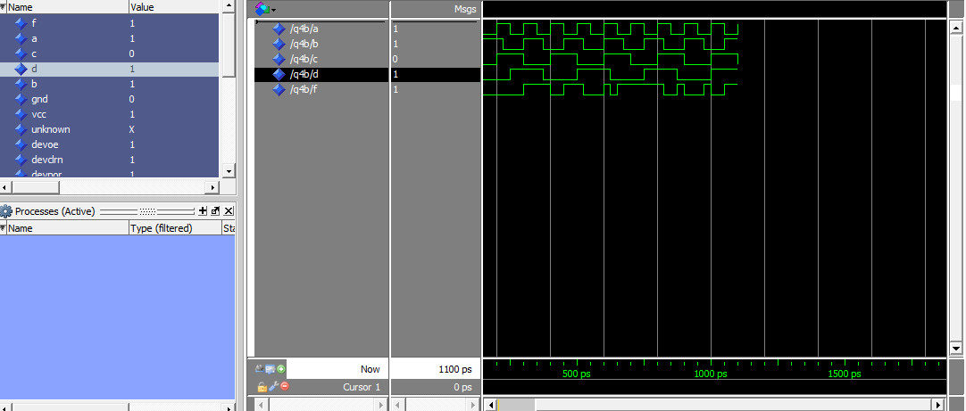

**C**

**Truth Table**

|  |  |  |  |
| --- | --- | --- | --- |
| **A** | **B** | **C** | **F** |
| **0** | **0** | **0** | **0** |
| **0** | **0** | **1** | **1** |
| **0** | **1** | **0** | **0** |
| **0** | **1** | **1** | **1** |
| **1** | **0** | **0** | **0** |
| **1** | **0** | **1** | **1** |
| **1** | **1** | **0** | **1** |
| **1** | **1** | **1** | **1** |

**Circuit Diagram**

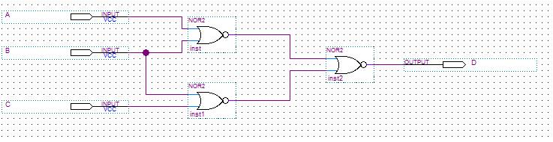

**Wave Output**

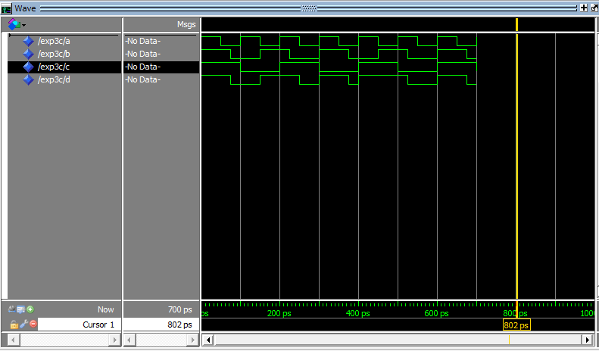

**D**

**Truth Table**

|  |  |  |  |  |
| --- | --- | --- | --- | --- |
| **A** | **B** | **C** | **D** | **F** |
| **0** | **0** | **0** | **0** | **0** |
| **0** | **0** | **0** | **1** | **0** |
| **0** | **0** | **1** | **0** | **0** |
| **0** | **0** | **1** | **1** | **0** |
| **0** | **1** | **0** | **0** | **1** |
| **0** | **1** | **0** | **1** | **0** |
| **0** | **1** | **1** | **0** | **0** |
| **0** | **1** | **1** | **1** | **0** |
| **1** | **0** | **0** | **0** | **1** |
| **1** | **0** | **0** | **1** | **0** |
| **1** | **0** | **1** | **0** | **0** |
| **1** | **0** | **1** | **1** | **0** |
| **1** | **1** | **0** | **0** | **1** |
| **1** | **1** | **0** | **1** | **1** |
| **1** | **1** | **1** | **0** | **1** |
| **1** | **1** | **1** | **1** | **0** |

**Circuit Diagram**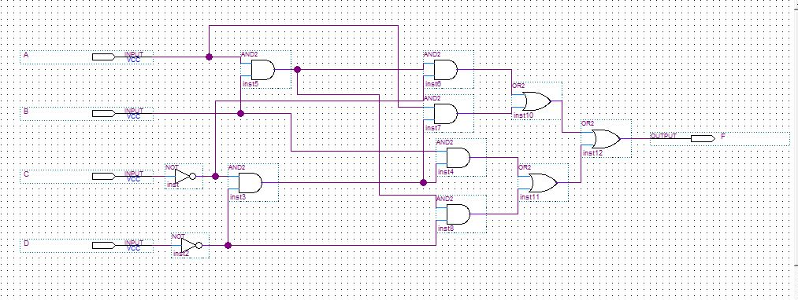

**Wave Output**

