**NAME: VOLETI RAVI**

**REGISTRATION NUM: 15BCE0082**

**Experiment 5**

**A**

**Truth Table**

|  |  |  |  |  |
| --- | --- | --- | --- | --- |
| **A** | **B** | **C** | **SUM** | **CARRY** |
| **0** | **0** | **0** | **0** | **0** |
| **0** | **0** | **1** | **1** | **0** |
| **0** | **1** | **0** | **1** | **0** |
| **0** | **1** | **1** | **0** | **1** |
| **1** | **0** | **0** | **1** | **0** |
| **1** | **0** | **1** | **0** | **1** |
| **1** | **1** | **0** | **0** | **1** |
| **1** | **1** | **1** | **1** | **1** |

**Circuit Diagram**

**SUM=A(XOR)B(XOR)C**

**CARRY=(A XOR B).C + A.B**

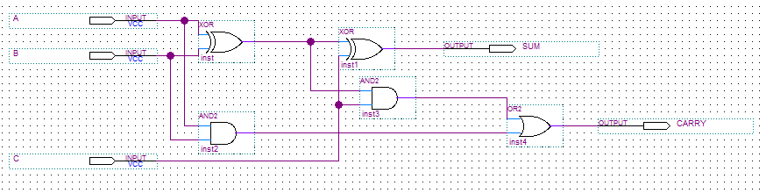

**Wave Output**

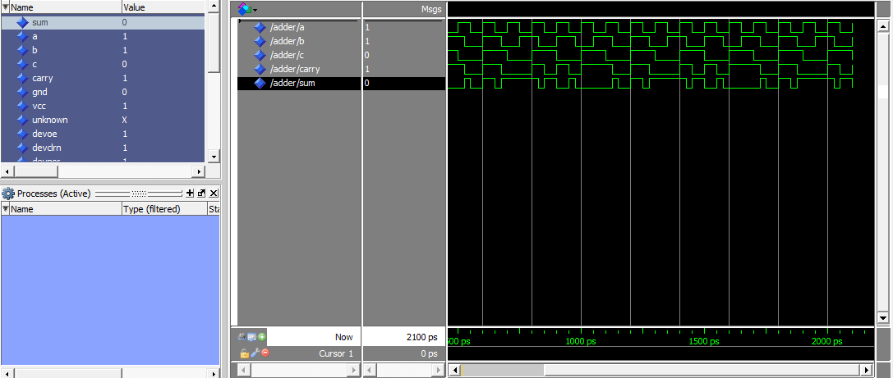

**B**

**Truth Table**

|  |  |  |  |  |  |
| --- | --- | --- | --- | --- | --- |
| **X** | **Y** | **Z** | **A** | **B** | **C** |
| **0** | **0** | **0** | **0** | **0** | **1** |
| **0** | **0** | **1** | **0** | **1** | **0** |
| **0** | **1** | **0** | **0** | **1** | **1** |
| **0** | **1** | **1** | **1** | **0** | **0** |
| **1** | **0** | **0** | **0** | **1** | **1** |
| **1** | **0** | **1** | **1** | **0** | **0** |
| **1** | **1** | **0** | **1** | **0** | **1** |
| **1** | **1** | **1** | **1** | **1** | **0** |

**Circuit Diagram**

**SUM: X⊕ Y⊕ z**

**CARRY: XY+XZ+YZ**

**C=Z’**

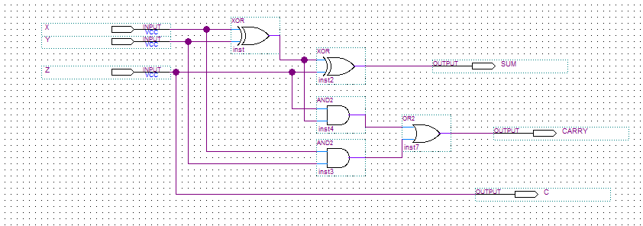

**Wave Output**

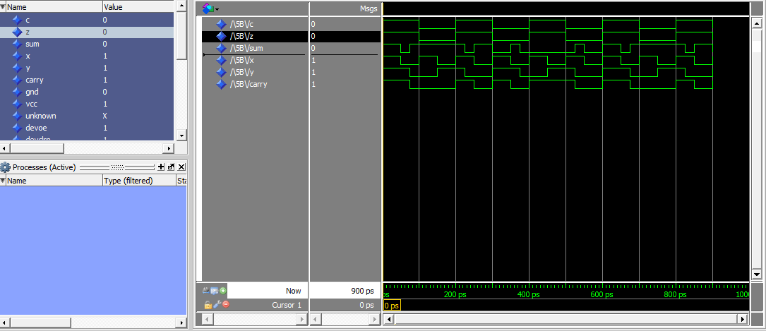

**C**

**Truth Table**

|  |  |  |  |  |
| --- | --- | --- | --- | --- |
| **A** | **B** | **C** | **DIFF** | **BORROW** |
| **0** | **0** | **0** | **0** | **0** |
| **0** | **0** | **1** | **1** | **1** |
| **0** | **1** | **0** | **1** | **1** |
| **0** | **1** | **1** | **0** | **1** |
| **1** | **0** | **0** | **1** | **0** |
| **1** | **0** | **1** | **0** | **0** |
| **1** | **1** | **0** | **0** | **0** |
| **1** | **1** | **1** | **1** | **1** |

**Circuit Diagram**

**DIFF=A XOR B XOR C**

**BORROW=A’.C+A’.B+BC**

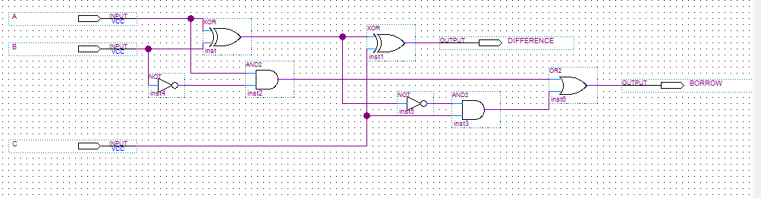

**Wave Output**

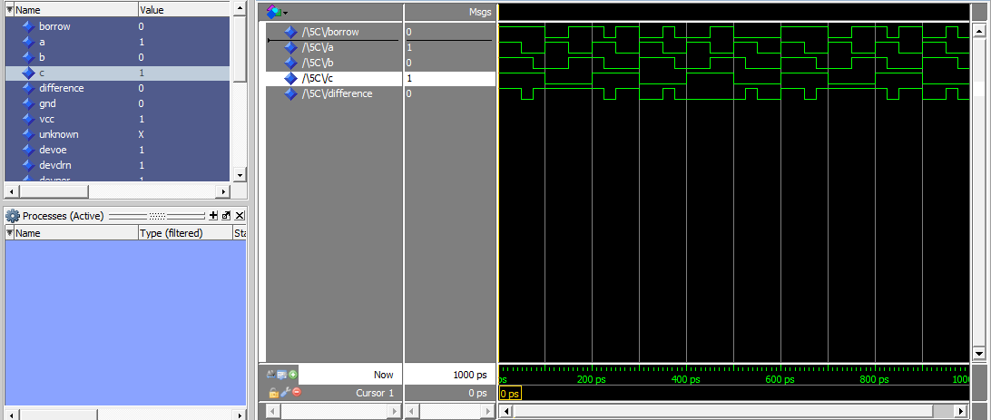

**D**

**Truth Table**

|  |  |  |  |  |  |
| --- | --- | --- | --- | --- | --- |
| A | B | C | D | G | E |
| 0 | 0 | 0 | 0 | 0 | 0 |
| 0 | 0 | 1 | 1 | 0 | 0 |
| 0 | 1 | 0 | 1 | 0 | 1 |
| 0 | 1 | 1 | 0 | 0 | 0 |
| 1 | 0 | 0 | 1 | 0 | 0 |
| 1 | 0 | 1 | 0 | 0 | 1 |
| 1 | 1 | 0 | 0 | 0 | 1 |
| 1 | 1 | 1 | 1 | 1 | 0 |

**Circuit Diagram**

D=A XOR B XOR C

E=A’BC+AB’C

G=ABC

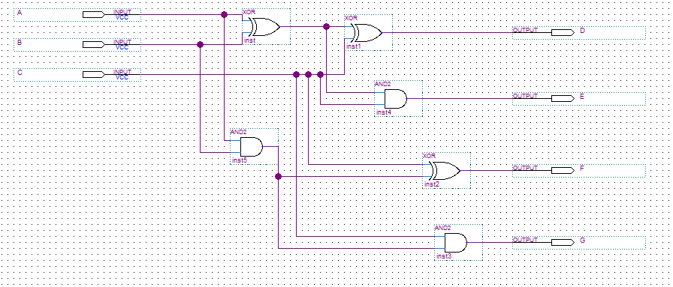

**Wave Output**

