**Experiment: 9**

**Multiplexers And De- Multiplexers**

**Name:** Voleti RAVI

**Reg No’:** 15BCE0082

**Slot:** L55 + L56

**Question 1)**

**AIM:** To implement a Boolean function using a multiplexer F(A,B,C,D)= ∑(0,1,3,4,8,9,15)

**Truth Table:**

|  |  |  |  |  |
| --- | --- | --- | --- | --- |
| A | B | C | D | F |
| 0 | 0 | 0 | 0 | 1 |
| 0 | 0 | 0 | 1 | 1 |
| 0 | 0 | 1 | 0 | 0 |
| 1 | 0 | 0 | 0 | 1 |
| 1 | 1 | 0 | 0 | 0 |

**Circuit Diagram:**

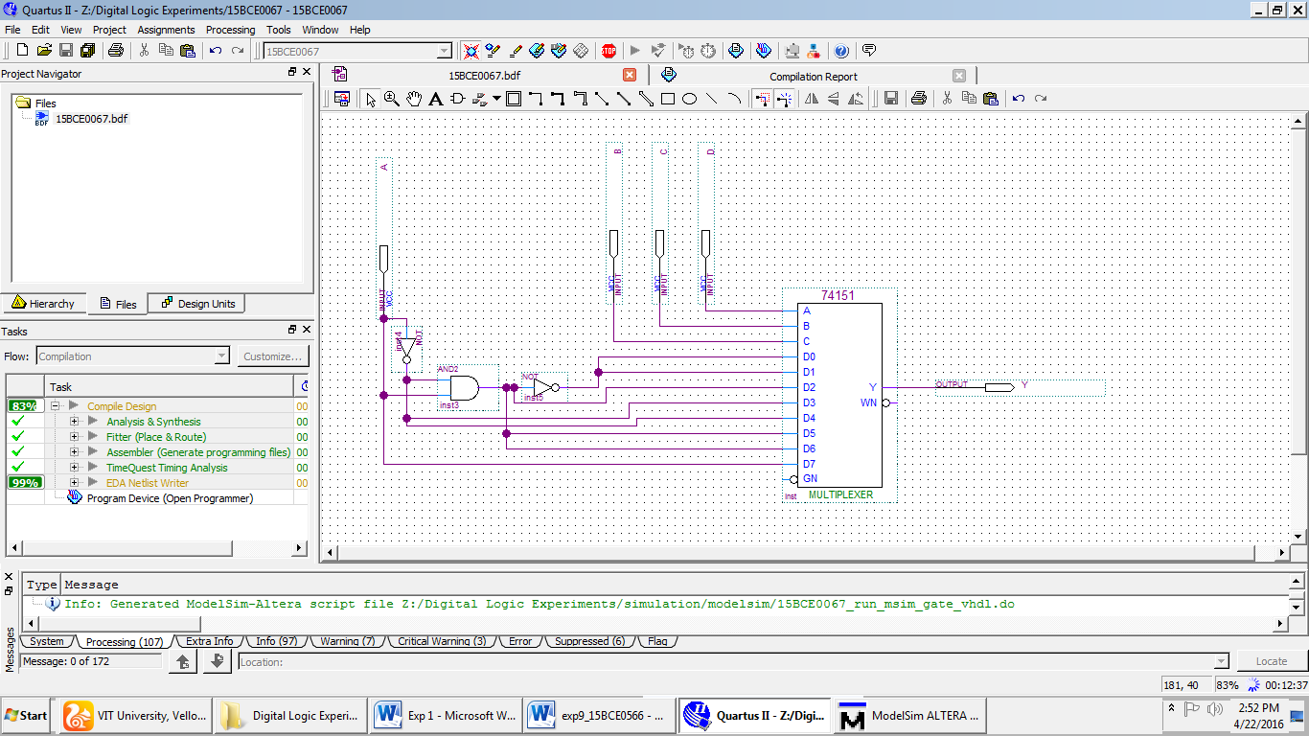

**Observation:**

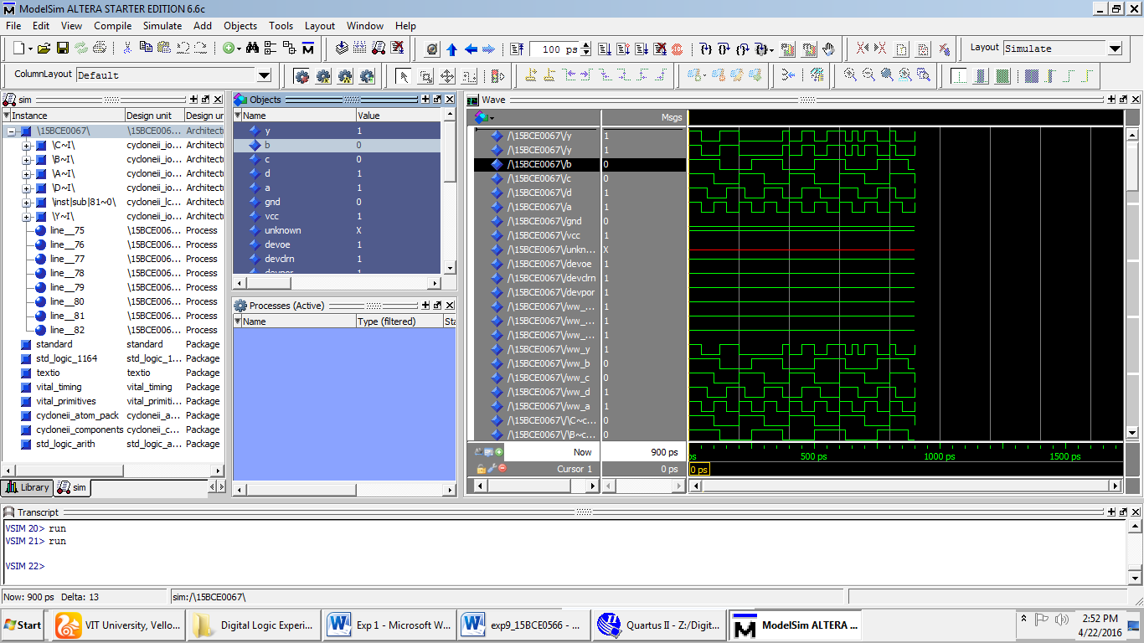

**Question 2)**

**AIM:** To design 2-to-4 line de-multiplexer using NOR gates.

**TRUTH TABLE:**

|  |  |  |  |  |  |
| --- | --- | --- | --- | --- | --- |
| **A** | **B** | **D0** | **D1** | **D2** | **D3** |
| 0 | 0 | 1 | 0 | 0 | 0 |
| 0 | 1 | 0 | 1 | 0 | 0 |
| 1 | 0 | 0 | 0 | 1 | 0 |
| 1 | 1 | 0 | 0 | 0 | 1 |

**Circuit Diagram:**

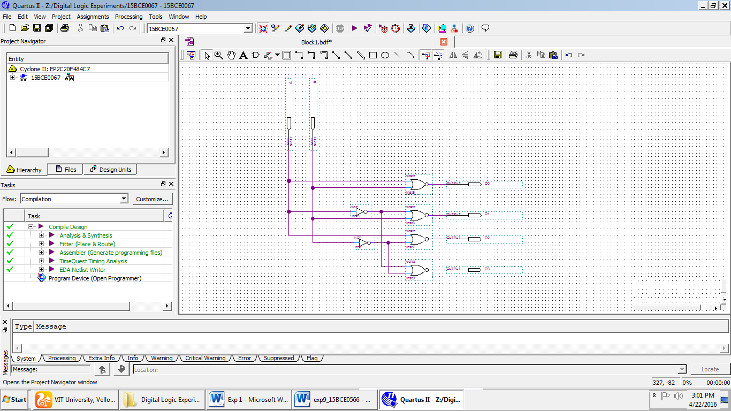

**Observation:**

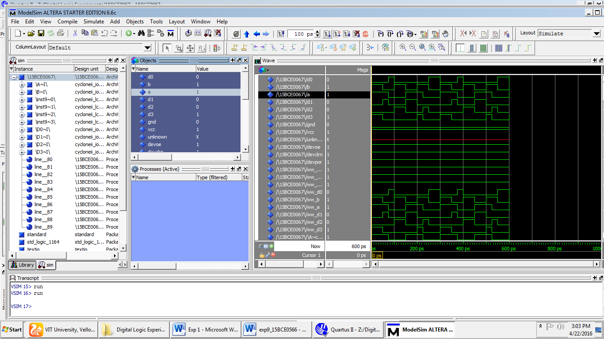

**Question 4)**

**AIM:** Design a 4-bit Odd parity generator using a multiplexer.

**Truth Table:**

|  |  |  |  |  |
| --- | --- | --- | --- | --- |
| **A** | **B** | **C** | **D** | **F** |
| 0 | 0 | 0 | 0 | 1 |
| 1 | 1 | 0 | 1 | 0 |
| 0 | 0 | 1 | 1 | 1 |
| 1 | 0 | 1 | 1 | 0 |

**Circuit Diagram:**

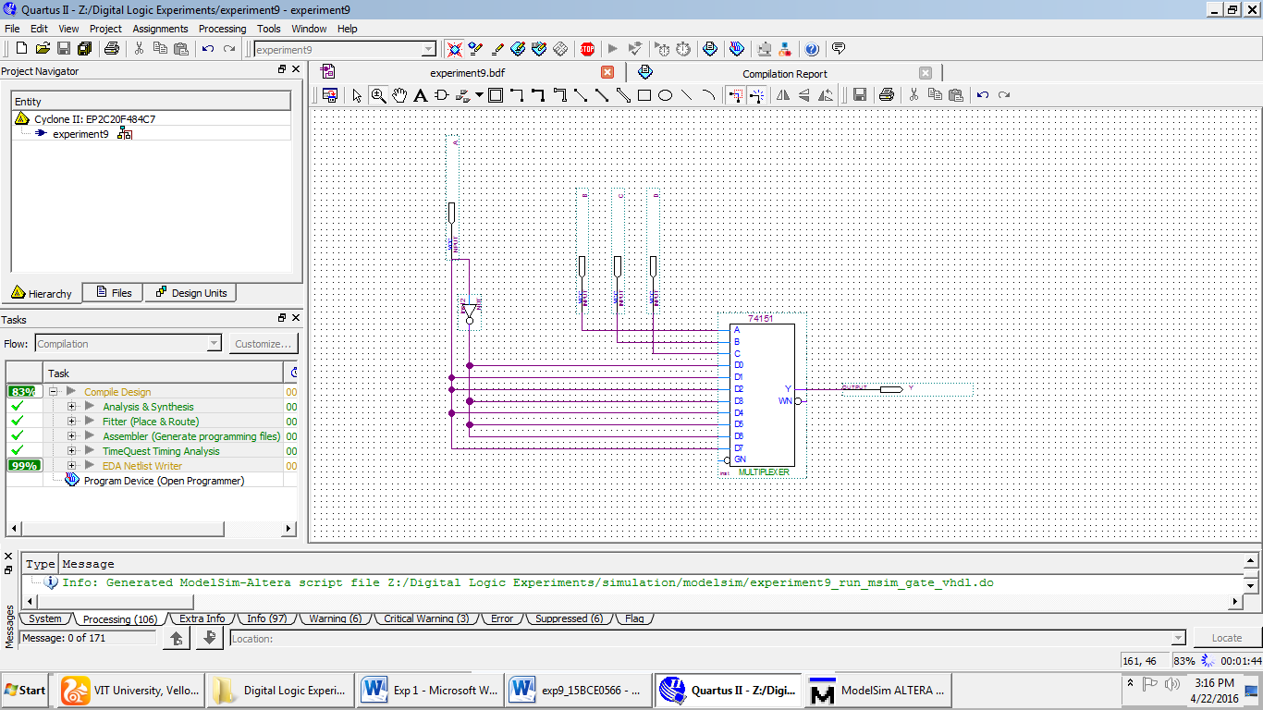

**Observations:**

