NAME- VOLETI RAVI

REG. NO-15BCE0082

SLOT-L55+56

**Flip Flop**

1.VERIFY FUNCTIONS OF ALL FLIP-FLOPS

**JK Flip Flop (Characteristic table)**

|  |  |  |
| --- | --- | --- |
| J | K | Q(t+1) |
| 0 | 0 | Q(t) |
| 0 | 1 | 0 |
| 1 | 0 | 1 |
| 1 | 1 | Q’(t) |

**SR Flip Flop (Characteristic table)**

|  |  |  |
| --- | --- | --- |
| J | K | Q(t+1) |
| 0 | 0 | Q(t) |
| 0 | 1 | 0 |
| 1 | 0 | 1 |
| 1 | 1 | Indeterminate |

**D Flip Flop (Characteristic table)**

|  |  |
| --- | --- |
| **D** | **Q(t+1)** |
| 0 | 0 |
| 1 | 1 |

**T Flip Flop (Characteristic table)**

|  |  |
| --- | --- |
| **T** | **Q(t+1)** |
| 0 | Q(t) |
| 1 | Q’(t) |

CIRCUIT DIGRAM:

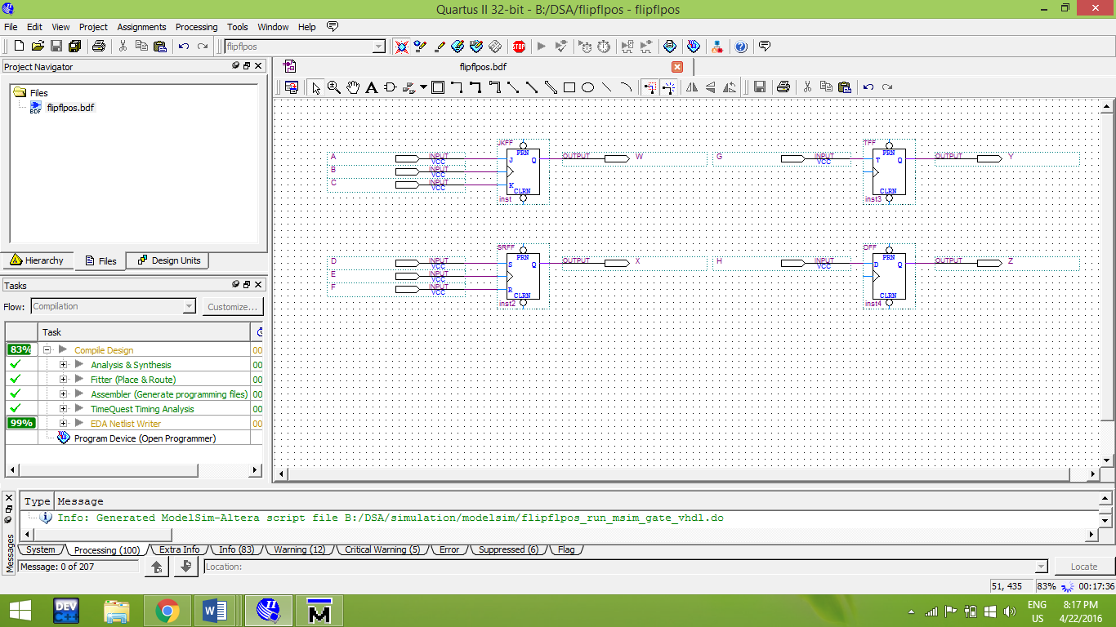

**OUTPUT:**

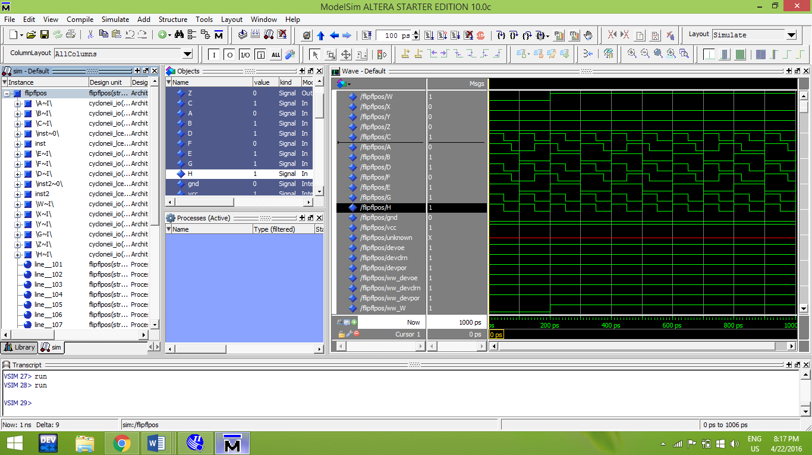

# 2.A sequential circuit has two flip-flops A and B, two inputs x and y, and an output z. The flip-

flop input functions and circuit functions are as follows:

JA = xB+y′B′ KA = xy′B′

JB = xA′ KB = xy′+A

Z = xyA + x′y′B

To obtain the state table and implement the circuit to verify the obtained state table

INPUTS;X,Y,CP

OUTPUTS;Z

STATETABLE

|  |  |  |  |
| --- | --- | --- | --- |
| J | K | Q(T+1) | Z |
| 0 | 0 | Q(T) | 1 |
| 0 | 1 | 0 | 0 |
| 1 | 0 | 1 | 1 |
| 1 | 1 | Q’(T) | 0 |

SIMULATION DIAGRAM

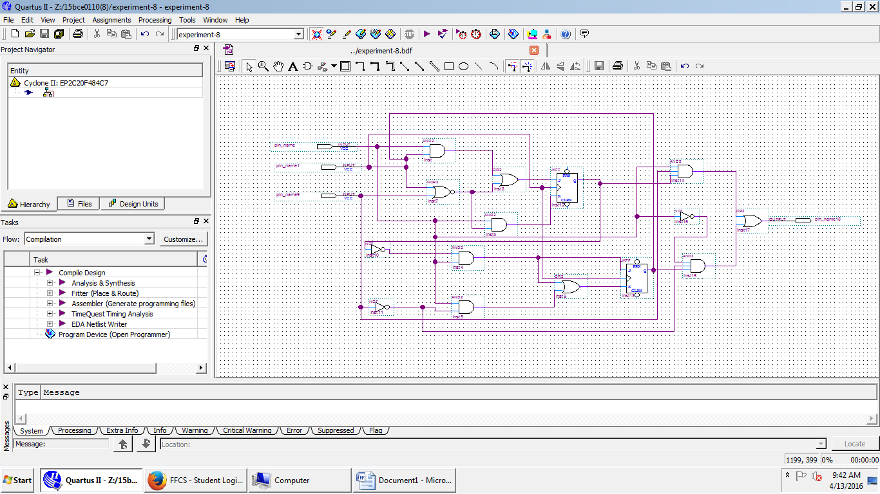

OUTPUT

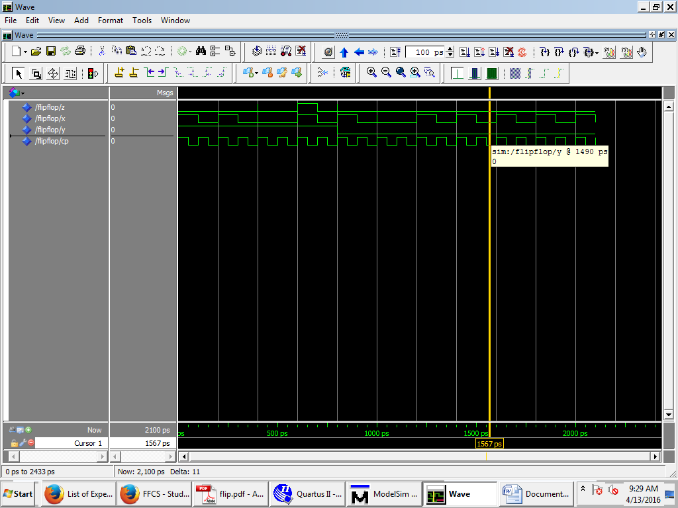

3.

J1=X(XOR)B

K1=X’.B

J2=X.A

|  |  |  |  |  |  |  |
| --- | --- | --- | --- | --- | --- | --- |
| X | P | S | N | S | J1 | K1 |
| 0 | 0 | 0 | 0 | 1 | 0 | X |
| 0 | 0 | 1 | 1 | 0 | 1 | X0 |
| 0 | 1 | 0 | 1 | 1 | 0 | 1 |
| 0 | 1 | 1 | 0 | 0 | 0 | 0 |
| 1 | 0 | 0 | 1 | 0 | 0 | 0 |
| 1 | 0 | 1 | 0 | 0 | 0 | 0 |
| 1 | 1 | 0 | 0 | 1 | 1 | 0 |
| 1 | 1 | 1 | 1 | 1 | 1 | 0 |

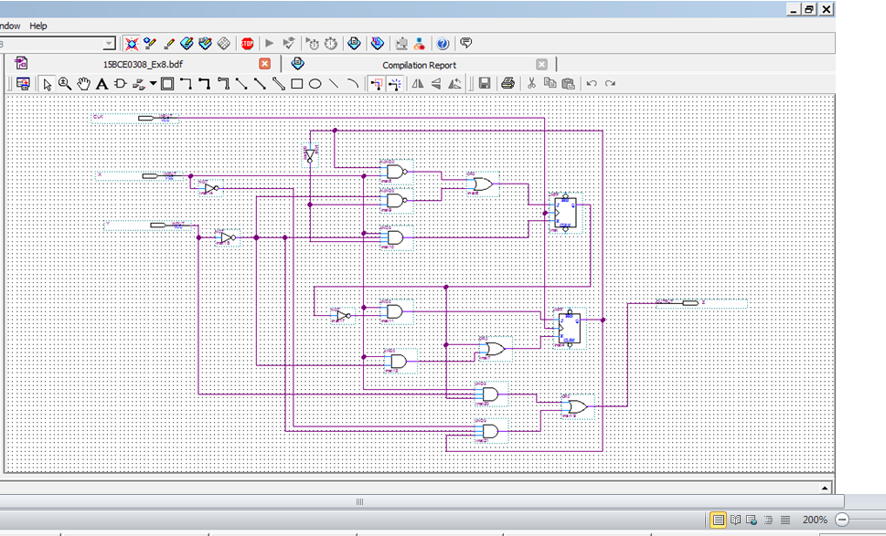

**OUTPUT**

