**L55-L56 DIGITAL LOGIC AND DEGISN LAB**

**FLIP FLOPS:-**

**JK FLIP FLOP**

1. **TABLE**

|  |  |  |  |
| --- | --- | --- | --- |
| Q | J | K | Q(t+1) |
| 0 | 0 | 0 | 0 |
| 0 | 0 | 1 | 0 |
| 0 | 1 | 0 | 1 |
| 0 | 1 | 1 | 1 |
| 1 | 0 | 0 | 1 |
| 1 | 0 | 1 | 0 |
| 1 | 1 | 0 | 1 |
| 1 | 1 | 1 | 0 |

**Diagram:**

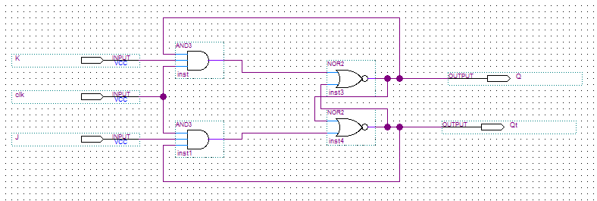

**OUTPUT:**

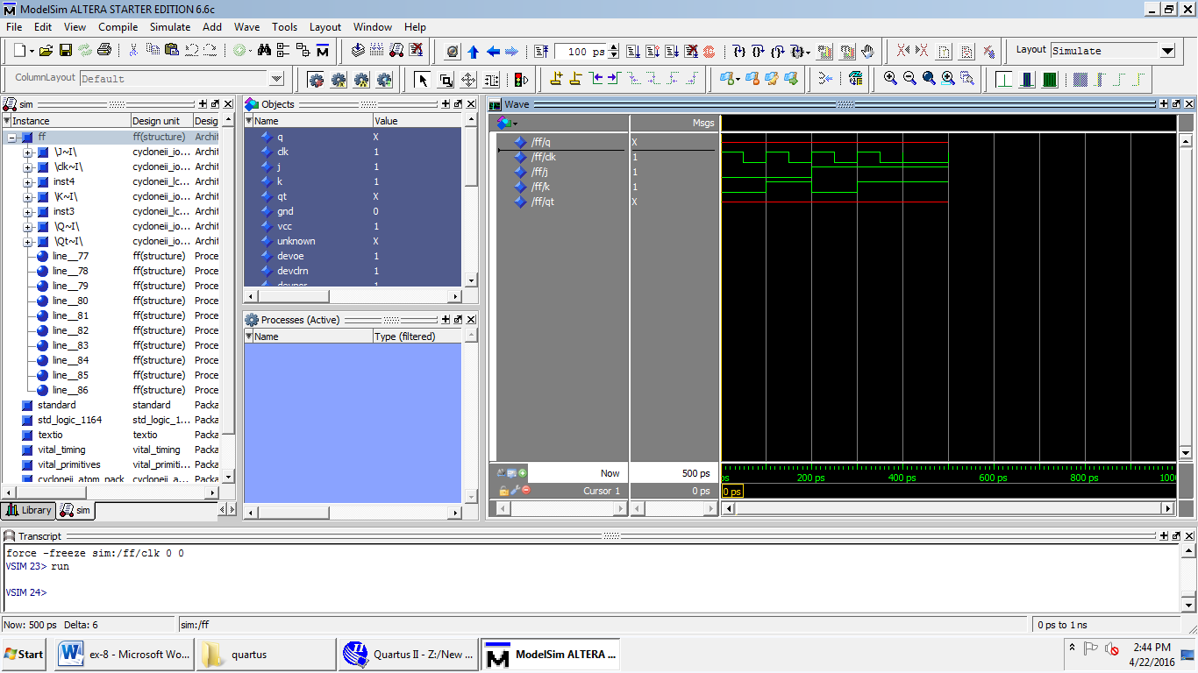

**T FLIP FLOP:**

**TABLE:**

|  |  |  |
| --- | --- | --- |
| **Q** | **T** | **Q(t+1)** |
| **0** | **0** | **0** |
| **0** | **1** | **1** |
| **1** | **0** | **1** |
| **1** | **1** | **0** |

**DIAGRAM:**

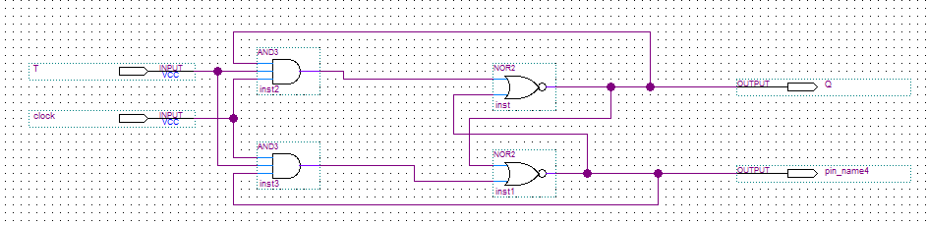

**OUTPUT:**

