Memento Pattern

Memento pattern is useful to restore the state of an object to a previous object. This pattern can be used in this system to easily undo the most recent 5 supervisor actions. This pattern basically uses the three classes:

Originator: It creates and stores the state of the object in memento objects.

Memento: Memento contains state of actions to be restored .

Care Taker: It is responsible to restore the object from memento.

**Memento Pattern Design**

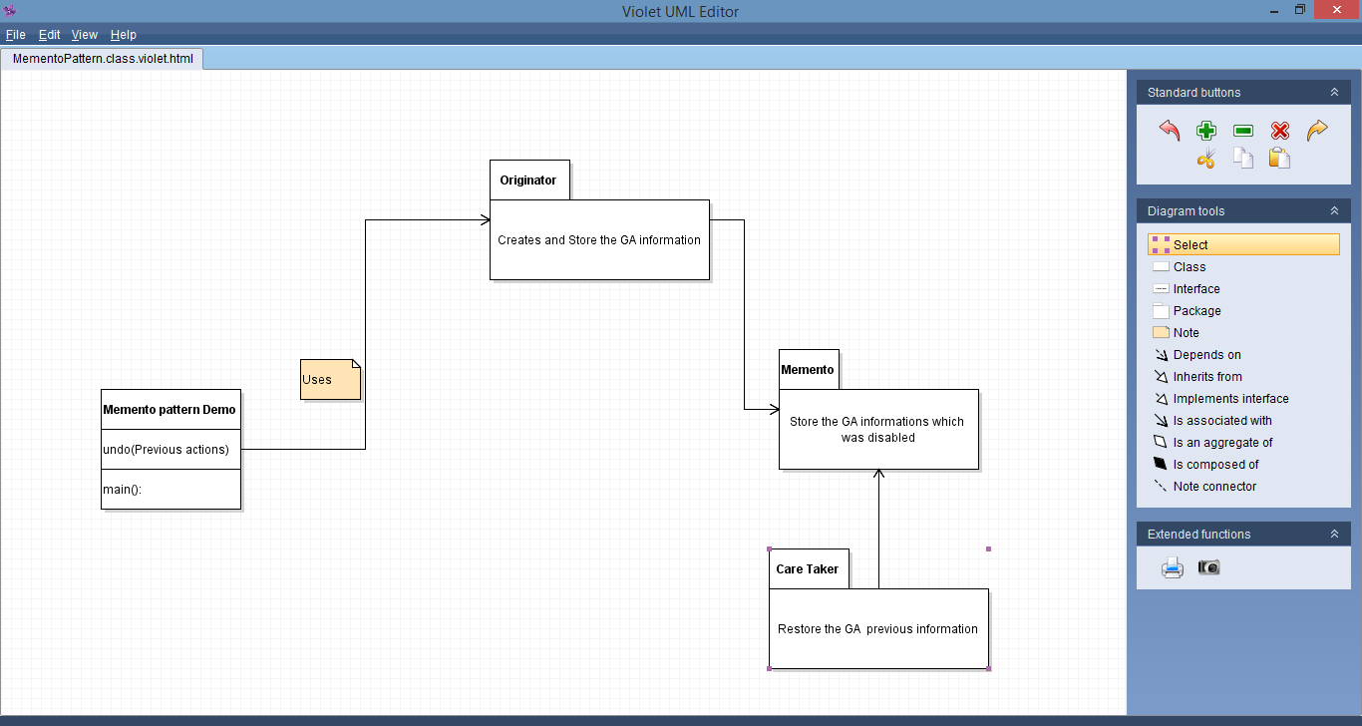

Intercepting Filter Pattern:

The intercepting filter pattern is used when we want to do some pre-processing with the request or response of the application. Filters are defined before processing the request to the target host. Following are the entities of this type of design pattern:

Filter: It performs certain task prior or after the execution of the request by request handler.

Target: Target object is the host which handles the requests.

Filter manager: Filter manger manages the filters and filter chain.

Client: Client is the object who sends requests to the Target object.

In our system, this pattern can be used to handle the change the schedule actions. It can be also be useful when disabling the GA account.

**Intercepting Filter Patter Design:**

