***FSM for Overall System***

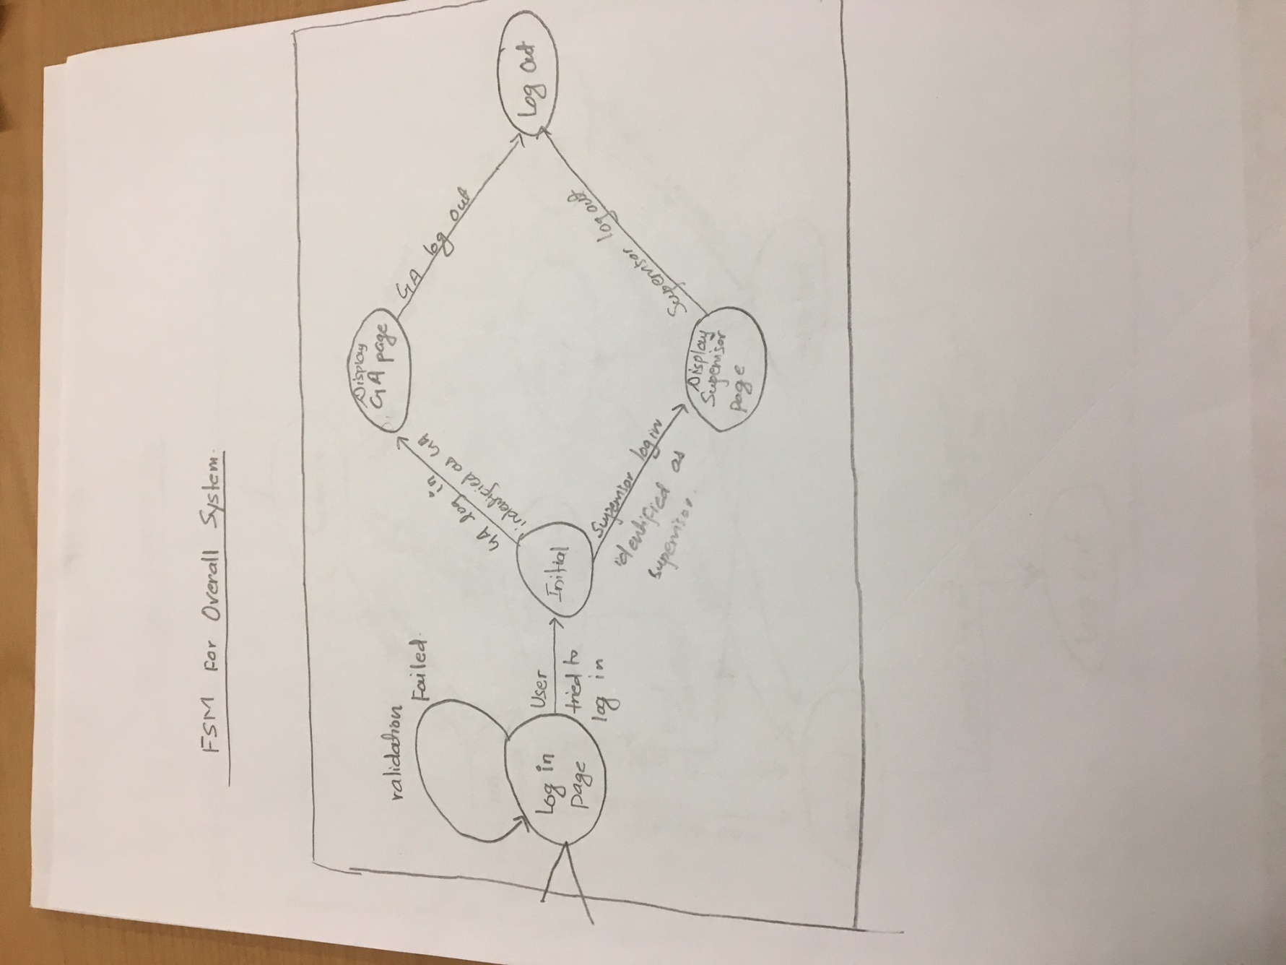

***States and Stimuli for the Overall System***

|  |  |
| --- | --- |
| **State** | **Description** |
| Log in page | When the user enters the URL |
| Log in page | When the user authentication failed |
| Initial | Determine whether the user is GA or Supervisor |
| Display GA Page | GA log in |
| Display Supervisor page | Supervisor log in |
| Log Out | GA or Supervisor Log Out |

***FSM for Supervisor Page Which requires Authentication***

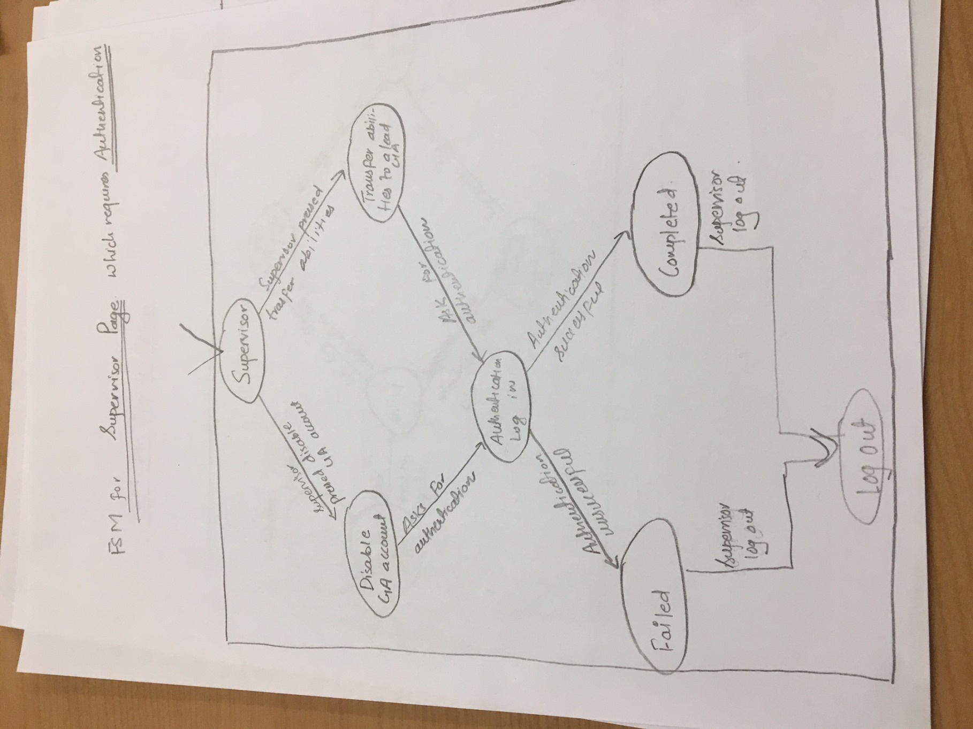

***States and Stimuli for the Supervisor Page which require Authentication***

|  |  |
| --- | --- |
| **State** | **Description** |
| Supervisor | The initial supervisor state |
| Disable GA Account | When the supervisor pressed the disable account |
| Transfer abilities | When the supervisor chose to transfer abilities to a lead GA |
| Authentication | The system asks for user authentication to proceed the action |
| Failed | When the authentication provided by the supervisor failed |
| Completed | When the authentication is right, and the action is performed |
| Log out | When the user log out |

***FSM for GA Page***

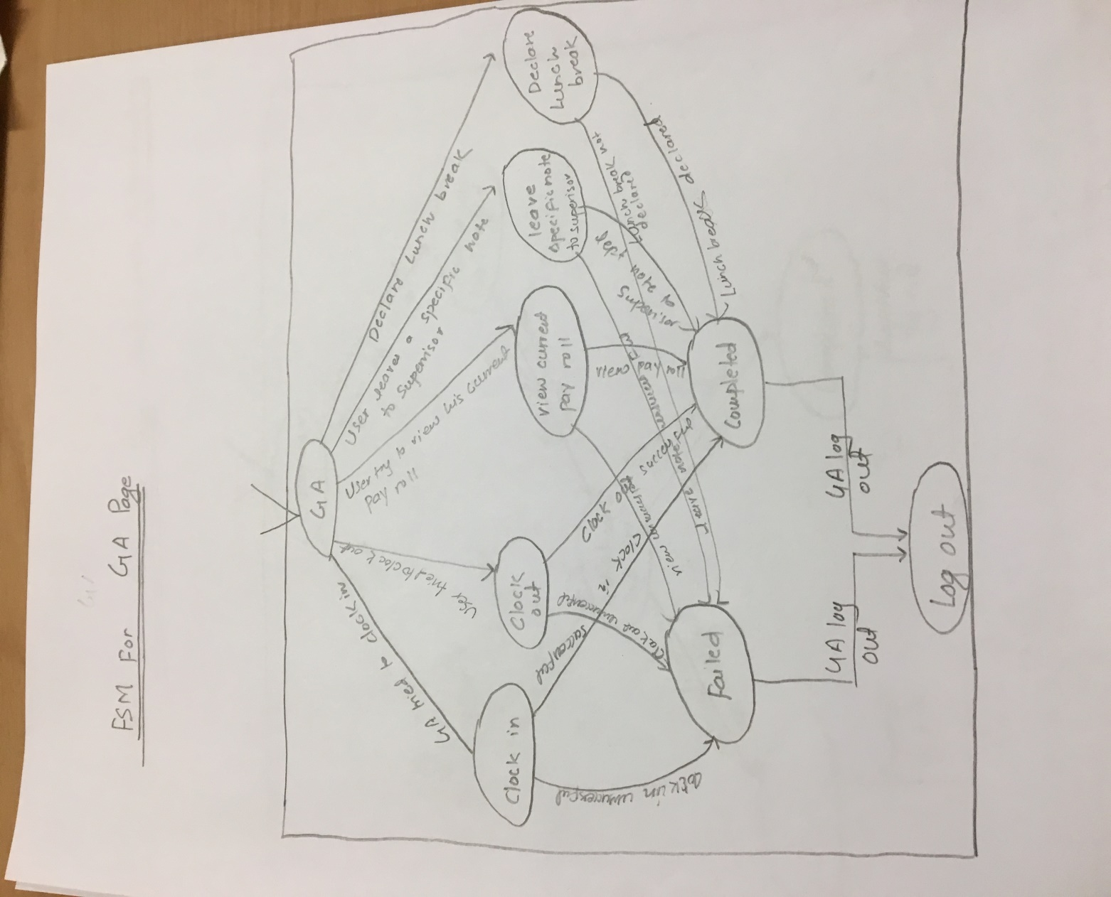

***States and Stimuli for the GA Page***

|  |  |
| --- | --- |
| **States** | **Description** |
| GA | Initial GA state when the GA log in |
| Clock in | When the GA pressed clock in |
| Clock out | When the GA pressed the clock out button |
| View Current Pay roll | When the GA Pressed the View Current Pay roll period |
| Leave note to supervisor | When the GA wants to leave some specific note to the supervisor |
| Declare Lunch break | When the GA pressed the Declare Lunch Break button |
| Failed | When the clock in is unsuccessful |
| Failed | When the clock out is unsuccessful |
| Failed | When the View current pay roll is not displayed |
| Failed | When the note to the supervisor is not sent |
| Failed | When the Lunch break is not declared |
| Completed | When the clock is successful |
| Completed | When the clock out is successful |
| Completed | When the Pay roll is viewed |
| Completed | When the specific note is delivered to the supervisor |
| Completed | When the Lunch Break is declared |
| Log Out | When the GA log out |

***FSM for Supervisor Page***

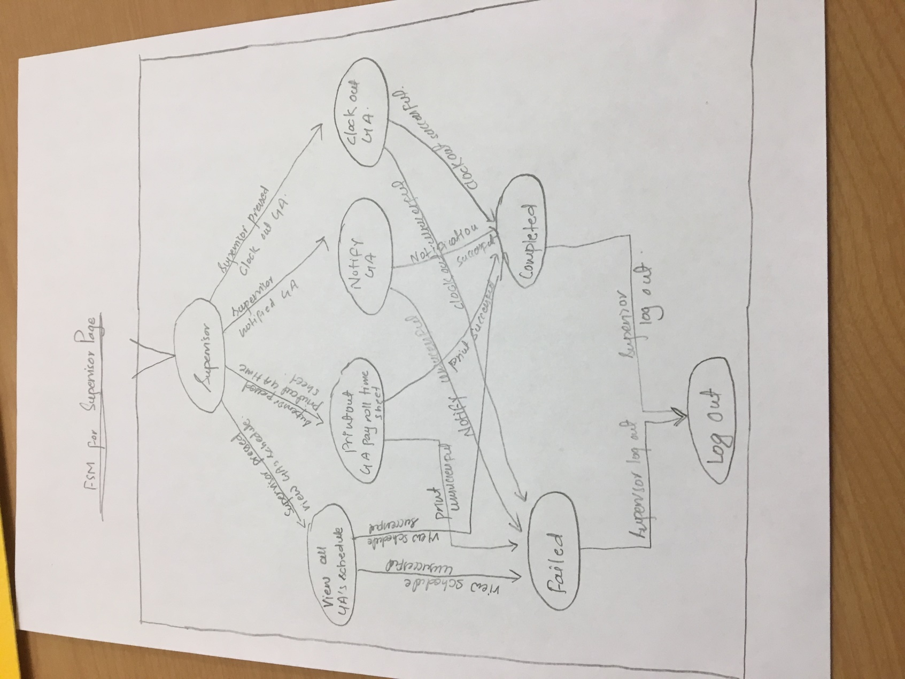

***States and Stimuli for Supervisor Page***

|  |  |
| --- | --- |
| **States** | **Description** |
| Supervisor | The initial state when the supervisor log in |
| View all GA schedule | When the supervisor pressed view GA Schedule |
| Print out Pay roll sheet | When the supervisor pressed the print roll sheet |
| Notify GA | When the supervisor pressed the notify GA |
| Clock out | When the Supervisor wants to clock out GA who forgot to do so |
| Failed | When the view schedule is not displayed |
| Failed | When the print is unsuccessful |
| Failed | When the notification to GA is not sent |
| Failed | When the clock out is unsuccessful |
| Completed | When the GA schedule is displayed |
| Completed | When the print is successful |
| Completed | When the notification to GA is successful |
| Completed | When the clock out of GA is successful |
| Log Out | When the supervisor clock out |