

**ADDIS ABABA INSTITUTE OF TECHNOLOGY**

**CENTER OF INFORMATION TECHNOLOGY AND SCIENTIFIC COMPUTING**

DEPARTMENT OF **SOFTWARE ENGINEERING**

**HISTORY, EVALUATION GUIDELINES AND THE DIFFERENT CATAGORIES OF WEBS AND WEBSITES**

Zemichael amsalu

Atr/8036/10

Section 1

Submitted To: Mr. Fitsum Alemu

March 2020

**History of internet**

Unlike technologies such as the light bulb or the telephone, the internet has no single “inventor.” Instead, it has evolved over time. The internet got its start in the United States more than 50 years ago as a government weapon in the Cold War. Today, we use the internet for almost everything, and for many people it would be impossible to imagine life without it.

There are five major events that set the internet into motion to becoming what it is today. They are: 1, The Sputnik Scare

2, The Birth of the ARPAnet

3, “LOGIN”

4, The Network Grows

5, The World Wide Web

We will try to see each of them in depth.

**1, The Spuntik Scare**

On October 4, 1957, the Soviet Union launched the world’s first manmade satellite into orbit. This satellite was not advanced in technology but since soviet and the US was enemies it made Americans take science and technology very seriously. And thus schools added courses on subjects like chemistry, physics and calculus. Corporations took government grants and invested them in scientific research and development. And the federal government itself formed new agencies, such as the National Aeronautics and Space Administration (NASA) and the Department of Defense’s Advanced Research Projects Agency (ARPA), to develop space-age technologies such as rockets, weapons and computers.

**2, The Birth of the ARPAnet**

The Americans were specially concerned what might happen if soviet launch missiles that could destroy the telephone system. A scientist from M.I.T. and ARPA named J.C.R. Licklider proposed a solution to this problem: a “galactic network” of computers that could talk to one another. Such a network would enable government leaders to communicate even if the Soviets destroyed the telephone system.

Another scientist from MIT then developed a way of sending information to its destination by breaking the components into packets. This way the information will not be vulnerable to enemy attack.

**3, “LOGIN”**

On October 29, 1969, ARPAnet delivered its first message: a “node-to-node” communication from one computer to another. The message—“LOGIN”—was short and simple, but it crashed the fledgling ARPA network anyway: The Stanford computer only received the note’s first two letters.

**4, The Network Grows**

By the end of 1969, just four computers were connected to the ARPAnet, but the network grew steadily during the 1970s. In 1971, it added the University of Hawaii’s ALOHAnet, and two years later it added networks at London’s University College and the Royal Radar Establishment in Norway. As packet-switched computer networks multiplied, however, it became more difficult for them to integrate into a single worldwide “internet.”

By the end of the 1970s, a computer scientist named Vinton Cerf had begun to solve this problem by developing a way for all of the computers on all of the world’s mini-networks to communicate with one another. He called his invention “Transmission Control Protocol,” or TCP.

**5, The World Wide Web**

Cerf’s protocol transformed the internet into a worldwide network. Throughout the 1980s, researchers and scientists used it to send files and data from one computer to another. However in 1991, internet changed again-a computer programmer in Switzerland named Tim Berners-Lee introduced the World Wide Web: an internet that was not simply a way to send files from one place to another but was itself a “web” of information that anyone on the Internet could retrieve. So in a way berners created the internet we know today.

**Observation and Assessment of chosen sites**

**1, Facebook**

The Facebook login and sign up page has a significant difference between 2010 and now.

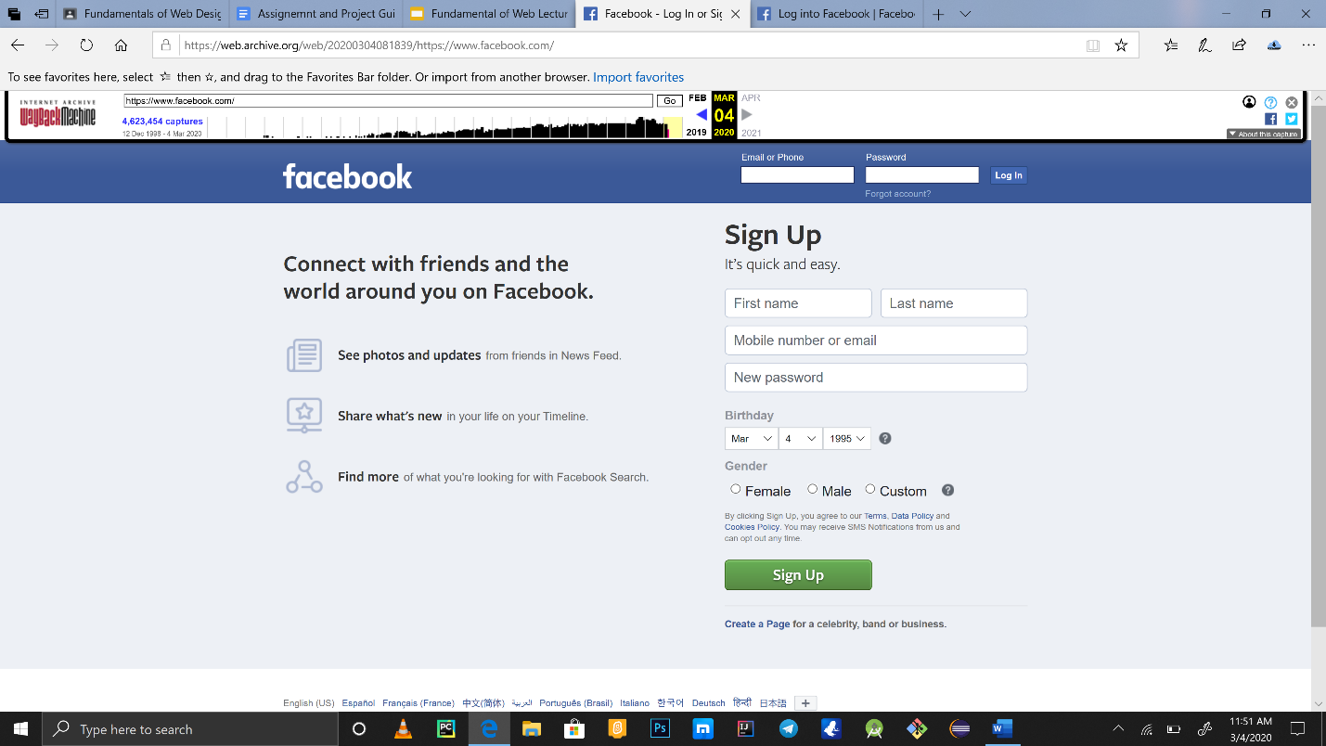

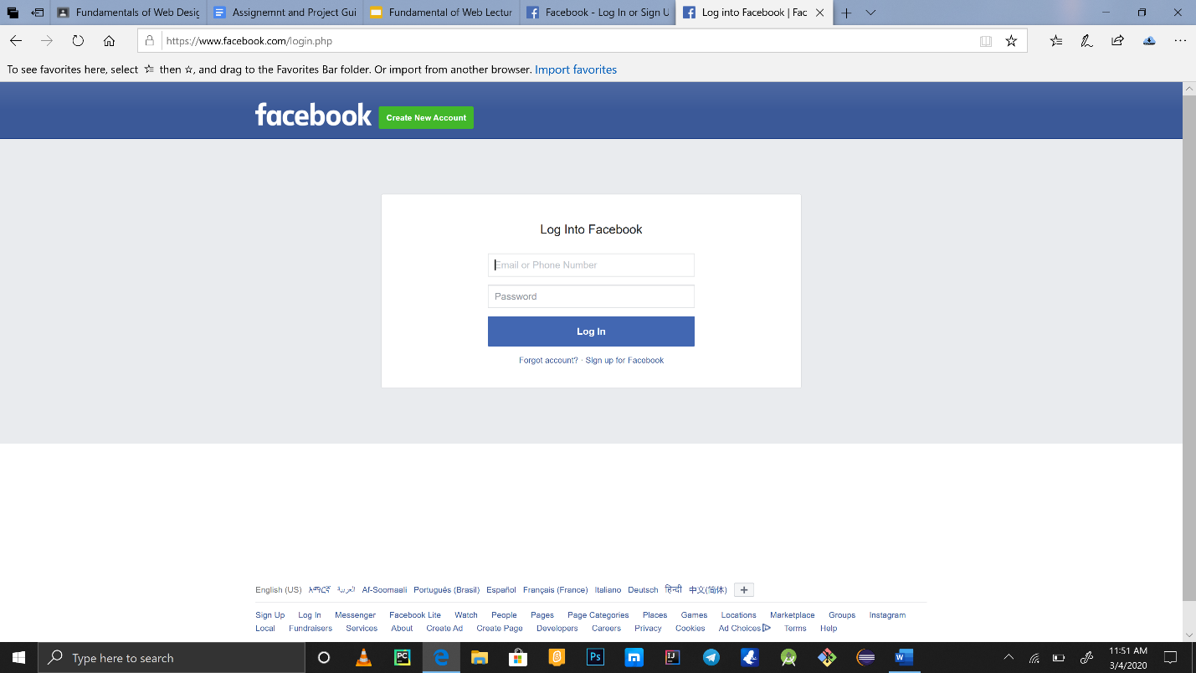

The first picture is the one that has been being used starting from 2010 while the second is the one we are using now. Using the pictures we can observe some things, the first is the “log into Facebook” panel is expanded in the latest version and it takes the central space while in the older version this panel was in the top bar along with the logo. Considering this differences it seems like the focus of the company was to acquire users and expand it popularity at the start of 1998 but now it seems like it is trying to make it easier for the users it acquired have a nice experience.

The other difference is Facebook removed the ad on the left that tells the user what to expect from the site once it registers on Facebook on the older site. The newer site is just plain in appearance which can imply the confidence Facebook has in regards to the amount of users they have.

**2, Twitter**

Twitter- the social media site founded by jack Dorsey is another very popular social media site that can be used to communicate over people as a population as a whole by endorsing a hashtag and it has over the years been able to influence major decisions.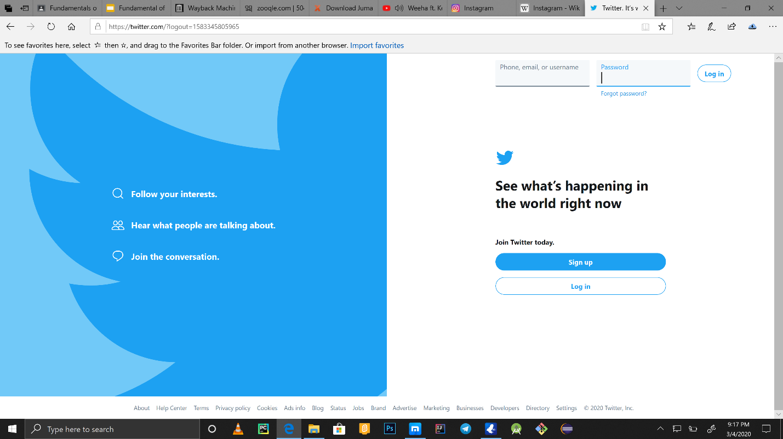

The above picture shows the sign up or login page. On the left side we can see what the website offers in a nutshell.

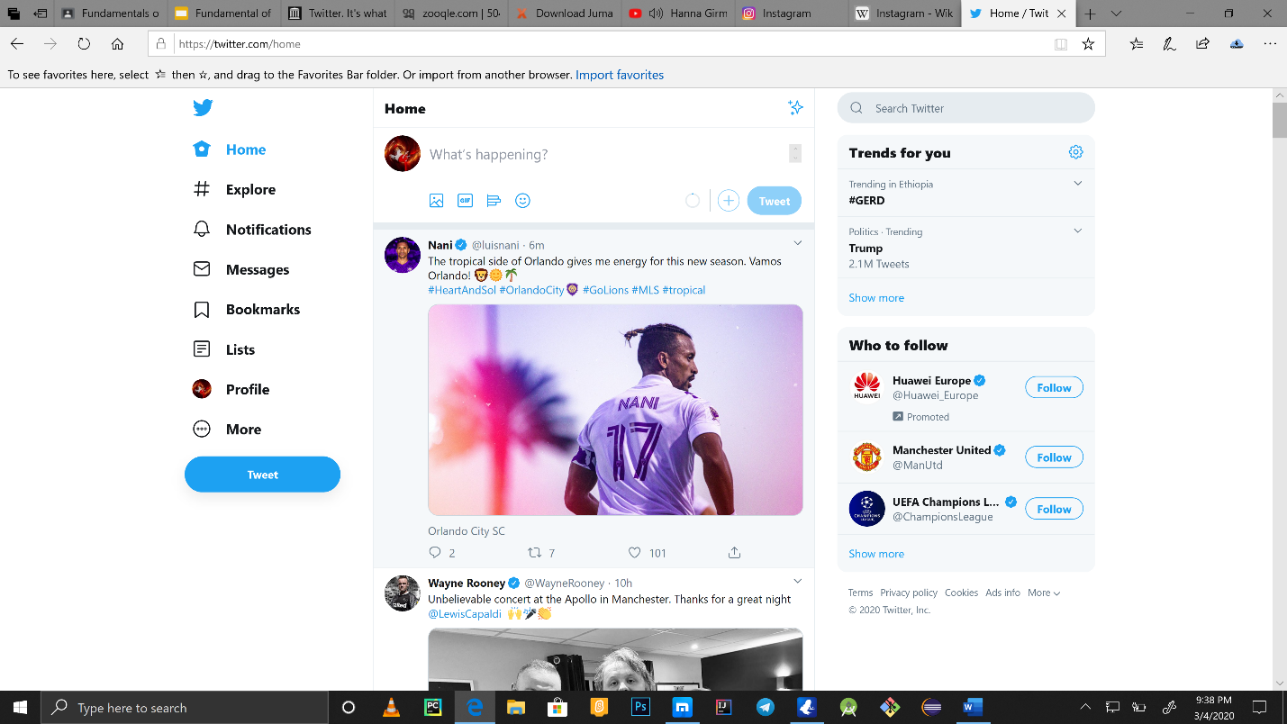

This page will show up after logging in. As we can see on the left side there are a series of choices the site offers. Using the explore tab we can see the tending hast-tagged things we can endorse on the above picture we can see #GERD. Besides the obvious tabs listed the bookmarks helps keep track of the tweets- we made. Tweets are like a twitter custom word meaning any post we make.

So for anyone who has little twitter using experience it is easy to see what makes exceptional profitability. Using twitter any company on any part of the world can promote their services thus paying twitter to release their ads on the site.

**3, Instagram**

Instagram which has now been acquired by Facebook has over 100 million daily active users. There are many features that makes this site as popular as it is. This site basically works by like Facebook the most important difference is one can only post pictures. Instagram also makes people be able to follow each other. On the homepage only posts(pictures) from people one person follows will appear. While on the search tab a user can search for a specific user. There is a a space under the search tab that displays posts that can interest a user based on his search activities.

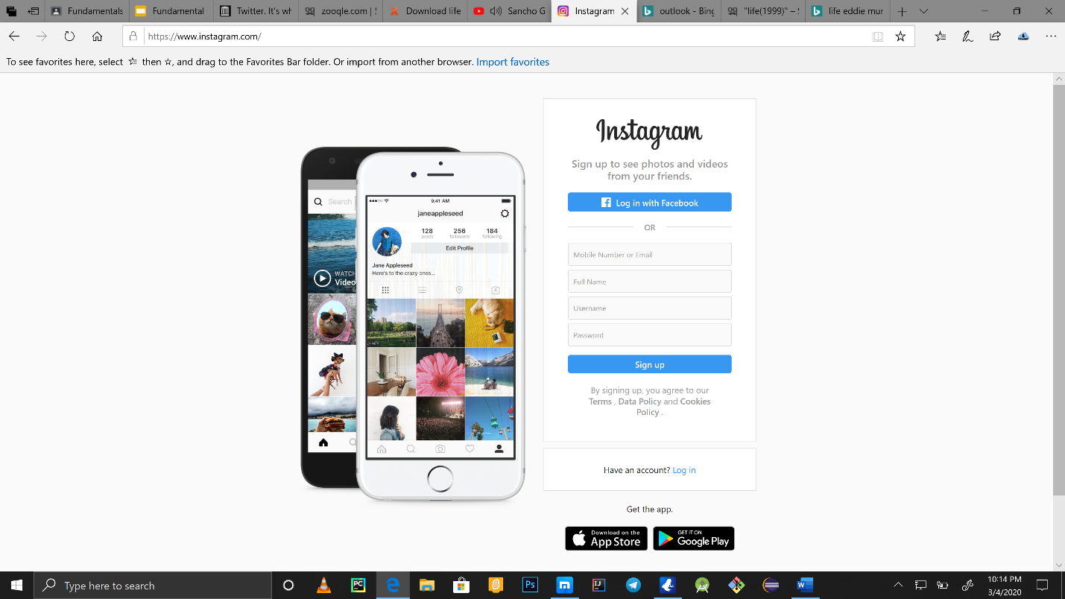

This is the login and signup page up for Instagram. After either signing up or logging we will be directed to a page that does the trick for Instagram immense popularity.

So like twitter and Facebook, Instagram main profit comes from being paid by companies to advertise their products. Aside from this, famous celebrities also get paid by endorsing a product and posting it on their profile pages.

**4, YouTube**

YouTube is another is social media site that uses videos as its primary entity. What makes it different to the other sites mentioned above is we are not necessarily required to register on the site to have access on its contents. The only time we are required to have an account is if we want to upload video or if we want to view an age-restricted video. Once we have an account, we can upload videos and get other users to subscribe our channel so they can get notified when we upload a video some other time. And what makes YouTube really attractive is if we manage to get over some amount of subscribes it pays us. There are actually very wealthy people whose life solely depends on YouTube and its users, they are called youtubers.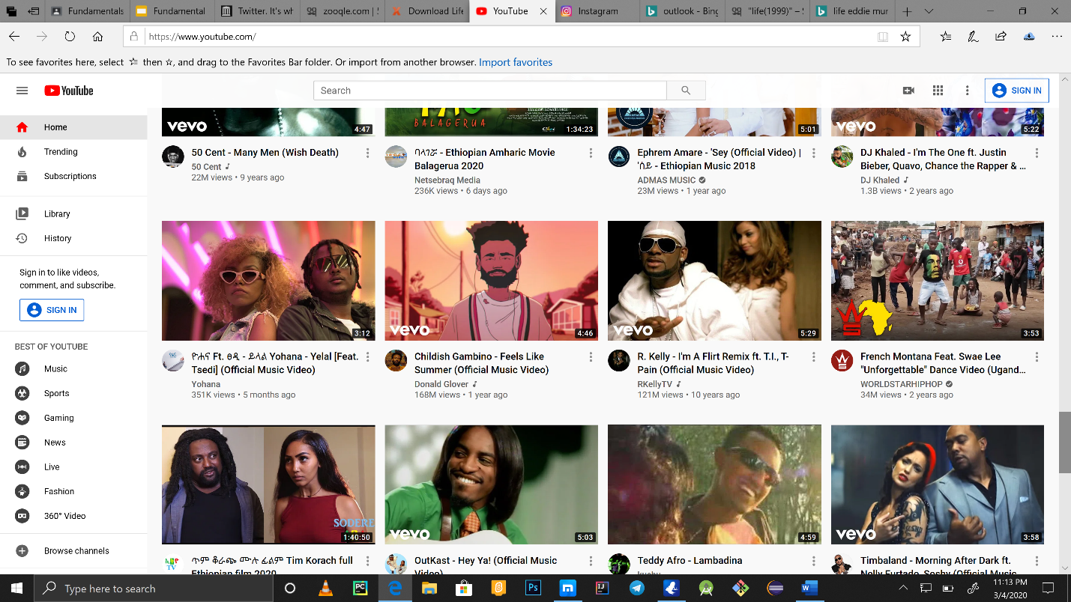

As can be seen from the picture it has many features like trending- which lists videos currently released and are popular, subscriptions- lists the channels we subscribed to, library-videos we saved and so on.

**5, LinkedIn**

LinkedIn is another popular site which uses to connect companies to work-seekers. Users simply form profiles and list their experiences and CVS and companies recruit accordingly. It differs to the other sites mentioned above because it is strictly professional. Its signup page looks like the figure below.

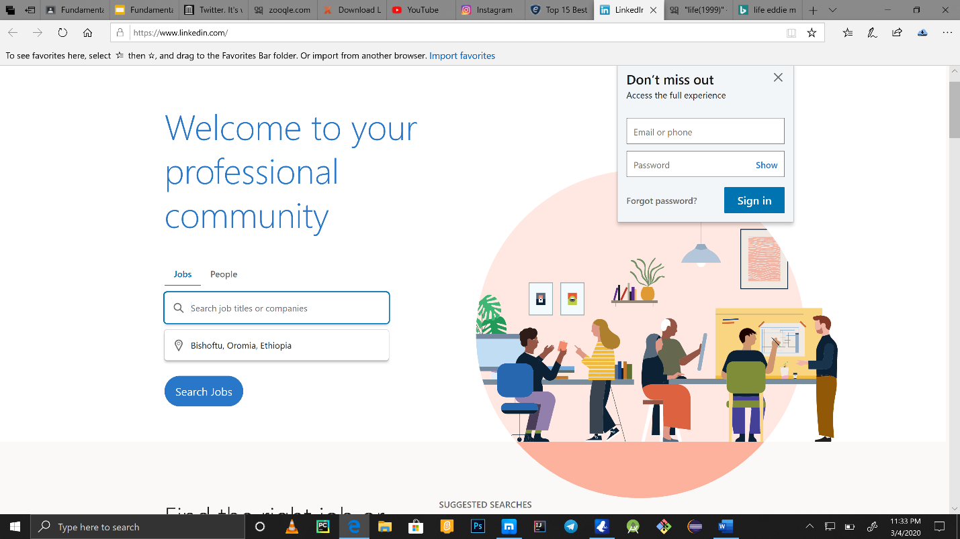

**FIVE WEBSITES FROM THE TWELVE CATAGORIRES**

**Category-1 PORTAL**

|  |  |  |  |
| --- | --- | --- | --- |
| number | name | URL | description |
| 1 | Myspace | https://myspace.com/ | With free form profiles that allow users to create their own custom look and an emphasis on music and entertainment myspace is one of the leaders in the social networking space. |
| 2 | Baidu | http://www.baidu.com/ | Baidu is the leading Chinese search engine with an emphasis on multimedia content like movies and MP3s. It was the first to offer WAP and mobile search in China. |
| 3 | Wikipedia | https://www.wikipedia.org/ | This community-driven Wiki is run by the non-profit Wikipedia Foundation and provides a wealth of information on almost any subject. |
| 4 | MSN | https://www.msn.com/en-xl/ | Originally developed to compete with AOL, [MSN](https://www.msn.com/) is slowly being phased out to make way for Microsoft's Live service |

**Category 2 News**

|  |  |  |  |
| --- | --- | --- | --- |
| number | name | URL | description |
| 1 | BBC | https://www.bbc.com/ | The British Broadcasting Corporation is a British public service broadcaster. It is the world's oldest national broadcaster, and the largest broadcaster in the world by number of employees. |
| 2 | CNN | https://www.cnn.com/ | CNN is an American news-based pay television channel owned by AT&T's Warner Media. CNN was founded in 1980 by American media proprietor Ted Turner as a 24-hour cable news channel. |
| 3 | MSN | https://www.msn.com/ | Originally developed to compete with AOL, [MSN](https://www.msn.com/) is slowly being phased out to make way for Microsoft's Live service. it is usually found integrated with Microsoft edge |
| 4 | GOAL | https://www.goal.com/ | Goal is an international association football news website founded in 2004 by Chicco Merighi and Gianluigi Longinotti-Buitoni. Goal represents one of the largest football communities in the world with 19 language versions covering more than 50 countries. |

**Category 3 - Informational**

|  |  |  |  |
| --- | --- | --- | --- |
| number | name | URL | description |
| 1 | Wikipedia | https://www.wikipedia.org/ | This community-driven Wiki is run by the non-profit Wikipedia Foundation and provides a wealth of information on almost any subject. |
| 2 | Airbnb | *website: https://airbnb.com* | The website includes the date and destination in a smart search form, which is the first info that visitors will see. |
| 3 | Dropbox for business | *https://www.dropbox.com/business* | The design of the website is simple and user-friendly – you will see nothing but the important info you really need: a huge image with simple and compelling copy and a “Try free for 30 days” CTA. It has all pricing we need to buy cloud storage service. |
| 4 | Mosaic Art Now | *http://www.mosaicartnow.com* | The website is full of meaningful content and you will find plenty of interactive elements here. That accommodates the amazing range of mosaic artists and arts. |

**Category 4 – business\marketing**

|  |  |  |  |
| --- | --- | --- | --- |
| number | name | URL | description |
| 1 | Dropbox for buisness | *https://www.dropbox.com/business* | The design of the website is simple and user-friendly – you will see nothing but the important info you really need: a huge image with simple and compelling copy and a “Try free for 30 days” CTA. It has all pricing we need to buy cloud storage service. |
| 2 | Amazon | *https://www.amazon.com* | Amazon.com, Inc., is an American multinational technology company based in Seattle that focuses on e-commerce, cloud computing, digital streaming, and artificial intelligence |

**category 5 – Educational**

|  |  |  |  |
| --- | --- | --- | --- |
| number | name | URL | description |
| 1 | coursera | *https://www.coursera.com* | Educational website that works with universities to get their courses on the Internet, free for you to use. Learn from over 542 courses. |
| 2 | Udacity | *https://www.udacity.com* | Advance your education and career through project-based online classes, mainly focused around computer, data science and mathematics. |
| 3 | Khan academy | https://www.khanacademy.org/ | It is a website where you can watch thousands of micro-lectures on topics ranging from history and medicine to chemistry and computer science. |
| 4 | Harvard medical school open courseware | http://www.freelearningtools.org/harvard-medical-school-open-courseware-initiative/ | The mission of the this site is to exchange knowledge from the Harvard community of scholars to other academic institutions, prospective students, and the general public. |

**Category 6 – entertainment**

|  |  |  |  |
| --- | --- | --- | --- |
| number | name | URL | description |
| 1 | YouTube | https://www.youtube.com/ | YouTube is an American video-sharing platform headquartered in San Bruno, California.  it is a website that has millions of videos and a user can get in to access them |
| 2 | Facebook | https://www.facebook.com/ | Facebook is an American online social media and social networking service based in Menlo Park, California and a flagship service of the namesake company Facebook, Inc |
| 3 | Instagram | https://www.instagram.com/ | Instagram is an American photo and video-sharing social networking service owned by Facebook, Inc. It was created by Kevin Systrom and Mike Krieger, and launched in October 2010 on iOS. |
| 4 | twitter | https://www.twitter.com/ | Twitter is an American microblogging and social networking service on which users post and interact with messages known as "tweets". |

**Category 7 – Advocacy**

|  |  |  |  |
| --- | --- | --- | --- |
| number | name | URL | description |
| 1 | The Heritage Foundation | https://www.heritage.org**/** | Founded in 1973, The Heritage Foundation is one of the most widely respected research and educational institutes in the world. As a think tank, it formulates and promotes conservative public ideas based on the principles of free enterprise, limited government, individual freedom, traditional American values, and a strong national defense. |  |
| 2 | The Cato Institute | https://www.cato.org**/** | The Cato Institute is one of the nation's leading authorities on public policy and its insight is guided by a strong moral purpose and "the principles of limited government, free markets, individual liberty, and peace**.** |
| 3 | Media Research Center | https://www.mrc.org/ | The mission of the is to bring balance to the news media. The aim of the Media Research Center is to expose the liberal bias that exists and influence the public's understanding of critical issues. |

**Category 8- Blog**

|  |  |  |  |
| --- | --- | --- | --- |
| number | name | URL | description |
| **1** | Goal | https://www.goal.com/ | Goal is an international association football news website founded in 2004 by Chicco Merighi and Gianluigi Longinotti-Buitoni. Goal represents one of the largest football communities in the world with 19 language versions covering more than 50 countries |
| **2** | blogger | https://www.blogger.com | Blogger is a blog-publishing service that allows multi-user blogs with time-stamped entries. It was developed by Pyra Labs, which was bought by Google in 2003**.** |
| **3** | medium | https://medium.com | Medium is an online publishing platform developed by Evan Williams and launched in August 2012. It is owned by A Medium Corporation. The platform is an example of social journalism, having a hybrid collection of amateur and professional people and publication |
| **4** | Tumblr | https://www.tumblr.com | Tumblr is an American microblogging and social networking website founded by David Karp in 2007 and currently owned by Automatic. The service allows users to post multimedia and other content to a short-form blog. |

**Category 9 – wiki**

|  |  |  |  |
| --- | --- | --- | --- |
| number | name | URL | description |
| 1 | Wikipedia | https://www.wikipedia.org/ | This community-driven Wiki is run by the non-profit Wikipedia Foundation and provides a wealth of information on almost any subject. |
| 2 | Wikihow | https://wikihow.com | Wikihow is a wiki style website that shows its users how to make things based on the procedure on the website |
| 3 | Wikitravel | https://wikitravel.com | Wikitravel is a massive source of information. It’s been online since 2003 and is overseen by a team of administrators. They can roll back unwanted edits, delete pages, lock pages, and generally keep the information on the site accurate and free of spam. |
| 4 | Wiktionary | https://en.wiktionary.org | This site supports multilingual dictionary of languages, but has a definition for every word supplied in English, regardless of the source language. Today, there are more than six million words included from more than 4,000 dialects. |

**Category 10– social network**

|  |  |  |  |
| --- | --- | --- | --- |
| number | name | URL | description |
| 1 | YouTube | https://www.youtube.com/ | YouTube is an American video-sharing platform headquartered in San Bruno, California.  it is a website that has millions of videos and a user can get in to access them |
| 2 | Facebook | https://www.facebook.com/ | Facebook is an American online social media and social networking service based in Menlo Park, California and a flagship service of the namesake company Facebook, Inc |
| 3 | Instagram | https://www.instagram.com/ | Instagram is an American photo and video-sharing social networking service owned by Facebook, Inc. It was created by Kevin Systrom and Mike Krieger, and launched in October 2010 on iOS. |
| 4 | twitter | https://www.twitter.com/ | Twitter is an American microblogging and social networking service on which users post and interact with messages known as "tweets". |

**Category 11 – content aggregator**

|  |  |  |  |
| --- | --- | --- | --- |
| number | name | URL | description |
| 1 | New360 | https://news360.com/ | News360 gathers digital content not only from popular news sites but also it collects useful content oriented post from microsites. The article aggregator site covers all popular categories like financial, insurance, health, art, technology, architecture, photography, gaming, web design, graphic design, and lot more topics |
| 2 | Reddit | https://reddit.com/ | Reddit is an American social news aggregation, web content rating, and discussion website. Registered members submit content to the site such as links, text posts, and images, which are then voted up or down by other members |
| 3 | [Google News](https://news.google.com/) | https://news.google.com/?hl=en-ET&gl=ET&ceid=ET:en | It is a free best news aggregator which shares selecting news from thousands of news websites. With Google news aggregator, you can easily get latest updates for world news, U.S. News, business, technology, entertainment, sports, science, health and more |
| 4 | Popurls | http://popurls.com/ | It is one of the best content aggregators that pulls in latest posts from a different kind of websites such as social networks, blogs, and news publications |

**Category 12- personal**

|  |  |  |  |
| --- | --- | --- | --- |
| number | name | URL | description |
| 1 | Stephen hawking | http://www.hawking.org.uk/ | It is a website dedicated to the late physicist Stephen hawking |
| 2 | Cristiano Ronaldo | https://www.cristianoronaldo.com/ | It is a website dedicated to the best football player the world has ever seen- Cristiano Ronaldo. |
| 3 | Barack Obama | http://www.barackobama.com | It is a website dedicated to the former US president Barack Obama. |
| **4** | Lionel Messi | https://messi.com | It is a website dedicated to the fc Barcelona player. |