LEAP: MACHINE LEARNING FINAL ASSIGNMENT

DOES A NEURAL NETWORK BEAT A CLASSICAL MODEL

Diogenis Xenidis

THE PROJECT
This report aims to present and explain the steps involved in completing the Final Assignment for the asynchronous course “LEAP: Machine Learning and Applications.” For the Final Assignment, Option 2 was selected, which examines the comparison of a classical model with a neural network; therefore, the central question to be answered at the end of this report is whether the neural network performs better and whether its additional complexity is worthwhile in this specific case. The written code and the accompanying explanation are based on the course modules, primarily those covering Supervised Learning and Deep Learning.
The scenario involves a public agency seeking to use a model that analyzes survey data to identify households in higher-income brackets so that a benefit or outreach program can be targeted. The examined dataset is called the Adult data set and it consists of tabular data mixing numbers and categories.
First, a classical logistic regression model is used. This model, through the necessary preprocessing- like scaling numbers and one-hot encoding categories- examines the linear relationship between the features and yields easily interpretable results, which is required in regulated fields, such as law enforcement by a public agency. Afterward, the same dataset is fed into a more complex neural network to determine whether the increased complexity of the solution will yield better results. We expect to observe certain benefits of this more sophisticated process in the solution, while at the same time it is important to ensure that this complexity does not interfere with the model’s functionality.
After the comparison, which is not only based on the accuracy of the outcome but also on other indicators like the F1 score, of the two models, we conclude that based on the case and the examined data set, a simple linear model like the Logistic Regression offers transparency, and the complicated method will not offer such a better result. Meanwhile, such an application teaches us how every heavy and high-cost method is not always the best way for us, and the solution's process depends on the case's needs

DESCRIPTION OF THE DATA AND THE PROCESS
The project addresses a binary classification problem using the Adult dataset from OpenML: predicting if a person earns more than $50,000 per year. The data set includes 48,842 observations and 14 tabular variables such as age, sex, education, etc. The target variable is highly skewed with only 23.9% of the records belonging to the positive class (>50K) and 76.1% records belonging to the majority class (<=50K).
Regarding the preprocessing, an 80/20 train-test split (test_size=0.2, random_state=42) is executed with stratification on the target variable. A LabelEncoder maps the binary textual target alphabetically into numeric labels: 0 for <=50K and 1 for >50K. The SimpleImputer is used to fill the missing values by replacing them with the median value for numerical features and the most frequent value for the categorial features. The StandardScaler scales distributions to unit variance, and the one-hot encoding is the necessary step to convert categorial features into binary numbers so they can be read from the model. Last, the ColumnTransformer is used to apply each pipeline to its assigned columns. The ColumnTransformer preprocessor and LogisticRegression are unified into a single Scikit-Learn Pipeline. The model establishes a linear decision hyperplane, providing transparent, verifiable feature weights directly interpretable as log-odds changes. Cross-validation offers more stable and trustworthy estimates by repeating the evaluation across multiple splits.
The dense neural network is built using Keras's Sequential API and is equipped with non-linear ReLU activation functions to capture curved decision boundaries and complex feature interactions. Dropout is used so the network cannot rely too heavily on the same neurons every time and Early Stopping protects the model from overfitting by halting the training process at the optimal time. To check if the network worked properly, the training and validation loss curves are examined to follow the expected shape.
It is worth mentioning that during the NN's evaluation these two curves diverged, indicating overfitting. To change this, the learning rate was reduced, some layers were removed, and the curves returned to their common look.
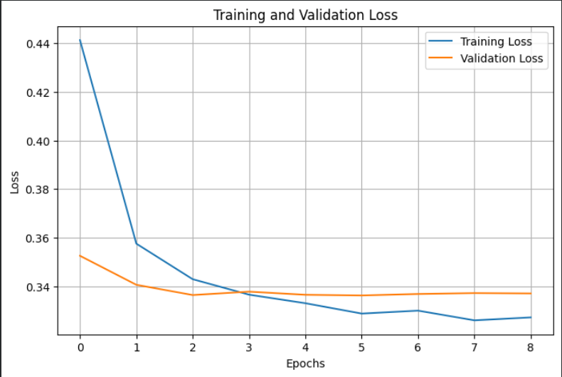
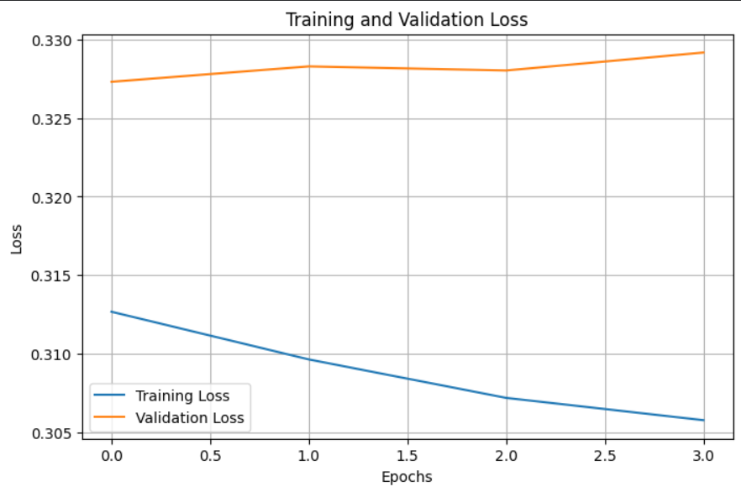

The most comprehensive way to evaluate the performance of the two models is using the F1 score and the confusion matrix. Accuracy alone is misleading because a model can achieve an impressively high score simply by predicting the majority class, even if it is completely useless and fails to detect the target class. These metrics are presented below, as determined by the evaluation.

KEY METRICS AND RESULTS
The basic metrics that are considered in the evaluation are the F1 score and the confusion matrix. The matrix allows us to understand if the model performs the same in each class separately. If the model we built was good at predicting the majority class (<=50k) then the result would be with a high accuracy but would overlook many higher-income households which are the main goal of the application.
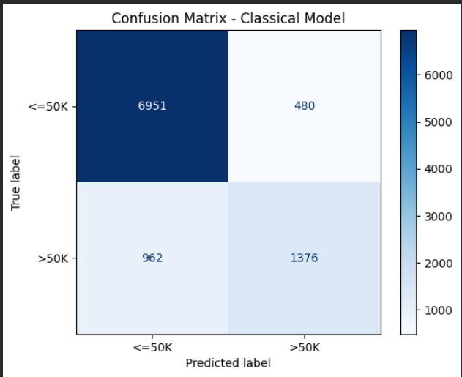
  - Classical Model- Confusion Matrix

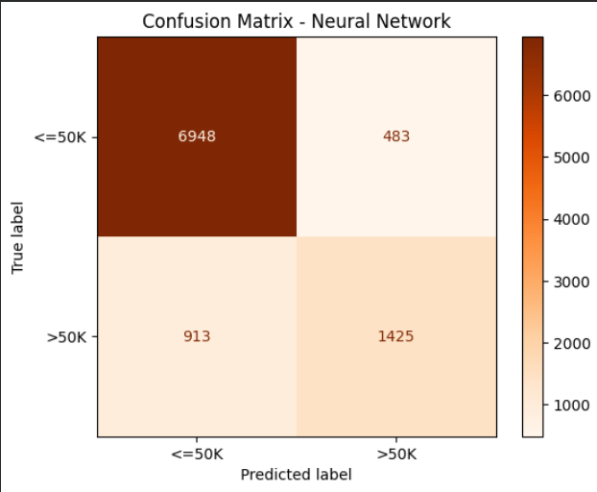
Neural Network- Confusion Matrix

The two tables show quite similar results. Both models appear to have a weakness in predicting the majority class (high false negative rates in both cases). The consistency of the two results lends credibility to the models and, at the same time, may indicate an issue with the dataset.
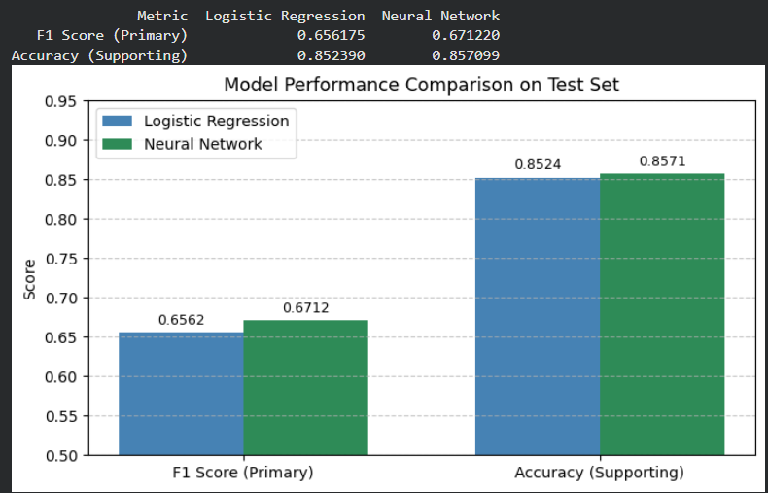
The F1 score is also included in the comparison of the two methods. These metrics confirm our prediction that, despite its complexity and enhanced capabilities, the neural network will not perform significantly better than the classical model, due to the nature of the task.

CONCLUSIONS
I believe that the final assignment is extremely interesting, especially when one considers the current challenges in the field of machine learning. An understanding of how both the classical model and neural networks work is essential, even if the need to write code is currently being bypassed by artificial intelligence, as it enables the programmer to understand the internal processes of the tool they are using and adapt accordingly. Throughout the course, I found the connection between machine learning and everyday applications to be very interesting, as well as the idea that such tools should not replace human judgment but rather be used as powerful tools wherever possible. It is very important that this course teaches us how the tools we seek out each time must be tailored to the needs of our work and that we should avoid actions that incur unnecessary costs or even burden our solution due to their complexity. Finally, it is important to emphasize the organization and presentation of the final project, as this exposes students to the requirements they will encounter later in research and in the job market.

