## IT 207 - JavaScript

### Animal Game

Create a web page that helps kids learn their animal names. Save your file as animalgame.html. Here is an example, but your page might look different. You may use the image files supplied on canvas, or choose your own. Feel free to use creative license!

Define an array of animal names, and display an animal name at random from your array of animal names. For example, FROG was randomly selected and displayed below.

When the user mouses over an image, display a border around it. You could achieve this by adding a **mouseover** event to each image that adds a border. When the user leaves an image, remove the border. You could achieve this by adding a **mouseout** event to each image that makes the border transparent. When the user clicks an image check to see if the clicked image matches the animal name that was randomly selected from the JavaScript array. If the image matches the name, display a positive message in green. If it doesn't match, display a negative message in red. (See below for examples) The user should be able to click on choices, until they get the correct answer. Each time they click, an appropriate response message is displayed.

**Hint:** *Don’t forget to give an “alt” property to each of your images. It should come in handy*.

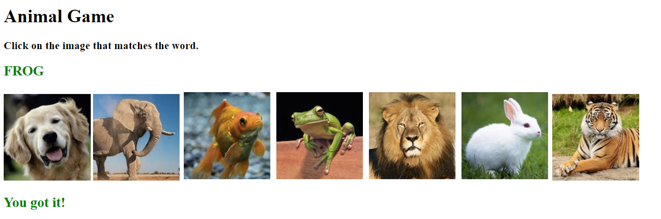

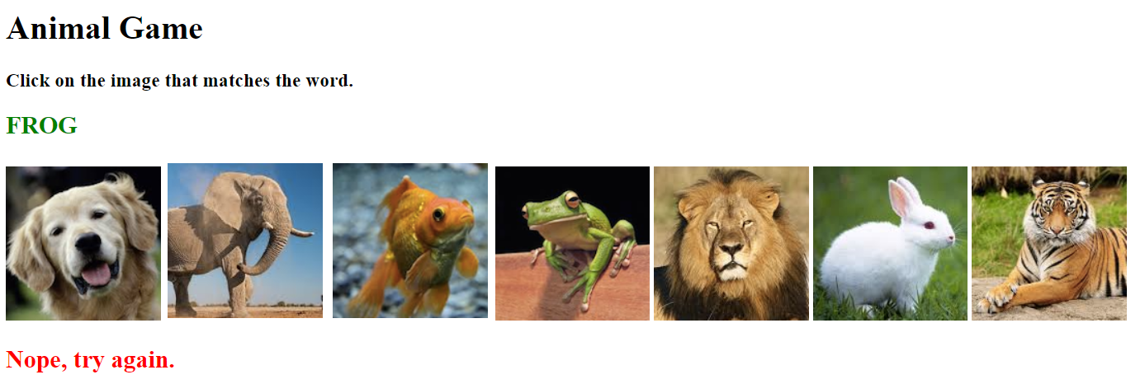

**Bonus Point:**Keep track of the total number of correct guesses on the first try (hits) and the total number of incorrect guesses (misses)

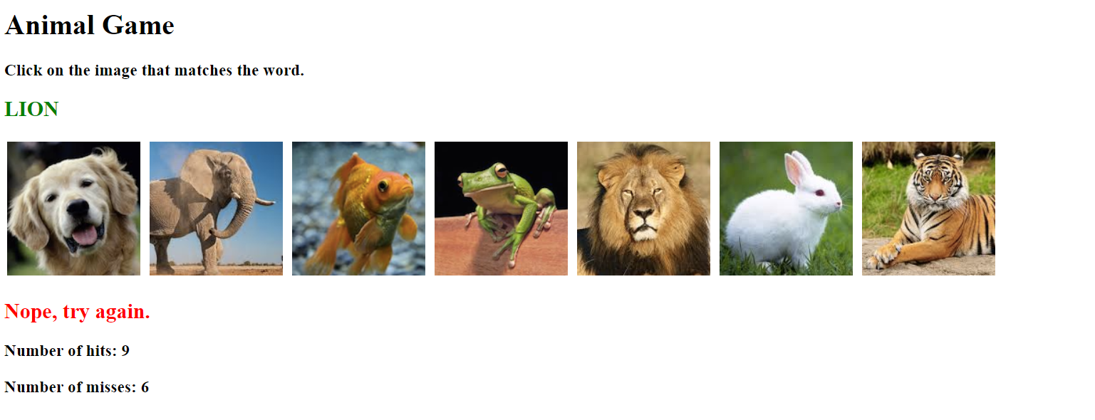

Submit the URL from your greenriverdev.com hosting website or a repl.it when you are finished.