# IT 207: Build A Bear Form Assignment

In this assignment, you will create a web form that allows your user to complete a Build A Bear Form indicating what they what the bear's name to be, the Color (at least three options), the Size (at least three options), and Add-ons(at least three options) and a Submit Button.

Save an html document called buildbear.html to your 207 directory on greenriverdev.com.

Your form should include at least four different form elements(checkbox, textfield, radiobutton, selection list, etc), along with a Submit button.

When the user clicks the Submit button, invoke a validateForm function that displays a validation error for **at least 3 fields** that are left blank.

When at least three of the inputs have been validated, display a “Thank you” success page

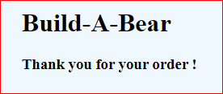

An example form is shown below:

