# IT 207: Mouse Events– Dollar Drive Thru

You will create a web page for a drive-thru restaurant, where everything costs a dollar. Download the starter template file: drivethru.zip from Canvas.

1. Open up drivethru.html. Add an html comment header at the top with your name and the date. Set the title of the page to your drive thru name.
2. Design your web page to display food items. You may use the images in the images folder or use your own. Set the **alt** property for each item to the full name of the item, e.g. "Fish Filet" or "Fruit Parfait." An example is shown below, but feel free to take creative license.

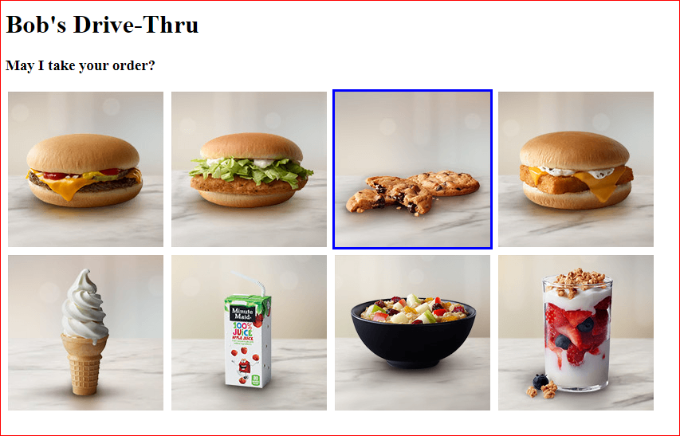

1. Add two HTML elements below your images: An unordered list with an **id** of **orders**

**i.e. <ul id='orders'></ul>**, and an **h3** with an id of **total** i.e. **<h3 id='total'></h3>**

These elements will not have any content yet. They are just placeholders.

1. Next, using the style sheet **drivethru.css**, write JavaScript code so that a border appears around an image when the mouse is hovering over it, and disappears when the mouse moves away. You should use the addEventListener() on each image element to call the addBorder() function on a **mouseover** event and to call the removeBorder() function on a **mouseout** event.
2. When the user **clicks** on an item, we want to add it to our **orders** list.

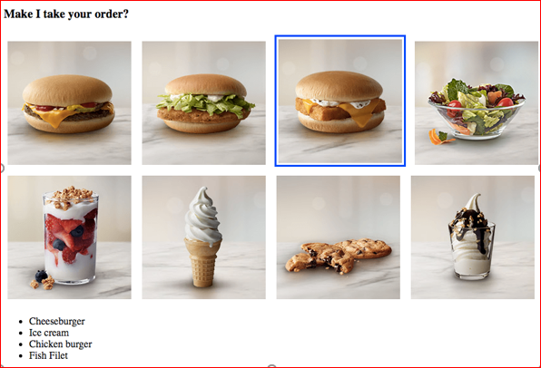

You should use the addEventListener() on each image element to call the placeOrder() function on a click event.

1. Finally, we will add an order total below our list of orders. Begin by declaring a script scope variable called **total** Then, increment **total** by one every time a new item is ordered. Format the order total to two decimal places, and display it in your **h3 with id = "total"** element.

