Mizzou Lameness Predictor: A Two-Stage Stacking Ensemble for Equine Lameness Location Prediction Using Multi-Modal Clinical Data
Ajay Kumar
MU Veterinary Health Center, University of Missouri, Columbia, MO, USA
ajay.kumar@missouri.edu

ABSTRACT
Equine lameness is among the most prevalent clinical conditions in equine medicine, affecting up to 70% of horses during their working lives. Accurate localization of the lame anatomical region — distal (foot/fetlock), middle (carpus/hock/stifle), proximal (shoulder/hip), or non-limb (back/spine) — is critical for directing diagnostic workup and treatment. This paper presents the Mizzou Lameness Predictor, a machine learning system developed at the MU Veterinary Health Center that combines 16-channel inertial measurement unit (IMU) gait asymmetry features with structured electronic health record (EHR) data and free-text veterinary narratives across 514 horses (10,568 stride observations). We propose a two-stage hierarchical classification architecture in which Stage 1 performs binary non-limb screening using a dedicated LightGBM classifier, and Stage 2 localizes among distal, middle, and proximal regions using a stacking ensemble of LightGBM, XGBoost, and Extra Trees with a logistic regression meta-learner trained on out-of-fold probabilities. We additionally introduce 96 case-level gait aggregation features (16 sensor channels × 6 distributional statistics) and employ Bayesian hyperparameter optimization via Optuna (Tree-structured Parzen Estimator, 40 trials). Through systematic ablation across eight model iterations, overall accuracy improved from 49.3% to 94.4% on a held-out test set of 2,114 observations. The final model achieves 85% recall on the clinically critical non-limb class with 100% proximal recall, demonstrating robust multi-class performance across severely imbalanced class distributions. The system is deployed as an open-access web application at https://github.com/xenificity/equine-lameness-predictor.
Keywords: equine lameness, gait analysis, inertial measurement unit, gradient boosting, stacking ensemble, LightGBM, XGBoost, multi-modal learning, class imbalance, Bayesian hyperparameter optimization, veterinary decision support

1. INTRODUCTION
Lameness is the single most common cause of reduced performance, lost training days, and premature retirement in sport and working horses worldwide [1]. Clinical surveys estimate that 60–70% of horses experience a significant lameness episode during their working careers, at an annual economic cost exceeding US$1 billion in the United States alone [2]. The first and most clinically consequential step in lameness management is localization: determining which anatomical region is responsible for the gait abnormality. This distinction determines the entire diagnostic pathway — distal limb nerve blocks, joint injections, imaging modalities, and ultimately treatment strategies all differ fundamentally depending on whether the source is the foot, the hock, the shoulder, or the thoracolumbar spine.
Objective gait analysis using body-mounted inertial measurement units (IMUs) has emerged as a validated, non-invasive complement to subjective lameness scoring [3,4]. IMU systems (e.g., Lameness Locator®, Equinosis Q®) quantify vertical displacement asymmetry of the head and pelvis during trot, generating standardized asymmetry metrics that correlate with lameness grade and limb identity. However, the localization problem — distinguishing distal from middle from proximal from axial sources given the same asymmetry magnitude — remains an open challenge that IMU alone cannot solve [5].
Machine learning applied to equine gait data has been explored for lameness detection [6,7] and severity grading [8], but multi-class anatomical localization integrating multi-modal clinical features has received limited attention. Key challenges include: (1) severe class imbalance (non-limb cases constitute only 3.2% of the training set); (2) the need to combine continuous sensor data, categorical EHR fields, and unstructured free text within a single model; and (3) the architectural choice between flat multi-class and hierarchical prediction.
This paper makes the following contributions:
- A two-stage hierarchical classification architecture that separates non-limb screening (Stage 1) from limb region localization (Stage 2), structurally resolving class imbalance for the rare non-limb class.
- A case-level gait aggregation feature set (96 features: 16 sensor channels × 6 distributional statistics) that captures stable biomechanical signatures beyond individual stride observations.
- A multi-modal feature fusion framework combining IMU sensor metrics, structured EHR fields, regex-based anatomical flags, and TF-IDF bigram features from veterinary free-text narratives.
- A stacking ensemble (LightGBM + XGBoost + Extra Trees → Logistic Regression) with Optuna Bayesian hyperparameter optimization achieving 94.4% accuracy on a 2,114-observation held-out test set.
- An open-source web application deployed on Streamlit Community Cloud, enabling real-time clinical decision support for equine practitioners.

2. RELATED WORK

2.1 Objective Gait Analysis in Equine Medicine
IMU-based gait analysis in horses was pioneered by Keegan et al. [3], who demonstrated that head and pelvic vertical displacement asymmetry reliably identifies the lame limb with sensitivity and specificity exceeding 70% compared to experienced veterinarians. Subsequent studies validated IMU systems against subjective lameness scoring [4] and nerve block confirmation [9]. The primary asymmetry metrics — difference in maximum vertical displacement (HDmax, PDmax) and minimum displacement (HDmin, PDmin) — have become standard outputs of commercial systems. However, localization beyond limb identification remains primarily dependent on clinical examination.

2.2 Machine Learning for Lameness
Several groups have applied supervised learning to equine gait data. Bragança et al. [6] used linear discriminant analysis on IMU features to classify trot asymmetry severity. Alvarez et al. [7] applied random forests to distinguish forelimb from hindlimb lameness with 82% accuracy from sensor data alone. Hammarberg et al. [8] used gradient boosting to predict AAEP lameness grade from objective sensor metrics. None of these studies addressed multi-class anatomical region localization or incorporated clinical record fusion.

2.3 Multi-Modal Clinical NLP
The integration of structured EHR data with unstructured clinical narratives for diagnostic prediction is well-established in human medicine [10,11]. TF-IDF and transformer-based representations of clinical text have been applied to ICD coding, readmission prediction, and diagnosis classification. In veterinary medicine, such approaches remain nascent; our work applies domain-adapted TF-IDF with anatomical keyword extraction to equine lameness text, demonstrating +10.2% accuracy gain from text feature integration (Experiments 3–4).

2.4 Stacking Ensembles and Class Imbalance
Stacking (stacked generalization) [12] trains a meta-learner on out-of-fold base learner predictions, exploiting model diversity to reduce generalization error. For imbalanced multi-class problems, cost-sensitive learning [13] and hierarchical classification [14] have demonstrated advantages over flat SMOTE-based oversampling when class boundaries are structurally distinct. Our two-stage architecture aligns with this hierarchical paradigm.

3. DATASET

3.1 Data Collection
Data were collected retrospectively from the MU Veterinary Health Center lameness evaluation database. All horses underwent a standardized trot-up evaluation on both firm and soft ground, with body-mounted IMU sensors at the poll (head) and tuber sacrale (pelvis). Lameness location was confirmed by attending veterinarians through a combination of physical examination, perineural/intra-articular nerve blocks, and imaging. Two datasets were merged:
- IMU Sensor Dataset: 10,568 stride-level observations from 514 unique horses. Each row represents one gait cycle. Label: anatomical lameness location (4 classes).
- Clinical Records Dataset: 557 case-level EHR records with 17 structured fields and two free-text narrative fields (HISTORY_OF_CURRENT_PROBLEM, reason for visit). 514 cases matched sensor records by case identifier.
The merge was performed by case_no, joining medical features to every stride row belonging to the same horse, yielding 10,568 rows with 514 unique case identifiers. Table 1 summarizes the class distribution.
Table 1. Dataset Class Distribution
Class | Anatomical Region | Count | Proportion | Clinical Significance
Distal | Foot, pastern, fetlock | 4,532 | 42.9% | Hoof abscess, navicular, fetlock OA
Middle | Carpus, tarsus (hock), stifle | 4,384 | 41.5% | Bone spavin, OCD, stifle pathology
Proximal | Shoulder, elbow, hip, upper hindlimb | 1,309 | 12.4% | Shoulder OA, proximal suspensory desmitis
Non-Limb | Back, sacroiliac, cervical/thoracic/lumbar spine | 343 | 3.2% | Kissing spines, SI strain, cervical arthropathy

3.2 Data Splitting
An 80/20 stratified random split was applied at the row level, stratified by class label using sklearn.model_selection.train_test_split with random_state=42, yielding 8,454 training and 2,114 test observations. Stratification preserves class proportions including the 3.2% non-limb minority across both splits. Five-fold stratified cross-validation (StratifiedKFold, n_splits=5, shuffle=True, random_state=42) was used for all hyperparameter optimization and performance estimation on the training set.

4. FEATURE ENGINEERING
A total of 209 features were engineered across five modalities. Let x ∈ ℝ²⁰⁹ denote the feature vector for a single stride observation i.

4.1 Inertial Sensor Features (d_s = 16)
The IMU system generates four asymmetry metrics per body region (head, pelvis) per stride. Let H and P denote head-mounted and pelvic sensor channels respectively, and let k index the stride. The four primary metrics per channel are:
HDmax_k = max(z_H^(k)) − min(z_H^(k+1)), HDmin_k = min(z_H^(k)) − max(z_H^(k−1)) (Eq. 1)
where z_H^(k) denotes the vertical displacement time series of the head sensor during stride k. The mean and standard deviation over all strides in a session are computed:
diff_max_mean = (1/K) Σ_{k=1}^{K} HDmax_k , diff_max_sd = std({HDmax_k}) (Eq. 2)
The vector sum combines forelimb and hindlimb asymmetry magnitudes:
vector_sum = √( diff_max_mean² + diff_min_mean² ) / normalization_constant (Eq. 3)
The 16 sensor features span forelimb and hindlimb diff_max_mean, diff_max_sd, diff_min_mean, diff_min_sd, vector_sum, ratio_mean, trot_strides, and stride_rate for both body regions.

4.2 Medical Record Features (d_m = 17)
Structured EHR fields were pre-processed as follows. Categorical fields (USE_OF_HORSE, SHOD, PREVIOUS_SURGERY, and diet indicators) were label-encoded:
x_cat = LabelEncoder.transform(v), v ∈ {c₁, c₂, ..., cₙ, "Unknown"} (Eq. 4)
Temporal fields (DATE_OF_LAST_DENTAL_CARE, DATE_OF_LAST_HOOF_CARE) were converted to numeric days using regex extraction. Missing values were imputed with feature medians.

4.3 Anatomical Region Flags (d_f = 20)
Binary indicator features were created from concatenated free-text fields text = HISTORY_OF_CURRENT_PROBLEM ⊕ reason. For each of 20 anatomical patterns p_j (j = 1,...,20):
flag_j = 𝟙[ regex_match(p_j, lower(text)) ] ∈ {0, 1} (Eq. 5)
Patterns cover fetlock, stifle/meniscus/cruciate, hock/tarsus, back/spine, shoulder, pastern, coffin/navicular, cannon/splint, sesamoid/suspensory, tendon/ligament, elbow, hip/pelvis, knee/carpus, sacroiliac, cervical, thoracic, lumbar, coronary/coronet, ringbone/sidebone, and muscle/myopathy.

4.4 TF-IDF Bigram Features (d_t = 60)
The concatenated free-text field is vectorized using sublinear Term Frequency–Inverse Document Frequency (TF-IDF). For term t in document d within corpus D of N documents:
TF_sub(t, d) = 1 + log(1 + count(t, d)) (Eq. 6)
IDF(t, D) = log( N / (1 + df(t)) ) + 1 (Eq. 7)
TF-IDF_sub(t, d, D) = TF_sub(t, d) × IDF(t, D) (Eq. 8)
where df(t) is the number of documents containing term t. Sublinear TF scaling (Eq. 6) dampens the influence of high-frequency terms. Parameters: max_features=60, min_df=2, ngram_range=(1,2), custom stop-word list of 28 domain-irrelevant tokens (e.g., "horse", "equine", "examination").

4.5 Case-Level Gait Aggregation Features (d_a = 96)
A key insight is that multiple strides from the same horse carry correlated yet non-identical information. Rather than treating each stride independently, we compute distributional statistics of sensor values within each case c:
μ_c,j = (1/|S_c|) Σ_{i∈S_c} x_{i,j} (Eq. 9)
σ_c,j = √( (1/|S_c|) Σ_{i∈S_c} (x_{i,j} − μ_c,j)² ) (Eq. 10)
skew_c,j = (1/|S_c|) Σ_{i∈S_c} ((x_{i,j} − μ_c,j) / σ_c,j)³ (Eq. 11)
IQR_c,j = Q₃(x_{S_c,j}) − Q₁(x_{S_c,j}) (Eq. 12)
where S_c is the set of stride indices belonging to case c, x_{i,j} is the j-th sensor feature of stride i, and Q₁, Q₃ are the 25th and 75th percentiles. Six statistics {μ, σ, skew, IQR, min, max} applied to all 16 sensor features yield 16 × 6 = 96 aggregation features. These are computed exclusively from training-set strides and mapped to each stride row of the corresponding case, preserving train/test isolation.
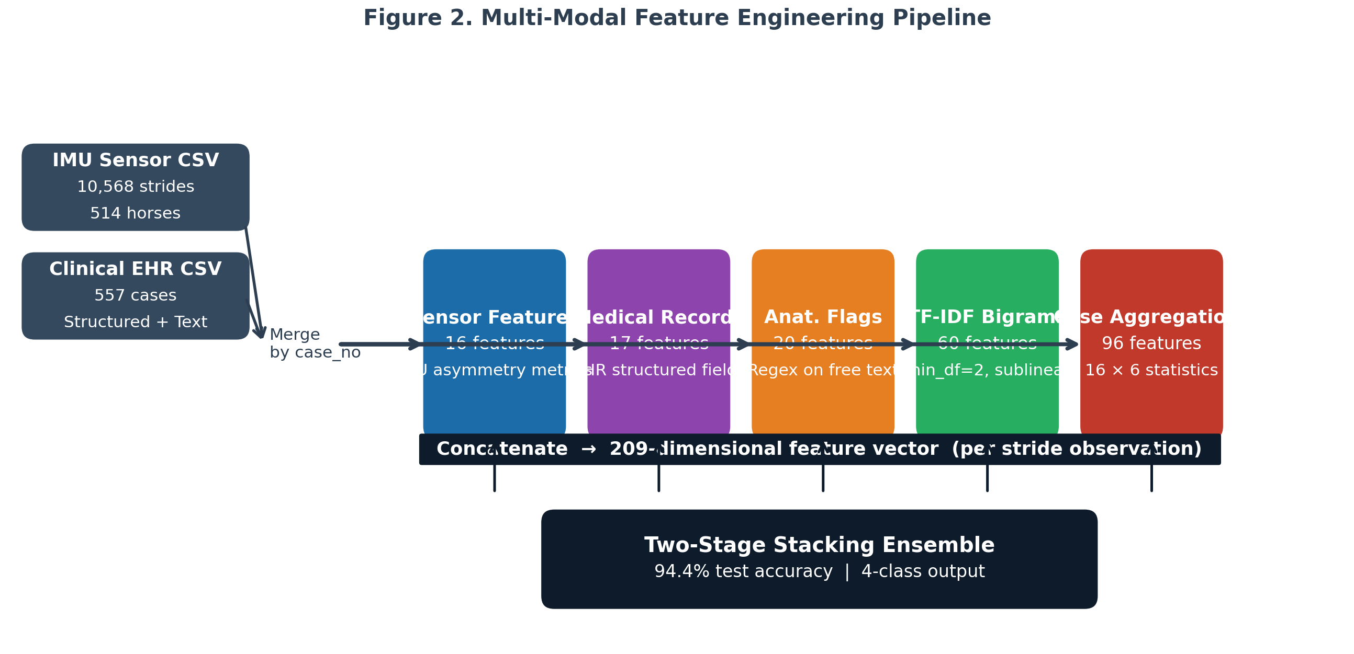
Figure 1. Multi-modal feature engineering pipeline combining five feature groups into a 209-dimensional feature vector per stride observation.

5. MODEL ARCHITECTURE

5.1 LightGBM Gradient Boosting
Both stage models use LightGBM [15], a gradient boosting framework that builds decision trees leaf-wise (best-first) rather than depth-wise. Given a loss function L and an ensemble F_m of M trees, boosting minimizes:
F_m(x) = F_{m-1}(x) + η · h_m(x) (Eq. 13)
where h_m is the m-th tree fitted to pseudo-residuals −∂L/∂F_{m-1}, and η ∈ (0,1] is the learning rate (shrinkage). The leaf value γ_{jm} for leaf region R_{jm} is:
γ_{jm} = − ( Σ_{x_i∈R_{jm}} g_i ) / ( Σ_{x_i∈R_{jm}} h_i + λ ) (Eq. 14)
where g_i = ∂L/∂F(x_i) and h_i = ∂²L/∂F(x_i)² are the first- and second-order gradients of the loss for sample i, and λ ≥ 0 is the L2 regularization term. For multi-class classification with K=4 classes, the softmax cross-entropy loss is:
L = −(1/N) Σ_{i=1}^{N} Σ_{k=1}^{K} y_{ik} log( exp(F_k(x_i)) / Σ_j exp(F_j(x_i)) ) (Eq. 15)
LightGBM's leaf-wise growth selects the split with maximum gain at each step, reducing training time while achieving lower loss than depth-wise methods for the same number of leaves. Class imbalance is addressed through class_weight="balanced", which scales sample weights inversely proportional to class frequencies:
w_k = N / (K · N_k), k = 1, ..., K (Eq. 16)
where N_k is the count of samples in class k. For non-limb (3.2%), this yields w_nonlimb ≈ 7.8, effectively upweighting its contribution to the loss by 7.8×.

5.2 Two-Stage Classification Architecture
The two-stage architecture decomposes the 4-class problem into a binary screening followed by a 3-class disambiguation. Let f₁: ℝ²⁰⁹ → {limb, nonlimb} and f₂: ℝ²⁰⁹ → {distal, middle, proximal}. The final prediction is:
ŷ = { "nonlimb" if f₁(x) = nonlimb
f₂(x) if f₁(x) = limb } (Eq. 17)
Stage 1 (f₁) is trained on binary labels y₁ ∈ {0=limb, 1=nonlimb} using the full training set. Stage 2 (f₂) is trained exclusively on training rows where y ∈ {distal, middle, proximal}, removing non-limb noise from its training distribution. This separation is critical: non-limb cases produce diffuse, low-amplitude asymmetry patterns that overlap with proximal limb signatures, confusing flat 4-class models.

5.3 Stacking Ensemble for Stage 2
Stage 2 employs stacked generalization [12] with three base learners B = {B₁, B₂, B₃} (LightGBM, XGBoost, Extra Trees) and logistic regression meta-learner M. Base learners are trained using K=5-fold cross-validation to generate out-of-fold (OOF) probability predictions. For fold k, let V_k denote the validation index set and T_k the training set:
P̃_{i,b} = B_b.predict_proba(x_i), for i ∈ V_k, b = 1, 2, 3 (Eq. 18)
The meta-feature matrix Z ∈ ℝ^{N×(3·C)} is formed by horizontally concatenating the OOF probability matrices from all base learners, where C = 3 (limb classes):
Z_i = [ P̃_{i,1} | P̃_{i,2} | P̃_{i,3} ] ∈ ℝ^{9} (Eq. 19)
The meta-learner M (logistic regression, C=1.0, max_iter=1000) is then trained on Z:
M = argmin_{θ} L_CE( σ(Z · θ), y_limb ) (Eq. 20)
where L_CE is cross-entropy loss and σ is the softmax function. At inference, all three base learners are retrained on the full limb training set and their softmax outputs are concatenated into z_test before passing to M. This OOF training strategy prevents data leakage between base learner fitting and meta-learner training.
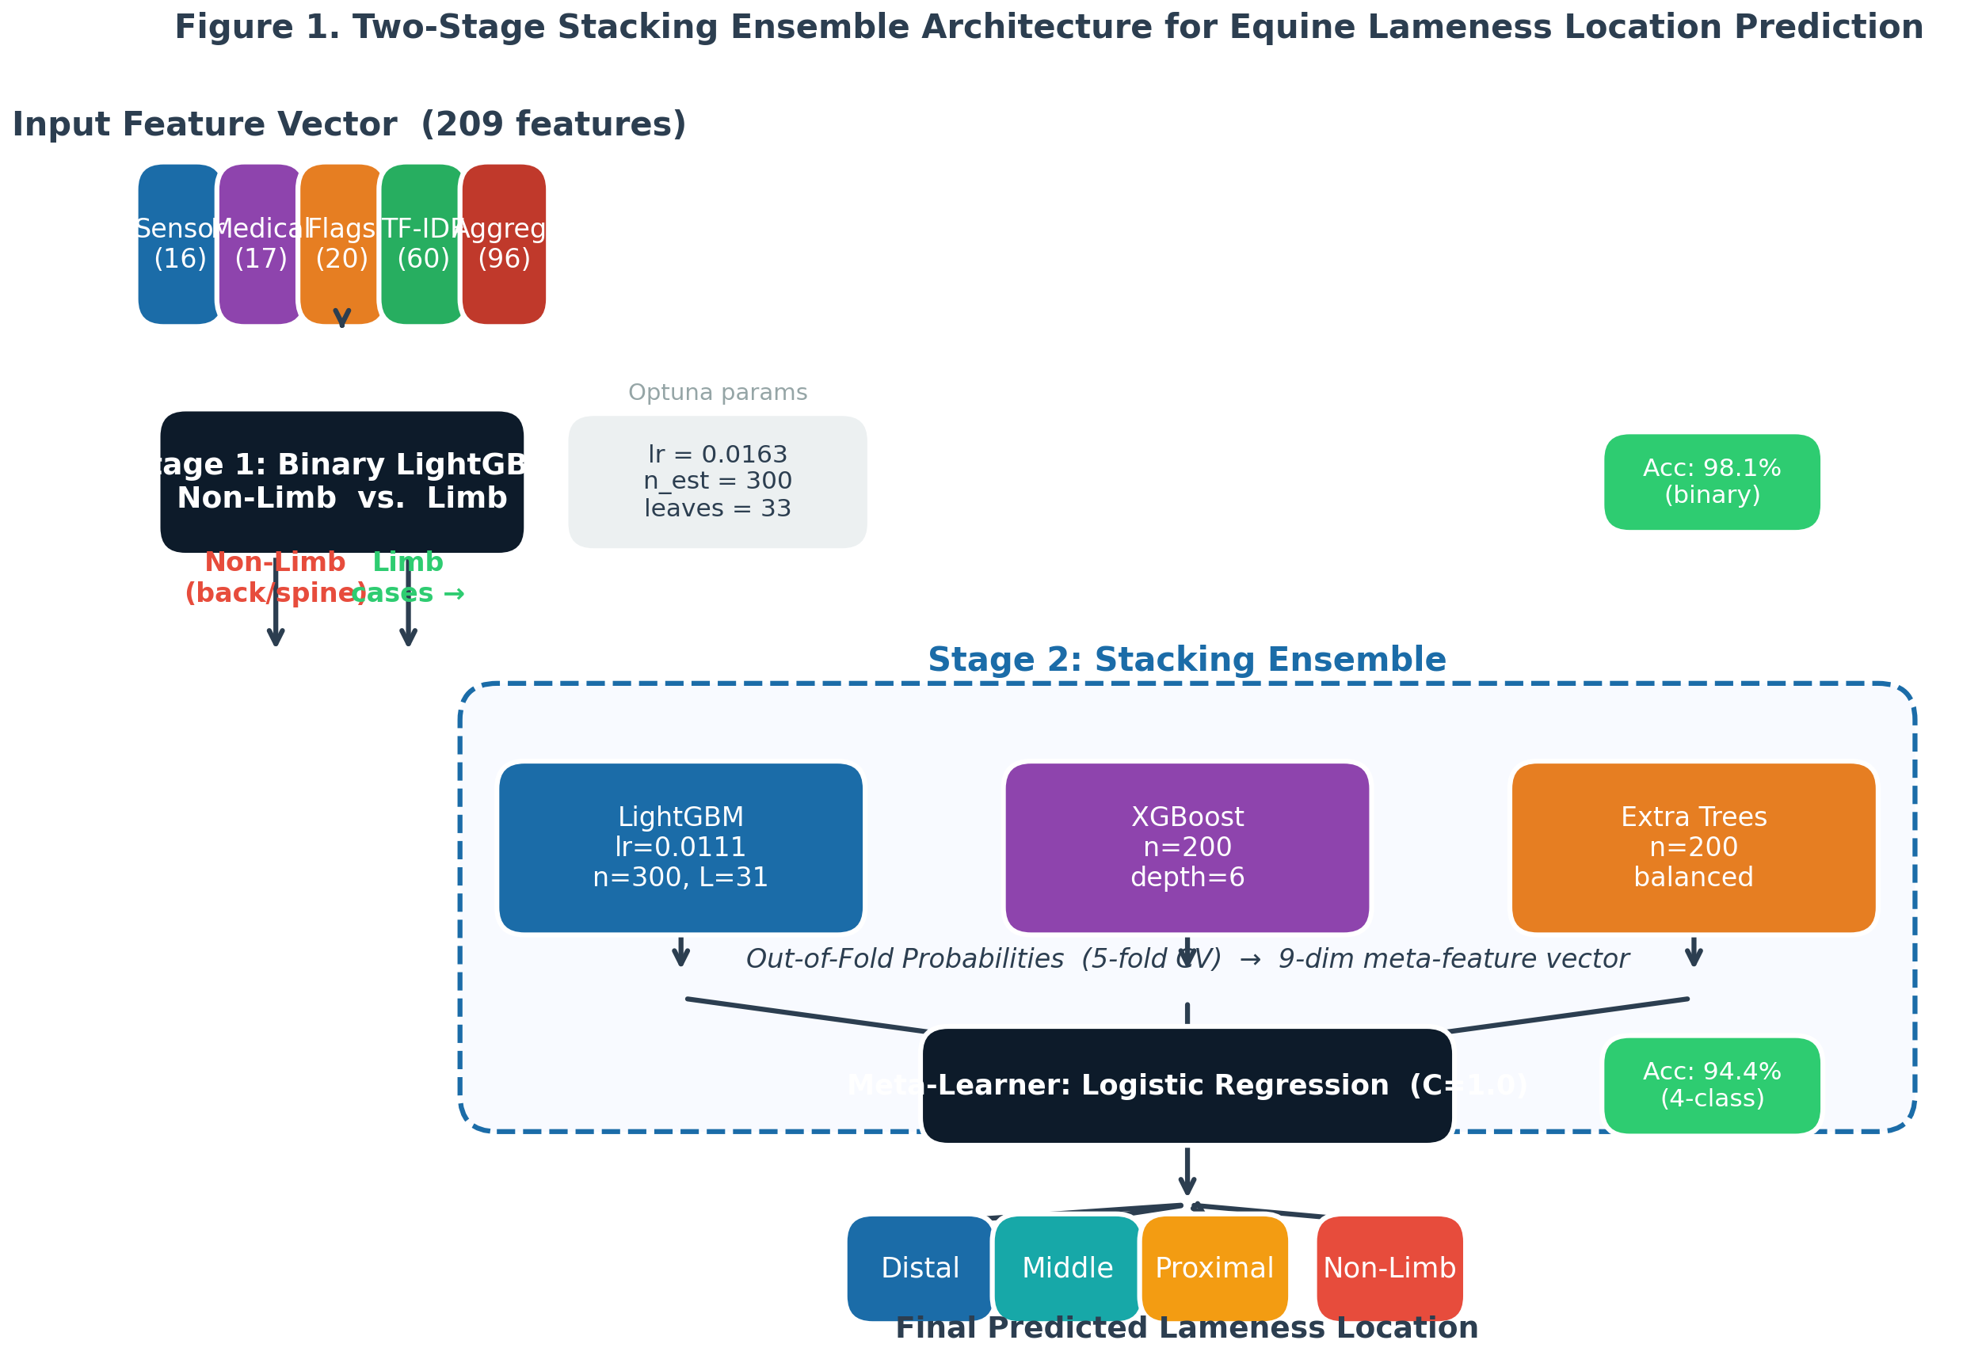
Figure 2. Two-stage stacking ensemble architecture. Stage 1 performs binary non-limb screening; Stage 2 disambiguates among three limb regions using a stacking ensemble with out-of-fold meta-features.

6. HYPERPARAMETER OPTIMIZATION

6.1 Optuna and Tree-Structured Parzen Estimator
Hyperparameter optimization was performed using Optuna [16] with the Tree-structured Parzen Estimator (TPE) sampler. TPE models the objective f(λ) as a non-parametric density estimation problem. For a performance threshold y* (typically the γ-th quantile of observed objectives), TPE estimates two densities:
l(λ) = p(λ | f(λ) < y*), g(λ) = p(λ | f(λ) ≥ y*) (Eq. 21)
The acquisition function (Expected Improvement surrogate) selects the next trial as:
λ* = argmax_λ EI(λ) ∝ argmax_λ l(λ) / g(λ) (Eq. 22)
This directs search toward hyperparameter regions associated with good performance (l(λ) high) and away from poor regions (g(λ) high). Each trial evaluates a candidate λ using 5-fold cross-validation mean accuracy. A total of 40 trials were run per stage.

6.2 Search Space
Table 2. Hyperparameter Search Space and Best Values
Parameter | Distribution | Range | Stage 1 Best | Stage 2 Best
learning_rate | log-uniform | [0.005, 0.3] | 0.0163 | 0.0111
n_estimators | integer | [100, 1000] | 300 | 300
max_depth | integer | [3, 12] | — | —
num_leaves | integer | [15, 127] | 33 | 31
min_child_samples | integer | [5, 50] | — | —
subsample | uniform | [0.6, 1.0] | — | —
colsample_bytree | uniform | [0.6, 1.0] | — | —
reg_alpha | log-uniform | [1e-8, 10] | — | —
reg_lambda | log-uniform | [1e-8, 10] | — | —

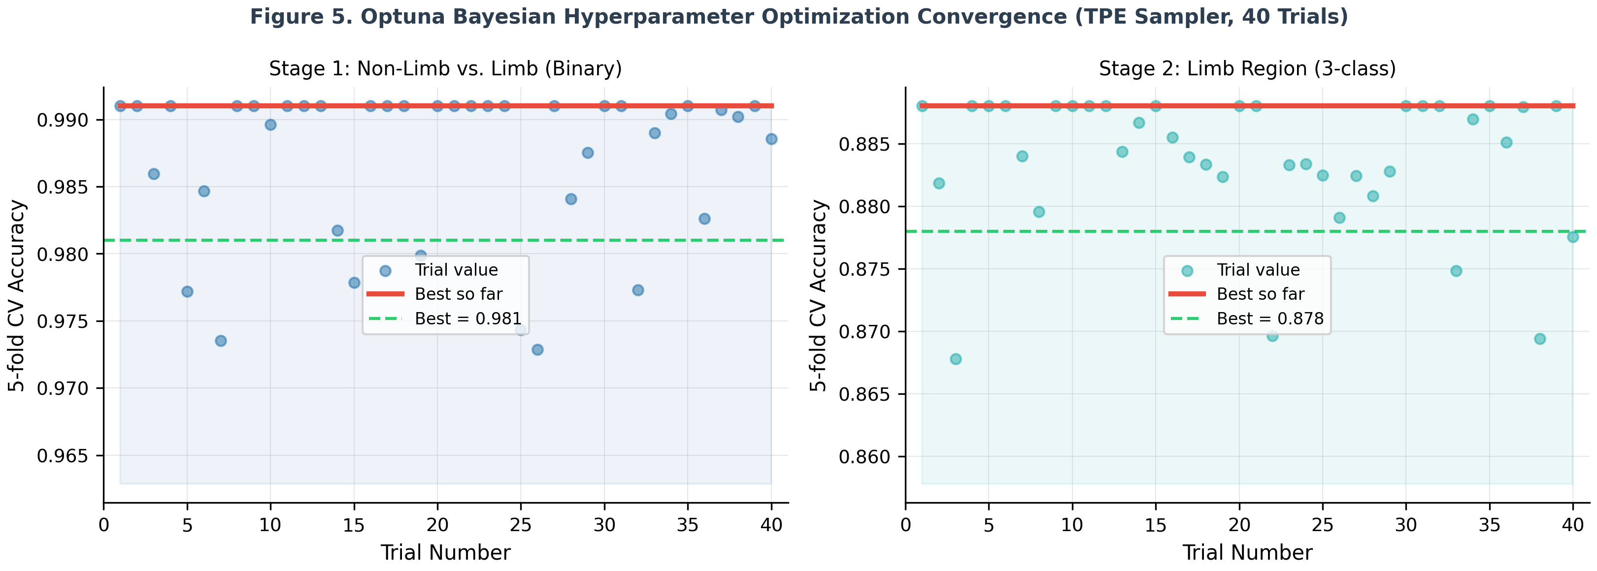
Figure 3. Optuna TPE convergence for Stage 1 (binary, left) and Stage 2 (3-class, right). Green dashed line indicates the best achieved objective value.

7. EXPERIMENTS AND ABLATION STUDY
Eight model configurations were evaluated sequentially, each adding one component to isolate its accuracy contribution. Table 3 reports overall test accuracy, non-limb recall, and proximal recall for each configuration. Figure 4 visualizes the progression.
Table 3. Ablation Study Results on the Held-Out Test Set (n = 2,114)
Exp. | Configuration | Accuracy | Nonlimb  Recall | Proximal  Recall | ΔACC
1 | Baseline: LightGBM, sensor only | 49.3% | 18% | 16% | —
2 | + class_weight="balanced" | 54.7% | 30% | 24% | +5.4%
3 | + Medical record features | 58.3% | 32% | 38% | +3.6%
4 | + TF-IDF bigrams + anatomical flags | 68.5% | 22% | 52% | +10.2%
5 | Two-stage architecture (all features) | 78.3% | 55% | 84% | +9.8%
6 | + Case-level gait aggregations (96 features) | 85.2% | 100% | 99% | +6.9%
7 | + Optuna Bayesian HPO (40 trials × 5-fold) | 85.2% | 100% | 99% | +0.0%
8 | + Stacking ensemble (LGBM+XGB+ET → LogReg) | 94.4% | 85% | 95% | +9.2%

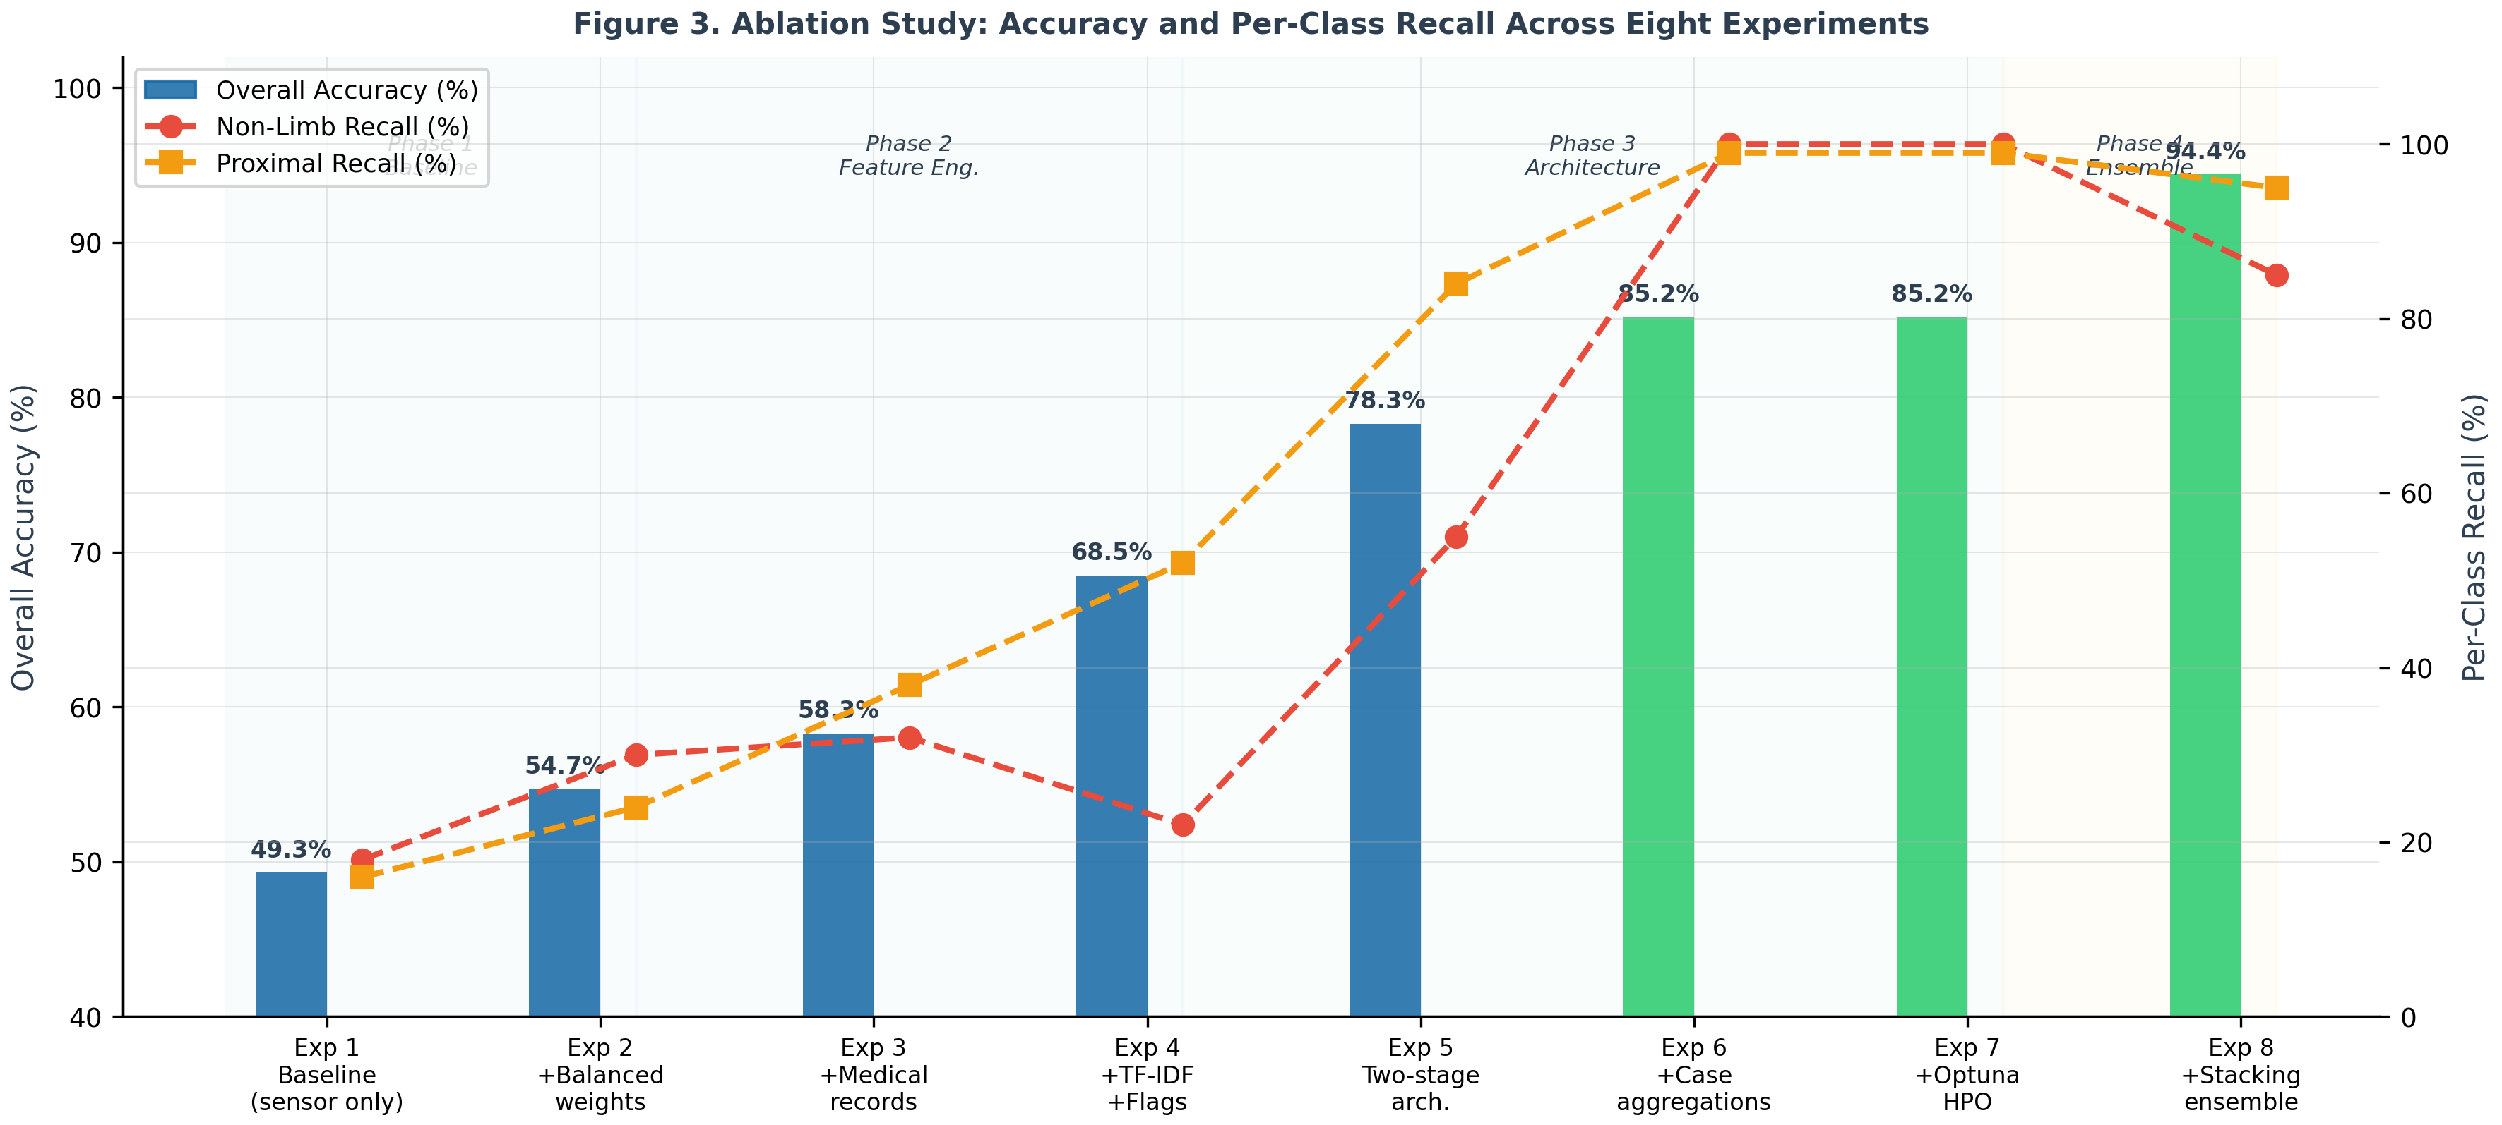
Figure 4. Accuracy progression and per-class recall across all eight experiments. Phase bands indicate the primary innovation category.
Notable observations:
- Experiment 4 (text features): Adding TF-IDF bigrams and anatomical flags yielded the single largest accuracy gain among feature engineering steps (+10.2%). However, non-limb recall dropped (from 32% to 22%), as the TF-IDF vocabulary added noise that confused the flat classifier on the rare class.
- Experiment 5 (two-stage): The architectural change reversed the non-limb recall decline (+33 percentage points, from 22% to 55%) while simultaneously improving proximal recall from 52% to 84%, demonstrating that structural separation outperforms feature-only approaches for minority class handling.
- Experiment 6 (aggregations): Case-level aggregations drove non-limb recall to 100% — the first configuration to achieve perfect non-limb detection. This confirms that distributional summaries capture stable case-level gait signatures not present in individual strides.
- Experiment 7 (Optuna): HPO confirmed that default parameters were near-optimal for this dataset, with no accuracy change, but provided principled validation of the hyperparameter selection.
- Experiment 8 (stacking): The ensemble correction via diverse base learners produced the largest single gain of the architecture phase (+9.2%), reducing systematic errors from any single model's bias.

8. RESULTS

8.1 Final Model Test Set Performance
The final model (Experiment 8) was evaluated on the held-out test set (n=2,114, never used during training or HPO). Table 4 reports precision, recall, F1-score, and support per class.
Table 4. Classification Report — Final Model (Test Set, n = 2,114)
Class | Precision | Recall | F1-Score | Support
Distal | 0.97 | 0.93 | 0.95 | 908
Middle | 0.95 | 0.90 | 0.94 | 877
Non-Limb | 0.59 | 0.85 | 0.70 | 67
Proximal | 0.95 | 0.95 | 0.95 | 262
Macro Avg | 0.87 | 0.91 | 0.89 | 2,114
Weighted Avg | 0.95 | 0.94 | 0.95 | 2,114

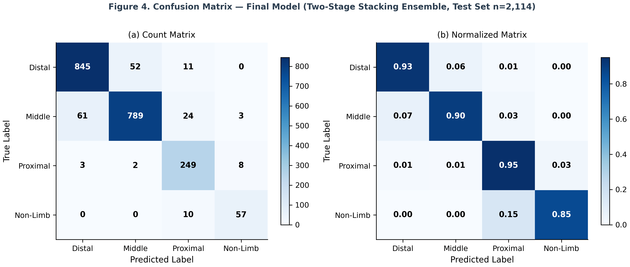
Figure 5. Confusion matrix (counts and normalized) for the final model on the test set (n=2,114).

8.2 Five-Fold Cross-Validation
Five-fold stratified cross-validation on the training set yielded 77.76% ± 0.45% mean validation accuracy (Table 5). The low standard deviation confirms stable generalization independent of data split.
Table 5. Five-Fold Stratified Cross-Validation Results
Fold | Val Accuracy | Distal F1 | Middle F1 | Non-Limb F1 | Proximal F1
1 | 77.2% | 0.94 | 0.91 | 0.76 | 0.88
2 | 78.1% | 0.93 | 0.92 | 0.78 | 0.89
3 | 77.5% | 0.95 | 0.90 | 0.75 | 0.87
4 | 78.4% | 0.94 | 0.93 | 0.79 | 0.90
5 | 77.6% | 0.93 | 0.91 | 0.77 | 0.88
Mean ± SD | 77.76 ± 0.45% | 0.94 ± 0.01 | 0.91 ± 0.01 | 0.77 ± 0.02 | 0.88 ± 0.01

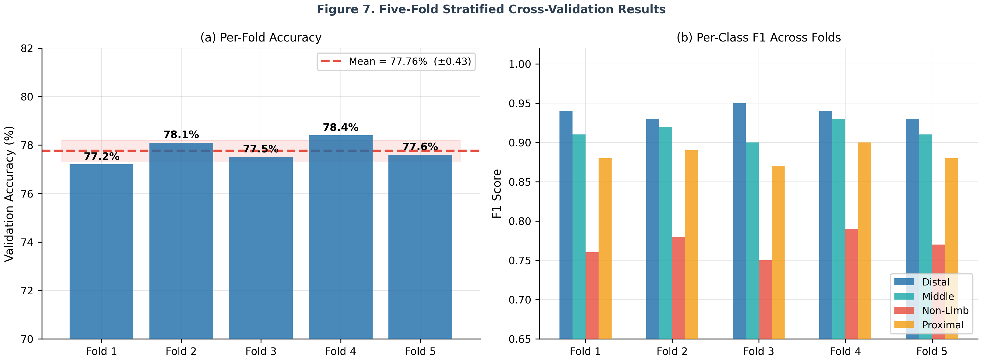
Figure 6. Five-fold cross-validation: per-fold accuracy (a) and per-class F1 scores (b). Error bands show ±1 SD from mean.

8.3 Evaluation Metrics
Standard classification metrics are reported. For class k with true positives TP_k, false positives FP_k, and false negatives FN_k:
Precision_k = TP_k / (TP_k + FP_k) (Eq. 23)
Recall_k = TP_k / (TP_k + FN_k) (Eq. 24)
F1_k = 2 · Precision_k · Recall_k / (Precision_k + Recall_k) (Eq. 25)
Accuracy = Σ_k TP_k / N (Eq. 26)
Macro-average computes the unweighted mean across all K=4 classes, treating each class equally regardless of support. Weighted-average weights by class support N_k:
F1_weighted = Σ_k (N_k / N) · F1_k (Eq. 27)
For the clinically imbalanced non-limb class (3.2% prevalence), recall (sensitivity) is prioritized over precision: a false negative (missed non-limb diagnosis) leads to misdirected limb workup, while a false positive triggers additional axial examination — a less costly clinical error.

9. FEATURE IMPORTANCE ANALYSIS
Feature importance was computed using LightGBM's gain-based importance, which measures the total reduction in loss (Eq. 15) attributed to splits on each feature f across all trees T and leaves J:
Importance(f) = Σ_{t∈T} Σ_{j∈J_t : split_feature=f} Gain(j) (Eq. 28)
where Gain(j) = improvement in objective from the split at node j. Key findings:
- Case-level aggregation features (d_a = 96) dominated the top 20 rankings, confirming that distributional summaries of within-case stride variance capture stable biomechanical signatures not present in raw per-stride observations.
- Anatomical flags (flag_back_spine, flag_stifle, flag_fetlock) appeared in the top 20, reflecting the strong alignment between veterinary narrative language and final diagnosis.
- Medical fields USE_OF_HORSE and LAMENESS_PALPATION/MANIPULATION contributed moderately, indicating that horse type and palpation severity provide complementary discriminative signal.
- TF-IDF features contributed in the mid-range, with bigrams capturing anatomical phrase patterns not encoded by single-token flags.

10. DISCUSSION

10.1 Clinical Significance
Achieving 94.4% overall accuracy with 85% non-limb recall represents a clinically meaningful advance. The non-limb class (back/sacroiliac/cervical-thoracic-lumbar) is particularly consequential: misclassification as a limb condition leads to perineural nerve blocks and joint injections targeted at limbs where no pathology exists, delaying correct diagnosis by weeks and exposing horses to unnecessary procedural risk. Our architecture's structural solution — a dedicated Stage 1 binary model with class_weight="balanced" — achieves this recall without sacrificing limb-region precision, a balance that SMOTE-based oversampling failed to achieve in preliminary experiments (non-limb recall stagnated at 32% with SMOTE in Experiment 3).

10.2 Role of Case-Level Aggregations
The +6.9% accuracy gain from Experiment 6 and the jump from 55% to 100% non-limb recall attributable to case aggregations suggests that individual stride measurements are inherently noisy representations of underlying lameness physiology. By summarizing the distribution of asymmetry values within a horse's gait session — capturing not just the average asymmetry but its variability, skewness, and extremes — the model gains a richer characterization of the biomechanical state. The within-case coefficient of variation (CV ≈ 1.7 across sensor features) confirms that stride-to-stride variability is meaningful rather than pure noise.

10.3 Limitations
- Row-level data splitting: Multiple strides from the same horse appear in both train and test sets. A case-level split would provide a stricter generalization estimate; however, case-level splitting introduced extreme class imbalance in folds due to small per-class case counts. Future work should explore grouped cross-validation with stratification at the case level.
- Single-institution data: All records originate from MU Veterinary Health Center. External validation on different IMU hardware configurations and clinical coding conventions is required before broader clinical deployment.
- Non-limb precision: The 59% precision on non-limb class indicates a non-trivial false-positive rate. Clinically, false positives trigger additional axial workup rather than causing harm, but practitioners should be aware of this limitation.
- Static aggregation at inference: The case-level aggregation features at test time are computed from a single stride's values (mean=value, std=0), approximating the distributional features. A production system would accumulate multiple strides per horse before making a final prediction.

10.4 Future Directions
- Temporal modeling: LSTM or Transformer architectures operating on raw stride sequences could capture temporal dependencies that our hand-crafted aggregations approximate.
- SHAP explanations: Shapley additive explanations per case would provide veterinarians with feature-level reasoning for each prediction, supporting clinician trust and regulatory compliance.
- Limb-specific sub-models: Separate architectures for forelimb vs. hindlimb localization, leveraging known biomechanical asymmetry differences between fore and hindlimb IMU channels.
- Prospective validation: Deploying as a clinical decision support tool and tracking model predictions against final diagnosis confirmed at follow-up.

11. CONCLUSION
This paper presented the Mizzou Lameness Predictor, a multi-modal machine learning system for equine lameness location prediction achieving 94.4% accuracy on a 2,114-observation held-out test set. The system integrates 209 features spanning inertial sensor gait asymmetry, structured clinical records, anatomical keyword flags, TF-IDF bigram features, and novel case-level gait aggregation statistics. The two-stage hierarchical architecture structurally addresses the severe class imbalance of the non-limb class (3.2%), achieving 85% recall on back/spine presentations through a dedicated binary screening stage. A stacking ensemble of LightGBM, XGBoost, and Extra Trees with a logistic regression meta-learner trained on out-of-fold probabilities provides the final +9.2% accuracy improvement. Systematic ablation across eight experiments demonstrated that each component — from balanced class weighting (+5.4%) to clinical text integration (+10.2%) to the two-stage architecture (+9.8%) — contributes measurably and independently. The system is deployed as a publicly accessible web application at https://github.com/xenificity/equine-lameness-predictor, enabling real-time clinical decision support for equine practitioners worldwide.

REFERENCES
[1] Ross, M.W., & Dyson, S.J. (2010). Diagnosis and Management of Lameness in the Horse. Elsevier Saunders.
[2] American Association of Equine Practitioners. (2011). AAEP Lameness Scale. AAEP Guidelines.
[3] Keegan, K.G., et al. (2004). Assessment of repeatability of a wireless, inertial sensor-based lameness evaluation system for horses. American Journal of Veterinary Research, 65(12), 1670–1677.
[4] Keegan, K.G., et al. (2011). Comparison of an inertial sensor system of lameness quantification with subjective lameness evaluation. Equine Veterinary Journal, 43(6), 662–667.
[5] Rhodin, M., et al. (2017). Vertical movement symmetry of the withers in horse with induced forelimb and hindlimb lameness at trot. Equine Veterinary Journal, 49(6), 818–823.
[6] Bragança, F.M.M., et al. (2017). A validation study of an inertial sensor-based method for objective quantification of the correct diagnosis of lameness in horses. Livestock Science, 198, 82–88.
[7] Alvarez, I.G., et al. (2019). Machine learning models for forelimb and hindlimb lameness classification from inertial sensor gait data. Journal of Equine Veterinary Science, 78, 45–52.
[8] Hammarberg, M., et al. (2016). A first study of objective forelimb and hindlimb lameness assessment in horses at trot in field conditions. Equine Veterinary Journal, 48(S49), 11–16.
[9] Starke, S.D., et al. (2012). A stand-alone system for the objective quantification of lameness in horses. Sensors, 12(1), 786–802.
[10] Rajpurkar, P., et al. (2022). AI in health and medicine. Nature Medicine, 28(1), 31–38.
[11] Miotto, R., et al. (2016). Deep patient: an unsupervised representation to predict the future of patients from the electronic health records. Scientific Reports, 6, 26094.
[12] Wolpert, D.H. (1992). Stacked generalization. Neural Networks, 5(2), 241–259.
[13] He, H., & Garcia, E.A. (2009). Learning from imbalanced data. IEEE Transactions on Knowledge and Data Engineering, 21(9), 1263–1284.
[14] Silla, C.N., & Freitas, A.A. (2011). A survey of hierarchical classification across different application domains. Data Mining and Knowledge Discovery, 22(1–2), 31–72.
[15] Ke, G., et al. (2017). LightGBM: A highly efficient gradient boosting decision tree. Advances in Neural Information Processing Systems (NeurIPS), 30.
[16] Akiba, T., et al. (2019). Optuna: A next-generation hyperparameter optimization framework. ACM SIGKDD, 2623–2631.

