10K pullup
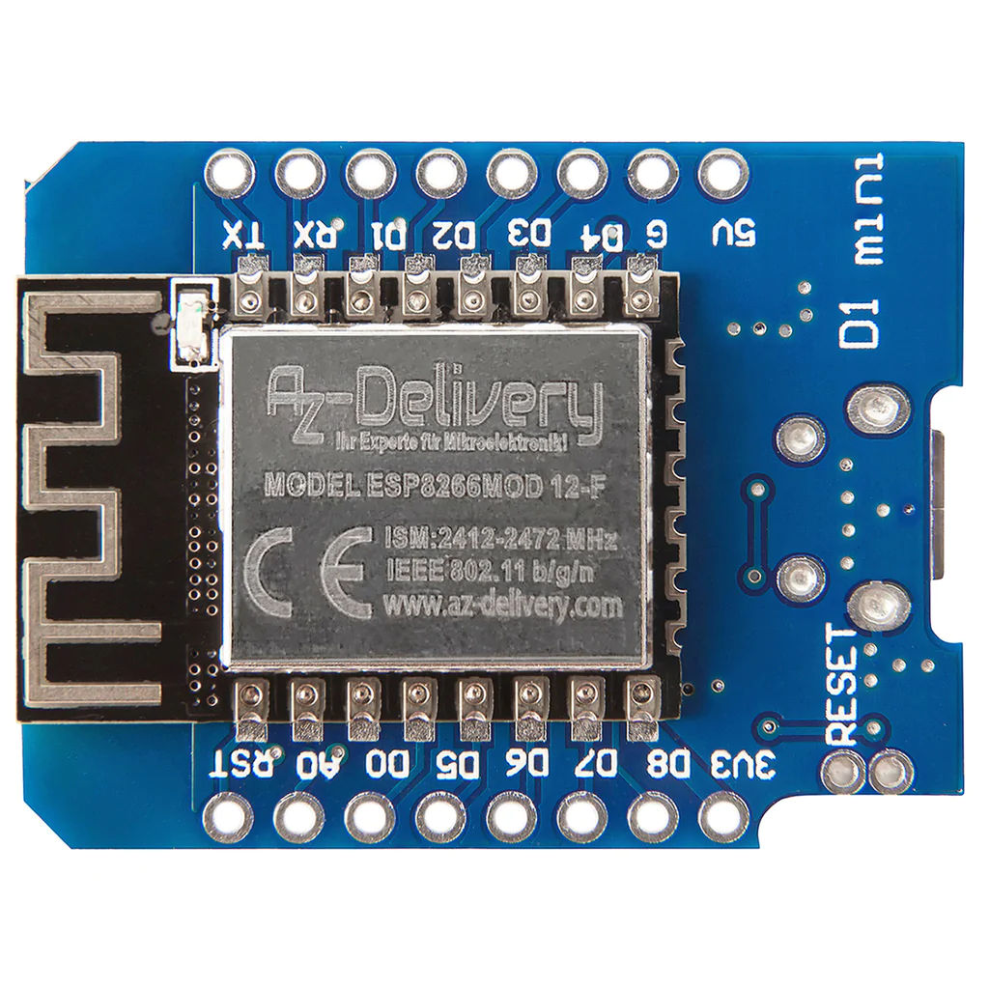
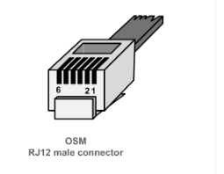
PIN 2 5V(data request)
PIN 5 DATA
PIN 3 GND

