Fundamentals of Data Science - Assignment 3 Report

Program 1: Read CSV File
This Python program reads a CSV file named "records.csv" and displays the details of all students in a neat table format on the screen (console/terminal).
Sample Input:
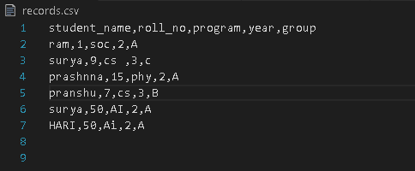
Sample Output:
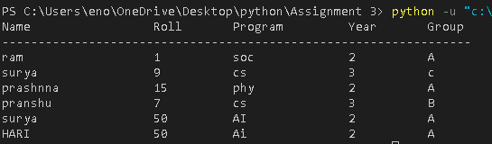

Program 2: Append to CSV
This program lets the user add a new student record to the "records.csv" file. It prompts the user to input details such as the student’s name, roll number, program, year, and group. The entered information is then added to the CSV file, and the header row is included only if the file is empty.
Sample input
Sample Output:
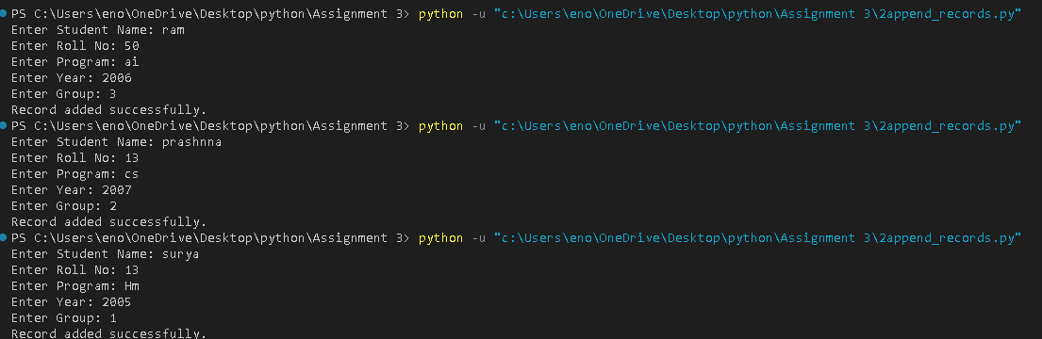
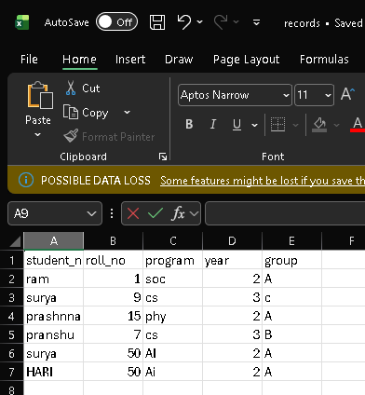

Program 3: Calculator with File Save
This program acts as a Math Logger. It accepts lists of integers from the user, performs calculations such as addition, subtraction, multiplication, and division, and then records the results along with a timestamp in the "math_results.txt" file. When the user exits the program, it displays the complete contents of the log file.
Sample Input:
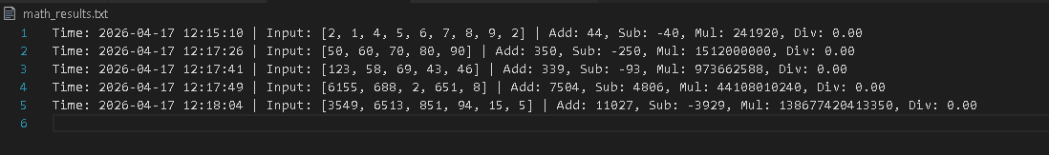
Sample Output:
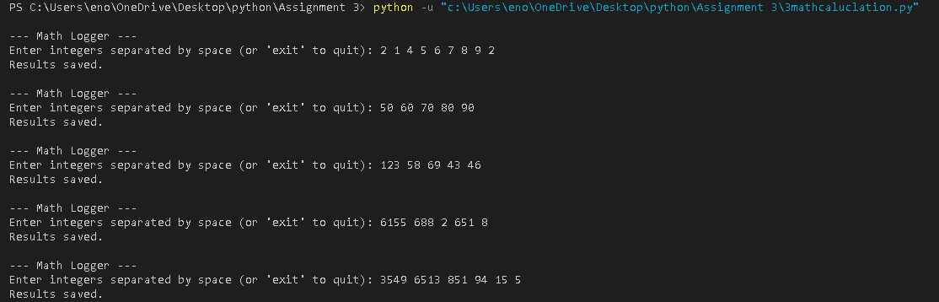

Program 4: File Copy
This program copies the contents of a source file into a new destination file. It first verifies that the source file exists and makes sure the destination file is not already present before proceeding with the copy.
Sample Output:
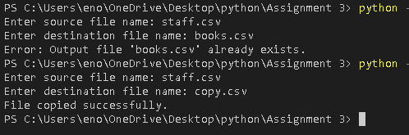

Program 5: Learner Class
This program defines a Learner class to hold student details such as roll number, name, address, enrollment year, program, and group. It collects input from the user, creates a Learner object, and then presents all the information in a well-structured format.
Sample Output:
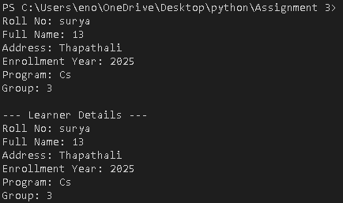

Program 6: Dish and Cookbook
This program defines a Dish class for storing recipe details and a Cookbook class for managing multiple dishes. It creates a Cookbook object, adds a Nepali dish (Dal Bhat), and then displays its ID, name, ingredients, and preparation steps.
Sample Output:
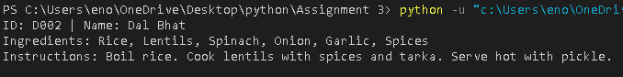

Program 7: Staff Management
This program manages staff records using a Staff class along with a CSV file. It offers a simple menu that allows users to add new staff information or view all existing records stored in "staff.csv".
Sample Output:
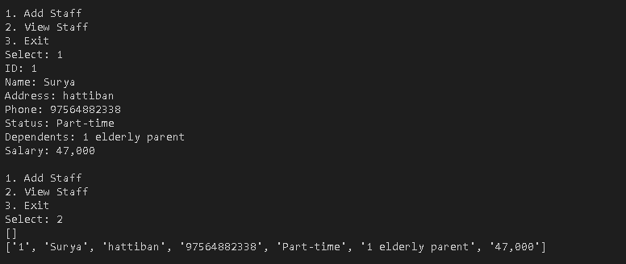

Program 8: Library Management System
This program implements a basic Library Management System using Book and Library classes. It enables users to search for books by title, borrow available ones, return borrowed books, and keeps all data stored permanently in "books.csv".
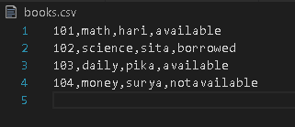
Sample Output:
