Fundamentals of Data Science - Assignment 4 Report

Program 1: NumPy Array Operations
This program creates a NumPy array containing the values [10, 20, 30, 40, 50] and computes its sum, average, maximum, and minimum. It then displays the original array along with these calculated statistics.
Sample Output:
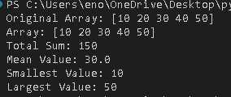

Program 2: List Sorting and Slicing
Takes Input: The program asks the user to enter 12 numbers one by one using a loop. All numbers are stored in a list called numbers.
Sorting: After taking all 12 numbers, it sorts the list in ascending order (smallest to largest) using numbers.sort ().
Slicing & Output: It then prints three different slices (parts) of the sorted list:
- Numbers [3:7] → shows elements from index 3 to 6 (4 elements)
- numbers [6:10] → shows elements from index 6 to 9 (4 elements)
- numbers [4:11] → shows elements from index 4 to 10 (7 elements)
Sample Output:
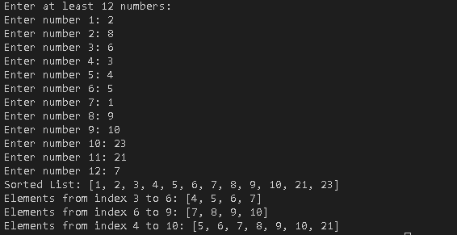

Program 3: Random Array and Reshape
This program generates 12 random integers between 1 and 100 using NumPy, sorts them in ascending order, and reshapes them into a 3×4 matrix. It then displays the original array, the sorted array, and the resulting reshaped matrix.
Sample Output:
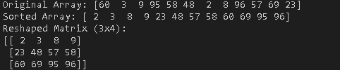

Program 4: Matrix Operations
This program accepts input for two 2×2 matrices from the user and performs addition, subtraction, and multiplication using NumPy. It verifies whether the matrices are compatible for each operation and displays appropriate messages if any operation cannot be carried out.
Sample Output:

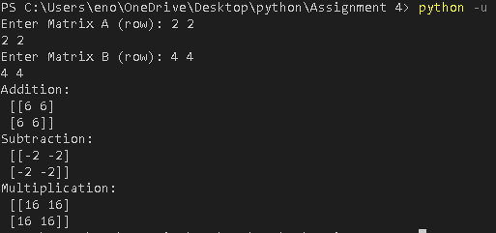

Program 5: Data Visualization
This code loads a CSV file called “health_data.csv” using pandas, then uses matplotlib to generate five scatter plots. These plots visualize different relationships between the variables, including weight vs height, age vs weight, height vs age, and comparisons of gender with both height and weight.
Sample Output:
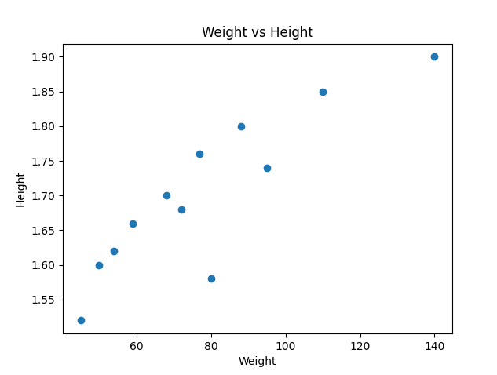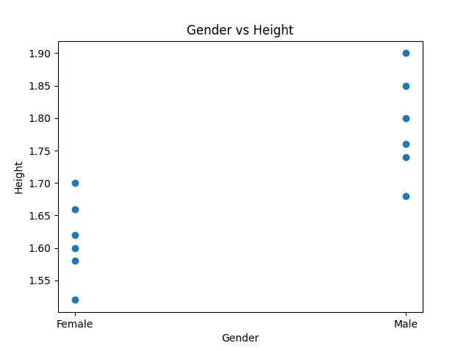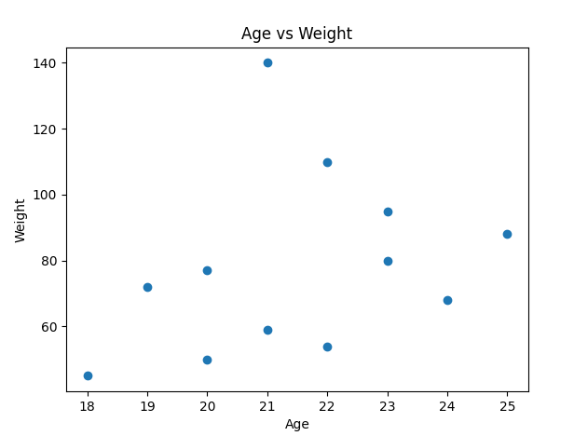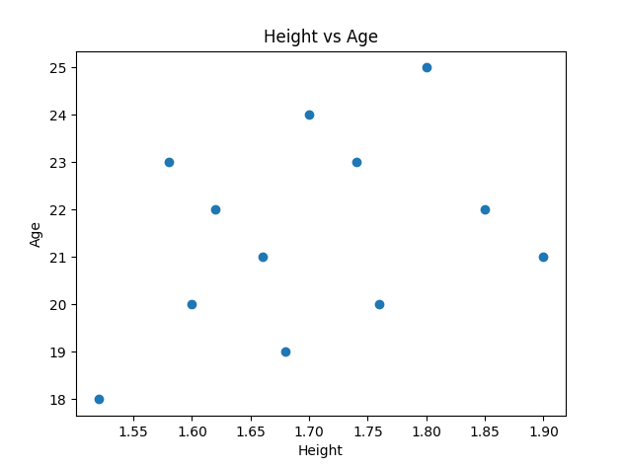
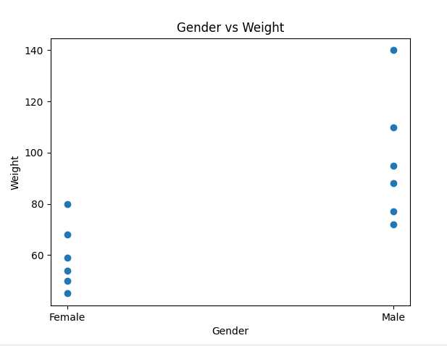

Program 6: BMI and Health Status
This code loads the file “health_data.csv” using pandas and computes the BMI for each individual. Based on the calculated BMI values, it assigns a corresponding Health Status category such as Underweight, Healthy, Overweight, High Risk, or Critical. Finally, it displays the first few rows of the updated dataset.
Sample Output:
