DVA231 – Project
Weather Compare

Group members & scopes
Filip Andersson  Frontend | Iván Muñiz  Frontend | Jonas Fändriks  Backend | Sylvio Ujvari  Backend, Database

Idea
We want to create an website where you get weather informations from different weather services (at least 3), because there are often differences. The user gets several results in the same view side by side. Then we calculate the average of all results an show this too.
In this case we have to ascertain which is the smallest cut quantity by the informations and this we will use.
The user should be able to search for a town and get the results.
The result should include:
- current weather information (temperature, wind speed, sunny, cloudy, rainfall quantity, ...)
- weather forecast if it's possible

Short description
A Web-Application which compare the results of various weather services (at least 3).
- The results (smallest cut quantity of selected weather services) should be shown side by side in boxes.
- There is another box with the average values of the various results including min and max of the original values.
- The user should be able to search for a town.
- The searched towns by user should be store and shown to the user (in a list?).
- Results should be saved in a database.
Only make an API call if the last update of this town is at least 1 hour (or longer?) ago.
- If is possible show an weather forecast.
- Different user level (admin, superuser, user)
  - admin → is able to delete/reset the database and all what superuser is allowed
  - superuser → ???
  - user → normal user
Nice to have:
- Search for an country and get the big towns.
- User specific settings for the users.
- User can rearrange the order of the searched town.

Prototype

Large screen
Homepage
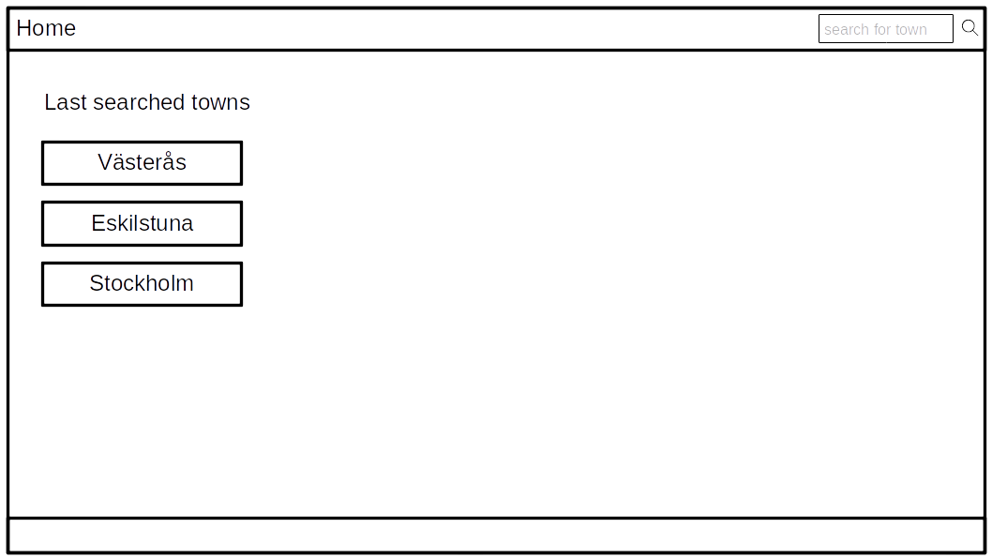
Town page
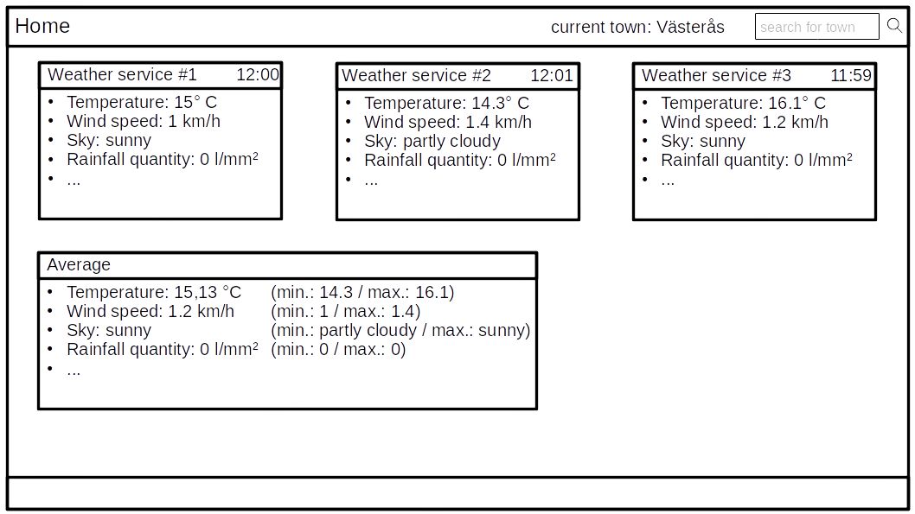

Handy screen
Homepage & Town page
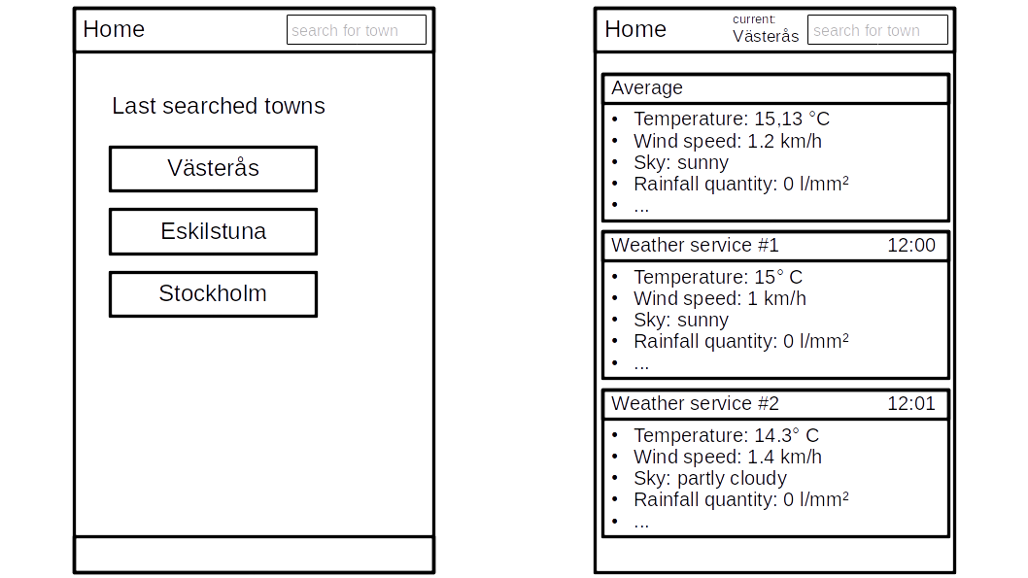

Requirements

Technical
- Server: Apache Server
- Used programming language (backend): PHP
- Database: MySQL

Programming
- Programming model: Model-View-Controller (MVC)
- Frameworks: Bootstrap (responsive), JQuery

Organisation / Collaboration - Tools
- Trello → Status of the project
  - Teampage: https://trello.com/dva231
  - Project-Board: https://trello.com/b/4e3DfyAY/project
  - Database-Board: https://trello.com/b/a21bOx2Y/database-development-database-interfaces-php
- GitHub → Code and documents of the project
  - URL: https://github.com/xenobius4slash/dva231_project
  - SSH access: git@github.com:xenobius4slash/dva231_project.git
  - HTTPS access: https://github.com/xenobius4slash/dva231_project.git
- Facebook Chat → Communication

