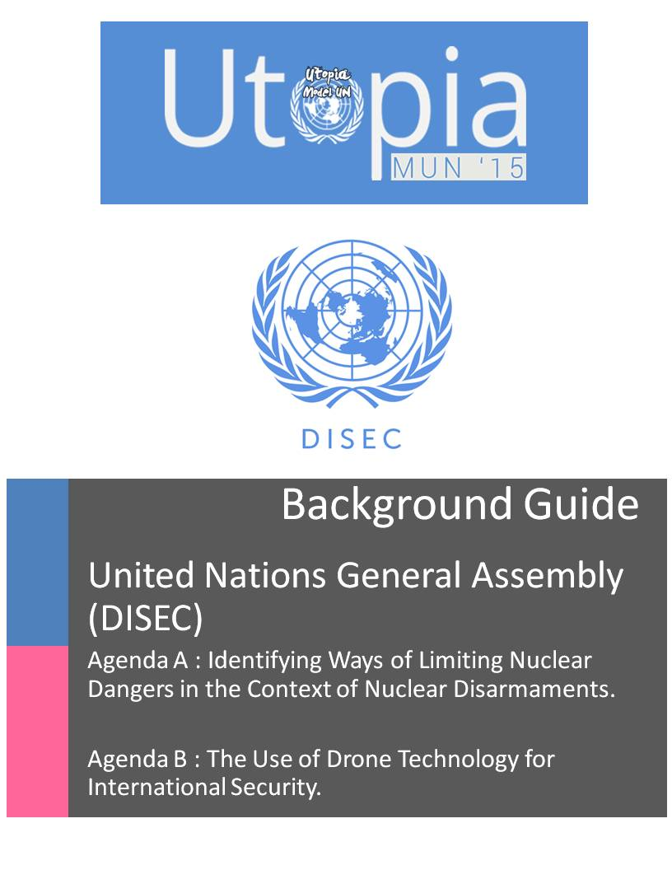

***United Nations General Assembly (DISEC)***

***About the Committee***

The First Committee deals with disarmament, global challenges and threats to peace that affect the international community and seeks out solutions to the challenges in the international security regime.

It considers all disarmament and international security matters within the scope of the Charter or relating to the powers and functions of any other organ of the United Nations; the general principles of cooperation in the maintenance of international peace and security, as well as principles governing disarmament and the regulation of armaments; promotion of cooperative arrangements and measures aimed at strengthening stability through lower levels of armaments.

The Committee works in close cooperation with the United Nations Disarmament Commission and the Geneva based Conference on Disarmament. It is the only Main Committee of the General Assembly entitled to verbatim records coverage.

***AGENDA 1***

*Identifying Ways of Limiting Nuclear Dangers in the Context of Nuclear Disarmaments.*

“People understand that nuclear weapons cannot be used without indiscriminate effects on civilian populations. Such weapons have no legitimate place in our world. Their elimination is both morally right and a practical necessity in protecting humanity”.

Ban Ki-moon

*Topic Background*

The first purpose of the United Nations is "to maintain international peace and security," and there may be no greater threat to peace and security than nuclear weapons. With over 22,000 nuclear weapons in existence worldwide, there are enough nuclear weapons to destroy the world many times over. And yet, various states refuse to give up their nuclear weapons and other states seek to acquire nuclear weapons.

Mankind has invented few, if any, weapons as powerful and destructive as the nuclear bomb. The world saw the first use of nuclear weapons on August 6, 1945, during World War II, when American pilots dropped one atomic bomb, dubbed Little Boy, on Hiroshima, Japan. Three days later, they dropped a second one, dubbed Fat Man, on Nagasaki, Japan. Casualties range from 150,000 to 200,000.The injuries and scars of that destruction are still in evidence today, both in the memories of its victims and the cancers they have developed.

By the end of World War II, the world realized that nuclear weapons were a very dangerous thing. The Nuclear Non-Proliferation Treaty went into effect on January 1, 1967. At that time, only five countries had tested and manufactured nuclear weapons. They were United Nations Security Council permanent members: Russia, China, France, the UK, and the US. All other signatories to the NPT agreed to not pursue nuclear weaponry, instead focusing on the development of nuclear technology for peaceful purposes. Since then, other countries have sought, developed, or claimed to have developed nuclear weapons. India, Pakistan, and North Korea have developed nuclear weapons, while Israel and Iran may or may not secretly harbour nuclear devices and technology. Some countries, most of them signatory to the NPT, have possessed or technology but have since destroyed or surrendered them, such as the former Soviet Union republics Kazakhstan and Ukraine. The original five countries initially built nuclear weaponry for a powerful offense, but many have since repurposed them for domestic defence under the concept of nuclear deterrence.

Countries now recognize that any nuclear strike will leave the offending country vulnerable to a nuclear retaliation, either from the defending country or its nuclear-capable allies. The result of such an eye-for-an-eye mentality would be mutually assured destruction. To this end, countries seeking to protect themselves from aggressors began amassing nuclear weapons to deter hostile countries from attack. It is against the interest of both nuclear-capable and non-nuclear capable countries to see nuclear weaponry spread. The effort to stop the spread of nuclear weapons is referred to as nuclear non-proliferation.

The Nuclear Non-Proliferation Treaty (NPT) has spearheaded the movement to establish a nuclear-weapon-free regime and seeks to deter states and organizations that have nuclear arms or capabilities from transferring its nuclear weapons or capabilities to states or organizations that do not. To enforce and monitor the NPT, the treaty calls upon the actions of the International Atomic Energy Agency, an international agency that works primarily by inspecting nuclear facilities.

Nuclear research has also yielded a double-edged sword. Nuclear technology can be harnessed for peaceful, civilian nuclear energy. This free, cheap energy would be a boon to developing and developed countries around the world. However, the nuclear material used to create this energy can also be used to create nuclear weapons. Understandably, while some countries perceive the pursuit of nuclear energy as their sovereign right, other countries fear these nuclear power plants may instead harbour or research nuclear weaponry. To compound the issue, non-state actors, e.g. terrorists, have accelerated nuclear proliferation by covertly creating, stealing, selling, and distributing nuclear technology and weapons to nuclear-incapable parties. These goods include nuclear scientists, equipment, knowledge, or arms.

*Important treaties*

The following are the important treaties related to disarmament. Delegates should read further on these and understand the ramifications and problems associated with them.

1. Treaty on the Non-Proliferation of Nuclear Weapons

The NPT is a landmark international treaty whose objective is to prevent the spread of nuclear weapons and weapons technology, to promote cooperation in the peaceful uses of nuclear energy and to further the goal of achieving nuclear disarmament and general and complete disarmament. The Treaty represents the only binding commitment in a multilateral treaty to the goal of disarmament by the nuclear-weapon States. Opened for signature in 1968, the Treaty entered into force in 1970. On 11 May 1995, the Treaty was extended indefinitely.  A total of 190 parties have joined the Treaty, including the five nuclear-weapon States. More countries have ratified the NPT than any other arms limitation and disarmament agreement, a testament to the Treaty's significance.

1. Treaty Banning Nuclear Weapon Tests in the Atmosphere, in Outer Space and Under Water

Nuclear Test-Ban Treaty, formally Treaty Banning Nuclear Weapons Tests in the Atmosphere, in Outer Space, and Under Water, treaty signed in Moscow on Aug. 5, 1963, by the United States, the Soviet Union, and the United Kingdom that banned all tests of nuclear weapons except those conducted underground.

1. Comprehensive Nuclear-Test-Ban Treaty (CTBT)

The Treaty was introduced directly to the U.N. General Assembly, where it was adopted on 10 September 1996. The CTBT bans all nuclear explosions on Earth whether for military or for peaceful purposes. It also established the Preparatory Commission for the Comprehensive Nuclear-Test-Ban Treaty Organization (CTBTO).

*Dangers posed by Nuclear Weapons and Energy*

Radiation

Radiation occurs naturally in our environment; a typical person is, and always has been struck by 15,000 particles of radiation every second from natural sources, and an average medical X-ray involves being struck by 100 billion. While this may seem to be very dangerous, it is not, because the probability for a particle of radiation entering a human body to cause a cancer or a genetic disease is only one chance in 30 million billion (30 quintillion).

Nuclear power technology produces materials that are active in emitting radiation and are therefore called "radioactive". These materials can come into contact with people principally through small releases during routine plant operation, accidents in nuclear power plants, accidents in transporting radioactive materials, and escape of radioactive wastes from confinement systems.

Radioactive Waste

Nuclear waste is produced at every stage of the nuclear fuel cycle, from uranium mining and enrichment, to reactor operation and the reprocessing of spent nuclear fuel. Much of this nuclear waste will remain hazardous for hundreds of thousands of years, leaving a poisonous legacy to future generations

Reactor accidents

One of the worst nuclear accidents to date was the Chernobyl disaster which occurred in 1986 in Ukraine. The accident killed 30 people directly and damaged approximately $7 billion of property. A study published in 2005 estimates that there will eventually be up to 4,000 additional cancer deaths related to the accident among those exposed to significant radiation levels. Radioactive fallout from the accident was concentrated in areas of Belarus, Ukraine and Russia. Approximately 350,000 people were forcibly resettled away from these areas soon after the accident.

Although various security measures are used these days, reactor accidents still pose a threat however unlikely they may be.

Nuclear Terrorism

Although there is no formal definition for nuclear terrorism, it can be understood as the use of radioactive or nuclear war heads intended to cause death or serious bodily harm to civilians or non-combatants with the purpose of intimidating a population or compelling a government or an international organization to do or abstain from doing any act. This area also includes issues like theft of technology, scientists and fuel. It has been observed that terrorists utilize old discarded nuclear facilities and steal the fuel and the brains required to operate it.

*Further Research*

The following points can aid you in writing the position paper as well as getting a good background of the agenda. Although it is important to point out that the committee should not be restricted by these points. They are merely being provided to point the delegates in the right direction.

- Does your country have weapons of mass destruction or the desire to acquire them? Why or why not?

- Has your country ratified and is it in compliance with the NPT and other disarmament treaties?

- If your country is a nuclear state, what relationship has it historically had with today’s non-nuclear states? Has it been willing to consider disarmament? Why or why not?

- If your country is not a nuclear state, what relationship has it historically had with today’s nuclear states? Has it agreed to accept their weapons on its territory? Has it been affected by their nuclear tests?

- What relationship does your country have with Iran, and what is its position on the Iranian nuclear program?

- From your country’s point of view, is disarmament necessary, possible, and/or desirable? Why or why not? What would be the costs and benefits?

- Would it be better for each country to dismantle its own weapons or turn them over to a re-invigorated Military Staff Committee or some other, new UN agency? If the latter, how should that agency be organized, and what should its responsibilities and capabilities be?

- Would it be easier for disarmament to occur first at the regional level and then internationally, or would it be necessary for all states to disarm at the same time

- What further steps can the IAEA take to further guarantee that nuclear facilities are only being used for peaceful purposes?

**AGENDA II**

The Use of Drone Technology for International Security

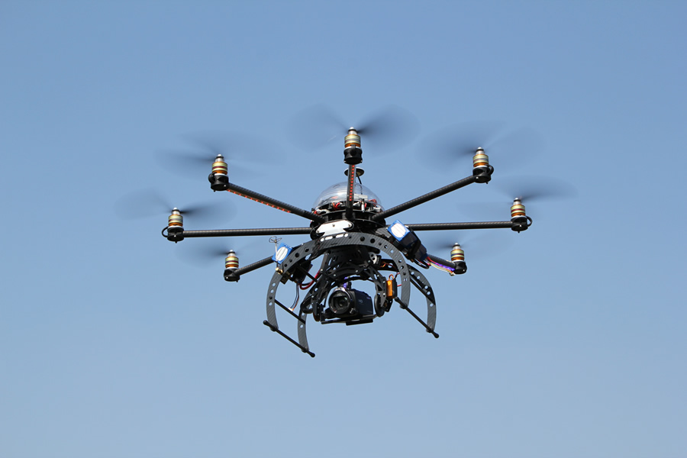

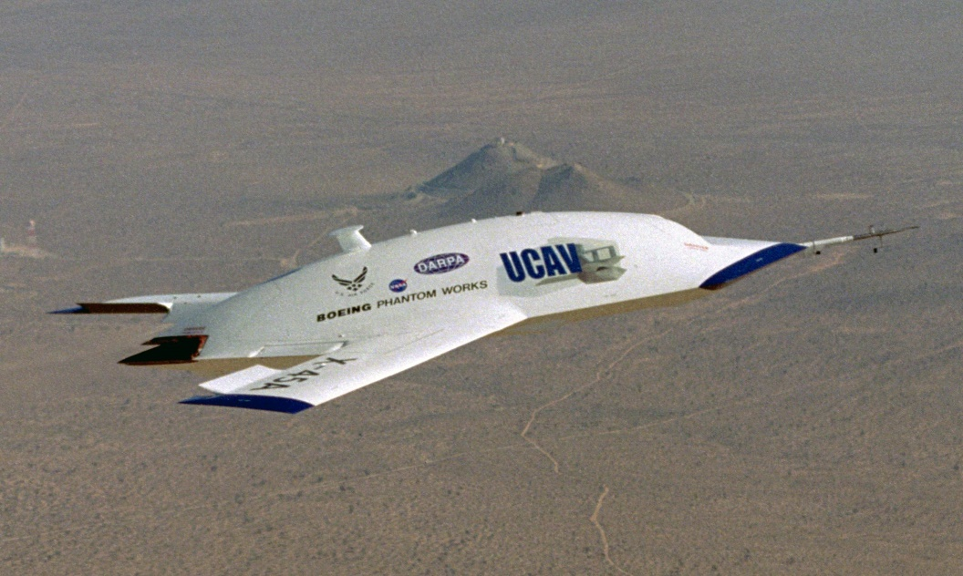

*INTRODUCTION*

A drone, otherwise classified as an unmanned aerial vehicle (UAV), can be controlled from the ground by a pilot or autonomously based on a predetermined mission, and can carry either a lethal or nonlethal cargo. Although there exist many types of drones, they are mainly utilized for either surveillance purposes or are equipped with bombs and missiles.



Currently, drones are simply unmanned aircrafts that are controlled remotely by an operator on the ground. The operator may be located in the same country as the drone or in another part of the world. This has raised questions about liability and responsibility for those killed in drone strikes, as the countries where the strikes occur have no jurisdiction over the individual(s) controlling the attack. Because drones have only been in use for about a decade, there is almost no legal infrastructure governing their use.

***NOTE****: It is imperative for the delegates to be aware of the difference between an Unmanned Aerial Vehicle (UAVs) and an Unmanned Combat Aerial Vehicle (UCAVs).*

* *To distinguish UAVs from missiles, a UAV is defined as a "powered, aerial vehicle that does not carry a human operator, uses aerodynamic forces to provide vehicle lift, can fly autonomously or be piloted remotely, can be expendable or recoverable, and can carry a lethal or nonlethal payload.*
* *Whereas, an unmanned combat aerial vehicle (UCAV), also known as a combat drone or drone, is an*[*unmanned aerial vehicle*](http://en.wikipedia.org/wiki/Unmanned_aerial_vehicle)*(UAV) that is usually armed (*[*aircraft ordnance*](http://en.wikipedia.org/wiki/Aircraft_ordnance)*) such as missiles.*

Currently, only the United States, Israel, and the United Kingdom and Pakistan possess armed drones. This situation is bound to be temporary as other countries gain the technology and begin their own programs. Along with using drones for military surveillance and defence purposes, it is highly likely that civilians will soon be using them for recreational reasons.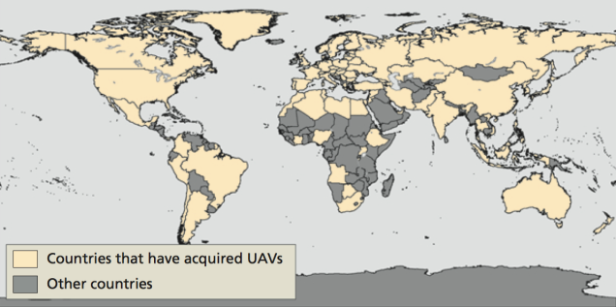

*Drones and the War on Terror*

*“*By reducing the risks and costs of war, the use of UAVs and precision weapons may actually encourage more bellicosity and longer war.”

The first ever use of a drone as a weapon was carried out by Iran, and there have been other multiple uses for it. The United States of America has frequently made use of drones to bomb areas in Pakistan as well as Yemen. In both cases the national governments gave an outcry of security infringement.

Some believe the future of modern warfare will be fought by automated weapons

Systems. The U.S. Military is investing heavily in research and development towards testing and deploying increasingly automated systems. The most prominent system

Currently in use is the unmanned aerial vehicle (IAI Pioneer & RQ-1 Predator) which can be armed with Air-to-ground missiles and remotely operated from a command center in reconnaissance roles.

The United States has admitted to using drones to kill foreign and American citizens outside of the U.S. It also uses drones over its own territory, mostly for surveillance over its border with Mexico. American use of drones has mostly centered on the war in Afghanistan, where they are used to provide aerial assistance to soldiers on the ground, gather information about enemy locations and movements, and drop bombs without the risk of American casualties.



Pakistan protests drone strikes by USA

*USE OF DRONES OUTSIDE ARMED CONFLICT*

Unmanned Aerial Vehicles (UAVs) are used for :

* Domestic law enforcement purposes, including border and road patrols, infrastructure protection, and the detection, identification and surveillance of objects and individuals.
* So far, there has been no known use of armed drones in the context of domestic law enforcement and border protection, although the United States appear to have contemplated using them in support of counter-narcotics operations in Mexico.
* Just as is the case for non-state groups in armed conflict, the technology necessary to build and operate drones is also accessible to criminals, other private individuals, corporations and organizations, and the distinction between drones and private remotely controlled aircraft may become increasingly blurred.
* However, easily accessible methods of building a drone and the proliferation of such devices and their combination with powerful miniature cameras, data processing tools and communication systems possess a threat to civil air traffic control, also raises questions of privacy protection between private individuals, espionage and other issues of private and public safety

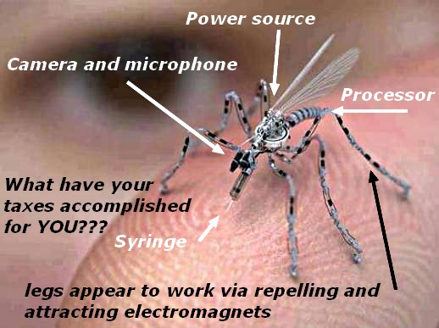 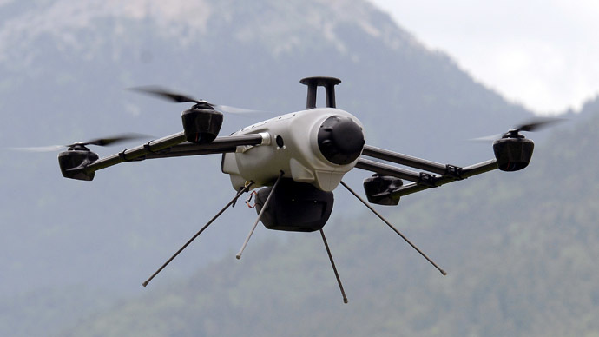

*Concerns Surrounding Drone Technology*

1. ***ETHICAL AND LEGAL ISSUES***

* Drone strikes, most especially by the United States of America, have been called out time and time again for breaching the Law of War. The most common and targeted reason for the disapproval of drone strikes is that bombings carried out by drone are not reliable and may often result in the killing of civilians in an equal ratio to the militants.
* The death of civilians is a major point of distaste for not only the bombed state but also for international communities such as Amnesty International and the Human Rights Watch, international organisations which have called out the death of civilians as a direct violation of the Rules of War.
* The Pakistani government has stated that bombings within its borders has brought about more harm than good and has undermined the government since civil matters are not left to be handled by the government before international intervention takes place
* Ethical issues were highlighted around the time when autonomous drone strikes were being tested with advanced drone technology. The autonomous drones violated the proportionality and distinction International Humanitarian Law, since the weapons are solely controlled by algorithms with no direct involvement by an on land pilot.

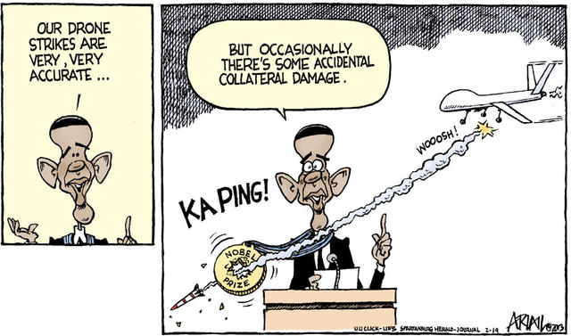

1. ***Sovereignty***

* The legal basis for the use of drones on the principles of sovereignty, the Geneva Conventions and the Additional Protocols, the principle of private property and private life, as such, International Humanitarian Law and Human Rights.
* Opponents of the Drone program contest that it violates national sovereignty, alienates foreign governments and populations, and kills more civilians than the United States government admits.
* The United Nations has stated that the drone strikes carried out by the United States have violated the sovereignty of Pakistan and Yemen, as the strikes are carried out without consent of any elected representatives or the Government of the nations and involve the use of force on the territory of another nation. Drone strikes normally are carried out without prior consent as they are meant to possess the element of surprise so as to increase the chances of successfully getting to the target before they are informed.
* USA has backed its violations by stating that the United States is at a war with the Al-Qaeda and all of its drone strikes involve the Al-Qaeda militants as targets, thus clearing the bombings of any legal issues and civilian casualties, no matter how grave, do not constitute as a war crime unless the attacks were specifically aimed at the civilians.

*MAJOR PARTIES INVOLVED*

1. ***UNITED STATES OF AMERICA***

Drone strikes carried out by the USA have been justified by the nation’s government in statements by saying they are “fighting against terrorism” and that civilian deaths are not justified as war crimes since civilians are not the targets of said strikes. Drone strikes have seen a massive spike ever since Obama took office. With around 700 drones in its possession, the United States is a force to be reckoned with in the matters of drone technology. In May of 2013, President Obama acknowledged the deaths of four American citizens in drone strikes since 2009. He also referred to his administration’s use of drone strikes as “legal” and “effective,” insisting that only al Qaeda forces are being targeted, and that heavy drone use is always constrained.

1. ***PAKISTAN***

Pakistan has been at the receiving end of drone strikes, much to the distaste of its government which has repeatedly protested the attacks and has called the infringement of its sovereignty. Along with this the deaths of civilians, which largely include mothers and children has angered the government even more. Though constant request for drone strikes have been made by the Pakistani government, USA has show little to no interest in these requests and has in fact increased drone strikes in the nation.

1. ***YEMEN***

Yemen, like Pakistan is also on the receiving end of the drone strikes. The most notable outcry for the drone strikes in Yemen, was when a drone targeted a wedding procession which was mistakenly identified for housing suspects of the Al-Qaeda in the Arabian Peninsula. The attack killed only 5 suspected militants but wounded over 17 wedding attendees.

1. ***ISRAEL***

Israel has been developing drones since the 1970’s. Since then it has spent considerable funds towards drone technology and has shown a greater export rate in drone technology when compared to that of the United States. With tensions already being high between USA and Israel, the development of drone technology in Israel makes it one of the leading nations in the Middle East to possess such technology

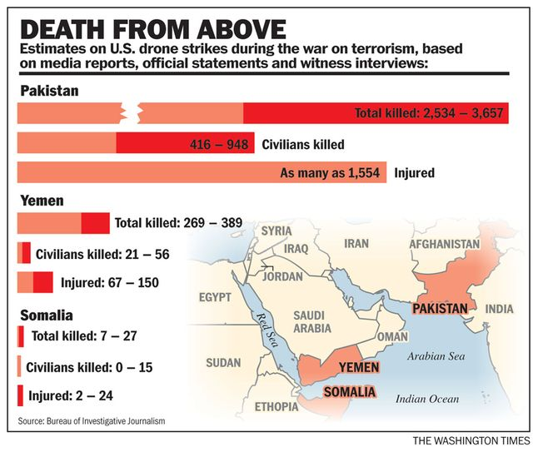

***CONCLUSION***

* To combat the abuses of the future with today’s tools, states should regulate a code of conduct on how autonomous drones should behave in combat, outside of combat and how manufacturers must build and program these vehicles.
* The United Nations as a main actor in diplomacy and dialogue between states could help develop moratoriums and additional provisions to already existent treaties or normative blocks, next to new treaties that keep up with the pace of technological evolution. The new provisions that would be envisioned should go past simple agreements of good-faith and good-practice and should include a guideline for contracting parties on how building, developing, selling, using and researching should be done.
* Next to such aspects, new bodies could be formed to regulate new technologies seeing as how this aspect of day-to-day life is spiralling out of control step by step. The most important aspect will also be the impact on the public opinion, because as the drone experience proved everything up until now, is that people will most likely criticize something that has as sole purpose the destruction of the enemy.

***QUESTIONS TO CONSIDER***

1. Does your country have unmanned aircrafts? If not, what are the prospects for you or your allies developing them in the future?
2. Are drone strikes a violation of international laws governing war practices and human rights?
3. What are some major issues of unmanned weapons and how can they be fixed?
4. What are major implications of unmanned weaponry?
5. How can the international community work to ensure unmanned aircrafts are used for beneficial purposes?
6. Which countries, if any, should have unmanned aircrafts? How might their use be regulated?