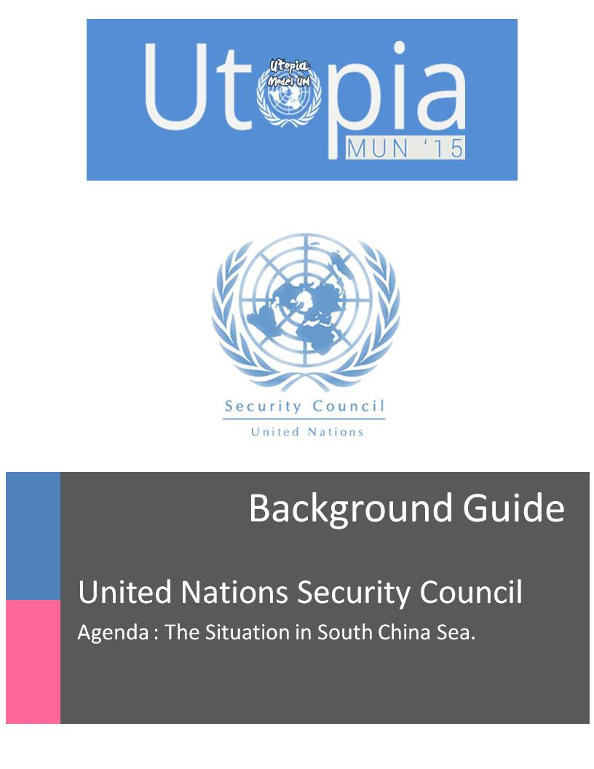

**MESSAGE FROM THE EXECUTIVE BOARD**

Dear Delegates

This Background Guide serves to introduce you to the agenda for this committee. However, it has to be noted that the background guide only contains certain basic information which may form the basis for the debate and your research. It is not meantto replace further research.

We expect you to put in whole-hearted efforts to research and comprehensively grasp all important facets of the diverse agenda.

For any further assistance with your preparation feel free to contact us at: *scutopia15@gmail.com*

We wish you all the best in your preparations, and we look forward to seeing you at the conference!

**INTRODUCTION TO THE TERRITORY**

The **South China Sea** is a  [marginal sea](http://en.wikipedia.org/wiki/Marginal_sea) that is part of the  [Pacific Ocean](http://en.wikipedia.org/wiki/Pacific_Ocean), encompassing an area from the  [Singapore](http://en.wikipedia.org/wiki/Singapore_Strait) and  [Malacca Straits](http://en.wikipedia.org/wiki/Strait_of_Malacca) to the  [Strai](http://en.wikipedia.org/wiki/Taiwan_Strait)t  [of Taiwan](http://en.wikipedia.org/wiki/Taiwan_Strait) of around 3,500,000 square kilometers (1,400,000 sq. mi).

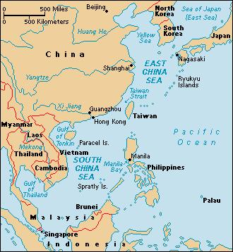The South China Sea is an extremely resource rich body. It has close to 1.2km³ oil reserves within the sea and around 7500km³ natural gas reserves

It is an extremely significant body of water in a geopolitical sense. It is the second most used [sea lane](http://en.wikipedia.org/wiki/Sea_lane) in the world, while in terms of world annual merchant fleet tonnage; over 50% passes through the  [Strait of Malacca](http://en.wikipedia.org/wiki/Strait_of_Malacca), the  [Sunda Strait,](http://en.wikipedia.org/wiki/Sunda_Strait) and the  [Lombo](http://en.wikipedia.org/wiki/Lombok_Strait)k  [Strait.](http://en.wikipedia.org/wiki/Lombok_Strait) Over 1.6 million m³ (10 million barrels) of  [crude oil](http://en.wikipedia.org/wiki/Crude_oil) a day are shippedthrough the Strait of  [Malacca](http://en.wikipedia.org/wiki/Malacca).

States and territories with borders on the sea include: the  [People's Republic of China](http://en.wikipedia.org/wiki/People%27s_Republic_of_China) (including  [Macau](http://en.wikipedia.org/wiki/Macau) and  [Hong](http://en.wikipedia.org/wiki/Hong_Kong) Kong), the  [Republic of](http://en.wikipedia.org/wiki/Republic_of_China) [China(Taiwan),](http://en.wikipedia.org/wiki/Taiwan) the  [Philippines,](http://en.wikipedia.org/wiki/Philippines) [Malaysia,](http://en.wikipedia.org/wiki/Malaysia) [Brunei,](http://en.wikipedia.org/wiki/Brunei) [Indonesia](http://en.wikipedia.org/wiki/Indonesia),  [Singapore,](http://en.wikipedia.org/wiki/Singapore) and  [Vietnam](http://en.wikipedia.org/wiki/Vietnam).

**THE DISPUTE**

The dispute among the countries bordering the South China Sea is mainly over territorial and jurisdictional claims. This is due to the fact that South China Sea is packed with large deposits of natural resources like oil and gas.

Several countries have made competing territorial claims over the South China Sea. Such disputes have been regarded as Asia's most potentially dangerous point of conflict.

|  |  |
| --- | --- |
| **Territory Claimed** | **Claiming Nations** |
|  |  |
| Natuna Islands | Indonesia, People’s Republic of China, Republic of China |
|  |  |
| Scarborough Shoal | Philippines, People’s Republic of China, Republic of China |
|  |  |
| Spratly Islands | Vietnam, People’s Republic of China, Republic of China |
|  |  |
| Paracel Islands | Vietnam, People’s Republic of China, Republic of China |
|  |  |
| Gulf of Thailand | Malaysia, Cambodia, Thailand |
|  |  |
| Strait of Singapore | Singapore, Malaysia |
|  |  |

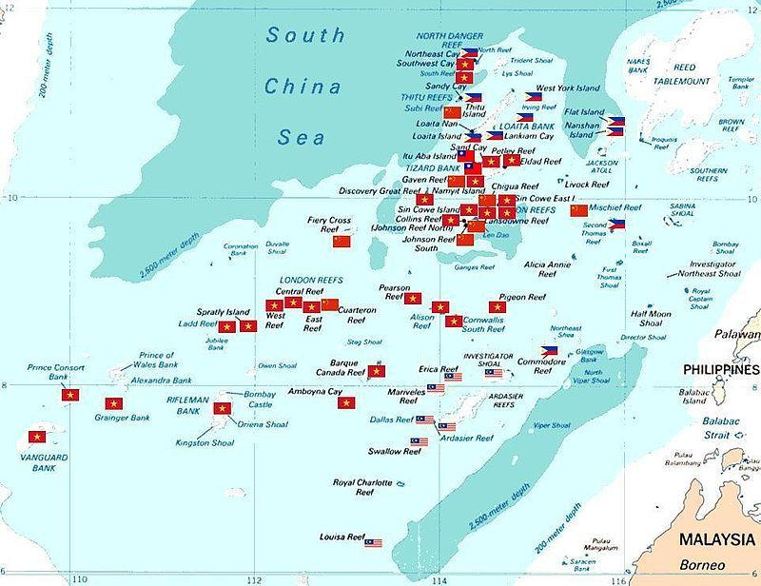

**TIMELINE**

The interest in South China Sea is not new. Although it has been present for centuries, the interest and tension in the region has amplified exponentially.

In 1904, China map entitled Map of all Chinese Provinces from Shanghai Publishing House showed that China stretched as far as Hainan Island and Spratly Island and Paracel Island did not belong to China. In 1933, French asserted its claim from 1887 to Spratly and Paracel Islands on behalf of its then colony- country, Vietnam. China, in 1948, made a claim in the South China Sea, with eleven dotted-lines (later named nine dotted-line by the Communist Party) which included both Spratly Island and Paracel Islands. In 1970s, Philippines, Malaysia and other countries started referring to the Spratly Islands as part of their territory, completely ignoring the nine-dotted line. A conflict between China and Vietnam in 1974 resulted in 18 soldiers being killed and China controlling Paracel. On top of this tension, when the United Nations Convention on the Law of the Sea (UNCLOS) came into effect in 1982, debates on the ownership of the ownership of the area became intensified. Navy conflict between the two nations over Spratly Island ended in 1988 with seventy dead soldiers. ASEAN has been working hard to prevent armed military conflict in the area. In 2002, China signed a non-binding declaration with ASEAN to promote freedom of navigation in South China Sea.

1902 – China sends naval forces on inspection tours of the Paracel Islands to preempt French claims.

1907 – China sends another naval force, this time to plan for resource exploitation.

1911 – The newly formed Republic of China, successor state to the Qing Dynasty, moves administration of the Paracel Islands to Hainan, which would not become a separate Chinese province until 1988.

1927 – Japan makes its earliest documented claim to the Paracel and Spratly Islands

1928 – The Republic of China states that the Paracel Islands are the southernmost limits of its territory

1931 – France claims the Paracel Islands

1939 – Japan occupies the islands and takes control of the South China Sea. The Spratlys and the Paracels were conquered by Japan in 1939. Japan administered the Spratlys via Taiwan's jurisdiction and the Paracels via Hainan's jurisdiction.

1946 – Republic of China sent warships to claim Itu Aba, the largest of the Spratly Islands and renamed it Taiping Island. The Paracels and Spratlys were handed over to Republic of China control from Japan after the 1945 surrender of Japan, since the Allied powers assigned the Republic of China to receive Japanese surrenders in that area. After WW2 ended, the Republic of China was the "most active claimaint". The Republic of China then garrisoned Itu Aba (Taiping) island in 1946 and posted Chinese flags and markers on it along with Woody Island in the Paracels, France tried, but failed to make them leave Woody Island. The aim of the Republic of China was to block the French claims. The Republic of China drew up The Southern China Sea Islands Location Map, marking the national boundaries in the sea with 11 lines, showing the U shaped claim on the entire South China Sea, and showing the Spratly and Paracels in Chinese territory, in 1947. Later in 1953 the People's Republic of China published the map with 9 lines remained.

1952 – Japan renounced any claims of sovereignty over the Spratly and Paracel archipelagos in accordance with Article 2 Clause (f) of the San Francisco Peace Treaty, but no beneficiary was designated.

1954 – French claims to the Paracel Islands transferred to Vietnam

1956 – North Vietnam declares Paracel and Spratly Islands are historically Chinese territory

1970 – China occupies Amphitrite Group of the Paracel Islands

1971 – Philippines announces claim to islands adjacent to its territory in the Spratlys, which they named Kalayaan, which was formally incorporated into Palawan Province in 1972. The Philippines President Marcos announced the claims after Taiwanese troops attacked and shot at a Philippine fishing boat on Itu Aba

1992 – China passes a law declaring the entire South China Sea as its territory, triggering protests from around the region

1997 – Philippines begins to challenge Chinese sovereignty over the Scarborough Shoal.

1999 – Under President Lee Teng-hui, Taiwan stated that "legally, historically, geographically, or in reality", all of the South China Sea and Spratly islands were Taiwan's territory and under Taiwanese sovereignty, and denounced actions undertaken there by Malaysia and the Philippines, in a statement on 13 July 1999 released by the foreign ministry of Taiwan. During international talks involving the Spratly islands, China and Taiwan have cooperated with each other since both have the same claims.

9 May 1999 – The day after the US bombing of the Chinese embassy in Belgrade, Philippine navy sent BRP Sierra Madre and ran her aground on Second Thomas Shoal. China issued official protest afterward. Philippine refused to withdraw the ship. Since then China deploys subservience ships to the corresponding water regularly.

1 April 2001- The Hainan Island incident occurred when a mid-air collision between a United States Navy EP-3E ARIES II signals intelligence aircraft and a People's Liberation Army Navy (PLAN) J-8II interceptor fighter jet resulted in an international dispute between the United States of America and the People's Republic of China.

The EP-3 was operating about 70 miles (110 km) away from the PRC island province of Hainan, and about 100 miles (160 km) away from the Chinese military installation in the Paracel Islands, when it was intercepted by two J-8 fighters. A collision between the EP-3 and one of the J-8s caused the death of a PRC pilot, and the EP-3 was forced to make an emergency landing on Hainan. The 24 crew members were detained and interrogated by the Chinese authorities until a statement was delivered by United States government regarding the incident. The exact phrasing of this document was intentionally ambiguous and allowed both countries to save face while defusing a potentially volatile situation between militarily strong regional states.

The United States and the People's Republic of China disagree on the legality of the overflights by U.S. naval aircraft of the area where the incident occurred. This part of the South China Sea comprises part of the PRC's exclusive economic zone based on the United Nations Convention on the Law of the Sea. The PRC is a signatory to this Convention whereas the United States is not.

2002- ASEAN and China agree to a code of conduct in the Declaration on the Conduct of Parties in the South China Sea.

8 January 2005 – Chinese ships fired upon two Vietnamese fishing boats from ThanhHoa province, killing 9 people and detaining one ship with 8 people on Hainan Island. Chinese Foreign Ministry claims they were pirates that opened fire first and obtained confession from the arrested members.

March 2009 – The Pentagon reported that Chinese ships harassed US surveillance ship. According to the report, five Chinese vessels "shadowed and aggressively maneuvered in dangerously close proximity to USNS Impeccable, in an apparent coordinated effort to harass the U.S. ocean surveillance ship while it was conducting routine operations in international waters." The crew members aboard the vessels, two of which were within 50 feet, waved Chinese flags and told the US ship to leave the area, the statement said.

13 May 2009 – The deadline for states to make seabed hydrocarbon claims under the United Nations Convention on the Law of the Sea. This is suspected to have caused ancient island claims to surface and become inflamed.

25 February 2011– The Chinese frigate Dongguan fired three shots at Philippine fishing boats in the vicinity of Jackson atoll. The shots were fired after the frigate instructed the fishing boats to leave, and one of those boats experienced trouble removing its anchor.

26 May 2011– The clash involved the Vietnamese Binh Minh 02 oil and gas survey ship and three Chinese maritime patrol vessels occurred 120 km (80 miles) off the south-central coast of Vietnam and some 600 km south of China's Hainan Island. Vietnam says the Chinese boats deliberately cut the survey ship's cables in Vietnamese waters. China denies the allegation. The event stirred up unprecedented anti-China protests in Hanoi and Ho Chi Minh City.

9 June 2011 – A Norwegian-flagged seismic conducting ship hired by Vietnam Oil & Gas Corporation (PetroVietnam) clashed with another three Chinese fishery patrol vessels within Vietnam's Exclusive Economic Zone. Vietnam once again claimed its exploration cables were deliberately cut.

10 October 2011 – Vietnam and China agree to a new set of principles on settling maritime disputes

November 2011 – Former Malaysian PM Mahathir Mohamad said that China was not a threat to anyone and was not worried about aggression from China, accusing the United States of provoking China and trying to turn China's neighbors against China. Mahathir believes Malaysia could profit from China's economic growth through co-operation with China.

April 2012– The Philippine warship Gregorio delPilar was involved in a standoff with two Chinese surveillance vessels in the Scarborough Shoal, an area claimed by both nations. The Philippine navy had been trying to arrest Chinese fishermen who were allegedly taking government-protected marine species from the area, but the surveillance boats prevented them.

14 April 2012, USA and the Philippines held their yearly exercises in Palawan, Philippines.

16 April 2012, the Chinese Foreign Ministry urged a Philippine archaeological ship to immediately leave the waters of the Scarborough Shoal, which China claims is an "integral part of its territory."

7 May 2012, Chinese Vice Foreign Minister Fu Ying called a meeting with Alex Chua, Charge D'affaires of the Philippine Embassy in China, to make a serious representation over the current incident at the Scarborough Shoal. China also warned its nationals against travel to the Philippines and raised trade barriers on the import of pineapples and bananas.

16 May 2012- A fishing ban in the Scarborough Shoal by the governments of China and the Philippines became effective.

June 2012- Both nations had withdrawn their vessels from the waters around the disputed Shoal due to the arrival of the typhoon season.

July 2012- China had erected a barrier to the entrance of the shoal, and that vessels belonging to Beijing's China Marine Surveillance and Fisheries Law Enforcement Command were observed nearby the disputed shoal; as of December 2012, Chinese government ships remained around the shoal and had been turning away Filipino vessels; additionally, China had stated it would interdict, and board, any foreign vessel that entered waters it claimed. China later clarified that it would only conduct interdiction, and boarding, vessels within 12 nautical miles for which China has announced baselines.

May 2012 – Taiwan rejected a pan-Chinese approach of coordinating with the PRC in asserting claims to the South China Sea.

June 2012– Indian Navy vessels sailing in the South China Sea received an unscheduled escort by a People's Liberation Army Navy frigate for 12 hours.

July 2012 – a Jianghu-V type frigate of the PLA Navy, 560 Dongguan, ran aground on HasaHasa Shoal just 60 nmi west of Rizal, well within the Philippines' 200 mi.-EEZ.The ship had been refloated and was returning to port with no injuries and only minor damage. The 2012 ASEAN summit was taking place in Phnom Penh, Cambodia at the same time, where the mood was already tense over the escalating aggression in the region.The National Assembly of Vietnam passed a law demarcating Vietnamese sea borders to include the Spratly and Paracel islands.Citing reports from diplomats’ on-hand, Reuters wrote that Cambodia "batted away repeated attempts to raise the issue about the disputed waters during the ASEAN Meeting last week as well as the ASEAN Regional Forum."The Central Military Commission (China) decided to establish the Sansha garrison. The move was criticized by the Philippines and Vietnam. China responded by calling in a senior US diplomat and reiterating their "absolute sovereignty" over the region.

1st September 2012 – Taiwan performed live fire military exercises on Taiping Island on September 2012; reports said that Vietnam was explicitly named by the Taiwanese military as the "imaginary enemy" in the drill. Vietnam protested against the exercises as violation of its territory and "voiced anger", demanding that Taiwan stop the drill. Taiwan rejected Vietnam's protests, and Taiwan's Department of East Asian and Pacific Affairs declared that "Taiping Island is part of the Republic of China's territory....We have noted Vietnam's dissatisfaction over the drill...No one has the right to protest over Taiwan's exercise of its sovereign rights there", while China voiced its approval and support of Taiwan's military drill on the island. Taiwan's Ministry of Foreign Affairs also said, "Our sovereignty over the island is undisputable and all of our activities and deployments on the island are legal and will never cause regional tensions." in response to Vietnamese claims on the island. Among the inspectors of the live fire drill were Taiwanese national legislators, adding to the tensions.

5th September 2012 – Philippine president Aquino promulgated Administrative Order No. 29, naming maritime areas on the western side of the Philippine archipelago as the West Philippine Sea. The order declares that the Philippines exercises "sovereign jurisdiction" in its exclusive economic zone, an area declared by Presidential Decree No. 1599 of 11 June 1978 to extend to a distance of two hundred nautical miles beyond and from the baseline from which the territorial sea is measured. The Philippine Baselines are defined by Republic Act No. 3046, as amended. Official PRC media responded that this was a "fond dream".

23rd September 2012– China launched a program to increase the number of UAVs monitoring the Scarborough Shoal, Paracel Islands, Spratly Islands and East China Sea, which follows a national marine zoning program approved by the State Council during the previous year as a part of China's 12th five year plan.

December 2012– In an interview with the Times of India, Philippines Vice-President Binay welcomed the statement made by Indian Navy Admiral Joshi who stated that the Indian Navy is prepared to operate in the South China Sea.

March 2013– Malaysia displayed no concern over China conducting a military exercise at James Shoal on March 2013.

August 2013– Malaysia suggested that it might work with China over their South China Sea claims and ignore the other claimants, with Malaysian Defence Minister Hishamuddin Hussein saying that Malaysia had no problem with China patrolling the South China Sea, and telling ASEAN, America, and Japan that "Just because you have enemies, doesn't mean your enemies are my enemies

10th January 2014 – China imposes a "fishing permit" rule in the South China Sea, over the objections of the United States, the Philippines, and Vietnam.

11th March 2014– Two Philippine ships are expelled by the Chinese Coast Guard from Ayungin Shoal in the Spratly group of islands.

30th March 2014– The Republic of the Philippines files a case to the International Court of Justice in The Hague in its case against China over competing South China Sea claims.

2nd May 2014– Vietnamese naval ships and Chinese vessels collide in the South China Sea. The incident occurred as China set up an oil rig in an area to which both nations lay claim. On 26 May, a Vietnamese fishing boat sank near the oil rig, after colliding with a Chinese vessel. As both sides imputed the blame to each other, Vietnam released video footage a week later, showing the Vietnamese boat being rammed by the Chinese vessel before sinking. Meanwhile, ASEAN leaders expressed "serious concerns" over the tensions, calling for self-restraint and peaceful acts from both sides. Many observers observed that this marked a change in tone by ASEAN members, who had previously avoided a collision of their economic interests with China.

19th August 2014– American Boeing P-8 Poseidon of VP-5 harassed by Chinese Shenyang J-11. Zhang Zhaozhong calls on Chinese fighters to "fly even closer to U.S. surveillance aircraft"

5thMarch 2015- Vietnam protests about China’s move to expand construction on the disputed Spratly islands, which Vietnam calls Truong Sa, in the South China Sea.“Vietnam strongly protests and demands that China respect Vietnam’s sovereignty and immediately stop its illegal activities in the area of Truong Sa archipelago and that China strictly adhere to the Declaration on the Conduct of Parties in the South China Sea,” Vietnam foreign ministry’s vice spokeswoman, Pham Thu Hang, said in a statement. The declaration refers to a dispute-resolution pact that China and the member-states of the Association of Southeast Asian Nations signed in 2002.Images provide the first visual evidence that China has built an artificial island covering 75,000 square yards and including two piers, a cement plant and a helipad, at a land formation called Hughes Reef, according to experts who have studied the pictures. The images also show that China has made significant progress in building similar infrastructure in two other places, Johnson South Reef and Gaven Reefs, where Beijing’s territorial claims overlap with those of its neighbors.Ms. Hang said Vietnam has sufficient legal foundation and historical evidence to affirm its sovereignty over the Hoang Sa and Truong Sa islands.

14th March 2015- Japan used to be aloof from the three-way chess game of conflicting territorial claims in the South China Sea. Tokyo was pre-occupied with its own territorial dispute with China over a group of uninhabited islands in the East China Sea, known as the Senkaku in Japan and the Daioyu in China.However, quietly encouraged by the U.S., Japan is moving not so stealthily into a new arena of potential conflict by forging security ties with Vietnam and the Philippines, the two Southeast Asian countries at the fore of territorial disputes with China.Both Vietnam and the Philippines have weak navies but are acquiring more warships and patrol vessels, some from Japan. The first of ten coast guard vessels that Japan is building for the Philippines should be delivered by the end of the year. Six more coast guard ships will be delivered to Vietnam.In the past year, Vietnam has taken possession of three modern kilo-class submarines purchased from Russia. Two more are on the way. Meanwhile, Moscow has been pressuring Hanoi to allow its warships to use the extensive port facilities at Cam Ran Bay, mostly built by the U.S. Navy during the Vietnam War. Japan and the Philippines will hold joint naval exercises this spring, yet considering the tiny size of the Philippine navy, the maneuvers might be dominated by Japanese vessels. Some trainers have been sent to Vietnam to help man the new submarines. Under its conservative prime minister, Shinzo Abe, Japan’s military posture is rapidly changing. Just last month the government revised the Overseas Development Program, its civilian foreign aid scheme, to allow Tokyo to provide military aid and assistance abroad.

16th March 2015- Images showing dredging in Mischief Islands surface

The transformation of Mischief Reef, which the Chinese call Meiji Reef is within territory claimed by the Philippines and is one of seven small outposts the Chinese have sought to establish in the South China Sea. These will allow Beijing to conduct regular, sustained patrols of the airspace and water, and to attempt to press its far-flung maritime claims as many as 1,000 miles from its shores

18th March 2015- The Philippines submitted 3,000 pages rebutting China’s claim that an international body does not have the jurisdiction to decide on Manila’s South China Sea complaints. The Philippine Department of Foreign Affairs said the supplemental documentation had been submitted to the Permanent Court of Arbitration on 16th March. China has refused to official participate in the case, saying it does not accept international arbitration over the South China Sea disputes. However, Beijing did openly release a position paper making clear its objections to the arbitration process. In particular, China argued that the arbitral tribunal does not have the jurisdiction to decide the case. Beijing also rebutted Manila’s arguments that China’s nine-dash line claim in inconsistent with the principles of the UN Convention on the Law of the Sea (UNCLOS).Though that position paper was not an official document submitted to the tribunal, it apparently was seen and considered anyway – exactly as Beijing intended. According to DFA spokesman Charles Jose, the tribunal sent 26 questions for clarification to Manila on December 16, a little over a week after Beijing’s position paper went public. The questions considered both the issue of jurisdiction and the merits of the case. The Philippine response, over 3,000 pages in length, included “200 pages of written arguments” and “a 200-page atlas containing detailed information about 49 islands, reefs and other features in the South China Sea.”

22 March 2015, the Mutual Defense Treaty was invoked and a US Joint Task Force was formed to restore the territorial integrity of the Philippines. The US Joint Task Force aggregated forces in Palawan, conducted Maritime Pre-positioned Force operations, and embarked a combined landing force.

23rd March 2015- Indonesian President JokoWidodo says one of China’s main claims to the majority of the South China Sea has no legal basis in international law, but Jakarta wants to remain an “honest broker” in one of Asia’s most sensitive territorial dispute.

9th April 2015- South China Sea islands plan unveiled

China unveiled details of its plan for building and maintenance projects on some of its islands in the South China Sea, saying it aims mainly to provide a civilian service that will benefit other countries.The details were announced by the Foreign Ministry, which also accused Washington of adopting double standards on the issue by ignoring building work by other countries on islands owned by China.Foreign Ministry spokeswoman HuaChunying said at a regular news briefing, "We are setting up shelters, aids for navigation, search and rescue as well as marine meteorological forecasting services, fishery services and other administrative services."These will provide necessary services to China, neighboring countries and individual vessels sailing in the South China Sea."Hua said the construction work also aims to meet "necessary demands" for China's military defense, but the efforts "are aimed more at providing civilian services" in an area that suffers frequently from typhoons and where many vessels sail far from land."The construction work is a matter that is entirely within the scope of China's sovereignty. It is fair, reasonable and lawful. It does not affect, and is not targeted against, any country. It is beyond reproach," Hua said.

15th April 2015- Philippines’s Foreign Affairs Secretary Albert del Rosario revealed that the United States is looking at sending advanced air and naval support to the Philippines amid the country's simmering dispute with China over the West Philippine Sea Rosario quoted US Defense Secretary Ashton Carter as saying the US is looking at deploying to the Philippines various advanced air force, naval, and maritime domain equipment. ‘These were outlined by Secretary Carter recently and we welcome this,'' Del Rosario said. Del Rosario said the plan was revealed a few days ago and the Philippine government has yet to discuss the matter with the US government.

16th April 2015- China is building a concrete runway on an island in the South China Sea’s contested waters that will be capable of handling military aircraft when finished. The first section of the runway appears like a piece of gray ribbon on an image taken last month of Fiery Cross Reef, part of the Spratly Islands, an archipelago claimed by at least three other countries. Adjacent to the runway, work is underway on an apron for taxiing and parking planes.

China is likely to install radar and missiles that could intimidate countries like the Philippines, an American ally, and Vietnam. These countries also have claims to the Spratlys, as they resupply modest military garrisons in the area. China’s ability to use Fiery Cross Reef as a landing strip for fighter and surveillance aircrafts will vastly expand its zone of competition with the United States in the South China Sea. China’s Foreign Ministry said in a statement that the reclamation efforts were intended to serve civilian purposes, such as providing a base for search-and-rescue operations, but also for “satisfying the need of necessary military defense.” Though the statement placed more emphasis on the nonmilitary goals, it was a rare acknowledgment of Chinese military 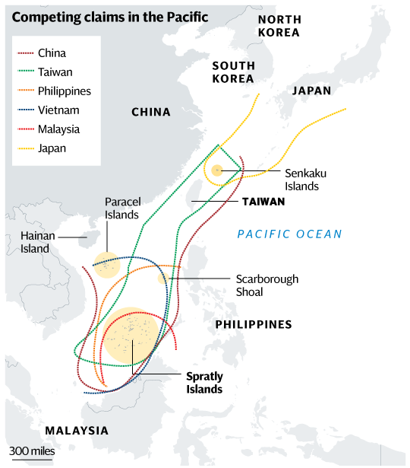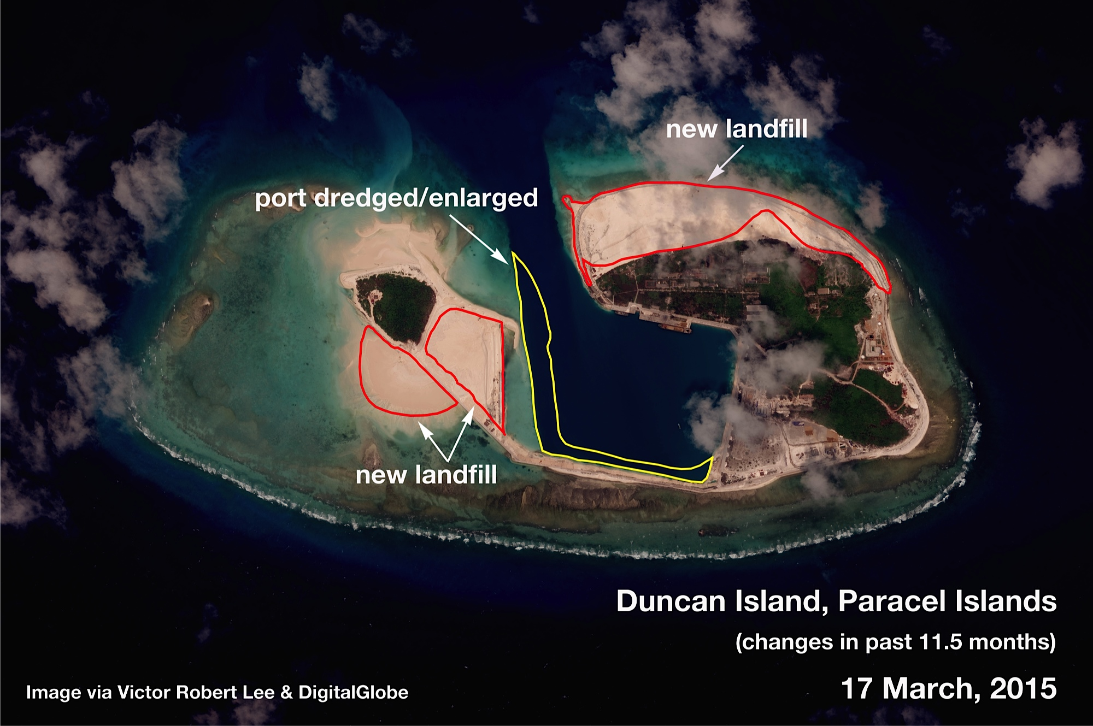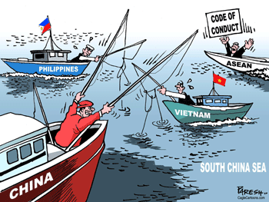intentions in the South China Sea.

**COUNTRIES INVOLVED**

**PEOPLE’S REPUBLIC OF CHINA**

PRC claims by far the largest portion of territory - an area defined by the "nine-dash line" which stretches hundreds of miles south and east from its most southerly province of Hainan. PRC says its right to the area goes back centuries to when the Paracel and Spratly island chains were regarded as integral parts of the Chinese nation.

Vietnam hotly disputes China's historical account, saying China had never claimed sovereignty over the islands before the 1940s. Vietnam says it has actively ruled over both the Paracels and the Spratlys since the 17th Century - and has the documents to prove it. Both the Philippines and China lay claim to the Scarborough Shoal (known as Huangyan Island in China) - a little more than 100 miles (160km) from the Philippines and 500 miles from China.

**INDIA**

India's state-run explorer, [Oil and Natural Gas Corporation (ONGC)](https://en.wikipedia.org/wiki/ONGC) said that its overseas investment arm, ONGC Videsh Limited, had signed a three-year agreement with [PetroVietnam](https://en.wikipedia.org/wiki/PetroVietnam) for developing long-term co-operation in the oil sector, and that it had accepted Vietnam's offer of exploration in certain specified blocks in the South China Sea. In response, Chinese Foreign Ministry spokesperson Jiang Yu, without referring to India by name, stated:

"China enjoys indisputable sovereignty over the South China Sea and the island. China's stand is based on historical facts and international law. China's sovereign rights and positions are formed in the course of history and this position has been held by Chinese Government for long. On the basis of this China is ready to engage in peaceful negotiations and friendly consultations to peacefully solve the disputes over territorial sovereignty and maritime rights so as to positively contribute to peace and tranquility in the South China Sea area. We hope that the relevant countries respect China's position and refrain from taking unilateral action to complicate and expand the issue. We hope they will respect and support countries in the region to solve the bilateral disputes through bilateral channels. As for oil and gas exploration activities, our consistent position is that we are opposed to any country engaging in oil and gas exploration and development activities in waters under China's jurisdiction. We hope the foreign countries do not get involved in South China Sea dispute."

**INDONESIA**

As an archipelagic state, Indonesia is entitled to an exclusive economic zone (EEZ) around its Natuna Islands (or Riau Islands in Indonesia), which are located in the South China Sea. In that zone are some of Indonesia’s largest offshore natural gas fields. Unfortunately, a portion of that zone also falls within China’s “nine-dash line” claim that encloses most of the South China Sea.

People’s Republic of China has long asserted its sovereignty over everything inside its claim line, including the part that overlaps with Indonesia’s EEZ. But, until recently, it had no way to enforce its claims. Chinese naval and air forces were unable to project and sustain power into the southern South China Sea.

**MALAYSIA**

The features claimed by Malaysia are the islands named Swallow Reef, Amboyna Cay (Vietnam occupied), Barque Canada Reef (Vietnam occupied) and Commodore Reef/Rizal Reef (Philippine occupied), and the rocks forming Erica Reef, Investigator Shoal, and Mariveles Reef. The islands are entitled to a territorial sea, EEZ, and continental shelf. The rocks are entitled only to a 12-mile territorial sea.

**PHILLIPINES**

The Philippines has asserted claims to Scarborough Shoal as well a collection of 50 [Spratly island] features which are known collectively as the Kalayaan island group (KIG). The Philippine claims to sovereignty over the features known as Scarborough Shoal and the KIG are independent of its archipelagic status both legally and historically.

The Philippines has been long facing a dispute against PRC over the use of natural resources in the overlapping claimed territories. A contingency involves conflict between China and the Philippines over natural gas deposits, especially in the disputed area of Reed Bank, located eighty nautical miles from Palawan. Oil survey ships operating in Reed Bank under contract have increasingly been harassed by Chinese vessels.

**UNITED STATES OF AMERICA**

U.S. policy towards the South China Sea has been premised on the principle of maintaining neutrality regarding the conflicting claims to sovereignty. Taking sides would be costly for the United States, as the United States does not want to increase its direct involvement in China’s sovereignty disputes nor make the South China Sea a central issue in the U.S.-China relationship. Nevertheless, a tension exists between the principle of maintaining neutrality and greater involvement in efforts to manage tensions in the dispute, especially when one country is identified as being the primary source of increased tensions.The Department of Defence states that it is taking action to protect U.S. national interests in the South China Sea: peaceful resolution of disputes, freedom of navigation and over flight and other internationally lawful uses of the sea related to these freedoms, unimpeded lawful commerce, respect for international law, and the maintenance of peace and stability.

The presence includes ship visits, reconnaissance aircraft flights, and military exercises with Philippines, Malaysia, and Vietnam. Additional military assistance and intelligence of Chinese activities in the sea also is being provided. Today, 51 of the U.S, Navy’s 289 ships are deployed in the Asia-Pacific area.  The numbers will grow to 58 ships next year and to 67 by the year 2020. The US has expanded negotiations with Manila and is seeking to build facilities and storage sites in the Philippines, as well as gain greater access to bases for its aircraft and warships. Bases the US is considering are all facing the South China Sea. U.S. claims that this presence not only reinforces their regional diplomacy, it also deters provocative conduct and reduces the risk of miscalculation in the area.

A strictly bilateral issue between Washington and Beijing exists in both the South China Sea, and, for that matter, the East China Sea. China objects to U.S. surveillance activities in its coastal EEZ. There is a decided difference of opinion regarding what military activities are permitted in an EEZ: Washington argues that UNCLOS permits nations to exercise “high seas freedoms” in the EEZs of coastal states. These “high seas freedoms” include the right to conduct peaceful military activities, which include, inter alia, surveillance and military surveys. China disagrees. It claims that these are not peaceful activities.

The U.S. desires for a Code of Conduct between China and ASEAN (the Association of Southeast Asian Nations) to prevent escalation in the South China Sea. An effective Code of Conduct according to U.S. would promote a rules based framework for managing and regulating the behavior of relevant countries in the South China Sea. A key part of that framework, which U.S. believes should be adopted quickly, is inclusion of mechanisms such as hotlines and emergency procedures for preventing incidents in sensitive areas and managing them when they do occur in ways that prevent disputes from escalating.

**The U.S. rebalances to Asia strategy**

This strategy includes an integrated mix of diplomatic, economic, budgetary, and security initiatives. Specific military posture changes are focused on Southeast Asia, and are intended to increase U.S. presence through rotational deployment, more frequent port visits, and improved military-to-military engagements and training exercises with the Philippines, Vietnam, and Singapore.

### [Treaty of Mutual Cooperation and Security](http://en.wikipedia.org/wiki/Treaty_of_Mutual_Cooperation_and_Security_between_the_United_States_and_Japan)between the United States and Japan

The treaty established that any attack against Japan or the United States perpetrated within Japanese territorial administration would be dangerous to the respective countries' own peace and safety. It requires both countries to act to meet the common danger. To support this requirement, it provided for the continued presence of U.S. military bases in Japan. The treaty also included general provisions on the further development of international cooperation and on improved future economic cooperation.

**The Mutual Defense Treaty between the Republic of the Philippinesand the United States of America**

The overall accord contained eight articles and dictated that both nations would support each other if either the Philippines or the United States were to be attacked by an external party.

Enhanced Defense Cooperation Agreement

The EDCA seeks to bolster the U.S. – Philippines security relationship by allowing the United States to station troops and operations on Philippine territory. However, the Agreement clearly states that the U.S. is not allowed to establish a permanent base. The Agreement also stipulates that the U.S. is not allowed to store or position any nuclear weapons on Philippine territory.

**VIETNAM**

Vietnam has laid its claims upon the Paracel Islands. Vietnam demonstrated a clear intent to assert sovereignty over the islands through the establishment of a government-sponsored company to exploit and manage the resources of the archipelago. That intent was confirmed by the annexation of the islands and symbolic acts of sovereignty in the early 19th century, followed by peaceful, effective, and continuous administration of the islands by successive Nguyen dynasties until the advent of the French colonial period.

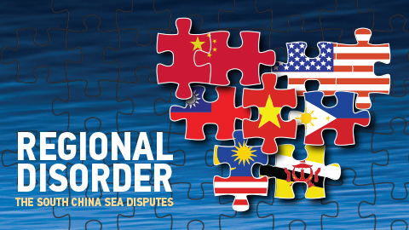

**BASICS OF INTERNATIONAL LAW**

**A. PURPOSE OF THIS DOCUMENT**

This document is intended to provide delegates an overview of international law and the structure of the international legal system. In many cases it oversimplifies the law by summarizing key principles in less than one page in order to provide the student with an overview that will enhance further study of the topic.

**B. DEFINITION OF INTERNATIONAL LAW** International Law consists of the rules and principles of general application dealing with the conduct of States and of international organizations in their international relations with one another and with private individuals, minority groups and transnational companies.

**C. INTERNATIONAL LEGAL PERSONALITY**

International legal personality refers to the entities or legal persons that can have rights and obligations under international law.

1. States

A State has the following characteristics: (1) a permanent population; (2) a defined territory; (3) a government; and (4) the capacity to enter into relations with other States. Some writers also argue that a State must be fully independent and be recognized as a State by other States. The international legal system is a horizontal system dominated by States which are, in principle, considered sovereign and equal. International law is predominately made and implemented by States. Only States can have sovereignty over territory. Only States can become members of the United Nations and other international organizations. Only States have access to the International Court of Justice.

1. International Organizations

International Organizations are established by States through international agreements and their powers are limited to those conferred on them in their constituent document. International organizations have a limited degree of international personality, especially vis-à-vis member States. They can enter into international agreements and their representatives have certain privileges and immunities. The constituent document may also provide that member States area legally bound to comply with decisions on particular matters. The powers of the United Nations are set out in the United Nations Charter of 1945. The main political organ is the General Assembly and its authority on most matters (such as human rights and economic and social issues) is limited to discussing issues and making recommendations. The Security Council has the authority to make decisions that are binding on all member States when it is performing its primary responsibility of maintaining international peace and security. The main UN judicial organ is International Court of Justice (ICJ), which has the power to make binding decisions on questions of international law that have been referred to it by States or give advisory opinions to the U.N.

1. Nationality of individuals, companies, etc.

Individuals are generally not regarded as legal persons under international law. Their link to State is through the concept of nationality, which may or may not require citizenship. Nationality is the status of being treated as a national of a State for particular purposes. Each State has wide discretion to determine who is a national. The most common methods of acquiring nationality at birth are through one or both parents and/or by the place of birth. Nationality can also be acquired by adoption and naturalization. Companies, ships, aircraft and space craft are usually considered as having the nationality of the State in whose territory they are registered. This is important because in many circumstances States may have international obligations to regulate the conduct of their nationals, especially if they are carrying out act activities outside their territory. Under the principle of nationality of claims, if a national of State A is injured by State B through internationally unlawful conduct, State A may make a claim against State B on behalf of its injured national. This is known as the doctrine of diplomatic protection.

**E. INTERNATIONAL OBLIGATIONS (SOURCES OF LAW)**

It is generally accepted that the sources of international law are listed in the Article 38(1) of the Statute of the International Court of Justice, which provides that the Court shall apply:

a) International conventions, whether general or particular, establishing rules expressly recognized by the contesting states;

b) International custom, as evidence of a general practice accepted as law;

c) The general principles of law recognized by civilized nations;

d) Subject to the provisions of Article 59, judicial decisions and the teachings of the most highly qualified publicists of the various nations, as subsidiary means for the determination of rules of law.

**F. STATUS OF THE SEAS, OUTER SPACE AND ANTARCTICA**

1. High Seas The high seas are governed by several fundamental principles. First, no State may purport to assert sovereignty over any part of the high seas. Second, all States have the right to exercise the freedoms of the seas, including freedoms of navigation, freedom of overflight, freedom to lay submarine cables and pipelines, and freedom to conduct marine scientific research. Freedom of fishing was a traditional high seas freedom but fishing on the high seas is subject to restrictions as set out in the 1982 United Nations Convention on the Law of the Sea. It is generally agreed that freedom of the seas also includes the right of all States to use the high seas for military purposes, including weapons testing and naval exercises.

2. Exclusive economic zone Coastal States are permitted to claim an exclusive economic zone (EEZ) of up to 200 nautical miles from the baselines from which the territorial sea is measured wherein they have the sovereign right to explore and exploit the natural resources of the sea and of the seabed and subsoil. The EEZ is neither under the sovereignty of the coastal State nor part of the high seas. It is a specific legal regime in which coastal States have the rights and jurisdiction set out in UNCLOS, and other States have the rights and freedoms set out in UNCLOS. Other States have the right to exercise high seas freedoms in the EEZ of any State. With respect to jurisdiction over matters outside of economic activities, the principles of jurisdiction governing the high seas apply in the EEZ.

3. Deep Seabed beyond the limits of national jurisdiction The natural resources of the deep sea bed beyond the limits of national jurisdiction are vested in mankind as a whole under the principle of the common heritage of mankind. No State may claim or exercise sovereignty or sovereign rights over any part of this area or its resources and it is governed by the International Sea Bed Authority (ISBA) No State or natural or juridical person may appropriate any part of the area or its resources except under the authority of the ISBA.

4. Outer Space The principles governing the use of outer space are similar to those that the high seas. First, no State may purport to assert sovereignty over any part of outer space. Second, all States have the freedom to use outer space for peaceful purposes. Third, States on whose registry a space object is launched shall retain jurisdiction and control over the space object and over any persons on board the space object.

**COMPETING LEGAL CLAIMS IN THE SOUTH CHINA SEA**

The following principles of law have been stated and used for argumentation by various countries in the several issues that concern the South China Sea. The table below enlists the different issuesalong with the different international provisions that should be kept in mind.

|  |  |  |
| --- | --- | --- |
|  | The issue of Spartly Islands | Historical Claims, Effective Occupation |
|  |  |  |
|  | The issue of Paracel Islands | Historical Claims, Effective Occupation |
|  |  |  |
|  | The issue of the nine dashed lines | Historical Claims |
|  |  |  |
|  | The issue of the US Navy Fleets | Principles of Military Aggression |
|  |  |  |
|  | Oil drilling in the South China Sea | UNCLOS Exclusive Economic Zone provisions |
|  |  |  |
|  | The issue of the East China Sea Islands | Historical Claims, Military engagement between Japan-China |
|  |  |  |
|  |  |

The several competing claims in the area of South China Sea are summarized:

China’s claims are **quite historical,**but oftentimes invalidated by its incapacity to adhere to the Palmas Case of April 1928 that requires that continuing and effective occupation is necessary to make a claim of historical occupation. China and Vietnam claim the entire area of the South China Sea and the islands within it while Malaysia, the Philippines, Indonesia, and Brunei have laid claims to contiguous areas. Two principles govern the claims, both of which work against the Chinese claim to the entire area.

One is *‘‘****effective occupation****,’’*a precedent established by the **Permanent Court of Arbitration in the Island of Palmas case in April 1928.**Effective occupation entails an ability and intention to exercise continuous and uninterrupted jurisdiction, which is distinguished from conquest. Though China has occupied the Paracel Island, an archipelago of around 30 islands about equidistant from the Chinese and Vietnamese coasts the doctrine of effective occupation goes against China in the Spratly Island an archipelago off the coasts of the Philippines and Malaysia where, except for nine islands it occupied from 1988—1992, the islands are occupied by the ASEAN claimants.

The second principle is the **United Nations Convention on the Law of the Sea (UNCLOS), which lays down the rules to decide claims to resources based on exclusive economic zones (EEZs) and continental shelves**(an EEZ is a maritime zone stretching up to 320 kilometers from the coast that supports the coastal state’s claims to the resources there). UNCLOS does not support claims that go beyond EEZs or declared continental shelves, yet China’s claim goes well beyond its EEZ and overlaps with the legal claims of the ASEAN states.

China’s claim is based on history, but such claims do not carry much weight in international law, which from the Chinese perspective downgrades China’s ancestral heritage and is a source of resentment. China’s attitude is that its claim predates UNCLOS (which was agreed to in 1982 and came into force in 1994 after the 60th state ratified it) and that it should be adjusted to accommodate historical rights. To assert those claims in a situation where the complexity of international law may not support them, the Chinese have resorted to constant diplomatic pressure

to either revise international law or gain a special exception to it, where China’s ancestral claims would be recognized by all.

China’s unflinching assertion of its nine-dotted line has created diplomatic tensions between China and its maritime neighbours.