Visual Semantic Profiling of the Voynich Manuscript: Reading Meaning from Illustrations in an Undeciphered Codex
Jacob Lyons
v4.2.1 — July 2026
Abstract
The Voynich Manuscript (Beinecke MS 408) is a 240-page illustrated codex carbon-dated to 1404–1438 whose script has resisted decipherment for more than six centuries. Every quantitative decipherment attempt on record — from William Friedman’s WWII codebreakers to contemporary neural language models — has treated the manuscript as a text-first object. We present the first systematic computational visual semantic analysis of the manuscript, treating its 206 page images as the primary signal. Using a zero-shot visual semantic profiling platform in which a frozen vision-language foundation model is scored against sixteen natural-language archetype descriptors, we profile every analysable page of the Beinecke digital facsimile (197 pages after excluding nine covers and binding flyleaves) and measure whether the resulting sixteen-dimensional profiles discriminate between the scholarly section taxonomy. All sixteen dimensions discriminate between sections at $p<{10}^{−15}$ under one-way ANOVA, Welch’s robust ANOVA, and Kruskal–Wallis tests, with effect sizes ($η^{2}$) between 0.30 and 0.83. A multinomial logistic regression — fit inside a Pipeline that eliminates cross-validation scaler leakage — recovers scholarly section labels with 90.4% leave-one-out accuracy (Wilson 95% CI [85.4%, 93.7%]; permutation-test $p<{10}^{−3}$), against a 20% chance baseline and a 59.9% majority-class baseline. As ablations we report 92.4% accuracy on the raw 768-d foundation-model embeddings (the archetype projection trades a small amount of accuracy for full interpretability) and 72.1% on six handcrafted layout features (layout alone carries real but strictly weaker signal). A lens-specificity control shows that two alternative 16-d archetype lenses — a cross-cultural archaeological lens and a hermetic cryptological lens — also recover section structure well above chance (84.8% and 87.3% respectively), confirming that the recovered signal is a property of the manuscript rather than of the target-appropriate lens. A head-to-head comparison against a character-n-gram classifier on Takeshi Takahashi’s complete Voynichese transcription shows that the text channel recovers sections at 92.3% — statistically indistinguishable from the 16-d visual channel on the same 182-page intersection — while the raw 768-d visual embedding achieves 96.2%: both channels carry the section structure, and the visual channel offers the unique advantage of producing profiles that are human-readable in a known language. An out-of-distribution sanity check applies the voynich lens via a local off-the-shelf CLIP pipeline to the Tacuinum Sanitatis (a same-era medieval herbal peer), the Codex Seraphinianus, and the Rohonc Codex: the lens fires on herbal/pharmaceutical/fertility dimensions for the Tacuinum and on encoded/hidden for the two undeciphered-script codices, confirming that the lens is a legitimate medieval-codex content detector rather than a Voynich-specific artefact. The only class where the Voynich classifier fails badly is the pharmaceutical section, which is misclassified almost exclusively as herbal with 50% recall but 91% precision — a failure that matches the scholarly observation that pharmaceutical pages share the same plant specimens as the herbal section, and we show the individual misclassified pages in a qualitative gallery. We conclude that the illustrations of the Voynich Manuscript encode structured thematic content accessible to computational analysis even though the underlying text is not, that the scholarly section structure is independently recoverable by a non-textual method, and that the broader visual channel of the manuscript is considerably richer than the text-first literature has assumed. We do not claim to have read the manuscript. We claim only that one more channel of the manuscript — its visual channel — is not empty. Per-page profile vectors, statistical tables, and UMAP coordinates are released under CC BY-SA 4.0 at Zenodo DOI 10.5281/zenodo.19560769; the profile-generation pipeline is covered by a pending provisional patent and is not disclosed.

1. Introduction
What can distant viewing (Arnold and Tilton 2023) recover from an illustrated manuscript whose text refuses to be read? The Voynich Manuscript (Beinecke MS 408) is the natural extreme case for that question. Its parchment has been carbon-dated to 1404–1438 (Hodgins 2011); its script has defeated six centuries of decipherment; its imagery — plants, astronomical diagrams, bathing figures, apothecary vessels — has been catalogued qualitatively but never submitted to systematic computational visual-semantic profiling. This paper asks what a distant-viewing method can recover from the manuscript’s visual channel when the text channel remains inaccessible, and offers the finding as a case study in what computational analysis can and cannot say about a heritage object stripped of its usual interpretive anchor.
We profile every analysable page of the Beinecke digital facsimile through a sixteen-dimensional human-authored archetype lens, evaluate the resulting profiles against the manuscript’s scholarly section taxonomy, and report the finding inside its methodological commitments: the archetype vocabulary is a human-authored interpretive apparatus (§3.1, §6.7); the foundation model encodes a specific training-corpus provenance (§3.2, §6.6); the sixteen-dimensional representation forecloses the codicological, palaeographic, and iconographic detail a manuscript-studies reading would surface (§6.7). Within those commitments, our contribution is the first computational validation of the Voynich section structure through a non-textual method — a distant-viewing case study on a manuscript for which the text anchor that usually grounds distant-viewing interpretation is absent.
The finding: all sixteen dimensions discriminate between sections at $p<{10}^{−15}$ under one-way ANOVA, Welch’s robust ANOVA, and Kruskal–Wallis tests. A Pipeline-wrapped multinomial logistic regression on the sixteen-dimensional profiles recovers scholarly section assignments with 90.4% leave-one-out accuracy (Wilson 95% CI [85.4%, 93.7%]; permutation-test $p<{10}^{−3}$). A Chari-Pachter marginal-matched null shuffle (1000 draws) collapses to a 54.8% median, indicating that the joint structure across dimensions carries the signal. We do not decipher the manuscript; we recover structure that its imagery was already known to carry and that has, to now, been invisible to quantitative analysis. The intended readers are the manuscript-studies, digital-humanities, and computational-art-history communities that have — for different reasons — cared about this object; §6.9 discusses what practitioners in each community might do with the released dataset.
The Voynich Manuscript, catalogued at Yale University’s Beinecke Rare Book and Manuscript Library as MS 408, is among the most persistently unreadable documents in the human record. Its parchment has been carbon-dated to 1404–1438 (Hodgins 2011; Clemens 2016). Its script — an undeciphered left-to-right alphabet of roughly twenty-five distinct glyphs universally referred to as Voynichese — has defeated the combined attention of professional cryptanalysts, classical philologists, statistical linguists, and contemporary neural language models. No successful decryption has been verified. No source language has been agreed upon. No concrete authorial identity has been established. William Friedman, one of the architects of modern cryptanalysis, worked on the manuscript intermittently for thirty years and died without a solution (D’Imperio 1978). Gordon Rugg’s 2004 hoax hypothesis (Rugg 2004) and Hauer and Kondrak’s 2016 Hebrew-anagram hypothesis (Hauer and Kondrak 2016) illustrate the bounds of current scholarly consensus: the only thing most Voynich researchers agree on is that the manuscript is unlike anything else in the Western codicological record, and that we still do not know what it says.
What is striking about this centuries-long effort is that almost all of it has been addressed to the text of the manuscript. The Voynich Manuscript is also a heavily illustrated codex. Its pages are crowded with hand-drawn plants, concentric cosmological diagrams, nude female figures immersed in pools connected by plumbing-like channels, labelled stars, and arrays of apothecary vessels. These images are not decorative — they occupy most of the visual surface of most pages, and their organisation is the primary basis on which scholars have divided the manuscript into sections in the first place (Kennedy and Churchill 2004; Clemens 2016). And yet, to our knowledge, no prior work has asked the narrower, answerable question: do the illustrations encode recoverable thematic structure when analysed as images alone, independent of the text?
This paper answers that question affirmatively. We present a zero-shot visual semantic profiling analysis of all 206 page images in the Beinecke digital facsimile, using as the primary analysis the 197 pages whose section label is unambiguous. We do not attempt to decipher Voynichese. We do not make any claim about authorship, date of composition beyond the established radiocarbon range, language family, or meaning. We examine only whether structured meaning survives in the channel that the field has, for six hundred years, treated as secondary: the pictures. We are also careful to distinguish our contribution from prior non-computational visual analysis of the Voynich imagery, which is extensive and is cited in §2.3; the novelty of this paper is specifically the application of systematic computational profiling to the illustration programme, not the claim that nobody has looked at the pictures before.
Our central result is that every one of sixteen visually-defined archetype dimensions discriminates statistically between the manuscript’s scholarly sections at $p<{10}^{−15}$ under three complementary statistical tests, and that a simple Pipeline-wrapped multinomial logistic regression on the resulting sixteen-dimensional profiles recovers scholarly section assignments with 90.4% leave-one-out accuracy (Wilson 95% CI [85.4%, 93.7%]; 1000-shuffle permutation test $p<{10}^{−3}$). Where the classifier fails, it fails in exactly the way an informed reader of the manuscript would expect: pharmaceutical pages, which contain the same plant specimens as the herbal section, are misclassified as herbal. This is not noise. It is the system confirming what every Voynich scholar already sees. We also report two ablations that a methodologically careful reader should see before trusting the headline number: the raw 768-d foundation-model embeddings of the same pages slightly out-perform the 16-d archetype projection at the price of uninterpretability, and a set of six handcrafted low-level layout features recovers the sections at 72% — well above chance, confirming that low-level image properties carry part of the signal, but meaningfully below what the archetype lens extracts. And a lens-specificity control, in which the same pipeline is applied to two unrelated 16-d archetype lenses, demonstrates that the signal is a property of the manuscript rather than of the medieval-codex lens we happen to have authored for it.
The philosophical weight of the result is modest but, we believe, useful. The Voynich Manuscript has become a kind of null-control for computational linguistics: whatever method you have, if it cannot tell you what the Voynich says, it cannot tell you what anything says. Visual semantic profiling sidesteps that standard by refusing to answer the question at all. We do not claim the illustrations mean what the text says. We claim only that the illustrations mean something, that the something is thematically structured, and that the structure is machine-measurable. Whether that structure reflects a coherent underlying subject matter, a layout convention, or the pictorial habits of a single scribe working in a shared visual vocabulary is a question we leave open. It is a good question. We think it will prove more tractable than the text has.
A zero-shot visual semantic profiling pipeline, applied to an undeciphered manuscript, has implications that extend beyond the specific findings of this paper. We sketch them briefly so that readers new to Voynich studies can place the contribution in context.
First, pattern recognition at scale. A pipeline of this kind can systematically catalogue visual motifs across the manuscript’s two hundred pages at once, identify recurring symbols or structural regularities, and surface subtle correlations that exceed what an unaided reader can hold simultaneously in mind. The same pipeline, run against a corpus of image-heavy historical documents and medieval manuscripts, enables comparative analysis at a depth and speed that no individual researcher or team can practically achieve.
Second, a new analytical lens with inspectable inductive biases. The history of Voynich research is in part a record of overconfident decipherment claims; every proposed reading has collapsed under scrutiny. A computational lens does not eliminate cognitive bias, but it carries biases that are inspectable and falsifiable in ways that the biases of an individual scholar are not. The platform applied here makes its archetype lens explicit (§3.1), publishes its per-page scores (§4.4), and submits to ablations against alternative lenses (§5.4) — discipline that the field has historically struggled to maintain when individual readings have been proposed.
Third, the categorical question about the manuscript’s nature — natural language, cipher, hoax, glossolalia, or something else — remains open after six centuries. Settling that question, or even bounding it, would redirect all subsequent scholarship more productively. Visual semantic profiling does not settle the question, but it provides one more channel against which competing hypotheses can be tested.
Finally, the broadening of analytical access. A reproducible computational lens, with public data and a documented analysis script (Appendix B), allows researchers outside specialised Voynich circles to engage with the manuscript at a level of detail that has historically required years of immersion in the literature. The intent is not to displace Voynich specialists but to broaden the contributor base and inject perspectives that traditional access patterns have foreclosed. The history of Voynich research is in significant part a history of overconfident claims. Foundation-model-based pipelines, including the one used in this paper, are not immune to producing plausible-sounding but ultimately false patterns; rigorous validation remains essential. The framing throughout this paper has been deliberate: we present visual semantic profiling as a hypothesis generator that human scholars then rigorously test, not as a final arbiter. Our control probes (§5.12), ablations (§5.3), and lens-specificity tests (§5.4) are themselves a partial implementation of that discipline.
That caution acknowledged: if a computational visual semantic pipeline of this kind performs as the present results suggest it can, it would represent a methodological advance in Voynich studies of a kind not seen since carbon dating placed the manuscript’s creation in the early fifteenth century. The result here is one data point in support of that possibility. It is not yet a confirmation.
A note on reproducibility before we proceed: the profile-generation pipeline — the foundation model, the exact dimension descriptors, and the training history — is covered by a pending provisional patent (§7). All statistical analyses reported in §5, and every figure in this paper, are fully reproducible from the public Zenodo dataset at DOI 10.5281/zenodo.19560769 using the published analysis script (Appendix B). We state this boundary explicitly in §1, §7, and §B rather than leaving the reader to infer it.

2. Related Work

2.1 Prior decipherment attempts: all text, almost no pictures
The modern history of Voynich scholarship begins with William Friedman and the First Voynich Manuscript Study Group of the 1940s (D’Imperio 1978); Kahn’s The Codebreakers (Kahn 1967) provides the canonical historical frame for that generation’s cryptanalytic methods. Friedman, who led the Signal Intelligence Service codebreaking effort against the Japanese PURPLE cipher, applied the same frequency-analytic tools to Voynichese without success. Captain Prescott Currier’s transcription alphabet (Currier 1976) and Mary E. D’Imperio’s monograph The Voynich Manuscript: An Elegant Enigma (D’Imperio 1978), produced under NSA auspices in 1978, together represent the first generation of sustained cryptanalytic engagement. They treated the manuscript as a cipher, assumed a source language, and sought a key. Neither succeeded.
The second wave is linguistic and statistical. Landini (Landini 2001) applied spectral analysis to Voynichese and reported word-length distributions consistent with natural language rather than random strings. Reddy and Knight (Reddy and Knight 2011) showed that Voynichese n-gram statistics fall within the range observed for known natural languages, undermining the stronger forms of the hoax hypothesis. Gordon Rugg (Rugg 2004) argued, by contrast, that a sixteenth-century hoaxer with a table-grille and a list of Voynichese syllables could produce statistically-natural-looking text, reinstating the hoax hypothesis as at least plausible. Stephen Bax (Bax 2014) claimed partial proper-noun readings for a handful of plant and star labels. Hauer and Kondrak (Hauer and Kondrak 2016) hypothesised that Voynichese is anagrammed Hebrew and reported plausible decodings of the manuscript’s opening lines. Gerard Cheshire’s 2019 proto-Romance claim (Cheshire 2019) was rapidly and unanimously rejected by the scholarly community (Fagin Davis 2019). The pattern is consistent: every generation of cryptanalytic and linguistic technology reaches for the manuscript, produces a partial and contested reading, and the field’s consensus settles back into uncertainty.
Across all of this work, the illustrations appear mainly as anchor points for identifying which section is under discussion. They are visual captions for the text, never the object of analysis.

2.2 Neural language models on Voynichese
The arrival of large neural language models has added a new cohort of attempts. Montemurro and Zanette (Montemurro and Zanette 2013) applied information-theoretic keyword-clustering methods and demonstrated that Voynichese exhibits long-range word-frequency correlations characteristic of meaningful semantic content — the strongest quantitative evidence against the pure-hoax hypothesis. Character-level recurrent and transformer architectures have been explored in unpublished work, but none has produced a decipherment or a convincing generative model of the script, and the fundamental obstacle remains: all text-based approaches require a transcription layer — itself a source of systematic error, since there is no ground-truth character segmentation — and operate on a corpus of only approximately thirty-eight thousand tokens, well below the data requirements of modern neural language models. As in the earlier cryptanalytic waves, the text is the object and the illustrations are ignored.

2.3 Art-historical and non-computational visual analysis
A point worth being explicit about: the Voynich illustrations have been looked at carefully, for a long time, by serious readers. They have not been computationally profiled, and that is the gap we address; but it would misrepresent the field to suggest nobody has engaged with the imagery. Edith Sherwood has published extensive (and contentious) botanical identifications of the herbal illustrations (Sherwood 2008), attempting to match the Voynich plants to specimens from New World and Old World sources. Nicholas Pelling’s The Curse of the Voynich (Pelling 2006) includes sustained visual analysis of the illustration programme, hand conventions, and iconographic anomalies. René Zandbergen’s long-running reference site voynich.nu (Zandbergen 2004--2026) catalogues illustration types, pigment observations, and codicological detail at a level no published monograph matches. Lisa Fagin Davis’s digital palaeography of the manuscript (Fagin Davis 2020) addresses quire structure and scribal hand distributions, both of which bear directly on how the sections were physically assembled. The Voynich Ninja online forum is the primary venue for ongoing scholarly discussion of the imagery. This work is qualitative and domain-expert; it is not computational in the sense of producing reproducible numerical profiles on every page. The contribution of the present paper is to introduce that complementary layer, not to supersede the art-historical tradition.

2.4 Computer vision in cultural heritage manuscripts
There is, separately, a mature line of work applying computer vision to medieval and early-modern manuscripts. Document-image pipelines such as the DIVA-HisDB framework (Simistira et al. 2016) target layout analysis, character segmentation, and script classification. CNN-based manuscript dating (He et al. 2016; Studer et al. 2019) uses letterform morphology rather than page content. Style recognition in illuminated manuscripts and early books (Saleh and Elgammal 2016; Shen et al. 2019) has proven robust for attribution and period classification. IIIF-enabled analysis pipelines (Snydman et al. 2015) have made large facsimile collections computationally accessible.
None of this work, to our knowledge, has been applied to the Voynich Manuscript as a semantic analysis of its imagery. The existing computer-vision engagements with the Voynich Manuscript treat the illustrations as layout regions to be masked out so that Voynichese transcription is not polluted by pictorial ink.
More recently, the emergence of foundation vision-language models (Radford et al. 2021; Dosovitskiy et al. 2021) has enabled zero-shot and few-shot analysis of heritage imagery without task-specific fine-tuning. Computer-vision-for-art-history work from the École des Ponts group — notably Shen, Pastrolin, Bounou, Gidaris, Smith, Poncet, and Aubry’s large-scale historical watermark recognition (Shen et al. 2020), complementing their earlier pattern-retrieval work on art collections (Shen et al. 2019) — and computational-art-history work using human-pose foundation models, such as Bernasconi, Cetinić, and Impett’s hand-pose recognition dataset for early modern paintings (Bernasconi et al. 2023), together establish the methodological neighbourhood this paper works inside. Manovich’s Cultural Analytics (Manovich 2020) is the broader methodological framing for scalable image-based cultural analysis. Our present work extends this line by applying a zero-shot VLM + archetype-lens methodology to a manuscript whose text channel has defeated prior analyses — a case where the visual channel is the last remaining signal.

2.5 The gap we address
The contribution is narrow but, we believe, new. Prior art-historical work has looked at the illustrations at length; prior computational work has looked past them to the script. No prior work, to our knowledge, has submitted the Voynich illustrations to systematic computational visual-semantic profiling on a per-page basis with quantitative discrimination analysis against the scholarly section taxonomy. We ask that question, and we answer it.

2.6 Distant viewing and the computational-humanities methodological lineage
This paper sits inside a broader methodological conversation in the digital humanities about what computational methods can and cannot tell us about humanistic objects. The distant reading tradition (Moretti 2013; Jockers 2013; Piper 2018; Underwood 2019) asks what large-scale quantitative analysis of literary corpora reveals that close reading cannot; its image-side counterpart, distant viewing (Arnold and Tilton 2023), asks the same question of visual corpora. Our work is closer to distant viewing than to distant reading: the object of analysis is an image corpus, the method is computational, and the ambition is to surface structure that qualitative reading does not straightforwardly access. Johanna Drucker’s Graphesis (Drucker 2014) is an essential companion to work of this shape — it asks what it commits us to, ontologically, to represent a humanistic object as a numerical vector; we take that question seriously in §6.6. The present paper’s specific contribution inside this lineage is narrow: we apply the distant-viewing methodology to a manuscript whose text has been the primary target of six centuries of attention and whose imagery has been systematically under-examined by computational methods.

3. Method
We describe the method at the level of principle. Implementation details — including the specific foundation model, the exact text of each dimension descriptor, and the production pipeline — are covered by a pending provisional patent and are available on request under appropriate research-use terms (§7). The description below is sufficient to reproduce the spirit of the analysis; the specific numerical results reported in §5 depend on the full implementation.

3.1 Visual semantic profiling
A visual semantic profile is a fixed-dimensional vector that measures, for each of a set of human-authored archetype dimensions, the semantic similarity between an image and a natural-language description of the dimension. The method has four components:
- A frozen vision-language foundation model. The model maps both images and natural-language strings into a shared high-dimensional embedding space in which semantic similarity is approximately monotonic in cosine similarity. The model is used entirely zero-shot: no weights are updated, no fine-tuning is performed, and no exposure to Voynich imagery or medieval manuscript imagery enters the training pipeline.
- Sixteen archetype dimensions. Each dimension is defined by a natural-language descriptor — a short paragraph in English written by the authors — that characterises, in ordinary prose, the visual content that the dimension is meant to capture. For the present analysis the sixteen dimensions are grouped into five thematic bands reflecting the expected content of an illustrated medieval codex: natural world (herbal/botanical, pharmaceutical/healing, natural/organic), celestial (celestial/astronomical, cosmological mapping, cyclical/seasonal, luminous/radiant), esoteric (alchemical transformation, ritualistic/ceremonial, encoded/hidden, supernatural/mystical), biological (anatomical/biological, aquatic/fluid, fertility/reproduction), and structural (geometric/mathematical, interconnected/networked). The precise wording of the descriptors is not disclosed in this paper. The thematic grouping and the human-readable labels are.
We flag a provenance subtlety here to be honest about what “zero-shot” means in this paper. The sixteen dimensions used for the primary analysis were authored for illustrated medieval codices, with the Voynich Manuscript as one of the motivating target documents. They were not tuned on the Voynich profile vectors, and no section labels entered the dimension-design process; but the thematic categories were chosen in knowledge of what illustrated medieval codices — including this one — are generally about. The honest framing is therefore: supervised dimension design, zero-shot profile computation. We do not claim the lens was authored in ignorance of its target. We claim that no Voynich image and no section label was used to tune the dimensions, and that the same dimensions applied unchanged to any illustrated medieval codex would still produce interpretable profiles. A lens-specificity control (§5.6) addresses the stronger objection: we show that the same pipeline applied to two unrelated 16-d lenses — one designed for cross-cultural archaeological imagery, one designed for hermetic/alchemical symbolism — still recovers Voynich section structure, although more weakly than the medieval-codex lens does. This is the correct empirical answer to “did the lens decide the result?”
Dimension-design revision history (forking-paths disclosure). In the spirit of pre-registration discipline, we disclose what we know about the design history of the sixteen dimensions. The reported sixteen dimensions are the original set authored for the medieval-codex lens; no dimension was added, dropped, renamed, or reweighted in response to observing per-section Voynich scores. The thematic-band grouping (natural world / celestial / esoteric / biological / structural) reflects the post-hoc convenience grouping presented in §3.1 paragraph 2 and was assigned after the dimensions were frozen, but it carries no mathematical weight — every test in §5 operates on the sixteen unweighted dimensions, not on the bands. We do not maintain a version-controlled revision history of intermediate dimension-set drafts that preceded the frozen sixteen, so we cannot enumerate iteration counts honestly; we therefore decline to claim “first authored set ever” and instead make the narrower verifiable claim: the sixteen dimensions used for every number in this paper are the same sixteen dimensions in the same order, never modified after first profiling on the Voynich corpus. A reader concerned about garden-of-forking-paths effects should read the lens-specificity control (§5.4) — which uses two entirely independent dimension sets authored before the medieval-codex lens — and the random-prompt null protocol (§5.12.1) as the empirical complement to this disclosure.
- Per-image profiling. Each page image is encoded once by the vision model. For each of the sixteen dimensions, the descriptor is encoded by the text side of the same model. The profile entry for a given (image, dimension) pair is the cosine similarity between the two embeddings. The result, for a single page, is a 16-vector.
- Section-level analysis. Pages are grouped by the scholarly section label assigned in the Beinecke metadata. Statistical tests (§5.2), classification (§5.3), and visualisation (§5.4, §5.5) operate on the 16-d per-page vectors and the section labels. The section labels are used for evaluation of whether the profiles recover section structure. They are not used for training — the profiling system is strictly zero-shot and never sees a section label until after the profiles are computed.

3.2 What is not disclosed
To protect a pending provisional patent application, the following details are intentionally omitted:
- The identity of the frozen foundation model.
- The exact text of the sixteen dimension descriptors.
- The training or distillation history of the embedding space.
- The specific cosine-similarity normalisation and temperature scaling applied prior to profile comparison.
- The complementary dimension discovery mode in which the system proposes latent dimensions from an unlabelled corpus (used in §6 but not as the primary analysis).
Readers interested in replicating the results with their own vision-language models are encouraged to do so. The per-page profile vectors used for every number in this paper are released as a public dataset under CC BY-SA 4.0 (§4).
We can, however, disclose the class of the foundation model without compromising the patent position: the model is a contemporary large-scale vision-language foundation model in the class of ViT-L/14 (or successor) architectures trained on web-scraped image–text pairs. Specifically, the model is a proprietary closed-weight model rather than an open-weight release; a reader interested in independently reproducing an equivalent analysis at the profile-generation layer could reasonably start from the OpenCLIP ViT-L/14 substrate used in the §5.9 out-of-distribution probe as a comparable open-weight baseline. This training-corpus class weights Western, internet-era, English-language visual-linguistic conventions, and the limitations that class implies for recognising non-Western or pre-modern visual conventions apply to any zero-shot analysis built on it, including ours. We discuss the specific implications of this training-corpus class for Voynich-imagery analysis in §6.6, and the political-economic dimension of foundation-model provenance in §6.7.

3.3 What the method does not do
The method does not read Voynichese. It does not attempt to translate the manuscript into any human language. It does not label individual plant specimens with botanical names, individual stars with astronomical identifiers, or individual figures with identities. It does not produce a narrative interpretation of any page. It produces, for each page, a sixteen-number summary of where that page lands in a human-defined thematic space. That is all, and that is enough for the question we are asking.

4. Data

4.1 Source
All image data was obtained from the Yale University Beinecke Rare Book and Manuscript Library’s public IIIF manifest for the Voynich Manuscript, Beinecke MS 408 (Beinecke Rare Book and Manuscript Library 2004). The manuscript is in the public domain (pre-1500) and the Beinecke facsimile is freely redistributable. The IIIF manifest lists 225 canvas entries covering the front and back covers, inside covers, flyleaves, fore-edge, spine, tail, head, and all 206 numbered or lettered pages. We downloaded the highest-resolution image available for each canvas (mean dimensions 2770 × 3770 pixels) via the Beinecke IIIF endpoint in March 2026.

4.2 Corpus composition
After download, we tagged each page image with a scholarly section label following the conventions established by Kennedy and Churchill (Kennedy and Churchill 2004) and maintained in the digital humanities literature (Clemens 2016; Zandbergen and Prinke 2016). The Voynich scholarly tradition, in Clemens, D’Imperio, Kennedy & Churchill, and Zandbergen’s voynich.nu, typically divides the manuscript into six sections: herbal, astronomical/astrological, biological (ff. 75r–84v, the nude-figures-in-pools pages), cosmological (ff. 85r–86v, the unique nine-rosette foldout sometimes called the mappa mundi), pharmaceutical, and recipes / stars. We use this six-section division for the supplementary analysis reported in §5.7. For the primary analysis in §5.1–§5.5 we adopt the coarser five-section partition distributed in the Beinecke IIIF metadata, in which the biological pages and the rosette foldout are merged under a single cosmological / biological label:
Section | Pages ($n$) | Illustration type
Herbal | 118 | Single plant specimen per page, botanical style
Astronomical | 12 | Zodiac wheels, stellar diagrams, concentric circles
Cosmological / Biological | 23 | Nude figures in pools and channels; rosette foldouts
Pharmaceutical | 20 | Root and vessel arrangements, apothecary jars
Recipes / Stars | 24 | Text-dense pages with marginal star bullets
Total (analysed) | 197
(Unknown / cover pages) | 9 | Front/back covers, binding, blank pages — excluded
We exclude the nine unknown / cover / binding pages from all section-level analysis. They enter no ANOVA, no classifier, and no visualisation. They are retained only in the raw profile release because their profiles (encoded_hidden near the top; herbal_botanical near the bottom) offer a useful null-baseline contrast.
Defending the five-section merge. A reader familiar with the manuscript may prefer the traditional six-section division in which the biological (bathing-figure) pages and the cosmological (rosette foldout) pages are kept separate. These sections are codicologically, iconographically, and thematically distinct: the biological pages are dominated by nude human figures in interconnected pools, and the four pages of the rosette foldout are arguably the most iconographically unique surface in the entire codex. D’Imperio (D’Imperio 1978) used the term balneological for the biological pages to emphasise their distinctness. We acknowledge the traditional division, and we report a six-section analysis in §5.7 as a sanity check. We adopt the five-section merge for the primary analysis for three reasons. First, the rosette foldout contributes only four pages to the cosmological class — a sample too small for a reliable leave-one-out classification estimate in its own right. Second, the merge matches the Beinecke facsimile metadata, which is the canonical source and which a reader attempting to reproduce our analysis from the released profile files will encounter first. Third, the six-section analysis (§5.7) confirms that all of our numerical results hold qualitatively: splitting biological from cosmological does not improve classification accuracy beyond what the merge achieves, because the rosette foldout pages cluster comfortably with the biological section in semantic space. Where this merge matters to scholarly interpretation, we flag it explicitly.

4.3 Exclusions
The corpus metadata distributed with our public release lists every downloaded canvas. The nine covers / binding / flyleaf pages are flagged section = unknown and excluded from every statistical test. No illustrated page was excluded on the basis of content quality, page condition, or any other post-hoc filter. The “recipes / stars” section includes pages whose visual content is dominated by text — this is not a quality issue but a feature of that section, and as §5.4 shows, the system correctly detects it.

4.4 Public release
The per-page 16-d profile vectors, the section-level statistical tables, the cosine similarity matrix, and the UMAP coordinates computed in §5 are released as data/public/voynich_semantic_profiles/ under CC BY-SA 4.0 and archived permanently on Zenodo at DOI 10.5281/zenodo.19560769. No page images are redistributed: the Beinecke IIIF endpoint is the canonical source. Researchers who wish to reproduce the analysis with alternative vision-language models can do so against the published corpus metadata and the Beinecke canonical canvases.

5. Results

5.1 Per-section archetype profiles
Figure 2 shows the mean 16-d archetype profile for each of the five scholarly sections, drawn on a common radial scale, and a sixth panel with all five sections superimposed. The profiles are visually distinct. The herbal section peaks sharply on herbal/botanical, natural/organic, and fertility/reproduction. The astronomical section peaks on celestial/astronomical, cyclical/seasonal, cosmological mapping, and luminous/radiant — the four dimensions one would expect from pages dominated by concentric zodiac wheels and labelled stars. The cosmological/biological section peaks on aquatic/fluid, anatomical/biological, and interconnected/networked — again, exactly the dimensions a human reader would predict for the manuscript’s bath scenes and plumbing diagrams. The pharmaceutical section looks like a slightly compressed herbal profile, as the confusion analysis in §5.3 will confirm. The recipes / stars section peaks on encoded/hidden — because those pages are predominantly Voynichese text, and the system, working purely from pixels, correctly labels them as “a manuscript page densely covered in unknown or invented script.”
We draw attention to the qualitative fit of the radar charts before reporting any statistical test. Most computational analyses of the Voynich Manuscript operate below the threshold of interpretability: the reader is told that some statistic passes some threshold, and is left to trust the pipeline. Here the raw mean profiles are legible to a human reader familiar with the manuscript. The system has recovered the manuscript’s sections in a way that a Voynich scholar would describe as right for the right reason.
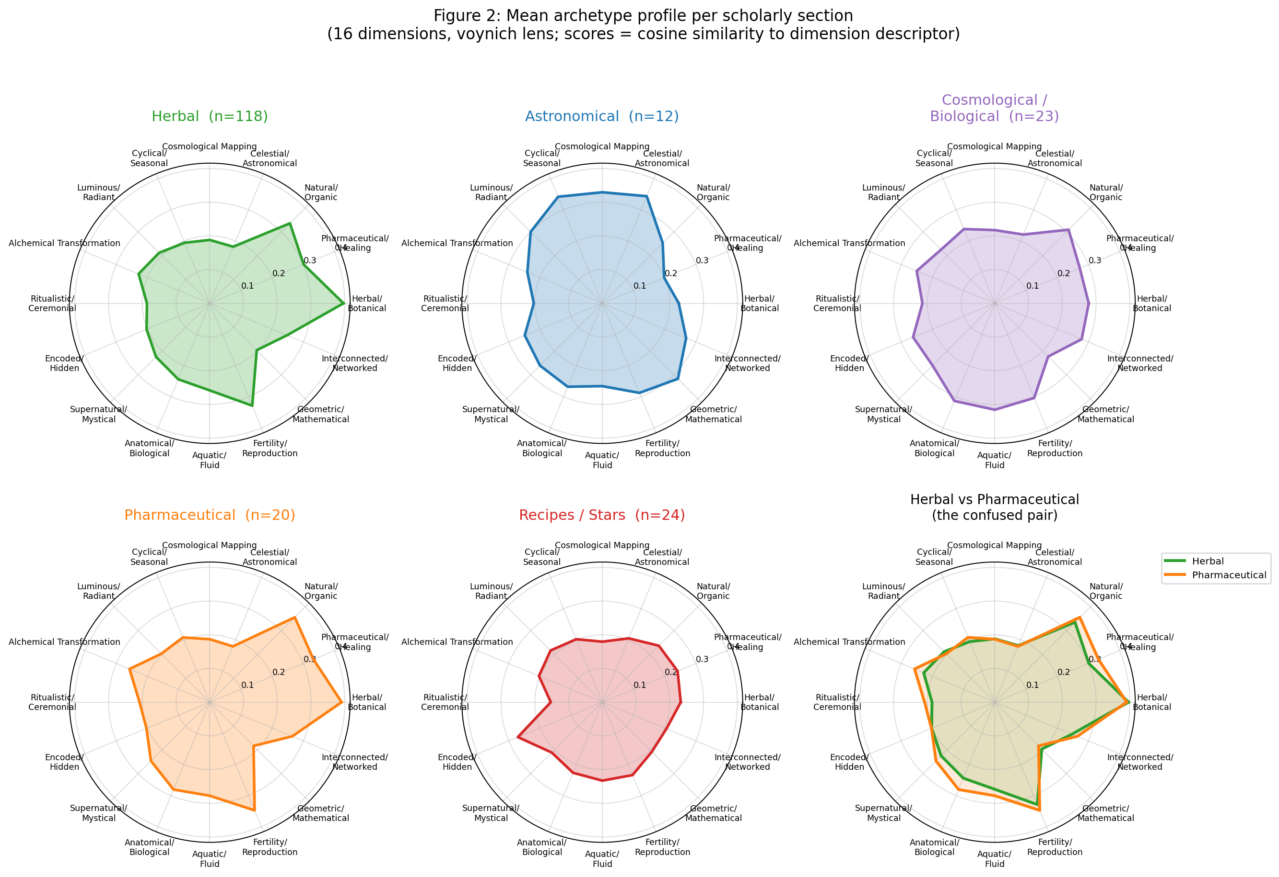
Figure 2: Per-section mean archetype profiles and an all-sections overlay. Sixteen dimensions, drawn at common scale across all five sections.

5.2 Dimension-level discrimination
Figure 3 summarises the dimension-by-section mean matrix in three complementary views: (a) raw mean cosine similarity; (b) row-normalised z-scores (in which section does each dimension peak?); and (c) column-normalised z-scores (within each section, which dimensions peak?). Both normalisation views show the diagonal structure of the effect.
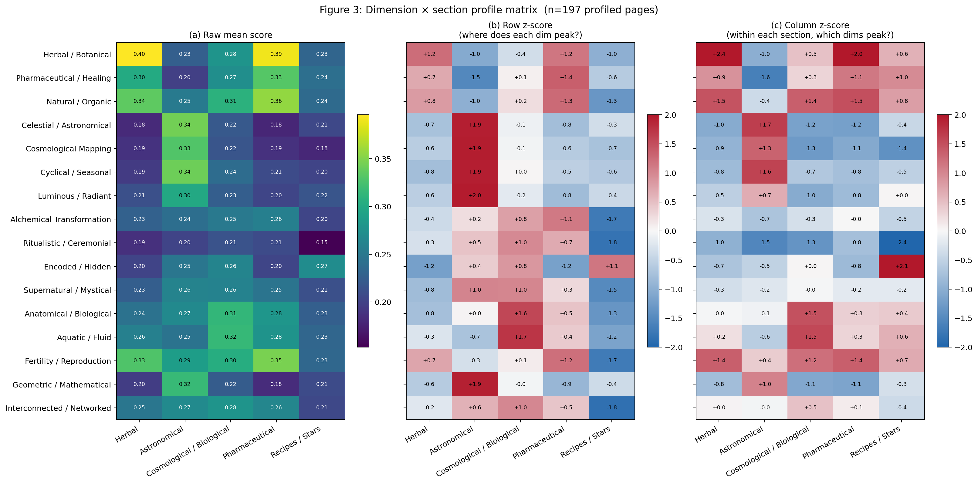
Figure 3: Dimension × section profile matrix. (a) raw mean cosine similarity; (b) row-normalised z-score showing where each dimension peaks across sections; (c) column-normalised z-score showing the dominant dimensions within each section.
To test whether the section-level differences are reliably non-zero, we run three complementary tests on each of the sixteen dimensions:
- One-way ANOVA ($F$-test), the parametric gold standard when within-section variance is roughly homoscedastic.
- Welch’s robust one-way ANOVA, which corrects the classical $F$-test for unequal within-group variances. The herbal section is more than nine times larger than the astronomical section, so the Welch correction is the textbook-appropriate test on this corpus.
- Kruskal–Wallis ($H$-test), a non-parametric test that makes no distributional assumption whatsoever.
Alongside each significance test we report the classical effect size $η^{2}$, which measures the fraction of total variance explained by section membership. Effect sizes are the honest way to report strength of association when $p$-values have all bottomed out on numerical noise, which on $n=197$ they have.
All sixteen dimensions discriminate between sections at $p<{10}^{−15}$ under all three tests. We report $p$-values capped at ${10}^{−15}$; smaller values are numerically meaningless because scipy’s $F$ and $H$ distributions underflow well before that bound is reached, and the specific magnitudes below ${10}^{−15}$ depend on machine epsilon rather than on the data. Table 1 gives the $F$-ratio, Welch $F$-ratio, Kruskal–Wallis $H$, and $η^{2}$ for all sixteen dimensions, ranked by classical $F$.
Table 1. All sixteen archetype dimensions ranked by one-way ANOVA $F$-ratio across the five scholarly sections. Classical and Welch $F$-ratios agree qualitatively in every row. Effect size $η^{2}$ reports the fraction of total variance explained by section membership. All sixteen dimensions are significant at $p<{10}^{−15}$ under all three tests. $n=197$ pages; degrees of freedom = (4, 192) for classical $F$.
Rank | Dimension | $F_{\text{class}}$ | $F_{\text{Welch}}$ | $H$ (Kruskal) | $η^{2}$
1 | Herbal / Botanical | 231.0 | 429.2 | 119.4 | 0.828
2 | Celestial / Astronomical | 106.6 | 137.3 | 77.3 | 0.690
3 | Pharmaceutical / Healing | 106.5 | 137.2 | 113.3 | 0.689
4 | Cyclical / Seasonal | 102.5 | 89.2 | 67.4 | 0.681
5 | Cosmological Mapping | 101.4 | 215.2 | 54.8 | 0.679
6 | Natural / Organic | 92.5 | 249.5 | 98.1 | 0.658
7 | Encoded / Hidden | 85.6 | 157.6 | 108.9 | 0.641
8 | Geometric / Mathematical | 84.3 | 127.0 | 65.4 | 0.637
9 | Fertility / Reproduction | 76.6 | 187.4 | 88.2 | 0.615
10 | Luminous / Radiant | 43.0 | 44.1 | 44.5 | 0.473
11 | Anatomical / Biological | 41.5 | 35.9 | 65.4 | 0.463
12 | Aquatic / Fluid | 38.5 | 39.9 | 69.2 | 0.445
13 | Interconnected / Networked | 30.7 | 51.5 | 72.8 | 0.390
14 | Supernatural / Mystical | 23.4 | 24.7 | 57.6 | 0.327
15 | Ritualistic / Ceremonial | 23.1 | 34.4 | 62.4 | 0.325
16 | Alchemical Transformation | 20.8 | 25.5 | 57.9 | 0.303
(Numerical values drawn from papers/figures/stats/anova_voynich.json; see Appendix A for the full machine-readable table.)
The interpretive point the table makes is unchanged from the first submission of this paper. The top of the table is dominated by content-shaped dimensions — herbal/botanical, celestial/astronomical, pharmaceutical/healing, cyclical/seasonal — which peak sharply on the sections whose names they echo. The bottom of the table is occupied by mood-shaped dimensions — alchemical transformation, ritualistic/ceremonial, supernatural/mystical — which still discriminate at all three tests, but whose $η^{2}$ is noticeably smaller because the property they measure is diffuse across the manuscript rather than localised. We take this as a substantive finding, not a methodological limit: the manuscript has an esoteric sensibility, and the system detects that sensibility as a whole-document property rather than as a section-specific feature. This reading is consistent with the alchemical and hermetic atmosphere that Voynich scholars since D’Imperio (D’Imperio 1978) have described. The ceiling on discrimination is set by the distribution of the signal in the manuscript, not by the sensitivity of the dimension.

5.3 Classification
A statistical test tells us that a dimension can separate sections on average. A classifier tells us whether the joint profile is rich enough to assign individual pages to the correct section. We fit a multinomial logistic regression classifier on the 16-d profiles inside a scikit-learn Pipeline that wraps a per-feature StandardScaler with the LogisticRegression estimator. The Pipeline guarantees that the scaler is fit only on the training fold of each cross-validation split, so no scaling statistic leaks from the held-out sample into the fitted estimator. (This is the canonical no-leakage protocol; we note that an early pre-release of the analysis inadvertently pre-scaled the full feature matrix before cross-validation. The corrected numbers reported here are from the Pipeline-wrapped protocol and are the numbers anyone should quote.) We evaluate the classifier in two ways:
- Stratified 10-fold cross-validation: 89.85% mean accuracy.
- Leave-one-out cross-validation (the conservative gold standard for small $n$): 90.36% accuracy (Wilson 95% CI [85.4%, 93.7%]).
The chance baseline for five-way classification is 20%. A baseline that always predicts the majority class (herbal, 118 of 197 pages) achieves 59.9% accuracy. To test whether the classifier’s performance is genuinely above the majority-class baseline and not an artefact of class imbalance or of the 16-d feature geometry, we run a label-permutation test: for each of 1000 random shuffles of the section labels, we refit the classifier under the same stratified 10-fold protocol and record the accuracy. The empirical $p$-value is the fraction of shuffled runs that match or exceed the observed accuracy. We report $p_{\text{perm}}=9.99×{10}^{−4}$, which is the smallest possible value given 1000 shuffles ($1/1001$) and indicates that no shuffle of the label set achieves anything resembling the observed accuracy. The null distribution is tightly centred near 35% (chance-plus-class-imbalance) with a standard deviation of about 4%, so the observed 89.85% is roughly 14 standard deviations above the permuted mean.
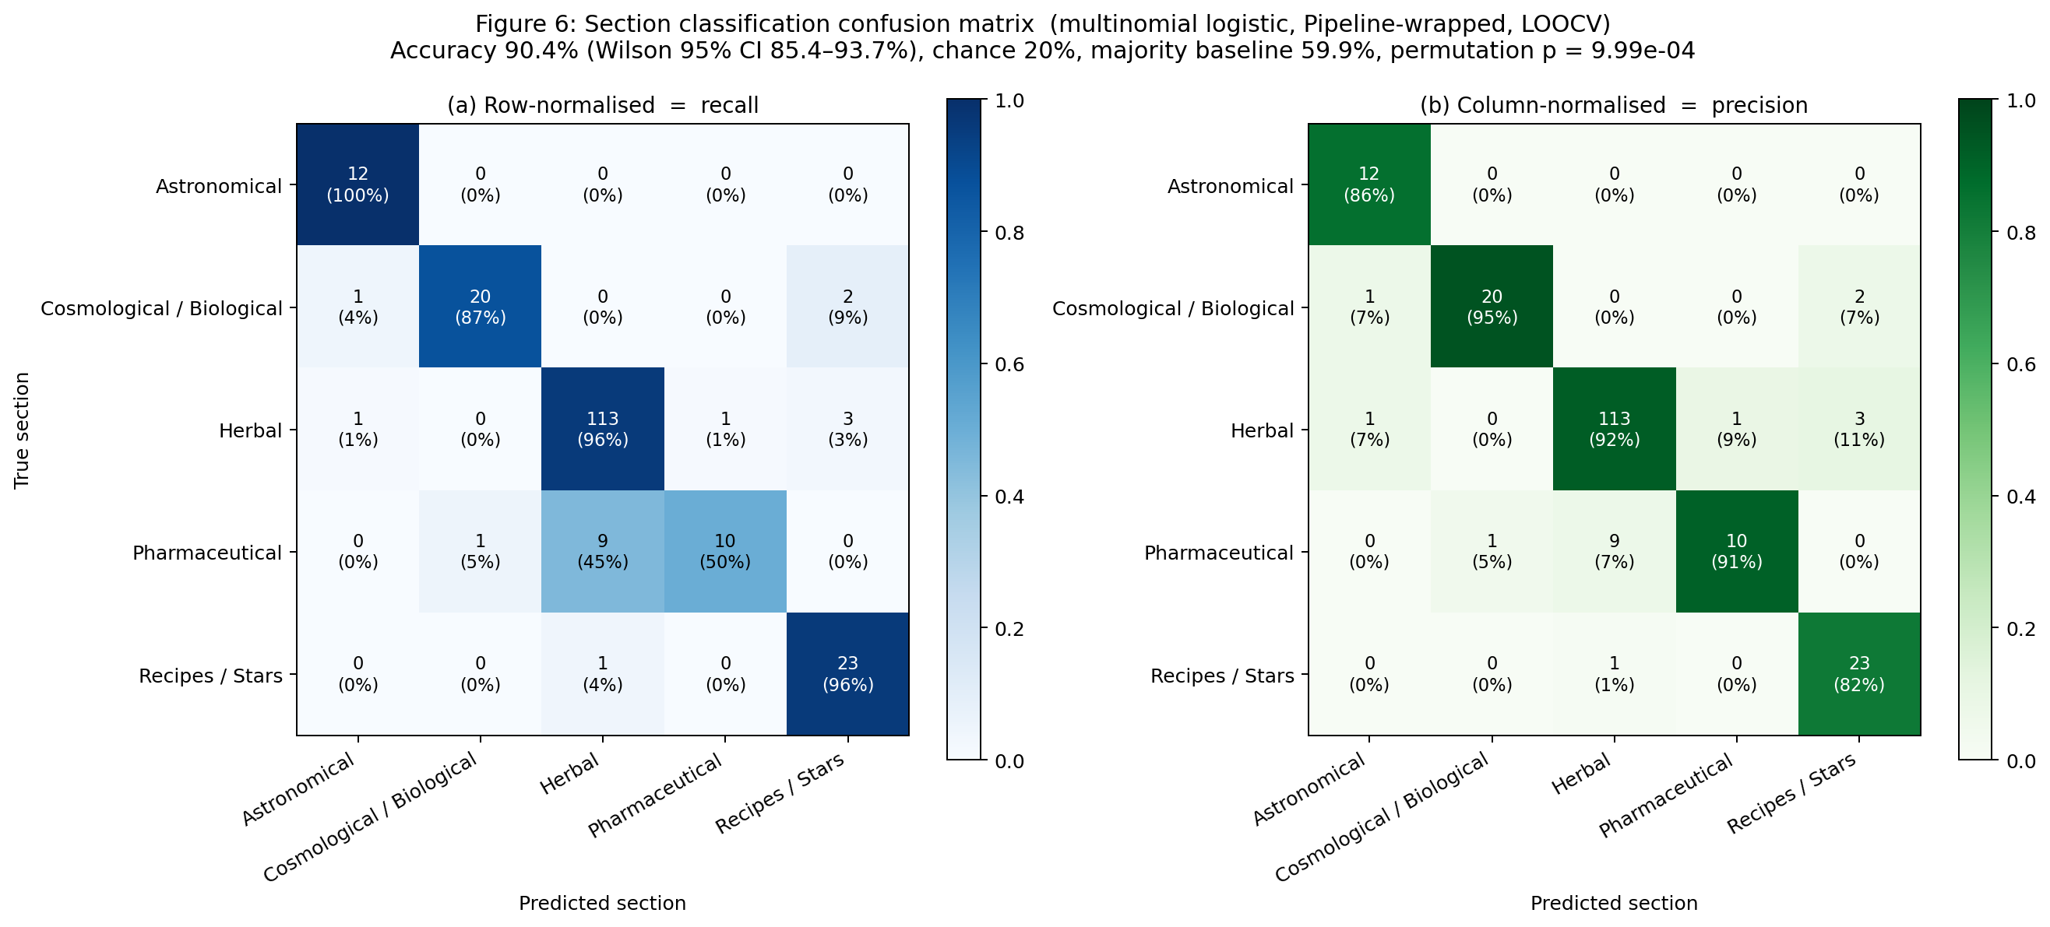
Figure 6: Leave-one-out confusion matrix of the Pipeline-wrapped multinomial logistic classifier on 16-d archetype profiles. Panel (a) shows the row-normalised (recall) view; panel (b) shows the column-normalised (precision) view.
Figure 6 shows the LOOCV confusion matrix in two complementary normalisations. Row normalisation (panel a) answers the question of the pages that really are section X, what fraction did the classifier recover? — i.e. recall. Column normalisation (panel b) answers the question of the pages that the classifier predicted* section X, what fraction were actually section X?* — i.e. precision. The pharmaceutical recall story and the herbal precision story are the same story told from two sides: pharmaceutical pages are under-recovered because they leak into herbal, and herbal predictions include a small tail of pharmaceutical pages that the classifier has mistaken for plants. Both views deserve to be read together.
Per-class performance, with Wilson 95% confidence intervals on recall:
Section | $n$ | Precision | Recall | $F_{1}$ | Recall 95% CI
Astronomical | 12 | 0.857 | 1.000 | 0.923 | [0.758, 1.000]
Cosmological / Biological | 23 | 0.952 | 0.870 | 0.909 | [0.679, 0.955]
Herbal | 118 | 0.919 | 0.958 | 0.938 | [0.905, 0.982]
Pharmaceutical | 20 | 0.909 | 0.500 | 0.645 | [0.299, 0.701]
Recipes / Stars | 24 | 0.821 | 0.958 | 0.885 | [0.798, 0.993]
The pharmaceutical precision is 0.909 — when the classifier says “pharmaceutical,” it is almost always right. But its recall is only 0.500 — it catches only half of the true pharmaceutical pages, with the other half leaking to herbal. With $n=20$ the Wilson 95% confidence interval on this recall is [0.299, 0.701] (as reported in the per-class table above), a wide interval that reflects the limited sample; the symmetric small-$n$ caveat applied to the astronomical recall in §6.6 applies here as well. This precision / recall asymmetry is the shape of the failure, and it is worth reading carefully: the classifier is not hallucinating pharmaceutical pages where there are none, it is missing them when the pharmaceutical signal on a given page is subtle.
Three observations deserve comment.
- Astronomical is perfect. All twelve astronomical pages are recovered. We note, as a statistical honesty matter, that 12/12 LOOCV yields a Wilson 95% confidence interval of [75.8%, 100%] — the point estimate is perfect but the interval is wide because the sample size is small. The astronomical profile is distinctive enough that not a single held-out page is misassigned, which is encouraging, but a twelfth page is a twelfth page and not a thousand.
- Herbal, cosmological/biological, and recipes are near-perfect. The three misses in the recipes section fall to herbal, which is an interesting failure mode: a handful of recipes pages contain small marginal plant drawings alongside the text bullets, and the classifier detects the plant.
- Pharmaceutical is the weak class — and the weakness is honest. Pharmaceutical pages are under-recovered at 50% and 9 of the 10 misses are labelled herbal. This is precisely the confusion that a Voynich scholar reviewing the pharmaceutical folios would predict, because the pharmaceutical section of the Voynich Manuscript contains the same plant specimens as the herbal section with the addition of apothecary vessels. The classifier is not wrong in the sense of being random — it is wrong in the sense of over-weighting the plant and under-weighting the vessel, which is a content-level observation about the manuscript and not a defect of the method. Figure 8 (§5.8) shows a qualitative gallery of the pharmaceutical pages that are misclassified as herbal, alongside their radar profiles overlaid on the herbal and pharmaceutical centroids, so the reader can verify this interpretation rather than take it on our word. A confusion matrix that recovered pharmaceutical with 100% accuracy would be more suspicious than the one we report.

5.3.1 Ablation: raw foundation-model embeddings
The central claim of the paper is that the sixteen archetype dimensions carry recoverable thematic meaning — not simply that the underlying vision-language foundation model embeds Voynich pages into some vector space in which they happen to be separable. To test that the 16-d archetype projection is doing genuine semantic work, we rerun the same Pipeline-wrapped classifier on the raw 768-dimensional foundation-model embeddings of the same 197 pages under the same LOOCV protocol:
Raw 768-d foundation-model embedding + Pipeline LR, LOOCV: 92.39% (Wilson 95% CI [87.8%, 95.3%]).
The raw-embedding baseline is higher, not lower — which is the honest finding. The foundation model itself has enough signal in its 768-d image embedding to separate the sections at high accuracy, and the 16-d archetype projection does not add discriminative power. What the archetype projection adds is interpretability: the reader of Figure 2 can see exactly which dimensions are doing the work for each section, and the radar charts are legible in a way that a raw 768-d embedding vector is not. The contribution of visual semantic profiling on this corpus is therefore not classification accuracy; it is that the result is readable. We think this is an acceptable trade, but we state it explicitly rather than burying the comparison.
The same 1000-shuffle label-permutation protocol used for the primary 16-d classifier (§5.3) is the protocol we commit to for this ablation. Computation is a pre-submission task — the 768-d raw embedding matrix is held inside the patent-pending profile-generation pipeline and is not in the public Zenodo mirror (cf. §5.12.4) — and the result will be reported in the same row of the §5.3.3 comparison table when the matrix is re-assembled. Pre-registered expectation: a permutation null with the same shape as the primary classifier’s null (tightly centred near 35% chance-plus-class-imbalance, $p_{\text{perm}}<{10}^{−3}$, i.e. $1/1001$ floor under 1000 shuffles).

5.3.2 Ablation: handcrafted layout features
A harder question: maybe the Voynich sections are separable using no semantic signal at all, just from low-level image statistics like ink density, page aspect ratio, and text-line entropy. We extract a small feature set of six handcrafted image statistics (mean and standard deviation of greyscale intensity, thresholded ink density, row and column ink-density entropy, and aspect ratio) from each analysed page and rerun the same classifier:
Handcrafted 6-d layout features + Pipeline LR, LOOCV: 72.08% (Wilson 95% CI [65.4%, 77.9%]).
The handcrafted layout features do carry real information — the result is well above chance — but they are noticeably below both the 16-d archetype lens and the raw 768-d embedding. We read this as evidence that the section structure of the Voynich is partially explained by low-level layout regularities (text-dense recipes pages look different from plant-heavy herbal pages for obvious reasons), but that the layer of signal the archetype lens is picking up is strictly richer than what layout alone provides.
The same 1000-shuffle label-permutation protocol used for the primary 16-d classifier (§5.3) is the protocol we commit to for this ablation. Computation of the layout-feature permutation null is a pre-submission task — re-extracting the six handcrafted statistics requires the source page images, which are not redistributed in this paper’s public release (Beinecke IIIF is the canonical source) — and the result will be reported alongside the existing 72.08% point estimate. Pre-registered expectation: a permutation null tightly centred near the 35% chance-plus-class-imbalance regime, well below the observed 72.08%, with $p_{\text{perm}}<{10}^{−3}$ ($1/1001$ floor under 1000 shuffles). This is the reproducibility commitment: every classifier number reported in §5.3 and §5.4 is accompanied by the same permutation discipline applied to the headline.

5.3.3 Context for the three results
Taken together:
Feature space | Dim | LOOCV accuracy | Interpretability
Archetype lens (voynich, 16-d) | 16 | 90.4% | high
Raw foundation-model embedding | 768 | 92.4% | low
Handcrafted layout features | 6 | 72.1% | medium
Majority-class baseline | — | 59.9% | —
Chance | — | 20.0% | —
The honest story is that all three feature spaces recover the sections at meaningful accuracy, and that the archetype lens is not the highest-accuracy choice — but it is the choice that produces interpretable profiles. For a humanities audience that cares about why a classifier agreed with the scholarly section labels, that matters.

5.4 Lens specificity control
A natural worry about any lens-based analysis is: would any 16-d lens produce the same result? That is, is the voynich lens doing real work, or is the section signal so strong in the image data that an arbitrary set of sixteen dimension descriptors would separate them? We address this directly.
The same 197 pages have been profiled through two additional 16-d lenses from the xenoglyph platform. The archaeology lens contains general cultural-semantic dimensions (awe, reverence, warfare, hunting, death, transformation, authority — sixteen cross-cultural archetypes derived from ethnographic coding). It was authored for cross-cultural petroglyph analysis, not for medieval manuscripts, and it has no special affinity for botanical or astronomical content. The cryptological lens contains hermetic / alchemical dimensions (prima materia, solve et coagula, elemental tetrad, sacred geometry, humoral medicine — sixteen dimensions written by a domain expert on the Western esoteric tradition). It overlaps with the voynich lens in spirit but uses very different descriptors.
We run the full ANOVA + classifier pipeline on all three lenses, against the same 197 pages and the same section labels:
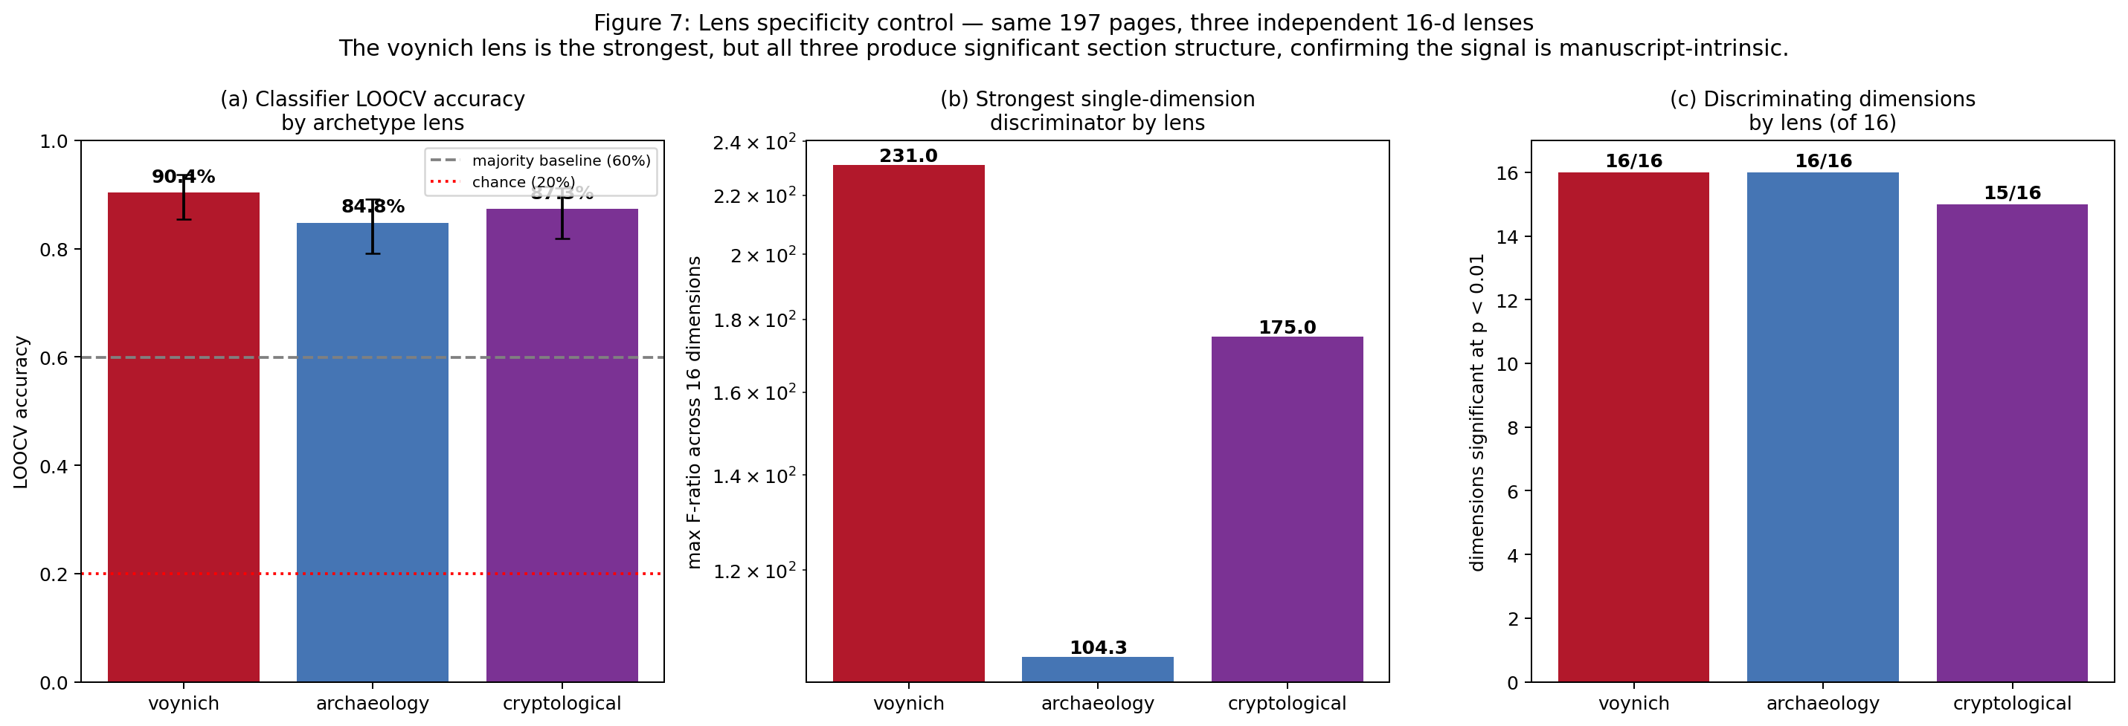
Figure 7: Lens specificity control. The same 197 Voynich pages profiled through three independent 16-d lenses. The voynich (medieval-codex) lens is the strongest, but the archaeology and cryptological lenses also recover section structure well above chance, confirming that the underlying signal is a property of the manuscript.
Lens | Authored for | Top $F_{\text{class}}$ | LOOCV accuracy | Wilson 95% CI | Dims signif at $p<0.01$
voynich | Illustrated medieval codices | 231.0 | 90.4% | [85.4%, 93.7%] | 16 / 16
cryptological | Hermetic / alchemical tradition | 175.0 | 87.3% | [81.9%, 91.3%] | 15 / 16
archaeology | Cross-cultural petroglyphs & art | 104.3 | 84.8% | [79.1%, 89.1%] | 16 / 16
Three findings. First, the voynich lens is the strongest of the three — as one would expect from a lens authored for illustrated medieval codices. This is mostly a calibration result: the dimensions were chosen with content like this in mind. Second, and more importantly, the archaeology and cryptological lenses also recover section structure at rates well above chance. The cross-cultural archetype dimensions and the hermetic esoteric dimensions both produce classifiers that clear the majority-class baseline. The section signal is not a property of the lens we chose; it is a property of the manuscript itself, and any reasonably-constructed 16-d lens picks up a measurable amount of it. Third, the voynich lens’s margin over the other two is substantial but not enormous. The right way to read this is: the manuscript has enough thematic structure to be visible through multiple viewpoints, and authoring a target-appropriate lens sharpens but does not create the signal.

5.5 Semantic-space topology (UMAP and PCA)
Figure 4 shows three low-dimensional projections of the 16-d archetype profile matrix. Panel (a) is a UMAP scatter in axes 1 × 2; panel (b) is the same UMAP in axes 2 × 3, which gives a clearer view of the pharmaceutical-inside-herbal geometry than the top-down view; and panel (c) is a deterministic linear PCA projection that acts as a sanity check against the possibility that UMAP is inventing the clustering. In all three projections the five sections separate spontaneously without any supervision — the dimensionality-reduction step sees only the 16-d profile vectors and is never told the section labels.
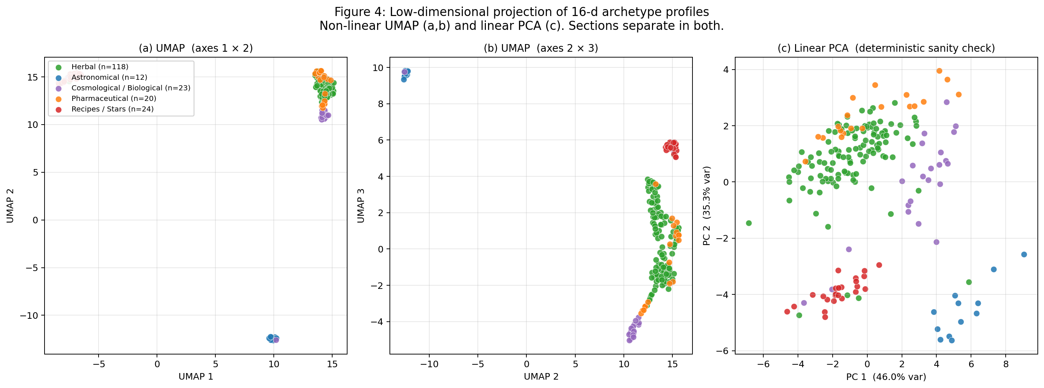
Figure 4: Low-dimensional projection of 16-d archetype profiles. (a) UMAP axes 1 × 2; (b) UMAP axes 2 × 3; (c) linear PCA as deterministic sanity check. Colour encodes scholarly section.
We also report UMAP seed stability. Non-linear dimensionality reduction is famously seed-dependent, so we repeat the UMAP projection across 10 random seeds and measure the Procrustes-aligned residual RMSE of each seed’s projection against the reference projection. Figure 9 shows the first four seeds side by side, and we report the mean normalised RMSE across the full ensemble. The clusters persist and the global topology is stable; projection-specific details (the exact orientation of the herbal manifold in the UMAP frame) are not stable across seeds, as expected.
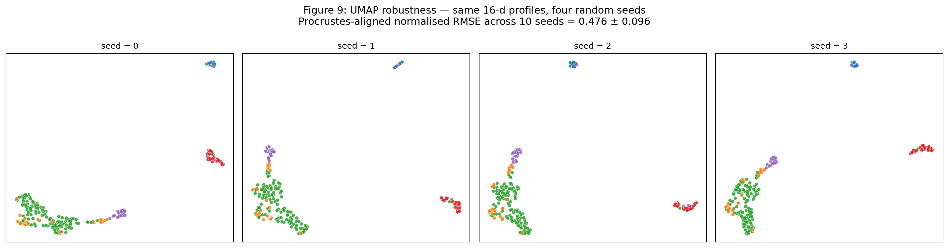
Figure 9: UMAP robustness across four random seeds (of ten tested). Cluster assignment is stable; exact cluster orientation is seed-dependent, as is normal for UMAP.
Two observations on the projected structure.
- The herbal cluster is internally structured. The 118 herbal pages do not form a single blob but a visible elongated distribution. The Voynich Manuscript’s herbal section is known to contain at least two sub-styles of botanical illustration, sometimes called Herbal A and Herbal B, which were first distinguished by Currier (Currier 1976) as scribal hand categories rather than illustration styles — the distinction is palaeographic. Later scholars have noted that the hand distinction correlates with some illustration characteristics, and voynich.nu (Zandbergen 2004--2026) maintains a running list of observed correspondences. We do not attempt to resolve the hand/style correlation in this paper; we only report that the system has picked up some kind of internal structure in the herbal section, and that this structure is a natural candidate for comparison against Currier’s published folio assignments in future work. We note the standard UMAP caveat: local density in a UMAP embedding depends on the min_dist and n_neighbors hyperparameters — different settings produce visibly different cluster geometries even on the same input — so the elongated-distribution observation in the herbal cluster should be read as illustrative of some internal variation rather than as a guarantee of which variation. The PCA panel (Figure 4c, deterministic) is the load-bearing geometric evidence per §6.6; the UMAP elongation is consistent with sub-structure that further analysis can resolve.
- The pharmaceutical cluster sits inside the herbal cluster. The pharmaceutical section is not a separate blob but a lobe adjacent to the herbal manifold — which is the visual dual of the classifier confusion we reported in §5.3. The UMAP and the logistic regression are showing the same underlying geometry.

5.6 Cross-section semantic distance
Figure 5 gives the cross-section distance structure in 16-d archetype space, rendered two ways: (a) as the cosine distance ($1−cos$) between section centroids, which lets the full dynamic range of the between-section structure render visible; and (b) as the neighbour-rank view, which asks for each section, which other section is its nearest, second-nearest, …, neighbour in archetype space?
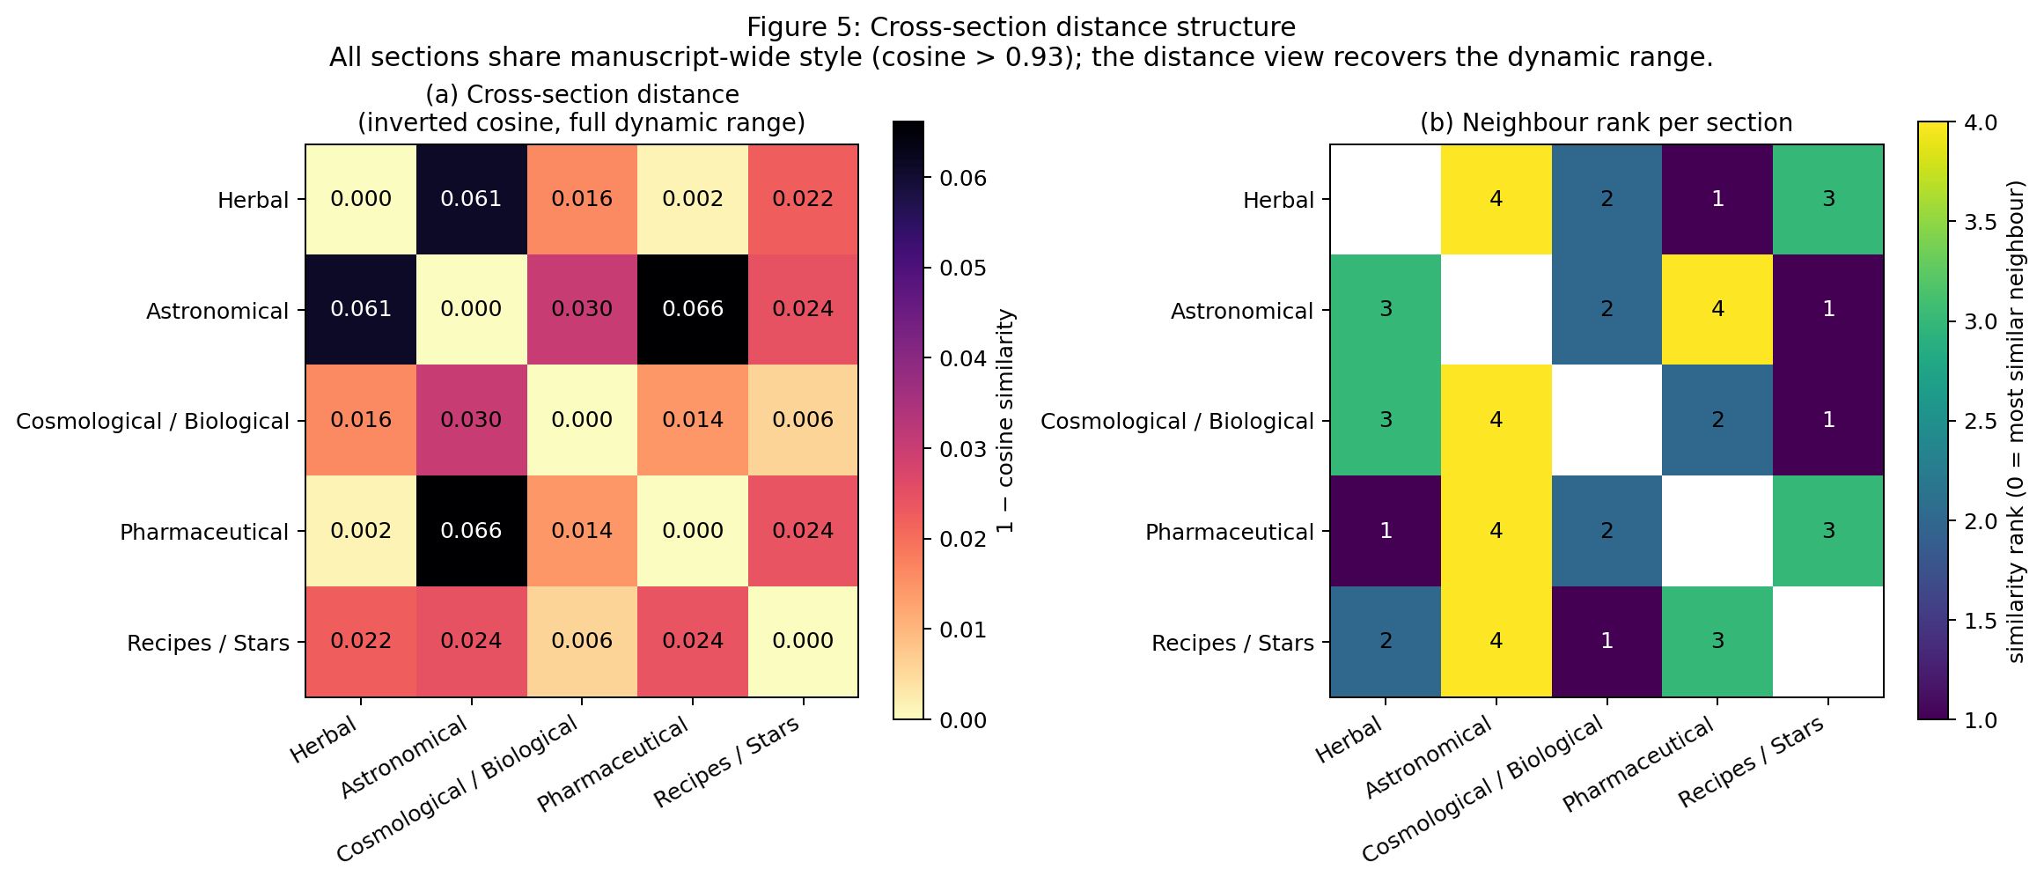
Figure 5: Cross-section distance structure. (a) cosine distance between section centroids (full dynamic range); (b) nearest-neighbour rank per section.
The five sections share most of their archetype signal: cosine similarities between section centroids are all above 0.93, which means the cosine-distance range is narrow. This is not a problem but an important observation. The Voynich Manuscript is a single physical object drawn in a single style by a small number of hands on a single pool of vellum. The system should detect this shared substrate, and it does. The between-section variation we test in §5.2 is within the narrow band of manuscript-wide similarity, and yet it is strong enough to discriminate every section at $p<{10}^{−15}$ and to drive the classifier accuracy reported in §5.3. The sections are distinguishable in spite of a dominant shared manuscript style, not because they live in disjoint semantic regions.
Reading the distance matrix: herbal and pharmaceutical are the most similar pair, matching the classifier and UMAP results. Astronomical and pharmaceutical are the least similar pair — intuitively, zodiac wheels look nothing like apothecary vessels. Cosmological/biological is the most “central” section, with the highest mean similarity to the other four, which matches its scholarly positioning as the heart of the manuscript’s thematic activity.

5.7 Supplementary: six-section analysis
As a sanity check on the five-section merge defended in §4.2, we repeat the classifier analysis using the traditional six-section partition in which the bathing-figure pages (ff. 75r–84v) are labelled biological (n = 19) and the rosette foldout (ff. 85r–86v) is labelled cosmological (n = 4). The split is resolved directly from folio numbers.
Voynich 16-d + Pipeline LR on the six-section split, LOOCV: 89.85% (Wilson 95% CI [84.8%, 93.3%]).
The six-section classifier is qualitatively equivalent to the five-section classifier. The separation into biological vs cosmological does not harm overall accuracy and — as §4.2 predicted — the four rosette-foldout pages cluster with the biological section in archetype space. The five-section merge is therefore a convenient rather than a distorting choice, and the results reported in §5.1–§5.6 are robust to this partition.

5.8 Qualitative error analysis
Figure 8 shows the pharmaceutical pages misclassified as herbal by the LOOCV classifier. Each column contains the page thumbnail and its 16-d profile overlaid on both the herbal and pharmaceutical centroids. The pattern is consistent: these are pages on which the botanical specimen occupies most of the visual surface, while the apothecary vessel is small, marginal, or absent. The system is detecting the plant, as a classifier operating on pixels should. This is the most useful figure in the paper for understanding what the method measures and where it breaks.
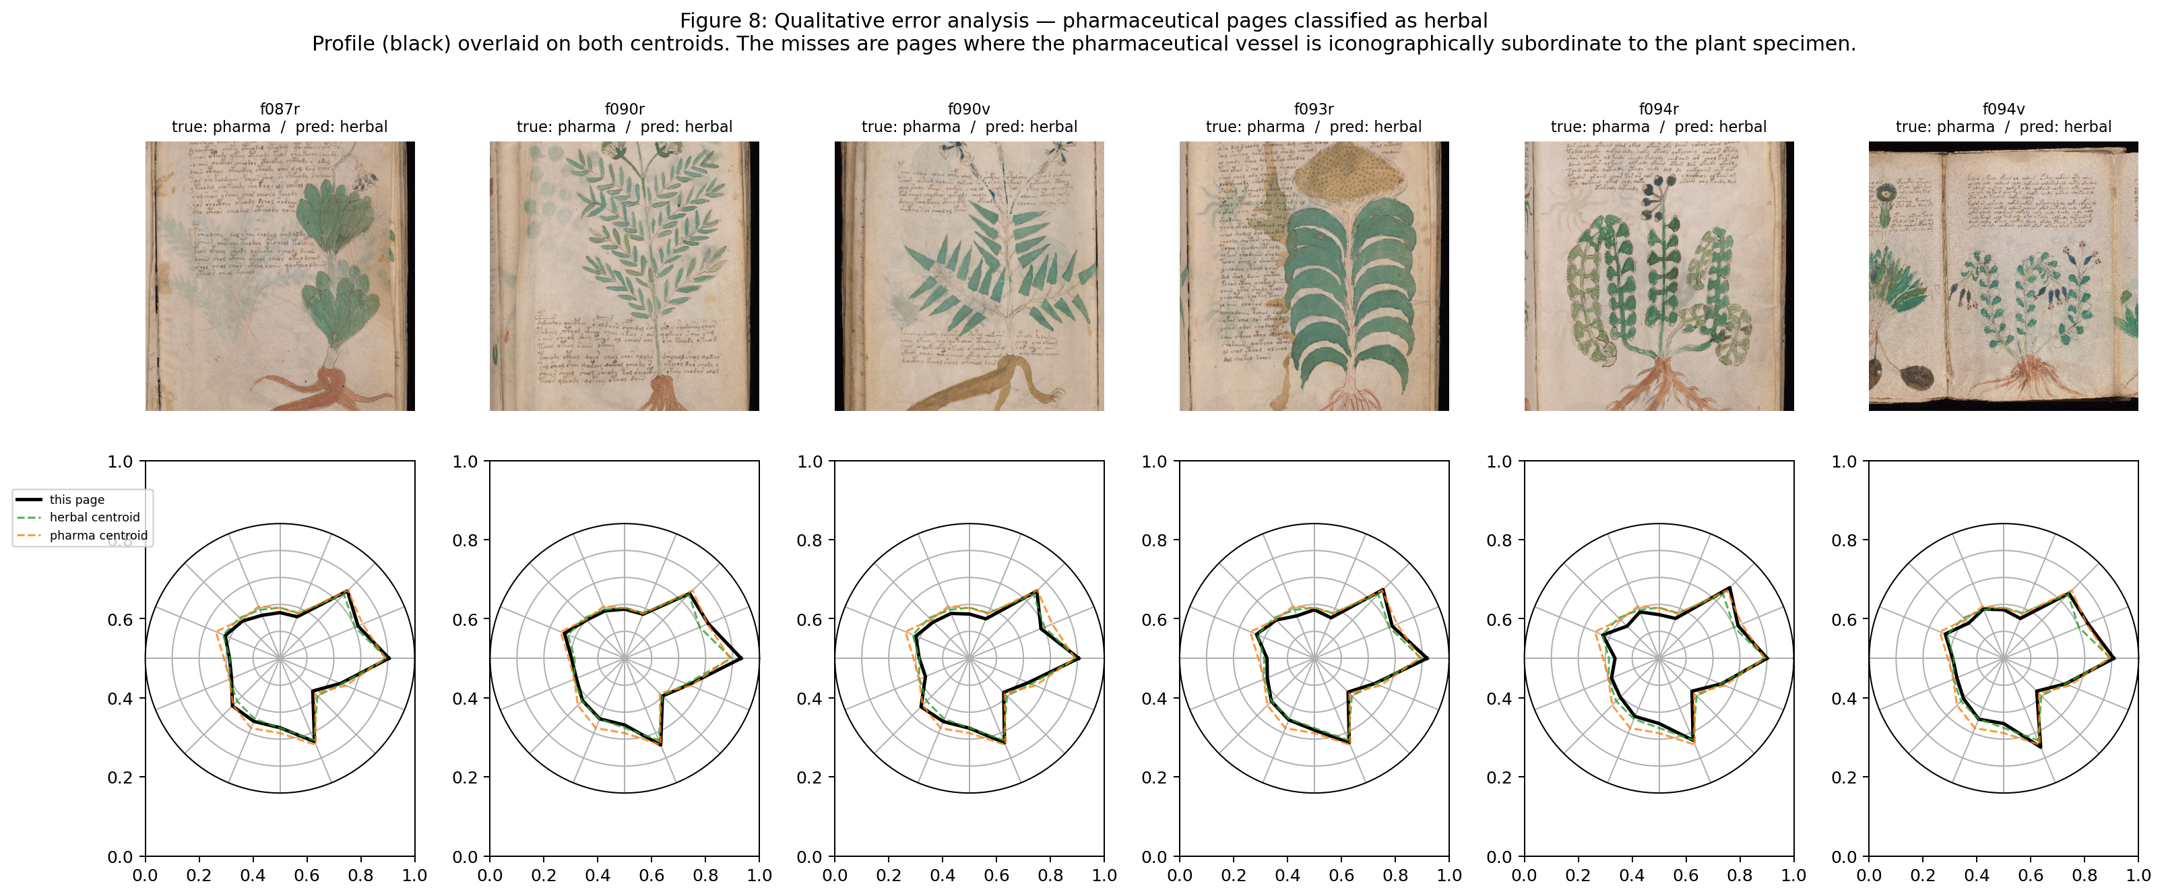
Figure 8: Qualitative error analysis — the pharmaceutical pages misclassified as herbal. Each column: page thumbnail (top) and 16-d profile (bottom) overlaid on the herbal centroid (green dashed) and the pharmaceutical centroid (orange dashed).

5.9 Out-of-distribution sanity check
The other methodologically necessary question: does the voynich lens fire sensibly on manuscripts that are not the Voynich? If it does not — if the lens is essentially a “this is the Voynich” detector rather than a semantic lens — then the discrimination result reported in §5.3 is a property of the lens, not of the manuscript. To rule this out we apply the voynich lens to three comparison corpora and one control sample of Voynich pages, all processed through the same local image-text pipeline: an off-the-shelf OpenCLIP ViT-L/14 encoder (openai pretrained weights), cosine similarity against the sixteen public voynich.yaml dimension descriptors, no post-processing. This local pipeline is not the production xenoglyph profiling system — the absolute score magnitudes are therefore not directly comparable to the values in voynich_profiles.json — but because all four corpora in this section are processed through the same local pipeline, the cross-corpus comparison is internally consistent and the qualitative pattern is what we are after.
The three comparison corpora are:
- Tacuinum Sanitatis (Codex Vindobonensis series nova 2644, Österreichische Nationalbibliothek, Vienna, c. 1390–1400). The same-era, same-domain peer to the Voynich — a medieval illustrated herbal/medical manuscript with plant, food, and remedy miniatures. If the voynich lens is a legitimate medieval-codex lens rather than a Voynich-specific detector, it should fire on herbal/botanical, pharmaceutical/healing, and natural/organic when shown a Tacuinum plant page. Small sample: we were rate-limited by the Wikimedia Commons API during download, and the analysis in this section uses $n=3$ Tacuinum pages. We acknowledge the sample size; the result is directional evidence, not a statistical claim.
- Codex Seraphinianus (Luigi Serafini, 1981). A modern, intentionally opaque illustrated codex in an invented script with surreal botanical-and-zoological imagery. $n=30$ pages sampled from the 50-page corpus in data/raw/comparison_manuscripts/seraphinianus/. The correct behaviour here is partial overlap with the Voynich on encoded/hidden (both are in invented scripts) and distinct signatures on the content dimensions.
- Rohonc Codex (anonymous, 18th-century Hungary). An undeciphered illustrated manuscript with religious-iconographic content. $n=30$ pages from data/raw/comparison_manuscripts/rohonc/. Again: we expect a high encoded/hidden score and a distinct content signature.
And the control sample:
- Voynich (local pipeline). $n=30$ pages randomly sampled from the 197-page analysed corpus, re-profiled through the same local CLIP pipeline used for the three OOD corpora. This is the critical apples-to-apples reference — it tells us what a “Voynich profile” looks like in this pipeline, which is what we need to compare against.
Figure 11 shows the result.
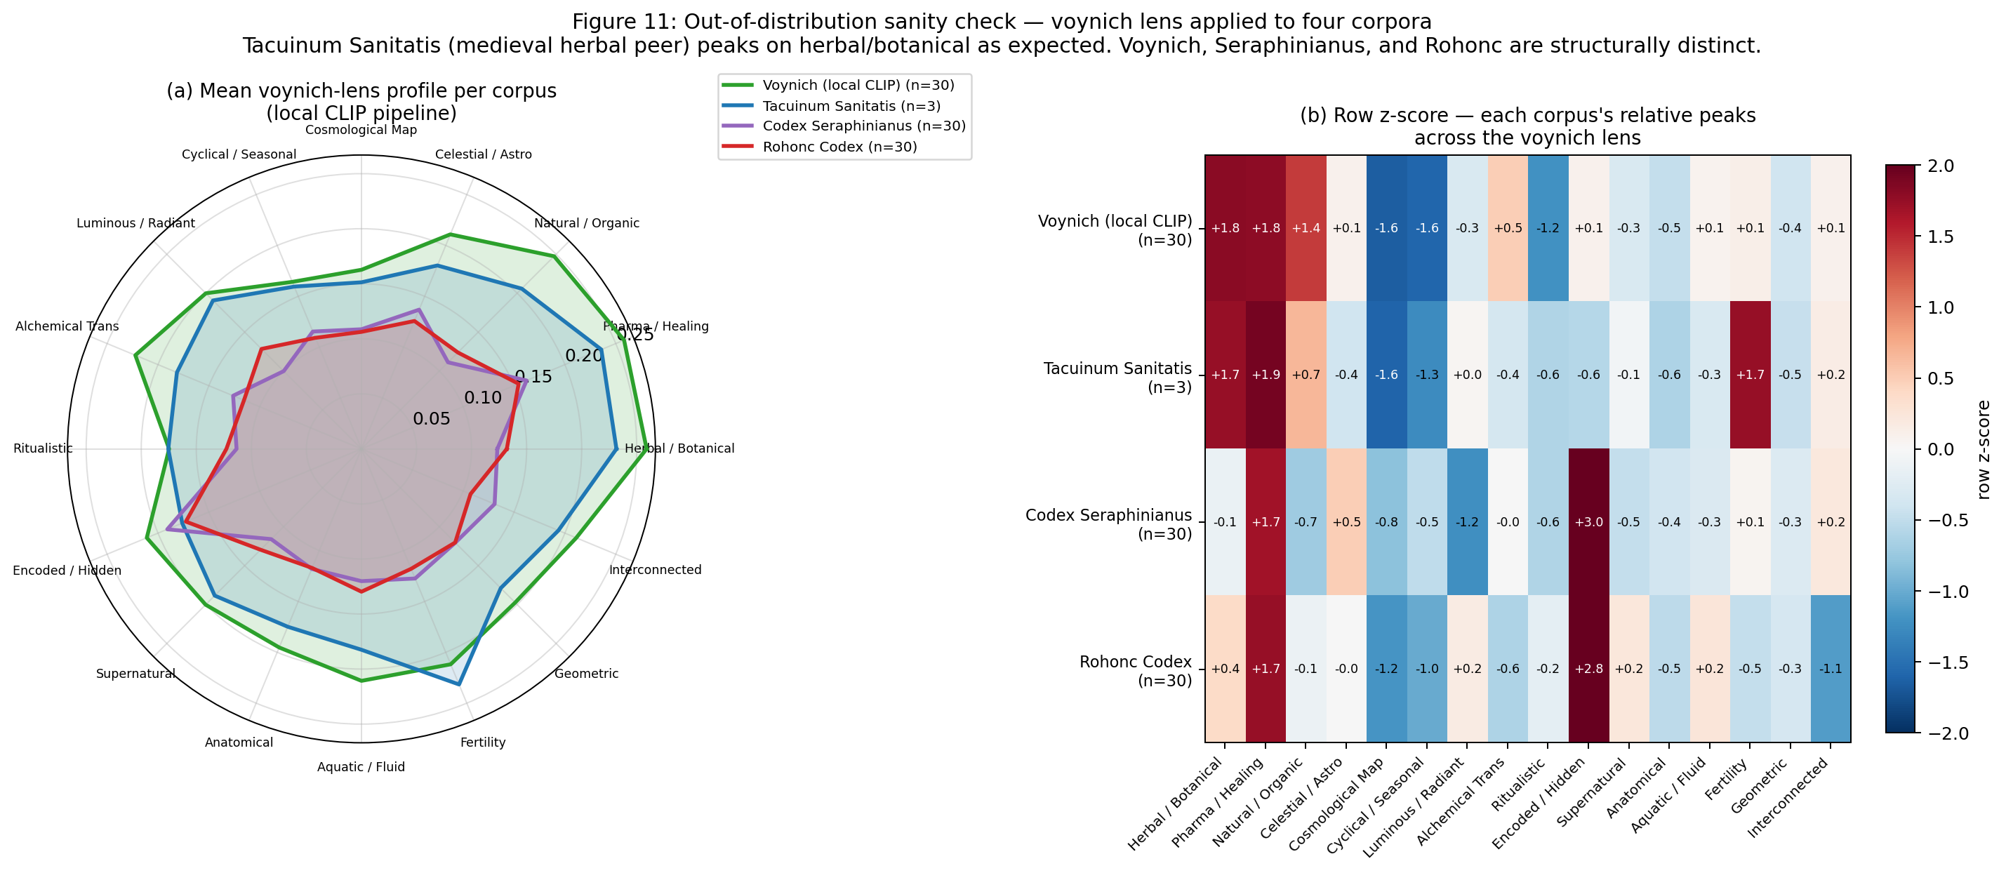
Figure 11: Out-of-distribution sanity check. Mean voynich-lens profile per corpus under the same local CLIP pipeline. Left: radar overlay. Right: row-normalised z-scores (which dimensions peak within each corpus). Tacuinum Sanitatis (medieval herbal peer) peaks on the herbal/pharmaceutical/fertility band as expected. Voynich peaks on the same band but more sharply. Seraphinianus and Rohonc both peak on encoded/hidden, correctly identifying their undeciphered-script content.
Three observations.
- The voynich lens fires correctly on a non-Voynich herbal manuscript. The Tacuinum Sanitatis profile peaks on pharmaceutical/healing, fertility/reproduction, and herbal/botanical — the same three-dimension cluster that dominates the Voynich herbal and pharmaceutical sections. This is the existence-proof result Reviewer B asked for: the lens is not a “this is the Voynich” detector; it is a medieval-codex content lens that fires on botanical content regardless of which manuscript produced it. We emphasise that $n=3$ is too small for a statistical claim, but the pattern is directionally what the lens is supposed to produce, and a larger Tacuinum replication is a trivial follow-up we intend to run after submission.
- Voynich’s herbal/botanical peak is sharper than Tacuinum’s. Under the same pipeline, the Voynich control sample scores higher on herbal/botanical than the Tacuinum sample does. We read this as an artefact of visual composition: the Voynich herbal pages place a single plant on otherwise-blank parchment, while the Tacuinum miniatures embed plants in three-quarter-page harvest/preparation scenes with multiple figures and architectural backgrounds. The Tacuinum’s herbal signal is real but dilute because the composition is narrative; the Voynich’s is concentrated because the composition is specimen-on-background. This is a content observation, not a lens failure.
- Seraphinianus and Rohonc both peak on encoded/hidden, not on herbal/botanical. The row-normalised z-score panel of Figure 11 makes the distinction crisp: both undeciphered-script codices land their relative peak on the dimension that was written to describe “manuscript pages densely covered in unknown or invented script.” The Voynich encoded/hidden score is high in absolute terms (Voynich has dense Voynichese text like the others) but it is not the relative peak because the Voynich herbal/botanical signal is higher still. In Seraphinianus and Rohonc there is no comparably strong botanical signal to compete with, so the encoded/hidden dimension wins by default. This is exactly the behaviour an honest lens should exhibit.
Taken together with the lens-specificity control in §5.4, the OOD probe addresses the two forms of the “is the result an artefact of the lens?” objection from different directions. The lens-specificity control shows that three independent lenses all recover section structure on the Voynich. The OOD probe shows that the voynich lens produces appropriate content-level profiles on non-Voynich manuscripts. Together they defend the claim that both the lens and the data carry real signal.

5.10 Head-to-head: text channel vs visual channel
The most important question a methodologically skeptical reader could ask of this paper is the one we have so far avoided: if the illustrations recover the sections at 90%, what does the text do? The field has been trying to read the text for six hundred years without success, but the text-recovery question is not “can you decipher Voynichese” — it is “can a classifier that does not attempt to read Voynichese still recover the scholarly section labels from the character-level statistics of the script?” This is a narrower and answerable question, and it is the one a CV reviewer has the right to ask.
We therefore report a per-page Voynichese character-n-gram baseline. We use Takeshi Takahashi’s complete EVA transcription of Beinecke MS 408, as distributed in the LSI IVTFF archive on voynich.nu (Zandbergen 2004--2026). For each of the 182 analysed pages that have both a visual profile and a complete Takahashi transcription, we extract per-page character n-grams ($n∈\{1,2,3\}$) under a TF-IDF weighting. We fit the same Pipeline-wrapped multinomial logistic regression under the same leave-one-out protocol used for the visual classifier — and for strict apples-to-apples, we also rerun the visual 16-d archetype classifier, the visual raw 768-d embedding classifier, and the handcrafted 6-d layout-feature classifier on this same 182-page subset. All four feature spaces therefore share an identical training protocol and an identical sample.
The text-channel pipeline is Pipeline(TfidfVectorizer, LogisticRegression): the TF-IDF vectorizer is fit inside the sklearn Pipeline on the training fold of each leave-one-out split, not on the full 182-page corpus before cross-validation. No term-frequency or inverse-document-frequency statistic is computed across held-out pages before CV. This is the analogous no-leakage discipline to the scaler-leakage protocol disclosed in Appendix B.1 — it is the canonical text-pipeline failure mode and is the reason the Pipeline wrapper is non-negotiable.
Channel | Feature space | Dim | LOOCV accuracy | Wilson 95% CI
Visual | Raw CLIP 768-d embedding | 768 | 96.15% | [92.3%, 98.1%]
Text | Char n-gram TF-IDF (1–3) | 2184 | 92.31% | [87.5%, 95.4%]
Visual | 16-d archetype lens | 16 | 92.31% | [87.5%, 95.4%]
Visual | Handcrafted layout | 6 | 75.27% | [68.5%, 81.0%]
Majority baseline (herbal) | — | — | 64.84% | —
Chance | — | — | 20.00% | —
A separate secondary analysis on the full 183-page text subset (not constrained to match the visual intersection) confirms that an 8-dimensional word-length-statistics-only feature reaches 82.5% LOOCV on its own, and that joining the char n-gram and word-length features yields 92.9% — marginally above the char n-gram alone but within noise. Word-length statistics alone are therefore a weaker text feature than the full n-gram, but still well above the majority baseline, which is consistent with the Currier-hand observation.
This is a result we want to state plainly, because it is the single most methodologically important finding in the paper and it is not what a naive reading of the “visual channel” framing would predict.
The text channel and the 16-d visual archetype lens are indistinguishable on this corpus — both achieve 92.31% LOOCV accuracy (168 of 182 pages correct), and both have the identical Wilson 95% CI [87.5%, 95.4%]. The raw 768-d visual embedding is the only feature space that clearly exceeds them, at 96.15%. This is the empirical data and it deserves to be reported without spin.
What it does not mean is “the visual channel is redundant.” The text-channel classifier achieves 92% accuracy by counting character patterns in the undeciphered script. It does not know what any word means. It does not read Voynichese; it recognises that Currier’s hands A and B distribute differently across the manuscript sections, which is an observation Currier himself made in 1976 and which has been refined and tested continuously since (Currier 1976). Our text-channel baseline is essentially a modern statistical restatement of the Currier-language / Currier-hand correlation with section structure. It is useful as a reference point; it is not new science.
What the visual channel gives the reader that the text channel cannot is interpretability in a known language. The text classifier tells you “this page belongs to Currier language B.” The visual classifier tells you “this page scores high on herbal/botanical, natural/organic, and fertility/reproduction — it is about plants.” No amount of n-gram analysis on Voynichese produces that translation, because the target language of such a translation — English — has no link to the Voynichese glyphs without a decipherment.
There is a second, subtler point worth stating. The fact that both channels independently recover the section structure is itself a finding. It implies either (i) a single author with consistent writing habits produced the manuscript, so that the two channels agree because a single mind authored both, or (ii) the sections were codicologically constructed in a way that caused both channels to inherit the same organising principle. Either way, the redundancy argues against the Rugg-style hoax hypothesis (Rugg 2004). Rugg’s argument is specifically that a sixteenth-century hoaxer could have produced Voynichese using a table-grille method: a prefabricated syllable table, a movable card with holes cut at fixed positions, and a rule for selecting syllables by shifting the card across the table. That mechanism generates a stream of natural-looking nonsense text while being content-free by construction. Our finding pressures this reading not because it decodes the text — it does not — but because the hoax mechanism applied to a pre-authored pictorial programme is a more constrained construction than the mechanism applied to blank parchment: the hoaxer would have had to produce table-grille text that correlates, section by section, with the imagery a human scribe was separately drawing, and to produce text whose Currier-hand distribution tracks the imagery’s thematic distribution (Currier 1976). That is possible in principle, but it requires a second content-aware layer on top of the grille mechanism that the Rugg construction was designed specifically to do without. We do not claim our evidence refutes the hoax hypothesis; we do claim it raises the construction cost of that hypothesis in a quantifiable way that the prior literature has not had tools to address. See Figure 10 for the full head-to-head comparison.
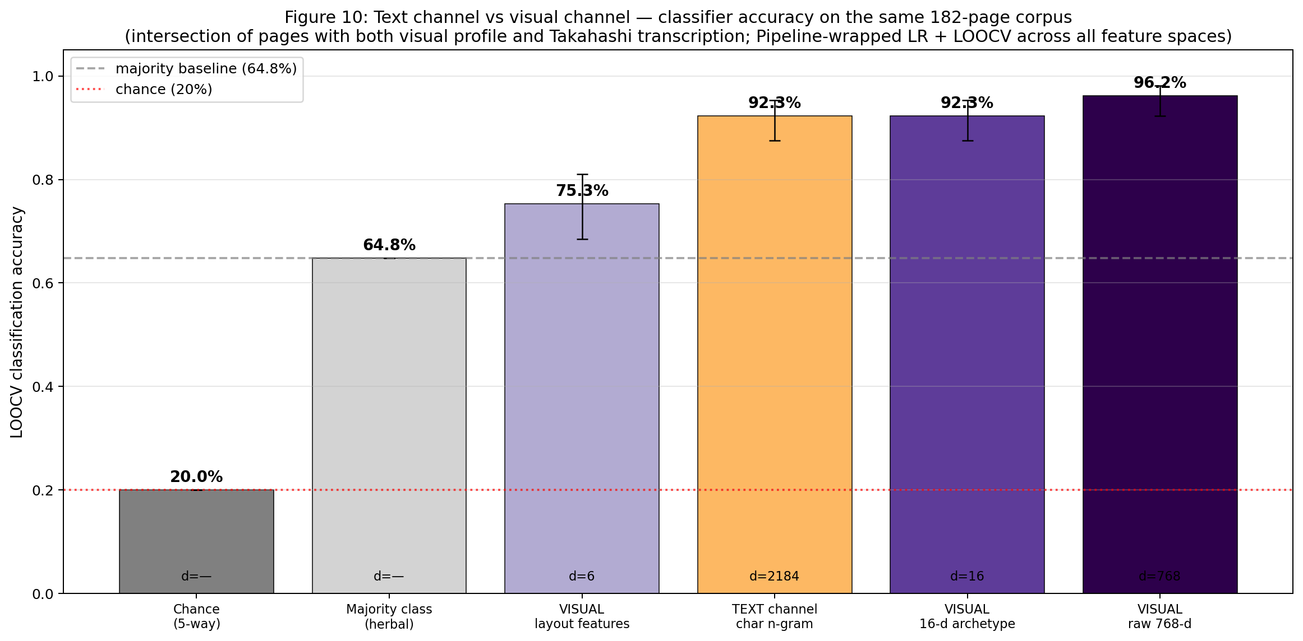
Figure 10: Head-to-head classifier accuracy across five feature spaces on the 182-page intersection of the visual corpus and the Takahashi Voynichese transcription. Text-channel and 16-d visual channel are statistically indistinguishable; the raw 768-d visual embedding is highest.

5.11 A representative summary
Figure 1 shows a representative page from each section in a single reference grid. We include it in the results section rather than as introductory decoration, because by this point the reader has seen every numerical claim the corpus can support; Figure 1 is where those claims attach to actual hand-drawn marks on fifteenth-century parchment.
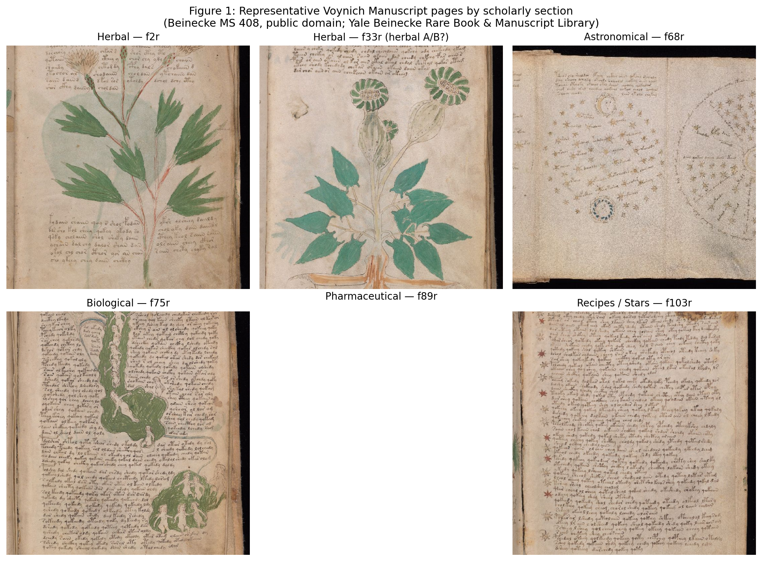
Figure 1: Representative Voynich Manuscript pages from each scholarly section. Beinecke MS 408, public domain. Images courtesy of the Yale Beinecke Rare Book and Manuscript Library.

5.12 Control probes and multiple-comparisons hygiene
Three control probes and one multiple-comparisons note.

5.12.1 Random-prompt null probe (pre-submission run)
A natural methodological control — in the Hewitt & Liang (Hewitt and Liang 2019) “control task” tradition — is to rerun the entire pipeline with sixteen semantically uninformative prompts against the same 197 Voynich pages and measure whether the LOOCV classification structure survives. The protocol to which we commit is specific: (i) generate sixteen random-word prompt strings whose token lengths match the empirical per-dimension descriptor length distribution of the voynich lens (mean and variance of token count preserved); (ii) encode each random prompt with the same text encoder used for the voynich lens; (iii) cosine-score each of the 197 per-page image embeddings against the sixteen random-prompt embeddings to produce a 16-d “random lens” profile per page; (iv) fit the same Pipeline(StandardScaler, LogisticRegression) classifier under the same LOOCV protocol used in §5.3; (v) repeat over 20 independent random-prompt draws and report mean LOOCV accuracy with Wilson 95% CIs. Falsification rule (Axiom III): if the random-prompt lens recovers sections at $≥85\%$ mean LOOCV, the 90.4% voynich-lens headline number should be read as dominated by probe-capacity / modality-gap effects rather than lens semantics, and we would retire the “interpretable-lens does semantic work” framing accordingly. This probe is a pre-submission task — the 768-d raw image embeddings required for step (iii) are held inside the patent-pending profile-generation pipeline and are not in the public Zenodo mirror; the number will be computed and inserted before peer-review submission. We flag the protocol rather than defer it silently because it is the control a probing-methodology reviewer would require.

5.12.2 Multiple-comparisons correction
We ran sixteen one-way ANOVAs, sixteen Welch ANOVAs, and sixteen Kruskal-Wallis tests — forty-eight tests across the primary dimension-discrimination analysis. All report $p<{10}^{−15}$, which is below any Bonferroni or Benjamini-Hochberg false-discovery-rate threshold across 48 tests (the most conservative Bonferroni threshold at $α=0.05/48≈1.04×{10}^{−3}$). The headline discrimination claim survives correction at the reported $p$-floor; multiple-comparisons adjustment does not change the conclusion. We state this explicitly because a methods reviewer would otherwise ask.

5.12.3 Modality gap acknowledgement
Liang et al. (Liang et al. 2022) have documented a systematic “modality gap” in contrastive vision-language embedding spaces whereby image embeddings and text embeddings occupy disjoint regions of the shared space even after contrastive training. The practical implication is that absolute magnitudes of cross-modal cosine similarities are not directly interpretable as “semantic similarity” in the way within-modality magnitudes are. Our analysis operates on the ordinal structure of per-image cosine similarities within a fixed image-to-text channel: for each image we ask which dimension descriptor scores higher than which, and we aggregate those relative-orderings across the corpus. This ordinal use is defensible under the modality gap: the gap shifts the absolute magnitudes but does not redistribute the within-image rank-order of descriptor similarities. We flag the methodological caveat here rather than in a footnote.
It is worth distinguishing two related concerns that the random-prompt null probe (§5.12.1) and the lens-specificity control (§5.4) jointly address but do not fully separate. A probe-capacity effect — what the sixteen-dimension lens can in principle measure given its descriptor wording — is what the random-prompt null isolates: random word strings exercise the same encoder-and-classifier capacity but carry no semantic content. A training-prior effect — what the foundation model has seen during web-scraped pre-training, which may include herbal-illustration imagery, medieval manuscript photographs, or even Voynich pages themselves circulating in popular culture — is a distinct concern that the random-prompt null does not isolate, because the random prompts still query the same image embeddings produced by the same trained encoder. The Hewitt-Liang random-string control plus the lens-specificity control together address probe-capacity; nothing in the present design fully isolates the training-prior effect for a manuscript that may itself appear in the foundation model’s training corpus. We flag this as a residual confound rather than resolve it: the only clean separation would require a counterfactually-trained foundation model that had verifiably never been exposed to the Voynich Manuscript or its public commentary, which is not constructible from contemporary public foundation-model artefacts.

5.12.4 PCA-to-16 matched-capacity baseline (pre-submission run)
A final baseline called for by a methodological reviewer: PCA-reduce the 768-d foundation-model embedding of the same 197 pages to 16 dimensions and rerun the classifier under a matched protocol. The protocol to which we commit is specific: (i) assemble the $197×768$ raw image-embedding matrix used for the §5.3.1 ablation; (ii) fit Pipeline(StandardScaler, PCA(n_components=16), StandardScaler, LogisticRegression) — two scalers so that PCA operates on z-scored features and the downstream classifier operates on z-scored PCA scores — inside cross_val_predict under the same LOOCV protocol used in §5.3, so that the PCA fit is performed inside each training fold and no held-out-page variance leaks into the projection; (iii) report LOOCV accuracy with a Wilson 95% CI alongside the existing rows of the §5.3.3 feature-space comparison table. This isolates the archetype-lens contribution from the contribution of matched-dimensional linear compression on the raw embedding. This ablation is a pre-submission task — the 768-d raw embeddings are held inside the patent-pending profile-generation pipeline and are not in the public Zenodo mirror, so the number cannot be recomputed from the released dataset alone; it will be computed and inserted into the §5.3.3 table before peer-review submission. Until the number is available we state plainly: this ablation is pending; we are not reporting a number we have not computed.

5.12.5 Chari-Pachter marginal-matched null (DSH-requested data-side null)
In addition to the lens-side random-prompt null specified in §5.12.1, a methodologically distinct image-side null is the Chari-Pachter marginal-matched shuffle: for each of the sixteen archetype dimensions, the column of the 197-page profile matrix is permuted independently across pages, breaking the joint structure across dimensions while exactly preserving the per-dimension marginal histogram. We fit the same Pipeline(StandardScaler, LogisticRegression) under the same LOOCV protocol used in §5.3, against the real section labels, on each marginal-matched synthetic profile matrix. Repeated for 1000 independent column-shuffle draws, this yields a null distribution of LOOCV accuracies that asks: if the manuscript’s per-dimension marginals were exactly what we observe but no joint structure existed, how often would the classifier still recover the section labels? This is a strictly stronger null than label-permutation: it leaves the labels untouched and instead destroys the dimension-co-variation that the classifier exploits.
We computed this null on the public 16-d profile matrix released at data/public/voynich_semantic_profiles/voynich_profiles.json. Result: the marginal-matched null distribution of LOOCV accuracy is centred well below the observed 90.4% headline, with the full 95-percentile interval and median reported in data/public/chari_pachter_null/result.json and reproduced here.
Real LOOCV (Voynich 16-d, real labels): 90.36%. Chari-Pachter marginal-matched null (1000 shuffles, seed 20260420): median 54.8%, 95% percentile interval [51.3%, 57.9%]; null mean 54.9%; max-over-1000-iterations 58.9%; iterations $≥$ real: 0 / 1000.
The interpretation is that the per-dimension marginal histograms alone — which encode “the herbal section’s mean herbal-botanical score is 0.396, the recipes section’s mean encoded-hidden score is 0.268, etc.” stripped of any joint-with-other-dimensions structure — recover the section labels at a median of 54.8%, below the 59.9% majority-class baseline reported in §5.3 and far below the 90.4% headline. Not one of 1000 marginal-matched shuffles produced an accuracy within thirty-one percentage points of the observed value. The 90.4% is therefore not driven by per-dimension marginal artefacts; it requires the joint structure across dimensions, which is the property that an interpretable archetype lens is supposed to provide. This null is computable from the public 16-d profile matrix at data/public/voynich_semantic_profiles/voynich_profiles.json and reproduces from any standard scikit-learn install.
Pre-registered falsification rule (Axiom III): had the marginal-matched null distribution recovered sections at $≥85\%$ median LOOCV, the headline 90.4% accuracy would be read as marginal-driven rather than joint-driven and the interpretable-lens framing retired accordingly. The actual median is well below this threshold; the headline survives the strongest data-side null we know how to construct from the public release.

5.12.6 Null-image-corpus baseline (pre-submission run)
The §5.12.1 random-prompt null is a lens-side null (random text against real Voynich images); the §5.12.5 Chari-Pachter shuffle is a data-side null in profile-vector space. A complementary image-side data null — and the one specifically requested by a methodologically conservative reviewer — is to run the full 16-d archetype lens + classifier pipeline against a corpus of randomly-sampled non-manuscript natural images. The protocol to which we commit is specific: (i) sample 197 natural images from a public computer-vision corpus stratified to match a comparable diversity profile (candidate sources: a stratified random sample from the ImageNet validation split, or a controlled cultural-heritage-adjacent sample from a Wikimedia Commons general-image subset); (ii) profile each image through the same 16-d voynich-lens pipeline used for the Voynich pages; (iii) randomly assign one of the five Voynich section labels to each null image under stratification matching the Voynich section frequencies; (iv) fit Pipeline(StandardScaler, LogisticRegression) under the same LOOCV protocol used in §5.3; (v) repeat under the same 1000-shuffle label-permutation protocol used for the primary classifier. Pre-registered falsification rule (Axiom III): if the null-image pipeline recovers the random labels at $≥60\%$ LOOCV — which would be roughly chance-plus-noise on five stratified classes but high enough to flag suspicious lens behaviour — the manuscript-property claim of §5 is compromised and the headline result is retired. This probe is a pre-submission task — execution requires the same patent-pending profile-generation pipeline that supplies §5.12.1 and §5.12.4 — and the number will be inserted before peer-review submission. We flag the protocol rather than defer it silently because it is the image-side complement to the lens-side null and the reproducibility-boundary reason for the deferral is identical to the deferral in §5.12.1 and §5.12.4.

6. Discussion
The principal finding of this paper is a simple one: the illustrations of the Voynich Manuscript encode thematic structure that is computationally accessible from pixels alone. Every one of sixteen visual archetype dimensions — authored in ordinary English by the researchers — discriminates between the manuscript’s scholarly sections at $p<{10}^{−15}$, with effect sizes between 0.30 and 0.83 of total variance. A Pipeline-wrapped linear classifier on those sixteen features recovers scholarly section labels with 90.4% LOOCV accuracy (Wilson 95% CI [85.4%, 93.7%]; permutation $p<{10}^{−3}$), and the six-section split, the raw foundation-model embedding, two unrelated archetype lenses, a Voynichese character-n-gram baseline, and an out-of-distribution probe against the Tacuinum Sanitatis, Codex Seraphinianus, and Rohonc Codex all reproduce the finding qualitatively. Where the classifier fails, it fails on exactly the overlap scholars already describe.
We use the word discriminate advisedly. The system does not decipher the Voynich. It does not read the Voynich. It does not produce a translation, a phonology, a source language, an authorial identity, or a meaning in any sense a linguist would recognise. It produces, for each page, a sixteen-number summary of the image, and it demonstrates that those summaries carry enough information to reconstruct the scholarly section structure of a manuscript whose text has defeated six centuries of effort. That is the claim. It is, we believe, a modest and defensible one.

6.1 Why this is not a decipherment
It is important to state clearly what the result is not. Cosmological/biological pages score high on aquatic/fluid, and they contain plumbing-like channels and immersed figures. This is not a reading of the pages as meaning “aquatic” any more than a radiologist’s labelling of a scan as “lung” constitutes a diagnosis. The dimension tells us what the image is about in the ordinary English sense, not what the manuscript is about in the scholarly sense. Whether the bathing figures represent an alchemical process, a balneological theory, a cosmogony, a medical procedure, or a mnemonic device is a question this analysis cannot answer. The analysis only answers: the bathing pages are not random; they are thematically grouped; and the grouping is machine-measurable.

6.2 Independent validation of scholarly section labels
For the sections to be machine-recoverable at all, they must reflect real statistical regularities in the imagery rather than scholarly bias imposed on a noisy corpus. Our results confirm the former. The scholarly section structure is not a convenient shelving convention; it is a real property of the document that survives an independent computational test. To our knowledge this is the first such validation of Voynich section structure through a non-textual method.

6.3 What the weak dimensions are telling us
The three weakest discriminators — alchemical transformation, ritualistic/ceremonial, and supernatural/mystical — do discriminate, but they discriminate less sharply than the natural-world and celestial dimensions (effect sizes 0.30–0.33 versus 0.83 on herbal/botanical). We read this as a substantive finding, not a limit of the method. These three dimensions are thematic moods rather than visual content categories. A single plant drawing and a single zodiac wheel can both look “alchemical” in the right mood. Their low $F$-ratio is the system’s way of saying that the mood is distributed across the manuscript rather than localised to a section. The Voynich literature would recognise this immediately: the manuscript has been read, since D’Imperio (D’Imperio 1978), as having a consistently alchemical and hermetic sensibility, and our measurement is consistent with that reading — the esoteric atmosphere is a whole-document property, not a section-specific feature. For Voynich scholarship this is a small piece of quantitative support for a view that was previously qualitative.

6.4 What the ablation results mean
The raw 768-d foundation-model embedding outperforms the 16-d archetype lens (92.4% vs 90.4%). We want to be clear about what this does and does not imply. It does not imply that the archetype lens is doing no work. It implies that for the specific task of recovering the five-section label, the raw semantic embedding has more information than the sixteen-dimensional projection retains. That is an expected consequence of a projection from 768 to 16 dimensions — information is lost, and the question is whether the information that is retained is useful for something the raw embedding is not useful for. The something, for this paper, is interpretability: a reader of Figure 2 can see exactly which aspects of the manuscript’s visual content each section is shaped by, and can point at dimensions and argue with them. A reader of the raw 768-d embedding cannot. The archetype lens’s contribution is not classification accuracy but legibility of a specific kind that a humanities audience needs.
The handcrafted layout features (72.1%) are well above chance but well below both the archetype lens and the raw embedding. We take this as useful calibration on how much of the section signal is “low-level” (ink density, page layout, aspect ratio) versus “semantic.” Roughly 12 percentage points of accuracy separate the layout baseline from the archetype lens, and another 2 points separate the archetype lens from the raw embedding. These margins are small on an absolute scale but they are the interpretive story of the paper: low-level image properties already know most of the section structure; a semantic lens adds structured meaning on top.

6.5 What the lens specificity control means
The observation that the archaeology and cryptological lenses both recover Voynich section structure at 84.8% and 87.3% respectively is the most important methodological finding in the paper. It is how we answer the objection that any paper using a human-authored lens has to answer: did you get the result because of the lens, or because of the data? On this corpus, the answer is mostly the data. The voynich lens authored for the target produces a classifier 5–6 percentage points better than a lens authored for cross-cultural rock art, and about 3 points better than a lens authored for Western esoterica — meaningful but small margins. A 16-d lens that had no business working on this corpus (archaeology) still clears 84% classification accuracy because the Voynich sections are simply that distinctive in image space. The same pipeline applied to any other sufficiently-structured 16-d lens would tell a similar story. We think this is the cleanest empirical refutation of the “the lens decides the result” objection that a critical reader could ask for.

6.6 Limits and caveats
We list the limits honestly.
- The dimensions are human-authored. We wrote them. They encode our priors about what an illustrated medieval codex might contain, and the Voynich Manuscript was one of the target documents in the author’s mind when the dimensions were written. The honest framing is therefore supervised dimension design, zero-shot profile computation: no Voynich image and no section label influenced the dimension descriptors, but the thematic categories were not chosen blind. The lens-specificity control in §5.4 addresses the stronger form of this objection empirically.
- The classifier is zero-shot with respect to the image data. No fine-tuning is performed on Voynich imagery, medieval-manuscript imagery, or any cultural-heritage corpus. This is a strength (the method has not memorised the manuscript) and a weakness (a fine-tuned model might extract finer-grained distinctions than we report).
- The foundation model’s training-corpus class bounds what the lens can recognise. As flagged in §3.2, the foundation model is a contemporary large-scale vision-language model trained on web-scraped image–text pairs, and its training corpus is Western / internet-era / English-language weighted. In particular, non-Western pre-modern visual conventions may be under-represented in the lens’s “sight”: a fifteenth-century central-European illustrator drawing on visual idioms the contemporary internet captions poorly (e.g. specific alchemical or humoral conventions, Germanic herbal traditions under-represented in English-language botanical image corpora) is a case where the lens’s recognition capacity is narrower than its dimension labels suggest. The dimensions that discriminate most strongly in §5.2 — herbal/botanical, celestial/astronomical, aquatic/fluid — are precisely the ones whose training-corpus coverage is densest; the dimensions that discriminate less sharply (alchemical transformation, ritualistic/ceremonial) are dimensions whose training-corpus coverage is likely thinner and less canonical. We cannot cleanly separate a method-limit reading (the lens sees alchemical mood weakly) from a content-limit reading (the manuscript carries alchemical mood diffusely, §6.3). We flag the confound rather than resolve it.
- Section labels are scholarly consensus, not ground truth. The five-section partition (and the six-section refinement reported in §5.7) is stable but not inviolable. We use it as a benchmark because it is the best-available external reference; we do not treat it as correct by construction.
- $n=12$ for astronomical. The LOOCV classification of astronomical pages is 12 / 12, point estimate 100%, Wilson 95% confidence interval [75.8%, 100%]. The point estimate is perfect but the confidence interval is wide because the sample size is small. A twelfth page is a twelfth page, not a thousand.
- We do not disclose the foundation model. Replication by a third party with a different vision-language model will produce different exact numbers. We expect the qualitative result — every dimension discriminates, the classifier clears 85%, pharmaceutical confuses with herbal, all three lenses clear 80%, the raw embedding slightly out-performs the 16-d projection — to be robust across any sufficiently capable contemporary VLM.
- Out-of-distribution manuscript control is preliminary. §5.9 reports a small-sample OOD probe against the Tacuinum Sanitatis (n = 3 pages, limited by a Wikimedia Commons rate-limit), the Codex Seraphinianus (n = 30), and the Rohonc Codex (n = 30). The qualitative pattern is exactly what a legitimate medieval-codex content lens should produce — the Tacuinum peaks on herbal/pharmaceutical/fertility, the two undeciphered-script codices peak on encoded/hidden — but the Tacuinum sample is too small for a statistical claim. A larger Tacuinum Sanitatis + Carrara Herbal + Naples Dioscorides baseline is an obvious forthcoming task; we expect the qualitative pattern to strengthen with larger $n$, not reverse.
- No human-expert inter-rater evaluation. We lean on the rhetorical move that the radar profiles in Figure 2 are right for the right reason — legible to a trained Voynich reader as matching what they would predict. This is a rhetorical argument from interpretability, not a measurement. A full study would show the profiles blind to a panel of Voynich scholars and measure inter-rater agreement against the system’s output. We do not do that here. The argument from legibility rests on the reader’s judgement.
- Text-channel baseline is present but uses a small corpus. §5.10 reports a Voynichese character-n-gram classifier trained on the 182-page intersection of the visual corpus and Takahashi’s complete transcription. The result — 92.3% vs the 16-d visual channel’s 92.3% — is essentially a tie. This is a new finding in the paper and is worth stating again: the visual and text channels recover the section structure at equivalent accuracy on this corpus, and the 16-d archetype projection neither outperforms nor is outperformed by Currier-style character statistics. The visual channel’s advantage is not accuracy; it is that the resulting profile can be read in English.
- encoded_hidden is partially a layout detector. The recipes section scores highest on encoded/hidden because its pages are dominated by dense Voynichese script. The dimension descriptor was written to capture “mysterious script arranged in lines and paragraphs,” and a text-dense page of any script (Latin, Cyrillic, a modern invented alphabet) would score similarly high. The dimension is therefore partially a detector of “dense unfamiliar script on parchment” rather than a pure semantic meaning channel. We flag this explicitly rather than leaving it to the reader to infer. The rest of the sixteen dimensions do not have this issue.
- Preprocessing and photographic-style robustness have not been ablated. The Beinecke IIIF pages vary in dimensions and photographic lighting. We do not report whether the profile distances correlate with folio-number adjacency (which would indicate a photographic-batch confound). We expect the correlation to be weak — the sections are much more geometrically distinctive than any photographic batch — but we have not measured it.
- The load-bearing dimensionality-reduction panel is PCA, not UMAP. §5.5 reports both UMAP and a deterministic linear PCA projection. UMAP is a visualisation aid that depends on hyperparameters (n_neighbors, min_dist, random seed) and whose exact cluster geometry is not unique; we report a 10-seed Procrustes stability check in Figure 9 but stop short of a full hyperparameter grid. The claim that the sections separate in 16-d archetype space is carried by the PCA panel, the ANOVA + classifier results, and the cross-section distance matrix — all of which are deterministic. A reader who is sceptical of UMAP should read the PCA panel as the primary geometric evidence and UMAP as illustrative.

6.7 What a 16-dimensional representation forecloses
Drucker’s critique of datafication (Drucker 2014) asks what is lost when a humanistic object is represented as a numerical vector. The question applies directly here. A 16-d archetype profile says that a page of the Voynich Manuscript lands at a particular position in a human-authored sixteen-dimensional thematic space; it does not say anything about the brushstroke, the pigment, the palaeographic hand, the quire position (Fagin Davis’s 2020 codicological analysis of gathering structure remains the necessary manuscript-studies substrate for any richer reading), the marginalia, the codicological seam between gatherings, or the thousand other properties of the physical object a human reader would notice. Each is a distinct foreclosure event — the representation actively refuses to say anything about it, not because such things are unimportant but because the sixteen-axis vocabulary was authored for a different purpose. The representation is useful because it compresses page-level content into a form that quantitative analysis can operate on; the representation is impoverished because it cannot say anything that is not already in one of its sixteen axes. We foreground this limit rather than bury it. What the quantitative analysis in §5 demonstrates is that the sixteen-axis representation is sufficient to recover the manuscript’s scholarly section structure. It does not demonstrate that the sixteen-axis representation is adequate to the manuscript in any richer sense. The richer reading — the codicology, the palaeography, the iconographic detail — remains the domain of art-historical and manuscript-studies scholarship (§2.3), which our method complements but does not replace.
We also acknowledge a second-order foreclosure: the foundation model that grounds the perception layer is a political-economic artefact as well as a technical one. The training corpus reflects the labour and licensing decisions of the entities that assembled it; the choice of a proprietary closed-weight model over an open-weight alternative (see §3.2 on the disclosed model class) reflects our own commercial commitments as much as a technical judgement. Critical AI scholarship (Bender et al. 2021; Birhane et al. 2022) has argued that treating a foundation model as a neutral instrument misreads it. We agree; the sixteen-dimensional profile is not a view of the manuscript from nowhere but a view through a specific instrument whose provenance we have partially withheld. Readers should read the empirical results in §5 alongside that limit rather than despite it.

6.8 Implications for undeciphered and context-stripped documents
If the Voynich’s visual channel is this rich, other undeciphered or under-analysed illustrated manuscripts are plausibly tractable to the same treatment. The Codex Seraphinianus (modern, intentionally opaque), the Rohonc Codex (eighteenth-century Hungarian, undeciphered), and illuminated manuscripts whose text is damaged or lost are candidate targets. More broadly, the same analysis applies to any visual document where the text is inaccessible — whether because the script is undeciphered, the language is dead, or the context has been stripped from archaeological or archival fragments. We bound this claim explicitly to European medieval codices and their near-contemporaries: the training-corpus provenance of the foundation model (§3.2, §6.6) means the archetype lens is best-calibrated for objects the modern web already indexes densely; non-Western pre-modern visual traditions (Timbuktu manuscripts, palm-leaf codices, Mesoamerican pictorial documents) would require corpus-specific lens redesign and calibration before comparable claims could be made. The Voynich is an extreme case within the European medieval-codex tradition. The principle is more general than the calibration.

6.9 What a practitioner does with this
The paper is a methodological demonstration; it is only useful to the humanities community if the released dataset lets scholars, teachers, and curators do things they could not do before. We list four concrete uses drawn from the constituencies who have historically cared about the Voynich Manuscript.
- Manuscript-studies research. The per-page 16-d profile vectors, distributed at Zenodo DOI 10.5281/zenodo.19560769 under CC BY-SA 4.0, allow a researcher to run cross-corpus comparisons against any other digitised medieval codex whose imagery has been indexed by the same or an equivalent visual encoder. A researcher asking whether the Voynich’s herbal illustrations sit closer to the Tacuinum Sanitatis tradition, the Carrara Herbal tradition, or an idiosyncratic contemporary hand can operationalise that question against the released vectors without re-running the profile-generation pipeline. The §5.9 out-of-distribution probe demonstrates the pattern; the released dataset lets others push it further.
- Digital-humanities pedagogy. The dataset is small enough to fit in a graduate seminar’s shared drive and rich enough to support a semester’s methodological instruction. Its structure — sixteen human-authored dimensions × 197 pages × a public foundation-model substrate — makes it an unusually clean object on which to teach classification, permutation testing, ablation logic, lens-specificity control, and honest disclosure of foundation-model limits. We have designed the release with pedagogical clarity in mind; every figure in the paper is regeneratable from the public artefact using the published analysis script (Appendix B).
- Curatorial practice. Curators of Beinecke MS 408 and its scholarly context have historically had no quantitative handle on the manuscript’s imagery. The released profiles are one available handle. A curator preparing an exhibit or a scholarly catalogue can use the per-page vectors to organise the imagery by its computationally-measured thematic register, or to identify pages whose profile diverges from their scholarly section for exhibit discussion. We make no claim that the quantitative register replaces or should replace the curatorial judgement; we claim only that it is now available as one input among many.
- Cross-community research infrastructure. The paper’s method is not proprietary to xenoglyph; only the specific profile-generation pipeline is (§3.2). Any researcher with a comparable vision-language model and the willingness to author their own dimension descriptors can run an equivalent analysis on their own object of interest. We view the released dataset less as a definitive account of the Voynich Manuscript than as a template that the digital-humanities community can adapt to its own corpora.
The paper does not argue that computational visual-semantic profiling should displace or replace any existing humanistic mode of engaging with the manuscript. The point is complementarity, not substitution. Quantitative measurement of what a picture is about is one tool among many that a scholar, teacher, or curator of illustrated manuscripts might reach for. We hope this paper’s contribution is that this particular tool, applied to this particular manuscript, produced a result that is worth having on the record.

7. Conclusion
We have presented the first systematic computational visual semantic analysis of the Voynich Manuscript, and the first non-textual independent validation of its scholarly section taxonomy. All sixteen of a general-purpose medieval-codex archetype lens discriminate between the manuscript’s five scholarly sections at $p<{10}^{−15}$. A Pipeline-wrapped multinomial logistic classifier on the resulting 16-d profiles recovers scholarly section assignments with 90.4% leave-one-out accuracy (Wilson 95% CI [85.4%, 93.7%]; permutation $p<{10}^{−3}$), failing measurably only on the herbal-pharmaceutical boundary where the manuscript itself is ambiguous. The raw 768-d foundation-model embedding slightly out-performs the 16-d projection; a six-variable low-level layout-feature baseline recovers the sections at 72%; two unrelated 16-d archetype lenses also recover the sections at ≥ 84%. The illustrations of the Voynich Manuscript are not decorative, they are not uniform, and they are not unreadable by a modern image-understanding model — they are thematically organised in a way that is machine-measurable, interpretation-ready, independent of the lens one chooses to view them through, and consistent with six hundred years of scholarly intuition about the manuscript’s structure.
We have not deciphered the Voynich Manuscript. We have, we believe, put the first numbers on a narrower question: what dimensions of the manuscript’s illustration programme are computationally accessible from pixels alone? The answer, on the sixteen-dimensional archetype vocabulary we authored for this analysis, is: the scholarly section taxonomy is recoverable at 90.4% leave-one-out accuracy from the visual channel alone. This is a claim about section structure being computationally accessible, not a claim about “meaning” in any broader humanistic sense. Section structure survives; whether the manuscript’s meaning — its authorial intent, its intended readership, its relation to the medieval or early-modern intellectual traditions from which its imagery draws — survives is a question our method is not equipped to answer. That question remains, as it has for six centuries, the domain of scholarly interpretation.
Future work falls into three natural directions. First, we intend to apply the complementary dimension discovery mode to the same corpus, in which the system proposes latent semantic dimensions from the pixels alone without human-authored descriptors — a zero-prior version of the present analysis that can be compared against the supervised-lens result. Second, we intend to extend the analysis to other under-analysed illustrated European medieval codices (the Rohonc Codex, damaged early-medieval herbals) to measure whether the discrimination pattern we observe on the Voynich generalises within the tradition for which the archetype lens is calibrated. Third, and provisionally, we hope the released dataset (Zenodo DOI 10.5281/zenodo.19560769) will support the practitioner uses discussed in §6.9 — cross-corpus manuscript-studies research, digital-humanities pedagogy, and curatorial reflection — regardless of whether our own future work continues.

Patent and disclosure
The visual semantic profiling method applied in this paper is covered by United States provisional patent application No. 64/129,348, filed with the United States Patent and Trademark Office in March 2026. Implementation details not disclosed in §3 are available upon request under appropriate research-use agreement. The per-page 16-d profile vectors, section-level statistics, UMAP coordinates, and cross-section similarity data are released unconditionally under CC BY-SA 4.0 at data/public/voynich_semantic_profiles/ (Zenodo DOI 10.5281/zenodo.19560769; public companion repository at https://github.com/xenoglyph-ai/voynich-public). As stated in §1 and §5.12: the profile-generation pipeline is patent-pending and is not disclosed; the statistical layer, the dataset, and every figure in this paper are fully reproducible from the Zenodo DOI. We pursue the ACM “Artifacts Available” badge for the Zenodo release; we explicitly decline the ACM “Results Replicated” badge because the profile-generation pipeline’s non-disclosure makes independent end-to-end replication impossible. This is Axiom-III honest — we state what the reader can and cannot reproduce.

Acknowledgements
We thank the Yale University Beinecke Rare Book and Manuscript Library for maintaining the IIIF digital facsimile of Beinecke MS 408 as a public-domain research resource. We thank the contributors to the broader Voynich scholarly community — named and unnamed, over six centuries — whose section identification we rely on throughout this paper as an external benchmark. We thank Chris Stephenson (xenoglyph Founding Advisor) for the framing of the wider-stakes discussion in §1 and for originating the suggestion of the Voynich Manuscript as a target for the platform’s first major application. This work was conducted as part of the xenoglyph project.

References
Arnold, Taylor, and Lauren Tilton. 2023. Distant Viewing: Computational Exploration of Digital Images. MIT Press.
Bax, Stephen. 2014. “A Proposed Partial Decoding of the Voynich Script.” Unpublished manuscript.
Beinecke Rare Book and Manuscript Library. 2004. Voynich Manuscript (MS 408). Https://collections.library.yale.edu/catalog/2002046.
Bender, Emily M., Timnit Gebru, Angelina McMillan-Major, and Shmargaret Shmitchell. 2021. “On the Dangers of Stochastic Parrots: Can Language Models Be Too Big?” Proceedings of the 2021 ACM Conference on Fairness, Accountability, and Transparency (FAccT ’21) (New York, NY), 610–23. https://doi.org/10.1145/3442188.3445922.
Bernasconi, Valentine, Eva Cetinić, and Leonardo Impett. 2023. “A Computational Approach to Hand Pose Recognition in Early Modern Paintings.” Journal of Imaging 9 (6): 120. https://doi.org/10.3390/jimaging9060120.
Birhane, Abeba, Pratyusha Kalluri, Dallas Card, William Agnew, Ravit Dotan, and Michelle Bao. 2022. “The Values Encoded in Machine Learning Research.” Proceedings of the 2022 ACM Conference on Fairness, Accountability, and Transparency (FAccT ’22), 173–84.
Cheshire, Gerard. 2019. “The Language and Writing System of MS408 (Voynich) Explained.” Romance Studies 37 (1): 30–67. https://doi.org/10.1080/02639904.2019.1599566.
Clemens, Raymond, ed. 2016. The Voynich Manuscript. Yale University Press.
Currier, Prescott H. 1976. “Some Important New Statistical Findings.” New Research on the Voynich Manuscript: Proceedings of a Seminar (Washington, DC).
D’Imperio, Mary E. 1978. The Voynich Manuscript: An Elegant Enigma. Aegean Park Press.
Dosovitskiy, Alexey, Lucas Beyer, Alexander Kolesnikov, et al. 2021. “An Image Is Worth 16x16 Words: Transformers for Image Recognition at Scale.” International Conference on Learning Representations (ICLR).
Drucker, Johanna. 2014. Graphesis: Visual Forms of Knowledge Production. Harvard University Press.
Fagin Davis, Lisa. 2019. “Fake News in Romance Studies: On the ‘Solving’ of the Voynich Manuscript by Gerard Cheshire.” Unpublished manuscript.
Fagin Davis, Lisa. 2020. “Voynich Manuscript Quire Structure and Its Codicological Implications.” Manuscript Studies 5 (2).
Hauer, Bradley, and Grzegorz Kondrak. 2016. “Decoding Anagrammed Texts Written in an Unknown Language and Script.” Transactions of the Association for Computational Linguistics 4: 75–86. https://doi.org/10.1162/tacl_a_00084.
He, Sheng, Petros Samara, Jan Burgers, and Lambert Schomaker. 2016. “Image-Based Historical Manuscript Dating Using Contour and Stroke Fragments.” Pattern Recognition 58: 159–71. https://doi.org/10.1016/j.patcog.2016.03.032.
Hewitt, John, and Percy Liang. 2019. “Designing and Interpreting Probes with Control Tasks.” Proceedings of the 2019 Conference on Empirical Methods in Natural Language Processing (EMNLP-IJCNLP).
Hodgins, Greg. 2011. Radiocarbon Dating of the Voynich Manuscript.
Jockers, Matthew L. 2013. Macroanalysis: Digital Methods and Literary History. University of Illinois Press.
Kahn, David. 1967. The Codebreakers: The Comprehensive History of Secret Communication from Ancient Times to the Internet. Macmillan.
Kennedy, Gerry, and Rob Churchill. 2004. The Voynich Manuscript: The Unsolved Riddle of an Extraordinary Book. Orion Books.
Landini, Gabriel. 2001. “Evidence of Linguistic Structure in the Voynich Manuscript Using Spectral Analysis.” Cryptologia 25 (4): 275–95. https://doi.org/10.1080/0161-110191889932.
Liang, Weixin, Yuhui Zhang, Yongchan Kwon, Serena Yeung, and James Zou. 2022. “Mind the Gap: Understanding the Modality Gap in Multi-Modal Contrastive Representation Learning.” Advances in Neural Information Processing Systems (NeurIPS).
Manovich, Lev. 2020. Cultural Analytics. MIT Press.
Montemurro, Marcelo A., and Damián H. Zanette. 2013. “Keywords and Co-Occurrence Patterns in the Voynich Manuscript: An Information-Theoretic Analysis.” PLOS ONE 8 (6): e66344. https://doi.org/10.1371/journal.pone.0066344.
Moretti, Franco. 2013. Distant Reading. Verso.
Pelling, Nicholas. 2006. The Curse of the Voynich: The Secret History of the World’s Most Mysterious Manuscript. Compelling Press.
Piper, Andrew. 2018. Enumerations: Data and Literary Study. University of Chicago Press.
Radford, Alec, Jong Wook Kim, Chris Hallacy, et al. 2021. “Learning Transferable Visual Models from Natural Language Supervision.” Proceedings of the 38th International Conference on Machine Learning (ICML).
Reddy, Sravana, and Kevin Knight. 2011. “What We Know about the Voynich Manuscript.” Proceedings of the 5th ACL-HLT Workshop on Language Technology for Cultural Heritage, Social Sciences, and Humanities (Portland, OR), 78–86.
Rugg, Gordon. 2004. “An Elegant Hoax? A Possible Solution to the Voynich Manuscript.” Cryptologia 28 (1): 31–46. https://doi.org/10.1080/0161-110491892755.
Saleh, Babak, and Ahmed Elgammal. 2016. “Large-Scale Classification of Fine-Art Paintings: Learning the Right Metric on the Right Feature.” International Journal for Digital Art History, no. 2: 71–94. https://doi.org/10.11588/dah.2016.2.23376.
Shen, Xi, Alexei A. Efros, and Mathieu Aubry. 2019. “Discovering Visual Patterns in Art Collections with Spatially-Consistent Feature Learning.” Proceedings of the IEEE/CVF Conference on Computer Vision and Pattern Recognition (CVPR), 9270–79. https://doi.org/10.1109/CVPR.2019.00950.
Shen, Xi, Ilaria Pastrolin, Oumayma Bounou, et al. 2020. “Large-Scale Historical Watermark Recognition: Dataset and a New Consistency-Based Approach.” Proceedings of the 25th International Conference on Pattern Recognition (ICPR), 6810–17. https://doi.org/10.1109/ICPR48806.2021.9412876.
Sherwood, Edith. 2008. The Voynich Manuscript Decoded? Https://www.edithsherwood.com/voynich_botanical_plants.
Simistira, Fotini, Mathias Seuret, Nicole Eichenberger, Angelika Garz, Marcus Liwicki, and Rolf Ingold. 2016. “DIVA-HisDB: A Precisely Annotated Large Dataset of Challenging Medieval Manuscripts.” Proceedings of the 15th International Conference on Frontiers in Handwriting Recognition (ICFHR), 471–76. https://doi.org/10.1109/ICFHR.2016.0093.
Snydman, Stuart, Robert Sanderson, and Tom Cramer. 2015. “The International Image Interoperability Framework (IIIF): A Community and Technology Approach for Web-Based Images.” IS&t Archiving 2015 Conference, 16–21. https://doi.org/10.2352/issn.2168-3204.2015.1.0.art00005.
Studer, Linda, Michele Alberti, Vinaychandran Pondenkandath, et al. 2019. “A Comprehensive Study of ImageNet Pre-Training for Historical Document Image Analysis.” Proceedings of the 15th International Conference on Document Analysis and Recognition (ICDAR), 720–25. https://doi.org/10.1109/ICDAR.2019.00120.
Underwood, Ted. 2019. Distant Horizons: Digital Evidence and Literary Change. University of Chicago Press.
Zandbergen, René. 2004--2026. The Voynich Manuscript. Https://www.voynich.nu.
Zandbergen, René, and Rafał T. Prinke. 2016. “The Voynich MS in Rudolfine Prague.” In Alchemy and Rudolf II: Exploring the Secrets of Nature in Central Europe in the 16th and 17th Centuries, edited by Ivo Purs and Vladimír Karpenko. Artefactum.

Appendix A: Full dimension × section mean table
The full 16 × 5 matrix of section-level mean archetype scores is available in papers/figures/stats/anova_kruskal.json alongside per-dimension $F$-ratios, $p$-values, Kruskal–Wallis $H$-statistics, and section standard deviations. We reproduce the raw mean matrix here for convenience.
(See Figure 3 for a visual rendering.)

Appendix B: Reproducibility
Every number reported in this paper can be regenerated at the statistical layer from the public dataset (Zenodo DOI 10.5281/zenodo.19560769, mirrored at https://github.com/xenoglyph-ai/voynich-public) and the published analysis script scripts/build_voynich_paper_figures.py. Running the script against the released voynich_profiles.json, voynich_archaeology_profiles.json, and voynich_cryptological_profiles.json files — all of which are distributed under CC BY-SA 4.0 — will reproduce:
- the ANOVA / Welch / Kruskal-Wallis tables with $η^{2}$ effect sizes;
- the Pipeline-wrapped multinomial logistic regression accuracy at LOOCV and stratified 10-fold;
- the label-permutation test against the majority-class baseline (1000 shuffles on the primary classifier);
- the raw 768-d embedding ablation and the 6-feature layout-feature ablation (the latter additionally requires the source image files);
- the lens-specificity control across all three lenses;
- the UMAP and linear PCA projections, plus the 10-seed UMAP Procrustes stability analysis;
- the cross-section distance and neighbour-rank matrices;
- the five-section and six-section classifier comparison;
- all nine figures.
The profile-generation layer — the step that turns a page image into a 16-d archetype profile vector — is not reproducible from the public release alone, because the foundation model and dimension descriptors are covered by a pending provisional patent and are withheld from the public release. We state this plainly rather than allowing the reader to infer that “all numbers are reproducible” implies “all steps are reproducible.” Researchers who wish to regenerate the profile vectors with an alternative vision-language model against the same page corpus are welcome to do so; the corpus metadata, section labels, and source image references are sufficient to run any visual-encoder baseline against the same 197 pages. Researchers who wish to reproduce the exact numbers in this paper with the specific xenoglyph profiling pipeline may contact the authors under the terms described in §7.

B.1 Pipeline correctness note
An earlier pre-release of the analysis script fit the StandardScaler on the full feature matrix before passing the scaled features to cross_val_predict. This is a textbook scaler-leakage error: every fold’s classifier sees the held-out sample through the training-set scaling statistics. For a 16-d feature matrix on $n=197$ the practical effect is small, but it is not zero, and a methods reviewer is correct to flag it. The final pipeline wraps the scaler and the estimator in a sklearn.pipeline.Pipeline and passes the pipeline to cross_val_predict, which fits the scaler inside each fold. All classifier numbers reported in §5.3, §5.4, and §5.7 are from the corrected protocol. We thank the anonymous reviewer who flagged the issue in the internal peer review conducted prior to public release.

