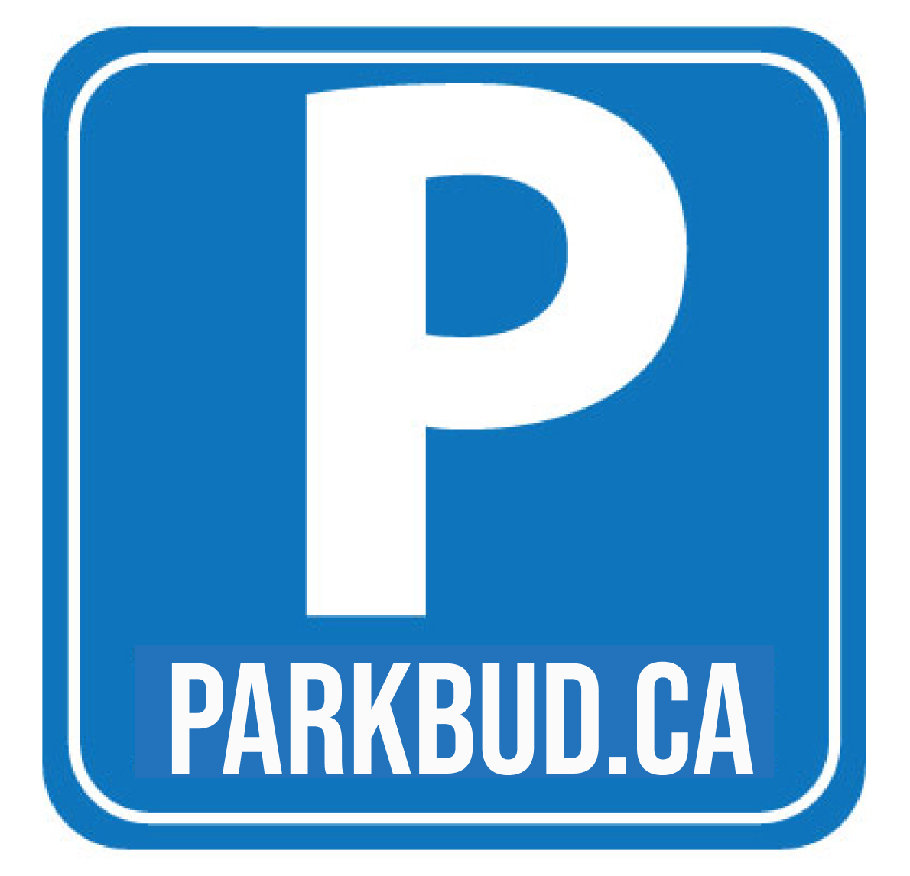

**PHP Project Proposal**

Title of the Project:

Parking Information Management: Parkbud.ca

Team 4 - Philip Ranieri, Nick Zenos, Ali Alaghbandrad

**Project description:**

Parkbud.ca is a parking rule sharing website that can be used to view the parking rules and signage from any location. It will feature a member page which will allow you to log in and submit the rules and times for public parking. You can enter the information manually, and submit a photo for verification. Anyone can view the rules, you will be greeted by a map and address bar on the front page where you can search up any location using the Google maps API.

Initially the map will be empty, but as more users log in and submit their information, the map will be full of useful information regarding public parking, including but most definitely not limited to the city of Montreal. Users can log in to their account to submit as well as share information with their friends via email or sms notifications, so for example, you could share the parking information on the odd or even address sided spots to guests who you have invited to your home, making sure they are well aware of the rules and nobody leaves with a parking ticket.

**Features and Functionalities:**

* Search for parking rules - by address, street name or postal code
* User Registration - by email and google authentication with confirmation email
* Posting, editing, deleting and disputing parking rules
* Admin panel for moderation
* Rating and commenting rules

**Technologies and libraries:**

* Google maps API
* Google/apiclient library for PHP
* Geocoder-php/google-maps-provider library
* PHP gettext library for language/localisation
* SMTP Server for sending emails
* GPS/location services - html5
* AJAX/Bootstrap/CSS/HTML

**Possible URLS:**

* index (Main page)
* login
* register
* submit-rule
* mysubmisions (User account page showing all submitted parking cards)
* delete/edit-my-submissions
* rate-comment-rule
* share (Share links to tell friends about the site)

**Scenarios:**

**Scenario 1: Search parking spot and its rule(s)**

**Scenario 1-1: Search without login**

* User searches for an address in the address bar and locates the intended parking spot by map. Locating can be pinned by typing the address and/or touching the map on mobile (like Uber).
* After finding the location, the user can click on the “See rule” icon to open rule details.

**Scenario 1-2: Search, rate, or comment with login**

* User login/register.
* User searches for an address in the address bar and locates the intended parking spot by map. Locating can be pinned by typing the address and/or touching the map on mobile (like Uber).
* After finding the location, the user can click on the “See rule” icon to open rule details.
* User can save the location and rule (optional).
* User can rate and/or leave a comment for rules.

**Scenario 2: Submitting, deleting, or editing parking rule(s)**

* User login/register.
* User searches for an address in the address bar and locates the intended parking spot by map. Locating can be pinned by typing the address and/or touching the map on mobile (like Uber).
* After pinning the location, the user can click on the “Add rule icon” to enter the rule details (text and/or image) and save rule-location.
* User can view his/her saved rule-locations.
* User can delete/edit his/her saved rule-locations.

**Entity Relationship Diagram (ERD):**

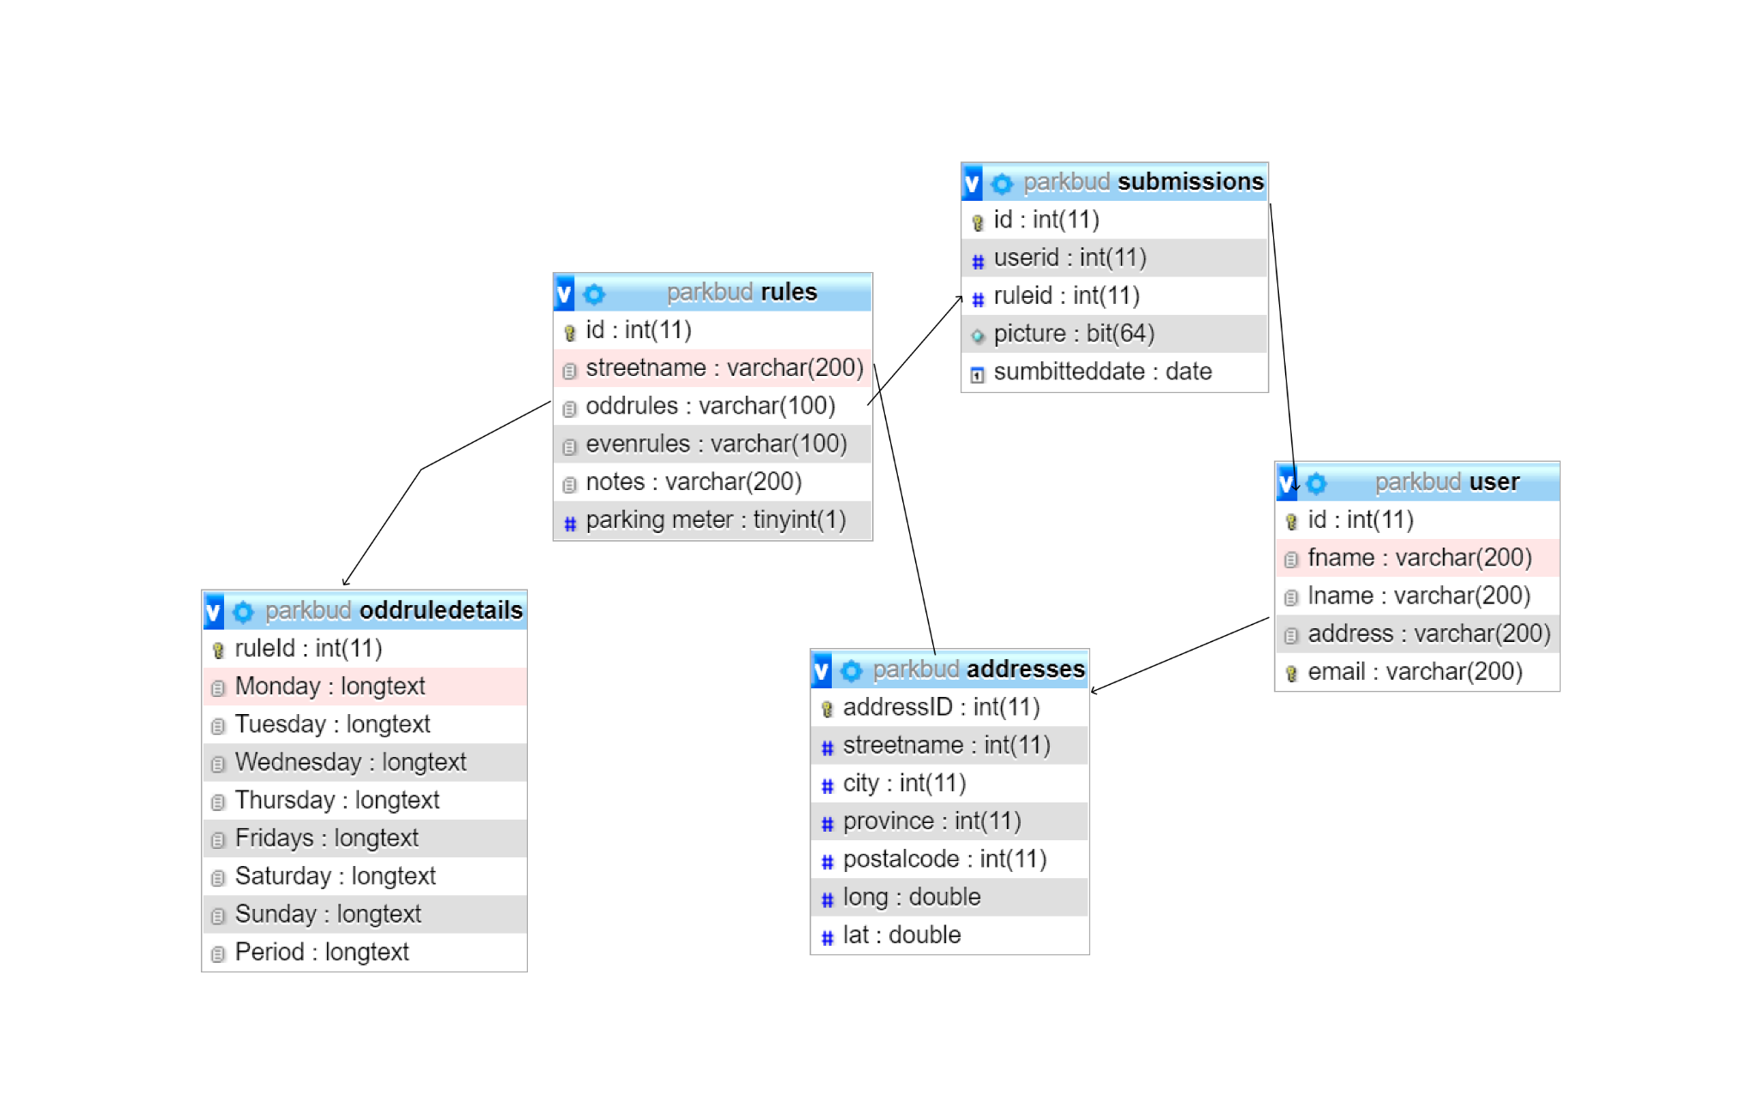

DB ENTITIES

**Mockups or snapshots of web pages:**

Main page

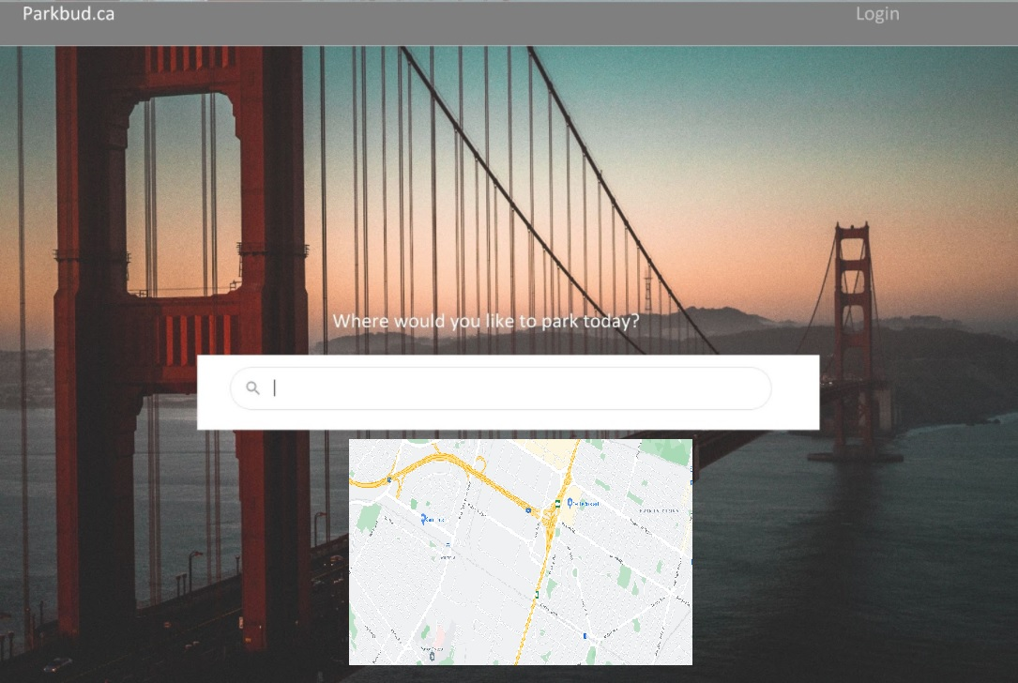

Search page

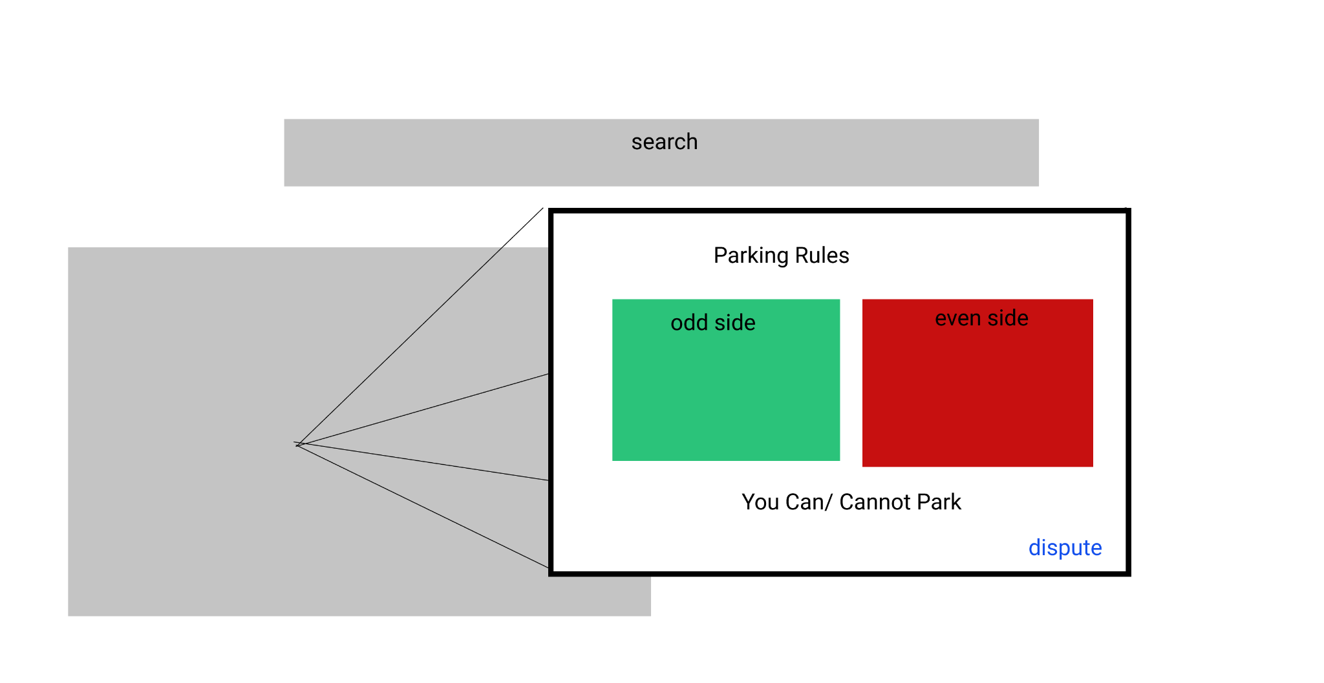

Profile page

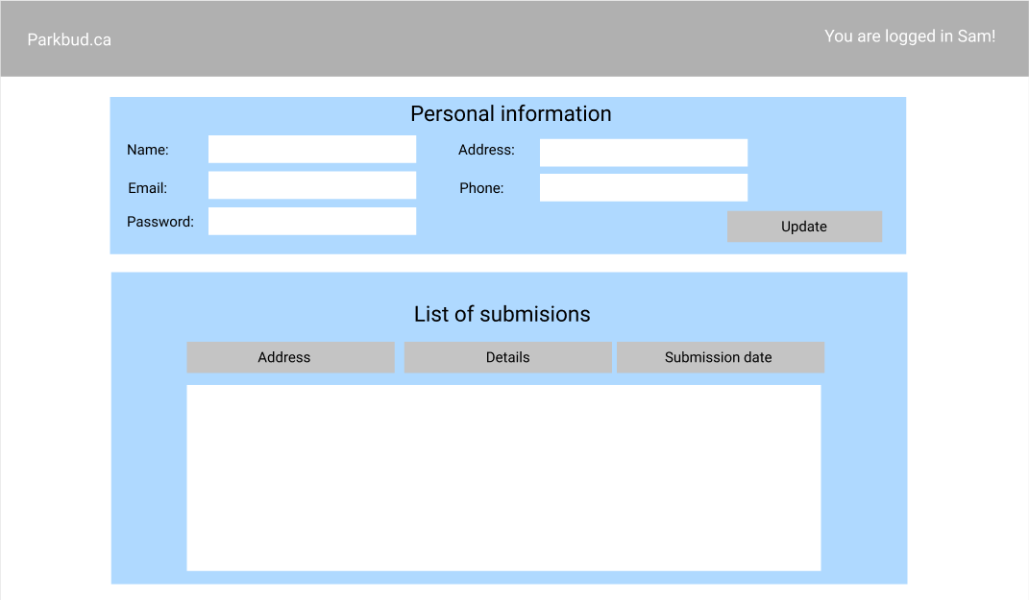

Add rule page

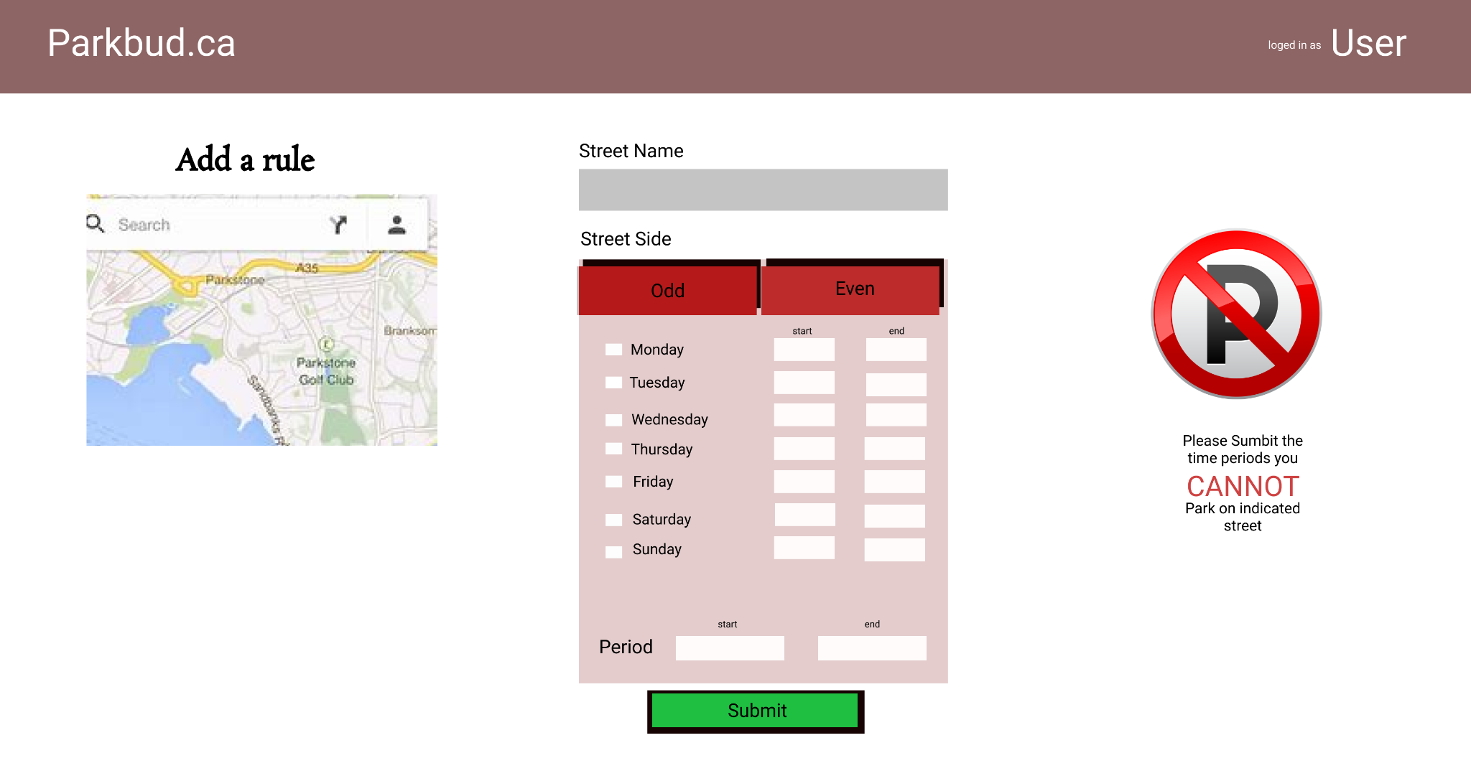

Style Guide

