Installing and Configuring the Oracle Database 10g
The Oracle Database 10g and the Oracle Developer Suite 10g must each be installed in a separate folder on your workstation, which is called the product's Oracle Home directory. This is because each product has a similar set of files that is used to configure the product and make it run correctly, and the product looks for its configuration files in its Oracle Home directory.

To install Oracle Database 10g:

1. Insert the Oracle Database 10g Release 1 (10.1.0.2) CD in your CD-ROM drive. The Oracle Database10g – Autorun dialog box opens.

HELP: If the program does not automatically start, start Windows Explorer, navigate to your CD-ROM drive and run setup.exe on the CD.

HELP: If at anytime during the installation process, a Windows Security Alert dialog box appears, like the one below, click the Unblock button.
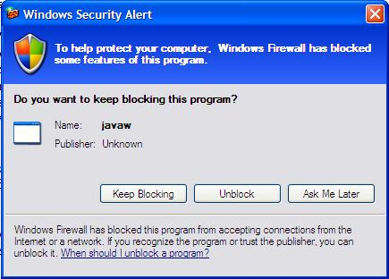

2. Click Install/Deinstall Products. Before the Welcome to the Oracle Universal Installer dialog box opens, Oracle will check your system for the necessary requirements and you will see the following screen.
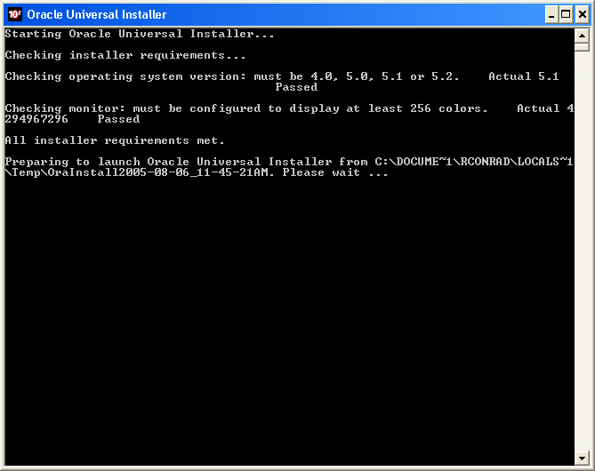

3. When the Welcome to the Oracle Database 10g Installation page appears, accept the default Basic Installation option and the Oracle Home Location: C:\oracle\product\10.1.0\Db_1 path.
4. Select the Installation Type Personal Edition, Standard Edition, or Enterprise Edition as directed by your instructor.
5. Accept the default Create Starter Database option and the default Global Database Name: orcl
6. Choose a password for your database. This password is used to login to the database as the SYS, SYSTEM, SYSMAN, or DBSNMP user. Type the password you chose in the Database Password and Confirm Password text boxes.

NOTE: The following restrictions apply to passwords:
- Passwords must be between 4 and 30 characters long.
- Passwords cannot be the same as the user name.
- Passwords must be from the database character set and can include the underscore (_), dollar ($), and pound sign (#) characters.
- Passwords cannot be Oracle reserved words.

- Click Next.

NOTE: The Product Registration page appears. On this page, you are prompted to enter a product registration key. Click the Register button to register your Oracle software with the Oracle Technology Network (OTN) before beginning the installation process. You will be prompted for information about the book that your Oracle CD came with. You will need to know the book title, ISBN, and publisher.

HELP: If you have not already obtained an OTN user_id and password you will need to do that to continue the software registration process. There is no charge to become a member of OTN.

TIP: If an Error dialog box appears that says: Thrown when the IP address of a host cannot be determined, click the Continue button to use the default value and go on. This may happen several times.

- The Preparing to Install window appears for a few moments.
- On the Summary page, click Install. The Install page appears. The installation process will take several minutes.
- When the Database Configuration Assistant page appears, click the Password Management button to unlock the Scott user. Scroll to the Scott user and uncheck the Lock Account? box. The default password for Scott is tiger, click OK, and then click OK close the Database Configuration Assistant.
- When the End of Installation page displays and confirms that the installation was successful, click Exit, and then click Yes to confirm exiting. The Oracle Enterprise Manager 10g Database Control web page opens.

Configuring a New User Account for the Oracle10g Database
When you start your computer, the Oracle10g database starts automatically, and is ready to accept data requests. Before you can use the Oracle10g database, you must perform some configuration tasks. First you create a user account, which is identified by a user name and password and is associated with an area in the database in which you create your database tables. You create a user account named dbuser, with password oracle.

To create the user account:
- On the Oracle Enterprise Manager Database Control Login page, type SYSMAN as the User Name and enter the password you specified in step 6 above, and then click Login.

TIP: If you are not on the Oracle Enterprise Manager Database Control Login page, then open a Web Browser and type the following URL: http://localhost:5500/em

- The Oracle Database Licensing Information 10g page will appear. Read the page and scroll to the bottom and then click I Agree. This page appears the first time a new user logs in to the Oracle Enterprise Manager Database Control application.
- The Oracle Enterprise Manager Database Control Home page will appear. To create a new user for the Oracle database: orcl, click the Administration link.
- Under the Security heading click the Users link.
- On the Oracle Enterprise Manager Database Control Users page, click the Create button located on the right hand side of the page.
- Type DBUSER in the Name field, oracle in the Enter Password field, and oracle in the Confirm Password field.
- Type USERS in the Default Tablespace field and Temp in the Temporary Tablespace field.
- Click the Roles link, click the Modify button, select DBA in the Available Roles list, and then click the move arrow so that DBA appears in the Selected Roles list.
- Click OK on the Modify Roles page, and then click OK on the Create User page. A message confirms that the object was successfully created.
- Click the Logout link at the bottom of the page.
- Close the Oracle Enterprise Manager 10g Database Control web page by clicking the X icon in the upper right corner of the web page.

Starting SQL*Plus and Logging On to the Oracle Database 10g
To confirm that you can connect to your Oracle10g database, you now start SQL*Plus and log on to the database using the DBUSER account.

To start SQL*Plus and log on to the database:
1. Click Start on the Windows taskbar, point to Programs or All Programs, point to Oracle – OraDb10g_home1, point to Application Development, and then click SQL Plus. The Log On dialog box opens and requests your user name, password, and host string.
2. Type DBUSER in the User Name field, press Tab, type oracle in the Password field, leave the Host String field blank, then click OK. The SQL*Plus program window opens, and the SQL prompt appears.
3. Close the Oracle SQL*Plus window.

