Laboratory Work 1
ERD Diagram

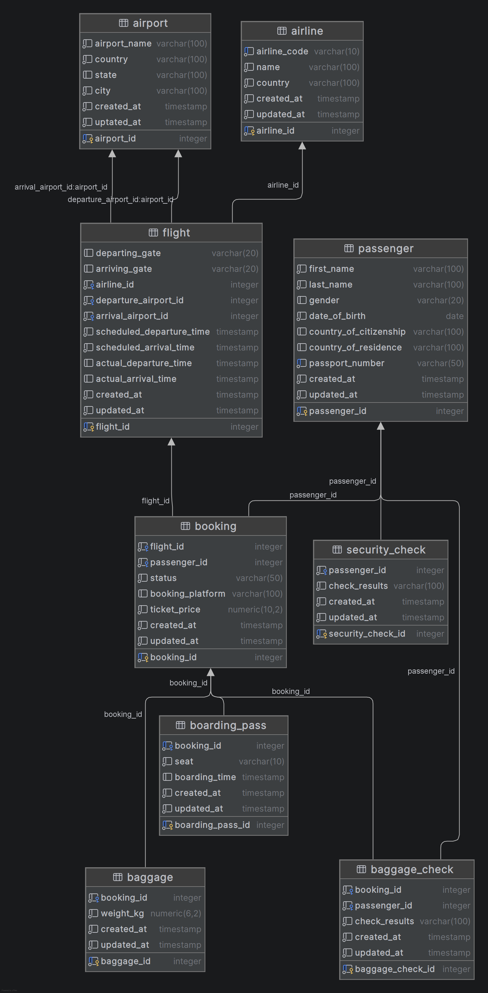
System Description

The International Airport Database is designed to manage information about airports, airlines, flights, passengers, bookings, boarding passes, baggage, baggage checks, and security checks.

The system connects flights with airlines and airports, bookings with passengers and flights, and stores additional information related to baggage and airport security procedures.
Entities and Attributes

1. Airport
Stores information about airports.

Primary Key:
airport_id

Attributes:
airport_id, airport_name, country, state, city, created_at, updated_at

2. Airline
Stores information about airline companies.

Primary Key:
airline_id

Unique Attribute:
airline_code

Attributes:
airline_id, airline_code, name, country, created_at, updated_at

3. Flight
Stores scheduled and actual flight information.

Primary Key:
flight_id

Foreign Keys:
airline_id → Airline
departure_airport_id → Airport
arrival_airport_id → Airport

Attributes:
flight_id, departing_gate, arriving_gate, airline_id,
departure_airport_id, arrival_airport_id,
scheduled_departure_time, scheduled_arrival_time,
actual_departure_time, actual_arrival_time,
created_at, updated_at

4. Passenger
Stores passenger information.

Primary Key:
passenger_id

Unique Attribute:
passport_number

Attributes:
passenger_id, first_name, last_name, gender,
date_of_birth, country_of_citizenship,
country_of_residence, passport_number,
created_at, updated_at

5. Booking
Stores information about passenger bookings.

Primary Key:
booking_id

Foreign Keys:
flight_id → Flight
passenger_id → Passenger

Attributes:
booking_id, flight_id, passenger_id,
status, booking_platform, ticket_price,
created_at, updated_at

6. Boarding Pass
Stores boarding pass information.

Primary Key:
boarding_pass_id

Foreign Key:
booking_id → Booking

Attributes:
boarding_pass_id, booking_id, seat,
boarding_time, created_at, updated_at

7. Baggage
Stores baggage information related to bookings.

Primary Key:
baggage_id

Foreign Key:
booking_id → Booking

Attributes:
baggage_id, booking_id, weight_kg,
created_at, updated_at

8. Security Check
Stores passenger security check results.

Primary Key:
security_check_id

Foreign Key:
passenger_id → Passenger

Attributes:
security_check_id, passenger_id,
check_results, created_at, updated_at

9. Baggage Check
Stores baggage check information.

Primary Key:
baggage_check_id

Foreign Keys:
booking_id → Booking
passenger_id → Passenger

Attributes:
baggage_check_id, booking_id, passenger_id,
check_results, created_at, updated_at
Relationships and Cardinalities

1. Airline — Flight
One airline can operate many flights.
Each flight belongs to one airline.

Cardinality:
Airline 1 : N Flight

2. Airport — Flight
One airport can be used as the departure airport for many flights.
Each flight has one departure airport.

Cardinality:
Airport 1 : N Flight

One airport can also be used as the arrival airport for many flights.
Each flight has one arrival airport.

Cardinality:
Airport 1 : N Flight

3. Flight — Booking
One flight can have many bookings.
Each booking belongs to one flight.

Cardinality:
Flight 1 : N Booking

4. Passenger — Booking
One passenger can have many bookings.
Each booking belongs to one passenger.

Cardinality:
Passenger 1 : N Booking

5. Booking — Boarding Pass
One booking can have one boarding pass.
Each boarding pass belongs to one booking.

Cardinality:
Booking 1 : 1 Boarding Pass

6. Booking — Baggage
One booking can have zero or many baggage records.
Each baggage record belongs to one booking.

Cardinality:
Booking 1 : N Baggage

Participation:
Baggage is optional because a passenger may travel without baggage.

7. Passenger — Security Check
One passenger can have many security check records.
Each security check belongs to one passenger.

Cardinality:
Passenger 1 : N Security Check

8. Booking — Baggage Check
One booking can have many baggage check records.
Each baggage check belongs to one booking.

Cardinality:
Booking 1 : N Baggage Check

9. Passenger — Baggage Check
One passenger can have many baggage check records.
Each baggage check belongs to one passenger.

Cardinality:
Passenger 1 : N Baggage Check

Legend

PK — Primary Key
FK — Foreign Key
1 : N — One-to-Many relationship
1 : 1 — One-to-One relationship

