LABORATORY WORK – 2 // NORMALIZATION

TASK_1.
The Booking_receipt table is not in 1NF because the seat_numbers column can contain more than one value in one field, for example "12A, 12B".
In 1NF, every field should contain only one atomic value.
The table can also have a 2NF problem after splitting seat_numbers into separate rows. If the key becomes (booking_id, seat_number), some attributes such as passenger_full_name, passenger_passport_number, flight_number and ticket_price depend only on booking_id, not on the whole key.
The table also violates 3NF because some non-key attributes depend on other non-key attributes.
For example:
booking_id ----> flight_number
flight_number ---- > airline_name
So airline_name depends on booking_id through flight_number.
TASK_2.
1 NF
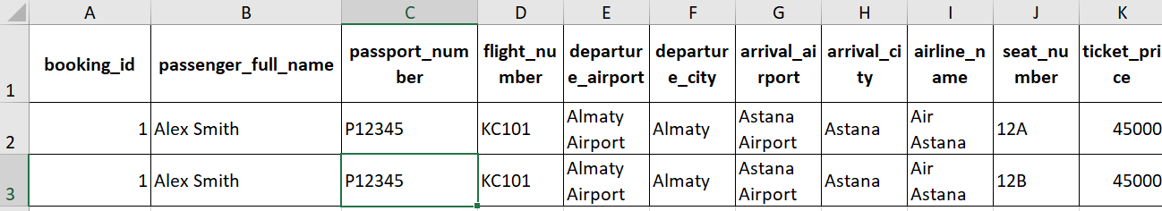
1NF: I separated seat_numbers because one cell should contain only one value.

2 NF
BOOKING
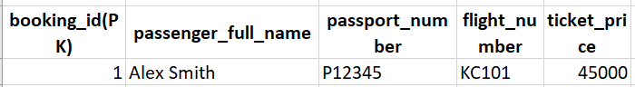
BOOKING_SEAT
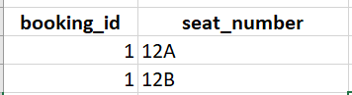

2NF: I separated seat information from booking information because booking data depends only on booking_id.

3NF
BOOKING
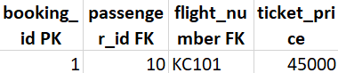
PASSENGER
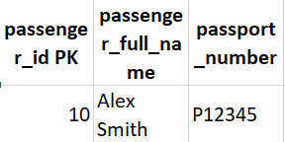
FLIGHT
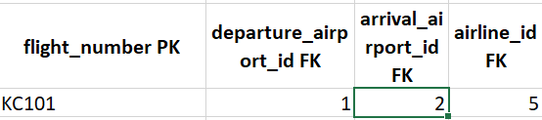
AIRPORT
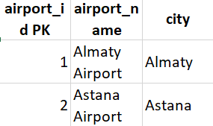
AIRLINE
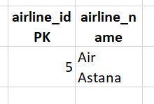
BOOKING_SEAT
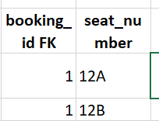

3NF: I separated passenger, flight, airport and airline data into different tables to remove transitive dependencies.

TASK_3.
booking_id -- > passenger_full_name
booking_id -- > passenger_passport_number
booking_id -- > flight_number
booking_id -- > ticket_price

flight_number -- > departure_airport_name
flight_number -- >departure_city
flight_number -- >arrival_airport_name
flight_number -- >arrival_city
flight_number -- >airline_name

passenger_passport_number -- >passenger_full_name

p.s A-- > B = A determines B
B depends on A.

TASH_4.

The primary key of the Flights table is flight_id.
Some functional dependencies are:
flight_id -- >sch_departure_time
flight_id -- >sch_arrival_time
flight_id -- >departing_airport_id
flight_id -- >arriving_airport_id
flight_id -- >departing_gate
flight_id -- >arriving_gate
flight_id -- >airline_id
flight_id -- >act_departure_time
flight_id -- >act_arrival_time

The Flights table is in 3NF because non-key attributes depend on flight_id.

There is no transitive dependency inside the Flights table because airport names and airline names are stored in separate tables.

The columns departing_airport_id, arriving_airport_id and airline_id are foreign keys only.

TASK_5
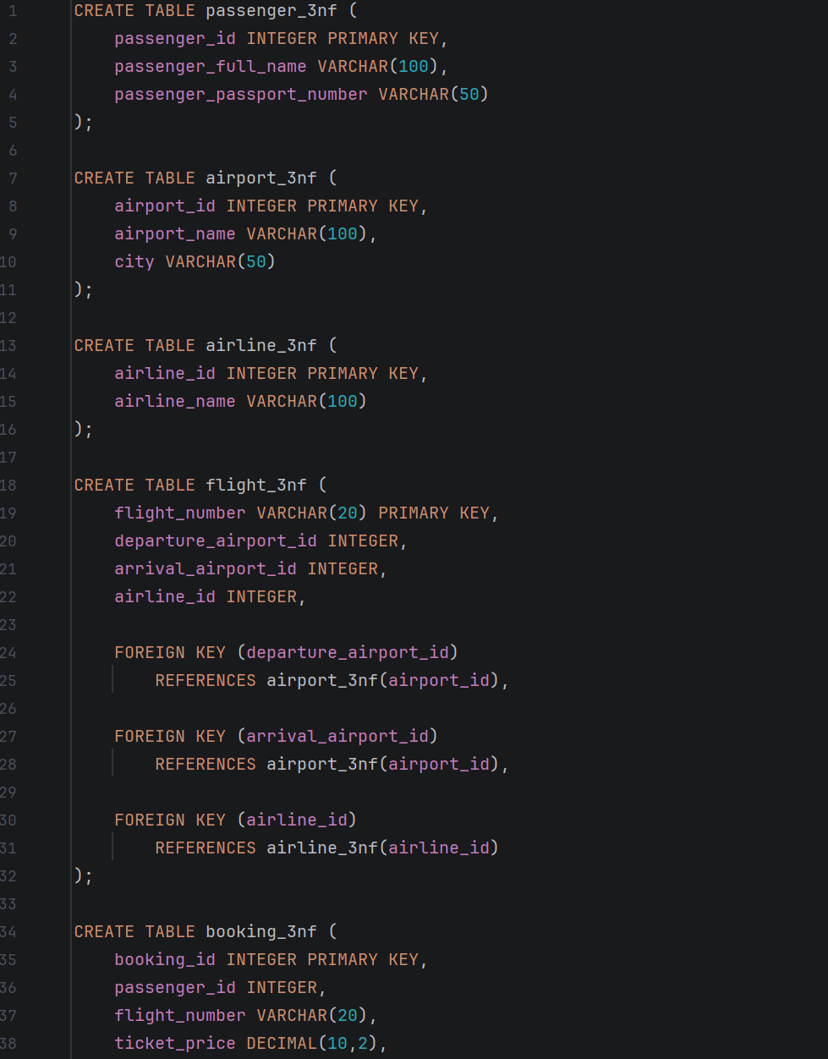

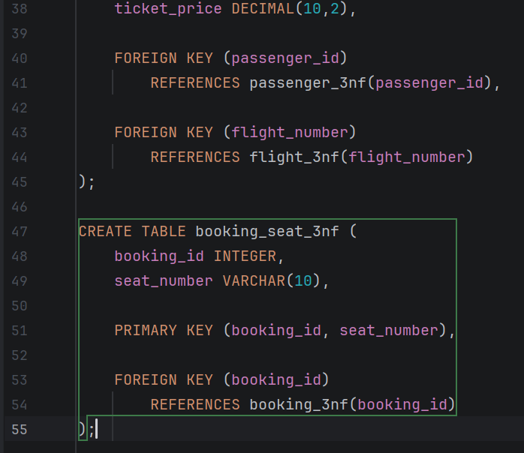
Airport:
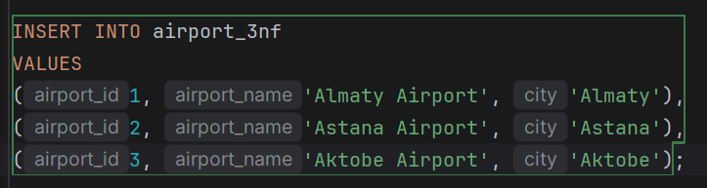
Airline:
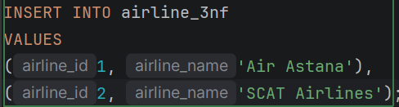
Passengers:
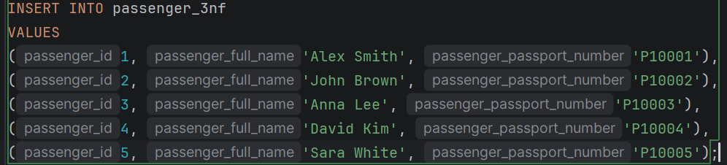
flightS:
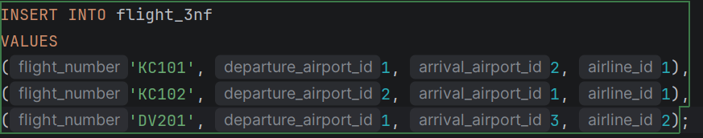
Booking:
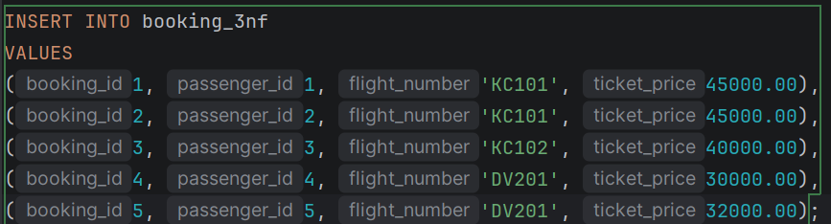

Seats:
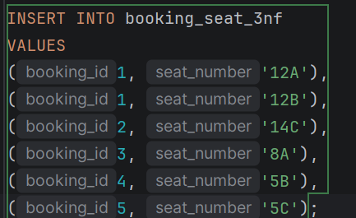

I created the 3NF tables using CREATE TABLE and added sample data using INSERT statements.

DDL
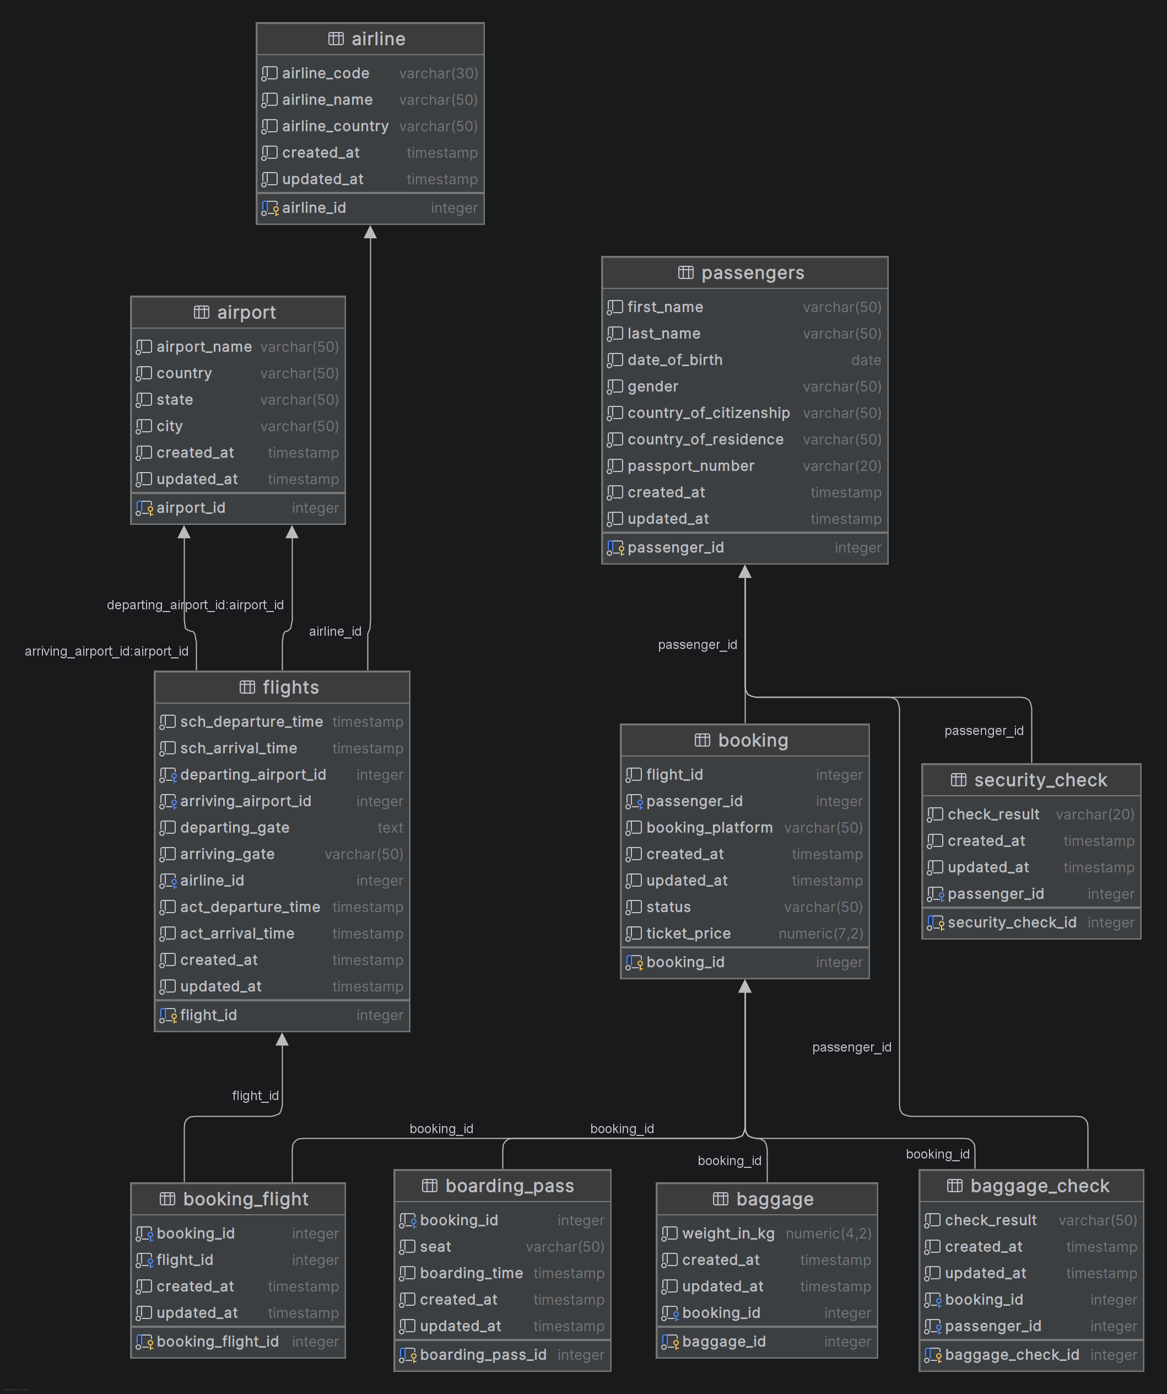
I created the required tables, added primary keys and NOT NULL constraints, changed the required table and column names, changed the data type, removed the info column, and created relationships using foreign keys.

