7
Exotic Options
All derivatives are financial contracts, and in these contracts there are far more features that can be agreed on than a simple right to buy or to sell. Complex payout structures can be engineered based on what-if scenarios, thus the final payout of an exotic contract can be dependent on a whole set of circumstances. Many times even the path of the underlying has serious influence on the final payout. Compared to these derivatives the good old call and put options were soon seen simple, thus getting a not too impressive nickname: plain vanilla
.
Vanilla call and put options are like plain vanilla ice-creams, the simplest possible ice-cream without any fancy optional toppings. The expression plain vanilla is so strongly embedded in finance that it is even used in the bond market, where a vanilla bond is the simplest possible coupon paying bond.
Any option that has some extras over the basic plain vanilla options belong to a very numerous group called exotic options. Exotic options are popular because sell-side bankers are in fierce competition to offer tailor made products for the clients. Another reason behind the fact that exotics are widely spread is that interestingly enough most of the time quoting a price on an exotic structure is not much more difficult task for market makers than quoting vanilla prices.

A general pricing approach
Exotic or not there is one intrinsic feature that is always the same in every derivative product, it is a function of other instruments, hence comes the name derivative. Thus the price of a derivative is not independently developed as the outcome of a direct supply and demand rather it is given as an estimated construction cost. As an example the one month forward dollar price of a euro is highly dependent on the spot dollar price of the euro: the forward price is just the function of the spot price (and the interest rates). If exactly the same benefits that are granted by holding a derivative can be constructed by a trading strategy that involves less complex instruments then the derivative can be replicated. Derivatives are not like unique paintings, the forgery of a derivative has the very same value, replicas are as good as the original. By using the no-arbitrage argument Black and Scholes (1973) and Merton (1973) showed that the price of a derivative should be equal to the expected sum of expenses arise during the proper implementation of the dynamic replication strategy. Taleb (1997) extensively describes that implementing that proper replication strategy under real market circumstances could many times be really tricky.

The role of dynamic hedging

Most of the time replication is a dynamic strategy: one should do more or less trading almost continuously during the lifetime of the derivatives. Haug (2007b) shows that hedging error of non-continuous hedging could be significant even for plain vanilla options. Anyway continuous hedging is a huge effort which is many times not seen explicitly in the pricing formulae, however most pricing functions are based on the assumption that dynamic hedging should be done in the background properly all the time. Also this is the case whenever we are talking about risk neutral world, or risk neutral pricing. For further references see Wilmott (2006).
Luckily however hard dynamic hedging could be running an option book is at least a scalable business: hedging thousands of options are not much more difficult than hedging just a couple of them. All options can be decomposed into certain sensitivities, the so called Greek letters (or simply Greeks). This nickname came from the fact that some crucial sensitivity was named with a letter from the Greek alphabet (delta, gamma, theta). They are partial derivatives and thus they are additive. Summing up the deltas of the individual options gives the delta of the portfolio and so on. This works not only for the plain vanillas but for the exotics too thus creating a very strong link between the vanillas and the exotics.

How R could help a lot

We start this chapter by showing some examples for exotic options giving one possible classification. We will show examples from the fExoticOptions package and how the so called Black-Scholes surface can be created for any derivative pricing function. Afterwards we will focus on the numerical estimation of the Greeks of any exotic derivative. Next we will show how pricing of an exotic option that is not yet included in the fExoticOptions package. We have chosen the Double-no-touch (DNT) binary option mainly because of its popularity on the foreign exchange (FX) markets and the many conclusions that are relevant even for other exotics. We will use AUDUSD as underlying because in the time of writing this chapter there is a significant interest differential between the AUD and the USD interest rates and we can show how to put these rates into the pricing functions. We show a second way of calculating the price of a DNT by using static option replication arguments. We show a real life example of a DNT and in a simulation we will show a way to estimate the survivorship probability of a DNT. Using this we can discuss the relationship of real world and risk neutral probabilities and the role of risk premium. Finally we show some practical fine tuning tricks for embedding exotic options into structured products.
Besides seeing examples for implementing complex exotic option pricing functions and simulations in R, as a side effect understanding the Greeks as links between exotics and vanillas will be the learning outcome of this chapter. We will use the same terminology that was introduced in Chapter 5, FX Derivatives which also includes much more about currencies and plain vanilla options.

A glance beyond vanillas

Haug (2007a) book is a rather comprehensive collection of pricing formulae for a couple of hundred exotic derivatives. The fOptions and the fExoticOptions packages are based on this book. Wilmott (2006), Taleb (1997) and DeRosa (2011) show a lots of practical issues about them
.
The first impression could be that there are way too many exotic options. There are many ways of classification. Market makers talk about different generations of exotics like first generation, second generation, and so on. Their approach is from a hedging point of view. We will use a bit different angle, the end-user approach and classify the options based on their main exotic feature
.
Asian type exotics are about the average. It could be an average rate or an average strike, and also it could be arithmetic or geometric average. These options are path dependent: their value at expiry is not purely a function of the underlying price at expiry, but the total path. Asian options are cheaper than the vanillas since the volatility of the average price is lower than the volatility of the price itself
.

library(fOptions)
library(fExoticOptions)

a <- GBSOption("c", 100, 100, 1, 0.02, -0.02, 0.3, title = NULL,
description = NULL)
(z <- a@price)
[1] 10.62678
a <- GeometricAverageRateOption("c", 100, 100, 1, 0.02, -0.02, 0.3,
title = NULL, description = NULL)
(z <- a@price)
[1] 5.889822

Barrier type exotics are also path dependent options. There could be one or two barriers. Each barrier could be either knock-in (KI) or knock-out (KO). During the lifetime of the option the price of the underlying is monitored and if it is traded at or over the barrier there will be knock event. Options with KI barriers become exercisable if the knock event occurs. Options with KO barriers start their life as exercisable options however they become non-exercisable if the knock event occurs. If there are two barriers they could be both the same type: double-knock-out (DKO) and double-knock-in (DKI), or it could be a knock-in-knock-out (KIKO) type
.
If all other parameters are set to be the same then the following equation holds
:
KI + KO = vanilla.
This is because in this case KI and KO options are mutually exclusive, but one of them will be exercisable for sure. The first parameters cuo and cui are flags for call-up-and-out and call-up-and-in. Next we check that
vanilla - KO - KI = 0.

library(fExoticOptions)
a <- StandardBarrierOption("cuo", 100, 90, 130, 0, 1, 0.02, -0.02, 0.30,
title = NULL, description = NULL)
x <- a@price
b <- StandardBarrierOption("cui", 100, 90, 130, 0, 1, 0.02, -0.02, 0.30,
title = NULL, description = NULL)
y <- b@price
c <- GBSOption("c", 100, 90, 1, 0.02, -0.02, 0.3, title = NULL,
description = NULL)
z <- c@price
v <- z - x - y
[1] 0

Based on the same logic DKO + DKI = vanilla and we can even state that KO - DKO = KIKO. So the KIKO options starts as non-exercisable and as long both the short DKO and the long KO is alive they are neutralizing each other. Should the short DKO die and the long KO survive than it is a KI event for the KIKO option. However the KIKO can still die even after being knocked-in. Naturally the KIKO + DKO = KO approach leads to the same conclusion.
Also there are some important convergence features among barrier options. Based on the KO+KI= vanilla equation the KO converges into vanilla as we push the barrier further from the spot, since KI converges into zero if we push the barrier further from the spot. The next chart is prepared to demonstrate this feature.

vanilla <- GBSOption(TypeFlag = "c", S = 100, X = 90, Time = 1,
r = 0.02, b = -0.02, sigma = 0.3)
KO <- sapply(100:300, FUN = StandardBarrierOption, TypeFlag = "cuo",
S = 100, X = 90, K = 0, Time = 1, r = 0.02, b = -0.02, sigma = 0.30)
plot(KO[[1]]@price, type = "l",
xlab = "barrier distance from spot",
ylab = "price of option",
main = "Price of KO converges to plain vanilla")
abline(h = vanilla@price, col = "red")

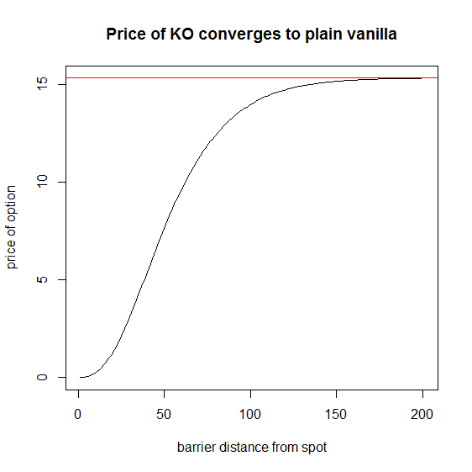
Insert Image 2078OT_07_01.png
Similarly double barrier options converge into single barrier ones if one of the barrier starts to get unimportant and converge towards plain vanillas if both the barriers are getting unimportant
.
Thanks to the preceding mentioned parities most of the time finding pricing formulae for KO options is enough. Although this means a huge help, many times pricing a KO could be still very tricky. Replicating the KO event is based on a technique that tries to build a portfolio made of vanillas that worth exactly zero when the knock event occurs, so at that point they can be closed for free. There are two famous methods for this explained by Derman-Ergener-Kani (1995) and Carr-Ellis-Gupta (1998).
The so called Black-Scholes surface is a 3D chart where the option price can be shown as a function of time to maturity and the underlying price. Since some of the exotic pricing functions can go crazy under extreme input circumstances it is advisable to use our financial knowledge that an option price can never go below zero.
install.packages('plot3D')

BS_surface <- function(S, Time, FUN, ...) {
require(plot3D)
n <- length(S)
k <- length(Time)
m <- matrix(0, n, k)
for (i in 1:n){
for (j in 1:k){
l <- list(S = S[i], Time = Time[j], ...)
m[i,j] <- max(do.call(FUN, l)@price, 0)
}
}
persp3D(z = m, xlab = "underlying", ylab = "Remaining time",
zlab = "option price", phi = 30, theta = 20, bty = "b2")
}

BS_surface(seq(1, 200,length = 200), seq(0, 2, length = 200),
GBSOption, TypeFlag = "c", X = 90, r = 0.02, b = 0, sigma = 0.3)
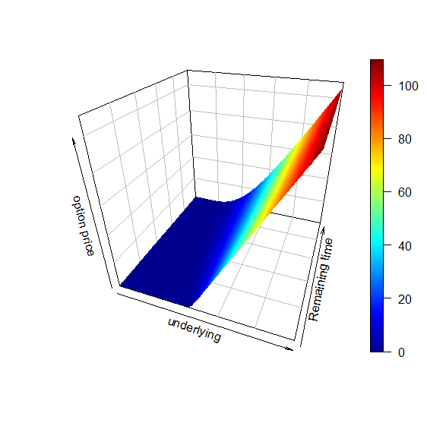
Insert Image 2078OT_07_02.png
First we prepared the Black-Scholes surface of a plain vanilla call option. However the BS_surface code can be used for much more purposes. Just like the fact that the concept of Black-Scholes surface can be used for any kind of single-underlying dependent derivative, if we have a pricing function it can be used as the FUN argument
.
BS_surface(seq(1,200,length = 200), seq(0, 2, length = 200),
StandardBarrierOption, TypeFlag = "cuo", H = 130, X = 90, K = 0,
r = 0.02, b = -0.02, sigma = 0.30)

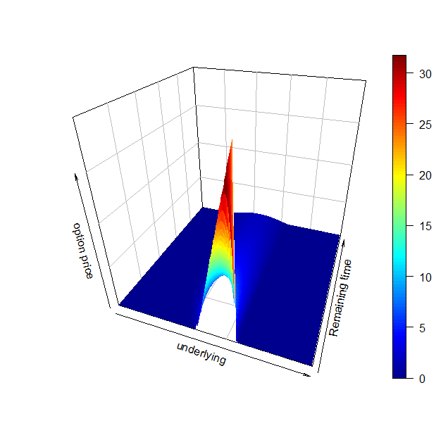
Insert Image 2078OT_07_03.png

It is easy to see that compared to the plain vanilla call, the up-and-out call option has a limited value.
On [page 23] we use this same function to chart the BS Surface for a Double-no-touch option.
Binary options are exotics having a fix contingent payout. The name is coming from the feature that they have only two possible outcomes: either pay a fix amount or don't pay at all. They are the 0-1 relationship in the options world. Binary feature could be mixed with barrier feature thus they become path dependent. A One-Touch (OT) option pays only if during the lifetime a knock event occurred, while a No-Touch pays only if no knock event occurred. There could be two barriers associated to the binaries thus getting a Double-One-Touch and Double-No-Touch options. Based on no arbitrage arguments the following equations must hold
:
NT + OT = T-Bill, DNT + DOT = T-Bill
Convergence can be seen here too very similarly to the cases we have shown for the barriers. A DNT converge to a NT if one of the barrier is far enough and converges to a T-Bill if both the barriers are far enough. A pricing function for a DNT is the Jack-of-all-trades of the binaries, similarly to the DKO option for the barrier type.
Lookback options are also path dependent. Lookback feature is very convenient: at expiry the holder of the position can look back and choose the best price from the path of the underlying. For a floating rate lookback the option holder can look back for the strike price. A fixed rate lookback the holder can exercise the option against any price on that the underlying was traded during the lifetime of the option. Taleb (1997) shows how lookbacks can be replicated by an infinite chain of KIKO options. In this sense this is at least second generation exotic, since we need exotics as building blocks to be able to replicate a lookback.
More than one underlying is also a common exotic feature. Two examples are already discussed in the Chapter 5: exchange option and quanto. However there are plenty more. Best-of and worst-of (also called rainbow) options are giving the best or the worst performing underlying from a basket. Spread option is very similar to a vanilla with a twist that the underlying of this option is the difference of two assets. These are just a few examples, enough to show that not surprisingly in all of these cases correlation plays an important role. Also these features can be mixed with barrier or lookback or Asian features resulting an almost endless number of combinations. In this chapter we are not discussing these types any further
.

Greeks – the link back to the vanilla world

As we explained in the introducing part of this chapter Greeks are partial derivatives. Some important Greeks are following:

- delta = DvalueDspot = the change of the option price in respect of the change of the underlying spot price
- gamma = DdeltaDspot
- vega = DvalueDvolatility
- theta = DvalueDtime
- rho = DvalueDinterest rate

In some simple cases these partial derivatives can be found analytically. For example fOptions package includes GBSGreeks function that gives the Greeks for vanillas.

Analytical Greeks are convenient, however there are two problems with them. First problem is that market traded parameters are not changing in infinitesimal small increments. For example on the New York Stock Exchange the smallest possible change in the stock price is one cent. The stock price either changes at least one cent or there is no change at all. Or on the OTC (over-the-counter) FX market traders are quoting volatility as an integer multiple of 0.0005. The second problem with analytical Greeks is coming from the fact that for many exotics we have no closed formula for them. We still need to know the Greeks anyway, because we would like to sum them to get the Greeks for the portfolio. Adding up analytical Greeks and numerical ones can lead to errors, so using numerical Greeks is a much safer way.
The GetGreeks function calculates any Greeks for any pricing function:
GetGreeks <- function(FUN, arg, epsilon,...) {
all_args1 <- all_args2 <- list(...)
all_args1[[arg]] <- as.numeric(all_args1[[arg]] + epsilon)
all_args2[[arg]] <- as.numeric(all_args2[[arg]] - epsilon)
(do.call(FUN, all_args1)@price -
do.call(FUN, all_args2)@price) / (2 * epsilon)
}

OTC market makers are not quoting FX volatility in any quantities, but normally as an integer multiple of 0.0005, a typical quote for AUDUSD at-the-money volatility is 5.95 percent/6.05 percent. Of course for exchange traded derivatives that are quoted in price instead of volatility it could happen that the price change implied volatility change is smaller than 0.0005.
So when we are calculating vega numerically we should set epsilon = 0.0005 as a market consistent smallest possible change, and for example to calculate a delta of an AUDUSD option we can set epsilon = 0.0001 (one pip) or for a stock epsilon = 0.01 (one cent). It is also useful to adjust epsilon = 1/365 (one day) for theta, and epsilon = 0.0001 (one basis point) for rho.
Following code plots the delta, vega theta and rho for a FloatingStrikeLookbackOption:
x <- seq(10, 200, length = 200)
delta <- vega <- theta <- rho <- rep(0, 200)
for(i in 1:200){
delta[i] <- GetGreeks(FUN = FloatingStrikeLookbackOption,
arg = 2,
epsilon = 0.01, "p", x[i], 100, 1, 0.02, -0.02, 0.2)
vega[i] <- GetGreeks(FUN = FloatingStrikeLookbackOption,
arg = 7,
epsilon = 0.0005, "p", x[i], 100, 1, 0.02, -0.02,
0.2)
theta[i] <- GetGreeks(FUN = FloatingStrikeLookbackOption,
arg = 4,
epsilon = 1/365, "p", x[i], 100, 1, 0.02, -0.02,
0.2)
rho[i] <- GetGreeks(FUN = FloatingStrikeLookbackOption,
arg = 5,
epsilon = 0.0001, "p", x[i], 100, 1, 0.02, -0.02, 0.2)
}
par(mfrow = c(2, 2))
plot(x, delta, type = "l", xlab = "S", ylab = "", main = "Delta")
plot(x, vega, type = "l", xlab = "S", ylab = "", main = "Vega")
plot(x, theta, type = "l", xlab = "S", ylab = "", main = "Theta")
plot(x, rho, type = "l", xlab = "S", ylab = "", main = "Rho")
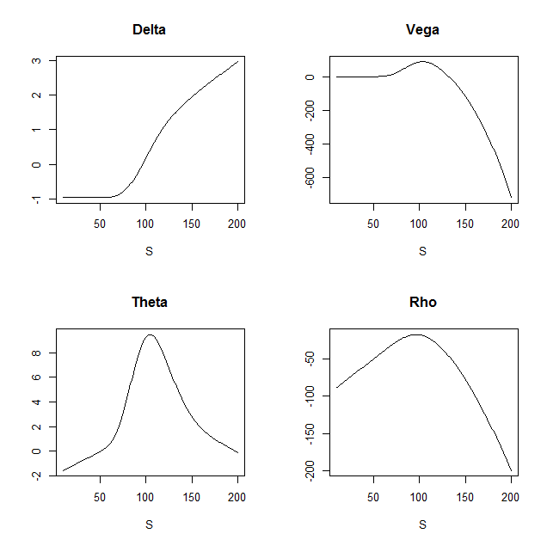
Insert Image 2078OT_07_04.png

Pricing the Double-no-touch option

A Double-no-touch (DNT) option is a binary option that pays a fixed amount of cash at expiry. Unfortunately fExoticOptions package does not contain a formula for this option at present. We will show two different ways for pricing DNTs incorporating two different pricing approaches. In this part we will call the function dnt1 and for the second approach we will use dnt2 as the name for the function
.

Hui (1996) showed how a one-touch double barrier binary option can be priced. In his terminology the one-touch means that a single trade is enough to trigger the knock-out event, and the double barrier binary means that there are two barriers and this is a binary option. We call this DNT as it is commonly used on the FX markets. This is a good example for the fact that many popular exotic options are running under more than one names. In Haug (2007a) the Hui-formula is already translated into the generalized framework. S, r, b, σ, T have the same meaning as in Chapter 5, FX Derivatives K means the payout (dollar amount) L and U are the lower and upper barrier.

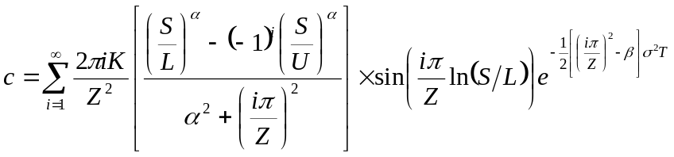
where:
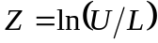, 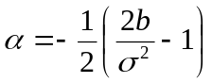, 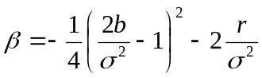

Implementing the Hui (1996) function to R starts with a big question mark: what should we do with an infinite sum? How high number should we substitute as infinity? Interestingly for practical purposes many times a small number like 5 or 10 could play the role of infinity rather well. Hui (1996) tells that convergence is fast most of the time. We are a bit skeptical about this since α will be used as exponent. In case b is negative and sigma is small enough the (S/L)^{α} part in the formula could turn up to be a problem
.

First we make a try with normal parameters and see how quick the convergence is.

dnt1 <- function(S, K, U, L, sigma, T, r, b, N = 20, ploterror = FALSE){
if ( L > S | S > U) return(0)
Z <- log(U/L)
alpha <- -1/2*(2*b/sigma^2 - 1)
beta <- -1/4*(2*b/sigma^2 - 1)^2 - 2*r/sigma^2
v <- rep(0, N)
for (i in 1:N)
v[i] <- 2*pi*i*K/(Z^2) * (((S/L)^alpha - (-1)^i*(S/U)^alpha ) /
(alpha^2+(i*pi/Z)^2)) * sin(i*pi/Z*log(S/L)) *
exp(-1/2 * ((i*pi/Z)^2-beta) * sigma^2*T)
if (ploterror) barplot(v, main = "Formula Error");
sum(v)
}
print(dnt1(100, 10, 120, 80, 0.1, 0.25, 0.05, 0.03, 20, TRUE))
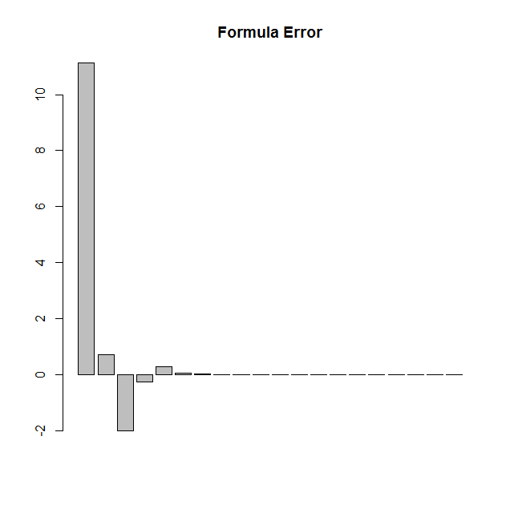
Insert Image 2078OT_07_05.png

The Formula Error chart shows that after the 7th step additional steps were not influencing the result. This means that for practical purposes the infinite sum can be quickly estimated by calculating only the first seven steps. This looks like a very quick convergence indeed. However this could be pure luck or coincidence
.
What about decreasing the volatility down to 3 percent? We have to set N = 50 to see the convergence:
print(dnt1(100, 10, 120, 80, 0.03, 0.25, 0.05, 0.03, 50, TRUE))
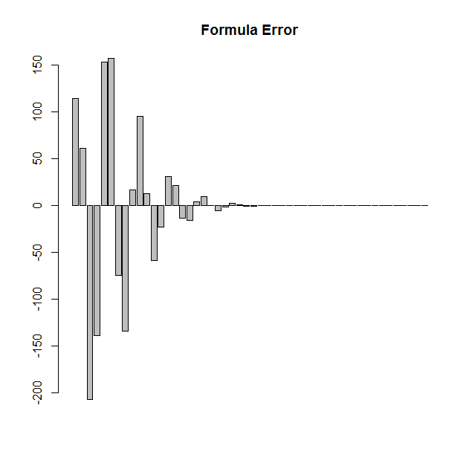
Insert Image 2078OT_07_06.png

Not so impressive? 50 steps still not that bad. What about decreasing the volatility even lower? At 1 percent, the formula with these parameters simply blows up. First this looks catastrophic; however the price of a DNT was already 98.75 percent of the payout when we used 3 percent volatility. Logic says that DNT price should be a monotone decreasing function of volatility, so we already know that the price of the DNT should worth at least 98.75 percent if volatility is below 3 percent.
Another issue is that if we choose extreme high U or extreme low L there calculation errors emerge. However similarly to the problem with volatility common sense helps here too: the price of a DNT should increase if we make U higher or L lower.
And there is still another trick. Since all the problem is coming from the α parameter, we can try setting b = 0 which will make α = 0.5. If we also set r = 0 DNT price converge into 100 percent as the volatility drops.
Anyway whenever we substitute an infinite sum by a finite sum it is always good to know when it will work and when it will not. We made a new code that takes into consideration that convergence is not always quick. The trick is that the function calculates a next step as long as the last step made any significant change. This is still not good for all the parameters, there is no cure for very low volatility except we accept the fact that if implied volatilities are below 1 percent that is an extreme market situation in which case DNT options should not be priced by this formula.

dnt1 <- function(S, K, U, L, sigma, Time, r, b) {
if ( L > S | S > U) return(0)
Z <- log(U/L)
alpha <- -1/2*(2*b/sigma^2 - 1)
beta <- -1/4*(2*b/sigma^2 - 1)^2 - 2*r/sigma^2
p <- 0
i <- a <- 1
while (abs(a) > 0.0001){
a <- 2*pi*i*K/(Z^2) * (((S/L)^alpha - (-1)^i*(S/U)^alpha ) /
(alpha^2 + (i *pi / Z)^2) ) * sin(i * pi / Z * log(S/L)) *
exp(-1/2*((i*pi/Z)^2-beta) * sigma^2 * Time)
p <- p + a
i <- i + 1
}
p
}

Now that we have a nice formula it is possible to draw some DNT-related charts to get more familiar with this option. Later we will use a particular AUDUSD DNT option with following parameters: L = 0.9200, U = 0.9600, K (payout) = USD 1 million, T = 0.25 year, volatility = 6%, r_AUD = 2,75%, r_USD = 0,25%, b = -2,5%. We will calculate and plot all the possible values of this DNT from 0.9200 to 0.9600, each step will be one pip (0.0001), so we will use 2000 steps.

x <- seq(0.92, 0.96, length = 2000)
y <- z <- rep(0, 2000)

for (i in 1:2000){
y[i] <- dnt1(x[i], 1e6, 0.96, 0.92, 0.06, 0.25, 0.0025, -0.0250)
z[i] <- dnt1(x[i], 1e6, 0.96, 0.92, 0.065, 0.25, 0.0025, -0.0250)
}
matplot(x, cbind(y,z), type = "l", lwd = 2, lty = 1,
main = "Price of double barrier option with volatility 6% and
6.5%",
cex.main = 0.8, xlab = "Price of underlying" )
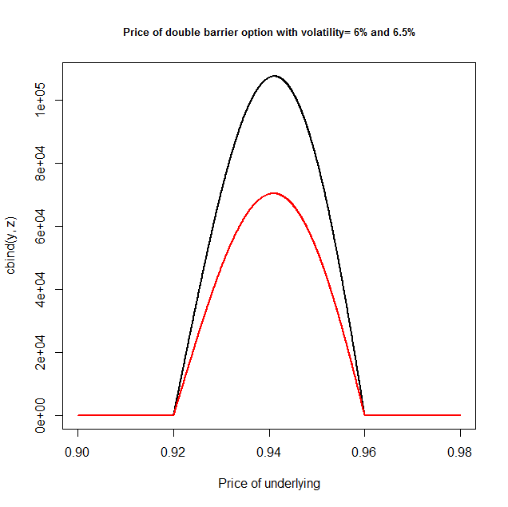
Insert Image 2078OT_07_07.png

It can be clearly seen that even a small change in volatility can have a huge impact on the price of a DNT. This is another intuitive way to find that vega must be negative. What is not trivial that absolute value of vega is not that important if we are close to the barriers. This can be explained by the fact that the DNT already has a much lower value in the near of the barriers.
Most end-users think that the biggest risk is when the spot is getting close to the trigger. This is because end-users really think about binary options in a binary way. As long as the DNT is alive they focus on the positive outcome. However for a dynamic hedger the risk of a DNT is not that interesting when the value of the DNT is already small.
It is also very interesting that since the T-Bill price is independent from the volatility and since the DNT + DOT = T-Bill equation holds, increasing volatility will decrease the price of the DNT by the exact same amount just like it will increase the price of the DOT. It is not surprising that the vega of the DOT should be the exact mirror of the DNT.
We can use the getgreeks function to estimate vega, gamma, delta and theta. For gamma we can use the following function:

Gamma <- function(FUN, epsilon, S, ...) {
arg1 <- list(S, ...)
arg2 <- list(S + 2 * epsilon, ...)
arg3 <- list(S - 2 * epsilon, ...)
y1 <- (do.call(FUN, arg2) - do.call(FUN, arg1)) / (2 * epsilon)
y2 <- (do.call(FUN, arg1) - do.call(FUN, arg3)) / (2 * epsilon)
(y1 - y2) / (2 * epsilon)
}

x = seq(0.9202, 0.9598, length = 200)
delta <- vega <- theta <- gamma <- rep(0, 200)

for(i in 1:200){
delta[i] <- GetGreeks(FUN = dnt1, arg = 1, epsilon = 0.0001,
x[i], 1000000, 0.96, 0.92, 0.06, 0.5, 0.02, -0.02)
vega[i] <- GetGreeks(FUN = dnt1, arg = 5, epsilon = 0.0005,
x[i], 1000000, 0.96, 0.92, 0.06, 0.5, 0.0025, -0.025)
theta[i] <- - GetGreeks(FUN = dnt1, arg = 6, epsilon = 1/365,
x[i], 1000000, 0.96, 0.92, 0.06, 0.5, 0.0025, -0.025)
gamma[i] <- Gamma(FUN = dnt1, epsilon = 0.0001, S = x[i], K =
1e6, U = 0.96, L = 0.92, sigma = 0.06, Time = 0.5, r = 0.02, b = -0.02)
}

windows()
plot(x, vega, type = "l", xlab = "S",ylab = "", main = "Vega")

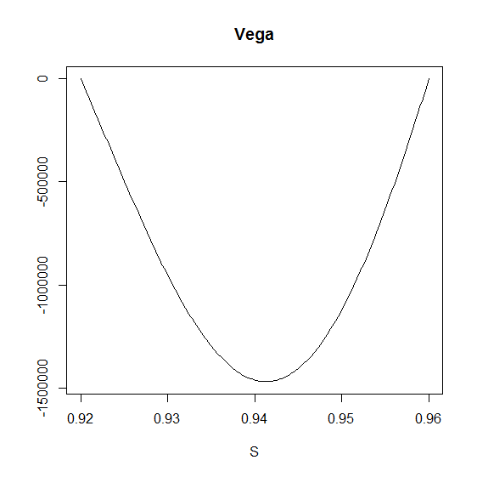
Insert Image 2078OT_07_08.png

After having a look at the value chart delta of a DNT is also very close to intuitions: if we are coming close to the higher barrier, our delta gets negative, if we are coming closer to the lower barrier the delta gets positive.

windows()
plot(x, delta, type = "l", xlab = "S",ylab = "", main = "Delta")

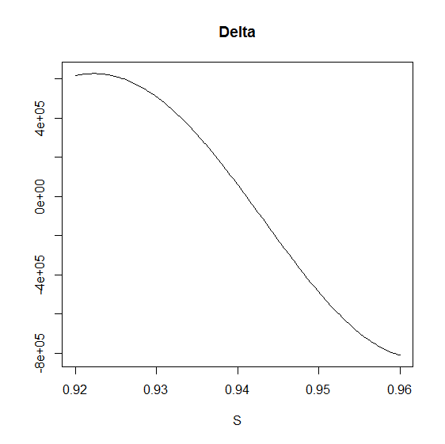
Insert Image 2078OT_07_09.png
This is really a non-convex situation, if we would like to do a dynamic delta hedge we will lose money for sure. If the spot price goes up, the delta of the DNT decreases so we should buy some AUDUSD as a hedge. However if spot price goes down, we should sell some AUDUSD. Imagine a scenario where AUDUSD goes up 20 pips in the morning and then goes down 20 pips in the afternoon. For a dynamic hedger this means buying some AUDUSD after the price moved up and selling this very same amount after the price come back. The changing of the delta can be described by the gamma.
windows()
plot(x, gamma, type = "l", xlab = "S",ylab = "", main = "Gamma")

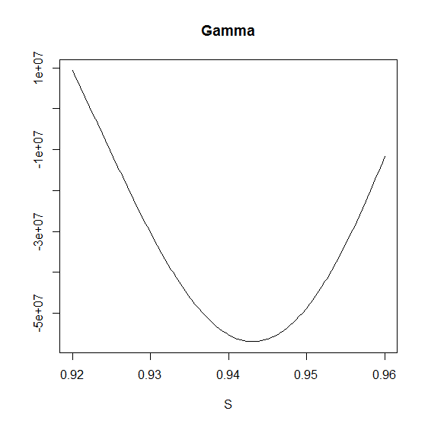
Insert Image 2078OT_07_10.png

Negative gamma means that if the spot goes up, our delta is decreasing, but if the spot goes down our delta is increasing. This doesn't sound great. For this inconvenient non-convex situation there is some compensation: theta is positive. If nothing happens but one day passes the DNT will automatically worth more. Here we use theta as minus one times the partial derivative, since if (T-t) is the time left we check how the value changes as t increases by one day.
windows()
plot(x, theta, type = "l", xlab = "S",ylab = "", main = "Theta")

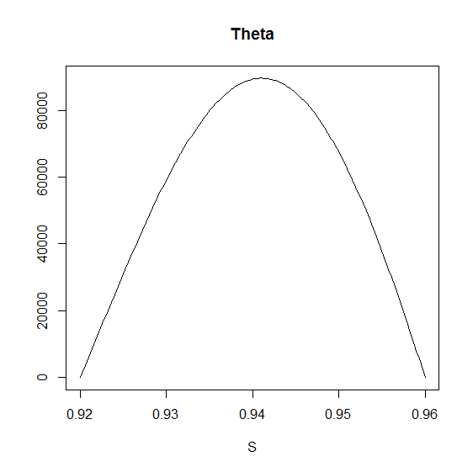
Insert Image 2078OT_07_11.png

The more negative the gamma, the more positive our theta: this is a way how time is compensating for the potential losses generated by the negative gamma.
Risk neutral pricing also implicates that negative gamma should be compensated by a positive theta. This is the main massage of the Black-Scholes framework for vanilla options, but this is also true for exotics. See Taleb (1997) and Wilmott (2006).
We already introduced the Black-Scholes surface before, now we can say even more. This Surface is also a nice interpretation of how theta and delta works. It shows the price of an option for different spot prices and time to maturities, so the slope of this surface is the theta for one direction and delta for the other.

BS_surf <- function(S, Time, FUN, ...) {
n <- length(S)
k <- length(Time)
m <- matrix(0, n, k)
for (i in 1:n) {
for (j in 1:k) {
l <- list(S = S[i], Time = Time[j], ...)
m[i,j] <- do.call(FUN, l)
}
}
persp3D(z = m, xlab = "underlying", ylab = "Time",
zlab = "option price", phi = 30, theta = 30, bty = "b2")
}
BS_surf(seq(0.92,0.96,length = 200), seq(1/365, 1/48, length = 200),
dnt1, K = 1000000, U = 0.96, L = 0.92, r = 0.0025, b = -0.0250,
sigma = 0.2)
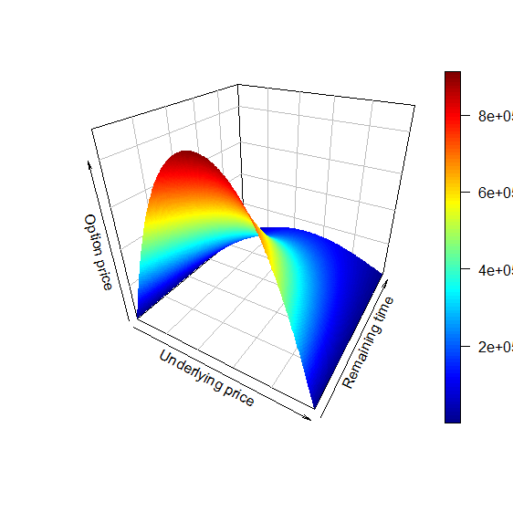
Insert Image 2078OT_07_12.png

We can see what was already suspected: DNT likes when time is passing and the spot is moving to the middle of the (L,U) interval.

Another way for pricing the Double-no-touch option

Static replication is always the most elegant way of pricing. The no arbitrage argument will let us say that if some time in the future two portfolios will have the same value for sure, than their price should be equal any time before this. We will show how double-knock-out (DKO) options could be used to build a DNT. We will need to use a trick: strike price could be the same as one of the barriers. For a DKO call the strike price should be lower than the upper barrier, because if the strike price is not lower than the upper barrier, the DKO call would be knocked out before it could become in-the-money so in that case the option would be worthless since nobody can ever exercise it in-the-money. However we can choose the strike price to be equal to the lower barrier. For a put the strike price should be higher than the lower barrier, so why not make it equal to the upper barrier. This way this DKO call and DKO put option will have a very convenient feature: if they are still alive, they will both expiry in-the-money.
Now we are almost done. We just have to add the DKO prices and we will get a DNT that has a payout of (U-L) dollars. Since DNT prices are linear in the payout we only have to multiply the result by K*(U-L).

dnt2 <- function(S, K, U, L, sigma, T, r, b) {

a <- DoubleBarrierOption("co", S, L, L, U, T, r, b, sigma, 0,
0,title = NULL, description = NULL)
z <- a@price

b <- DoubleBarrierOption("po", S, U, L, U, T, r, b, sigma, 0,
0,title = NULL, description = NULL)
y <- b@price

(z + y) / (U - L) * K
}

Now we have two functions, we can compare the results:

dnt1(0.9266, 1000000, 0.9600, 0.9200, 0.06, 0.25, 0.0025, -0.025)
[1] 48564.59

dnt2(0.9266, 1000000, 0.9600, 0.9200, 0.06, 0.25, 0.0025, -0.025)
[1] 48564.45

For a DNT with USD 1 million contingent payout and an initial market value of over 48,000 dollars it is very nice that the difference in the prices are only 14 cents. Technically however there is not much step forward here. Low volatility is also an issue for dnt2.

We will use dnt1 for the rest of the chapter.

The life of a Double-no-touch option – a simulation

How would the DNT price have been evolving during the second quarter year of 2014? We have five minutes open-high-low-close data for AUDUSD, so we know all the extreme prices.
d <- read.csv2("audusd.csv")
underlying <- as.vector(t(d[, 2:5]))
t <- rep( d[,6], each = 4)
n <- length(t)
option_price <- rep(0, n)

for (i in 1:n) {
option_price[i] <- dnt1(S = underlying[i], K = 1000000, U = 0.9600,
L = 0.9200, sigma = 0.06, T = t[i]/(60*24*365), r = 0.0025,
b = -0.0250)
}
a <- min(option_price)
b <- max(option_price)
option_price_transformed = (option_price - a) * 0.03 / (b - a) + 0.92

par(mar = c(6, 3, 3, 5))
matplot(cbind(underlying,option_price_transformed), type = "l",
lty = 1, col = c("grey", "red"),
main = "Price of underlying and DNT",
xaxt = "n", yaxt = "n", ylim = c(0.91,0.97),
ylab = "", xlab = "Remaining time")
abline(h = c(0.92, 0.96), col = "green")
axis(side = 2, at = pretty(option_price_transformed),
col.axis = "grey", col = "grey")
axis(side = 4, at = pretty(option_price_transformed),
labels = round(seq(a/1000,1000,length = 7)), las = 2,
col = "red", col.axis = "red")
axis(side = 1, at = seq(1,n, length=6),
labels = round(t[round(seq(1,n, length=6))]/60/24))

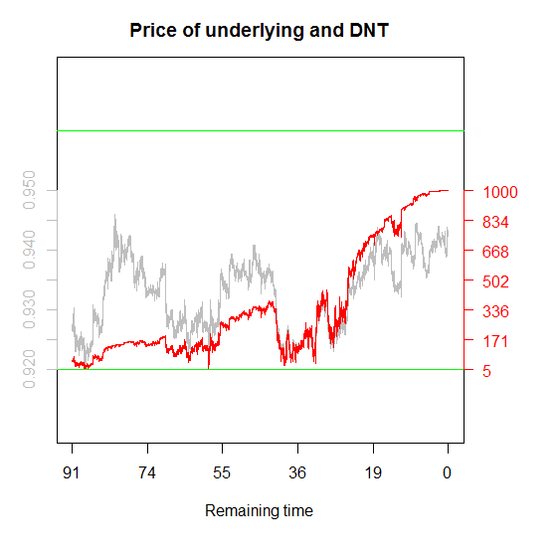
Insert Image 2078OT_07_13.png

The price of a DNT is shown in red on the right axis (divided by 1000) and the actual AUDUSD price is shown in grey on the left axis. The green lines are the barriers of 0.9200 and 0.9600. The chart shows that in 2014 Q2 the AUDUSD currency pair was traded inside the (0.9200;0.9600) interval, thus the payout of the DNT would have been USD 1 million. This DNT looks like a very good investment; however reality is just one trajectory out of an a priori almost infinite set. It could have happened differently. For example on May 02, 2014, there were still 59 days left until expiry and AUDUSD was traded at 0.9203, just three pips away from the lower barrier. At this point the price of this DNT was only 5302 dollars.

dnt1(0.9203, 1000000, 0.9600, 0.9200, 0.06, 59/365, 0.0025, -0.025)
[1] 5302.213

Compare this 5302 dollar to the initial 48564 dollar option price!
In the following simulation we will show some different trajectories. All of them start from the same 0.9266 AUDUSD spot price as it was in the dawn on April 01 and will see how many of them stayed inside the (0.9200;0.9600) interval. To make it simple we will simulate geometric Brown motions by using the same 6 percent volatility as we used for pricing the DNT.

library(matrixStats)
DNT_sim <- function(S0 = 0.9266, mu = 0, sigma = 0.06, U = 0.96,
L = 0.92, N = 15) {
dt <- 5 / (365 * 24 * 60)
t <- seq(0, 0.25, by = dt)
Time <- length(t)

W <- matrix(rnorm((Time - 1) * N), Time - 1, N)
W <- apply(W, 2, cumsum)
W <- sqrt(dt) * rbind(rep(0, N), W)
S <- S0 * exp((mu - sigma^2 / 2) * t + sigma * W )
option_price <- matrix(0, Time, N)

for (i in 1:N)
for (j in 1:Time)
option_price[j,i] <- dnt1(S[j,i], K = 1000000, U, L, sigma,
0.25-t[j], r = 0.0025,
b = -0.0250)*(min(S[1:j,i]) > L & max(S[1:j,i]) < U)

survivals <- sum(option_price[Time,] > 0)
dev.new(width = 19, height = 10)

par(mfrow = c(1,2))
matplot(t,S, type = "l", main = "Underlying price",
xlab = paste("Survived", survivals, "from", N), ylab = "")
abline( h = c(U,L), col = "blue")
matplot(t, option_price, type = "l", main = "DNT price",
xlab = "", ylab = "")}

set.seed(214)
system.time(DNT_sim())

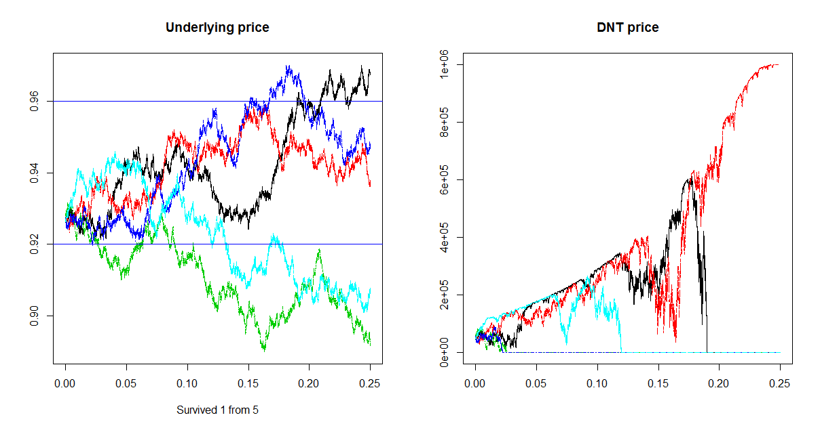 Insert Image 2078OT_07_14.png

Here the only surviving trajectory is the red one, in all other cases the DNT hits either the higher or the lower barrier. The line set.seed(214) grants that this simulation will look the same anytime we run this. One out of five is still not that bad, it would suggest that for an end-user or gambler who does no dynamic hedging this option has an approximate value of 20 percent of the payout (especially since the interest rates are low time value of money is not important).
However five trajectories are still too few to jump to such conclusions. We should check the DNT survivorship ratio for a much higher number of trajectories
.
The ratio of the trajectories could be a good estimator of the a priori real world survivorship probability of this DNT, thus the end-user value of it. Before increasing N rapidly we should keep in mind how much time this simulation took. For my computer it took 50.75 seconds for N = 5, and 153.11 seconds for N = 15.
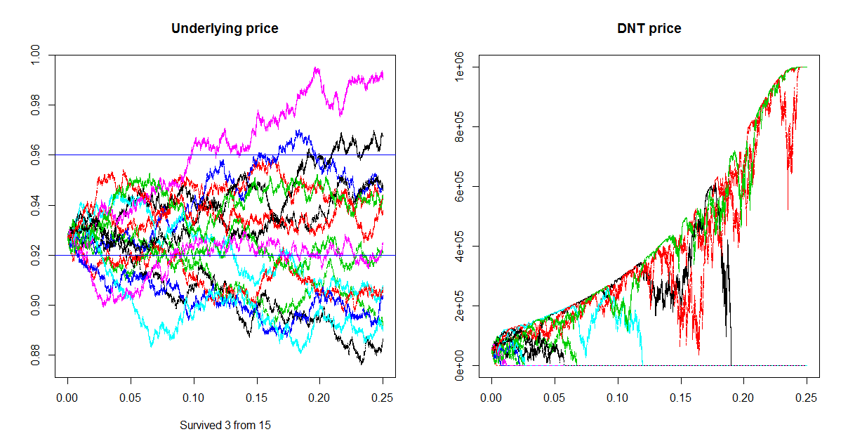
Insert Image 2078OT_07_15.png

Now 3 out of 15 survived, so the estimated survivorship ratio is still 3/15 = 20%. Looks like this a very nice product: the price is around 5 percent of the payout, while 20 percent is the estimated survivorship ratio. Just out of curiosity run the simulation for N = 200. This would take about 30 minutes.

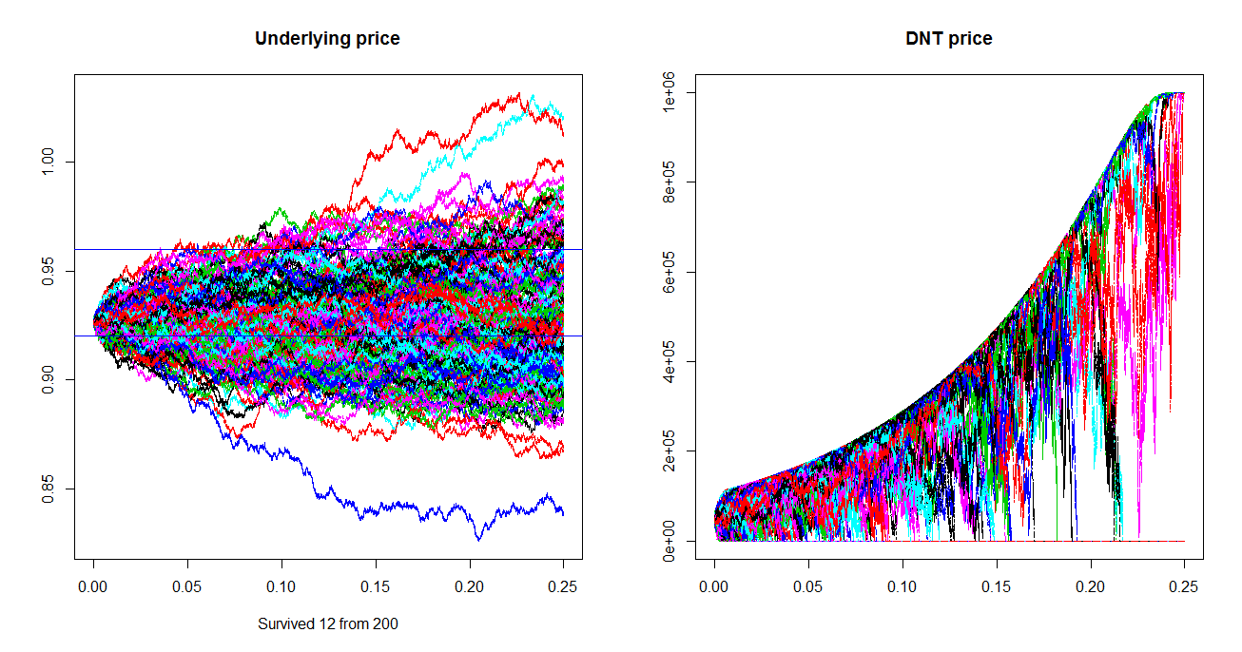
Insert Image 2078OT_07_16.png
The results are shocking, now only 12 out of 200 survives, the ratio is 6 percent only! So to get a better picture we should run the simulation for larger N.
The movie Whatever Works by Woody Allen (starring Larry David) is 92 minutes long, in simulation time that is N = 541. For this N = 541 there are 38 surviving ones resulting a survivorship ratio of 7 percent
.
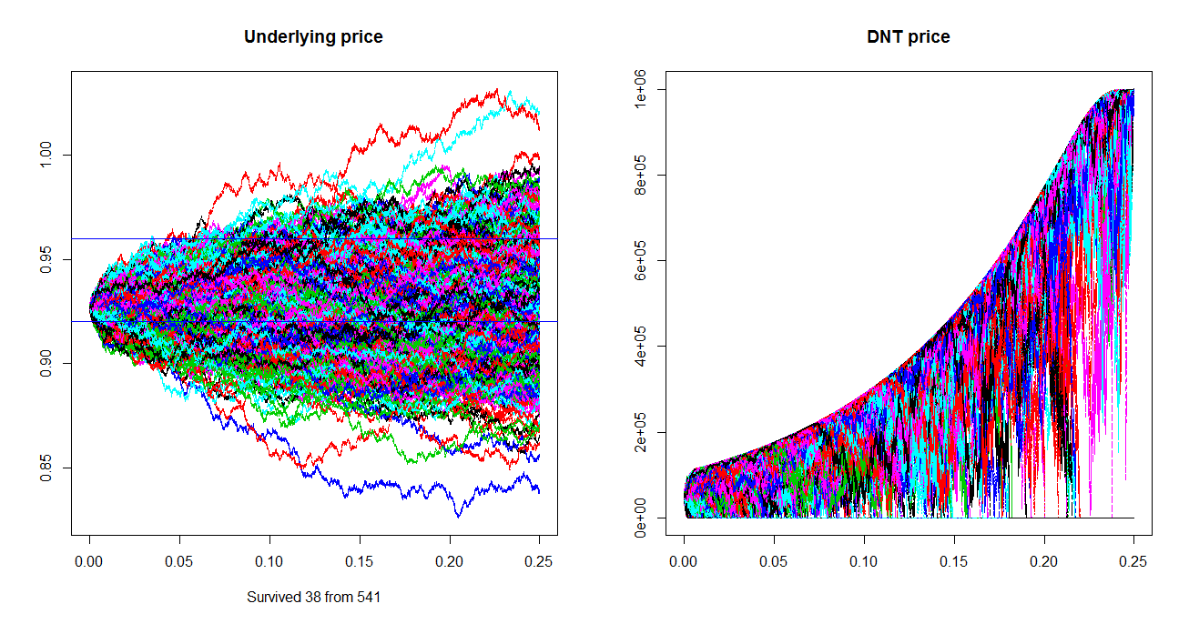
Insert Image 2078OT_07_17.png
What is the real expected survivorship ratio? Is it 20 percent, 6 percent, or 7 percent? We simply don't know at this point. Mathematicians warn us that the law of large numbers require large numbers, where large is much more than 541. So it would be advisable to run this simulation for as large N as time allows. Of course getting a better computer also help doing more N during the same time. Anyway from this point of view Hui's (1996) relatively fast converging DNT pricing formula gets some respect.
So far we have used the very same stochastic process for pricing that we used for the simulation. Common sense says that in some cases market implied volatility could be biased either higher or lower than the expected volatility. Not surprisingly running the simulation for N = 200, and sigma = 5.5 percent result in more surviving trajectories: 15 (for this seed), and running the simulation for N = 200 and sigma = 6.5 percent result in less surviving: nine trajectories (for this seed). This again shows the high impact of vega, here in a very intuitive way: the number of surviving trajectories 9, 12 or 15 mostly depends on the volatility of the process. Survivorship rates are 4.5 percent, 6 percent or 7.5 percent. This also raises a more philosophical question: what about risk premium? If market needs vega it could happen that we can purchase a DNT based on 6 percent volatility even if we expect 5.5 percent volatility. In some tense circumstances market could be really vega-thirsty. In these cases risk premium is included.
Derivative pricing always assume dynamic hedging, because we are looking for the marginal cost of producing such an instrument then we use the no-arbitrage argument. Some market players are actually trying to play this strategy and become providers for the derivatives, like a factory. They are willing to take any side of a deal, since they will eliminate almost all of their risk by almost continuous dynamic hedging. They are the market makers. However not all market players are derivative factories, there are many of them who deliberately seek sensitivities, thus they are not hedging their derivative position. This second group is called the market takers, or end-users. Some of them are looking for sensitivities because they already have some and they want to decrease those (natural hedgers). Some others are not having any sensitivities at the beginning, but would like to make a financial bet (speculators).
Interestingly there could be significant difference between the price of the derivative and its value for the end-user. By purchasing a DNT an end-user can make a bet and eventually either get nothing, or win much more than the initial price. Is there any risk premium for this bet, or is it similar a casino? Is the real life expected value of a DNT higher than the risk neutral expected value (which equals the price)? The value in use, or the 'user experience' could be different because the market maker will quote a price based on the implied volatilites. In case of a tense market situation the demand for vega could push its price (i.e. the implied volatility) higher than the expected volatility. In this case if anyone who can still sell volatility will get a premium. In the case of DNT getting a premium means that its price will be lower than the real life expected value of its payout.
What about a Double-one-touch (DOT)? Since a Treasury bill = DOT + DNT holds if the DNT is too cheap, the DOT must be too expensive. Thus these exotic options are easy bets on volatilities: if a speculator thinks volatility will be significantly lower than the implied purchasing a DNT is a straightforward bet. If the speculator expects higher volatility than the implied a DOT is the proper bet
.
In this sense DNT is similar to a short straddle, DOT is to a long straddle, however binary options are much easier to calibrate to the desired size. A long straddle is a long call and long put in the same size, strike price and expiry. Short straddle is the mirror picture: short call and short put. A strangle is very similar to a straddle, the only difference is that the strike price of a call is not equal but higher than the strike price of the put. Compared to a short straddle or short strangle betting on volatility is much more convenient by purchasing a DNT, because holding a long DNT option position requires no further collateral adjustment. DNT is a highly leveraged product, however the total amount that can be lost is already paid upfront, so it fits to the menu of online trading platforms where the typical client is a small retail speculator.
Based on this logic risk premium goes only to players who are willing to take a position that is less favourable by other market players. If there is an extra demand for volatility than DNTs will include risk premium, if there is an extra supply of volatility DOTs will include risk premium. It could also happen that market is in a stable equilibrium and neither DNTs nor DOTs include any risk premium.

Exotic options embedded in structured products

Most of the time exotic options are traded in camouflage: they are embedded in structured bonds, or certificates. The exotic behavior is translated into a much more user friendly language easier to understand by an everyday investor. For example a binary payout can be calculated into coupon yield: the investor get higher coupon if the circumstances let the binary option to give its payout. A knock-out option including structure could be called as an airbag certificate, since as far as a long KO option is not knocked-out it gives some protection against market losses, similar to an airbag that protects the driver in a case of a less serious accident. Another example is a turbo certificate which is most of the time just a securitized form of a knock-out option with a deep in-the-money strike and a KO close to the strike. Lookback options can be found in capital guarantee products with coupons linked to the extreme values of stock indices.
As a numerical example let's take a look at a three month maturity certificate of deposit (CD) that either pays 3 percent coupon or 0 percent, conditionally on FX market behavior. This capital guaranteed product that can be seen as a portfolio of a T-Bill and a binary option. If the 3 month T-bill can be purchased at 99.75 percent then there is 0.25 cent on each dollar that can be spent on a binary option. The capital at maturity will be granted by the T-Bill part while the binary option will be responsible for the contingent 3 percent coupon.
At this point any binary option would do the trick, purchasing a DNT would work too, but there are way too many parameters. Banks must fine tune all the parameters to make the whole construction attractive. In the risk neutral world from the market makers point of view a lower trigger of L=0.9200 with three month maturity is almost the same as L=0.9195 with a bit more than 3 month maturity:

dnt1(0.9266, 1000000, 0.9600, 0.9200, 0.06, 90/365, 0.0025, -0.025)
[1] 50241.58
dnt1(0.9266, 1000000, 0.9600, 0.9195, 0.06, 94/365, 0.0025, -0.025)
[1] 50811.61

This is a very common feature among options including knock-out events: some extra time can most of the time compensate for pushing the barrier a bit further from the spot. In the risk neutral world the S/L distance is always divided by a factor of , so there is a trade- off: we can make L lower, but in return we should increase the maturity. In the real world the expectation of end-users are driven by their subjective or perceived probabilities. Provided that we are not planning to dynamically hedge our DNT we would prefer L = 0.9195 and T = 94 days over L = 0.9200 and T = 90 days.
That is why L, U and T should be set in a way that helps the product look attractive to end-users. Also if the exotic option is embedded into a structure, the structure itself should be easy to sell. At the end most of the structures will be cut into smaller, retail sized pieces, like USD 1000 notional. Of course each slice of the cake will be the same, so for the bank it can be seen as one huge product.
Coming back to setting L, U and T it is easy to see that the price of a DNT is strictly monotone function of L, U, T (and also monotone for volatility). Under certain market conditions (S, r, b, volatility) we set say L = 0.9195, T = 94 days. Now we can ask the following inverse pricing question: for what U will the price of the DNT be 33 percent of the payout?
This will be the 'implied upper barrier'. Implied in a sense that the price is already given. Here comes a strange answer: it is not sure that such implied U exists! This is because if we start increasing the upper barrier the DNT price will converge to the price of a No-Touch (NT) option. If this NT worth less than 33 percent no U will make our DNT worth 33 percent. We use the BinaryBarrierOption funcion from the fExoticOptions package to price the No-Touch option.

dnt1(0.9266, 1000000, 1.0600, 0.9200, 0.06, 94/365, 0.0025, -0.025)
[1] 144702
a <- BinaryBarrierOption(9, 0.9266, 0, 0.9200, 1000000, 94/365,
0.0025,
-0.025, 0.06, 1, 1, title = NULL, description = NULL)
(z <- a@price)
[1] 144705.3

In the risk neutral world if we push U 1000 pips higher it will become almost completely irrelevant, such DNT behaves like an NT.
So in this case if we want the DNT to cost 33 percent, we should choose an L lower than 0.9195. Next we try L = 0.9095 and try to find an U that makes the DNT worth 33 percent. At the end of this part we will show a way finding implied U by using the implied_U_DNT function. Now suppose that from other reasons we use U = 0.9745.

dnt1(0.9266, 100, 0.9705, 0.9095, 0.06, 90/365, 0.0025, -0.025)
[1] 31.44338

This DNT costs only 31,44 percent of the payout, so there will be still some room for the bank to have some profit for all the hard work of structuring. Suppose the bank can sell a total of USD 100 million of such CD. Three months later the bank has to pay to the clients either USD 100 million (0% per annum.), or USD 100.75 million (approx. 3 percent per annum.). This contingent promise can be hedged by purchasing T-Bills in 100 million USD notional and DNT options with 0.75 million USD payout. At the beginning these instruments cost the bank 99.75%*100.000.000+31.44338%*750.000 = USD 99.985.825,35 thus the bank makes a profit of 14,174.65 USD.
In other cases implied time to maturity could be an interesting question. Under certain market conditions (S, r, b, volatility are given) for a given (L;U) pair what is the T that makes the DNT cost say 50 percent? Even for a very tight (L;U) interval we can find a T small enough to make the DNT price up to 50 percent, and also this is true the other way round too: even for a very wide (L;U) pair will make a DNT worth only 50 percent if there is long enough time. See implied_T_DNT at the end of this part.
Unlike L, U or T, we cannot choose the volatility parameter deliberately, however calculating the implied volatility could be useful to price other derivatives. This is a key pricing concept: risk neutral pricing is based on comparison. In case we know the price (and all other parameters) of a DNT, we can find out what volatility was used for pricing. See implied_vol_DNT at the end of this part.
Next we will show a lots of implied functions and finally draw the implied charts.

implied_DNT_image <- function(S = 0.9266, K = 1000000, U = 0.96,
L = 0.92, sigma = 0.06, Time = 0.25, r = 0.0025, b = -0.0250) {

S_ <- seq(L,U,length = 300)
K_ <- seq(800000, 1200000, length = 300)
U_ <- seq(L+0.01, L + .15, length = 300)
L_ <- seq(0.8, U - 0.001, length = 300)
sigma_ <- seq(0.005, 0.1, length = 300)
T_ <- seq(1/365, 1, length = 300)
r_ <- seq(-10, 10, length = 300)
b_ <- seq(-0.5, 0.5, length = 300)

p1 <- lapply(S_, dnt1, K = 1000000, U = 0.96, L = 0.92,
sigma = 0.06, Time = 0.25, r = 0.0025, b = -0.0250)
p2 <- lapply(K_, dnt1, S = 0.9266, U = 0.96, L = 0.92,
sigma = 0.06, Time = 0.25, r = 0.0025, b = -0.0250)
p3 <- lapply(U_, dnt1, S = 0.9266, K = 1000000, L = 0.92,
sigma = 0.06, Time = 0.25, r = 0.0025, b = -0.0250)
p4 <- lapply(L_, dnt1, S = 0.9266, K = 1000000, U = 0.96,
sigma = 0.06, Time = 0.25, r = 0.0025, b = -0.0250)
p5 <- lapply(sigma_, dnt1, S = 0.9266, K = 1000000, U = 0.96,
L = 0.92, Time = 0.25, r = 0.0025, b = -0.0250)
p6 <- lapply(T_, dnt1, S = 0.9266, K = 1000000, U = 0.96, L =
0.92,
sigma = 0.06, r = 0.0025, b = -0.0250)
p7 <- lapply(r_, dnt1, S = 0.9266, K = 1000000, U = 0.96, L =
0.92,
sigma = 0.06, Time = 0.25, b = -0.0250)
p8 <- lapply(b_, dnt1, S = 0.9266, K = 1000000, U = 0.96, L =
0.92,
sigma = 0.06, Time = 0.25, r = 0.0025)

dev.new(width = 20, height = 10)

par(mfrow = c(2, 4), mar = c(2, 2, 2, 2))
plot(S_, p1, type = "l", xlab = "", ylab = "", main = "S")
plot(K_, p2, type = "l", xlab = "", ylab = "", main = "K")
plot(U_, p3, type = "l", xlab = "", ylab = "", main = "U")
plot(L_, p4, type = "l", xlab = "", ylab = "", main = "L")
plot(sigma_, p5, type = "l", xlab = "", ylab = "", main =
"sigma")
plot(T_, p6, type = "l", xlab = "", ylab = "", main = "Time")
plot(r_, p7, type = "l", xlab = "", ylab = "", main = "r")
plot(b_, p8, type = "l", xlab = "", ylab = "", main = "b")
}

implied_vol_DNT <- function(S = 0.9266, K = 1000000, U = 0.96, L =
0.92,
Time = 0.25, r = 0.0025, b = -0.0250, price) {
f <- function(sigma)
dnt1(S, K, U, L, sigma, Time, r, b) - price
uniroot(f, interval = c(0.001, 100))$root

}

implied_U_DNT <- function(S = 0.9266, K = 1000000, L = 0.92,
sigma = 0.06, Time = 0.25, r = 0.0025, b = -0.0250, price = 4) {
f <- function(U)
dnt1(S, K, U, L, sigma, Time, r, b) - price
uniroot(f, interval = c(L+0.01, L + 100))$root
}
implied_T_DNT <- function(S = 0.9266, K = 1000000, U = 0.96, L =
0.92,
sigma = 0.06, r = 0.0025, b = -0.0250, price = 4){
f <- function(Time)
dnt1(S, K, U, L, sigma, Time, r, b) - price
uniroot(f, interval = c(1/365, 100))$root
}
library(rootSolve)

implied_DNT_image()
print(implied_vol_DNT(price = 6))
print(implied_U_DNT(price = 4))
print(implied_T_DNT(price = 30))
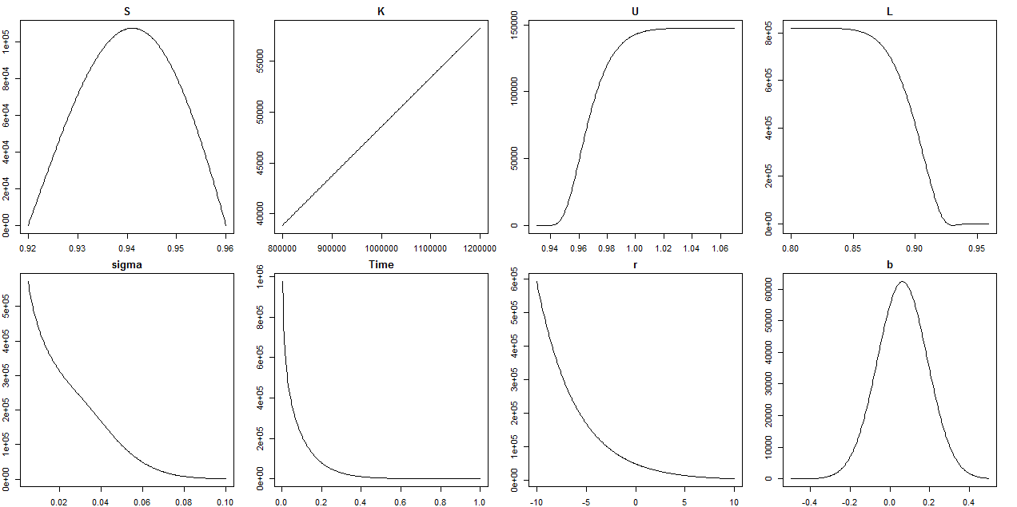
Insert Image 2078OT_07_18.png

Summary

We started this chapter by introducing exotic options. In a brief theoretical summary we explained how exotics and plain vanillas are linked together. There are many types of exotics, we showed one possible way of classification that is consistent with the fExoticOptions package. We showed how the Black-Scholes surface (a 3D chart containing the price of a derivative dependent on time and the underlying price) can be constructed for any pricing function
.
Pricing of exotic options is just the first step. Market makers keep thousands of different options in their trading books. This is possible only because each option can be decomposed into certain sensitivities, the so called Greeks. Being partial derivatives, Greeks are additive, thus the portfolio of derivatives has the sum of the Greeks of its elements. Next step was estimating Greeks for any derivative pricing functions. Our numerical method can be calibrated to the real market conditions: for many parameters we already know what the smallest possible change is. For example the smallest change for interbank AUDUSD fx rate is 0.0001. Even multiple partial derivatives like gamma, or vanna can be calculated with this numerical method.
On the second half of the chapter we have focused on one particular exotic option: the Double-No-Touch (DNT) binary option. The reason behind this focus is based on the popularity of DNT options and also because there are many tricks can be shown on DNTs with conclusions relevant to many other exotic options. We showed two different ways for pricing DNT options. First we implemented the Hui (1996) closed form solution, where the price is a result of an infinite sum. The speed of convergence is many times very quick, however this is not always the case. We showed a practical way how convergence issues can be handled without wasting too much computing time. Another way for pricing a DNT is a static replication from one DKO call and one DKO put option. For pricing these DKO options we used the fExoticOptions package. We found very little difference between the results of the two DNT pricing methods
.
We showed how DNT option behaves on real life data by using 5 minutes open-low-high-close AUDUSD rates from the second quarter of 2014. We estimated the survivorship probability of a DNT by simulation to show how risk premium could be included in DNTs or DOTs based on the supply-demand tensions for volatility. Finally we showed some practical fine tuning methods to find missing parameters for DNT in case of building a structured product by introducing functions for finding implied parameters.

References

- Black, F. and Scholes, M. [1973]: The Pricing of Options and Corporate Liabilities, The Journal of Political Economy, 81(3), pp. 637-654
- .
- Carr, P., Ellis, K. and Gupta, V. [1998]: Static hedging of exotic options, Journal of Finance, 53, 1165-1190.
- Derman, E., Ergener, D. and Kani, I. [1995]: Static Options Replication, Journal of Derivatives, 2 (4), 78-95.
- DeRosa, D. F. [2011]. Options on Foreign Exchange. Wiley Finance
- Haug, E. G. [2007a]. The Complete Guide to Option Pricing Formulas, 2nd edition. The McGraw-Hill Companies
- Haug, E. G. [2007b]. Derivatives Models on Models. John Wiley & Sons
- Hui, C. H. [1996].One-touch Double Barrier Binary Option Values, Applied Financial Economics, 1996, 6, pp. 343-346.
- Merton, R. [1973]: Theory of Rational Option Pricing, The Bell Journal of Economics and Management Science, 4(1), pp. 141-183.
- Taleb, N. N., [1997]. Dynamic Hedging. John Wiley & Sons
- Wilmott, P., [2006]. Quantitative Finance, 2nd edition. John Wiley & Sons

