12
Capital Adequacy
As we have already seen in the previous chapter, banking is a specifically risky industry and the safety of the clients' money is a top priority. In order to ensure that banks meet this primary objective, the industry is under strict regulation. It has always been a very important task for supervisors to build rules to avoid collapse of banks and to protect clients' wealth. Capital adequacy or capital requirement is one if not the most important regulatory tool to serve this goal. Given the high leverage in the financial sector, banks and other financial institutions are not allowed to freely use all their assets. These firms need to hold enough capital to ensure safe operation and solvency even if things turn bad.
Different countries have different banking supervisory bodies (financial watchdog, central bank) and regulation standards. However as the banking system became more and more globalized, a common worldwide standard became necessary. In 1974, the Basel Committee on Banking Supervision (BCBS) was set up by the G-10 central banks to provide banking regulatory standards that can be applied to different countries around the globe.
This area of economics has developed quite fast since then and more and more complex mathematical methods are used in risk management and capital adequacy calculation. R is such a powerful tool that it is perfectly capable for solving these complex mathematical and analytical problems. Therefore it is not surprising that many banks use this as an important tool for risk management.

Principles of the Basel Accords
In 1988, the BCBS published a regulatory framework in Basel, Switzerland to set the minimum capital a bank needs to hold to minimize the risk of insolvency. The so called First Basel Accord or now mentioned as Basel I was enforced by law in all of the G-10 countries by 1992. By 2009 27 jurisdictions were involved in the Basel Regulatory Framework. (History of the Basel Committee http://www.bis.org/bcbs/history.htm)

Basel I
The first Basel Accord mainly focuses on credit risk and formalizes the appropriate risk weighting considering different asset classes. Based on the Accord, the assets of banks should be classified into categories regarding credit risk and the exposure of each category should be weighted with the defined measures (0 percent, 20 percent, 50 percent and 100 percent). The resulted value of risk-weighted assets (RWA) is used for the determination of capital adequacy. According to the Basel I legislation, banks, which are present on international markets are required to hold capital at least 8 percent of their RWA. This is called the minimum capital ratio. (Basel Committee on Banking Supervision (Charter) http://www.bis.org/bcbs/charter.htm)
So-called off-balance sheet items such as derivatives, unused commitments and credit letters are included in RWA and should be reported, as well
.
The Accord was intended to amend and refine over time in order to address risks other than credit risk as well. Furthermore it was revised to give more appropriate definitions to certain asset classes included in the capital adequacy calculation and to recognize subsequently identified effects.
Basel I defines other capital ratios, as well, in order to quantify the banks' capital adequacy. The capital ratios are considered certain so called Tier capital elements relative to all RWA. Tier capital elements include types of capital grouped based on the definition of Basel I. However, each country's banking regulator may revise the classification of the financial instruments considered in capital calculation due to the different legal framework of the countries.
Tier 1 capital includes core capital, which is composed of common stock, retained earnings and certain preferred stocks, which meet the defined requirements. Tier 2 is considered supplementary capital, which involves supplementary debts, undisclosed reserves, revaluation reserves, general loan-loss reserves and hybrid capital instruments, while Tier 3 is deemed as the short-term additional capital. (Committee on Banking Regulations and Supervisory Practices (1987): Proposals for international convergence of capital measurement and capital standards; Consultative paper; December 1987; http://www.bis.org/publ/bcbs03a.pdf)

Basel II
Basel II was issued in 1999 as a new capital adequacy framework proposed to succeed Basel I and published in 2004 in order to ensure resolutions to certain issues, which was slightly regulated by the former Basel Accord.
The main objectives of Basel II were to
- Provide more risk sensitive capital allocation;
- Implement appropriate calculation methods for not only credit risk but market risk and operational risk, as well;
- Improve the disclosure requirement in order to make capital adequacy more perceptible for market participants; and
- Avoid regulatory arbitrage.

The framework of Basel II is based on the three following pillars:
- Minimum capital requirements by which to Committee intended to develop and expand the standardized capital adequacy calculations;
- Supervisory review of a financial institute's capital adequacy and internal assessment process;
- Effective disclosure to enhance market discipline.

Minimum capital requirements
Required capital on credit risk can be calculated according to the standardized approach. Based on this method, credit exposures should be weighted by measures considering primarily the related ratings by External Credit Assessment Institutions (ECAI). Claims on sovereigns, corporates, and banks or securities companies can be weighted by 0 percent, 20 percent, 50 percent, 100 percent or 150 percent according to their ratings, however, claims on international associations such as IMF, BIS, or EC, the risk weight should be consistently 0 percent.
Regarding secured claims, cash and other assets there are constant weights defined by the Committee and implemented by local regulators considering risk mitigation technics. Eligibility can be considered on different levels regarding the different asset classes and is regulated in local Acts and Decrees of the countries. Furthermore, real estate is not deemed as cover but as exposure according to standard approach, therefore it is included in the regulation on asset classes, as well.
Minimum capital requirement is defined as 8 percent of the RWA also considering conversion factors in case of off-balance sheet items. Capital requirement determined by this method should be appropriate to cover credit risk, market risk and operational risk, as well.
Other methods for calculation of credit risk are the so-called Internal Ratings-Based (IRB) approaches including Foundation IRB and Advanced IRB. IRB approaches are allowed to use only to banks approved by their local regulator.
IRB approaches apply a capital function to determine the required capital. There are key parameters that influence the capital function such as probability of default (PD), loss given default (LGD), exposure at default (EAD) and maturity (M).
Probability of default is considered the likelihood that the client will not (entirely) meet its debt obligation over a particular time horizon. By IRB methods, the bank is allowed to estimate the PD of its clients based on either own developed models or by applying the ratings of ECAI.
Loss given default is the percentage of a relating asset when the client defaults. LGD is related tightly to EAD. Exposure at default is the value of the outstanding liability towards the client at the time of the event of its default. Applying Foundation IRB, the calculation method of EAD is determined by the local regulator, however, by Advanced IRB, the banks are allowed to develop own methodology
.
Maturity is a duration type parameter, which indicates the average remaining part of the credit period.
Advanced IRB enables another classification of exposures and assets, which may reflect more on the characteristics on the bank's portfolio. Furthermore, the range of possibly applied credit risk mitigation actions expands as well.
Although RWA could be determined by various methods by applying either Foundation IRB or Advanced IRB, according to Basel II, the minimum capital requirement is the 8 percent of RWA in both cases.
Determination of operational risk can be executed by different methods. The simplest way of the calculation is the so-called Basic Indicator Approach (BIA). Based on this approach, the capital requirement is defined as the average of gross incomes (GI) of the previous 3 years of the bank multiplied by a given measure – Alpha, which is determined as 15 percent by the legislation.
The Standardized Approach (STA) is a little bit more complex methodology. This approach adopts certain methods of BIA; however, using STA, it is required to determine the gross income regarding the lines of business (LoB). The GI of each LoB should be multiplied by a fix measure – Beta (12 percent, 15 percent or 18 percent depending on the LoB). The capital requirement is the sum of the products of GIs and betas referring to the LoBs.
The aim of the Alternative Standard Approach (ASTA) is to avoid double imposition due to credit risk. ASTA adopts the methodology of STA, however, in case of two LoBs (Retail and Commercial banking) the calculation differs from the standardized approach. Regarding these LoBs, GI is replaced by the product of the value of loans and advances (LA) and a fix factor (m = 0,035).
The most complex methodology of determination of operational risk is the Advanced Measurement Approach (AMA). This approach has both quantitative and qualitative requirements, as well, which should be met. The internal model developed for the estimation of operational risk has to correspond to the standards of safe operation, such as risk measurement on 99.9 percent possibility regarding the period of 1 year. Furthermore, banks applying the AMA have to provide data of 5 past years in relation to their losses
.
Risk mitigation techniques can be applied for up to 20 percent of the capital requirement only by banks using the advanced measurement approach. The banks also have to meet certain strict requirements to be allowed to adopt the risk mitigation effects.
Regarding the calculation of capital requirement for market risk, standardized approach is based on the measures and techniques defined by regulators. For more advanced approaches, determination of Value at Risk (VaR) is considered the preferred methodology
.

Supervisory review:
Basel II defines the supervisory and interventional responsibilities of local regulators. It enables them to prescribe higher capital requirement than determined in Pillar I. Furthermore it allows regulating and managing the remaining risks not described in Pillar I, such as liquidity, concentration, strategic and systemic risk.
The International Capital Adequacy Assessment Process (ICAAP) is considered to ensure that the bank operates an appropriately sophisticated risk management system, which measures, quantifies, summarizes and monitors all the potentially occurring risks. Furthermore, it should oversee whether the banks have enough capital determined based on internal methods to cover all the mentioned risks.
The Supervisory Review Evaluation Process (SREP) is defined as the procedure for examination of risk and capital adequacy of the institutes executed by the local regulator. Moreover, considering Pillar II, the regulator has to regularly monitor the capital adequacy according to Pillar I and intervene in order to ensure the sustainable level of capital.

Transparency
Pillar III of Basel II focuses on the disclosure requirements of banks. It refers mainly to listed institutes, which are required to share information regarding the scope of application of Pillar I-II, risk assessment processes, risk exposure and capital adequacy. (Basel Committee on Banking Supervisions (1999): A New Capital Adequacy Framework; Consultative paper; June 1999; http://www.bis.org/publ/bcbs50.pdf)

Basel III
Even before the financial crisis, the need for review and the fundamental strengthening of Basel II framework became evident. During the crisis it was apparent that the banks had inadequate liquidity position and too much leverage. Risk management should have been more significant, while credit and liquidity risk has usually been mispriced.
The third installment of Basel Accords was developed in 2010 with the aim of providing a more stable and safe operation framework for the financial sector. Basel III and the relating Capital Requirements Directive (CRD IV) are supposed to be implemented by 2019 into the local legislation.
Although the implementation will be executed in several steps, the financial institutions are required to commence the preparation for the application of new capital standards even years before the deadline.
The areas concerned in the regulation of Basel III are the followings:
- The elements of the required capital – implementing a capital conservation buffer and a counter-cyclical buffer;
- Introduction of leverage ratio;
- Implementing liquidity indicators;
- Measuring of counterparty risk;
- Capital requirement of credit institutions and investment companies;
- Implementing global prudential standards.
In order to improve the quality of capital, Basel III regulates the composite of required capital. Core Tier 1 is defined within Tier 1 capital and a so-called capital conservation buffer is implemented with the constant measure of 2.5 percent. A discretionary counter-cyclical buffer is introduced, as well, which is considered an additional 2.5 percent of capital during periods of high credit growth.
A leverage ratio was also defined by Basel III, as a minimum amount of loss-absorbing capital compared to all assets and off-balance sheet items regardless of risk weighting.
The most significant provision of Basel III is the introduction of two liquidity indicators. The first one, considered on short-term horizon is the liquidity coverage ratio (LCR), which should be implemented in 2015. LCR is the value of liquid assets relative to the cumulated net cash-flow within a 30-day period. At the beginning, the minimum value of LCR should be 60 percent, however, it is intended to be raised to 100 percent by 2019.
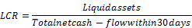
The Net stable funding ratio (NSFR) is going to be implemented in 2018. The aim of this indicator is to avoid maturity gaps between the assets and liabilities of financial institutions. The objective is to provide financing of long-term assets concerning the stability of liabilities. Consequently NSFR is defined as the stable liabilities on stable assets to be financed. The measure of NSFR should be minimum 100 percent from 2019, as well.
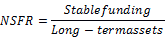
To avoid systemic risks, capital requirement is implemented also regarding counterparty risk. Expectations regarding the capital adequacy and liquidity position of counterparties are framed according to Basel III regulation. Regarding the capital adequacy, mainly institutes applying internal calculation methods are involved in the new regulation, since the regulation takes into consideration the more detailed examination of potential risks occurring and the exposures towards Systematically Important Financial Institutions (SIFI). Based on the third installment of Basel Accords, the institutions should identify the SIFI based on an indicator than apply the requirements determined by the regulator regarding them (refer History of the Basel Committee).
The main measures and phase-in arrangements of Basel III are included in the following table.
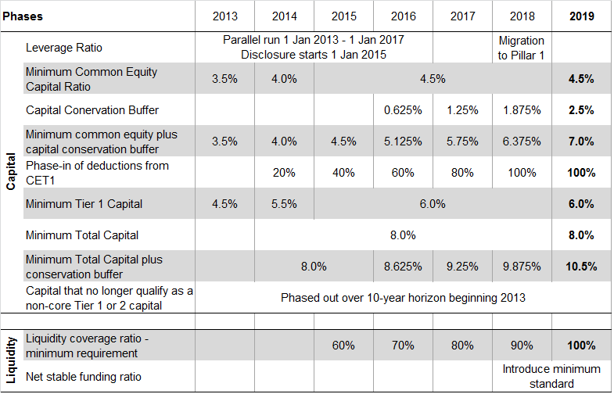
Insert Image 2078OT_12_01.png

Risk Measures
Financial risk is a tangible quantifiable concept, a value that one can lose on a certain financial investment. Note that here we strictly differentiate between uncertainty and risk, where the latter is measurable with mathematical-statistical methods with exact probabilities of the different outcomes. However there are various kinds of measures for financial risk. The most common risk measure is the standard deviation of the returns of a certain financial instrument. Nonetheless it is very widespread and easy to use, it has some major disadvantages. One of the most important problems of the standard deviation as a risk measurement is that it treats upside potential the same way as downside risk. In other words it also punishes a financial instrument that might bring huge positive returns and little negative ones than a less volatile asset.
Consider the following extreme example. Let us assume that we have two stocks on the stock market and we can exactly measure the stocks' yields in three different macroeconomic events. Next year stock A, a share of a mature corporation brings 5 percent yield in case the economy grows, 0 percent if there is stagnation and loses 5 percent in case of a recession. Stock B is a share of a promising start-up firm; it skyrockets (+50 percent) in case of good economic environment, brings 30 percent in case of stagnation and has a 20 percent annual yield even if the economy contracts. The statistical standard deviations of stock A's and stock B's return are 4.1 percent and 12.5 percent respectively. Therefore it is riskier to pick stock A than stock B if we make our choice based on the standard deviation. But – using our common sense – it is obvious that stock B is better in every case than stock A as it gives better yield in all different macroeconomic situations.
Our short example perfectly showed the biggest problem with standard deviation as a risk measure. The standard deviation does not meet the most trivial condition of a coherent risk measure; the monotonicity. We call the σ risk measure coherent if it is normalized and meets the following criteria. Please see the work of Artzner and Delbaen for further information on coherent risk measures.
- Monotonicity: If portfolio X₁ has no lower values than portfolio X₂ under all scenarios then the risk of X₁ should be lower than X₂. In other words, if an instrument pays more than another in every case, it should have lower risk.
- Sub-additivity: The risk of two portfolios together should be less than the sum of the risks of the two portfolios separately. This criterion represents the principle of diversification.
- Positive homogeneity: Multiplying the portfolio values by a constant, multiplies the risk by the same extent.
- Translation invariance: Adding a constant value to the portfolio decreases the risk by the same amount.
If the standard deviation is not a reliable risk measure then what can we use? This question popped up at J.P. Morgan by CEO Dennis Weatherstone in the early 1990s. He called the firm's departments for the famous 4:15 report, in which they aggregated the so-called values at risk 15 minutes before the market close. The CEO wanted an aggregated measure that shows what amount the firm might lose in the next trading day. As this cannot be calculated with full certainty, especially in the light of the 1987 Black Monday, the analysts added a probability of 95 percent.
The figure that shows what a position might lose in a specified time period with a specified probability (significance level) is called the Value at Risk (VaR). Although it is a quite new measure, it is widely used both by risk departments and financial regulators. There are several ways to calculate value at risk that can be categorized into three different methods. Under the analytical VaR calculation, we assume that we know the probability distribution of the underlying asset or return. If we do not want to make such assumption we can use the historical VaR calculation, using the the returns or asset values realized in the past. In this case, the implicit assumption is that the past development of the given instrument is a good estimator for the future distribution. If we would like to use a more complex distribution function that is hard to tackle by analytics, Monte-Carlo simulation could be the best choice to calculate VaR. This can be used by either assuming an analytical distribution of the instrument or by using past values. The latter is called historic simulation.

Analytical VaR
When calculating value at risk in an analytical approach, we need to assume that the return of a financial instrument follows a certain mathematical probability distribution. The normal distribution is used most commonly that is why we usually call it the delta-normal method for VaR calculation. Mathematically, X ~ N(μ,σ) where μ,σ are the mean and the standard deviation parameters of the distribution. To calculate the value at risk, we need to find a threshold (T) that has the ability that the probability of all data bigger than this is α (α is the level of significance that can be 95 percent, 99 percent, 99.9 percent etc.). Using the standard normal cumulative distribution function F:
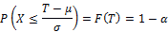
This brings that we need to apply the inverse cumulative distribution function to 1- α
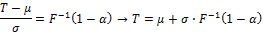
Although we do not know the closed mathematical formula of neither the cumulative function of normal distribution nor its inverse, we can solve this by using a computer
.
We use R below to calculate the 95 percent, 1 day VaR of the Apple stocks using the delta normal method, based on a two-year data set. The estimated mean and standard deviation of Apple returns are 0.13 percent and 1.36 percent.
Apple <- read.table("Apple.csv", header = T, sep = ";")
r <- log(head(Apple$Price,-1)/tail(Apple$Price,-1))
m <- mean(r)
s <- sd(r)
VaR1 <- -qnorm(0.05, m, s)
print(VaR1)
[1] 0.02110003

The threshold, which equals to the VaR if we appliedto the returns, can be seen below. Note that we always take the absolute value of the result as VaR is interpreted as a positive number.
The VaR(95 percent, 1 day) is 2.11 percent. This means that it has 95 percent probability that Apple shares will not lose more than 2.11 percent in one day. We can also interpret this with an opposite approach. An Apple share will only lose more than 2.11 percent in one day with 5 percent probability. The chart below show the actual distribution of Apple returns with the historic value at risk on it.
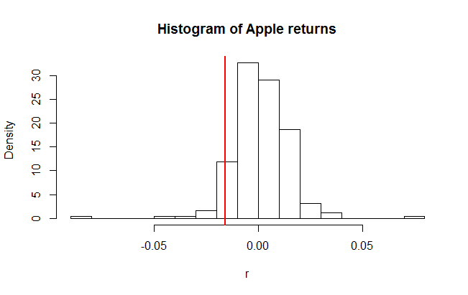
Insert Image 2078OT_12_02.png

Historical VaR
The simplest way of calculating the value at risk is using the historical approach. Here we assume that the past distribution of the financial instrument's return represent the future too. Therefore we need to find that threshold above which the α portion of the values can be found. In statistics, this is called the percentile. If we use a VaR with a 95 percent level of significance for instance then it will imply the lower 5th percentile of the data set. The code below shows how to calculate the percentile in R.
VaR2 <- -quantile(r, 0.05)
print(VaR2)
5%
0.01574694

Applying this to the Apple shares, we get a lower 5th percentile of 1.57 percent. The value at risk is the absolute value of this percentile. Therefore we can either say that it has only 5 percent probability that Apple shares lose more than 1.57 percent in a day or the stock will lose less than 1.57 percent with 95 percent likelihood.

Monte-Carlo Simulation
The most sophisticated approach to calculate the value at risk is the Monte-Carlo Simulation. However it is only worth using if other methods cannot be used for some reasons. These reasons can be the complexity of the problem or the assumption of a difficult probability distribution. Nevertheless, this is the best method to show the powerful capabilities of R that can support risk management.
Monte-Carlo Simulation can be used in many different fields of finance and other sciences as well. The basic approach is to set up a model and to assume an analytic distribution of the exogenous variable The next step is to randomly generate the input data to the model in accordance with the assumed distribution. Then the outcomes are collected and used to gather the result and draw the conclusion. When the simulated output data is ready, we can follow the same procedure as we would do if we used the historical approach.
Using a 10,000 step Monte-Carlo simulation on calculating VaR of Apple shares may seem to be overkill but it serves for the demonstration. The related R code is shown below.
sim_norm_return <- rnorm(10000, m, s)
VaR3 <- -quantile(sim_norm_return, 0.05)
print(VaR3)
5%
0.02128257

We get a result of 2.06 percent for the value at risk as a lower 5th percentile of the simulated returns. This is very close to the 2.11 percent estimated with the delta-normal method, which is not a coincidence. The basic assumption that the yield follows a normal distribution is the same, thus the minor difference is only a result of the randomness of the simulation. The more steps the simulation takes, the closer the result is to the delta-normal estimation.
A modification of the Monte-Carlo method is the historical simulation when the assumed distribution is based on the past data of the financial instrument. The generation of the data here is not based on an analytical mathematical function but the historical values are selected randomly, preferably via an independent identical distribution method.
We also use a 10,000 element simulation for the Apple stock returns. In order to select the values from the past randomly, we assign numbers to them. The next step is to simulate a random integer between 1 and 251 (the number of historic data) and then use a function to find the associated yield. The R code can be seen below.
sim_return <- r[ceiling(runif(10000)*251)]
VaR4 <- -quantile(sim_return, 0.05)
print(VaR4)
5%
0.01578806

The result for the VaR is 1.58%, not surprisingly close to the value derived from the original historic method.
Nowadays, value at risk is a common measure for risk in many fields of finance. However, in general, it still does not fulfill the criteria of a coherent risk measure as it fails to meet sub-additivity. Or in other words it might discourage diversification in certain cases. However, if we assume an elliptically distributed function for the returns, the VaR proves to be a coherent risk measure. This essentially means that the normal distribution suits the estimation of VaR perfectly. The only problem is that the stock returns in real life are rather leptokurtic (heavy tailed) compared to the Gaussian curve as it is experienced as a stylized fact of finance.
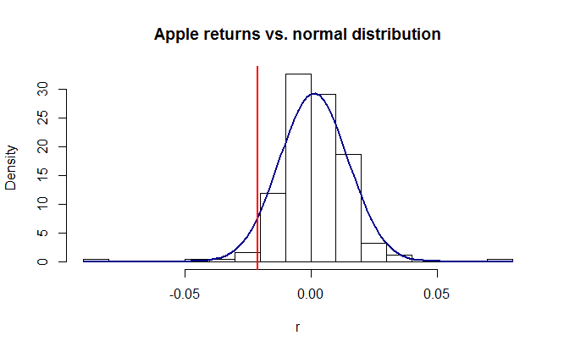
Insert Image 2078OT_12_03.png
In other words, the stocks in real life tend to show more extreme losses and profits than it would be explained by the normal distribution. Therefore, developed analysis of risk assumes more complex distributions to cope with the heavy tailed stock returns, the heteroskedasticity and other imperfections of the real life yields.
The use of Expected Shortfall (ES) is also included in the developed analysis of risk, which is in fact a coherent risk measure no matter what distribution we assume. The expected shortfall concentrates on the tail of the distribution. It measures the expected value of the distribution beyond the value at risk. In other words the expected shortfall at α significance level is the expected value of the worst α percent of the cases. Mathematically,
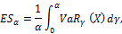.
where VaR_{γ} is the value at risk of the distribution of returns.
Sometimes expected shortfall is called conditional value at risk (CVaR). However the two terminologies does not mean exactly the same, it can be used as synonyms if continuous distribution functions are used for the risk analysis. Although R is capable of dealing with such complex issues as the expected shortfall, it goes beyond the goals of this book. For further information on this topic, please see the work of Acerbi, C.; Tasche, D. (2002).

Risk categories
Banks face various kinds of risks, for example client default, changes in the market environment, troubles in refinancing and fraud. These risks are categorized into Credit Risk, Market Risk, and Operational Risk.

Market risk
Losses realized from the movements of the market prices are covered by the market risk. It may include the losses on the trading book positions of a bank or financial institution but the losses realized on interest rate or currency that may be in connection with the core business of a bank also belongs to market risk. Market risk can include several sub-categories such as equity risk, interest rate risk, currency risk and commodity risk. Sometimes, liquidity risk is also treated in this topic. Based on the advanced approach of the Basel II directive, the capital needed to cover these risks is mostly based on value at risk calculations.
Currency risk refers to the possible loss on the movements of the foreign exchange rates (example: EUR/USD) or on its derivative products, while commodity risk covers the losses on the movements of commodity prices (example: gold, crude oil, wheat, copper, and so on). Currency risk can also affect the core business of a bank if there is a mismatch between the FX exposure in funding and lending. FX mismatch can lead to serious risk in a bank thus regulators usually make strict limitation on the maximum amount of the so called open FX positions. This means the mismatch of the FX exposure between the liability and the asset side of the bank. This can be tackled by certain hedging deals (cross-currency swaps, currency futures, forwards, FX options, and so on).
Equity risk is the possible loss on stocks, stock indices or derivative products with equity underlying. We saw examples on how to measure the equity risk using either the standard deviation or the value at risk. Now we show examples on how the risk of the equity derivative portfolio can be measured using the already mentioned techniques. First we look at a single call option's value at risk then we analyze how a portfolio of a call and a put option can be dealt by this method.
First, let us assume that all the conditions of the Black-Scholes model consist on the market. For more information on the Black-Scholes model and its condition, please see the book of John. C. Hull [9]. A stock is currently traded at S = USD 100 pays no dividend and follows a geometric Brownian motion with μ = 20% (drift) and σ = 30% (volatility) parameters.
An ATM (at-the-money) call option on this stock matures in two years from now and we would like to determine the 95 percent, one year value at risk of this option. We know that the stock price follows a lognormal distribution, while the logarithmic rate of return follows a normal distribution with the following m and s parameters.
Now, let us calculate the current price of the derivative given that the Black-Scholes conditions consist. Using the Black-Scholes formula the two-year option is trading at USD 25.98.
Please note that the price of the call option is a monotone growing function of the spot price of the underlying.

This characteristic helps us a lot in solving this problem. What we need is a threshold of the option price below which it goes with only a 5 percent probability. But because it is a monotone growing function of S, we only need to know where this threshold is for the stock price. Given the m and s parameters, we can easily find this value at:
Therefore we know now that it has only 5 percent chance that the stock price goes below USD 71.29 in one year (the time period for m and s parameters is one year). If we apply the Black-Scholes formula on this price and with a one year less maturity of the option, we get the threshold for the call option price.
Now we know that it has 95 percent likelihood that the option price goes above USD 2.90 in one year. So the value that we lose at most with 95 percent probability is the difference between the actual option price and the threshold. So the call option's 95 percent VaR for one year is:
Therefore, the call option on the given stock may only lose more than USD 23.08 or 88.82 percent with 5 percent probability in one year.
The calculations can be seen below in the R codes. Note that before running the code, we need to install the fOptions library using the command below:
install.packages("fOptions")
library(fOptions)

X <- 100
Time <- 2
r <- 0.1
sigma <- 0.3
mu <- 0.2
S <- seq(1,200, length = 1000)
call_price <- sapply(S, function(S) GBSOption("c", S, X, Time, r, r,
sigma)@price)
plot(S, call_price, type = "l", ylab = "", main = "Call option price
in function of stock prompt price")
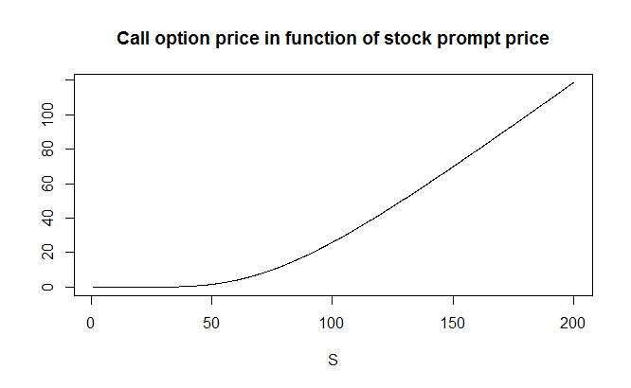
2078OT_12_04

The situation is not that simple if we would like to find the value at risk of a certain portfolio of call and put options. Let us use the previous example with the stock trading at USD 100. Now we add an ATM put option to the portfolio besides the ATM call option to form a complex position known as straddle in finance. From our point of view, the problem with this portfolio is the non-monotonicity of the function of the stock price. As seen on the chart below, the value of this portfolio as a function of the stock price is a parabola or similar to a V if the option is just before its maturity.

Therefore the previous logic of finding the appropriate stock price threshold to calculate the option price threshold does not work here. However, we can call the Monte-Carlo simulation method to derive the desired value.
First, let us use the so called put-call parity to gather the put option's value using the call price that has already been calculated previously. Put-call parity:
where c and p is the call and put option prices, both with a strike price of X and S is the actual stock price Hull (2002). The value of the full portfolio is USD 33.82 as a consequence.
Now, we use the simulation to gather 10,000 realizations of a possible portfolio value derived from a randomly generated set of input data. We use that the stock follows a geometric Brownian motion and that the logarithmic rate of return follows normal distribution with m and s parameters (15.5 percent and 30 percent). Applying the generated logarithmic return on the original stock price (USD 100), we will reach a simulated stock price for one-year from now. This can be used to recalculate the value of both the call and put options using the Black-Scholes formula. Note that here we replace the original stock price to the simulated one, while we also use a one year less maturity for the calculations. As a last step, we create 10,000 realizations of the simulated portfolio value (c + p) then find the lower fifth percentile. This will be the threshold below which the option portfolio value goes only in 5 percent of the cases. The steps can be seen in R below.
X <- 100
Time <- 2
r <- 0.1
sigma <- 0.3
mu <- 0.2
S <- seq(1,200, length = 1000)
call_price <- sapply(S, function(S) GBSOption("c", S, X, Time, r, r,
sigma)@price)
put_price <- sapply(S, function(S) GBSOption("p", S, X, Time, r, r,
sigma)@price)
portfolio_price <- call_price + put_price
windows()
plot(S, portfolio_price, type = "l", ylab = "", main = "Portfolio
price in function of stock prompt price")
# portfolio VaR simulation
p0 <- GBSOption("c", 100, X, Time, r, r, sigma)@price +
GBSOption("p", 100, X, Time, r, r, sigma)@price
print(paste("price of portfolio:",p0))
[1] "price of portfolio: 33.8240537586255"
S1 <- 100*exp(rnorm(10000, mu - sigma^2 / 2 , sigma))
P1 <- sapply(S1, function(S) GxBSOption("c", S, X, 1, r, r,
sigma)@price + GBSOption("p", S, X, 1, r, r, sigma)@price )
VaR <- quantile(P1, 0.05)
print(paste("95% VaR of portfolio: ", p0 - VaR))
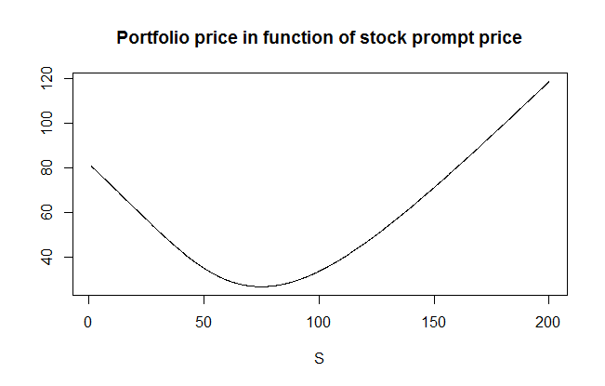

Insert Image 2078OT_12_05.png
The desired threshold came out at USD 21.45 thus the value at risk of the portfolio is 33.82 - 21.45 = USD 12.37. Therefore the probability that the portfolio loses more than 12.37 in one year is only 5 percent.

Interest rate risk arises from the core business, the lending and refinancing activity of a bank. However it also includes the possible losses on bonds or fixed income derivatives due to unfavorable change in interest rates. The interest rate risk is the most important market risk for a bank, given the fact that it mostly uses short term funding (client deposits, interbank loans, etc.) to refinance long-term assets (such as mortgage loans, government bonds, etc.).
Calculating the value at risk of a position or the whole portfolio can be a useful tool to measure the market risk of a bank or financial institution. However several other tools are also available to measure and to cope with the interest rate risk for example. Such tool can be the analysis of the mismatch of the interest sensitivity gap between assets and liabilities. This method was among the first techniques in asset liability management to measure and tackle interest rate risk but it is much less accurate than the modern risk measurement methods. In the interest sensitivity gap analysis asset and liability elements are classified by the average maturity or the timing of interest rate reset in case the asset or liability is a floater. Then the asset and liability elements are compared in each time period classes to give a detailed view on the interest rate sensitivity mismatch.
The value at risk based approach is a much more developed and accurate measure for interest rate risk of a bank or financial institution. This method is also based on the interest rate sensitivity but represented by the duration (and convexity) of a fixed income portfolio rather than the maturity mismatch of asset and liability elements.

Credit Risk
The primary risk a bank faces is the possible default of the borrower, where the required payment is failed to be made. Here the risk is that the lender loses the principal, the interest and all related payments. The loss can be partial or complete depending on the collaterals and other mitigating factors. The default can be a consequence of a number of different circumstances such as the payment fail of a retail borrower on mortgage, credit card or personal loan; the insolvency of a company, bank or insurance firm, a failed payment on an invoice due; the fail of payment by the issuer on debt securities, and so on.
The expected loss from credit risk can be represented as a multiple of three different factors; the PD, LGD, and EAD.
Probability of default (PD) is the likelihood that the event of failed payment happens. This is the key factor of all credit risk models and there are several types of approaches to estimate this value. The loss given default (LGD) is the proportion that is lost in percentage of the claimed par value. The recovery rate (RR) is the inverse of LGD and shows the amount that can be collected (recovered) even if the borrower defaults. This is affected by the collaterals and other mitigating factors used in lending. The exposure at default (EAD) is the claimed value that is exposed to the certain credit risk.
Banks and financial institutions use different methods to measure and handle credit risk. In order to reduce it, all the three factors of the multiple can be in focus. To keep the exposure under control, banks may use limits and restrictions in lending towards certain group of clients (consumers, companies and sovereigns). Loss given default can be lowered by using collaterals such as mortgage rights on properties, securities and guarantees. Collaterals provide security to the lenders and ensures that they get back at least some of their money. Other tools are also available to reduce loss given default such as credit derivatives and credit insurance.
A credit default swap (CDS) is a financial swap agreement that works as an insurance against the default of a third party. The issuer or seller of the CDS agrees to compensate the buyer in an event of the default of the debt holder. The buyer pays a periodical fee for the seller set in percentage of the par value of the bond or other debt security. The seller pays the par value to the buyer and receives the bond in case of a credit event. If there is no default by the debtor the CDS deal terminates at maturity without any payment from the seller.
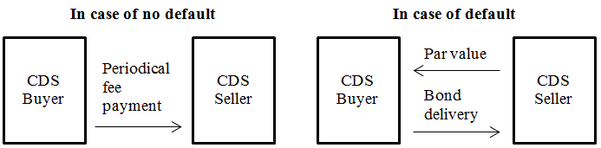
Insert Image 2078OT_12_06.png

The probability of default can be mitigated by due diligence of the business partners and the borrowers, using covenants and strict policies. Banks use a broad variety of due diligence from the standardized scoring processes to more complex in-depth research on clients. By applying these methods banks can screen out those clients who have too high probability of default and would therefore hit the capital position. Credit risk can also be mitigated by risk-based pricing. Higher probability of default leads to higher expected loss on credit risk that has to be covered by the interest rate spread applied to the specific client. Banks need to tackle this in their normal course of business and only need to form capital to the unexpected loss. Therefore, the expected loss on credit risk should be a basic part of product pricing.
Estimating the probability of default is a very important issue for all banks and financial institutions. There are several approaches of which we examine three different ones.
- An implicit probability is derived from the market pricing of risky bonds or credit default swaps (example: Hull-White method)
- Structural models (example: KMV model)
- Current and historic movements of credit ratings (example: CreditMetrics)
The first approach assumes that there are traded products on the market related to the instruments as an underlying that have credit risk. It is also assumed that the risk is perfectly showed in the market pricing of such instruments. For example if a bond of a risky company is traded on the market, the price of the bond will be lower than the price of a risk-free security. Or if a credit default swap is traded on the market on a certain bond then it also reflects the market's evaluation of the risk on that security. If there is enough liquidity on the market the expected credit risk loss should be equal to the observed price of the risk. If we know this price we can determine the implicit probability of default.
For example let us look at a short example. Let us assume that a one-year maturity zero-coupon bond with a par value of USD 1,000 issued by a BBB rated corporation trades at an YTM (yield-to-maturity).of 5 percent. An AAA rated government T-Bill with similar characteristics but without credit risk trades at 3 percent. We know that if the corporate bond defaults, 30 percent of the par value will be recovered. What is the probability of default of the bond if the market prices properly?
First, we need to calculate the current market price of both the corporate and the government bond. The corporate bond should trade at USD 952.4. Same, the government bond should trade at USD 970.9.
The price difference between the two bonds is USD 18.5. The expected credit loss is PD∙LGD∙EAD in one year. If we wanted to take a hedge against the credit loss through insurance or CDS, the present value of this amount would be the maximum we would pay. As a consequence, the price difference of the two bonds should equal to the present value of the expected credit loss. The LGD is 70 percent as 30 percent of the par value is recovered in case of a default.
Therefore, or 2.72%.
So the implicit probability of default is 2.72 percent during the next one year, if the market prices properly. This method can also be used if there is a credit derivative traded on the market related to the specific bond.
Structural methods create a mathematical model based on the characteristics of the financial instrument that is exposed to credit risk. A common example is the KMV model created by the joint company founded by three mathematicians, Stephen Kealhofer, John McQuown and Oldřich Vašíček. Currently this company runs under the name of Moody's Analytics after having been acquired by Moody's rating agency in 2002.
The KMV model is based on Merton's credit model (1974) that regards both the debt and equity securities of a corporation with credit risk as derivatives similar to options. The basic idea is that if a company is solvent than the market value of its assets (or enterprise value) should exceed the par value of the debts it holds. Therefore, just before the maturity of the corporate bonds, they worth their par value and the is the value of the equity (market capitalization of a public company). However, if the value of assets misses the par value of debt at maturity, the owners may decide to raise capital or go bankrupt. If the latter is the case, the market value of corporate bonds will equal the asset value and the equity holders will get nothing during liquidation.
The choice between the bankruptcy and capital raising is called the bankruptcy option that has the characteristics of a put option. This exists because the equity holders has no more responsibility on the company than the value they invested (the share price cannot go to negative). More specifically, the value of the corporate bond is the combination of a bond without credit risk and a bankruptcy option, which is a short put option from the point of view of the bondholder (Long Bond + Short Put). The equity of the company can be treated as a call option (Long Call). The asset value of the company is the sum of all the above: , where D is the par value of the corporate debt, V is the asset value, c is the market value of the equity (call option in this regard) and p is the value of the bankruptcy option.

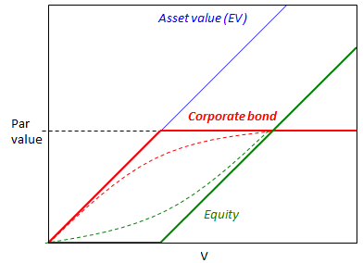
KMV model
Insert Image 2078OT_12_07.png
In practice the volatility of both the asset value and the equity is necessary to calculate the actual value of the risky corporate bond. A public company's equity volatility can easily be estimated from stock price movements but the asset volatility is not available as real economy goods are usually not traded publicly. The market value of assets is also a tricky one due to the same reason. Therefore, the KMV is has two equations and two unknown variables. The two equations are the conditions of the Black-Scholes theory
based on the Black-Scholes equation
and based on Itō's lemma,
where E, V is the market value of equity and assets, D is the par value of the bond, σE, σV are the volatilites of the equity and the assets. is the derivative of E with respect to V and it equals to N(d1) based on the Black-Scholes theory. The two unknown variables are V and σV.
Now let us look at an example where the market value of a company's equity (market capitalization) is USD 3 billion with 80 percent volatility. The company has a single series of zero-coupon bonds with a par value of USD 10 billion maturing exactly in one year. The risk-free logarithmic rate of return is 5 percent for one year. The solution of the equation above in R can be seen below:
install.packages("fOptions")
library(fOptions)
kmv_error <- function(V_and_vol_V, E=3,Time=1,D=10,vol_E=0.8,r=0.05){
V <- V_and_vol_V[1]
vol_V <- V_and_vol_V[2]
E_ <- GBSOption("c", V, D, Time, r, r, vol_V)@price
tmp <- vol_V*sqrt(Time)
d1 <- log(V/(D*exp(-r*Time)))/tmp + tmp/2
Nd1 <- pnorm(d1)
vol_E_ <- Nd1*V/E*vol_V
err <- c(E_ - E, vol_E_ - vol_E)
err[1]^2+err[2]^2
}
a <- optim(c(1,1), fn = kmv_error)
print(a)

The value of the aggregate of the corporate bonds is USD 9.40 billion with a logarithmic of yield to maturity at 6.44 percent and the value of the assets are USD 12.40 billion with 21.2 percent volatility.
The third way of estimating the probability of default is the rating based approach. This method of estimation starts from the credit rating of different financial instruments or economic entities (companies, sovereigns, institutions). CreditMetrics analytics was originally developed by JP Morgan's risk management division in 1997. Since then it has evolved further and now it is widely used among other risk management tools. The basic idea of CreditMetrics is to estimate probabilities on how the credit rating of an entity can change over time and what effect can it have on the value of the securities issued by the same entity. It starts with the analysis of the rating history then it creates a so-called transition matrix that contains the probabilities of how the credit rating may develop. For further information on CreditMetrics, please see the Technical Book published by MSCI (Committee on Banking Regulations and Supervisory Practices (1987)).

Operational Risk
The third major risk category is the operational risk. This refers to all the possible losses that can arise during the operation of a bank, financial institution or other company. It includes losses from natural disasters, internal or external fraud (example: bank robbery), system faults or failures and inadequate working processes. These risks can be categorized into four different groups seen below:
- Low impact with low probability: If the risk is low as well as its potential impact on the operation then it is not worth the effort to handle it.
- Low impact with high probability: If a risk event happens too often it means that some processes of the company should be restructured or it should be included in the pricing of the certain operation.
- High impact with low probability: If the probability of a high impact event is low, the best suitable method to mitigate the risk is to take insurance on such events.
- High impact with high probability: If both the impact and the probability of such risk is high then it should be considered to shut-down that operation. Here neither the restructuring nor the insurance works.
This part of the risk management rather belongs to the actuarial sciences than financial analysis. However, the tools provided by R are also capable of handling such problems as well. Let us take an example on the possible operational loss on the failures of an IT system. The number of failures follow a Poisson-distribution with a λ = 20 parameter, while the magnitude of each loss follow a lognormal distribution with m = 5 and s = 2 parameters. The average number of failures in a year is 20 based on the Poisson distribution, while the expected value of the magnitude of a loss is: 1,097.
However, we need to determine the joint distribution, the expected value and the quantile of 99.9 percent of the aggregate annual loss. The latter will be used to determine the necessary capital set by the advanced measurement approach (AMA) of Basel II. We use a 10,000 element Monte-Carlo simulation. The first step is to generate a discrete random variable that follows Poisson distribution. Then we generate independent variables with lognormal distribution in the number of the previously generated integers and we aggregate them. We can create the distribution of the aggregated losses by repeating this process 10,000 times. The expected value of the aggregate losses is USD 21,694 and the quantile of 99.9 percent is USD 382,247. Therefore we will only lose more than USD 382 thousand in a year by the failure of the IT system in the 0.1 percent of the cases. The calculations can be seen in R below:
op <- function(){
n <- rpois(1, 20)
z <- rlnorm(n,5,2)
sum(z)
}
Loss <- replicate(10000, op())
hist(Loss[Loss<50000], main = "", breaks = 20, xlab = "", ylab = "")
print(paste("Expected loss = ", mean(Loss)))
print(paste("99.9% quantile of loss = ", quantile(Loss, 0.999)))
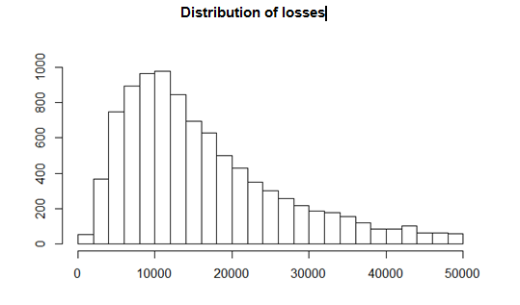
Insert Image 2078OT_12_08.png
We see the distribution of the aggregated losses on the chart above, which is similar to a lognormal distribution, but not necessarily is lognormal.

Summary
In this chapter, we learnt the basic principles of the Basel Accords, the capital adequacy requirements in banking regulation, the risk measures and different risk types, and most importantly, the powerful tools of R used in risk management
.
We saw that the Basel Accords are a world-wide harmonized banking regulatory framework and we learnt the ongoing development and more sophisticated approach of the financial regulations. Furthermore, we provided insights to the risk measures, starting from the most simple standard deviation of returns to the more sophisticated ones, most importantly, the Value at Risk (VaR). However we saw that VaR is not necessarily a coherent risk measure but it is still one of the most widely used figure in both regulation and risk management.

We went through the main risk types a bank or financial institution faces, the credit risk, the market risk and the operational risk. The reader could see how the different risk management approaches could be used to calculate the possible losses of the different risk types and the related capital adequacy. Finally, we presented several examples to show how R can be used to easily solve complex problems in risk management.

References
[1] History of the Basel Committee
[2] Basel Committee on Banking Supervision (Charter)
[3] Committee on Banking Regulations and Supervisory Practices (1987): Proposals for international convergence of capital measurement and capital standards; Consultative paper; December 1987
[4] Basel Committee on Banking Supervisions (1999): A New Capital Adequacy Framework; Consultative paper; June 1999
[5] Artzner, P.; Delbaen, F.; Eber, J. M.; Heath, D. (1999). Coherent Measures of Risk. Mathematical Finance, 9 (3 ed.): p. 203
[6] Wilmott, P. (2006). Quantitative Finance 1 (2 ed.): p. 342
[7] Acerbi, C.; Tasche, D. (2002). Expected Shortfall: a natural coherent alternative to Value at Risk. Economic Notes 31: p. 379–388
[8] Basel II Comprehensive Version
[9] Hull, J. C. (2002). Options, Futures and Other Derivatives (5th ed.)
[10] Principles for the Management of Credit Risk - final document. Basel Committee on Banking Supervision. BIS. (2000)
[11] Crosbie, P., Bohn, J. (2003): Modeling default risk. Technical Report, Moody's KMV
[12] Crouhy, M., Galai, D., Mark, R. (2000): A comparative analysis of current credit risk models. Journal of Banking & Finance, 24:59–117
[13] MSCI CreditMetrics Technical Book

