- chapter05EmbeddableEJBContainer
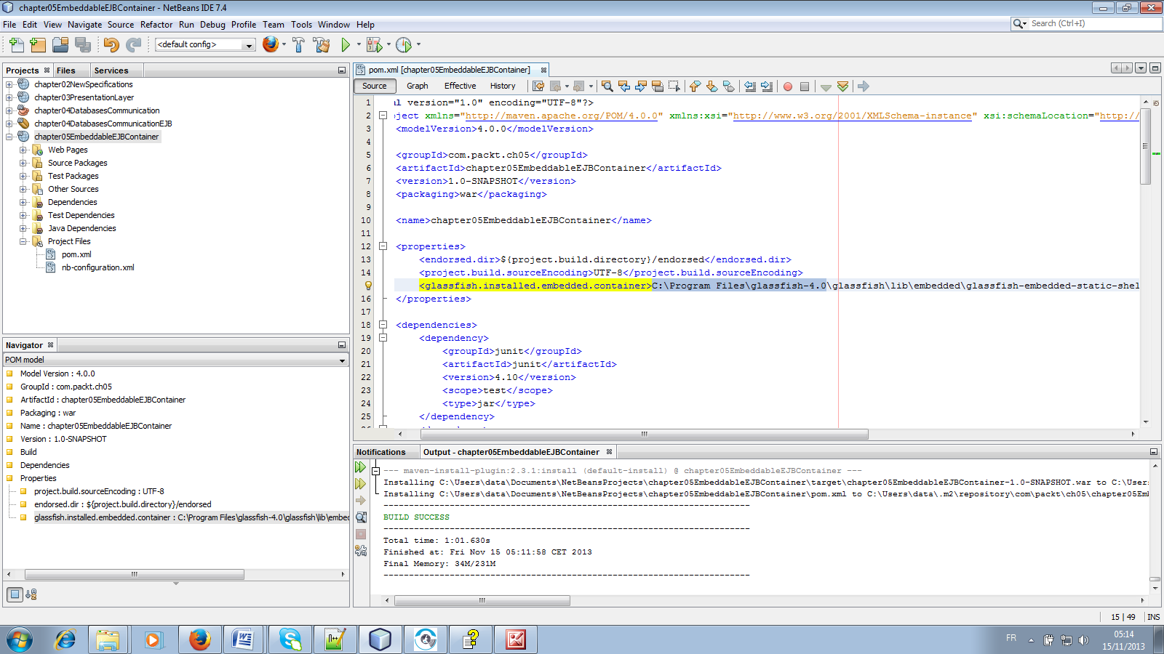
Open the pom.xml file
Make sure that this corresponds to your Glassfish home directory
- chapter07Annotation
For the code chapter07Annotation, « clean and build » the code annotations before chapter07Annotation
- chapter08ValidationAndInterceptors-web
For chapter08ValidationAndInterceptors-web, “clean and build” the codes chapter08Constraint and chapter08ValidationAndInterceptors-ejb in the specified order before chapter08ValidationAndInterceptors-web.
- chapter09-security-web
For chapter09-security-web, “clean and build” the code chapter09-jaspicmodule before chapter09-security-web

For any web and ejb project, make sure that you specified the running environment.
