1. In Recent Vacancies the Sort is not working – there is no sort option
2. In Home page, Recent Vacancies, one word is bold and other is normal – theme as follow in our clients heading and Welcome Tamil Nadu Ex-servicemen’s corporation limited in home page 
3. In Home Page, Our Clients is not showing anything.
4. In Home Page, Top search bar is not returning any results. It is giving error message when the Service No or Texco No is wrong. But when the right No is added the result is not shown – success message added
5. In Register ---Employee--- State and Character have default value as Tamilnadu and Good respectively – not an issue. If anything required please ask Karthi
6. In Our Services ---Gratuity spelling is wrong. Gratuaty and TDS Details are showing following page

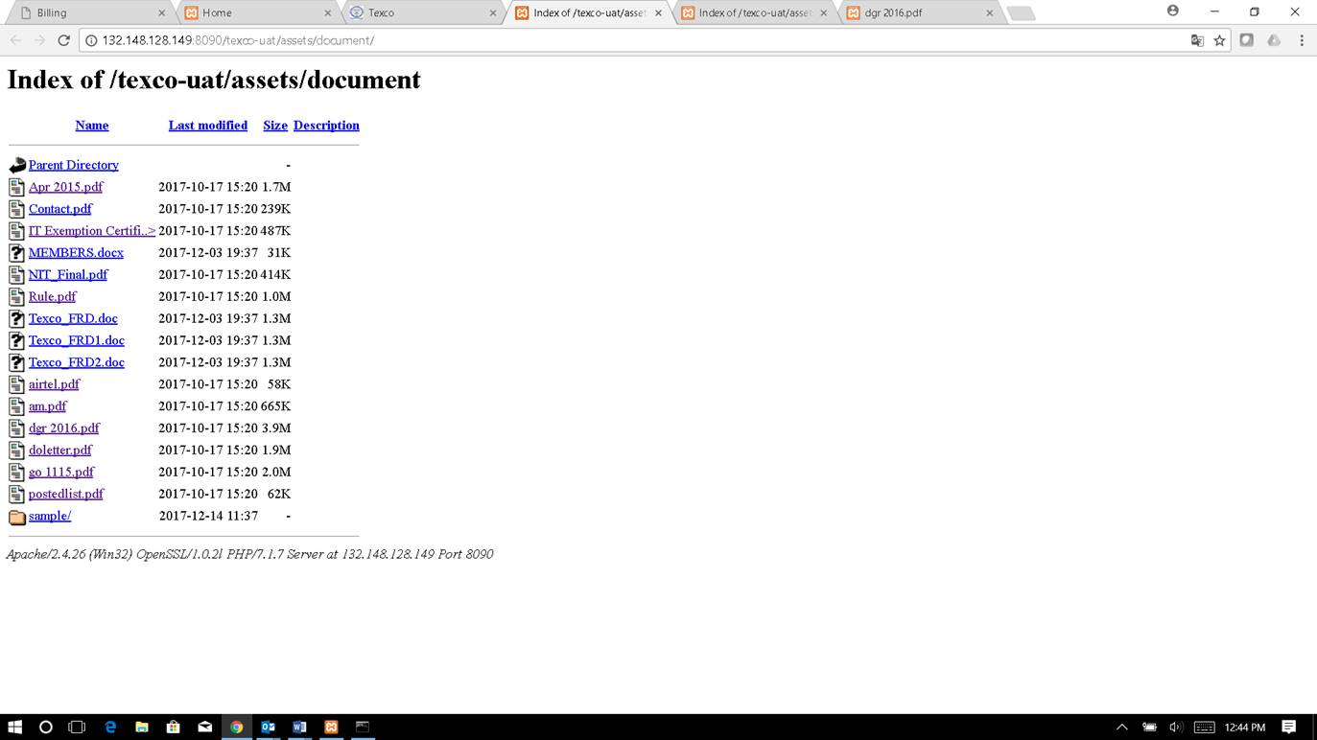

1. In Our services, some services are mentioned twice.

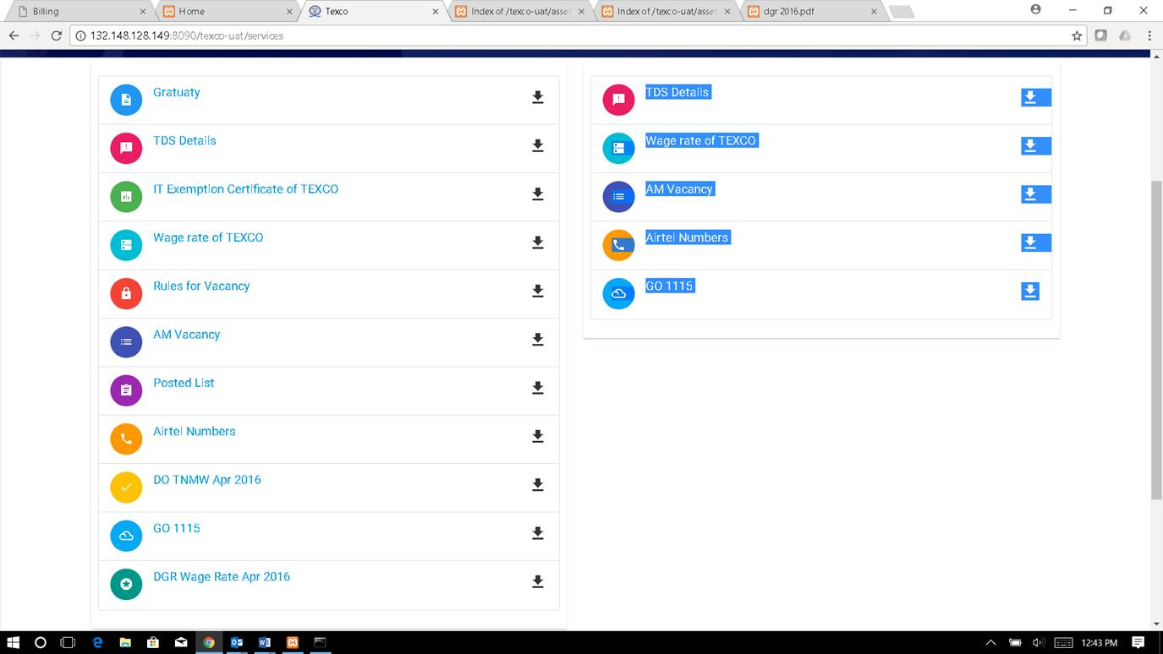

1. When you click on login , the email is present by default and some characters are shown in the password field.

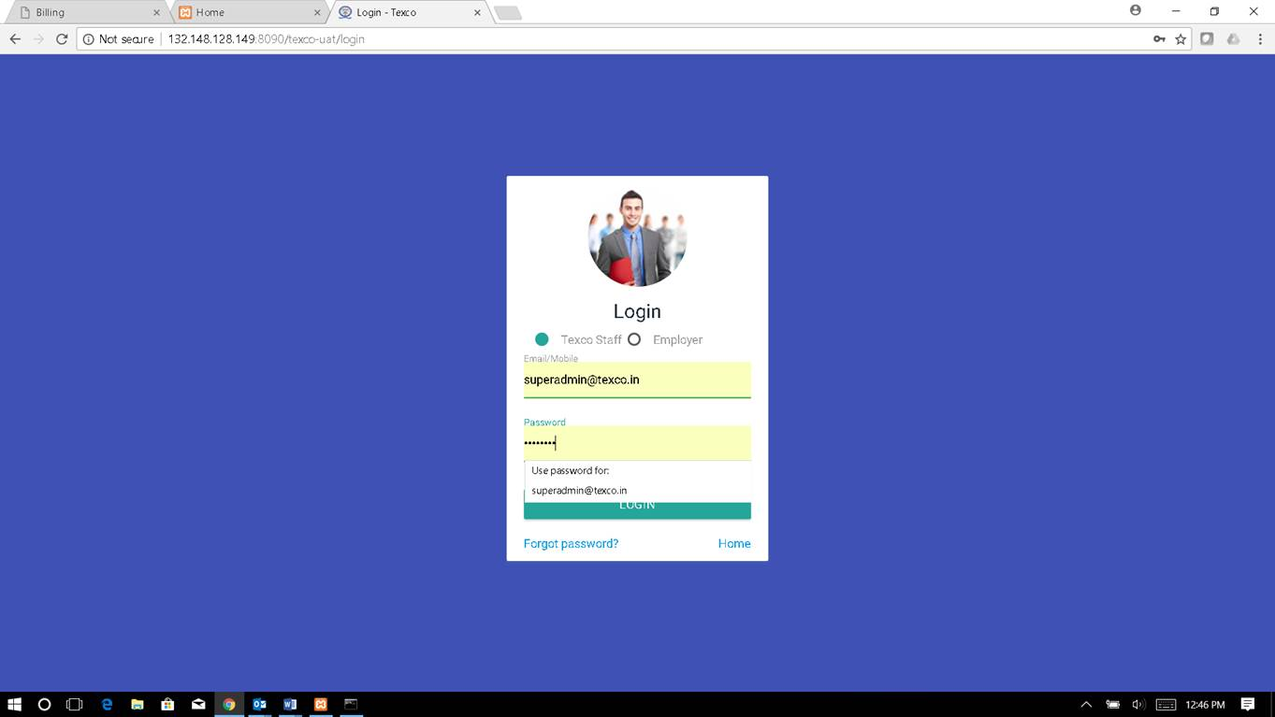

1. In Dashboard, Agreement Expire List , Sl No does not have sort option.
2. In Master Entry--- Employee. The Address , Civil Qualification and Village fields don’t have any limit of characters.

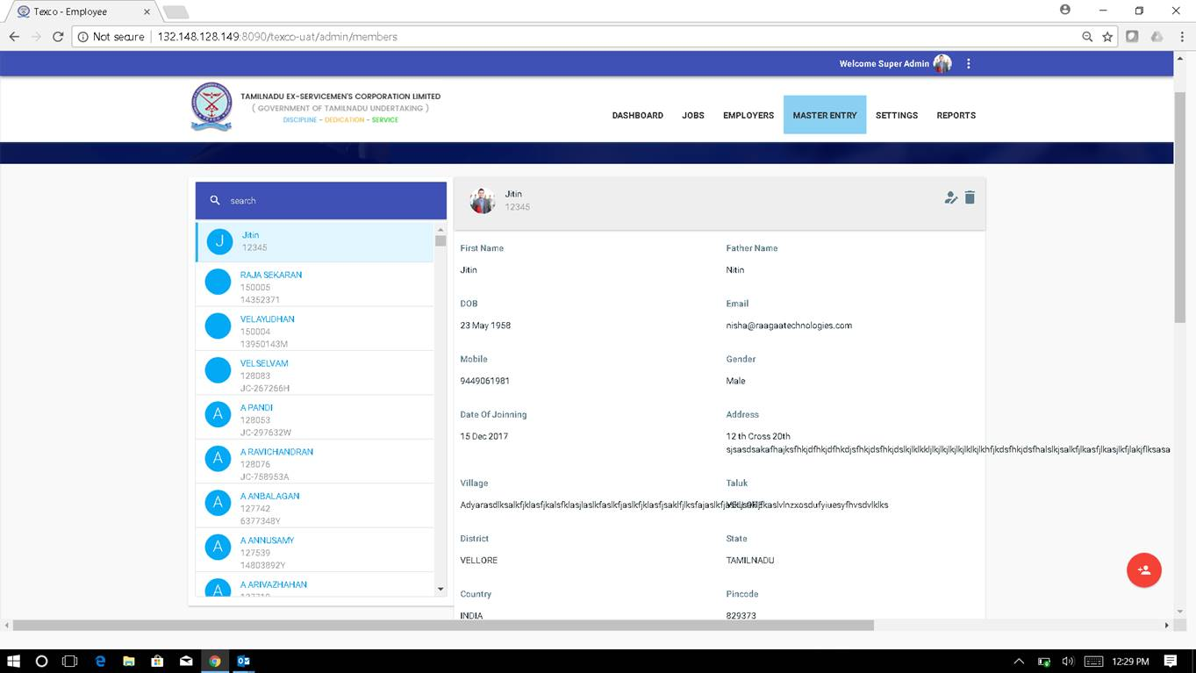

1. In Master Entry --- Employee. The Aadhar field is not validated
2. In Master Entry--- Employee. Though the dependent is selected and the name is entered. The dependent is not shown.
3. In Master Entry ---Staff. I am able to create 2 staffs with same Staff no.

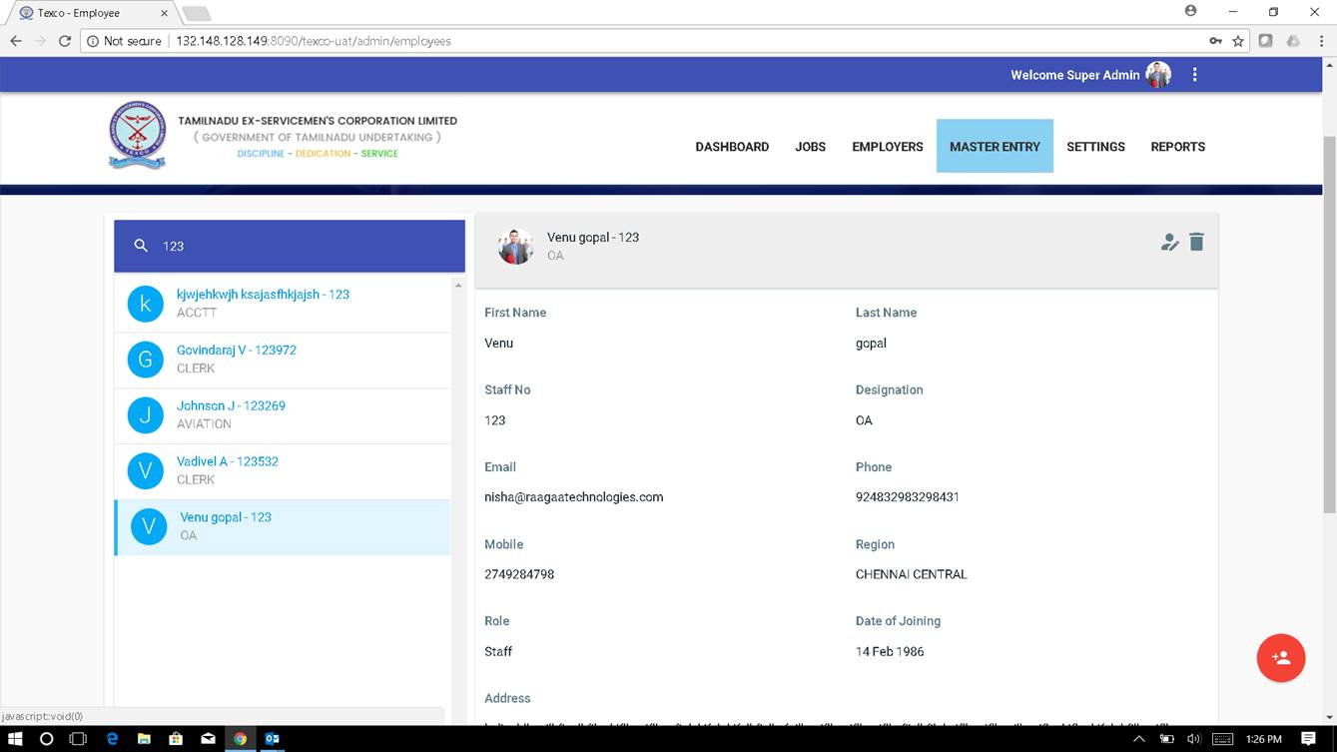

1. In Master Entry --- Staff .The address field have limit on characters. In Password field, there is text shown as below. 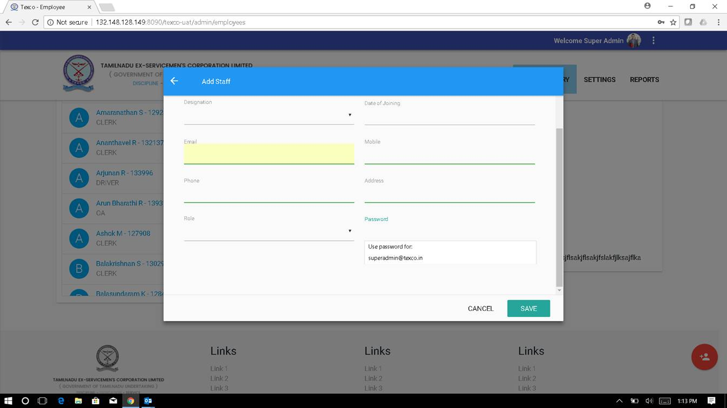
2. After you click save, in google chrome there is a pop up to remember password. The address is username and password is the password we have given.

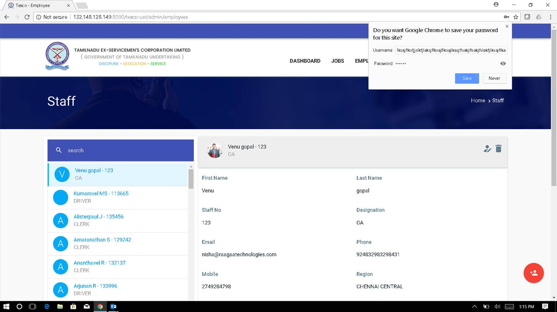

1. In Master Entry ---Directors. The Mobile field is not validated. It is taking characters. Address has no limit of characters. It is overlapping on email id. Able to create 2 directors with same mobile no.

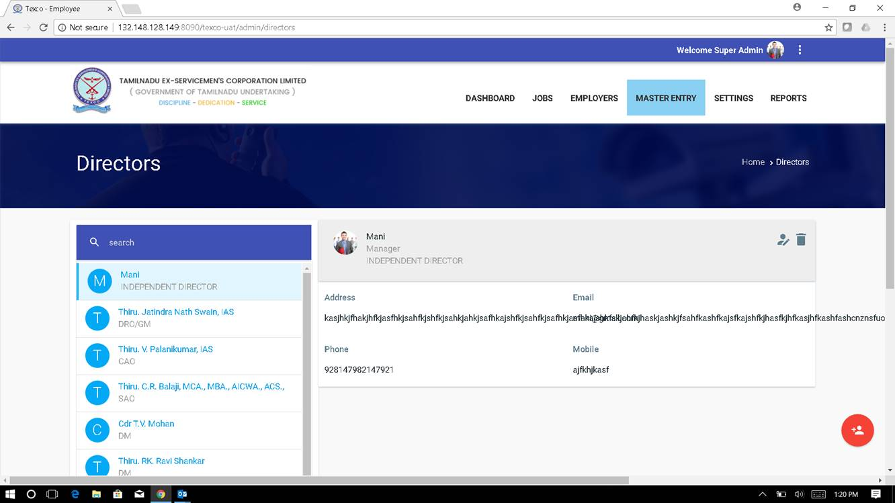

1. In Master Entry --- Lookup Master . The first option is present by default.

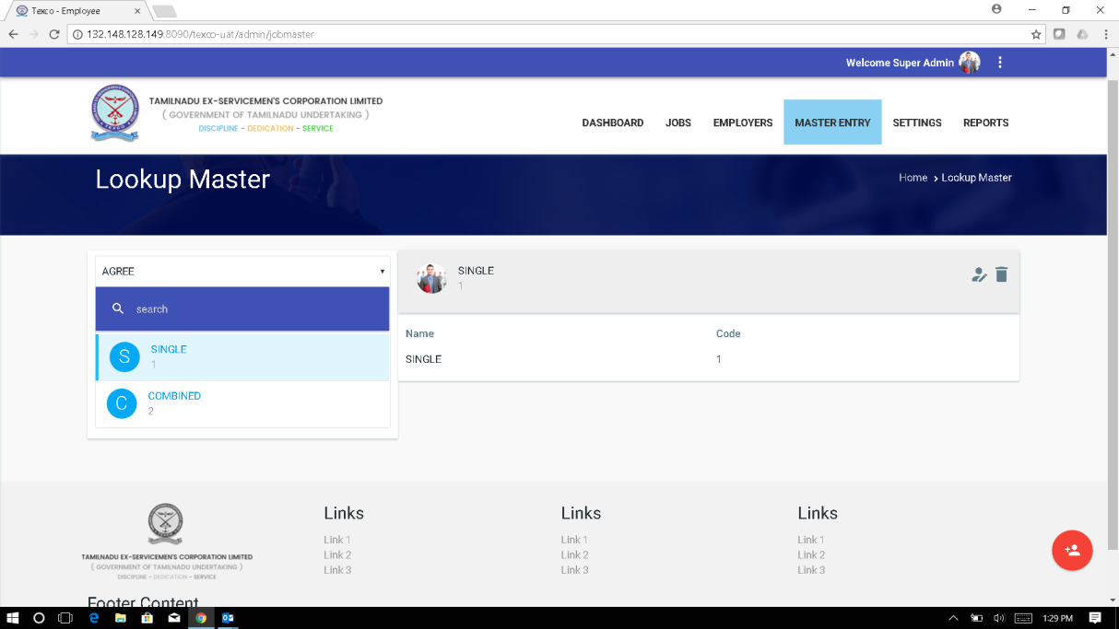

1. In Master Entry ---in Lookup Master, I checked whether I can add the same lookup again . It gave an error message. When I tried to add another lookup, the error message is still shown. Even if you click edit, the error message is present.

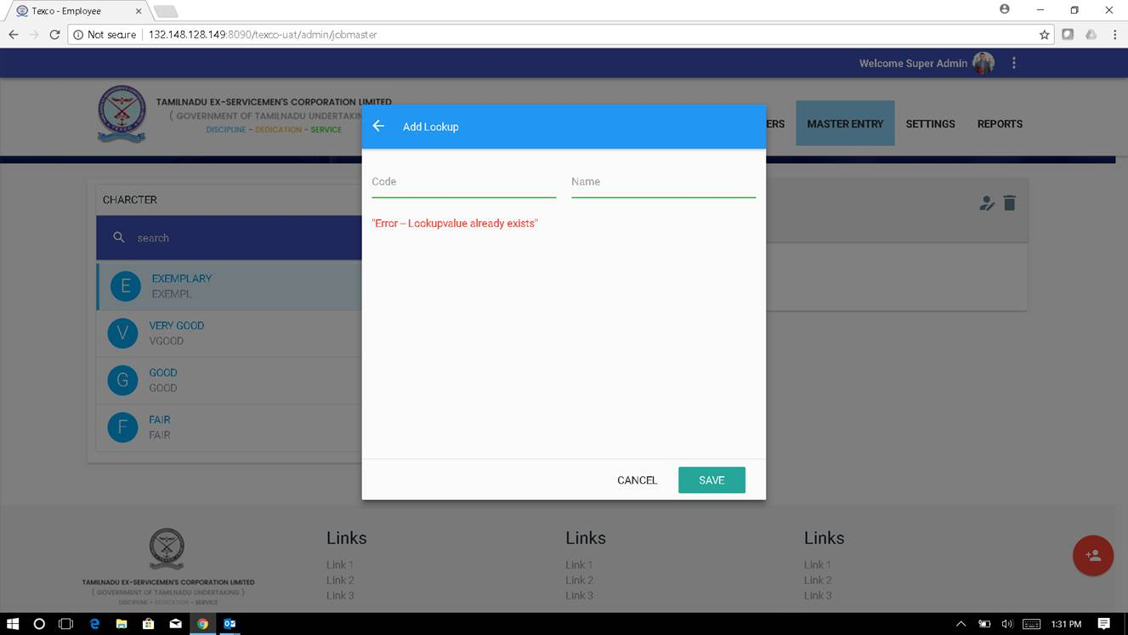

1. The name has no limit of characters and it is overlapping the code.

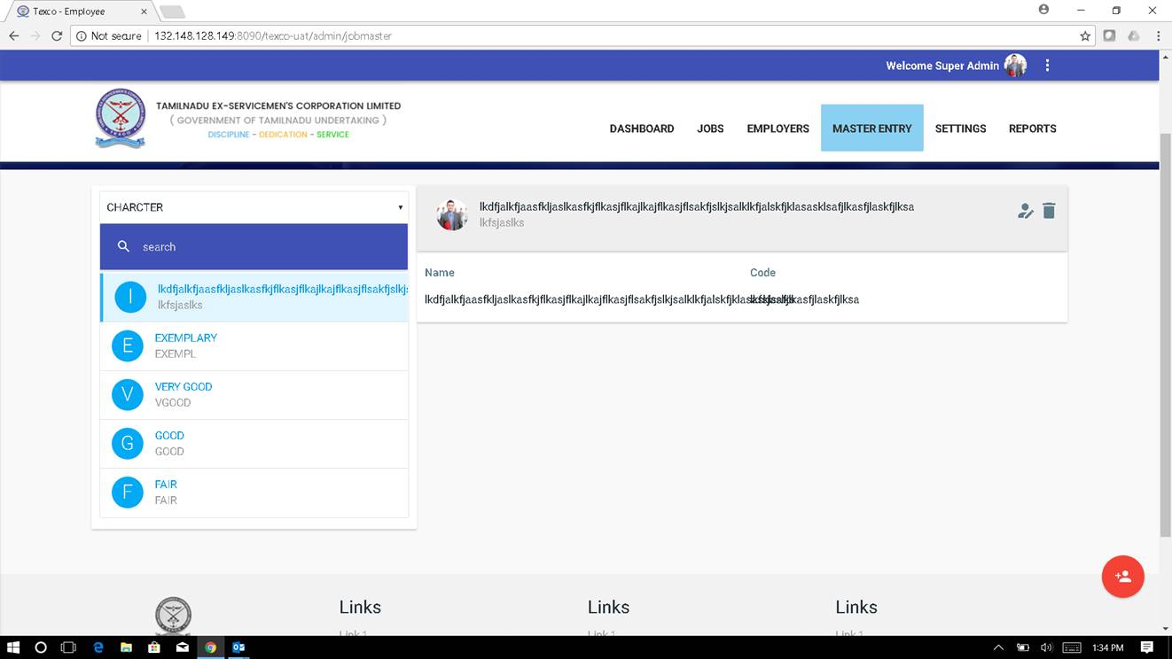

1. In Master Entry --- In Wage Master --- There is overlapping.

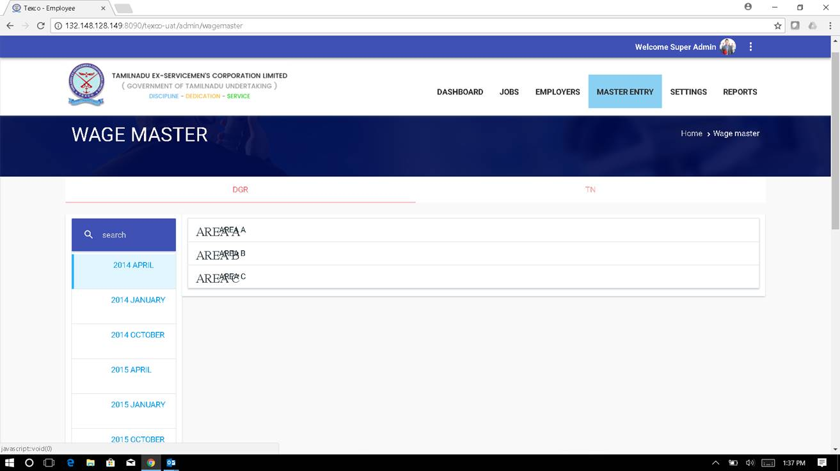

1. In Master Entry --- in Wage Master , For  DGR and TN, the **Other** column there is an alignment issue. Spelling mistake in Head Security **Gaurd** for both DGR and TN.

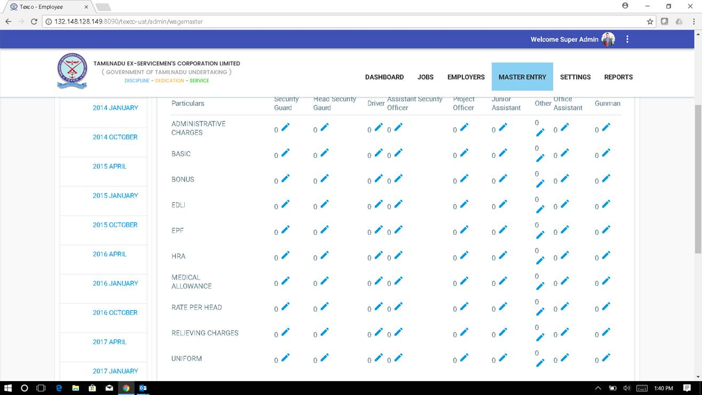

1. In Master Entry – in Wage Master , Import Wages is not working.
2. In Settings ---Documents. Description and File  is mandatory field. In edit Description and file is not shown as mandatory field. In Add new Document, file is not shown as mandatory field It is not displaying and when you click save. It is not saving.
3. In Employers--- Employers (Clients). In Pending Employers the heading is not the same. Address and taluk are in small case. Employer ID does not have sort.

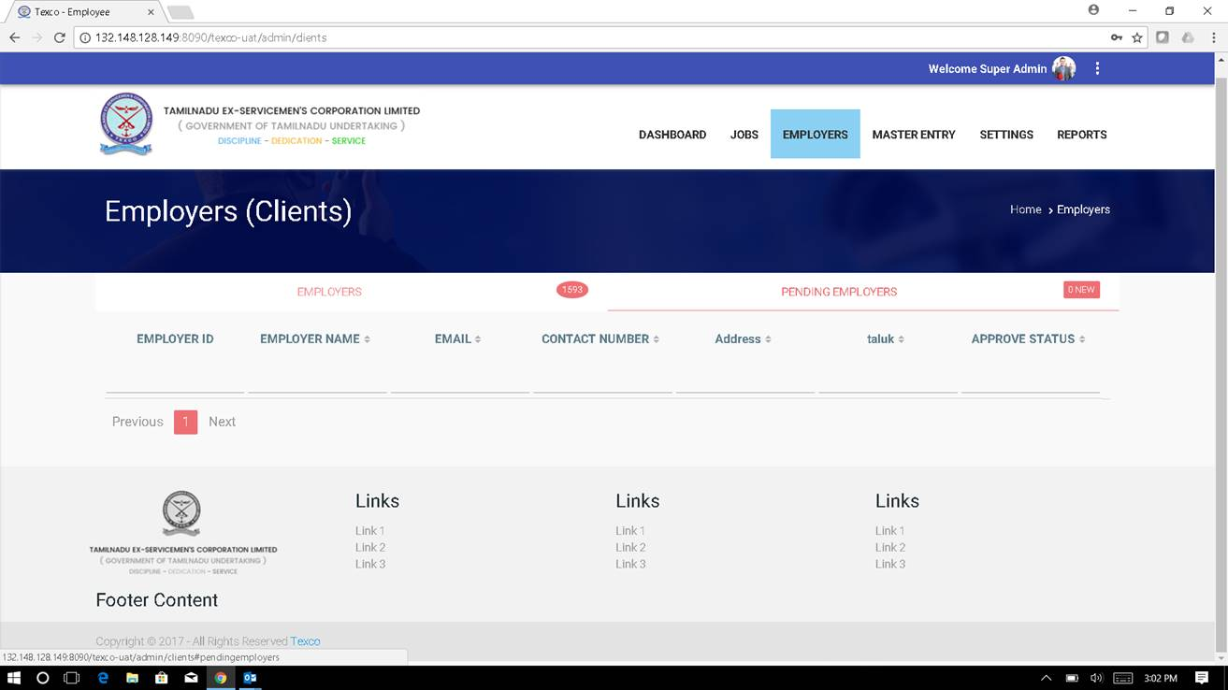

1. In Employers --- Employers (Clients). The password field is not validated. Entered 2 different passwords and it accepted. Mobile No field is not validated. It is accepting characters. Address field has limit but if you enter maximum characters, it is overlapping.

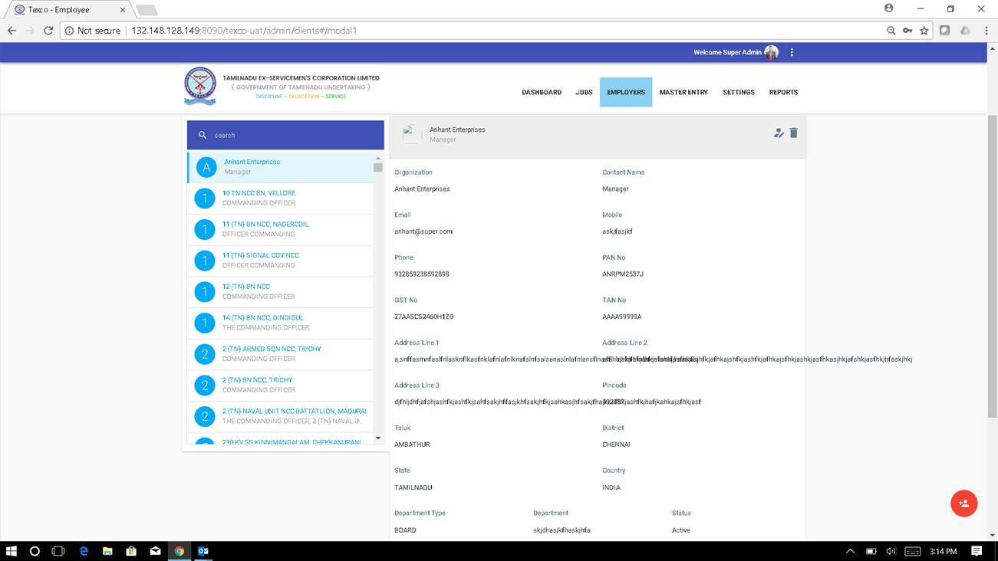

1. In Employers --- Projects . The address is overlapping.
2. In Employers ----Agreement . The Select Project text present in Project does not disappear after selecting project.

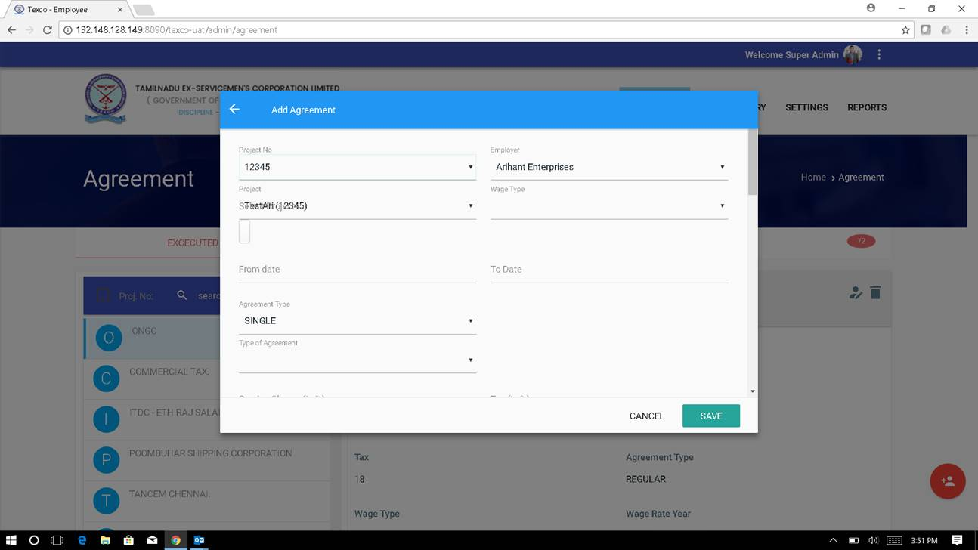

1. The is a checkbox under Project . Don’t know why is there. It is not selecting properly.

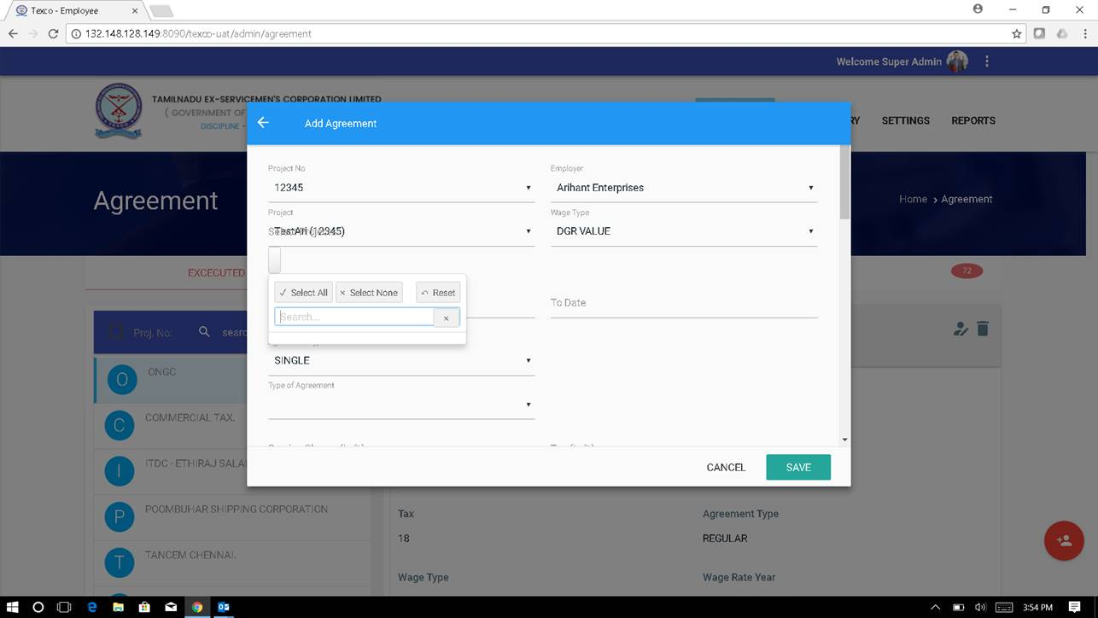

1. In Employers Attendance and Invoice are not working.
2. After Jobs ---      After Jobs posting vacancy is not displayed immediately. We have to logout and login to see the vacancy.
3. Sometimes in Master Entry --- Employees are not loading or taking a very long time to load.
4. I logged in as employee and clicked on Vacancy. View is not working.
5. Alignment issue in Date and Address in confirmation file. See the file attached.(confirmation.pdf)
6. After Confirmation of the employee , the job still open for applying.  There is only 1 vacancy. After filling that it  I can still apply.
7. There is alignment issue in the application form. The right side is cut off. Please see attachment. (docc.pdf)