Functional Requirements Document
Tamil Nadu Ex-Servicemen’s Corporation Ltd.(Texco)

Raagaa Value Add Technologies

Version: 1
Date

Version | Description of Change | Author | Date
1 | Initial Draft | Karthik

CONTENTS
1 INTRODUCTION 4
1.1 Purpose 4
1.2 Scope 4
1.5 Assumptions and Constraints 5
1.6 Exclusions 5
3 FUNCTIONAL REQUIREMENTS 6
3.1 Current System Study 6
3.2 Identified Modules 7
3.3 Texco Admin 7
4.1 Functional Requirements 11
5 OTHER REQUIREMENTS 11
5.1 Interface Requirements 11
5.2 Data Conversion Requirements 11
5.3 Hardware/Software Requirements 12
5.4 Operational Requirements 12
APPENDIX A - GLOSSARY 16

INTRODUCTION
The Tamil Nadu Ex-Servicemen’s Corporation Limited (Texco) was formed on 28-01-1986 and registered under the Companies Act, 1956 (Amended-2013) with the purpose of facilitating resettlement and rehabilitation of Ex-Servicemen.

Texco has been providing manpower through Ex-Servicemen and their dependents for different trades, such as Security Guards, Drivers, Clerks, Telecom Operators, Tourism Police, Nursing Assistants, Fire Crew, Gunmen and Wardens to major clients like Indian Oil Corporation, Chennai Petroleum Corporation Ltd etc. Texco has been sponsoring registered and well qualified Ex-Servicemen based on the needs of State/Central Government departments and their PSUs on contract basis for a minimum period of One year. Texco has been adopting and implementing two different wage rates: Tamil Nadu Minimum Wages fixed by the Commission of Labor (TNMW Rates) and Wage Rates fixed and promulgated by the Director General Resettlement (DGR Rates).

The management of the Recruitment System has been a challenge with manual processes being in effect till date. It has been identified that the use of Information Technology in this organization will surely enhance its efficiency and accountability, thus accommodating more opportunities to its. Members, at the same time, enhancing the satisfaction of the Clients who engage with Texco, also reducing the outstanding payments by better status updates.

Purpose
The purpose of this document is to provide a detailed description of the proposed application for Recruitment Management System at Texco. The document will cover the purpose and features of the system, the interfaces of the system, the constraints under which it must operate and how the system will be beneficial to organization, This document is intended for both the stakeholders and the developers of the system and will be proposed to the Organization for its approval.

Scope
The proposed software will be a Web based application for use of all Texco administration staff, Ex-service men registered with Texco and the Clients. System will provide clear workflows where each of the parties can perform their relevant with ease and following a defined process. There will be also dashboards with live status and alerts depending for the users and tracking of the recruitment process will be seamless.

Assumptions and Constraints
[Provide a list of contractual or task level assumptions and/or constraints that are preconditions to preparation of the FRD. Assumptions are future situations beyond the control of the project, whose outcomes influence the success of a project.]

Exclusions
[Provide a list of points which is not part of the project.]

FUNCTIONAL REQUIREMENTS

Current System Study
Based on the study at Texco office, the current manual process followed in the recruitment is as follows:

- Clients
  - Clients register with Texco for their man-power requirements towards various trades like Security Guard, Driver, Gun man etc.
  - An agreement is signed between the Client and Texco on the number of projects, vacancies.
  - The vacancies of all the clients are posted in weekly job posting and a Texco supplies resources to the clients based on the member preferences.
  - Client send an attendance sheet to Texco end of every month.
  - Monthly invoice will be sent to the clients based on the resource attendance.
- Members
  - Texco provides temporary job for Ex-Servicemen.
  - To avail this, Ex-Servicemen has to register at Texco office with their Service ID and other details.
  - A Texco number is then allocated to each member.
  - Every week, a counselling is done at Texco office for the Job openings and the members.
  - Members are allocated to the Openings based on their preference and eligibility.
  - Members should be joining the respective projects within 3 days of selection.
  - Wages are calculated based on the attendance provided by the clients.
- Texco Staff
  - Texco staff does client enrollment and agreement.
  - Prepare the Job vacancy list for every week.
  - Registers Ex-Service men as members.
  - Conducts counselling and allocates job to members.
  - Collects the member attendance from clients
  - Attendance is maintained in a Foxpro based system.
  - Raise monthly invoice to clients.
  - Provide wages to members.

Apart from this, there is a general public website for Texco (http://texco.in) which is available for general reference about Texco. Much of the information updated in the site is manual.

Identified Modules

Depending upon the procedures which they involve, the documentation of the functionality of the applications has been divided into various categories:

- Texco Admin
- Texco Staff
- Client
- Member
- General

Proposed system will be designed such that a single application will be developed and based on the user login and access rights given to the user, they will be authorized to do only specific modules.

Texco Admin
The proposed system would require an admin to have complete access to the system and setup users, control access permissions etc. Texco Admin users are basically Texco staff who have elevated privileges in the system.

Main aspects:
- Maintain Staff directory and provide login credentials
- Maintain Board of Directors
- Master Job List
- Control Access Rights to Users
- Publish Documents
- Publish Image Gallery
- General Settings.

Staff Master
The administrator of the system will be responsible for creating the master list of Staff working with Texco. Once the master entry is created, the respective staff will be able to login as Texco staff and perform required functionalities.

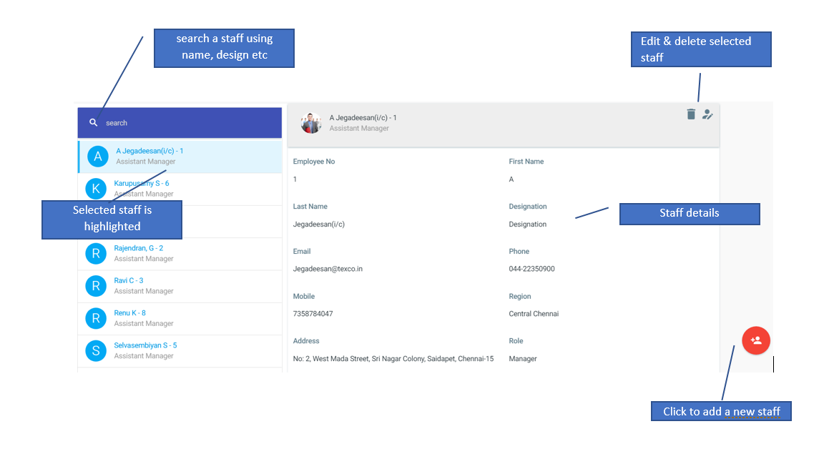

Logical Data Model/Data Dictionary
The following table details the data for Staff.

# | Field | Mandatory/Business Rule
1 | Firstname | Mandatory, minimum 3 character length
2 | Lastname | Mandatory
3 | Employee No | Mandatory
4 | Region | Mandatory, selection list.
5 | Designation | Mandatory, selection list.
6 | Date of Joining | Optional
7 | Email | Mandatory, valid email
8 | Mobile | Mandatory, valid mobile no
9 | Phone | Optional
10 | Address | Optional
11 | Role | Mandatory
12 | Password | Mandatory, minimum 6 characters length

Board of Directors
The system administrator will be maintaining the Board of Directors. This list will be available for reference to the public in the ‘Contact Us’ page in public website.
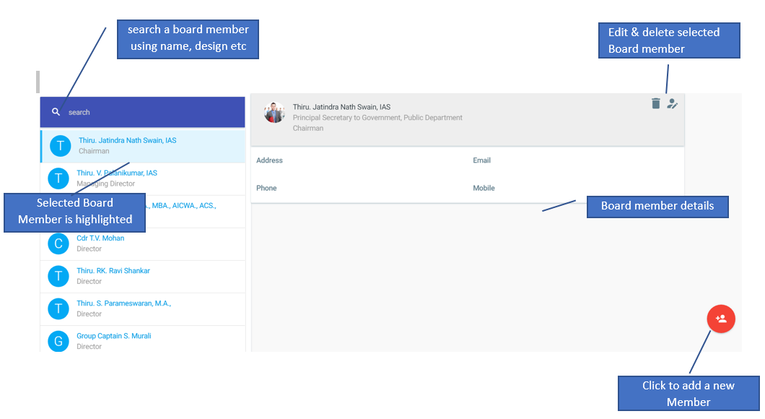

Logical Data Model/Data Dictionary
The following table details the data for Board Member.

# | Field | Mandatory/Business Rule
1 | Name | Mandatory, minimum 3 characters length, Should be the full name of the Board Member.
2 | Designation | Mandatory, the designation of the Board Member
3 | Title | Mandatory, Selection list (Chairman, Managing Director etc)
4 | Email | Optional
5 | Mobile | Optional
6 | Phone | Optional
7 | Address | Optional

Job Master
The master Job list will be provided as default by the vendor. The administrator will be able to modify any details or delete the job. Administrator will not be able to add a new Job as business rules for the new job has to be set. This will be done by the vendor.

Note: the code of the Job should not be modified as the business rules for the Job is based on the code.
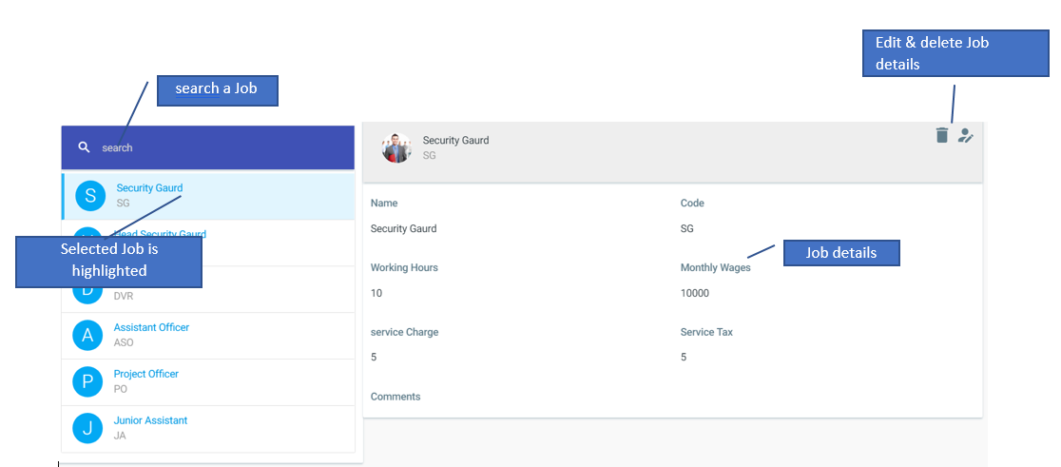

Logical Data Model/Data Dictionary
The following table details the data for Board Member.

# | Field | Mandatory/Business Rule
1 | Code | Job Code is the base for the business rule for the Job
2 | Name | Mandatory
3 | Monthly wages | Mandatory, if not applicable enter 0.
4 | Service Charge | Mandatory, if not applicable enter 0.
5 | Service Tax | Mandatory, if not applicable enter 0.
6 | Comments | Optional

Permissions
The User Roles will be provided as default by the vendor. The administrator can however use the permissions screen to control actions users in each role can perform. Selecting a role in the left panel will display all the permissions on the right panel. Only the permissions that has the tick will be available for the users in the role.
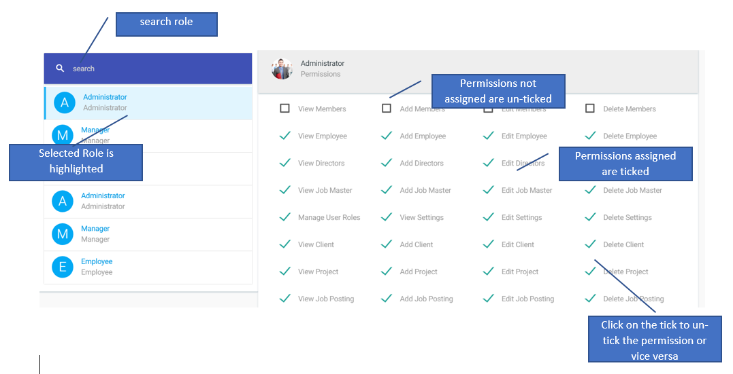

Publish Documents
The system administrator will have rights to upload new documents to the website so that the documents will be available in the public website.
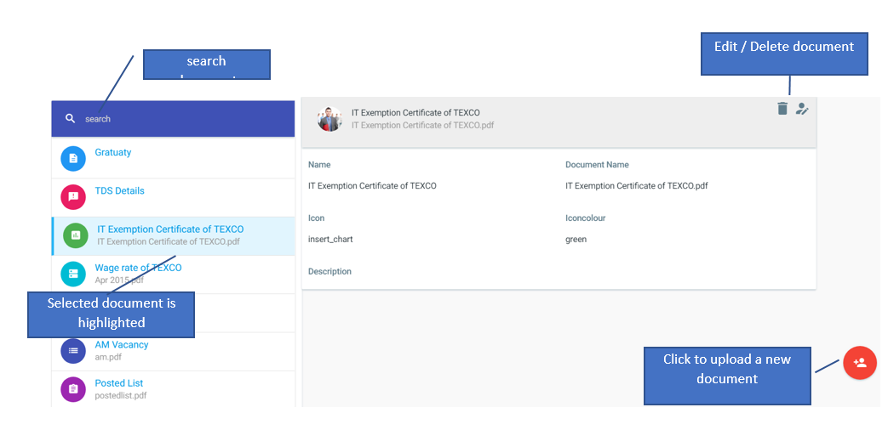
Note: Administator has to ensure the document is scanned and virus free before uploading. Also suggest uploading pdf documents.

Publish Image Gallery
The system administrator will have rights to create and publish an image gallery to the public website.
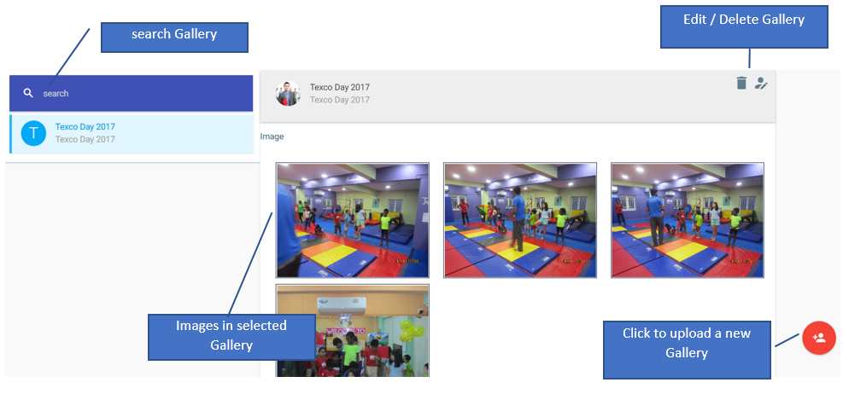

Texco Staff
The proposed system would digitalize most of the manual process done by the Texco staff so that the overall recruitment process would be done efficiently and effectively. The Texco staff would be able to login to the system with their email or mobile no and the password provided by the Texco admin.

Main aspects:
- Register Clients with Texco
- Maintain Client Projects
- Maintain Client Agreements
- Post Job Vacancy for all projects
- Manage Jobs weekly
- Job Confirmation
- Manage Member Attendance at Projects
- Generate Invoice for Clients

Texco Staff Workflow

Work flow for staff – Flow chart

Client Master
The Texco staff will be responsible for registering the Client in the system and provide access to the Clients using the email and password. Once the master entry is created, the respective client will be able to login as Texco client and perform required functionalities.
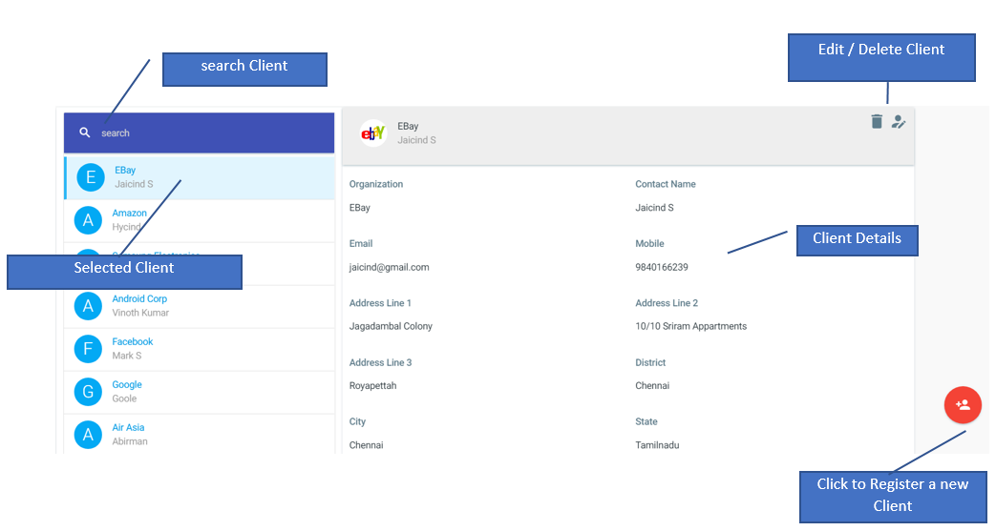

Logical Data Model/Data Dictionary
The following table details the data for Clients.

# | Field | Mandatory/Business Rule
1 | Organization Name | Mandatory, minimum 3 character length
2 | Contact Name | Mandatory, minimum 3 character length
3 | Mobile | Mandatory, Valid mobile
4 | Email | Mandatory, Valid email
5 | Address Line 1 | Mandatory
6 | Address Line 2 | Mandatory
7 | Address Line 3 | Mandatory
8 | District | Mandatory, Selection list
9 | City | Mandatory, Selection list
10 | State | Mandatory, Selection list
11 | Country | Mandatory, Selection list
12 | Password | Mandatory, minimum 6 characters length
13 | Client Logo | Image of client Logo

Project Master
Each client will have one or more projects. The job postings are maintained at the project level. The Texco staff will be able to create the Projects for the clients.
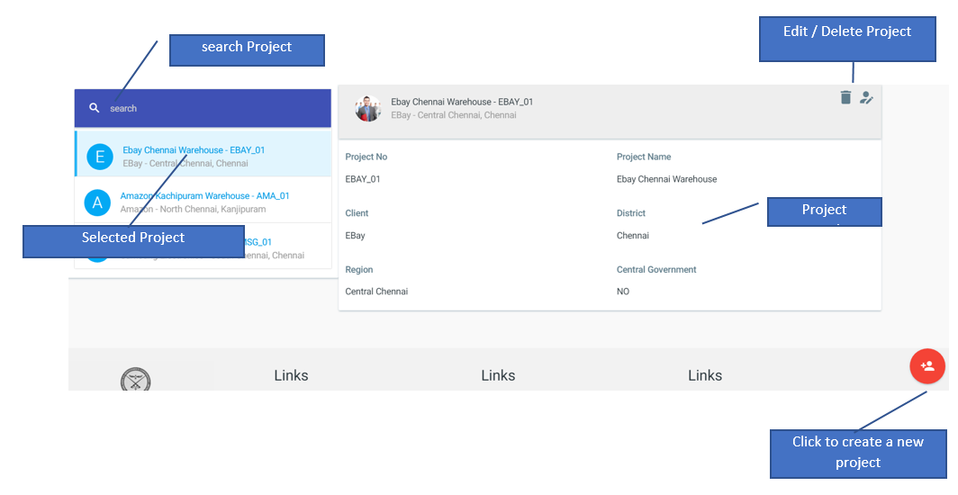

Logical Data Model/Data Dictionary
The following table details the data for Projects.

# | Field | Mandatory/Business Rule
1 | Client | Mandatory, Selection List from the list of Clients registered
2 | Project No | Mandatory
3 | Project Name | Mandatory
4 | District | Mandatory, Selection List
5 | Region | Mandatory, Selection List
6 | Central Government | Tick if the project is Central Government.

Manage Client Agreements
Texco Staff will have to maintain the agreements with the Clients for the man power supply. Agreement period will be captured in the system and alerts will be provided on agreement nearing expiry.
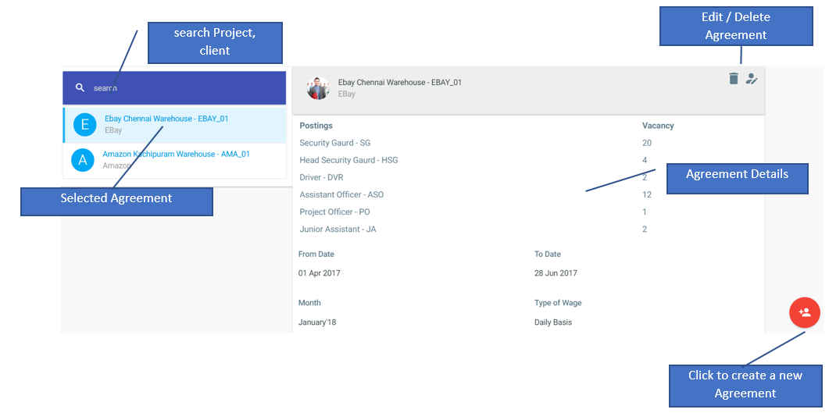

Logical Data Model/Data Dictionary
The following table details the data for Projects.

# | Field | Mandatory/Business Rule
1 | Client | Mandatory, Selection List from the list of Clients registered
2 | Project | Mandatory, Selection list from the list of projects for the selected client
3 | From Date | Date the agreement is effective
4 | To Date | End date of agreement
5 | Month | Mandatory
6 | Type of Wage | Mandator
7 | No of Job openings against each Job | Mandatory

Job Posting
Texco Staff will have to post job openings on various projects. Job postings for a project need to be done only once, after which the same will be managed using Manage jobs functionality. The job postings created by Texco staff will be displayed in the public website.
Note: In case of any change in job posting, staff can amend the posting details and the new vacancy will apply.
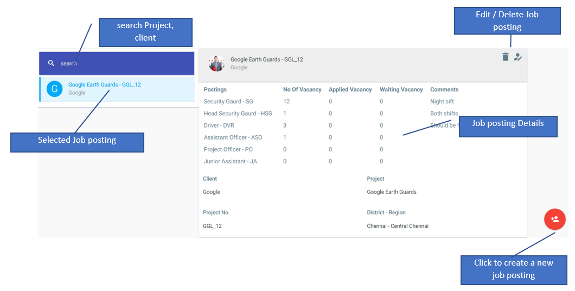

Logical Data Model/Data Dictionary
The following table details the data for Job posting.

# | Field | Mandatory/Business Rule
1 | Client | Mandatory, Selection List from the list of Clients registered
2 | Project | Mandatory, Selection list from the list of projects for the selected client
3 | No of Job openings against each Job | Mandatory
4 | Comments for each Job | Optional

Manage Job
The process of recruitment is done every week. For the Jobs posted for the week, Ex-servicemen who are registered with Texco will be attending a counselling at the Texco office and depending on their eligibility, they are allocated to various projects and the vacancy will be closed.
On the day before the counselling, Texco staff must close all the Job openings for the week so that no further members can show interest / register for the job.


- Close Vacancy: This will close all the job vacancies for this week. Members will not be able to apply until the jobs are imported.
- Export Vacancy: This will generate data on the Job vacancies from the last week.
- Import Vacancy: Texco staff can import the job vacancies remaining after the counselling from an excel.

Job Confirmation
Every week after the counselling, the members are allocated to job vacancies based on the eligibility. Texco staff will be provided with a list of members who attended the counselling and just need to click on the members who are selected. System will auto generate the Job posting order.

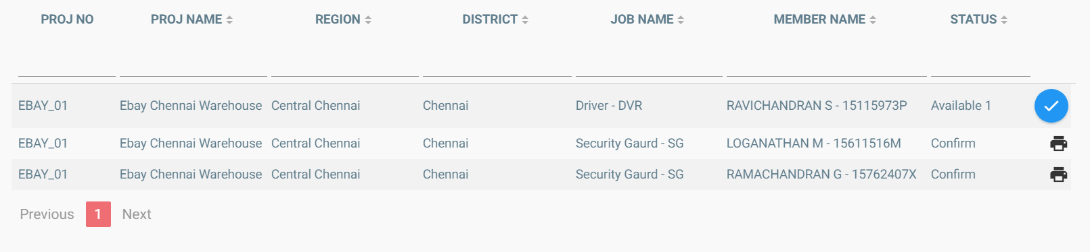
Sample Job posting order:
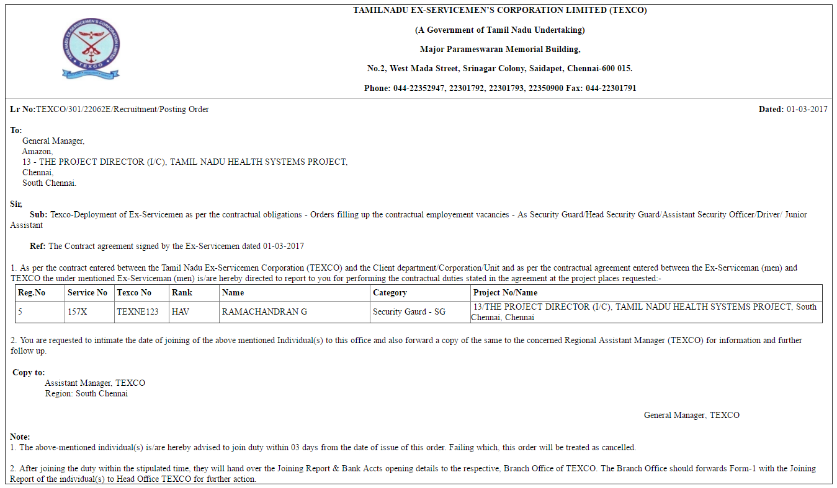

Manage Members
Texco Staff will have rights to register an Ex-Servicemen in the system. The registration process requires a set of details for the member to be mandatorily filled and then a Texco number will be assigned to the member. The unique identification for a member will be the Service Id.

Members can also directly register with the system, where a temporary Texco number will be allocated. Texco staff will be reviewing the details and then a permanent Texco number will be allocated.
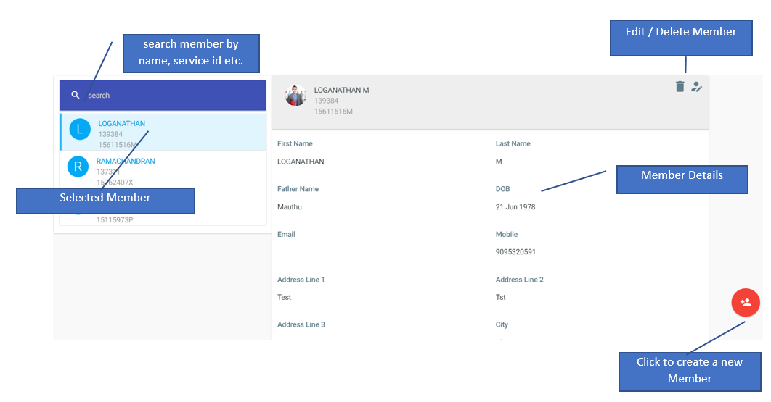

Logical Data Model/Data Dictionary
The following table details the data for Members.

# | Field | Mandatory/Business Rule
1 | First name | Mandatory
2 | Last name | Mandatory
3 | Father’s name | Mandatory
4 | Date of Birth | Mandatory
5 | Email | Optional
6 | Mobile | Mandatory, valid mobile no
7 | Address Line 1 | Mandatory
8 | Address Line 2 | Mandatory
9 | Address Line 3 | Optional
10 | City | Mandatory, Selection list
11 | State | Mandatory, Selection list
12 | Country | Mandatory, Selection list
13 | Nominee | Optional
14 | Nominee relationship | Optional, Selection list

OTHER REQUIREMENTS
The following sections will describe the non-functional requirements.

Interface Requirements
[Describe the user interfaces that are to be implemented by the system.]

Hardware Interfaces
[Define hardware interfaces supported by the system, including logical structure, physical addresses, and expected behavior.]

Software Interfaces
[Name the applications with which the subject application must interface. State the following for each such application: name of application, external owner of application, interface details (only if determined by the other application).
It is acceptable to reference an interface control document for details of the interface interactions.]

Communications Interfaces
[Describe communications interfaces to other systems or devices, such as local area networks.]

Data Conversion Requirements
[Describe the requirements needed for conversion of legacy data into the system.]

Hardware/Software Requirements
[Provide a description of the hardware and software platforms needed to support the system.]

Operational Requirements
[Provide the operational requirements in this section.
Do not state how these requirements will be satisfied. For example, in the Reliability section, answer the question, “How reliable must the system be”? Do not state what steps will be taken to provide reliability.
Distinguish preferences from requirements. Requirements are based on business needs, preferences are not. If, for example, the user requires a special response but does not have a business-related reason for it, that requirement is a preference.
Other applicable requirements on system attributes may be added to the list of subsections below.]
Operational requirements describe how the system will run and communicate with operations personnel.

Security and Privacy
[Provide a list of the security requirements using the following criteria:
A. State the consequences of the following breaches of security in the subject application:
- Loss or corruption of data
- Disclosure of secrets or sensitive information
- Disclosure of privileged/privacy information about individuals
- Corruption of software or introduction of malware, such as viruses
- State the type(s) of security required. Include the need for the following as appropriate:
- Physical security.
- Access by user role or types.
- State access control requirements by data attribute. For example, one group of users has permission to view an attribute but not update it while another group of users has permissions to update or view it.
- State access requirements based on system function. For example, if there is a need to grant access to certain system functions to one group of users, but not to another. For example, "The system shall make Function X available to the System Administrator only".
- State if there is a need for certification and accreditation of the security measures adopted for this application]
The Security Section describes the need to control access to the data. This includes controlling who may view and alter application data.

Audit Trail
[List the activities recorded in the application’s audit trail. For each activity, list the data recorded.]

Reliability
A. [State the following in this section:
- State the damage can result from failure of this system—indicate the criticality of the software, such as:
- Loss of human life
- Complete or partial loss of the ability to perform a mission-critical function
- Loss of revenue
- Loss of employee productivity
- What is the minimum acceptable level of reliability?
B. State required reliability:
- Mean-Time-Between-Failure is the number of time units the system is operable before the first failure occurs.
- Mean-Time-To-Failure is the number of time units before the system is operable divided by the number of failures during the time period.
- Mean-Time-To-Repair is the number of time units required to perform system repair divided by the number of repairs during the time period.]
Reliability is the probability that the system processes work correctly and completely without being aborted.

Recoverability
[Answer the following questions in this section:
A. In the event the application is unavailable to users (down) because of a system failure, how soon after the failure is detected must function be restored?
B. In the event the database is corrupted, to what level of currency must it be restored? For example “The database must be capable of being restored to its condition of no more than 1 hour before the corruption occurred”.
C. If the processing site (hardware, data, and onsite backup) is destroyed, how soon must the application be able to be restored?]
Recoverability is the ability to restore function and data in the event of a failure.

System Availability
[State the period during which the application must be available to users. For example, “The application must be available to users Monday through Friday between the hours of 6:30 a.m. and 5:30 p.m. EST. If the application must be available to users in more than one time zone, state the earliest start time and the latest stop time. Consider daylight savings time, too.
Include use peak times. These are times when system unavailability is least acceptable.]
System availability is the time when the application must be available for use. Required system availability is used in determining when maintenance may be performed.

General Performance
[Describe the requirements for the following:
A. Response time for queries and updates
B. Throughput
C. Expected rate of user activity (for example, number of transactions per hour, day, or month, or cyclical periods)
Specific performance requirements, related to a specific functional requirement, should be listed with that functional requirement.

Capacity
[List the required capacities and expected volumes of data in business terms. Do not state capacities in terms of system memory requirements or disk space—if growth trends or projections are available, provide them]

Data Retention
[Describe the length of time various forms of data must be retained and the requirements for its destruction.
For example, “The system shall retain application information for 3 years”. Different forms of data include: system documentation, audit records, database records, access records.]

Error Handling
[Describe system error handling.]

Validation Rules
[Describe System Validation Rules.]

Conventions/Standards
[Describe system conventions and standards followed.
For example: Microsoft standards are followed for windows, Institute of Electrical and Electronics Engineers (IEEE) for data formats, etc.]

APPENDIX A - GLOSSARY
[Define terms, acronyms, and abbreviations used in the FRD.]

TEXCO

CLIENT
ATTENDANCE FOR EMPLOYEES

REGISTER
AGREEMENT WITH TEXCO AND ADD
WEEKLY JOBPOSTINGS

MEMBERS
(EX-SERVICEMEN)

INVOICE GENERATION

SUITABLE
CANDIDATE? (YES)
ARRANGE MEETING IN TEXCO
MAKE EMPLOYEMNET OFFER

APPLY

