2017-2018

**DCS-2**

**EC-407**

**AMITESH K SINGH**

SERIAL IN PARALLEL OUT SHIFT REGISTER

# CODE

library IEEE;

use IEEE.STD_LOGIC_1164.ALL;

entity sipo_code is

Port ( ip : in STD_LOGIC;

clk : in STD_LOGIC;

rst : in STD_LOGIC;

q : inout STD_LOGIC_VECTOR(0 to 5));

end sipo_code;

architecture Behavioral of sipo_code is

begin

one:process(ip,rst,clk)

begin

if(rst='1')

then

q<="000000";

else if(clk='1' and clk'event)

then

q(0)<=ip;

q(1)<=q(0);

q(2)<=q(1);

q(3)<=q(2);

q(4)<=q(3);

q(5)<=q(4);

--q(6)<=q(5);

end if;

end if;

end process;

end Behavioral;

# TEST BENCH

LIBRARY ieee;

USE ieee.std_logic_1164.ALL;

ENTITY sipo_tb IS

END sipo_tb;

ARCHITECTURE behavior OF sipo_tb IS

COMPONENT sipo_code

PORT(

ip : IN std_logic;

clk : IN std_logic;

rst : IN std_logic;

q : INOUT std_logic_vector(0 to 5)

);

END COMPONENT;

--Inputs

signal ip : std_logic := '0';

signal clk : std_logic := '0';

signal rst : std_logic := '0';

--BiDirs

signal q : std_logic_vector(0 to 5);

BEGIN

-- Instantiate the Unit Under Test (UUT)

uut: sipo_code PORT MAP (

ip => ip,

clk => clk,

rst => rst,

q => q

);

-- -- Stimulus process

stim_proc: process

begin

-- hold reset state for 100 ns.

ip<='1';

clk<='1';

wait for 10 ns;

clk<='0';

wait for 10 ns;

ip<='0';

clk<='1';

wait for 10 ns;

clk<='0';

wait for 10 ns;

ip<='0';

clk<='1';

wait for 10 ns;

clk<='0';

wait for 10 ns;

ip<='0';

clk<='1';

wait for 10 ns;

clk<='0';

wait for 10 ns;

ip<='1';

clk<='1';

wait for 10 ns;

clk<='0';

wait for 10 ns;

ip<='1' ;

clk<='1 ';

wait for 10 ns;

end process;

END;

## OUTPUT

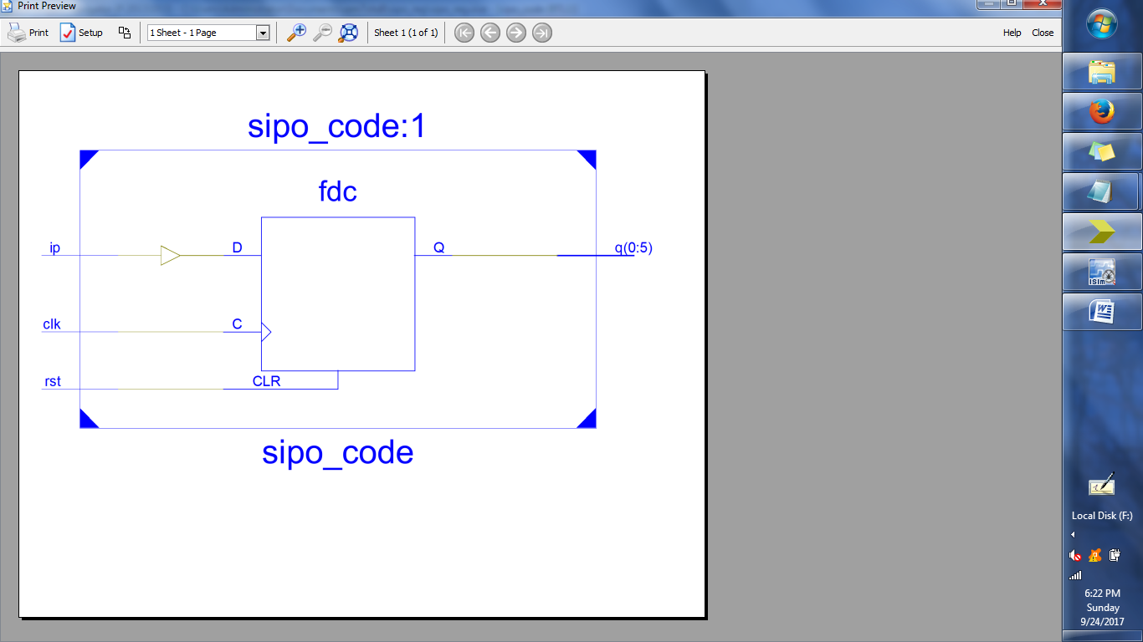

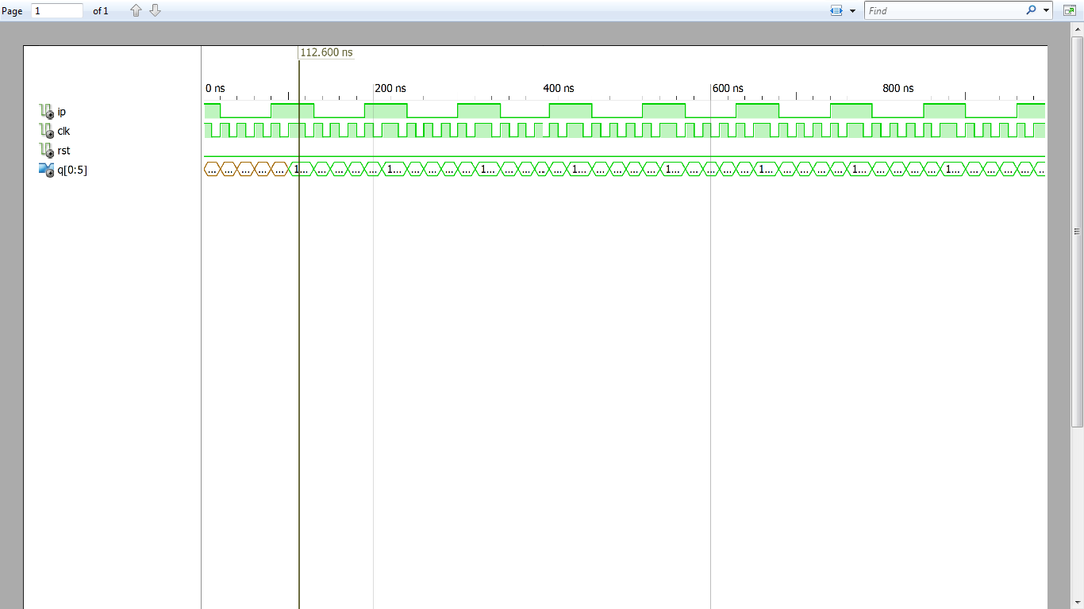

INTRODUCING A DELAY OF 1 AND 2 CYCLES

## CODE

library IEEE;

use IEEE.STD_LOGIC_1164.ALL;

entity delay_code is

Port ( ip : in STD_LOGIC;

rst : in STD_LOGIC;

clk : in STD_LOGIC;

d : inout STD_LOGIC_vector(0 to 2);

q : inout STD_LOGIC_vector(0 to 2));

end delay_code;

architecture Behavioral of delay_code is

begin

process(ip,clk,rst)

begin

if (rst='1')

then

q<="000";

else if(clk='1' and clk'event)

then

d(0)<=ip;

q(0)<=d(0);

d(1)<=q(0);

q(1)<=d(1);

d(2)<=q(1);

q(2)<=d(2);

end if;

end if;

end process;

end Behavioral;

# TEST BENCH

LIBRARY ieee;

USE ieee.std_logic_1164.ALL;

ENTITY delay_tb IS

END delay_tb;

ARCHITECTURE behavior OF delay_tb IS

-- Component Declaration for the Unit Under Test (UUT)

COMPONENT delay_code

PORT(

ip : IN std_logic;

rst : IN std_logic;

clk : IN std_logic;

d : INOUT std_logic_vector(0 to 2);

q : INOUT std_logic_vector(0 to 2)

);

END COMPONENT;

--Inputs

signal ip : std_logic := '0';

signal rst : std_logic := '0';

signal clk : std_logic := '0';

--BiDirs

signal d : std_logic_vector(0 to 2);

signal q : std_logic_vector(0 to 2);

-- Clock period definitions

--constant clk_period : time := 10 ns;

BEGIN

-- Instantiate the Unit Under Test (UUT)

uut: delay_code PORT MAP (

ip => ip,

rst => rst,

clk => clk,

d => d,

q => q

);

stim_proc: process

begin

-- hold reset state for 100 ns.

--wait for 100 ns;

ip<='1';

clk<='1';

wait for 10 ns;

clk<='0';

wait for 10 ns;

ip<='0';

clk<='1';

wait for 10 ns;

clk<='0';

wait for 10 ns;

ip<='0';

clk<='1';

wait for 10 ns;

clk<='0';

wait for 10 ns;

ip<='0';

clk<='1';

wait for 10 ns;

clk<='0';

wait for 10 ns;

ip<='1';

clk<='1';

wait for 10 ns;

clk<='0';

wait for 10 ns;

ip<='1' ;

clk<='1';

wait for 10 ns;

end process;

END;

OUTPUT