

2017-18

**DCS-2**

**ECE-407**

**AMITESH K SINGH**

|  |  |  |
| --- | --- | --- |
| S.NO | EXPERIMENT | REMARKS |
|  |  |  |
|  |  |  |

SWITCH DEBOUNCING[2 type]

library IEEE;

use ieee.std_logic_unsigned.all;

use IEEE.STD_LOGIC_1164.ALL;

entity debounce2 is

Port ( button : in STD_LOGIC;

clk : in STD_LOGIC;

res : out STD_LOGIC);

end debounce2;

architecture Behavioral of debounce2 is

signal ff:std_logic_vector(1 downto 0);

signal count_out:std_logic_vector(2 downto 0);

signal count_clr:std_logic;

begin

count_clr<=ff(1) xor ff(0);

process(button,clk)

begin

if(rising_edge(clk))

then

ff(0)<=button;

ff(1)<=ff(0);

if(count_clr='1')

then

count_out<=(others=>'0');

elsif (count_out(2)='0')

then

count_out<=count_out + '1';

else

res<=ff(1);

end if;

end if;

end process;

end Behavioral;

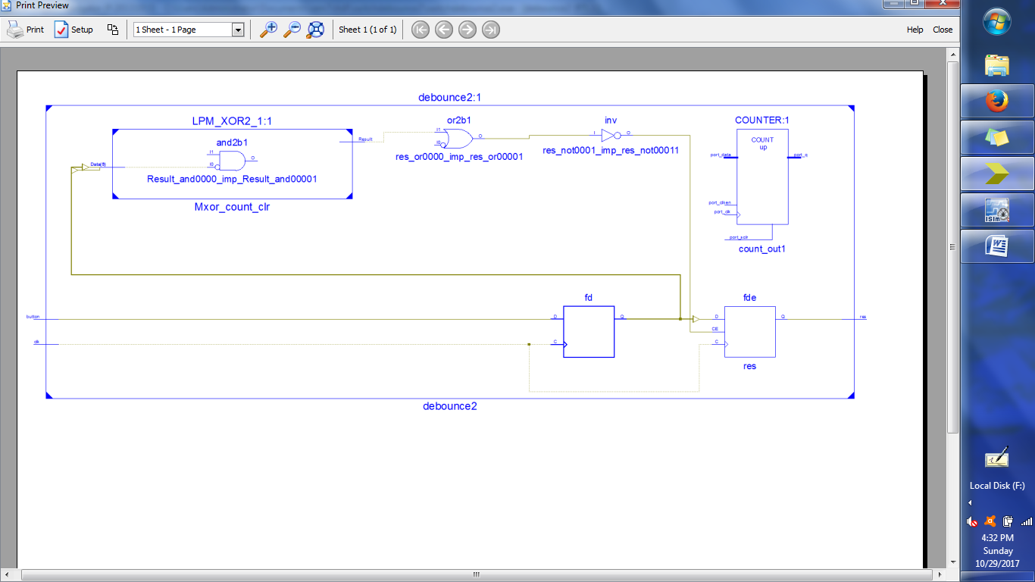

# TestBench:

LIBRARY ieee;

USE ieee.std_logic_1164.ALL;

ENTITY debouncetb IS

END debouncetb;

ARCHITECTURE behavior OF debouncetb IS

-- Component Declaration for the Unit Under Test (UUT)

COMPONENT debounce2

PORT(

button : IN std_logic;

clk : IN std_logic;

res : OUT std_logic

);

END COMPONENT;

--Inputs

signal button : std_logic := '0';

signal clk : std_logic := '0';

--Outputs

signal res : std_logic;

BEGIN

-- Instantiate the Unit Under Test (UUT)

uut: debounce2 PORT MAP (

button => button,

clk => clk,

res => res

);

-- Clock process definitions

clk_process :process

begin

clk <= '0';

wait for 10 ns;

clk <= '1';

wait for 10 ns;

end process;

-- Stimulus process

stim_proc: process

begin

-- hold reset state for 100 ns.

--wait for 100 ns;

button<='1';

wait for 100 ns;

wait;

end process;

END;

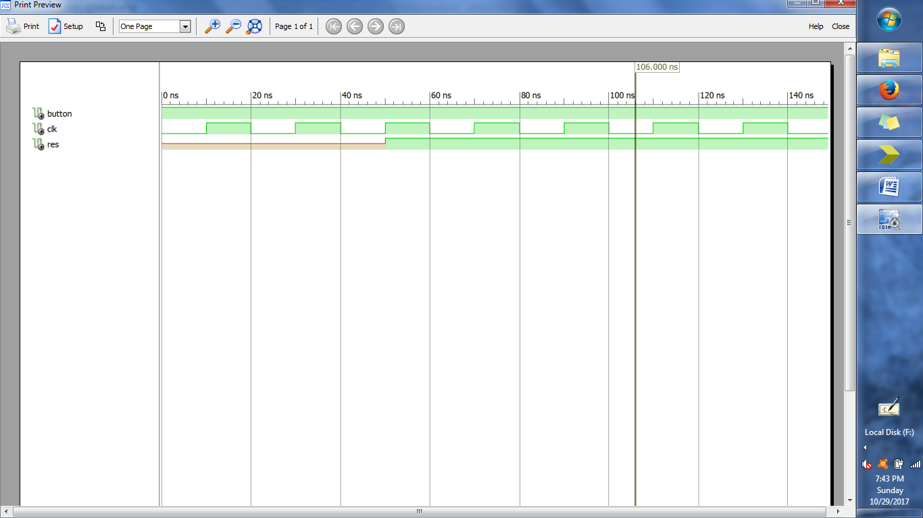

RANDOM NO. GENERATOR USING LFSR

library IEEE;

use IEEE.STD_LOGIC_1164.ALL;

entity prng is

Port ( clk : in STD_LOGIC;

rst : in STD_LOGIC;

rnum : out STD_LOGIC_vector(7 downto 0));

end prng;

architecture Behavioral of prng is

signal ff:std_logic_vector(7 downto 0);

signal temp:std_logic:='0';

begin

temp <= ff(4)xor ff(3) xor ff(2) xor ff(0);

process(clk,rst)

begin

if(rst='1')

then

ff<="00000001";

elsif(rising_edge(clk))then

ff<=temp & ff(7 downto 1);

end if;

end process;

rnum<=ff;

end Behavioral;

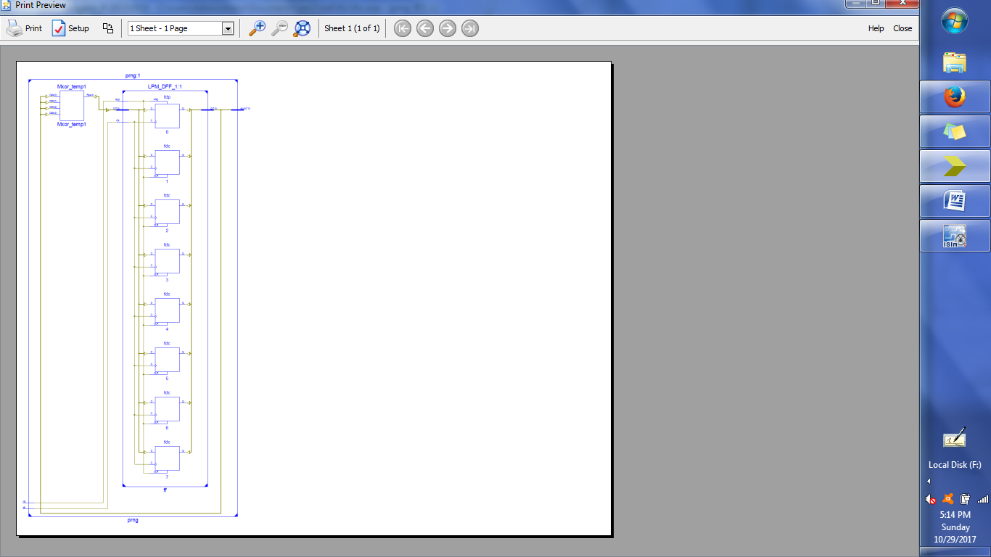

## TESTBENCH:

LIBRARY ieee;

USE ieee.std_logic_1164.ALL;

ENTITY tblfsr IS

END tblfsr;

ARCHITECTURE behavior OF tblfsr IS

-- Component Declaration for the Unit Under Test (UUT)

COMPONENT prng

PORT(

clk : IN std_logic;

rst : IN std_logic;

rnum : OUT std_logic_vector(7 downto 0)

);

END COMPONENT;

--Inputs

signal clk : std_logic := '0';

signal rst : std_logic := '0';

--Outputs

signal rnum : std_logic_vector(7 downto 0);

-- Clock period definitions

-- constant clk_period : time := 10 ns;

BEGIN

-- Instantiate the Unit Under Test (UUT)

uut: prng PORT MAP (

clk => clk,

rst => rst,

rnum => rnum

);

clk_process :process

begin

clk <= '0';

wait for 10 ns;

clk <= '1';

wait for 10 ns;

end process;

-- Stimulus process

stim_proc: process

begin

-- hold reset state for 100 ns.

wait for 10 ns;

rst<='1' ;

wait for 10 ns;

rst<='0';

wait;

end process;

END;

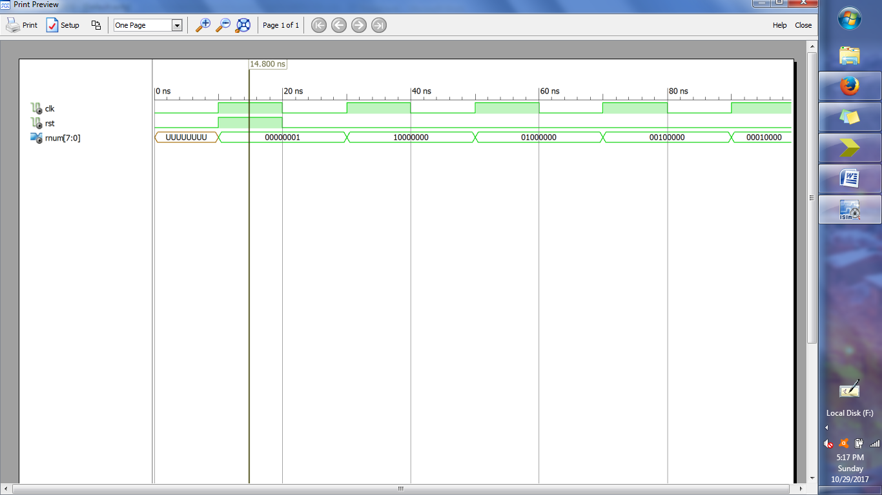

DICE GAME

library IEEE;

use IEEE.STD_LOGIC_1164.ALL;

use IEEE.STD_LOGIC_unsigned.ALL;

entity game1 is

Port ( sw : in STD_LOGIC;

clk : in STD_LOGIC;

clk_new : in STD_LOGIC;

rst : in STD_LOGIC;

led_w : out STD_LOGIC;

led_l : out STD_LOGIC;

led_pa : out STD_LOGIC;

ssd : out STD_LOGIC_vector(8 downto 0));

end game1;

architecture Behavioral of game1 is

signal p_state,n_state: integer range 0 to 3;

signal roll_value,roll_store:integer range 0 to 6;

begin

process(p_state,sw,clk_new)

begin

case p_state is

when 0=>

if(sw='0')then

n_state<=0;led_w<='0';led_l<='0';led_pa<='0';ssd<="011110111";

roll_value<=1;roll_store<=0;

else

n_state<=1;led_w<='0';led_l<='0';led_pa<='0';ssd<="011110111";

roll_value<=1;roll_store<=0;

end if;

when 1=> if(sw='1')then

n_state<=1;

if(rising_edge(clk_new))then

if(roll_value=6)then

roll_value<=1;

else

roll_value<=roll_value +1;

end if;

end if;

else

n_state<=2;led_pa<='1';roll_store<=roll_value;--storing 1 value

end if;

when 2=> --ssd o/p

if(roll_value=1)then ssd<="011111001";

elsif(roll_value=2)then ssd<="010100100";

elsif(roll_value=3)then ssd<="010110000";

elsif(roll_value=4)then ssd<="011100110";

elsif(roll_value=5)then ssd<="011101101";

else ssd<="010000010";

end if;

if(sw='0')then--keep the display on

n_state<=2;

else

n_state<=3;--sw=1

end if;

when 3=> if(sw='1')then

n_state<=3;

if(rising_edge(clk_new))then

if(roll_value=6)then

roll_value<=1;

else

roll_value<=roll_value+1;

end if;

end if;

else --

n_state<=0;led_pa<='0';

if(roll_store=roll_value)then

led_w<='1';led_l<='0';

else

led_w<='0';led_l<='1';

end if;

end if;

end case;

end process;

process(clk,rst)

begin

if(rst='1')then

p_state<=0;

elsif(rising_edge(clk))then

p_state<=n_state;

end if;

end process;

end Behavioral;

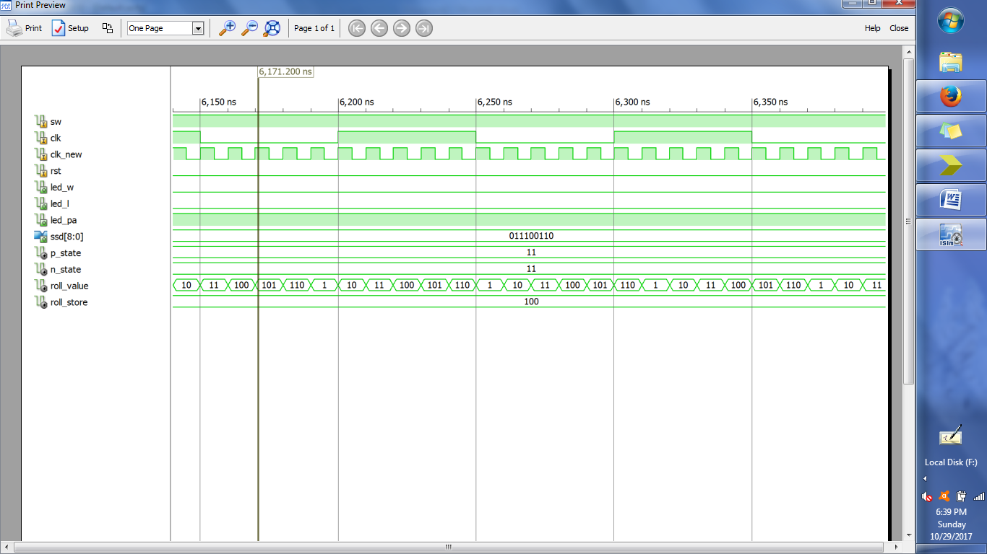

SEQUENCE DETECTOR[101]

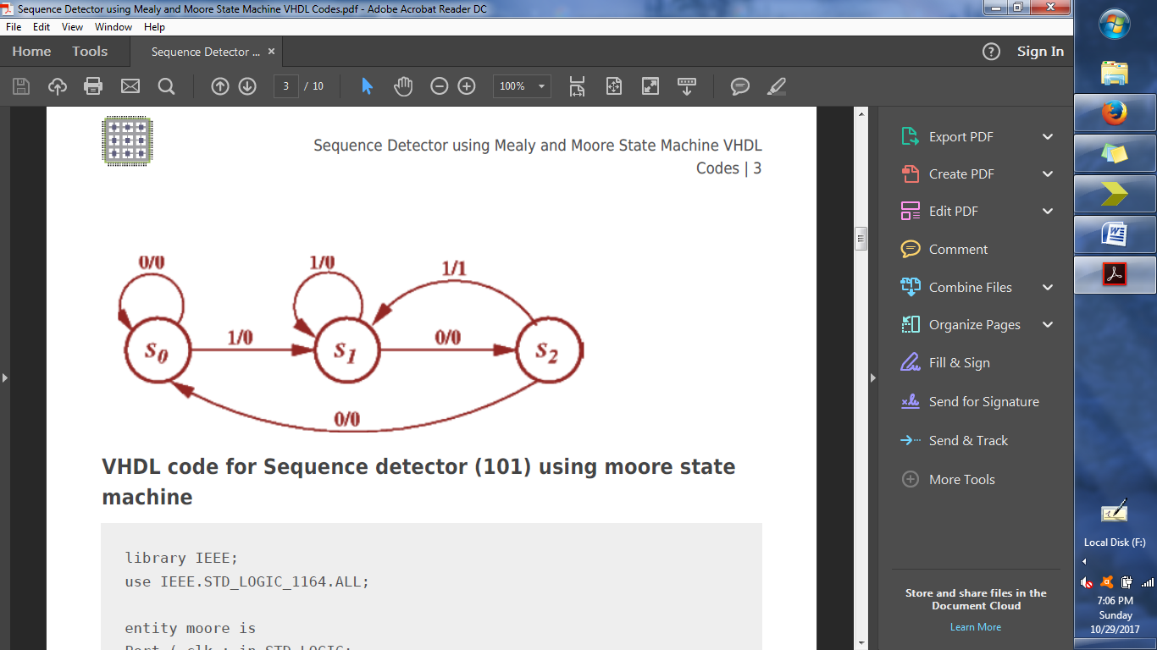

library IEEE;

use IEEE.STD_LOGIC_1164.ALL;

entity seq is

Port ( clk : in STD_LOGIC;

din : in STD_LOGIC;

rst : in STD_LOGIC;

dout : out STD_LOGIC);

end seq;

architecture Behavioral of seq is

type state is (st0, st1, st2, st3);

signal present_state, next_state : state;

begin

syncronous_process : process (clk)

begin

if rising_edge(clk) then

if (rst = '1') then

present_state <= st0;

else

present_state <= next_state;

end if;

end if;

end process;

next_state_and_output_decoder : process(present_state, din)

begin

dout <= '0';

case (present_state) is

when st0 =>

if (din = '1') then

next_state <= st1;

dout <= '0';

else

next_state <= st0;

dout <= '0';

end if;

when St1 =>

if (din = '1') then

next_state <= st1;

dout <= '0';

else

next_state <= st2;

dout <= '0';

end if;

when St2 =>

if (din = '1') then

next_state <= st1;

dout <= '1';

else

next_state <= st0;

dout <= '0';

end if;

when others =>

next_state <= st0;

dout <= '0';

end case;

end process;

end Behavioral;

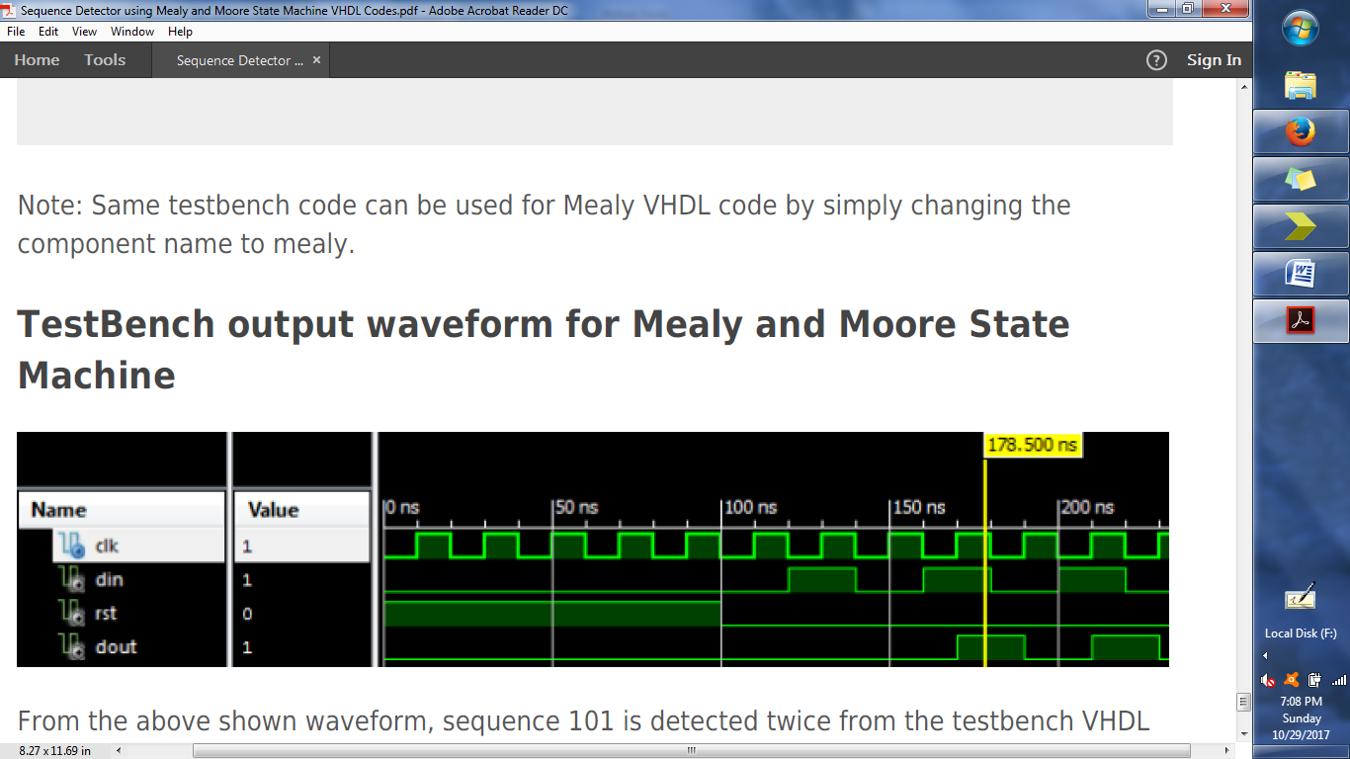

DICE GAME 2

library IEEE;

use IEEE.STD_LOGIC_1164.ALL;

entity datapath is

port(

button : in std_logic ;

led : out std_logic_vector(3 downto 0 ) ;

clk : in std_logic ;

display1 : out std_LOGIC_VECTOR(6 downto 0 ) ;

display2: out std_logic_vector(6 downto 0) );

end datapath;

architecture Behavioral of datapath is

signal c2_en, c1_en, l1_en, l2_en,switch: std_logic ;

signal count1, count2,lat1_count2, lat2_count1, lat1_count1,lat2_count2 : std_logic_vector(3 downto 0 ) ;

signal sum1, sum2 : std_logic_vector( 3 downto 0 ) ;

signal eq : std_logic_vector(1 downto 0 ) ;

component counter_en port (

en: in std_logic ;

clk : in std_logic ;

count: out std_logic_vector(3 downto 0)

);

end component ;

component latch_en port( D : in STD_LOGIC_vector(3 downto 0 );

Q : out STD_LOGIC_vector(3 downto 0 ) ;

en : in STD_LOGIC);

end component ;

component summer port(

ch1: in std_logic_vector(3 downto 0 ) ;

ch2 : in std_logic_vector( 3 downto 0 ) ;

sum : out std_logic_vector( 3 downto 0 ) );

end component ;

component comparator port(

sum1 : in std_logic_vector(3 downto 0 ) ;

sum2 : in std_logic_vector( 3 downto 0 ) ;

eq : out std_logic_vector( 1 downto 0 ) );

end component;

component decoder_bcd_7seg port (count : in STD_LOGIC_VECTOR (3 downto 0);

display : out STD_LOGIC_VECTOR (6 downto 0));

end component ;

component debounce port(clk : IN STD_LOGIC ;

button : IN STD_LOGIC;

result : OUT STD_LOGIC);

end component ;

component dicegame port (

sw : in std_logic ;

eq : in std_logic_vector(1 downto 0 ) ;

clk : in std_logic ;

output: out std_logic_vector(7 downto 0) );

end component ;

begin

A1: counter_en port map ( c1_en, clk, count1) ;

A2: counter_en port map ( c2_en , clk , count2) ;

A3: latch_en port map ( count1, lat1_count1 ,l1_en) ;

A4: latch_en port map ( count2, lat1_count2 ,l1_en) ;

A5: latch_en port map ( count1, lat2_count1,l2_en) ;

A6: latch_en port map ( count2, lat2_count2,l2_en) ;

A7: decoder_bcd_7seg port map ( lat1_count1, display1 );

A8: decoder_bcd_7seg port map ( lat1_count2, display2 );

A9: summer port map ( lat1_count1, lat1_count2, sum1) ;

A10: summer port map ( lat2_count1, lat2_count2, sum2) ;

A11: comparator port map ( sum1, sum2, eq) ;

A12: debounce port map ( clk, button, switch) ;

A13: dicegame port map (

sw => switch,

eq => eq,

clk => clk ,

output(3 downto 0) => led(3 downto 0),

output(4) => l1_en,

output(5) => l2_en,

output(6) => c1_en,

output(7) => c2_en );

end Behavioral;

entity dicegame is

port (

sw : in std_logic ;

eq : in std_logic_vector(1 downto 0) ;

clk : in std_logic ;

output: out std_logic_vector(7 downto 0)

) ;

end dicegame;

architecture Behavioral of dicegame is

type state_type is (S0,S1,S2,S3,S4,S5,S6,S7,S8,S9,S10,S11);

signal state, next_state : state_type ;

begin

SYNC_PROC : process(clk)

begin

if rising_edge(clk) then

state <= next_state ;

else

state <= state ;

end if ;

end process ;

NEXT_STATE_DECODE : process(state,sw,eq)

begin

next_state <= S0 ;

case(state) is

when S0 =>

if(sw = '0' ) then

next_state <= S1 ;

else

next_state <= S0 ;

end if ;

when S1 =>

if(sw = '1') then

next_state <= S2 ;

else

next_state <= S1 ;

end if ;

when S2 =>

next_state <= S3 ;

when S3 =>

if(eq = "00" ) then

next_state <= S4 ;

elsif(eq = "01") then

next_state <= S5 ;

else

next_state <= S6 ;

end if ;

when S4 =>

if(sw ='0') then

next_state <= S0 ;

else

next_state <= S4 ;

end if ;

when S5 =>

if(sw ='0') then

next_state <= S0 ;

else

next_state <= S5 ;

end if ;

when S6 =>

if(sw ='0') then

next_state <= S7 ;

else

next_state <= S6 ;

end if ;

when S7 =>

if(sw ='0') then

next_state <= S7 ;

else

next_state <= S8 ;

end if ;

when S8 =>

next_state <= S9 ;

when S9 =>

if(eq ="00") then

next_state <= S10 ;

elsif( eq = "10") then

next_state <= S11 ;

else

next_state <= S6 ;

end if ;

when S10 =>

if( sw ='0') then

next_state <= S0 ;

else

next_state <= S10 ;

end if ;

when S11 =>

if( sw ='1') then

next_state <= S11 ;

else

next_state <= S0 ;

end if ;

when others =>

next_state <= S0 ;

end case ;

end process ;

OUTPUT_DECODE : process (state,sw,eq)

begin

case(state) is

when S0 =>

output <= X"88" ;

when S1 =>

output <= X"C0" ;

when S2 =>

output <= X"00" ;

when S3 =>

output <= X"30" ;

when S4 =>

output <= X"8A" ;

when S5=>

output <= X"89" ;

when S6 =>

output <= X"84" ;

when S7 =>

output <= X"C0" ;

when S8 =>

output <= X"00" ;

when S9 =>

output <= X"10" ;

when S10 =>

output <= X"89" ;

when S11 =>

output <= X"8A" ;

when others =>

output <= X"88" ;

end case ;

end process ;

end Behavioral;

entity comparator is

port(

sum1 : in std_logic_vector(3 downto 0 ) ;

sum2 : in std_logic_vector( 3 downto 0 ) ;

eq : out std_logic_vector( 1 downto 0 ) );

end comparator;

architecture Behavioral of comparator is

begin

eq <= "00" when sum1 = "0100" or sum1 = "1000" or sum1 = "1100" else

"01" when sum1 = "0011" or sum1 = "0110" or sum1 = "1001" else

"10" when sum1 = sum2 else

"11" ;

end Behavioral;

entity summer is

port(

ch1: in std_logic_vector(3 downto 0 ) ;

ch2 : in std_logic_vector( 3 downto 0 ) ;

sum : out std_logic_vector( 3 downto 0 ) );

end summer;

architecture Behavioral of summer is

begin

sum <= ch1+ ch2 ;

end Behavioral;

### TESTBENCH:

ENTITY dicegame_tb IS

END dicegame_tb;

ARCHITECTURE behavior OF dicegame_tb IS

-- Component Declaration for the Unit Under Test (UUT)

COMPONENT datapath

PORT(

button : IN std_logic;

led : OUT std_logic_vector(3 downto 0);

clk : IN std_logic;

display1 : OUT std_logic_vector(6 downto 0);

display2 : OUT std_logic_vector(6 downto 0)

);

END COMPONENT;

--Inputs

signal button : std_logic := '0';

signal clk : std_logic := '0';

--Outputs

signal led : std_logic_vector(3 downto 0);

signal display1 : std_logic_vector(6 downto 0);

signal display2 : std_logic_vector(6 downto 0);

BEGIN

-- Instantiate the Unit Under Test (UUT)

uut: datapath PORT MAP (

button => button,

led => led,

clk => clk,

display1 => display1,

display2 => display2

);

-- Stimulus process

stim_proc: process

begin

-- hold reset state for 100 ns.

wait for 1 ns;

clk <= not clk ;

end process;

B : process

begin

wait for 56 ns ;

button <= '1' ;

wait for 93 ns ;

button <= '0' ;

wait for 97 ns ;

button <= '1' ;

wait for 91 ns ;

button <= '0';

wait for 84 ns ;

button <= '1' ;

end process ;

END;

## OUTPUT:

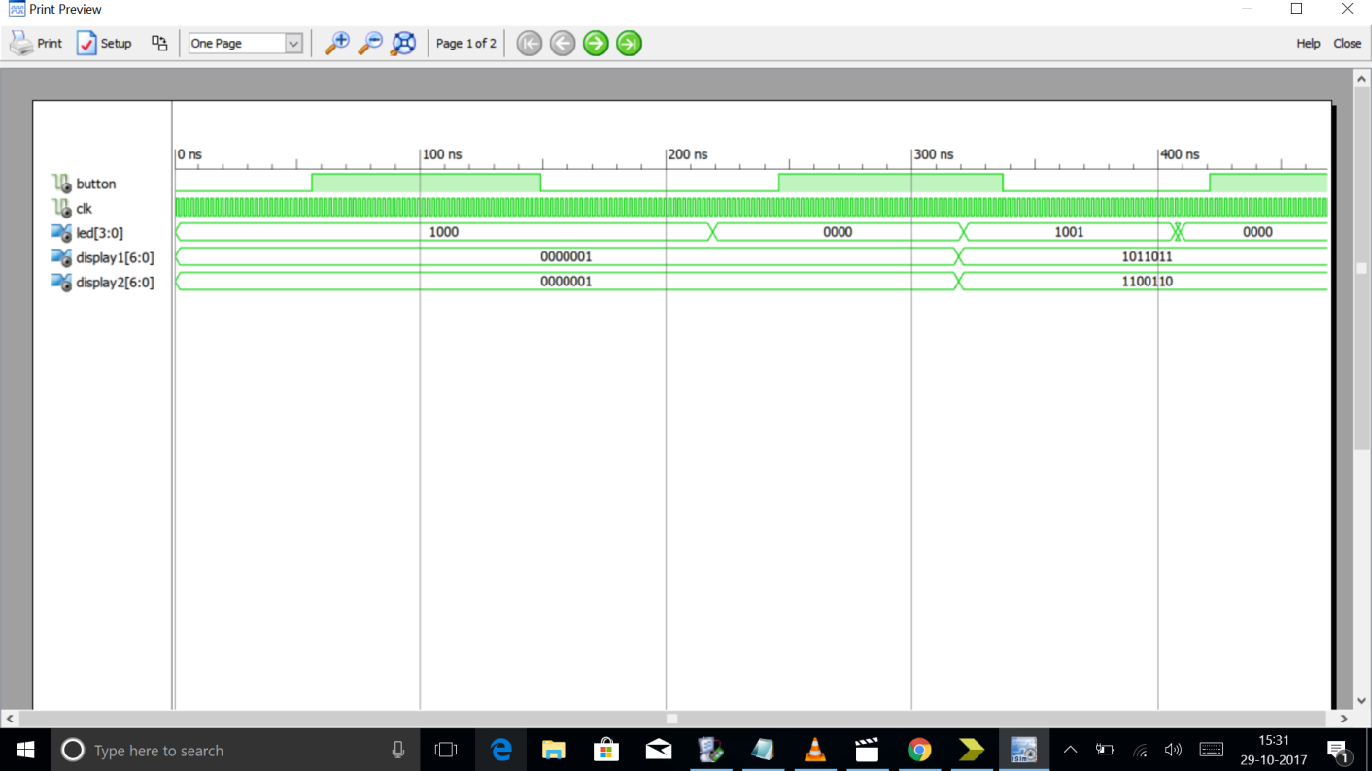

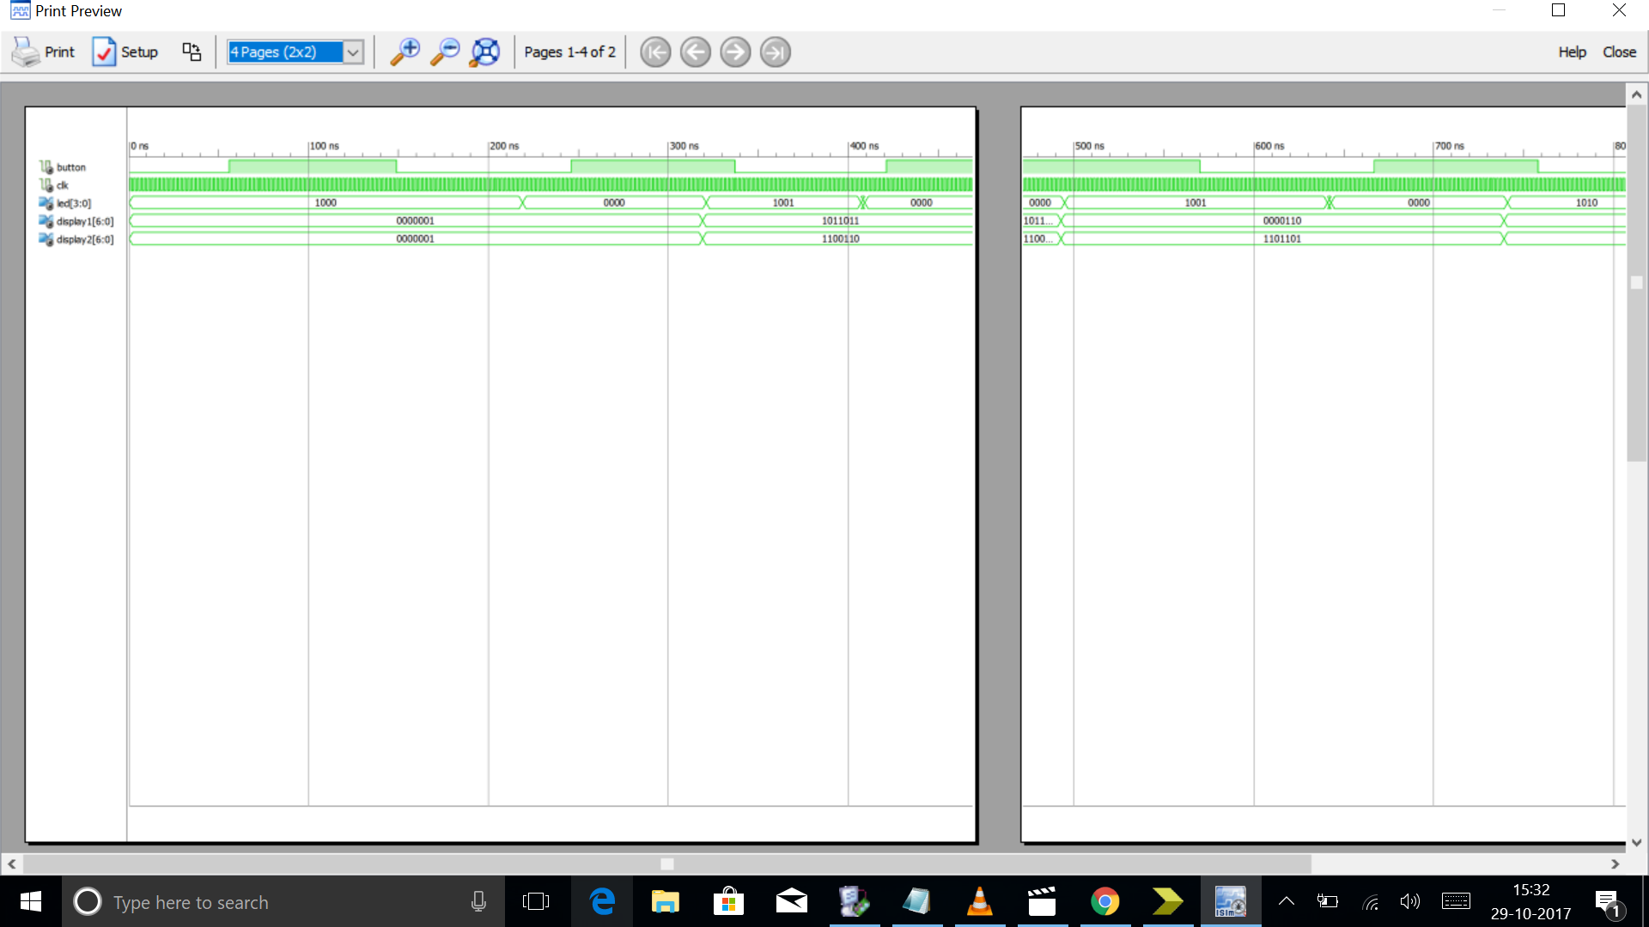

UART TX

-- This file contains the UART Transmitter. This transmitter is able

-- to transmit 8 bits of serial data, one start bit, one stop bit,

-- and no parity bit. When transmit is complete o_TX_Done will be

-- driven high for one clock cycle.

--

-- Set Generic g_CLKS_PER_BIT as follows:

-- g_CLKS_PER_BIT = (Frequency of i_Clk)/(Frequency of UART)

-- Example: 10 MHz Clock, 115200 baud UART

-- (10000000)/(115200) = 87

--

library ieee;

use ieee.std_logic_1164.all;

use ieee.numeric_std.all;

entity UART_TX is

generic (

g_CLKS_PER_BIT : integer := 115 -- Needs to be set correctly

);

port (

i_Clk : in std_logic;

i_TX_DV : in std_logic;

i_TX_Byte : in std_logic_vector(7 downto 0);

o_TX_Active : out std_logic;

o_TX_Serial : out std_logic;

o_TX_Done : out std_logic

);

end UART_TX;

architecture RTL of UART_TX is

type t_SM_Main is (s_Idle, s_TX_Start_Bit, s_TX_Data_Bits,

s_TX_Stop_Bit, s_Cleanup);

signal r_SM_Main : t_SM_Main := s_Idle;

signal r_Clk_Count : integer range 0 to g_CLKS_PER_BIT-1 := 0;

signal r_Bit_Index : integer range 0 to 7 := 0; -- 8 Bits Total

signal r_TX_Data : std_logic_vector(7 downto 0) := (others => '0');

signal r_TX_Done : std_logic := '0';

begin

p_UART_TX : process (i_Clk)

begin

if rising_edge(i_Clk) then

case r_SM_Main is

when s_Idle =>

o_TX_Active <= '0';

o_TX_Serial <= '1'; -- Drive Line High for Idle

r_TX_Done <= '0';

r_Clk_Count <= 0;

r_Bit_Index <= 0;

if i_TX_DV = '1' then

r_TX_Data <= i_TX_Byte;

r_SM_Main <= s_TX_Start_Bit;

else

r_SM_Main <= s_Idle;

end if;

-- Send out Start Bit. Start bit = 0

when s_TX_Start_Bit =>

o_TX_Active <= '1';

o_TX_Serial <= '0';

-- Wait g_CLKS_PER_BIT-1 clock cycles for start bit to finish

if r_Clk_Count < g_CLKS_PER_BIT-1 then

r_Clk_Count <= r_Clk_Count + 1;

r_SM_Main <= s_TX_Start_Bit;

else

r_Clk_Count <= 0;

r_SM_Main <= s_TX_Data_Bits;

end if;

-- Wait g_CLKS_PER_BIT-1 clock cycles for data bits to finish

when s_TX_Data_Bits =>

o_TX_Serial <= r_TX_Data(r_Bit_Index);

if r_Clk_Count < g_CLKS_PER_BIT-1 then

r_Clk_Count <= r_Clk_Count + 1;

r_SM_Main <= s_TX_Data_Bits;

else

r_Clk_Count <= 0;

-- Check if we have sent out all bits

if r_Bit_Index < 7 then

r_Bit_Index <= r_Bit_Index + 1;

r_SM_Main <= s_TX_Data_Bits;

else

r_Bit_Index <= 0;

r_SM_Main <= s_TX_Stop_Bit;

end if;

end if;

-- Send out Stop bit. Stop bit = 1

when s_TX_Stop_Bit =>

o_TX_Serial <= '1';

-- Wait g_CLKS_PER_BIT-1 clock cycles for Stop bit to finish

if r_Clk_Count < g_CLKS_PER_BIT-1 then

r_Clk_Count <= r_Clk_Count + 1;

r_SM_Main <= s_TX_Stop_Bit;

else

r_TX_Done <= '1';

r_Clk_Count <= 0;

r_SM_Main <= s_Cleanup;

end if;

-- Stay here 1 clock

when s_Cleanup =>

o_TX_Active <= '0';

r_TX_Done <= '1';

r_SM_Main <= s_Idle;

when others =>

r_SM_Main <= s_Idle;

end case;

end if;

end process p_UART_TX;

o_TX_Done <= r_TX_Done;

end RTL;

UART RX

-- This file contains the UART Receiver. This receiver is able to

-- receive 8 bits of serial data, one start bit, one stop bit,

-- and no parity bit. When receive is complete o_rx_dv will be

-- driven high for one clock cycle.

--

-- Set Generic g_CLKS_PER_BIT as follows:

-- g_CLKS_PER_BIT = (Frequency of i_Clk)/(Frequency of UART)

-- Example: 10 MHz Clock, 115200 baud UART

-- (10000000)/(115200) = 87

--

library ieee;

use ieee.std_logic_1164.ALL;

use ieee.numeric_std.all;

entity UART_RX is

generic (

g_CLKS_PER_BIT : integer := 115 -- Needs to be set correctly

);

port (

i_Clk : in std_logic;

i_RX_Serial : in std_logic;

o_RX_DV : out std_logic;

o_RX_Byte : out std_logic_vector(7 downto 0)

);

end UART_RX;

architecture rtl of UART_RX is

type t_SM_Main is (s_Idle, s_RX_Start_Bit, s_RX_Data_Bits,

s_RX_Stop_Bit, s_Cleanup);

signal r_SM_Main : t_SM_Main := s_Idle;

signal r_RX_Data_R : std_logic := '0';

signal r_RX_Data : std_logic := '0';

signal r_Clk_Count : integer range 0 to g_CLKS_PER_BIT-1 := 0;

signal r_Bit_Index : integer range 0 to 7 := 0; -- 8 Bits Total

signal r_RX_Byte : std_logic_vector(7 downto 0) := (others => '0');

signal r_RX_DV : std_logic := '0';

begin

-- Purpose: Double-register the incoming data.

-- This allows it to be used in the UART RX Clock Domain.

-- (It removes problems caused by metastabiliy)

p_SAMPLE : process (i_Clk)

begin

if rising_edge(i_Clk) then

r_RX_Data_R <= i_RX_Serial;

r_RX_Data <= r_RX_Data_R;

end if;

end process p_SAMPLE;

-- Purpose: Control RX state machine

p_UART_RX : process (i_Clk)

begin

if rising_edge(i_Clk) then

case r_SM_Main is

when s_Idle =>

r_RX_DV <= '0';

r_Clk_Count <= 0;

r_Bit_Index <= 0;

if r_RX_Data = '0' then -- Start bit detected

r_SM_Main <= s_RX_Start_Bit;

else

r_SM_Main <= s_Idle;

end if;

-- Check middle of start bit to make sure it's still low

when s_RX_Start_Bit =>

if r_Clk_Count = (g_CLKS_PER_BIT-1)/2 then

if r_RX_Data = '0' then

r_Clk_Count <= 0; -- reset counter since we found the middle

r_SM_Main <= s_RX_Data_Bits;

else

r_SM_Main <= s_Idle;

end if;

else

r_Clk_Count <= r_Clk_Count + 1;

r_SM_Main <= s_RX_Start_Bit;

end if;

-- Wait g_CLKS_PER_BIT-1 clock cycles to sample serial data

when s_RX_Data_Bits =>

if r_Clk_Count < g_CLKS_PER_BIT-1 then

r_Clk_Count <= r_Clk_Count + 1;

r_SM_Main <= s_RX_Data_Bits;

else

r_Clk_Count <= 0;

r_RX_Byte(r_Bit_Index) <= r_RX_Data;

-- Check if we have sent out all bits

if r_Bit_Index < 7 then

r_Bit_Index <= r_Bit_Index + 1;

r_SM_Main <= s_RX_Data_Bits;

else

r_Bit_Index <= 0;

r_SM_Main <= s_RX_Stop_Bit;

end if;

end if;

-- Receive Stop bit. Stop bit = 1

when s_RX_Stop_Bit =>

-- Wait g_CLKS_PER_BIT-1 clock cycles for Stop bit to finish

if r_Clk_Count < g_CLKS_PER_BIT-1 then

r_Clk_Count <= r_Clk_Count + 1;

r_SM_Main <= s_RX_Stop_Bit;

else

r_RX_DV <= '1';

r_Clk_Count <= 0;

r_SM_Main <= s_Cleanup;

end if;

-- Stay here 1 clock

when s_Cleanup =>

r_SM_Main <= s_Idle;

r_RX_DV <= '0';

when others =>

r_SM_Main <= s_Idle;

end case;

end if;

end process p_UART_RX;

o_RX_DV <= r_RX_DV;

o_RX_Byte <= r_RX_Byte;

end rtl;

# TESTBENCH

library ieee;

use ieee.std_logic_1164.ALL;

use ieee.numeric_std.all;

entity uart_tb is

end uart_tb;

architecture behave of uart_tb is

component uart_tx is

generic (

g_CLKS_PER_BIT : integer := 115 -- Needs to be set correctly

);

port (

i_clk : in std_logic;

i_tx_dv : in std_logic;

i_tx_byte : in std_logic_vector(7 downto 0);

o_tx_active : out std_logic;

o_tx_serial : out std_logic;

o_tx_done : out std_logic

);

end component uart_tx;

component uart_rx is

generic (

g_CLKS_PER_BIT : integer := 115 -- Needs to be set correctly

);

port (

i_clk : in std_logic;

i_rx_serial : in std_logic;

o_rx_dv : out std_logic;

o_rx_byte : out std_logic_vector(7 downto 0)

);

end component uart_rx;

-- Test Bench uses a 10 MHz Clock

-- Want to interface to 115200 baud UART

-- 10000000 / 115200 = 87 Clocks Per Bit.

constant c_CLKS_PER_BIT : integer := 87;

constant c_BIT_PERIOD : time := 8680 ns;

signal r_CLOCK : std_logic := '0';

signal r_TX_DV : std_logic := '0';

signal r_TX_BYTE : std_logic_vector(7 downto 0) := (others => '0');

signal w_TX_SERIAL : std_logic;

signal w_TX_DONE : std_logic;

signal w_RX_DV : std_logic;

signal w_RX_BYTE : std_logic_vector(7 downto 0);

signal r_RX_SERIAL : std_logic := '1';

-- Low-level byte-write

procedure UART_WRITE_BYTE (

i_data_in : in std_logic_vector(7 downto 0);

signal o_serial : out std_logic) is

begin

-- Send Start Bit

o_serial <= '0';

wait for c_BIT_PERIOD;

-- Send Data Byte

for ii in 0 to 7 loop

o_serial <= i_data_in(ii);

wait for c_BIT_PERIOD;

end loop; -- ii

-- Send Stop Bit

o_serial <= '1';

wait for c_BIT_PERIOD;

end UART_WRITE_BYTE;

begin

-- Instantiate UART transmitter

UART_TX_INST : uart_tx

generic map (

g_CLKS_PER_BIT => c_CLKS_PER_BIT

)

port map (

i_clk => r_CLOCK,

i_tx_dv => r_TX_DV,

i_tx_byte => r_TX_BYTE,

o_tx_active => open,

o_tx_serial => w_TX_SERIAL,

o_tx_done => w_TX_DONE

);

-- Instantiate UART Receiver

UART_RX_INST : uart_rx

generic map (

g_CLKS_PER_BIT => c_CLKS_PER_BIT

)

port map (

i_clk => r_CLOCK,

i_rx_serial => r_RX_SERIAL,

o_rx_dv => w_RX_DV,

o_rx_byte => w_RX_BYTE

);

r_CLOCK <= not r_CLOCK after 50 ns;

process is

begin

-- Tell the UART to send a command.

wait until rising_edge(r_CLOCK);

wait until rising_edge(r_CLOCK);

r_TX_DV <= '1';

r_TX_BYTE <= X"AB";

wait until rising_edge(r_CLOCK);

r_TX_DV <= '0';

wait until w_TX_DONE = '1';

-- Send a command to the UART

wait until rising_edge(r_CLOCK);

UART_WRITE_BYTE(X"3F", r_RX_SERIAL);

wait until rising_edge(r_CLOCK);

-- Check that the correct command was received

if w_RX_BYTE = X"3F" then

report "Test Passed - Correct Byte Received" severity note;

else

report "Test Failed - Incorrect Byte Received" severity note;

end if;

assert false report "Tests Complete" severity failure;

end process;

end behave;

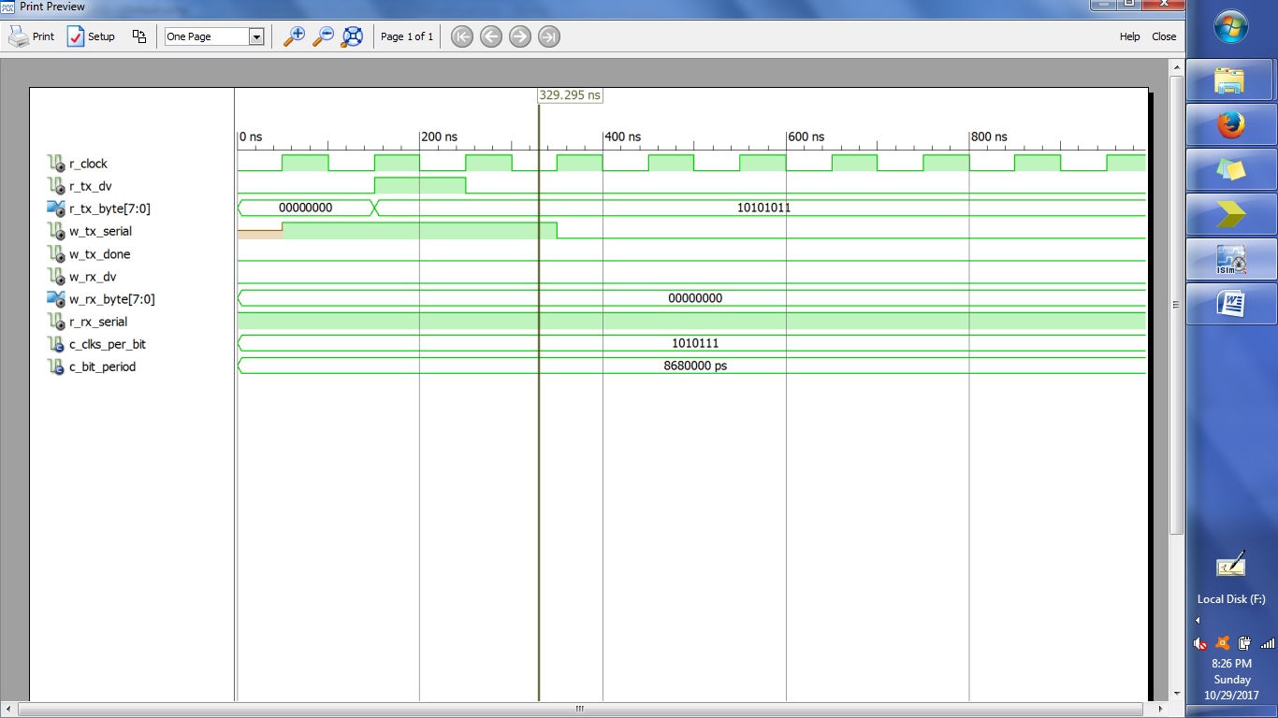

KEYBOARD SCANNER

library IEEE;

use IEEE.STD_LOGIC_1164.ALL;

entity scanner is

port (R0, R1,R2, R3, CLK: in std_logic ;

C0,A1,C2: inout std_logic;

N0,N1,N2,N3, V: out std_logic) ;

end scanner;

architecture behaviour of scanner is

signal QA, K,Kd:std_logic;

signal state ,nextstate: integer range 0 to 5;

signal temp1,temp2:std_logic:='0';

begin

K<=(R0 or R1 or R3); --this is the decoder section

N3 <=((R2 and (not(C0))) or (R3 and (not(C1))));

N2 <= (R1 or R2)and C0;

temp1<=not(R1)and(not(R0)and C0);

temp2<=(not(R2)and C2)or temp1;

N1 <= (R0 and (not (C0)))or temp2;

N0 <= ((R1 and C1) or ((not R1) and C2) or ((not R3) and (not R1) and (not C1)));

process (state , R0,R1,R2,R3,C0,C1,C2,K,Kd,QA)

begin

C0 <= '0' ; C1 <= '0' ; C2 <= '0' ; V <= '0';

case state is

when 0 => nextstate <= 1;

when 1 => C0 <= '1' ; C1 <='1' C2 <='1' ;

if ((Kd and K) ='1' )then

nextstate <=2;

else nextstate <=1;

end if ;

when 2 => C0<= '1'

if (Kd and K) ='1' then V <='1' nextstate<=5;

elsif K = '0' then nextstate <= 3;

else nextstate <=2;

end if ;

when 3 => C1 <= '1';

if (Kd and K) = '1' then V <= '1' next state <=5;

elsif K ='0' then nextstate <=4;

else nextstate <=3;

end if;

when 4 => C2 ,='1'

if (Kd and K) ='1' then V <='1'; nextstate <= 5;

else nextstate <=4;

end if;

when 5 => C0<= '1'; C1 <= '1'; C2 <= '1';

if Kd = '0' then nextstate <= 1;

else nextstate <=5;

end if ;

end case;

end process;

process (CLK)

begin

if (CLk = '1' and ClK'EVENT) then

state <= nextstate;

QA <= K;

Kd <= QA;

end if;

end process;

end behaviour;

OUTPUT:

