# MENTION ABOUT:

* Start with mentioning about embedded C and working of project…
* Software used: AVR Studio 4
* Simulation software: Proteus
* About microcontroller ATMega-16p and other hardware components like lcd ,relay,bluetooth etc..
* Uses and application,+ further development……
* Use the following codes and screenshots….

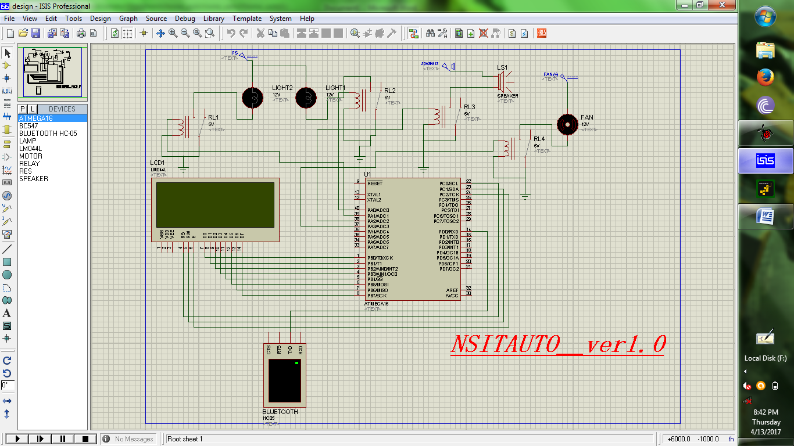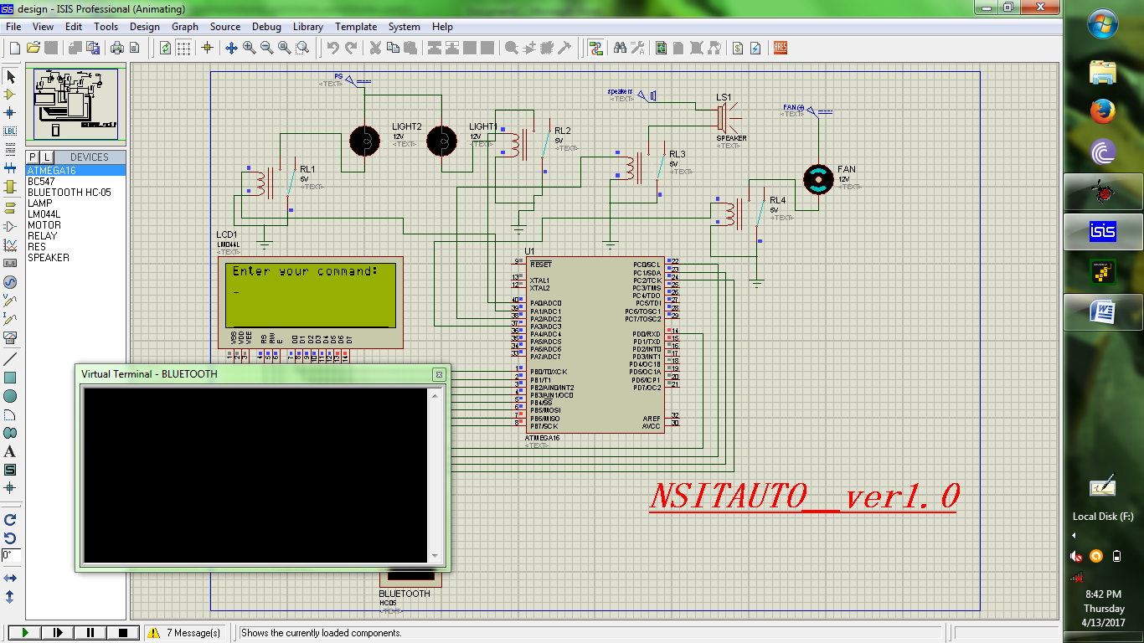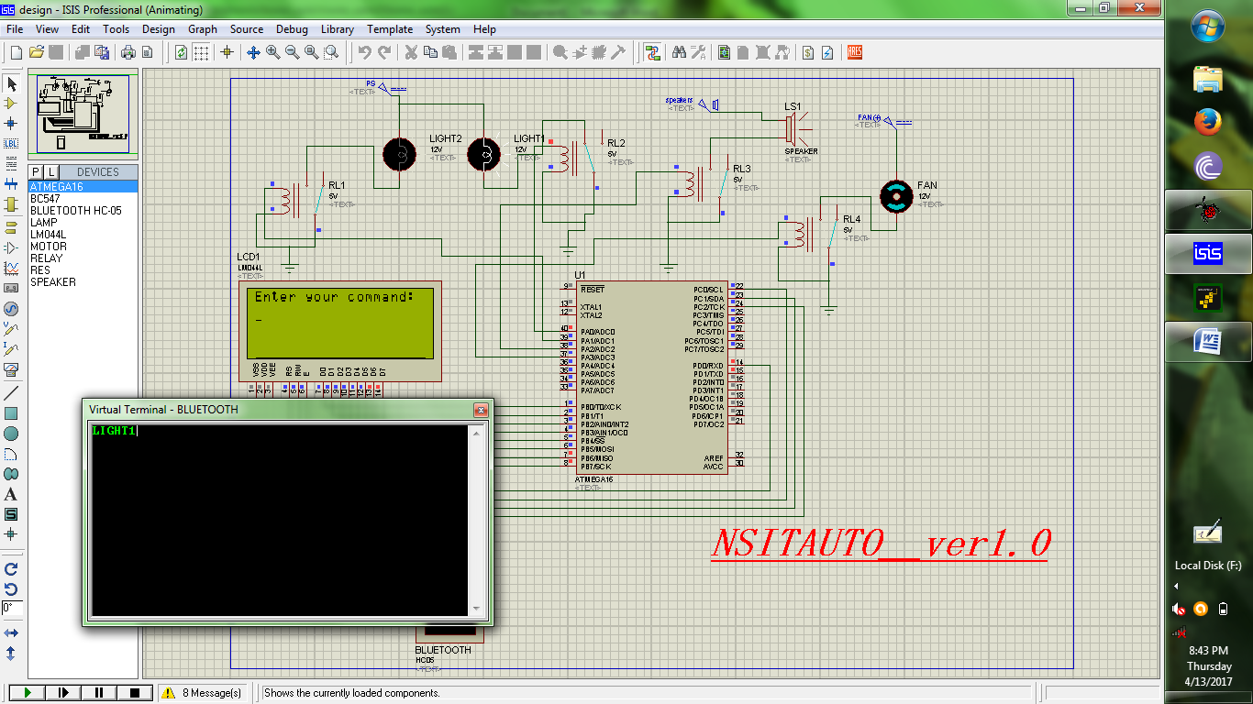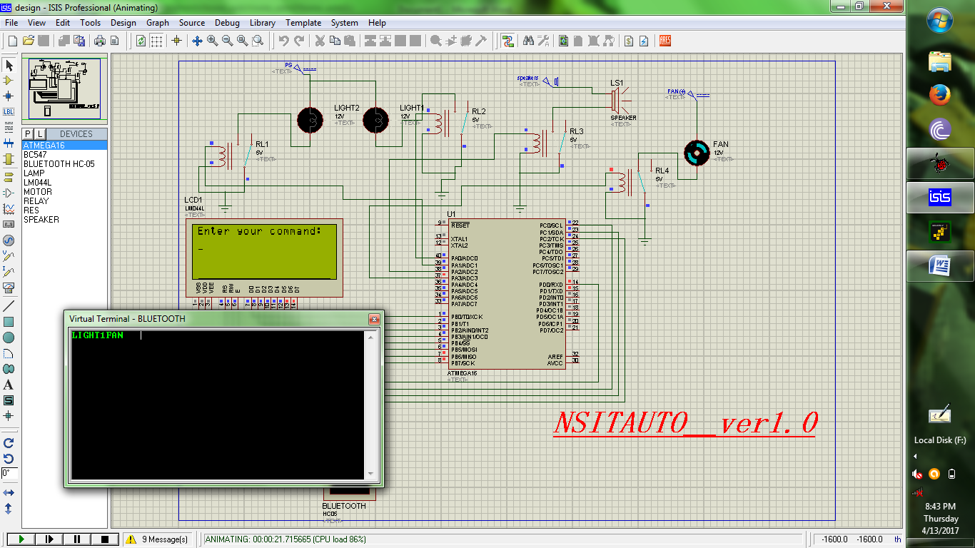

CODE

/*HOME-AUTOMATION USING USART COMM. [BLUETOOTH]*/

#include<avr/io.h> /*Includes io.h header file where all the Input/Output Registers and its Bits are defined for all AVR microcontrollers*/

#include<util/delay.h> /*Includes delay.h header file which defines two functions, _delay_ms (millisecond delay) and _delay_us (microsecond delay)*/

#include<string.h>

//#define F_CPU 8000000

/*Defines a macro for the delay.h header file. F_CPU is the microcontroller frequency value for the delay.h header file. Default value of F_CPU in delay.h header file is 1000000(1MHz)*/

//LCD FUNC.:cmd(),data() lcd(),string(),num()

void cmd(char c)

{

PORTB=c;

PORTC=0x04;

_delay_ms(10);

PORTC=0x00;

}

void data(char c)

{

PORTB=c;

PORTC=0x05;

_delay_ms(10);

PORTC=0x01;

}

void lcd()

{

cmd(0x38); //selecting 8-bit matrix

_delay_ms(10);

cmd(0x01); //clear

_delay_ms(10);

cmd(0x0e); //display on ,cursor on

_delay_ms(10);

cmd(0x80); //selecting first row first column

_delay_ms(10);

}

void string(unsigned char *p) //function for displaying strings

{

while(*p!='\0')

{data(*p);

p++;}

}

void num(unsigned int p) //functions for displaying ASCII values

{

unsigned int k,w,b=1;

k=p;

while(k>=10)

{

b=b*10;

k=k/10;

}

while(b>0)

{

w=p/b;

p=p%b;

b=b/10;

data(w+48);

}

}

unsigned char x;

unsigned char arr[6]="000000"; //temp array

//APPLIANCES-Enter the following in virtual terminal.

unsigned char card1[6]="LIGHT1";

unsigned char card2[6]="LIGHT2";

unsigned char card3[6]="SOUND ";

unsigned char card4[6]="FAN ";

void main()

{

//Ports init.

DDRC=0xff;

DDRB=0xff;

DDRD=0x00;

DDRA=0xff;

PORTA=0x00;

lcd();

string("WELCOME To NSITAUTO __[ver-1.0]");

_delay_ms(3000);

//cmd(0x1c);

//registers initialization ,see datasheet

UBRRL=51;

UCSRB=(1<<TXEN)|(1<<RXEN);

UCSRC=(1<<URSEL)|(1<<UCSZ0)|(1<<UCSZ1);

_delay_ms(800);

while(1)

{

lcd();

cmd(0x80);

string("Enter your command:");

_delay_ms(400);

cmd(0xc0);

for(int i=0;i<=5;i++)

{

while((UCSRA&(1<<RXC))==0);//polling for recieving data in UDR buffer

x=UDR;

arr[i]=x;

data(x);

}

cmd(0x01);

if((strncmp(arr,card1,6))==0)

{

cmd(0x80);

string("LIGHT1");

PORTA=0x01;

_delay_ms(40000);

//break;

}

else if((strncmp(arr,card2,6))==0)

{

cmd(0x80);

string("LIGHT2");

PORTA=0x02;

_delay_ms(4000);

//break;

}

else if((strncmp(arr,card3,6))==0)

{

cmd(0x80);

string("SPEAKERS");

PORTA=0x04;

_delay_ms(40000);

//break;

}

else if((strncmp(arr,card4,6))==0)

{

cmd(0x80);

string("FAN");

PORTA=0x08;

_delay_ms(4000);

//break;

}

else

{

//cmd(0x01);

cmd(0x80);

string("SORRY!! Wrong cmd:");

PORTA=0x00;

_delay_ms(4000);

}

}}