**Q0**) What are the possible state transitions of a process?

The process can be in any one of the following three possible states. 1) Running (actually using the CPU at that time and running). 2) Ready (runnable; temporarily stopped to allow another process run). 3) Blocked (unable to run until some external event happens).

**Q1**) What are the differences between a thread and a process?

A process is a collection of code, memory, data and other resources. A thread is a sequence of code that is executed within the scope of the process. You can (usually) have multiple threads executing concurrently within the same process.

**Q2**) What is a race condition?

A race condition is an undesirable situation that occurs when a device or system attempts to perform two or more operations at the same time, but because of the nature of the device or system, the operations must be done in the proper sequence to be done correctly.

**Q3**) Five jobs are waiting to be run. Their expected run times are 9, 6, 3, 5, and *X*. In what order should they be run to minimize average response time? Given X = 10 and X = 1

• 0 < X ≤ 3: X, 3, 5, 6, 9

• 3 < X ≤ 5: 3, X, 5, 6, 9.

• 5 < X ≤ 6: 3, 5, X, 6, 9.

• 6 < X ≤ 9: 3, 5, 6, X, 9.

• X > 9: 3, 5, 6, 9, X.

**Q4**) Five batch jobs *A* through *E*, arrive at a computer center at almost the same time. They have estimated running times of 10, 6, 2, 4, and 8 minutes. Their (externally determined) priorities are 3, 5, 2, 1, and 4, respectively, with 5 being the highest priority. For each of the following scheduling algorithms, determine the mean process turnaround time.

1. Round robin (RR=4).

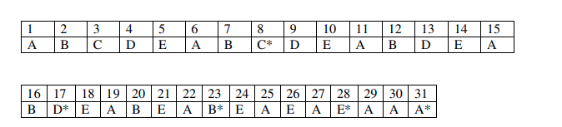

Average turnaround = (8 + 17 + 23 + 28 + 31)/5 = 107/5 = 21.4 minutes

1. Priority scheduling.



Avg. turnaround = (6 + 14 + 25 + 27 + 31)/5 = 103/5 = 20.6 minutes

1. First-come, first-served (run in order 10, 6, 2, 4, 8).



Avg. turnaround = (11 + 17 + 19 + 23 + 31)/5 = 101/5 = 20.2 minutes

1. Shortest job first.

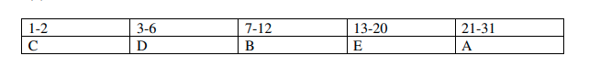

Avg. turnaround = (2 + 6 + 12 + 20 + 31)/5 = 71/5 = 14.2 minutes

**Q5)** What is the difference between preemption and non-preemption in the context of process scheduling.

In preemptive scheduling, the CPU is allocated to the processes for a limited time whereas, in Non-preemptive scheduling, the CPU is allocated to the process till it terminates or switches to the waiting state