CSE221: Algorithms

Lab-01: Adjacency List and Adjacency Matrix

# Task 01:

## Input:

1. Read an undirected graph from a file with vertices and edges.

## Output:

1. Corresponding AdjacencyMatrix.

## Example:

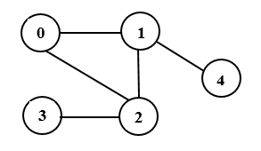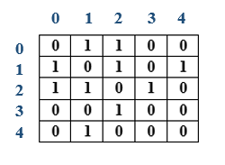

Input Output

### Sample input: Inputs must be taken from a file.

5 [# of nodes] 10[#ofedges] [Edges]

0 1

0 2

1 0

1 2

1 4

2 0

2 1

2 3

3 2

4 1

# Task 02:

## Input:

1. Read a directed graph from a file with vertices and edges.

## Output:

2. Corresponding Adjacency List.

## Example:

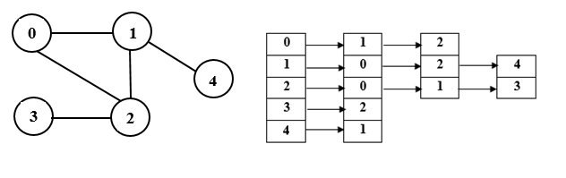

Input Output

### Sample input: Inputs must be taken from a file.

5 [# of nodes] 10[#of edges] [Edges]

0 1

0 2

1 0

1 2

1 4

2 0

2 1

2 3

3 2

4 1