EXT: check for installed extensions
Extension Key: patch10011
Language: en
Keywords: forEditors, forDevelopers, forIntermediates, Extension Manager
Copyright 2019, Franz Holzinger, <franz@ttproducts.de>

This document is published under the Open Content License
available from http://www.opencontent.org/opl.shtml

The content of this document is related to TYPO3
- a GNU/GPL CMS/Framework available from www.typo3.org
Table of Contents
EXT: check for installed extensions 1
Introduction 3
What does it do? 3
Users manual 4
Administration 5
Reference 5
Known problems 6
To-Do list 7
ChangeLog 8

Introduction

What does it do?
- It is sometimes necessary to give a different setup if an additional extension has been installed. See bug10011 , which is pending in the Core list for many years. You can use this to write one template setup for several sites with different installed extensions. You can configure an alternative output in the FE if an extension has not been installed. This can be used also for the default setup of extensions. Maybe you want to read an additional table field from the database if another extension has been installed.
- The Typoscript match condition userFunc (user defined) allows to have multiple parameters and a return value which can be checked against string values.

Example:
[userFunc = JambageCom\TtProducts\UserFunc\MatchCondition->checkShipping(delivery, country_code) = DEU]
some Typoscript lines

[ext=tt_news:version > 3.5.99]
Typoscript lines which will be active only if tt_news in a version greater than 3.5.99 has been installed.

Users manual
Just install the extension together with any other extension which supports this patch. This will enable new conditions for the template setup.
Be aware that this extension is using code based on the replacement of TYPO3 classes. Maybe it will make parts of TYPO3 unusable. If you discover any trouble with TYPO3 conditions, then deinstall this extension.

Administration

Reference
- See TSref

ext

Syntax:
[ext=extensionkey:parameter = value1, >value2, =value3, <value4, ...]

Comparison:
The values are compared with the attributes of the extension key .
paramters:
active, title, author, author_email, author_company, version, CGLcompliance, CGLcompliance_note

Examples:
[ext=tt_news:active = 1]
or
[ext=tt_news:version > 1.2.3]

userFunc

Syntax:
[userFunc = user_function(argument1, argument2, ...) = result]

Enhancement:
The original TYPO3 userFunc has been enhanced by an equation comparision with the result string. This gives you much more possibilites. The condition is only valid if the result fits to the comparison string. This is missing in standard TYPO3 where you only have a boolean result which must be true in order to have the condition activated.

Known problems
- Use the version 0.3.2 for TYPO3 8.7.
- In TYPO3 6.x.x before 6.2.13 you must apply this patch: https://review.typo3.org/#/c/38917/
- Some TYPO3 Core developers consider this patch as not useful. Please explain them the reasons why the current TYPO3 possibilities are not sufficient and simple enough to get the job done.
- For TYPO3 4.5 you must use version 0.1.0 of patch10011.

To-Do list
- This patch should become part of TYPO3. If you consider this extension useful, then please add your comments here:
https://forge.typo3.org/issues/19739

- Outdated info: This patch has been pending in the Core list since 2008.
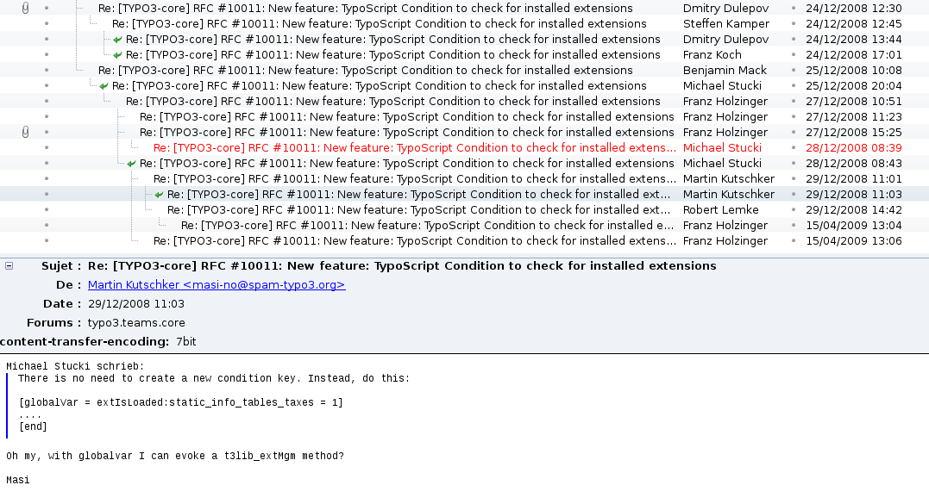

ChangeLog
See the file "ChangeLog"

