SmartCare v0.3 - Domain Model Workbook
Week 6 student resource

Requirement-to-Concept Trace
Requirement | Concept | State/behaviour | Decision
FR-01: Create appointments | Appointment | Create | Class
FR-02: Edit appointments | Appointment | Edit | Class
FR-03: Delete appointments | Appointment | Delete | Class
FR-04: Create patient record | Patient | Create | Class
FR-05: Edit patient record | Patient | Edit | Class
FR-06: Search for patient record | Patient | Search | Not class
FR-07: Edit appointment status | Appointment status | Edit | Not class
FR-08: Access appointment history per patient | Patient | Access | Class
FR-09: Create practitioner record | Practitioner | Create | Class
FR-10: Edit practitioner record | Practitioner | Edit | Class
FR-11: Delete practitioner record | Practitioner | Delete | Class
FR-12: Create statistics | Statistics | Create | Not class

CRC Cards

Patient
Responsibilities | Collaborators
Store patient information | Appointment
Access patient history | Practitioner

Practitioner
Responsibilities | Collaborators
Store practitioner information | Appointment
Access patient records | Patient

Appointment
Responsibilities | Collaborators
Connect patient with practitioner | Practitioner & patient
Store appointment status | Practitioner
Store appointment information | Practitioner & patient

UML Class Diagram
Insert/draw UML here. Include defensible relationships and multiplicities.
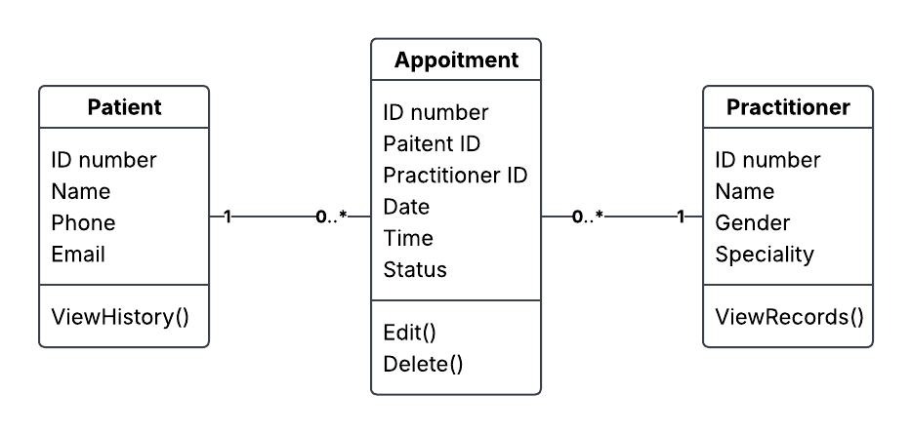

Design Rationale
Explain class selection, responsibility allocation and key relationships.
The class selection is based off the requirements as stated in SmartCare-V2. These three elements serve as the basis of most of the features and functions required by the client. Almost everything that needs to happen within the appointment system happened through one of these three. As for the responsibility allocation, while still a draft that may under go changes – I decided to allocate only the basic attributes and actions that cover the majority of the basic information, including name, ID number and appointment status. The relationships between practitioner/patient and appointment operate the same way – while one person can have multiple appointments, each appointment can only be booked to one person (or rather two, 1 patient and 1 practitioner).

AI Design Review Record
AI suggestion | Evidence | Decision | Reason | Model change
Patient | FR-04, FR-05, FR-06, and FR-08 | Accepted | Sufficient evidence | Add class
Appointment | FR-01, FR-02, FR-03, and FR-08 | Modified | Based upon the requirements, status change can be an attribute | Change status to attribute
Practitioner | FR-09, FR-10, and FR-11, | Accepted | Sufficient evidence | Add class
Appointment Manager | US-04 | Rejected | Not enough evidence | No change
Statistics | FR - 12 | Rejected | Not enough evidence | No change

