Objective.
As an SQL Developer, you often work with enormous amounts of data stored in different tables that are present inside multiple databases. It usually becomes strenuous to extract the data if it needs to be correctly organized. Using Normalization, you can solve the problem of data redundancy and organize the data using different forms. This tutorial will help you understand the concept of normalization in DBMS.

What is Normalization in DBMS?
Normalization is the process of structuring data in a database. It involves creating tables and defining relationships between them based on rules that safeguard the data and enhance the database's flexibility by reducing redundancy and preventing inconsistent dependencies.
Normalization in a DBMS (database management system) eliminates data redundancy and enhances data integrity in the table. It also helps organize the data in the database. This multi-step process sets the data into tabular form and removes duplicate data from the relational tables.
Normalization organizes the columns and tables of a database to ensure that database integrity constraints properly execute their dependencies. It is a systematic technique of decomposing tables to eliminate data redundancy (repetition) and undesirable characteristics like Insertion, Update, and Deletion anomalies.
In 1970, Edgar F. Codd defined the First Normal Form.
Now, let's understand the types of Normal forms with the help of examples.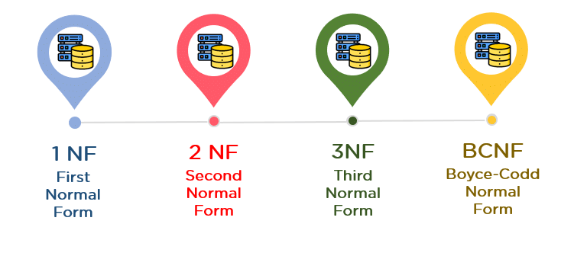

Normal Forms in DBMS

1. First Normal Form (1NF)
- A table is referred to as being in its First Normal Form if the atomicity of the table is 1.
- Atomicity states that a single cell cannot hold multiple values; it must hold only a single attribute.
- The First Normal Form disallows the multi-valued attribute, composite attribute, and their combinations.
Now, you will understand the First Normal Form with the help of an example.
Below is a students’ record table that has information about the student roll number, student name, student course, and age of the student.
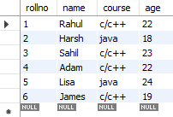
In the student record table, the course column has two values. However, it does not follow the First Normal Form. You get the table below if you use the First Normal Form in the above table.

By applying the First Normal Form, you achieve atomicity; every column has unique values.
Before proceeding with the Second Normal Form, get familiar with Candidate Key and Super Key.
- Candidate Key
A candidate key is a set of one or more columns that can identify a record uniquely in a table, and YOU can use each candidate key as a Primary Key.
Now, let’s use an example to understand this better.
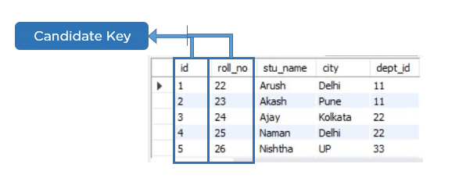
- Super Key
A super key is a set of more than one key uniquely identifying a table record. The primary Key is a subset of the Super Key.
Let’s understand this with the help of an example.
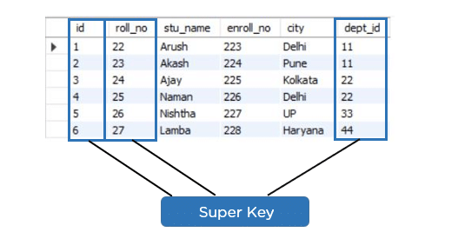

2. Second Normal Form (2NF)
The first condition for the table to be in the Second Normal Form is that the table has to be in the First Normal Form. The table should not possess partial dependency. The partial dependency here means the proper subset of the candidate key should give a non-prime attribute.
Now, understand the Second Normal Form with the help of an example.
Consider the table Location:
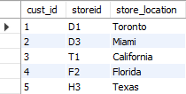
The Location table possesses a composite primary key cust_id, storeid. The non-key attribute is store_location. In this case, store_location only depends on storeid, which is a part of the primary key. Hence, this table does not fulfill the second normal form.
To bring the table to the Second Normal Form, you need to split the table into two parts. This will give you the tables below:
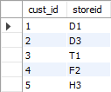
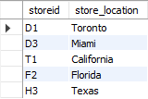
As you have removed the partial functional dependency from the location table, the column store_location entirely depends on the primary key of that table, storeid.
Now that you understand the 1st and 2nd Normal forms, you will look at the next part of this Normalization in the SQL tutorial.

3. Third Normal Form (3NF)
- The first condition for a table to be in the Third Normal Form is that it should be in the Second Normal Form.
- The second condition is that there should be no transitive dependency for non-prime attributes, which indicates that non-prime attributes (not part of the candidate key) should not depend on other non-prime attributes in a table. Therefore, a transitive dependency is a functional dependency in which A → C (A determines C) indirectly because of A → B and B → C (where it is not the case that B → A).
- The Third Normal Form ensures the reduction of data duplication. It is also used to achieve data integrity.
Below is a student table that has student ID, student name, subject ID, subject name, and address of the student as its columns.
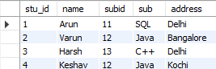
In the above student table, stu_id determines subid, and subid determines sub. Therefore, stu_id determines sub via subid. This implies that the table possesses a transitive functional dependency and does not fulfill the third normal form criteria.
Now, to change the table to the third normal form, you need to divide the table as shown below:
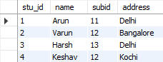
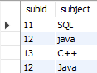
As you can see in both tables, all the non-key attributes are now fully functional, dependent only on the primary key. In the first table, the columns' names, subids, and addresses only depend on stu_id. In the second table, the sub only depends on the subid.
Source. https://www.simplilearn.com/tutorials/sql-tutorial/what-is-normalization-in-sql

