

StickIt! Rotary Encoder Manual

How to install and use your new
StickIt! Rotary Encoder Module

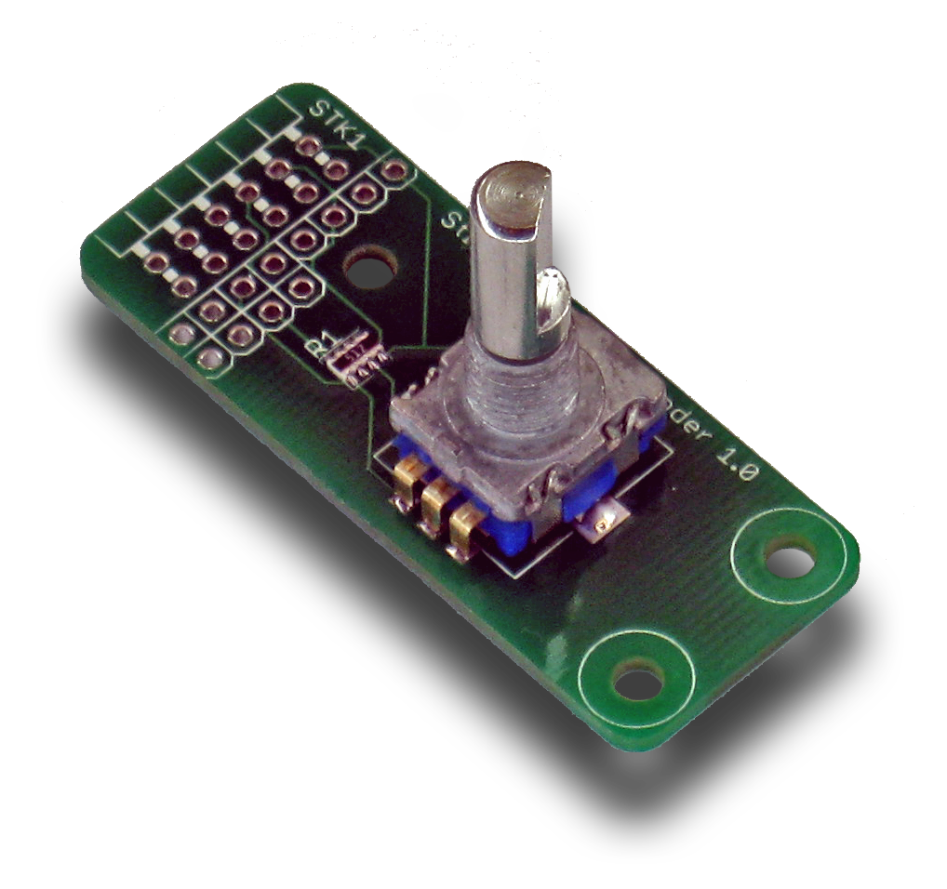
XESS is disclosing this Document and Intellectual Property (hereinafter “the Design”) to you for use in the development of designs to operate on, or interface with XESS hardware devices. XESS expressly disclaims any liability arising out of the application or use of the Design. XESS reserves the right to make changes, at any time, to the Design as deemed desirable in the sole discretion of XESS. XESS assumes no obligation to correct any errors contained herein or to advise you of any correction if such be made. XESS will not assume any liability for the accuracy or correctness of any engineering or technical support or assistance provided to you in connection with the Design.

THE DESIGN IS PROVIDED “AS IS” WITH ALL FAULTS, AND THE ENTIRE RISK AS TO ITS FUNCTION AND IMPLEMENTATION IS WITH YOU. YOU ACKNOWLEDGE AND AGREE THAT YOU HAVE NOT RELIED ON ANY ORAL OR WRITTEN INFORMATION OR ADVICE, WHETHER GIVEN BY XESS, OR ITS AGENTS OR EMPLOYEES. XESS MAKES NO OTHER WARRANTIES, WHETHER EXPRESS, IMPLIED, OR STATUTORY, REGARDING THE DESIGN, INCLUDING ANY WARRANTIES OF MERCHANTABILITY, FITNESS FOR A PARTICULAR PURPOSE, TITLE, AND NONINFRINGEMENT OF THIRD-PARTY RIGHTS.
IN NO EVENT WILL XESS BE LIABLE FOR ANY CONSEQUENTIAL, INDIRECT, EXEMPLARY, SPECIAL, OR INCIDENTAL DAMAGES, INCLUDING ANY LOST DATA AND LOST PROFITS, ARISING FROM OR RELATING TO YOUR USE OF THE DESIGN, EVEN IF YOU HAVE BEEN ADVISED OF THE POSSIBILITY OF SUCH DAMAGES. THE TOTAL CUMULATIVE LIABILITY OF XESS IN CONNECTION WITH YOUR USE OF THE DESIGN, WHETHER IN CONTRACT OR TORT OR OTHERWISE, WILL IN NO EVENT EXCEED THE AMOUNT OF FEES PAID BY YOU TO XESS HEREUNDER FOR USE OF THE DESIGN. YOU ACKNOWLEDGE THAT THE FEES, IF ANY, REFLECT THE ALLOCATION OF RISK SET FORTH IN THIS AGREEMENT AND THAT XESS WOULD NOT MAKE AVAILABLE THE DESIGN TO YOU WITHOUT THESE LIMITATIONS OF LIABILITY.

The Design is not designed or intended for use in the development of on-line control equipment in hazardous environments requiring fail-safe controls, such as in the operation of nuclear facilities, aircraft navigation or communications systems, air traffic control, life support, or weapons systems (“High-Risk Applications”). XESS specifically disclaims any express or implied warranties of fitness for such High-Risk Applications. You represent that use of the Design in such High-Risk Applications is fully at your risk.

© 2013 XESS, Inc. XESS, the XESS logo, and other designated brands included herein are trademarks of XESS Corporation. PMOD is a trademark of Digilent Inc. All other trademarks are the property of their respective owners.

This document is licensed under the Attribution-ShareAlike 3.0 Unported license, available at http://creativecommons.org/licenses/by-sa/3.0/.
StickIt! Rotary Encoder Manual
MAN010 (V1.0) November 12, 2013
The following table shows the revision history for this document.
Date | Version | Revision
11/12/2013 | 1.0 | Initial release for StickIt! Rotary Encoder module V1.0.

Table of Contents
C.1 Preliminaries 1
Getting Help! 1
Take Notice! 1
Packing List 1
C.2 Setup 2
Inserting Your StickIt! Rotary Encoder Module Into Your StickIt! Board 2
Inserting Into a PMOD Socket 2
Inserting Into a Wing Socket 3
C.3 Operation 5
C.4 Using the Module 7
A.1 I/O Locations 8
A.2 Schematic 9
- Preliminaries
Here's some helpful information before getting started.

Getting Help!
Here are some places to get help if you encounter problems:
- If you can't get the StickIt! Rotary Encoder module to work, send an e-mail message describing your problem to help@xess.com or submit a problem report at http://www.xess.com/help.php.
- Our web site also has
  - answers to frequently-asked-questions,
  - example designs, application notes and tutorials,
  - a forum where you can post questions.

Take Notice!
It's pretty hard to get in trouble with this module.

Packing List
Here is what you should have received in your package:
- a StickIt! Rotary Encoder module.
- PMODTM male header.
- Wing male headers (8-pin & 4-pin).
- Setup
The StickIt! Rotary Encoder module provides an eight-position DIP switch that connects to an eight-bit PMOD or a Wing socket on your StickIt! board.

Inserting Your StickIt! Rotary Encoder Module Into Your StickIt! Board

Inserting Into a PMOD Socket
To use the StickIt! Rotary Encoder module with a PMOD socket, first solder the included male PMOD header to the module as shown. (To insure a stable connection, only use a header with 0.025” square pins.)
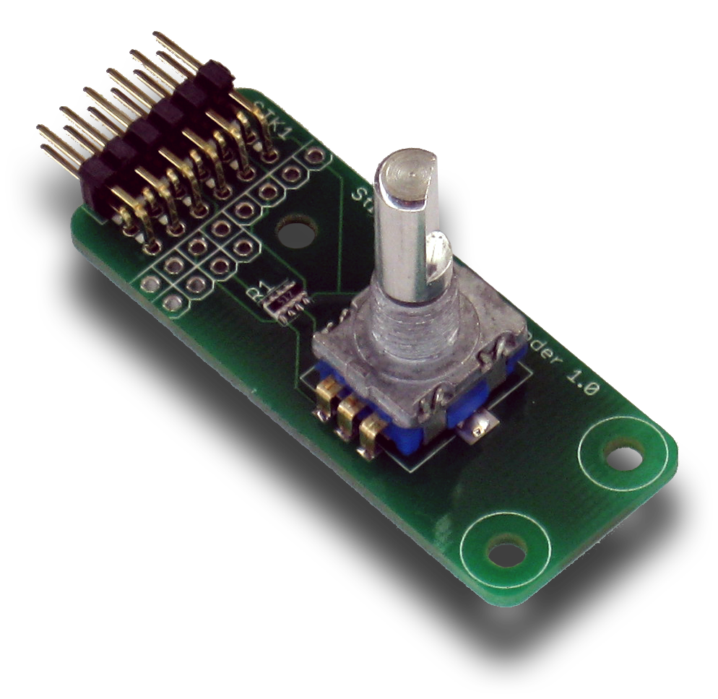
Then insert the module into one of the PMOD sockets on the StickIt! Board.
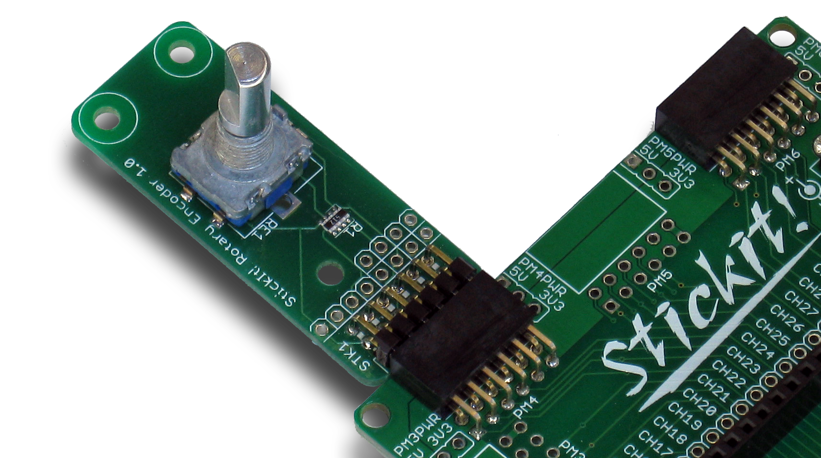

Inserting Into a Wing Socket
To use the StickIt! Rotary Encoder module with a Wing socket, first solder the included male Wing headers to the module as shown. (To insure a stable connection, only use a header with 0.025” square pins.)
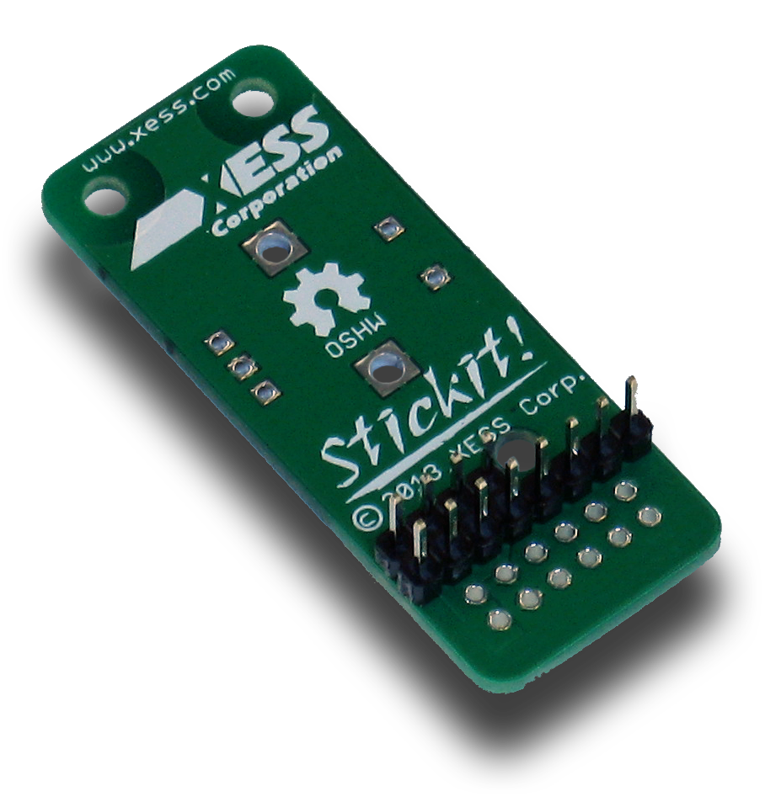
Then insert the module into one of the eight-bit Wing sockets on the StickIt! board.
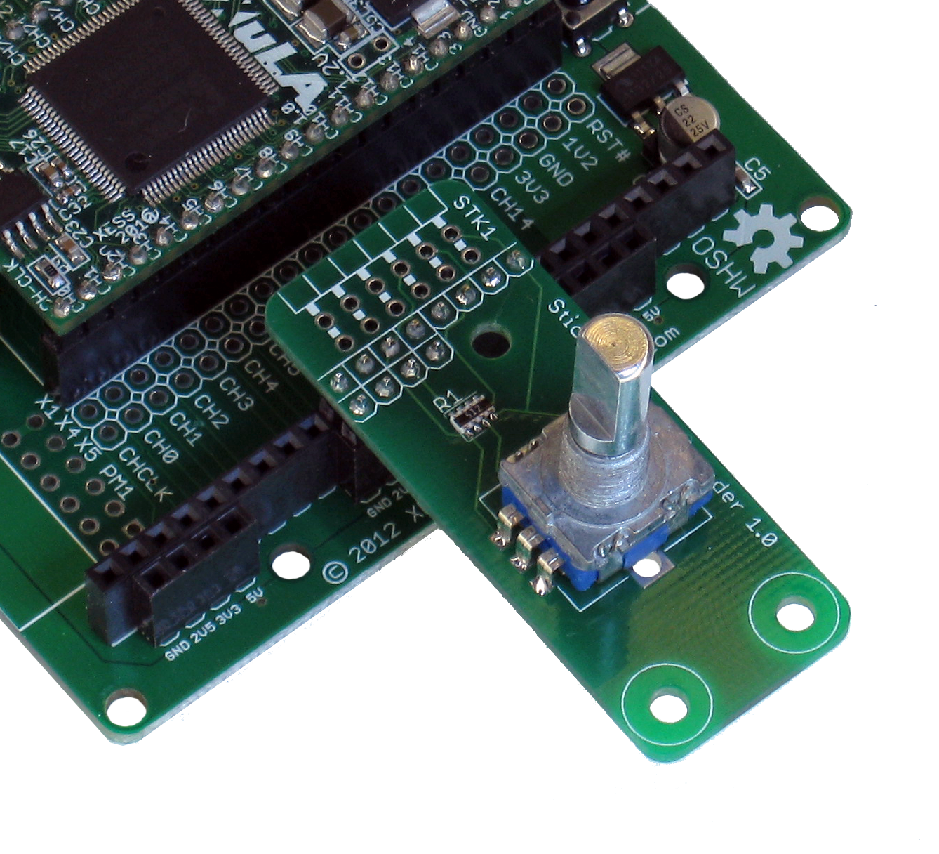
- Operation
This chapter describes the operation of the StickIt! Rotary Encoder module using a simplified schematic. You can find a complete schematic at the end of this manual.

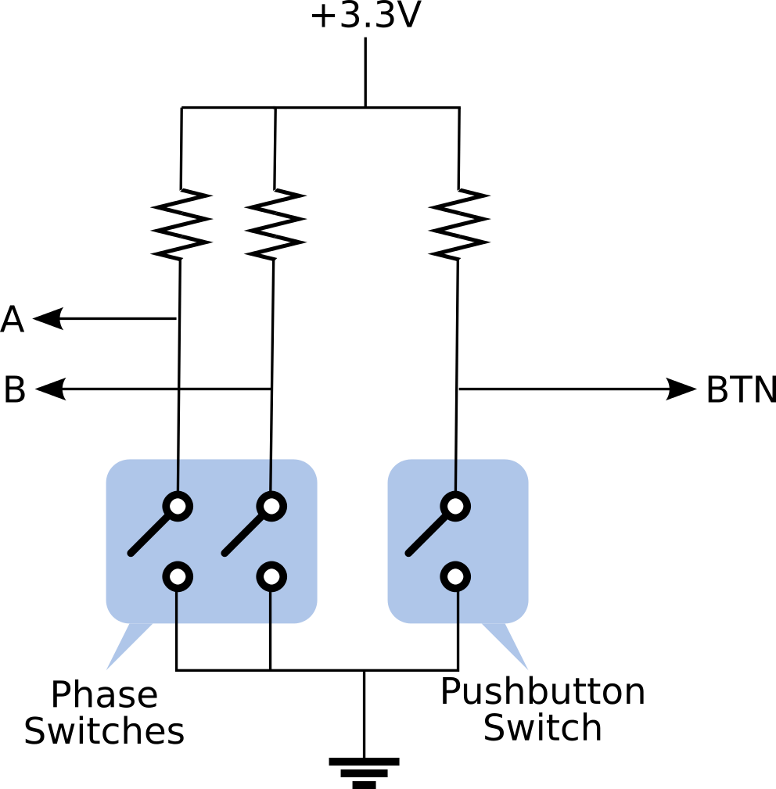
The StickIt! Rotary Encoder module has a single rotary encoder. The rotary encoder has two phase outputs (A and B) that indicate the direction of rotation of the control knob (clockwise or counter-clockwise). There is also an output (BTN) that indicates whether the control knob has been depressed or not.
The relationship between the A and B phase outputs for clockwise and counter-clockwise rotation of the control knob are shown below. For each rotation of the knob by a single click-stop (or detent), a single pulse is emitted by both the A and B outputs. The phase relationship between the A and B pulses determines whether the rotation was in the clockwise or counter-clockwise direction.
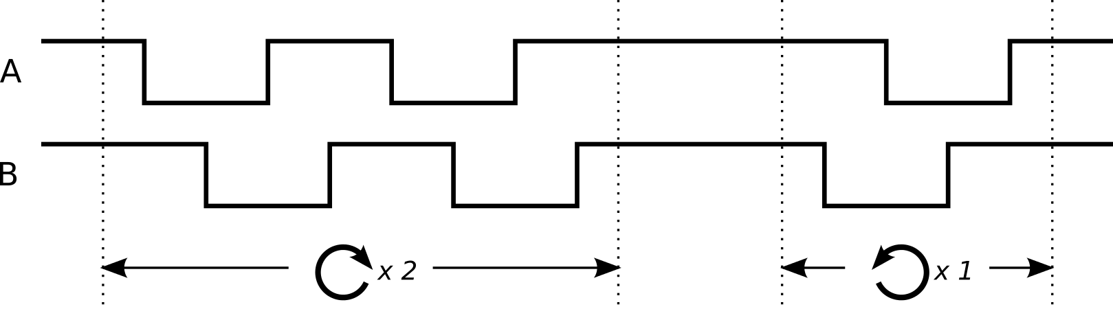
- Using the Module
To use the StickIt! Rotary Encoder module, you will need to do the following:
- Create a Xilinx ISE FPGA project and allocate three input ports to accept the A and B phase and the pushbutton outputs from the module.
- Attach the module to either a PMOD or Wing socket on the StickIt! board.
- Determine the channel signals on the PMOD or Wing socket that connect to each I/O pin of the module.
- Find which FPGA pin of the XuLA board connects to each channel signal. (You can find this information in the StickIt! Board manual.)
- Make a UCF file associating each FPGA pin with an I/O pin of the module.
- Include the UCF file in your ISE project.
That's a lot of work just to read the rotary encoder, so we've done most of it for you. Just go to http://github.com/xesscorp/StickIt. There, you will find a subdirectory with a Xilinx ISE project that includes:
- an FPGA design that senses the rotation of the encoder and displays an accumulator value on an LED Digits StickIt! module,
- a Python program that queries the module and displays the accumulator value,
- a UCF file containing the FPGA pin assignments to use when installing the StickIt! Rotary Encoder module into any of the PMOD or Wing sockets.
  - I/O Locations
The connections of the PMOD and Wing header I/O signals to the A and B phase switches and the BTN pushbutton outputs of the StickIt! Rotary Encoder module are shown below.

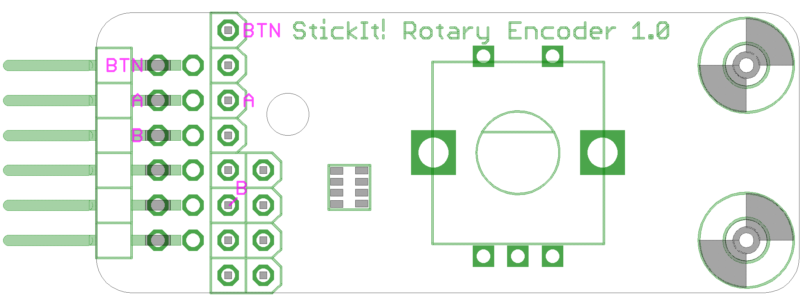
  - Schematic



