Xavier Arcamo

September 19, 2018

PWR 381

Assignment #1 – Nanotechnology Article

**Nanotechnology: Keeping Everything Standard in a Growing Industry**



*The properties of materials can change at a minute level.*

**What is Nanotechnology?**

Nanotechnology refers to the field that deals with materials at an extremely small scale. When we deal with some materials at a certain scale or smaller, their properties begin to change. Some materials may act like magnets and some may be good at conducting electricity when they are ground up or split into small sizes (nanomaterials). These things might not be possible if those materials were not broken down from a larger size. These special traits of certain materials make them very useful in industries that need advanced or precise methods and materials.

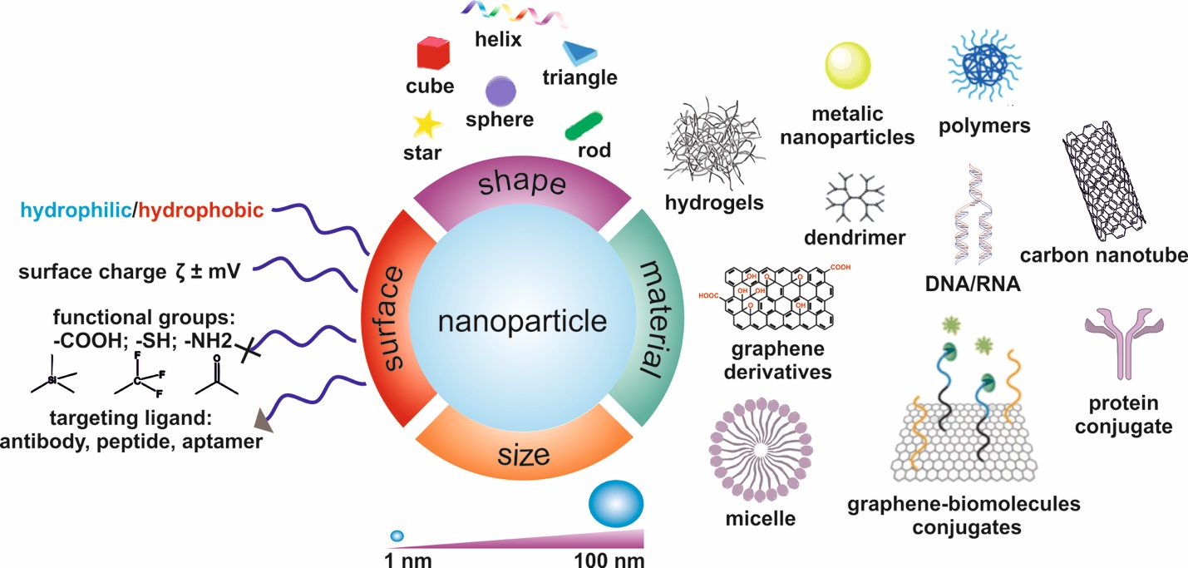  
*Examples of different shapes and forms materials can be changed into through the use of nanotechnology*

**The Growing Field of Nanotechnology**

Nanotechnology is a fairly new industry that has a lot of potential for growth and progress. Many companies realize this potential and have invested in nanotechnology research. Many companies are also looking for ways to use nanotechnology to make their products better.

Although there aren’t many nanotechnology products available right now, the public is interested enough to keep nanotechnology research going and to keep it going in ways that are safe and not harmful to our health and the environment.

**The ISO and the Challenge of Defining Nanotechnology Standards**

Because of this, the ISO (International Organization for Standardization) released a set of scientific standards for nanotechnology. This means that corporations, industries, and individuals working with nanotechnology would use the same terms and vocabulary. This prevents confusion created by different and changing terms used by these groups.

The ISO’s task is not easy, however. Nanotechnology overlaps into other industries as well, and the challenge faced by ISO is creating definitions and terms that work well with existing industry terms and do not work against them.

**Why Exactly is it Important to Use the Same Words?**

Why can’t companies create their own terms for the field of nanotechnology? The main problem is with communication. Two companies could be selling the same type of steel that is made of super strong nanomaterials, but without the ISO’s standards, they could call them two different things. People wanting to buy this steel would probably be confused and misled.

Similarly, a company could invent a special nanofabric (fabric made of microscopic materials) and name it one thing, while others would name it differently. This, again, would cause confusion. This is why having a standard set of terms and definitions created by the ISO would be useful and important in nanotechnology.

**Distinctions and What Will the ISO Do?**

As we learned earlier, the ISO is creating a set of consistent and coherent set of words and terms to use in the field of nanotechnology. It is important to note a distinction, however: what about materials that contain some nanomaterials? Will the ISO classify them as nanomaterials themselves? The answer is no. To be clear and straightforward, the ISO is strictly creating terminology for nanomaterials, and not materials that contain nanomaterials (in addition to other things). Most organizations and groups that regulate materials and goods recognize and agree with this distinction. This separation between nanomaterials and macromaterials (large-scale materials) will prevent the nanotechnology industry and governments from controlling and regulating goods and products just because they contain traces of nanomaterials inside them.

Image Credits:

<https://dolcelou.com/sportswear-fabrics/nanotechnology/>

<http://cnbm.amu.edu.pl/en/nanomaterials>