**SCHOOL OF COMPUTING (SOC)**

**DIPLOMA IN INFORMATION TECHNOLOGY**

**ST0504 – Mobile Application Development**

2022/2023 SEMESTER 2

ASSIGNMENT 3

**Instructions and Guidelines:**

1. The assignment must be submitted to the POLITEMall by **3th February 2023, 5 pm**. The cover page should contain your Class, Admission Number(s) and Name(s) of all the group members.
2. In this assignment, you are required to work in a group of maximum 2 members.
3. Marks will be awarded separately for each student in the group, depending on his/her contribution to the assignment. The assignment will account for **30%** of your final grade*.*

4. You are required to present the Assignment 3 during the practical lesson. The presentation will account for **10%** of your final grade*.*  **If you are absent from the presentation, you will be awarded ZERO mark for the assignment.**

5. **No marks will be awarded**, if the work is copied or you have allowed others to copy your work.

6. **50% of marks** to be deducted for submission of assignment within **ONE** calendar day after the deadline. **No marks shall** be awarded for assignments submitted **more than one day** after the deadline.

Warning: Plagiarism means passing off as one's own the ideas, works, writings, etc., which belong to another person. In accordance with this definition, you are committing plagiarism if you copy the work of another person and turning it in as your own, even if you would have the permission of that person.

Plagiarism is a serious offence, and if you are found to have committed, aided, and/or abetted the offence of plagiarism, disciplinary action will be taken against you. If you are guilty of plagiarism, you may fail all modules in the semester, or even be liable for expulsion.

1. **Assignment 3 Requirement**

* Convert or modified the React Native javascript to UI component.
* The UI component create is able to use throughout the Mobile Application.

**Marking Scheme for MAD – CA3**

|  |  |
| --- | --- |
| Create UI Component for the Mobile Application | 20% |
| UI component is use in different UI page | 20% |
| Page navigation and User Interaction  Assignment Demo/Presentation | 30%  10% |
| Implement other innovative features using React Native UI Components. | 20% |
| **Total** | **100%** |

1. **How to submit?**

* Delete the node_modules in your Assignment folder.

Delete this folder

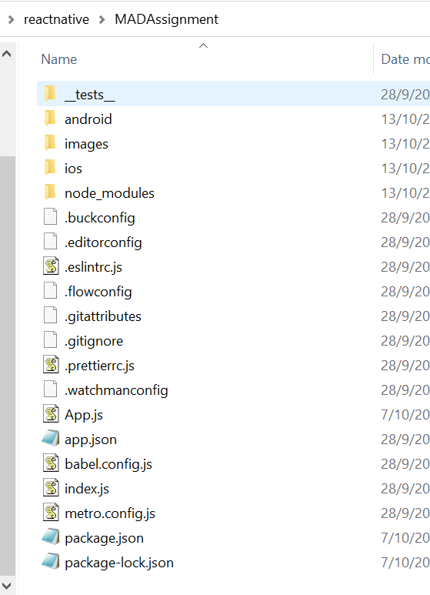

* Zip the Assignment 3 folder.

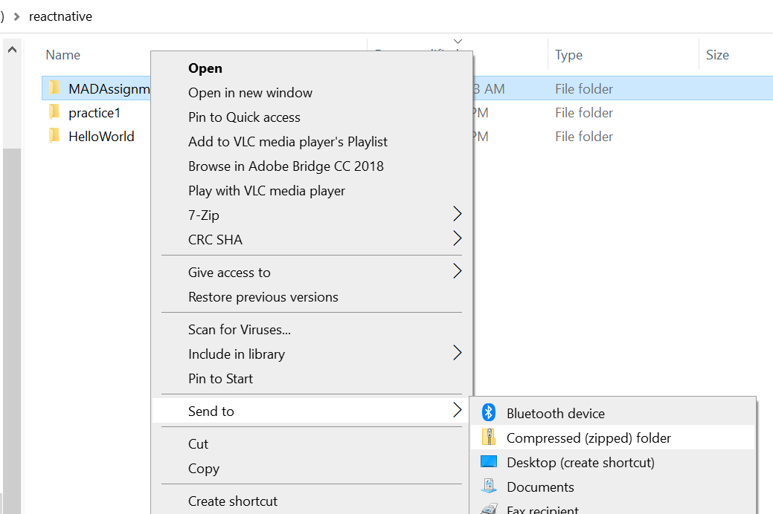

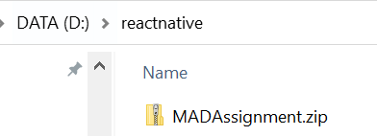

* Zip the project files (with the node_modules folder deleted), rename the file with group member admin id(pxxxxx_pxxxxx_pxxxxx.zip) and submit to Assignment 3 through POLITEMall before the deadline specified in the beginning of this document.
* State the individual contribution in the Assignment 3. Document the individual contribution in Microsoft Work document. Submit together with the project folder.