LAB01 - Introduction to 'Keil uVision' Integrated Development Environment (IDE) and first ARM uP program.

The following is a 'step-by-step' instruction for LAB01. Please, do everything very carefully.
1. For all LABs you will use "LPC4088 Experiment Base Board" ("Base Board" or "BB") with connected "LPC4088_QuickStart_Board" ("CPU Board" or "QS Board" or "Red Board"). Also, the 'bundle' may contains the "16x2 LCD display". The 'bundle' is shown on the picture below.
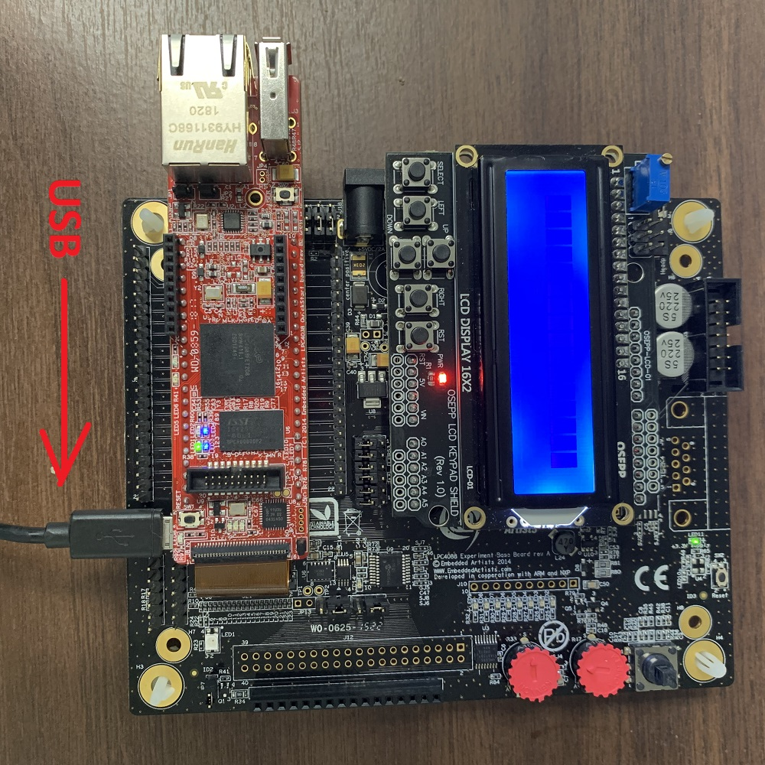
Note: The electronic components are very sensitive to static electricity. Also, the boards have a lot of pins with power voltage (+3.3V, +5V) and 'ground' pins. The voltage used is absolutely safe for humans, but "shortcut" between 'power' and/or 'ground' and/or 'signal' pins may damage CPU and other components. Handle with care!
The ""LPC4088_QuickStart_Board" is a small red board ("Red Board") placed on top of bigger "dark" " LPC4088 Experiment Base Board". The "16x2 LCD" is also placed on top of " LPC4088 Experiment Base Board". The whole bundle is powered by 'USB' cable, connected to side micro-USB socket (on "long" side of the board) of "Red Board". The same USB cable is used for debugging purposes.
Usually, the "bundle" coming with USB cable inserted into "Red Board". All you need is the connect the other side of the USB cable to your PC. When powered, some red, blue or green light will be illuminated. Probably, something will blinks or some words will be shown on the 16x2 LCD screen. It is all depend on what another student do with the "Boards" before you.
Connect the board to PC using USB cable! As connected to PC, the "Boards" are ready to go.
2. Create the directory for your project. Name it 'LAB01' or similar
Go to your X: or local Document folder.
Create a folder named CS107 2019;
Inside create Lab01 folder.
Keep all the files related to today’s lab in there.
Next week create a folder Lab02 and so on.
Remember: all the labs for this class are cumulative; we will reuse them through the semester. So, if you lost some of your Lab/Project then it would be your responsibility.
Keep you folders organized and up to date!
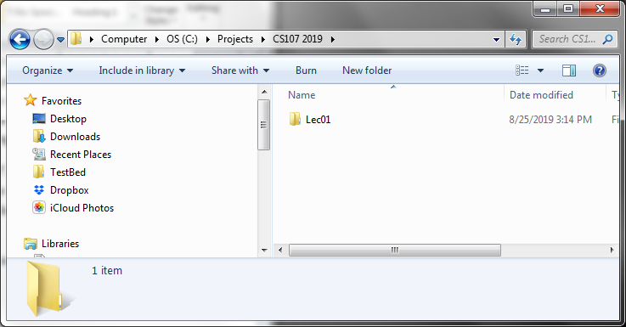
3. Download and copy 'blinks.s' and 'startup_LPC407x_8x_177x_8x.s' into your directory.

4. Locate 'Keil uVision' icon (  ) on the desktop and run it (double click)! The screen similar to shown below will be popped up...
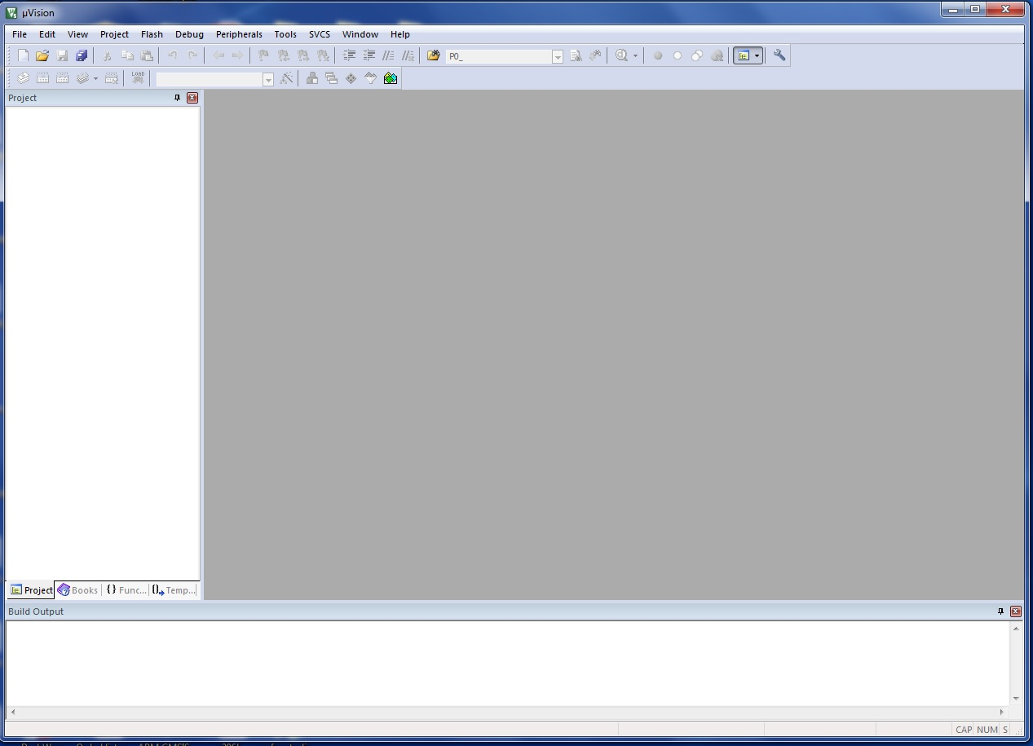
Note: 'uVision' remembers the last project at the time of 'shutdown'. Sometimes, when you open the 'uVision' you may see somebody's working environment like this: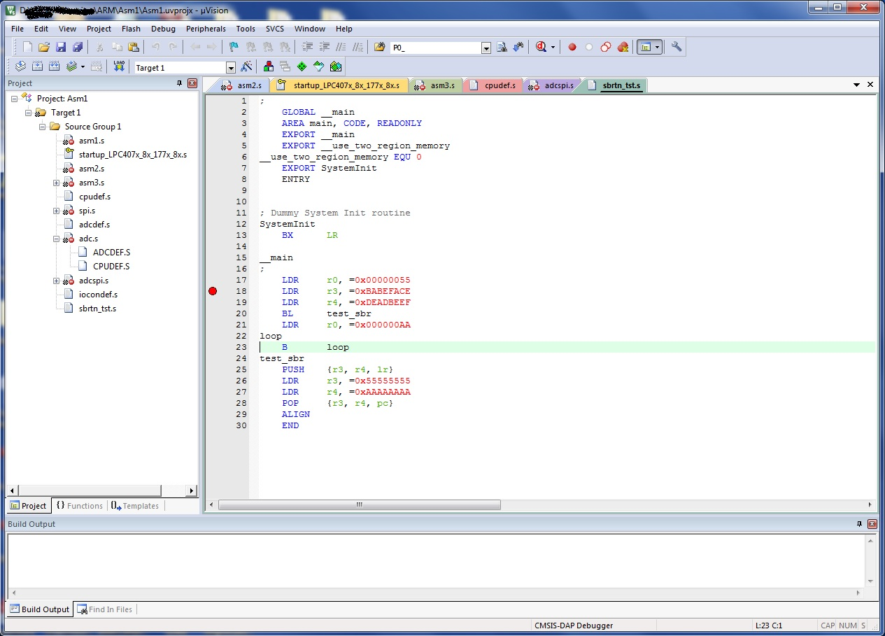
If it happens, Select 'Project' in the main menu, and then click on 'Close project'.
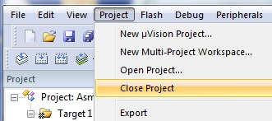
You are ready to go!
5. Now we have to create new uVision project (probably your very first uVision project, if you never used uVision before). In main menu, select 'Project'->'New uVision Project...'
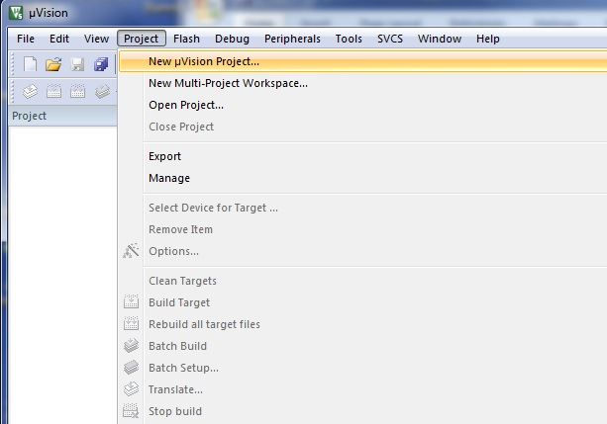
6. In the 'Create New Project' dialog:
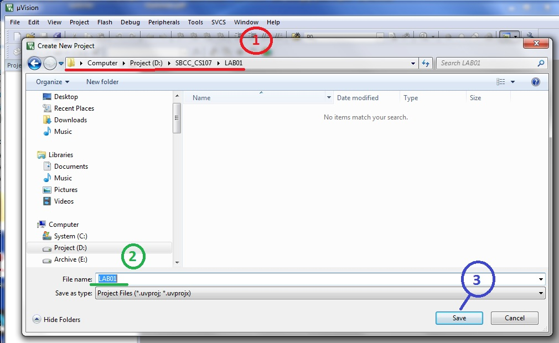
1. Locate and go inside of your 'LAB01' folder.
2. Type the name of your project (LAB01 for instance) into 'File Name:' edit box.
3. Click on 'Save' button.
7. Now, you will see 'Select Device for Target...' dialog box.
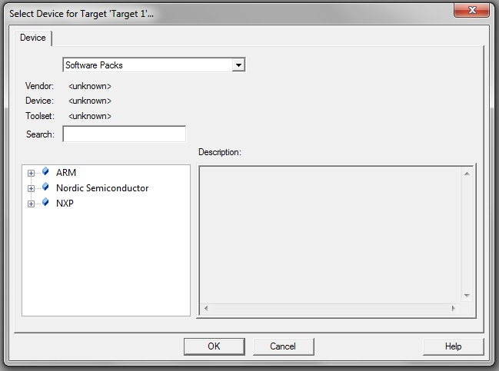
This is very important dialog! The 'Keil uVision' supports many different ARM processors. You have to select the correct one for your project! If you will select wrong processor, your code will not work.
Expand the 'NXP' node (click on '[+]') in 'left-bottom corner' 'tree view', expand 'LPC4000 Series' (another click on '[+]'), expand 'LPC408x' one more [+] and select the LPC4088FET208 as shown below!
Note: You may need to scroll the 'tree' up or down to find the correct 'CPU family' and your particular CPU.
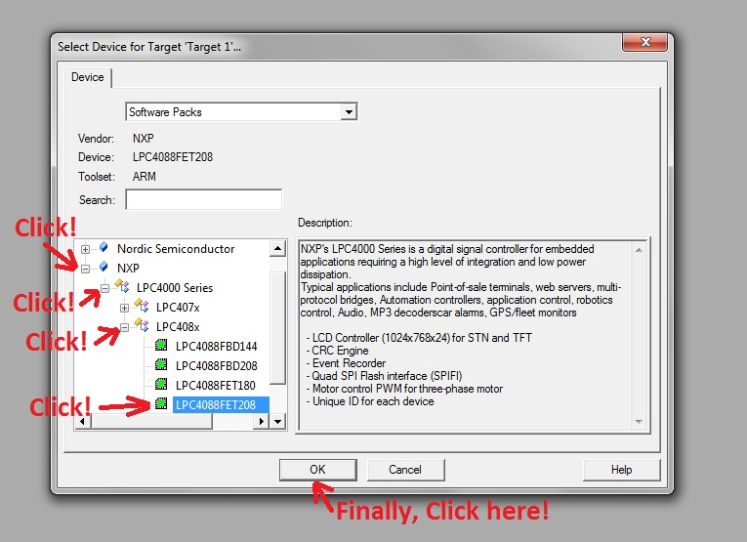
8. Next screen will be 'Manage Run-Time...'
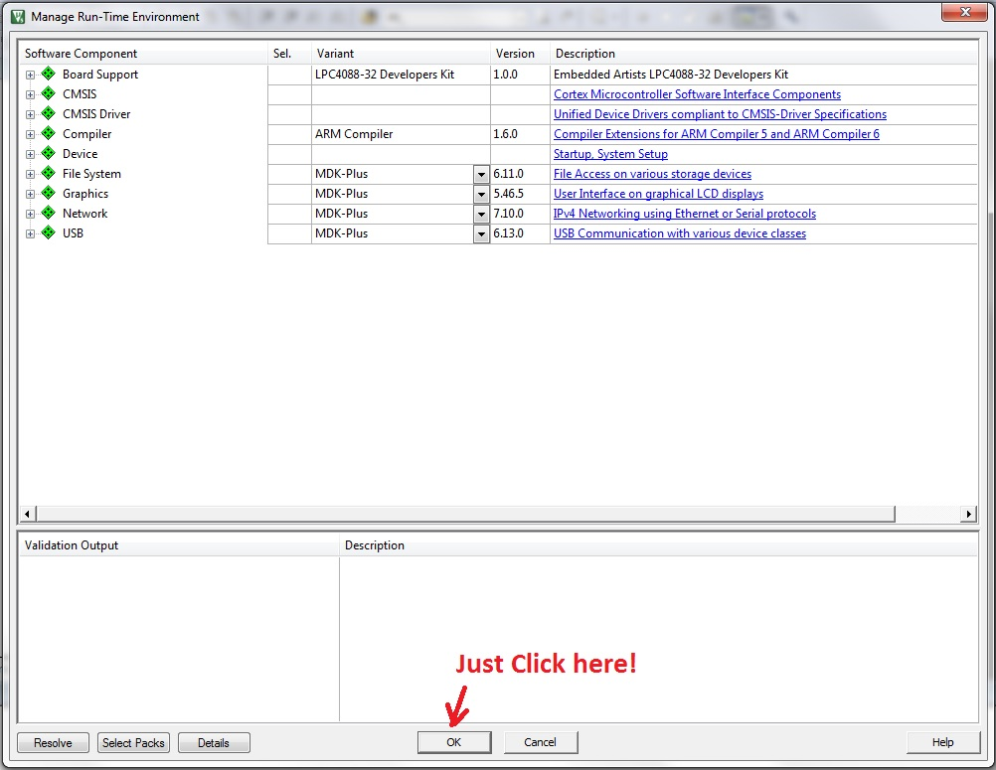
It is very big screen with many options... But, good news! You have to just 'click' on 'Ok' button and you will be fine!
Now, your screen should be looking similar to this (left-top corner of uVision IDE shown)
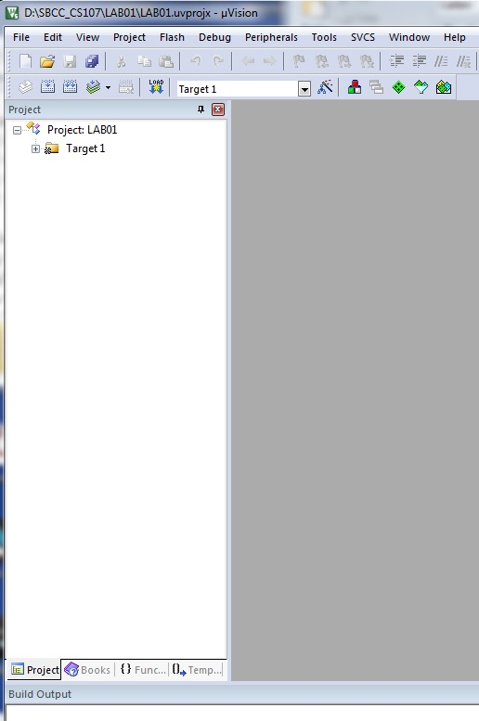
9. Place the cursor on 'Target1' in 'Project' window and 'right-click'. Then, select 'Options for target 'Target1'...
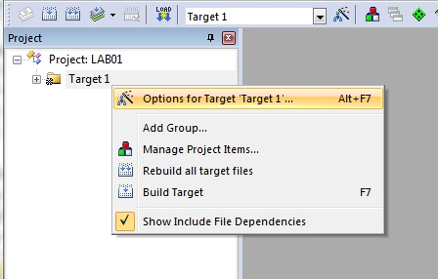
Note: You may just use 'Alt-F7' shortcut instead of 'right-click' and menu selection.
10. You will see the 'Options...' window:
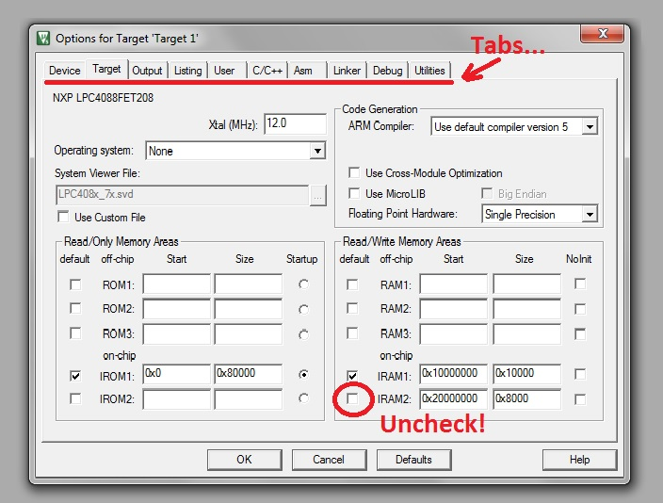
The window has lot of 'Tabs' on the top. The default 'Tab' is 'Target'. On this page you have to uncheck 'IRAM2' checkbox.
Then, go to 'Linker' 'Tab'...
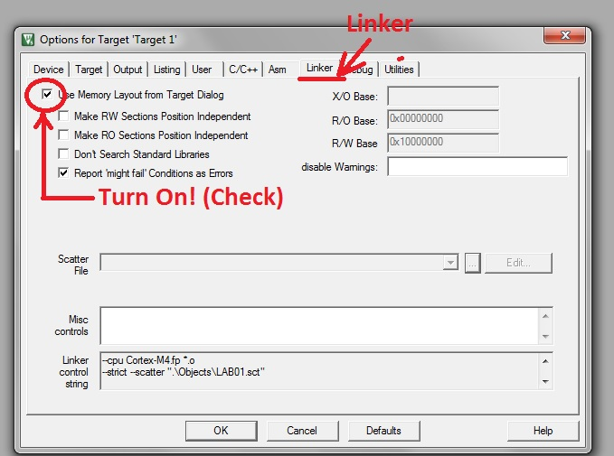
There you have to check 'Use Memory Layout...' checkbox.
Then, go to 'Debug' 'Tab'...
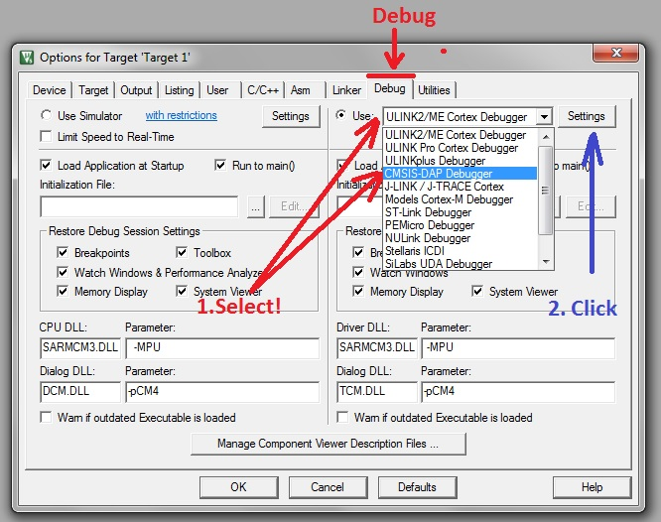
1. On 'Drop-Down list' select 'CMSIS-DAP Debugger'. This is very important! The "Red Board" has integrated MSIS-DAP Debugger' and not working with any others!
2. When ''CMSIS-DAP Debugger' is selected, click on 'Settings' button. Important: Do not click "Settings" before proper 'debugger' is selected!
In the 'Settings' window:
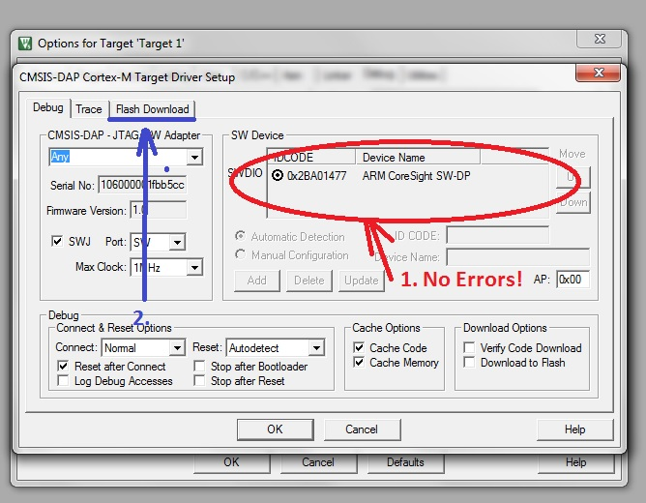
1. Make sure no error messages in the 'SW Device' area. This area should looks similar or very close to what you see on the picture. If you have some error message(s) here, the area is 'empty' or so, it means the "Board" is not connected to your PC, the "Red Board" is broken, you have a problem with USB driver or something else. It should be investigated before you go further.
2. If no error messages and all looks good, then select 'Flash Download' tab.
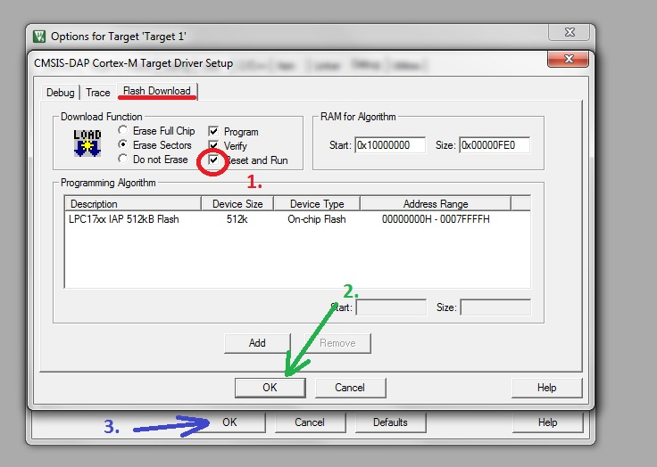
On 'Flash Download' tab:
1. "Check" "Reset and Run" checkbox in "Download Function" area.
2. Click "OK" on "CMSIS-DAP Cortex-M Target Driver Setup" dialog.
3. Click "OK" on "Options for Target 'Target 1'" dialog.
You are finished a good part of the LAB!
Please note: You will do steps 1 to 10 for all LABs you will done. Please download this document and keep it in some safe place for reference!

11. Ok! Lets add some files into your project.
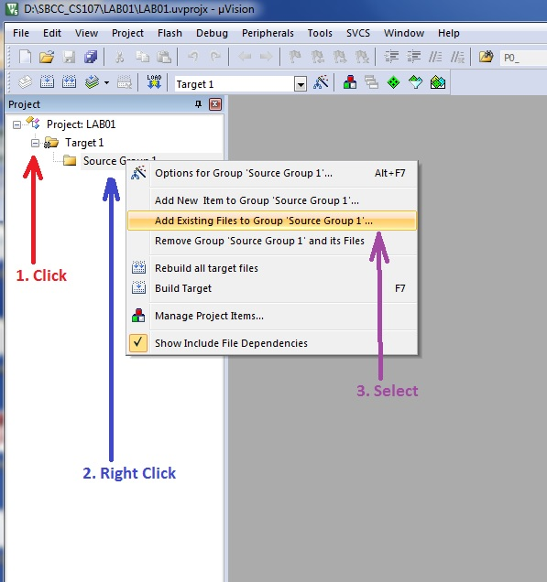
1. In 'Project' window click on [+] next to 'Target1'. You will see 'Source Group 1' folder.
2. Right-click on 'Source Group 1', and then...
3. Select "Add Existing Files to Group..." menu item.
"Add Files to Group..." dialog will appears:
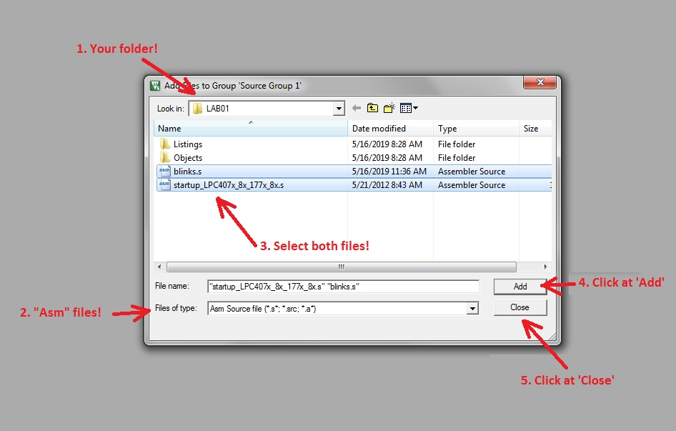
1. Make sure it is yours folder in the "Look In:" drop-down list. Locate your folder if needed.
2. In the "Files of type:" drop-down list select the "Asm Source file (".s"; ".src"; ".a").
3. Select both 'blinks.s' and 'startup_LPC407x_8x_177x_8x.s' files (Use Ctrl-Click and/or Shift-Click).
4. When both files are selected, click on 'Add' button.
5. Click on 'Close' button.
12. Now, click on [+] next to 'Source Group 1' in 'Project' window. The 'Project' window should looks like on the picture below.
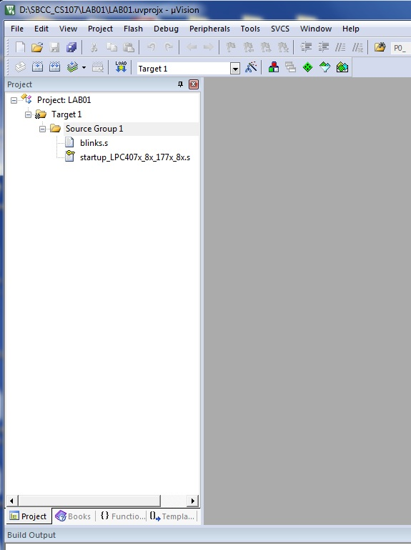
Please note: the 'startup_LPC407...' file is 'locked' (small 'key' next to 'page' symbol). It means it is 'read-only' and you can not to change anything in it (Of course, you can, if you will change file attributes manually). In the future you will see such 'locked' files in your LABs. In most cases those files are very useful and helpful for you. It may include some predefined numbers and constants like addresses of service registers, values of control fields, etc. The best you can do with those 'locked' files it is... not unlock and not changing it!
13. Double-click on 'blinks.s' file in 'Project' window, and the file will be loaded into IDE for editing:
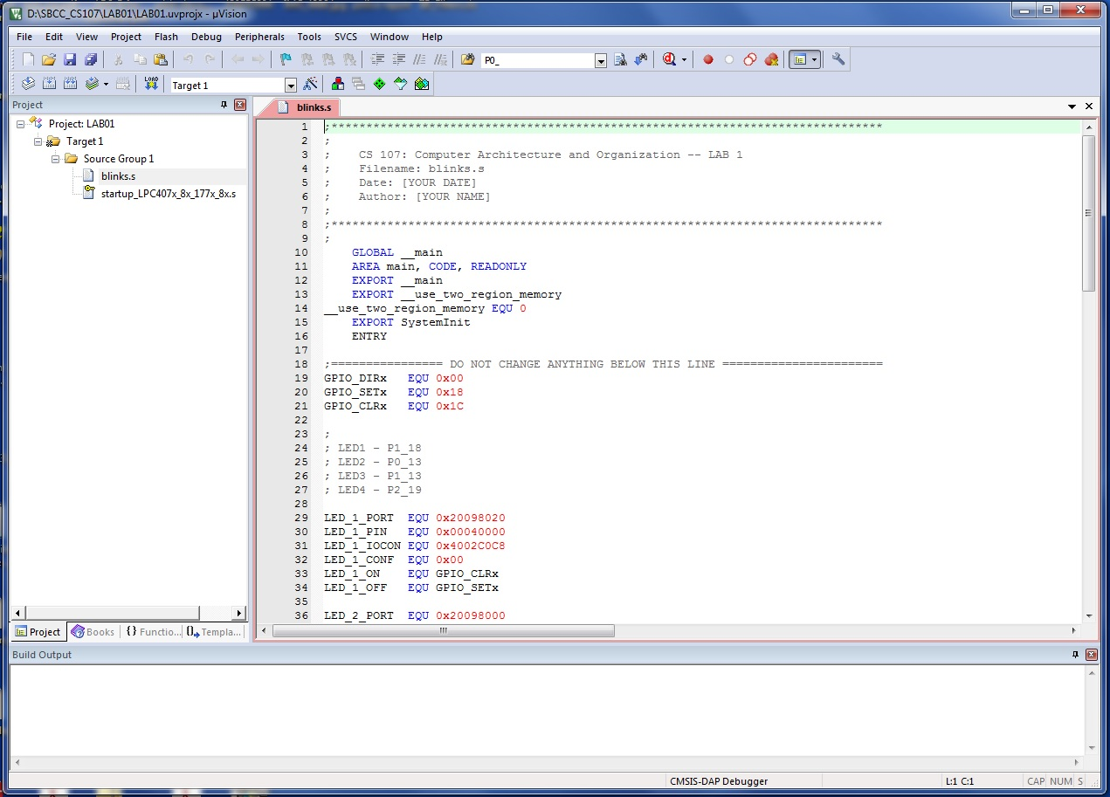
Please note: The uVision IDE itself is pretty standard. Editor functionality and commands, window's docking, compile/debug command are very similar to another IDEs ("Eclipse", "Visual Studio", etc.) that you may used for C, Java, etc. So, generally, it should be not a problem to edit the assembler files. The language is new, but the service tools may be familiar.
Let's make some simple editing.
14. In the file 'header', put actual date and your name:
;*******************************************************************************
;
; CS 107: Computer Architecture and Organization -- LAB 1
; Filename: blinks.s
; Date: [YOUR DATE]
; Author: [YOUR NAME]
;
;*******************************************************************************
Important: Please try to do not insert/remove any line(s) in "blinks.s". This tutorial refers to particular line numbers!

15. Looking on the file, you may note the following lines:
;================ DO NOT CHANGE ANYTHING BELOW THIS LINE =======================
GPIO_DIRx EQU 0x00
GPIO_SETx EQU 0x18
GPIO_CLRx EQU 0x1C
...
LED_4_ON EQU GPIO_SETx
LED_4_OFF EQU GPIO_CLRx
;================ DO NOT CHANGE ANYTHING ABOVE THIS LINE =======================

Probably you will see such notes in your future LABs too. The best practice is to really do not change anything between "== DO NOT CHANGE ANYTHING BELOW THIS LINE ==" and "== DO NOT CHANGE ANYTHING ABOVE THIS LINE ==".

16. Let's try to compile the file! (Assembler is also a compiler like "C" or "Java". It turns your "mnemonic" code (text) into processor's commands that are all numbers).
You may use the buttons ( 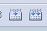 ) on 'Tool bar' (almost or absolutely same buttons are used in "Visual Studio", "Eclipse", etc.). You also can select "Project" in main menu and then select "Build Target" or "Rebuild all target files" (You will see the same small icons next to menu items).

The result of compilation will be printed in 'Build Output' window at the bottom of IDE window:

*** Using Compiler 'V5.06 update 6 (build 750)', folder: 'C:\Keil_v5\ARM\ARMCC\Bin'
Build target 'Target 1'
assembling blinks.s...
blinks.s(66): error: A1163E: Unknown opcode LOAD , expecting opcode or Macro
blinks.s(67): error: A1163E: Unknown opcode MOVE , expecting opcode or Macro
blinks.s(97): error: A1517E: Unexpected operator equal to or equivalent to =
blinks.s(99): error: A1163E: Unknown opcode OR , expecting opcode or Macro
blinks.s(105): error: A1163E: Unknown opcode set_delay , expecting opcode or Macro
".\Objects\LAB01.axf" - 5 Error(s), 0 Warning(s).
Target not created.
Build Time Elapsed: 00:00:00

Oops! We have 5 errors! Somebody did the homework not well! Let do more editing...

17.
blinks.s(66): error: A1163E: Unknown opcode LOAD , expecting opcode or Macro

First error is in line 66. Line numbers are on left border of editor window. Easy to locate the string! Or, you may double-click on the error message in 'Build Output' window to jump to problem line. In Line 66 you have to replace LOAD by LDR.

18.
blinks.s(67): error: A1163E: Unknown opcode MOVE , expecting opcode or Macro

In line 67 it should be MOVW instead of MOVE .

19.
blinks.s(97): error: A1517E: Unexpected operator equal to or equivalent to =

In line 97 the "LED_1_PORT" Is missed after '=' sign. It should be "=LED_1_PORT "

20.
blinks.s(99): error: A1163E: Unknown opcode OR , expecting opcode or Macro

In line 99 the "E" is missed before "OR" It should be "EOR "!

21.
blinks.s(105): error: A1163E: Unknown opcode set_delay , expecting opcode or Macro

Put the cursor at very begining of the line (before 'B') and type 'Tab' button. The code should looks like:

103  104  105  106 | STREQ R2, [R1,#LED_1_OFF] ; if flag==0, turn LED off  ;  B set_delay  ;

21. Run compiler again.

*** Using Compiler 'V5.06 update 6 (build 750)', folder: 'C:\Keil_v5\ARM\ARMCC\Bin'
Build target 'Target 1'
assembling blinks.s...
blinks.s(99): error: A1137E: Unexpected characters at end of line
".\Objects\LAB01.axf" - 1 Error(s), 0 Warning(s).
Target not created.
Build Time Elapsed: 00:00:00

Again?! Error!? Yes. it is normal. Remove "#" after " LED_FLAG" in line 99.

22. Run compiler yet another time.

*** Using Compiler 'V5.06 update 6 (build 750)', folder: 'C:\Keil_v5\ARM\ARMCC\Bin'
Build target 'Target 1'
assembling blinks.s...
blinks.s(84): error: A1516E: Bad symbol '_delay', not defined or external
blinks.s(92): error: A1516E: Bad symbol 'delayloop', not defined or external
".\Objects\LAB01.axf" - 2 Error(s), 0 Warning(s).
Target not created.
Build Time Elapsed: 00:00:00

Sometimes it may take a while to get a bug-free code!

23. Line 84 - type 'led_delay' instead of '_delay' (insert 'led' before '_'). In line 92 'delayloop' should be 'delay_loop'. Insert '_' between 'y' and 'l'. Run compiler again.

24.
*** Using Compiler 'V5.06 update 6 (build 750)', folder: 'C:\Keil_v5\ARM\ARMCC\Bin'
Build target 'Target 1'
assembling blinks.s...
linking...
.\Objects\LAB01.sct(8): warning: L6314W: No section matches pattern *(InRoot$$Sections).
Program Size: Code=540 RO-data=228 RW-data=0 ZI-data=1024
Finished: 0 information, 1 warning and 0 error messages.
".\Objects\LAB01.axf" - 0 Error(s), 1 Warning(s).
Build Time Elapsed: 00:00:00

This 'warning' is OK. It is because our program does not use any variables in the memory.

25. Ok! Let's RUN your code! First, set the 'Breakpoint' at the begin of your program. To do it, go to line 82 ("MOV R0, #0") and click on grey area left to number '82'. You will see the red circle here.

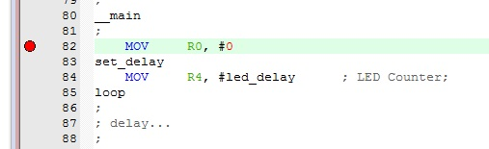

Now the program will stop at line 82.

26. Now, turn the debugger on. Press on the ( 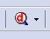 ) button on the 'Tool bar' or Ctrl+F5 on the keyboard. Click right on the center of 'magnifier glass', not on small 'triangle'. You will see the "32K code size" message box, just click "OK". We are using a free Academic version of uVision IDE, the code size is limited by 32 KBytes. No worries, this size is more than enough for all LABs you will do (including any 'Extra Credit' projects).

The program will be loaded into Processor's flash memory and the screen layout will be changed from 'Editor layout' to 'Debug layout'.

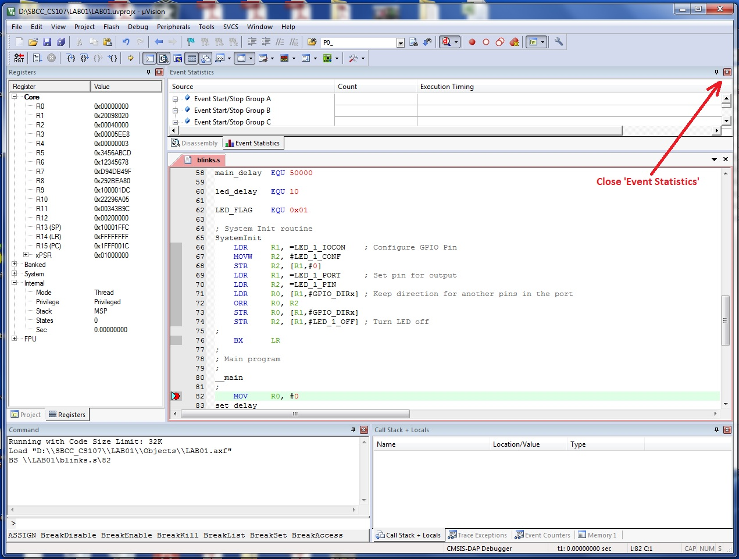

Close 'Event Statistics' windows. We do not need it for our work. The 'Disassembly' window is much more interesting!
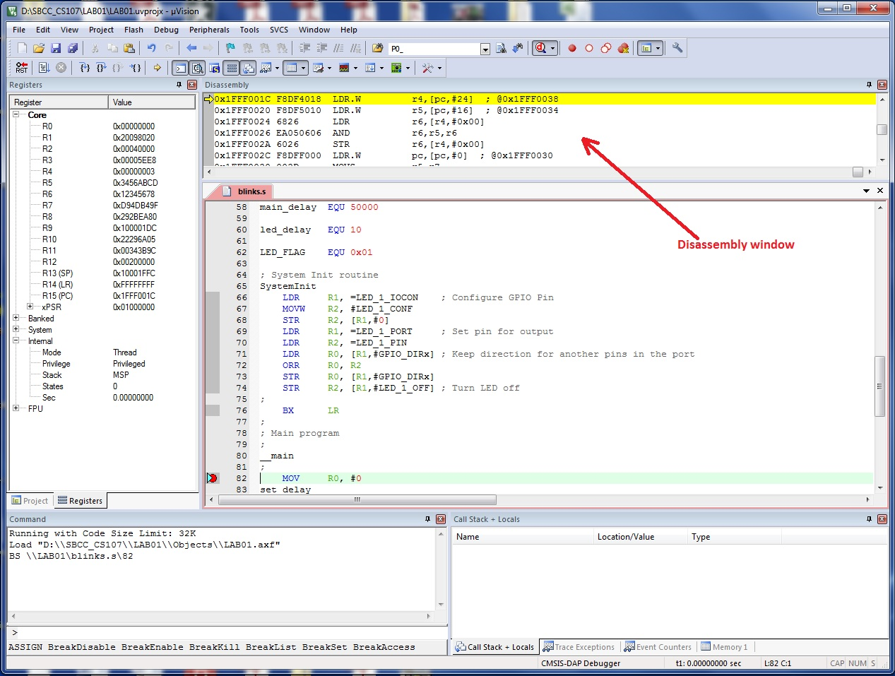

For better view, you may 'drag' disassembly window to the right side of the code window.
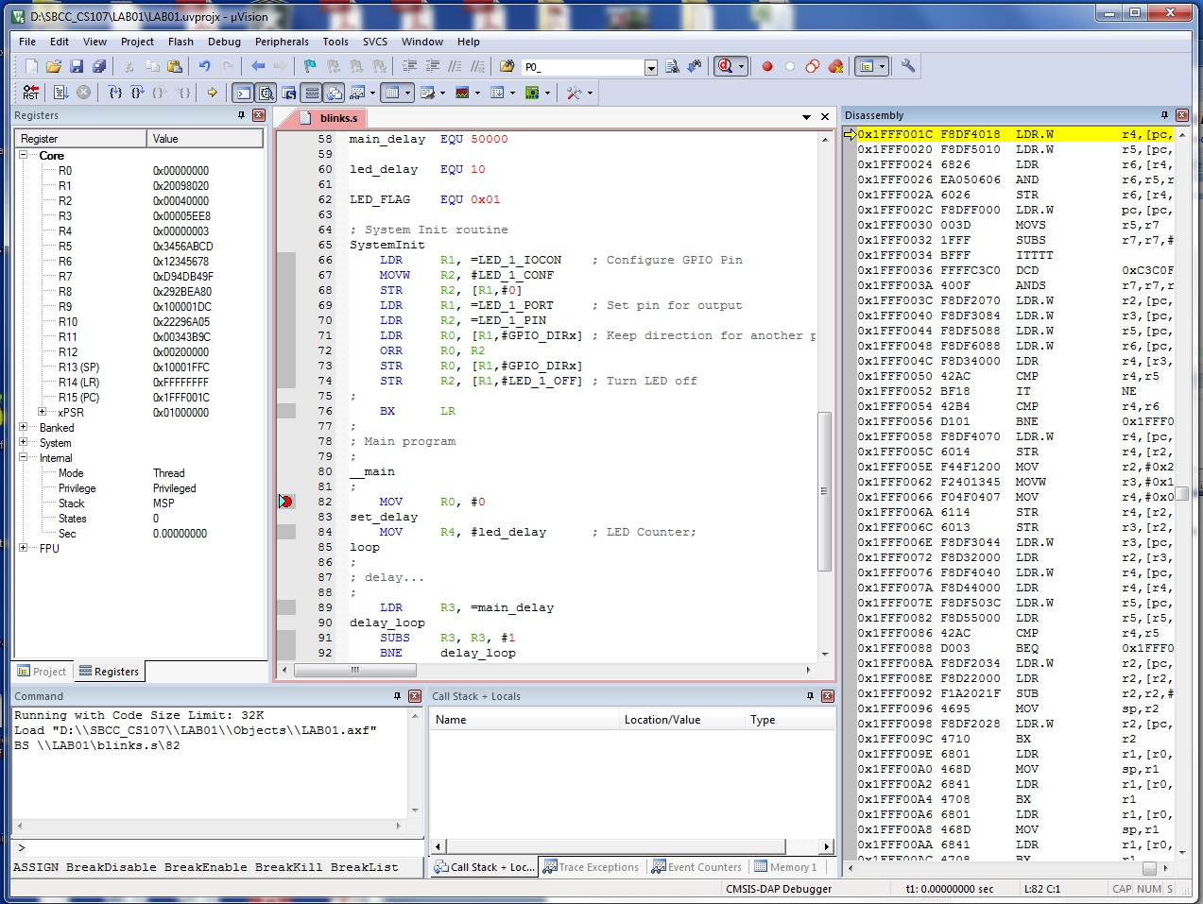

The uVision will remember the screen layout you made, so, next time you will not need to close 'Event' window and drag 'Disassembly' window to the right side.

You also may note that 'Tool bar' is now slightly different. For now you have some buttons for debugger commands. One of them is a 'Run (F5)' button ( 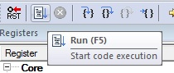 ). Or, you may use 'F5' key on your keyboard instead. By some reason, the debugger not executing code to 'main' procedure for programs written on assembler. You have to help to debugger. Press the 'Run' button (or press 'F5').

You will see, that processor executed some commands and reach your 'Breakpoint'! You can see it in both 'Editor' screen n(double blue-yellow triangle):

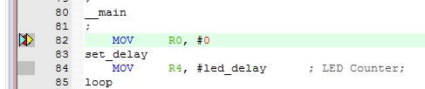

And, also, in 'Disassembly' windows (yellow string):

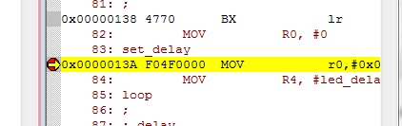

Lets the program run! Press 'Run' button (F5) again! The program now works!

What is it doing? Locate 4 small LEDs on the "Red Board":
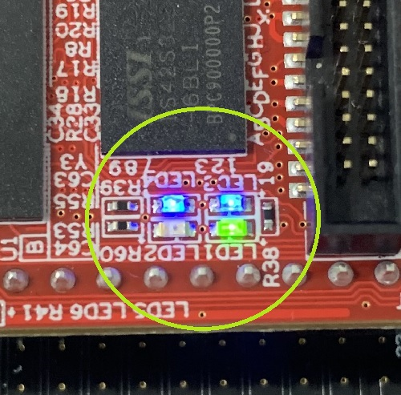

There are LED1, LED2 (Green) and LED3 and LED4 (blue). Blue ones (LED3, 4) are steady, LED2 is dark but LED1 is blinking (Green). This is your program! We did a small assembler program that can control the LED. It can periodically turn the LED on and off!

27. Let's try the "Step (F11)" and "Step Over (F10)" commands. ( 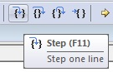 ) In our case both commands works the same way (we will see difference when we will call subprograms.)

First of all, let set another 'breakpoint' on line #99. You can do it even the program runs. Locate the line #99 in editor window ("blinks.s") and click left to number "99" on gray strip along window's left border.

Very shortly the program will stop on the line #99. You may note that LED1 is now steady (on or off) and two blue and yellow triangles are next to red dot on line 99. Look at 'Register' window left to "editor". The value of register R0 will be 0x00000000 or 0x00000001.

Click on 'Step' button or press "F11" on your keyboard. What happens?
A. Double "Blue-Yellow" triangle moves from line 99 to line 100. The CPU executed one command (EOR)!
B. The value of R0 is changed from 1 to 0 or from 0 to 1. Note the R0 is 'highlighted', it means the value of the register was changed by latest executed command.

28. Press "Step" 3 more times and look at the LED1. If the value of R0 was "0" on the line 100, the LED1 will become ON at line #102. If the value of R0 was '1' on the line 100, the LED1 will become OFF at line 103. Check it out!

29. You have to be at line #105 now. Press "Step" again and see the "double triangle" jumped to line #84. The processor executed a "BRANCH" command. This command is used if you need to make some 'loop' like "for" or "while" in C or Python.

30. On the line #84, the R4 should be "0x00000000". Press "Step". You see the R4 is highlighted now and its value is 0x0000000A now. The "Step" on Line #89 make R3 = 0x0000C350. There is something like assignment operators in Python or Java. "R0 = 10" or so. Continue pressing "Step"/"F11" you will note that processor executes commands on lines 91 and 92 (And number in the R3 register constantly decreasing. Operator like "R3 -= 1" on Java)...

31. It is very long loop and it will take a many clicks to get out of there. So, we will press "Run"/F5 button to let the processor runs freely.

32. When the long loop is done, the processor will stop again on line 99. Use steps ##27-28 to see the LED1 changing its state again...

33. Let remove the breakpoint from the line #99. Just click on the "red circle" and the breakpoint will disappear. (Note: Click on grey area left to line number sets the 'breakpoint', click on breakpoint "red circle" clears the breakpoint. Like in Visual Studio or Eclipse IDEs). Click on "Run" button and lets the program runs.

34. Close the debugger. Click on "magnifier glass" ( ) again (or Ctrl+F5 on the keyboard). The uVision IDE will returns to "Editor layout".

35. Let make some experiments with the code a little. For all following tasks, use the general workflow:
A. Use editor to make some changes in the code.
B. Translate the program ( or 'F7' ). Fix syntax errors if any.
C. When no compilation errors, turn on the debugger ( or Ctrl+F5 )
D. Run the program ( or "F5" one or more times )
E. If desired, use breakpoint and "Step" commands ( or "F11").
F. When done, leave the debugger ( or Ctrl+F5 ) and go back to editing.

36. Try to change "led_delay" (line #60, "led_delay EQU 10") from 10 to 3, 20, 100. Run the program for all 3 new values. What happens?

37. Question: If 'led_delay' will be 1, guess what will be happens with LED1? Check if you right.

38. Set 'led_delay' to 10, 15, 20 or even 100 or 200 again. In the lines ##66-103 replace all LED_1 by LED_2. (You need to select lines ##66-103 and use Main Menu->"Edit"->"Replace" dialog. Then choose the "Selection" option in "Look In" drop-down list. Fill all fields, use "Replace All" button. There are should be 9 replaces). Run the program. What happens?

39. Replace all LED_2 in lines ##66-103 by LED_3 or/and LED_4... Make sure BLUE LED blinks now.

The Lab is done! Submit it to Canvas.

40. Extra credit! Try to modify the program to allow any two LEDs (of your choice) blink simultaneously.

41. Super Extra Credit! Two, three or four LEDs blink each on its own frequency!

Note: If you done with "Super Extra Credit", you may be overqualified for CS107. Probably you have to think about not wasting your time and take some another class this semester.

