LAB03 - Arithmetic and Logic commands, Branches, Loops, Conditional execution.
The LAB includes up to 8 tasks. Student have to use template file and replace lines marked by '; -- Your code here ---' by ARM instructions. The code should be translated and executed. Student should use debugger to debug code (if necessary) and/or to see results. (By step-by-step executions or by using 'breakpoints') Tasks are roughly placed in 'easy to advanced' order. Tasks 7 and 8 are 'bonus' ones. Those ones may require more effort from you.
1. Probably, some of code you made, may be used in next Lab(s). It is important to organize your course workspace effectively. It is highly recommended to crease the root directory with some name like "YourId_CS107" ('YourID' may be your name or canvas login). Inside this route you will create separate directories for each Lab.
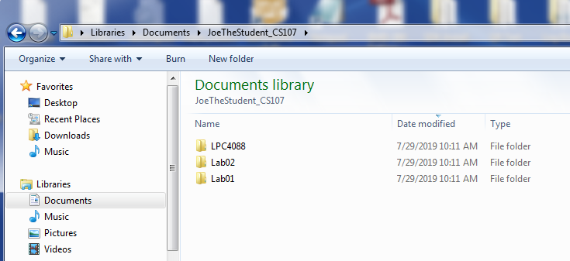
2. So, create the directory named 'Lab03'.
3. Download, unzip and copy the file 'startup_LPC407x_8x_177x_8x.s' into your ' Lab03' directory.
4. Download, unzip and copy the file 'Template_Lab03.s' into your 'Lab02' directory.
5. Rename 'Template_Lab03.s' to 'JoeTheStudent_Lab03.s' where 'JoeTheStudent' is your name or canvas login.
6. Open 'Keil uVision'  and create new project 'Lab03' like you did it for Lab01 and Lab02. (You may want to use Lab01 document for detailed instructions). Please note: the Project file should be in your 'Lab03' directory. Setting for your project is as following:
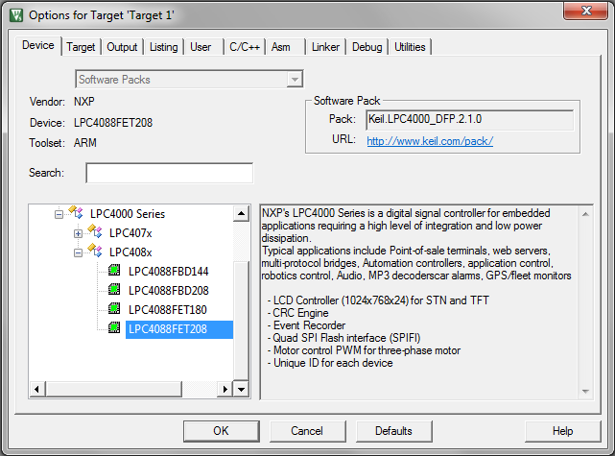
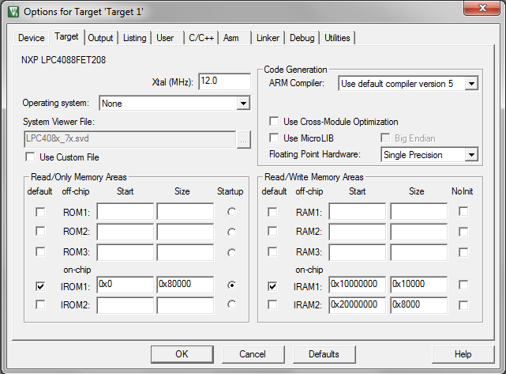

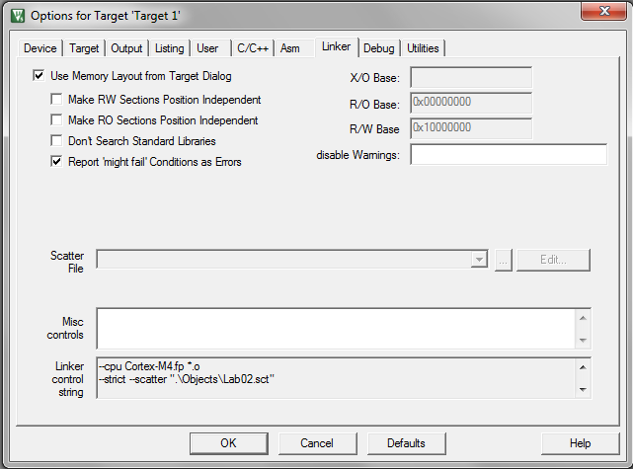
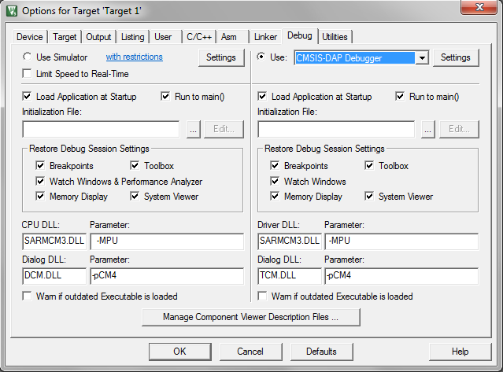
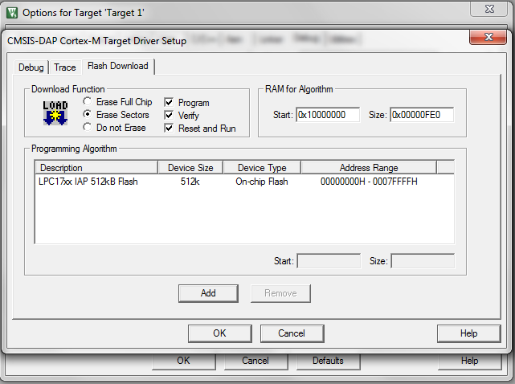
7. Add 'JoeTheStudent_Lab03.s' and 'startup_LPC407x_8x_177x_8x.s' files into your project.
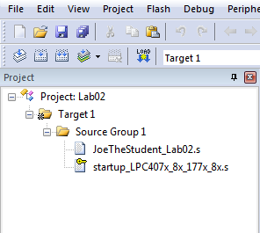
8. Open 'JoeTheStudent_Lab03.s' (Of course, It should be your name/login/ID instead of 'JoeTheStudent'..) file. Type your name and date into file header. Replace ';-- your code here --', '-- Your instruction here -- ', etc. lines with your instructions.
9. Use 'build target'  and 'start debug'  commands/buttons to compile, load your program. Remember LAB01 or LAB02: use the general workflow:

A. Use editor to make some changes in the code.

B. Translate the program ( or 'F7' ). Fix syntax errors if any.

C. When no compilation errors, turn on the debugger ( or Ctrl+F5 )

D. Run the program ( 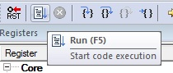 or "F5" one or more times )

E. Use breakpoints:
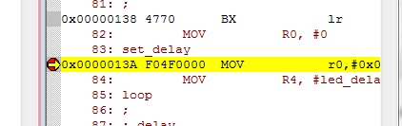

F. Use "Step" commands ( 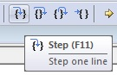 or "F11") to go throw your code and see results... Note what is working not good and figure out the way(s) to fix the problem(s).

G. When done, leave the debugger ( or Ctrl+F5 ) and go back to editing.

Use run, step execution commands/buttons ( and) to run the program and see results. Debug your instructions if necessary.
Probably you will want to use something you did in Lab02. You may do it! Reusing some code is always OK!
10. Zip and submit 'JoeTheStudent_Lab03.s' file when done.
Important Notes, please read:
1. Please keep your code readable.
It is supposed that you will locate lines like:
; -- Your instruction here ---
; -- Place your code here! --
; -- Place two commands here! --
etc. and you will replace those lines by your own processor's instructions.
2. Your code should work for any data!
Sometimes you are provided with some initial numbers in the registers. Those numbers are for testing purposes only. Do not make your code depended on those particular data. To grade your work, another numbers may be used.
3. You may be restricted with number of commands should be used, to keep some resisters unchanged, etc.
In low-level assembler programming, sometimes is very important to use minimal possible resources to make size- and time-efficient code. It is a reason because some constrains may be applied to some tasks in this Lab. Please read carefully and obey all the restrictions!
Examples:
a.
;
; 6. Write a small program to compare two 64-bit values. Set R0 to 0 if two values
; are equal, set R0 to 1 if two values are not equal. First 64-bit number placed into
; R1(HI bits) and R2(LO bits), second number is in R3(HI bits) and R4(LO bits). Use only
; 4 ARM instructions!
;

;-- Your 4 instructions here ---

Some points may be deducted if you will use more than 4 commands. The task really may be done by four commands when conditional suffixes are used. Take this as a little puzzle!
b.
;-- May be done in 3 instructions ---
;-- Approx. 3 instructions ---
This is not a limitations. It is just a guideline. Challenge yourself and make the code as short as possible!
c.
; - Do not use any other registers.
; Your code have to preserve (do not change) the value in R0
Self explained. The answer may be deemed incorrect and the rating may be lowered if these conditions are not met.

