LAB04 - Data transfer commands (memory access).
The LAB includes up to 7 tasks. Student have to use template file and replace lines marked by '; -- Your code here ---' by ARM instructions. The code should be translated and executed. Student should use debugger to debug code (if necessary) and/or to see results. (By step-by-step executions or by using 'breakpoints') Tasks are roughly placed in 'easy to advanced' order. Tasks 6 and 7 are 'bonus' ones. Those ones may require more effort from you.
1. Probably, some of code you made, may be used in next Lab(s). It is important to organize your course workspace effectively. It is highly recommended to crease the root directory with some name like "YourId_CS107" ('YourID' may be your name or canvas login). Inside this route you will create separate directories for each Lab.
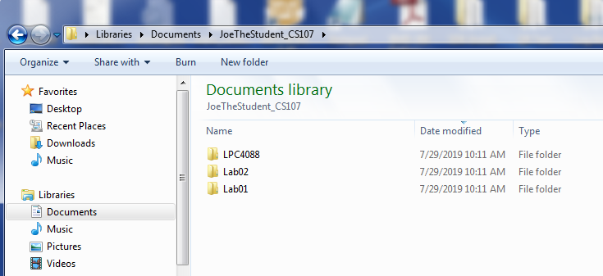
2. So, create the directory named 'Lab04'.
3. Download, unzip and copy the file 'startup_LPC407x_8x_177x_8x.s' into your ' Lab04' directory.
4. Download, unzip and copy the file 'Template_Lab04.s' into your 'Lab04' directory.
5. Rename 'Template_Lab04.s' to 'JoeTheStudent_Lab04.s' where 'JoeTheStudent' is your name or canvas login.
6. Open 'Keil uVision'  and create new project 'Lab04' like you did it for Lab01, Lab02 and Lab03. (You may want to use Lab01 document for detailed instructions). Please note: the Project file should be in your 'Lab04' directory. Setting for your project is as following:
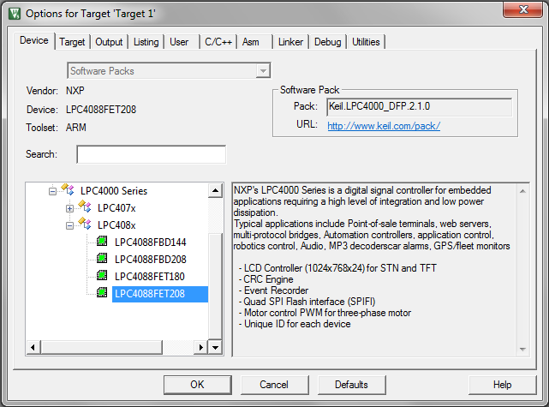
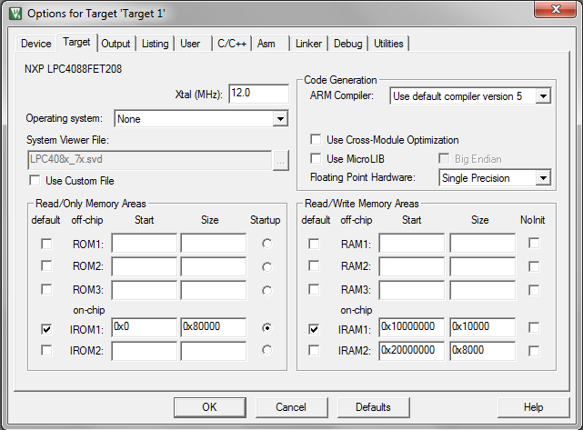

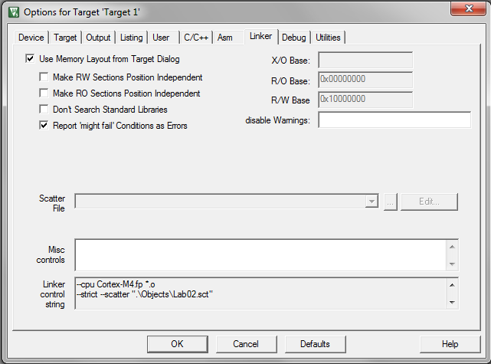
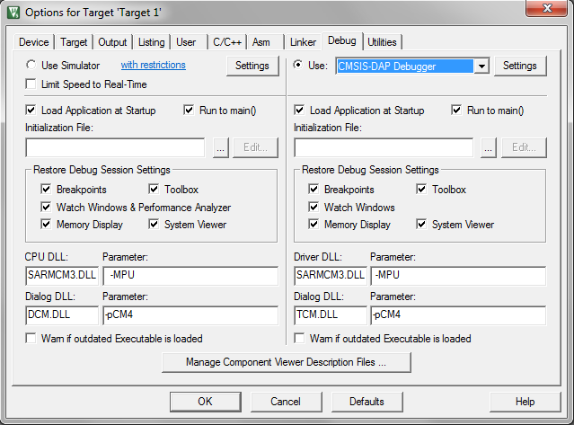
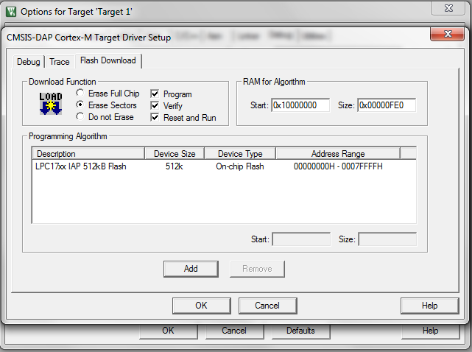
7. Add 'JoeTheStudent_Lab04.s' and 'startup_LPC407x_8x_177x_8x.s' files into your project.
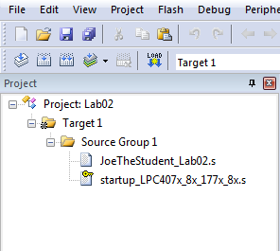
8. Open 'JoeTheStudent_Lab04.s' (Of course, It should be your name/login/ID instead of 'JoeTheStudent'..) file. Type your name and date into file header. Replace ';-- your code here --', '-- Your instruction here -- ', etc. lines with your instructions.
9. Use 'build target'  and 'start debug'  commands/buttons to compile, load your program. Remember LAB01 or LAB02: use the general workflow:

A. Use editor to make some changes in the code.

B. Translate the program ( or 'F7' ). Fix syntax errors if any.

C. When no compilation errors, turn on the debugger ( or Ctrl+F5 )

D. Run the program ( 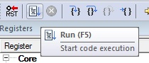 or "F5" one or more times )

E. Use breakpoints:
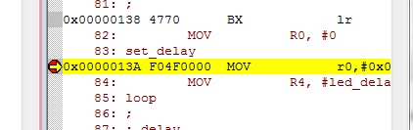

F. Use "Step" commands ( 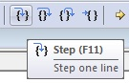 or "F11") to go throw your code and see results... Note what is working not good and figure out the way(s) to fix the problem(s).

G. When done, leave the debugger ( or Ctrl+F5 ) and go back to editing.

Use run, step execution commands/buttons ( and) to run the program and see results. Debug your instructions if necessary.
You will be need to look at content of microprocessor's memory.
In 'Debug' mode there are a special window to watch memory:
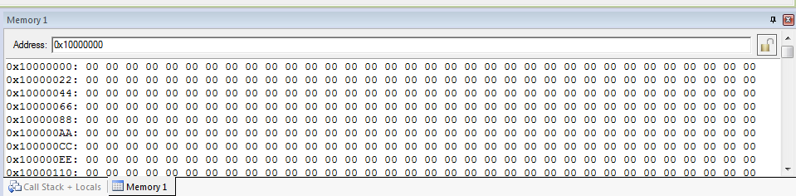
It calls 'Memory 1' and usually placed under 'Text Editor' window. The 'Memory' window available in 'Debug' mode only. You cannot see memory if not running your program.
The RAM is placed beginning address 0x1000000. You will need to type this number (0x10000000) into 'Address:' sting on the top of memory window.
Right click on 'Memory' window allows you to select the presentation format:
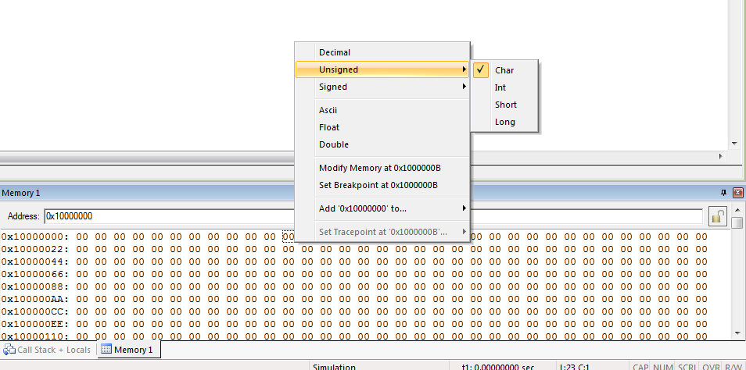
To see memory content as hex. numbers select 'Unsigned->Char', 'Unsigned->Int', 'Unsigned->Short' or 'Unsigned->Long'.
To see decimal numbers. select 'Decimal'.
To see memory as text, select 'Ascii'. More likely, in the Lab04, you will need 'Ascii' representation format.
Probably you will want to use something you did in your previous labs. You may do it! Reusing some code is always OK!
10. Zip and submit 'JoeTheStudent_Lab04.s' file when done.
Important Notes, please read:
1. Please keep your code readable.
It is supposed that you will locate lines like:
; -- Your instruction here ---
; -- Place your code here! --
; -- Place two commands here! --
etc. and you will replace those lines by your own processor's instructions.
2. Your code should work for any data!
Sometimes you are provided with some initial numbers in the registers, test strings, etc. Those numbers and strings are for testing purposes only. Do not make your code depended on those particular data. To grade your work, another numbers, strings, etc. may be used.

3. Do not use any hardcoded addresses in FLASH and RAM!
All physical addresses are assigned by linker. Even if we are know that all variables are placed starting address 0x10000000, we have to not relay on it! Any addresses may be changed by linker 'without prior notices'!
The code like:
MOV r0, #0x10000000 ; R0 is the address of result in RAM!
will be assumed incorrect!
The instruction like:
LDR r0, =my_result
is perfect!

